Supplementary Materials for Deep Learning-based Adaptive Downsampling of Hyperspectral Bands for Soil Organic Carbon Estimation

This section provides detailed model structures and results referenced in the main article.

# Inference Module Architecture for AD-CNN and FD-CNN

## Lower dimensional Size: 8

|  |  |
| --- | --- |
| Layer Type | Parameters / Details |
| Conv1d | In: 1 channel, Out: 32 filters, Kernel Size = 4, Stride = 1, Padding = 0 |
| BatchNorm1d | 32 channels |
| Activation | LeakyReLU |
| MaxPool1d | Kernel Size = 2, Stride = 2, Padding = 0 |
| Flatten | Starting from dimension 1 |
| Linear | In Features = 64, Out Features = 1 |

Table S: Inference module architecture for AD-CNN with Lower dimensional Size 8.

## Lower dimensional Size: 16

|  |  |
| --- | --- |
| Layer Type | Parameters / Details |
| Conv1d | In: 1 channel, Out: 32 filters, Kernel Size = 4, Stride = 1, Padding = 0 |
| BatchNorm1d | 32 channels |
| Activation | LeakyReLU |
| MaxPool1d | Kernel Size = 2, Stride = 2, Padding = 0 |
| Conv1d | In: 32 channels, Out: 64 filters, Kernel Size = 2, Stride = 1, Padding = 0 |
| BatchNorm1d | 64 channels |
| Activation | LeakyReLU |
| MaxPool1d | Kernel Size = 2, Stride = 2, Padding = 0 |
| Flatten | Starting from dimension 1 |
| Linear | In Features = 128, Out Features = 1 |

Table S: Inference module architecture for AD-CNN with Lower dimensional Size 16.

## Lower dimensional Size: 32

|  |  |
| --- | --- |
| Layer Type | Parameters / Details |
| Conv1d | In: 1 channel, Out: 32 filters, Kernel Size = 8, Stride = 1, Padding = 0 |
| BatchNorm1d | 32 channels |
| Activation | LeakyReLU |
| MaxPool1d | Kernel Size = 4, Stride = 4, Padding = 0 |
| Conv1d | In: 32 channels, Out: 64 filters, Kernel Size = 2, Stride = 1, Padding = 0 |
| BatchNorm1d | 64 channels |
| Activation | LeakyReLU |
| MaxPool1d | Kernel Size = 2, Stride = 2, Padding = 0 |
| Flatten | Starting from dimension 1 |
| Linear | In Features = 128, Out Features = 1 |

Table S3: Inference module architecture for AD-CNN with Lower dimensional Size 32.

## Lower dimensional Size: 64

|  |  |
| --- | --- |
| Layer Type | Parameters / Details |
| Conv1d | In: 1 channel, Out: 32 filters, Kernel Size = 8, Stride = 1, Padding = 0 |
| BatchNorm1d | 32 channels |
| Activation | LeakyReLU |
| MaxPool1d | Kernel Size = 4, Stride = 4, Padding = 0 |
| Conv1d | In: 32 channels, Out: 64 filters, Kernel Size = 4, Stride = 1, Padding = 0 |
| BatchNorm1d | 64 channels |
| Activation | LeakyReLU |
| MaxPool1d | Kernel Size = 4, Stride = 4, Padding = 0 |
| Flatten | Starting from dimension 1 |
| Linear | In Features = 128, Out Features = 1 |

Table S4: Inference module architecture for AD-CNN with Lower dimensional Size 64.

## Lower dimensional Size: 128

|  |  |
| --- | --- |
| Layer Type | Parameters / Details |
| Conv1d | In: 1 channel, Out: 32 filters, Kernel Size = 16, Stride = 1, Padding = 0 |
| BatchNorm1d | 32 channels |
| Activation | LeakyReLU |
| MaxPool1d | Kernel Size = 8, Stride = 4, Padding = 0 |
| Conv1d | In: 32 channels, Out: 64 filters, Kernel Size = 8, Stride = 1, Padding = 0 |
| BatchNorm1d | 64 channels |
| Activation | LeakyReLU |
| MaxPool1d | Kernel Size = 4, Stride = 4, Padding = 0 |
| Flatten | Starting from dimension 1 |
| Linear | In Features = 320, Out Features = 64 |
| BatchNorm1d | 64 channels |
| Activation | LeakyReLU |
| Linear | In Features = 64, Out Features = 1 |

Table S5: Inference module architecture for AD-CNN with Lower dimensional Size 128.

## Lower dimensional Size: 256

|  |  |
| --- | --- |
| Layer Type | Parameters / Details |
| Conv1d | In: 1 channel, Out: 32 filters, Kernel Size = 16, Stride = 1, Padding = 0 |
| BatchNorm1d | 32 channels |
| Activation | LeakyReLU |
| MaxPool1d | Kernel Size = 8, Stride = 6, Padding = 0 |
| Conv1d | In: 32 channels, Out: 64 filters, Kernel Size = 8, Stride = 1, Padding = 0 |
| BatchNorm1d | 64 channels |
| Activation | LeakyReLU |
| MaxPool1d | Kernel Size = 4, Stride = 4, Padding = 0 |
| Conv1d | In: 64 channels, Out: 128 filters, Kernel Size = 4, Stride = 1, Padding = 0 |
| BatchNorm1d | 128 channels |
| Activation | LeakyReLU |
| MaxPool1d | Kernel Size = 2, Stride = 2, Padding = 0 |
| Flatten | Starting from dimension 1 |
| Linear | In Features = 256, Out Features = 1 |

Table S6: Inference module architecture for AD-CNN with Lower dimensional Size 256.

## Lower dimensional Size: 512

|  |  |
| --- | --- |
| Layer Type | Parameters / Details |
| Conv1d | In: 1 channel, Out: 32 filters, Kernel Size = 16, Stride = 1, Padding = 0 |
| BatchNorm1d | 32 channels |
| Activation | LeakyReLU |
| MaxPool1d | Kernel Size = 8, Stride = 8, Padding = 0 |
| Conv1d | In: 32 channels, Out: 64 filters, Kernel Size = 8, Stride = 1, Padding = 0 |
| BatchNorm1d | 64 channels |
| Activation | LeakyReLU |
| MaxPool1d | Kernel Size = 8, Stride = 8, Padding = 0 |
| Conv1d | In: 64 channels, Out: 128 filters, Kernel Size = 4, Stride = 1, Padding = 0 |
| BatchNorm1d | 128 channels |
| Activation | LeakyReLU |
| MaxPool1d | Kernel Size = 2, Stride = 2, Padding = 0 |
| Flatten | Starting from dimension 1 |
| Linear | In Features = 128, Out Features = 1 |

Table S7: Inference module architecture for AD-CNN with Lower dimensional Size 512.

# Inference Module Architecture for AD-FCNN and FD-FCNN

## Lower dimensional Size: 8

|  |  |
| --- | --- |
| Layer | Parameters / Details |
| Linear | In Features: 8, Out Features: 10 |
| BatchNorm1d | 10 channels |
| Activation | LeakyReLU |
| Linear | In Features: 10, Out Features: 1 |

Table S8: Inference module architecture for AD-FCNN and FD-FCNN with Lower dimensional Size 8.

## Lower dimensional Size: 16

|  |  |
| --- | --- |
| Layer | Parameters / Details |
| Linear | In Features: 16, Out Features: 10 |
| BatchNorm1d | 10 channels |
| Activation | LeakyReLU |
| Linear | In Features: 10, Out Features: 1 |

Table S9: Inference module architecture for AD-FCNN and FD-FCNN with Lower dimensional Size 16.

## Lower dimensional Size: 32

|  |  |
| --- | --- |
| Layer | Parameters / Details |
| Linear | In Features: 32, Out Features: 16 |
| BatchNorm1d | 16 channels |
| Activation | LeakyReLU |
| Linear | In Features: 16, Out Features: 1 |

Table S10: Inference module architecture for AD-FCNN and FD-FCNN with Lower dimensional Size 32.

## Lower dimensional Size: 64

|  |  |
| --- | --- |
| Layer | Parameters / Details |
| Linear | In Features: 64, Out Features: 32 |
| BatchNorm1d | 32 channels |
| Activation | LeakyReLU |
| Linear | In Features: 32, Out Features: 1 |

Table S11: Inference module architecture for AD-FCNN and FD-FCNN with Lower dimensional Size 64.

## Lower dimensional Size: 128

|  |  |
| --- | --- |
| Layer | Parameters / Details |
| Linear | In Features: 128, Out Features: 64 |
| BatchNorm1d | 64 channels |
| Activation | LeakyReLU |
| Linear | In Features: 64, Out Features: 32 |
| BatchNorm1d | 32 channels |
| Activation | LeakyReLU |
| Linear | In Features: 32, Out Features: 1 |

Table S12: Inference module architecture for AD-FCNN and FD-FCNN with Lower dimensional Size 128.

## Lower dimensional Size: 256

|  |  |
| --- | --- |
| Layer | Parameters / Details |
| Linear | In Features: 256, Out Features: 128 |
| BatchNorm1d | 128 channels |
| Activation | LeakyReLU |
| Linear | In Features: 128, Out Features: 64 |
| BatchNorm1d | 64 channels |
| Activation | LeakyReLU |
| Linear | In Features: 64, Out Features: 1 |

Table S13: Inference module architecture for AD-FCNN and FD-FCNN with Lower dimensional Size 256.

## Lower dimensional Size: 512

|  |  |
| --- | --- |
| Layer | Parameters / Details |
| Linear | In Features: 512, Out Features: 256 |
| BatchNorm1d | 256 channels |
| Activation | LeakyReLU |
| Linear | In Features: 256, Out Features: 128 |
| BatchNorm1d | 128 channels |
| Activation | LeakyReLU |
| Linear | In Features: 128, Out Features: 1 |

Table S14: Inference module architecture for AD-FCNN and FD-FCNN with Lower dimensional Size 512.

# 1D-CNN using all 4,200 bands

|  |  |
| --- | --- |
| Layer | Parameters / Details |
| Conv1d | Input: 1 channel, Output: 32 filters, Kernel Size = 16, Stride = 1, Padding = 0 |
| BatchNorm1d | 32 channels |
| Activation | LeakyReLU |
| MaxPool1d | Kernel Size = 16, Stride = 16, Padding = 0 |
| Conv1d | Input: 32 channels, Output: 64 filters, Kernel Size = 8, Stride = 1, Padding = 0 |
| BatchNorm1d | 64 channels |
| Activation | LeakyReLU |
| MaxPool1d | Kernel Size = 16, Stride = 16, Padding = 0 |
| Conv1d | Input: 64 channels, Output: 128 filters, Kernel Size = 4, Stride = 1, Padding = 0 |
| BatchNorm1d | 128 channels |
| Activation | LeakyReLU |
| MaxPool1d | Kernel Size = 8, Stride = 8, Padding = 0 |
| Flatten | Starting from dimension 1 |
| Linear | Input Features: 128, Output Features: 1 |

Table S15: 1D-CNN using all 4,200 bands

# Computing Hardware Used

Processor: Intel(R) Core(TM) i7-8700 CPU @ 3.20GHz   3.19 GHz

GPU: NVIDIA GeForce GTX 1060 (6GB)

Installed RAM: 32.0 GB

Operating System: Windows 11

**Standard Deviation Heatmap for different metrics of AD-CNN Across Training Conditions**

## The recommended configuration is highlighted with blue rectangles in all heatmaps.

## *R2*

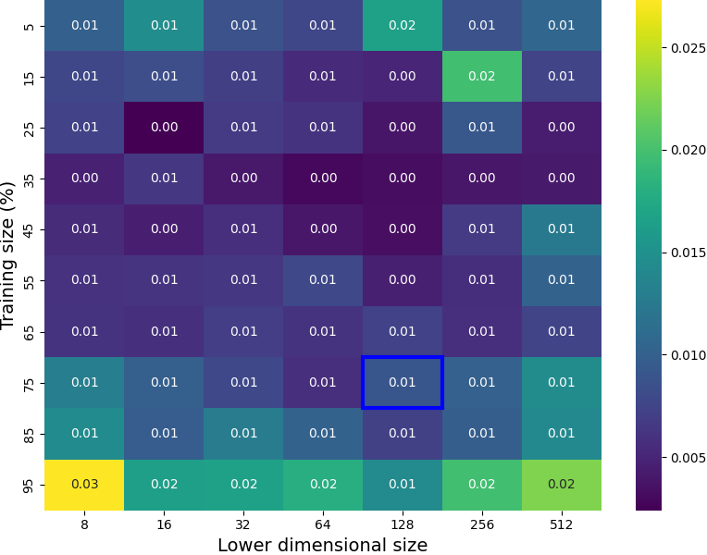

Figure S: Standard deviation heatmap for *R2* for AD-CNN across training conditions.

## RMSE

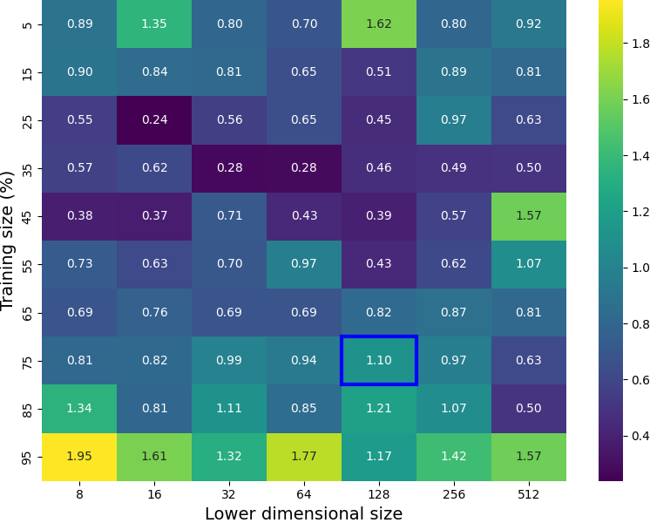

Figure S2: Standard deviation heatmap for RMSE for AD-CNN across training conditions.

## RPD

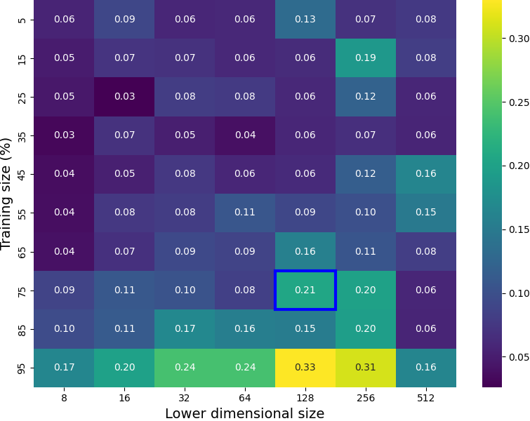

Figure S3: Standard deviation heatmap for RPD for AD-CNN across training conditions.

## Execution time

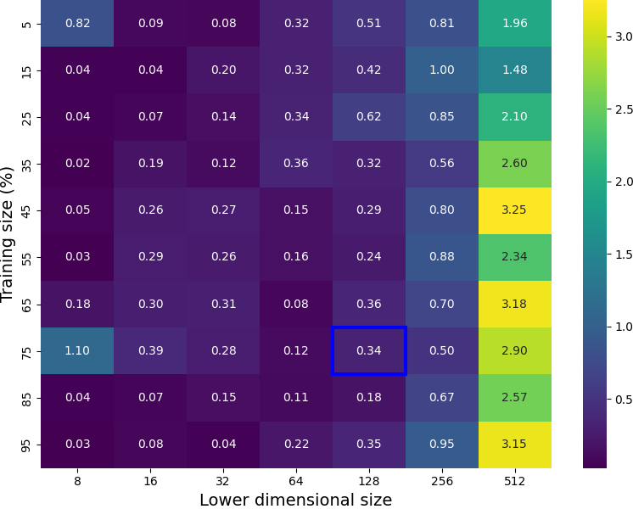

Figure S4: Standard deviation heatmap for execution time for AD-CNN across training conditions.