**Knowledge Management and Discover**

**CS 560**

**Lab I - Report**

**Problem:**

1) Design the Class and ER Diagrams using Visio for the InClass Exercise (Jan. 21) (check the attached file)

2) Create a GitHub account and post GitHub ID to the Lab 1 site

3) Create a ScrumDo account and define task/plan/delivery for your lab 1 assignment. Also post your ScrumDo ID to the Lab 1 site

4) Write  lab 1 report including screenshots of tasks (1, 2, 3) and post this report to your github Lab 1 folder and post the lab 1 folder to the Lab 1 site

**1: ER Diagram and Class Diagram**

**ER Diagram**

Above problem can be solved in two ways.

**Recursion model**:

Attached is the simple ER Schema which can be used to implement the problem.



The above diagram can be further generalized by categorizing the relations into a separate Entity and Roles into another.

This new model gives the advantage of adding new roles and responsibilities easily, without changing schema. Here the roles (Father, Mother, Husband, and Wife) can be listed in the roles table, and responsibilities (Parent, spouse) can be listed in on the responsibilities table. The responsibilities can be determined based on the gender of the person.



A person can have zero or many responsibilities, and a responsibility has one to one role.

**Class Diagram**

Father and Mother are inherited from Person, where both are associated as parents. Husband and wife roles have a dependency of marriage between them. Child class has a dependency relation with Father and Mother. Child class cannot exist without Father and Mother classes. (Or else only if child is Genetically-modified).



**2: Git HUB account**

Created a GIT Hub account and shared the necessary files in GITHUB

Please find the screenshot below.

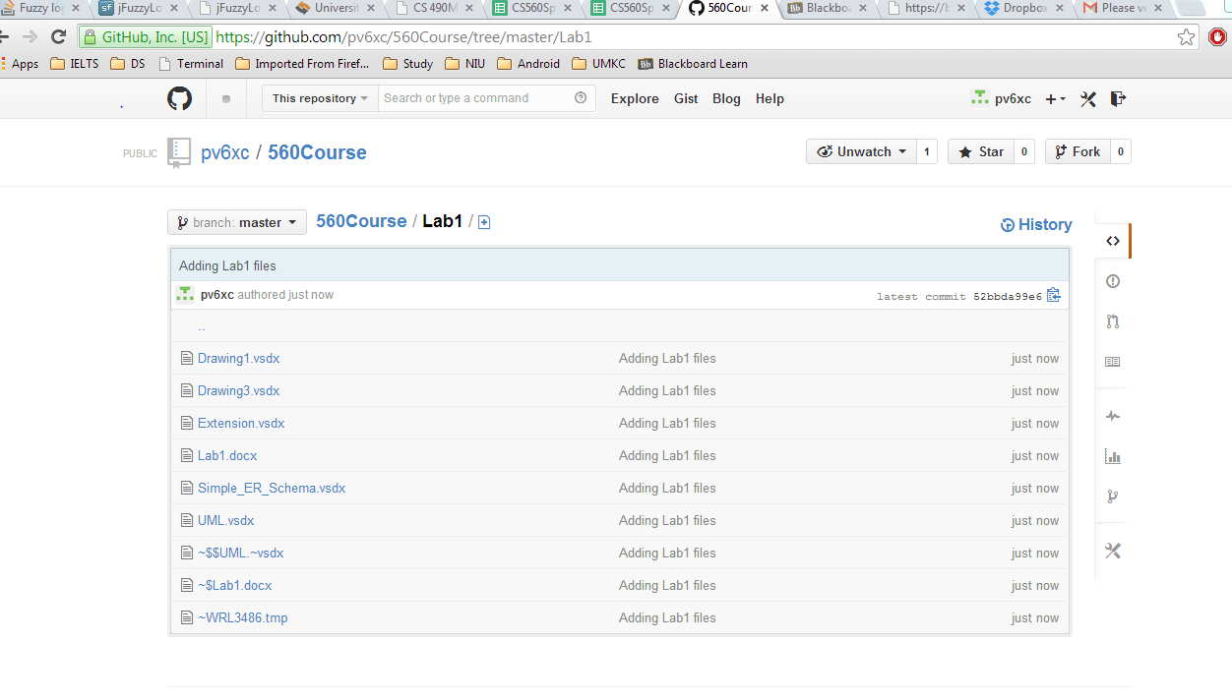

**3: ScrumDO account**

Created a scrum DO account and listed the tasks for LAB 1, and completed accordingly.

Please find the screenshot below