Sensor based Mobile Games for Healthy Life

A sensor based mobile application which uses machine learning to detect their movements and gives appropriate recommendation to users on their calorie intake and energy burnt while using the mobile application.

Malathy Krishnan

Prakash Vakka Reddy

**Sensor Based Mobile Games for Healthy Life**

1. **Introduction**

A sensor based mobile application which uses machine learning to detect their movements and gives appropriate recommendation to users on their calorie intake and energy burnt while using the mobile application.

Application has the following features:

Provides an interactive game to the user.

Reports the calorie the user burnt while playing with the application.

Recommendation to the user regarding his workout.

1. **Project Goal and Objectives**
2. **Overall goal**

Making the use of an interactive fun game to help user workout and burn calories and giving them recommendation.

1. **Specific Objectives**

Humans carry out many tasks on a daily basis, but the amount of energy intake and energy spend is not matching. On a long term basis this might lead to obesity or they might be emaciated. With a regular check on our daily energy consumption and usage, we can avoid such problems. Our objective is to build a mobile application which could help users monitor their calorie.

1. **Significance**

Current application and devices in market, just show the number of calories burnt on a day, but recommendations are not available based on their work out. Our application tries to implement this new functionality of recommending the users.

1. **Usefulness of the application:**

* Educational (Kids games with a physical activity ) and Medical(Obesity control) purposes.
* The user can get reminders if he is not working out or not getting enough of physical exercise on a day.
* The application gives recommendations based on few fixed criteria like how much energy to burn per day, minimum amount of exercise needed.
* As games as applications on mobile phones are getting more popular, using these for physical exercise in this mechanical world would be of great advantage.
* It is cheaper compared to fitbit and Nike + Fuel band, Polar loop.

1. **Project Background and Related work**

A series of products from fit-bit and others are available, most of them sense the data and give you an idea of how much calories you have burnt, and user can set his task or limit. But our app tries to recommend users the actions he should take based on his profile to have equal calorie intake and burn.

The existing applications are more of only workout which might be boring to the user. The application we develop will be interactive with games in which the user won’t know that he is working out explicitly. He will in turn have fun working out.

Links of the other related products:

<http://www.fitbit.com/>

<http://store.nike.com/us/en_us/pd/fuelband-se/pid-924482/pgid-924484>

<http://www.bowflexboost.com/bowflex-boost-us/homepage.jsp>

<http://www.bodymedia.com/Shop>

<https://jawbone.com/up>

<http://lark.com/products/larklife/experience>

1. **Proposed System**
2. **Requirement Specification**

**1.1 Functional Requirements**

| Req# | Requirement | Comments | Priority | Date Rvwd |
| --- | --- | --- | --- | --- |
| USER_CASE_01 | Android application should connect to the sensor device and when the user plays the game the data is collected. | Collected data should be sent to machine learning algorithms over rest service. (Temporarily data can be saved in text file) |  |  |
| USER_CASE_02 | Android application authentication, should collect user data with login details | User details should be saved in cloud for further use and recommendations based on user profile |  |  |
| USER_CASE_03 | Android application should show recommendations for the user based on his profile and calories intake | This could be using naive based classification and solr over a rest service. |  |  |
| MACHINE_LERN_CASE_01 | Received sensor data via rest service in the form of json/xml which will be classified in to the respective actions.(The actions are detected with the help of already trained data set) | Different actions, such as idle, walking, running and steps, cycling ...will be in trained se. Real time sensor data should be categorized into these classifications |  |  |
| MACHINE_LERN_CASE_02 | Analysis is saved to a hadoop system/ solr database with a time interval. This is user specific data. | This can use in build functionalities to push classifier data to hadoop or another rest service could be designed to implement this data push |  |  |
| MACHINE_LERN_CASE_03 | Classifier data (calorie burnt) should be pushed to android application periodically | Data for each user should be pushed to android app using a service |  |  |
| MACHINE_LERN_CASE_04 | Recommendations should be calculated based on the available data and calorie burnt algorithms | User should be displayed with the tasks to maintain calorie balance. |  |  |

**1.2 User Interface Requirements**

Application will have a

1. Login page
2. User profile page
3. Game for the user.
4. Report.
5. Recommendations.

**1.3 Workflow analysis**

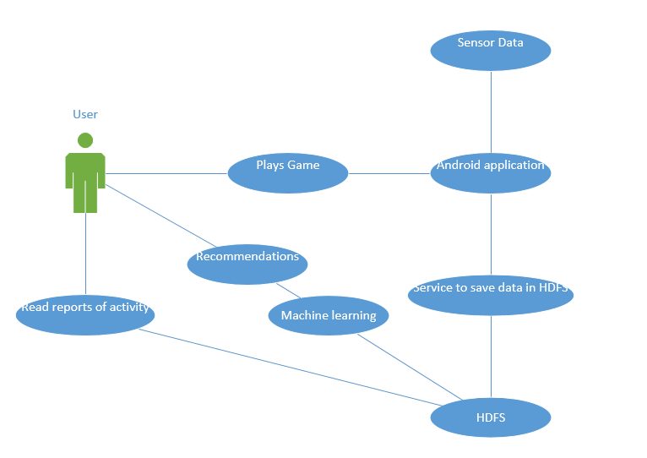

**1.4 Technologies and Architectural requirements**

1. Java based native Android application
2. Generic Attribute Profile(GATT) Profiles based Bluetooth low profile server and client communication
3. Saving user profile data in Hadoop system as unstructured data SOLR.
4. RESTFUL web service to transmit data from android device to Hadoop naive based classifiers
5. Mahout machine learning algorithm to classify different actions based on sensor data
6. Calorie burnt calculations based on sensor data. Accelerometer and gyroscope
7. Recommendations based on user profiles.
8. Pushing their recommendations into cloud, for the android app.
9. Use google api or R based tool to show the analytics data to user in graphical representation.
10. **Framework Specification**

**2.1 System Architecture Diagram**

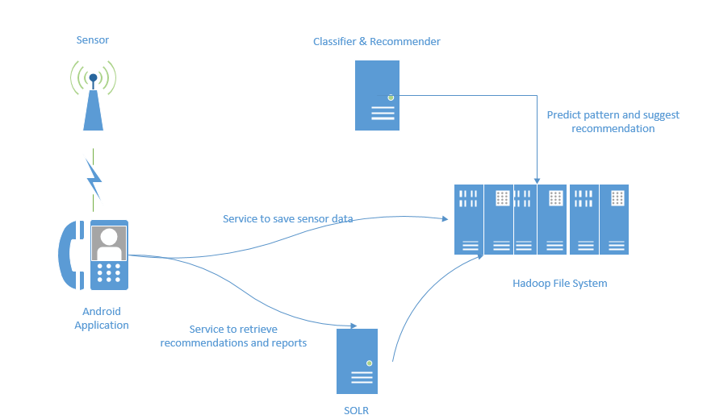

**2.2 Domain Model**

2.2.1 **Data sources**

* Sensor data from multiple sensor tags

Accelerometer

Gyroscope

Magnetometer

Barometer

RSSI

* Data from user
* User profile

Name

Age

Weight

Height

Number of calories intake per day

2.2.2 **Methodologies and Algorithms**

Any normal classifications can be used taking time-domain values and frequency-domain values. The windows width should be adjusted based on the action and device deployment.

2.2.3 **Analytic Tools**

We use Hadoop based mahout algorithm to analyze and use R statistical analytical tools to visualize data.

2.2.4 **Analytical Tasks**

Pattern recognition, calorie calculation, workout recommendation based on profile.

1. **System Specification:**
   * **Existing Application**:

A Sensor Connected Mobile Application:

The user uses the sensor with the mobile application. The sensor data are collected in the mobile device.

* + **New Services to be built**:

1. Restful service from the mobile client which collects the sensor data and writes to a file in HDFS.
2. Functionality which classifies the data into classes using naïve bayes classifier.
3. Restful service querying the data through solr which would retrieve the recommendation, work out per day, calories burnt, etc.

**3.1 Restful service to transfer sensor data from mobile to HDFS**

* **Diagram**

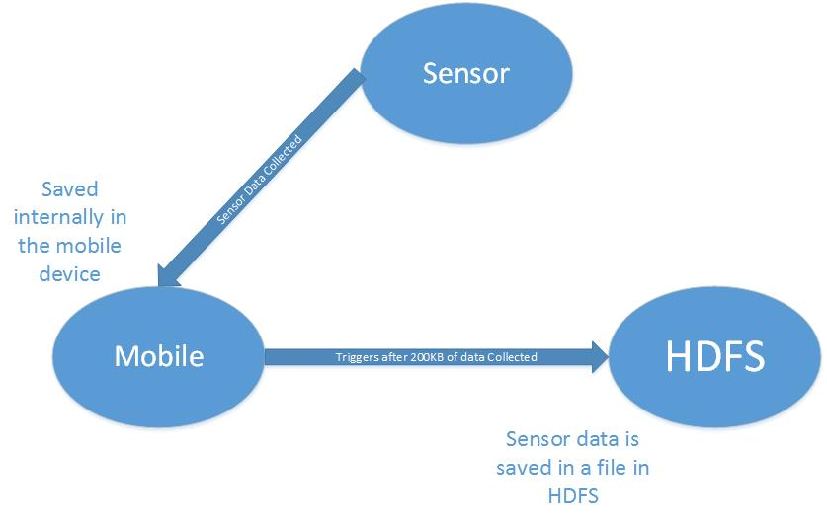

* **Service Specification**
* **Operational description** :

Received data is collected and saved into Hadoop file system for analytics.

* **Input/output for services**

Sensor data in the form of a file is collected as input for the service.

Output would be a Boolean value, informing successful file save in HDFS.

* **Constraints/exceptions**

Connection to the service must be available. HDFS should be active.

* **Design of Mobile Client**

The front end is a game mobile application which has to be played wearing the sensor. The game would involve either kicking, stomping, lifting hands, etc. The movement of the hand or leg is captured through the sensor and detected by the application.

**Example application:**

An image (eg: Fan) will slide through the screen and simultaneously a Text (Eg:”Fan” or “Light”) slides through the screen.

The user has to give a “stomp” if the image and the word matches.

If the image and the word don’t match, the user has to kick.

The score will be recorded as the user stomps on the correct matching.

* Technology: Android

**3.2 Functionality** **which classifies the data into classes according to naive bayes classifier**

* Diagram:

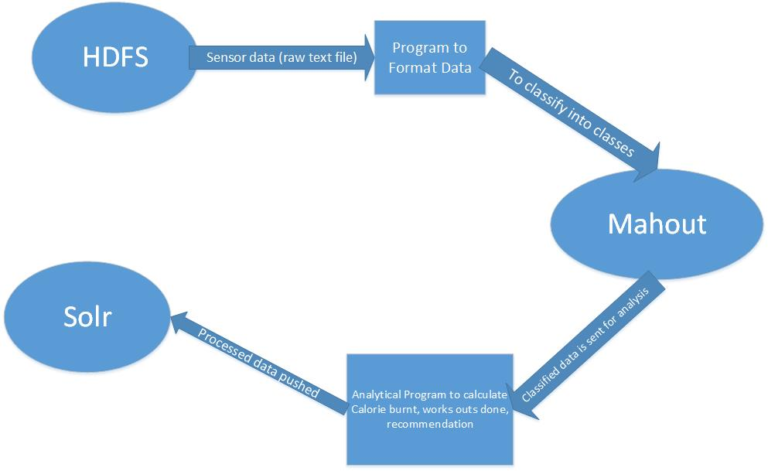

* **Functionality Specification**
* **Operational description** :

According to the training data, the classifier algorithm, classifies the data and groups it into the class like Stomp, front kick, back kick. The data from restful services is saved in a file in HDFS. This data is converted to a specific format and sent as test data. The data will then be classified into different classes.

According to each Class the calories burnt, number of stomps, number of kicks, the score for the application, etc is calculated and pushed to SOLR

* **Input/output for services**

A text file in HDFS which the sensor data. Output will be the calories burnt, number of stomps, number of kicks, and score for the application which will be in SOLR.

* 1. **SOLR Restful services** :
* **Diagram**

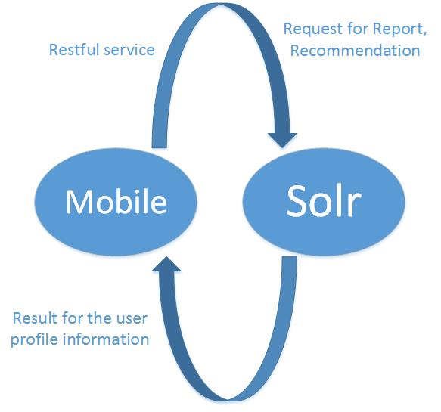

* **Service Specification**
* **Operational description :**

Return queried details such as calories burnt, stomps, recommendations depending on user in the form of XML/JSON.

* **Input/output for services**

Input is a Query using GET or POST methods to SOLR for particular user data.

Output is requested user data in the form of XML/JSON.

**V. Project Hosted sites**

Scrum do : [https://www.scrumdo.com/projects/project/kdm-project/summary#](https://www.scrumdo.com/projects/project/kdm-project/summary)

GitHub repo: <https://github.com/CS560KDM>

**VII. Bibliography**

[**http://hadoop.apache.org/**](http://hadoop.apache.org/)

[**http://www.health.harvard.edu/newsweek/Calories-burned-in-30-minutes-of-leisure-and-routine-activities.htm**](http://www.health.harvard.edu/newsweek/Calories-burned-in-30-minutes-of-leisure-and-routine-activities.htm)

<http://bigdatauniversity.com/wpcourses/>

<http://www.healthstatus.com/calculate/cbc>

<https://developer.bodymedia.com/docs/read/api_reference_v2/Burn_Service>

[**https://mahout.apache.org/**](https://mahout.apache.org/)