Step 1) Type “localhost/comp/” in your browser

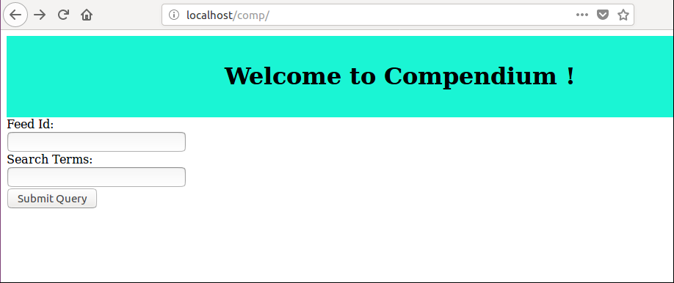

Step 2) Please Enter a valid feed id and click “Submit Query”to fetch the top 9 most recent feeds.

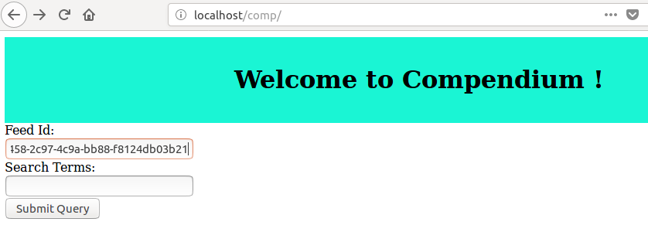

Step 3) Please enter both valid feed id and search terms to search for a specific listing.

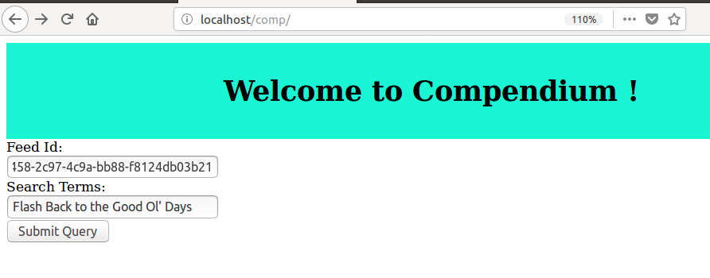

Step 4) On the results page, please click on the “go to details” button, to see more details, including body, image and website link.

