River Crossing IQ GAME

Demo: https://www.youtube.com/watch?v=cbHh3WI0VfQ&t=4s

The upcoming posts on this blog will be dedicated to explaining each step of the code of a river crossing game in which the player has to follow a certain set of rules and transport all characters to the left bank of the river in which case the player will the level and proceed to the next one.

The game tests the IQ of the player and their sharp-mindedness as each level becomes progressively harder and competitive, helping the player flex his/her brain muscles and use his/her intellect.



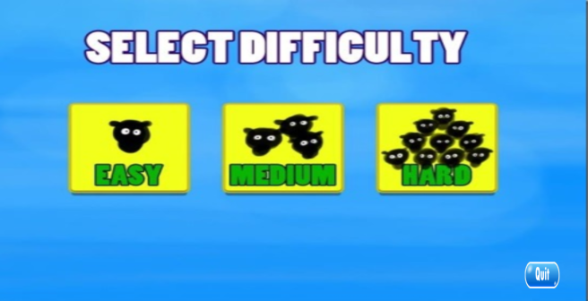
LEVEL 1
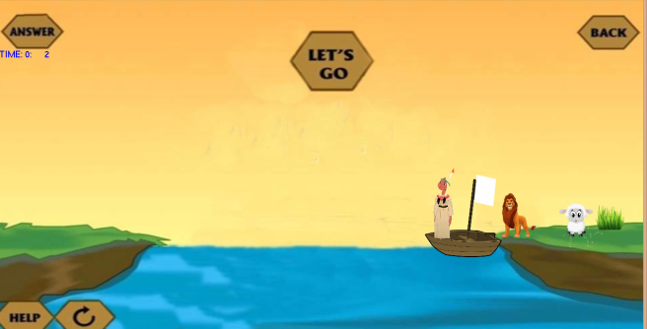
LEVEL 2
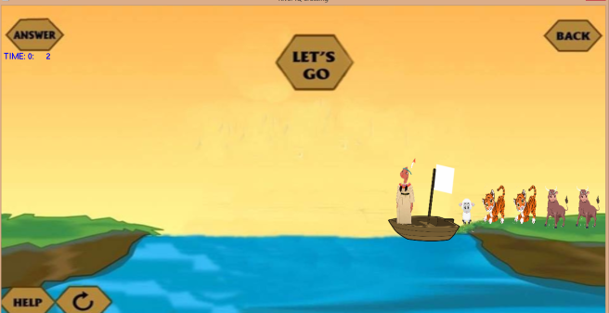

LEVEL 3
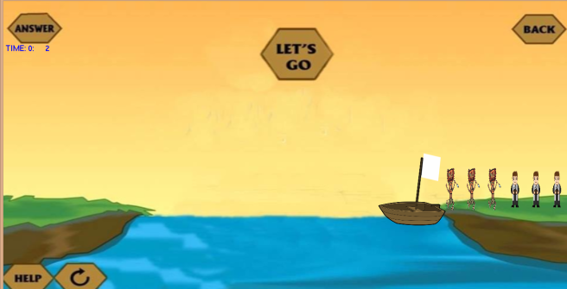
The first portion of this game will be dedicated to uploading all the characters and the background used in the game., according to the syntax of glass.

Line 1 includes the header file (for including glass library).
Line 2 includes the header file (for including built-in time header file).
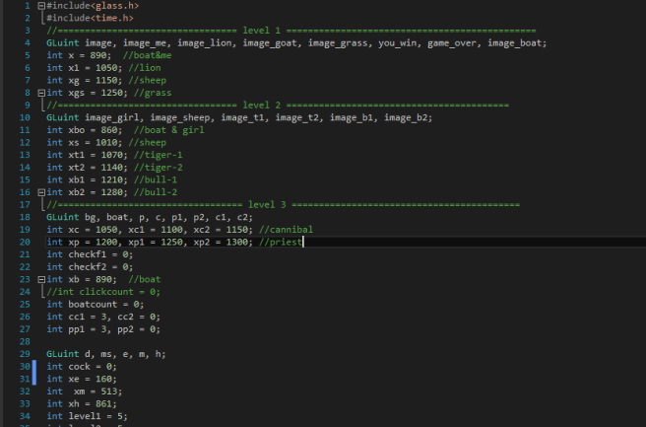
Line 4 begins with the Gluint keyword, followed by the initialization of all the images(by name) according to the following syntax:

Image_(name of the image)
“Image” is named for background.
Note: All the images must be in TGA format and saved in location of the source file.
Lines 4-8 initialize the x coordiantes(which determine the placement of the game character on the background( whose dimensions are 700 *350) for level 1.
Line 10-16 do the same for Level 2. Lines 18-20 do the same for Level 2, lines 18-20 for level 3.
Certain checks are introduced for level 3 for loading and unloading of characters o the boat.
Main function follows the syntax of glass

void main(int argc, char ** argv)
and uploads all the images and background on the screen for all levels. Lines 29-37 initialize all the images used in the welcome screen i.e. options for Easy, Medium and Difficult levels.

From Line 75, display function first clears the screen and then uploads all the images for welcome screen on the screen .I f the user clicks on the x and y coordinates of the option available for difficulty level. Level 1 is initialized to 1, level 2 to 2 , level 3 to 3.
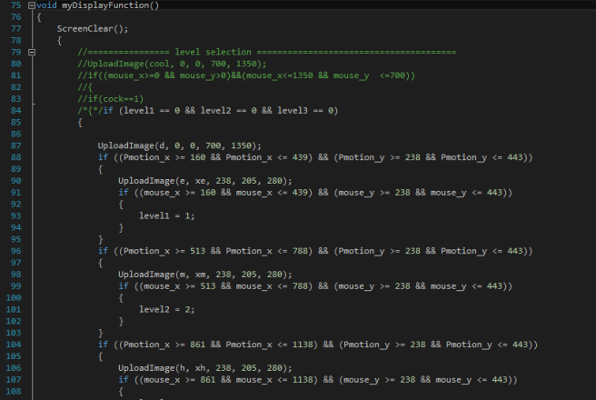

From Line 159, display function first clears the screen and then uploads all the images for level 1 on the screen according to the following syntax:

UploadImage(image name, x coordinate,y coordinate, height, width)
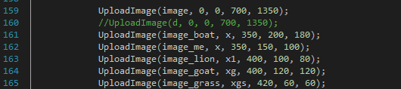

Line 180-197 show that if the user clicks beween x xoordinates in the range 614-784 and y coordinates 64 and 184,(the coordinates of the LET’S GO BUTTON) and if the boat is located on the right bank, then Clickcount % 2 == 0 ensures that boat returns to right bank after reaching the left bank once the user clicks the LET’S GO BUTTON again.

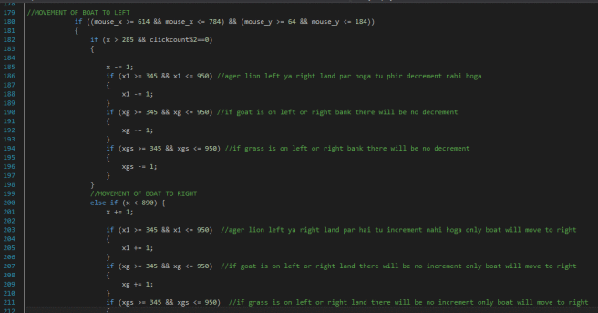

Time Counter
For each level, a counter for time will determine when the game will be over(the limited time range is 3 minutes) after which game will be over. TimeOnce denotes the time in seconds while TimeM determines the time in minutes which will be inccreased by 1 after 60 seconds.

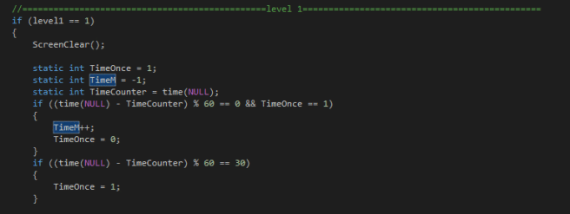

How will the boat move backwards/to the left?
If the boat is on the right bank, Line 46 show that boat’s x coordinates will be decremented if the user clicks the LET’S GO button. Lines 180 onward show that if any character is in between the 345 and 950( x coordinates for left bank and right bank respectively) i.e. on the river and the user clicks the LET’S GO button then the boat will move to the left along with any character on the boat.

How will the boat move forward/to the right?
If the boat is on the left bank, Line 201 shows that boat’s x coordinates will be incremented if the user clicks the LET’S GO button. Lines 203 onward show that if any character is in between the 345 and 950( x coordinates for left bank and right bank respectively) i.e. on the river and the user clicks the LET’S GO button then the boat will move to the right , along with any character on the boat.
However, if the boat is in the reaches any bank(left or right), the clickcount will increase by 1 and hence clickcount%2 in line 220 will equal zero and movement will stop.

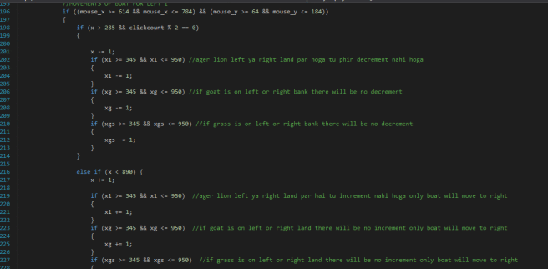

Line 224-233 tells us that if the player clicks anywhere on the x and y coordinates of the lion, if the boat is on the right bank and neither the goat and grass are already on the boat, and if the lion is on the right land then it will move onto the boat. Similarly, this will also happen for other characters.
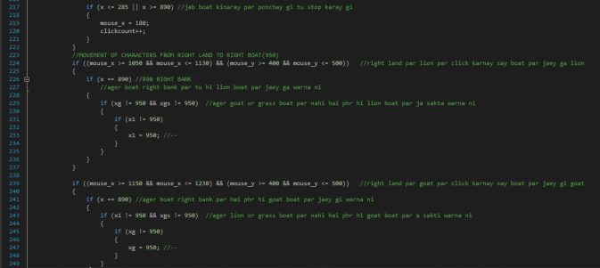

Lines 297-319 show that whenever player clicks on the x and y coordinates of lion placed on boat(at boat’s coordinates=345), it will move from the boat to the left land (at position of 100 x coordinates). Similarly, sheep will move to 0 position and grass to 200 position.
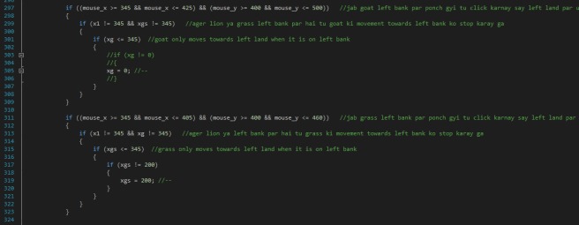

Lines below show that lion will only move to the left boat(at position 345) when the boat is on the left bank(at position 285) and if neither of other characters is already not at position 345 and if lion is on the left land(at position less than 285 i.e. left bank). Similar logic is used for other characters.
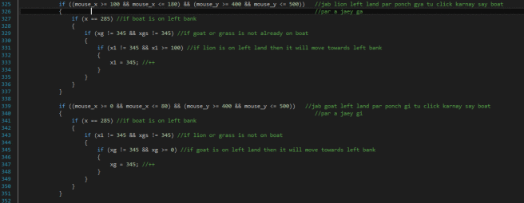
Lines 367-384 show that if the player clicks on the coordinates of lion and if lion is placed at position on the right boat (with x coordinates greater than 890) it will move towards its position (1050) in on the right land.
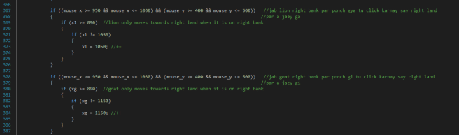
Similar logic is used for other characters.

Game over conditions from line 400 onward show that if the boat moves either to the left from right bank(when it’s x coordinates becomes less than 890) or moves to right from left bank(when boat’s x coordinates become greater than 285) when either lion and goat, or goat and grass are placed on the same bank, game will be over. And the user will be able to either replay the game or go back.
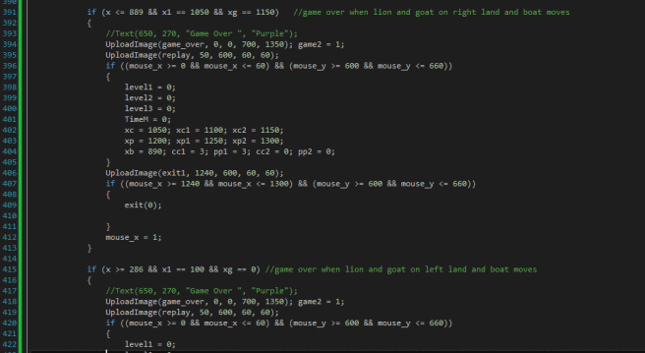

Player will win the game only when all the characters are placed on the left bank .
Lines below set the initial values of x coordinates to the default again and values of all levels equal to zero. Player will also be given the option to exit the game.
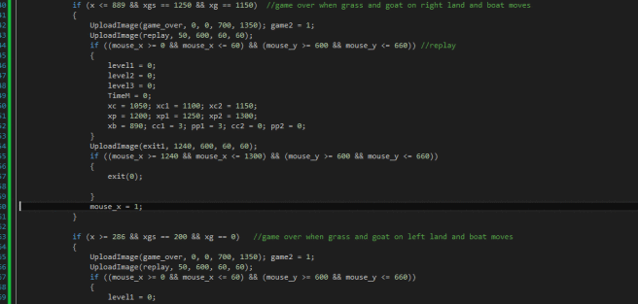
LEVEL 2
Lines below follow the same syntax of glass as mentioned in previous post, simply initializing the image name, their coordinates and upload them.

Time counter is set again for the new level.
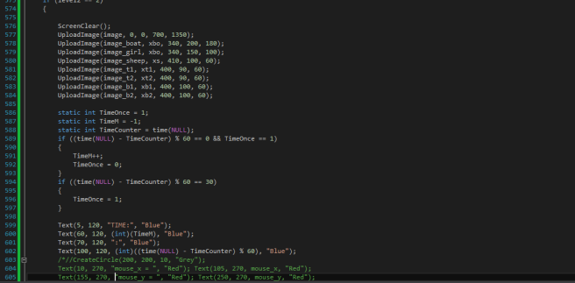

Line below show that if the user clicks between x coordinates in the range 614-784 and y coordinates 64 and 184,(the coordinates of the LET’S GO BUTTON) and if the boat is located on the right bank, then Clickcount % 2 == 0 ensures that boat returns to right bank after reaching the left bank once the user clicks the LET’S GO BUTTON again.

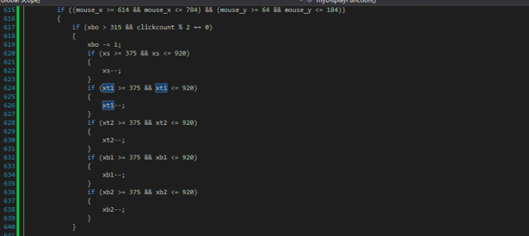

How will the boat move backwards/to the left?
If the boat is on the right bank, Line 463 show that boat’s x coordinates will be decremented if the user clicks the LET’S GO button. Lines 464-484 show that if any character is in between the 375 and 920( x coordinates for left bank and right bank respectively) i.e. on the river and the user clicks the LET’S GO button then the boat will move to the left along with any character on the boat.

How will the boat move forward/to the right?
If the boat is on the left bank, Line 490 shows that boat’s x coordinates will be incremented if the user clicks the LET’S GO button. Lines below show that if any character is in between the 345 and 950( x coordinates for left corner bank and right corner of boat respectively) i.e. on the river and the user clicks the LET’S GO button then the boat will move to the right , along with any character on the boat.
However, if the boat is in the reaches any bank(left or right), the clickcount will increase by 1 and hence clickcount%2 in line 617 will equal zero and movement will stop.
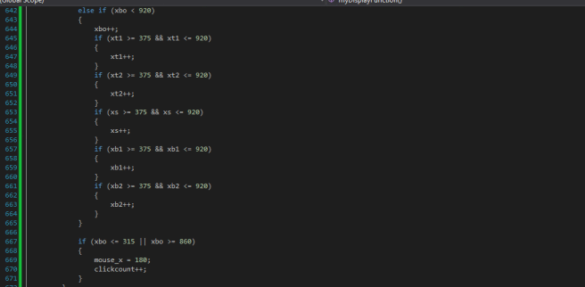
Lines below show that if the player clicks on the x and y coordinates of the sheep when the boat reaches the right bank(at x=860) and if none of other characters is already on the boat then by clicking on the x and y coordinates of the sheep while it is located on the right bank, it will move onto the boat(at position 920).
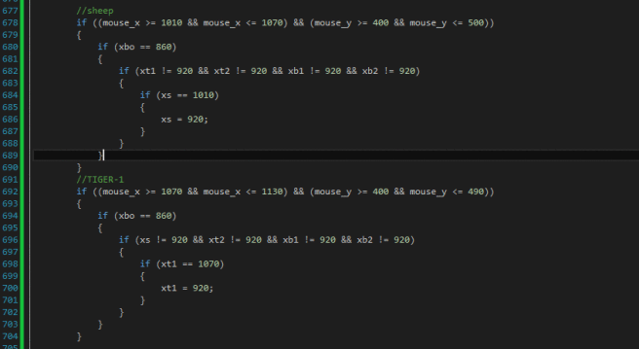
To unload characters from right boat to left land, simply specify the x and y coordinates of mouse by clicking on which the said character will move from boat to the left land. e.g from lines below, if we click on the specified coordinates of sheep,it will move from boat(at 375 x coordinates) to left land (at position 0).
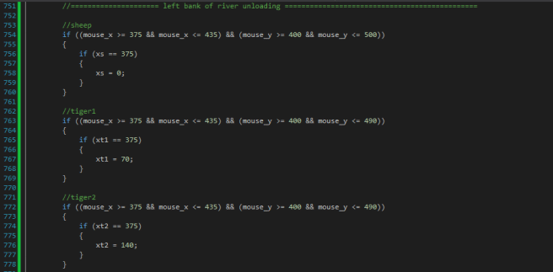
To move a character from left land to boat(at position 375), specify the mouse_x and mouse_y coordinates of that character for sheep and include checkers so that sheep to the left boat will only move if boat has reached the left bank (at position 315) .
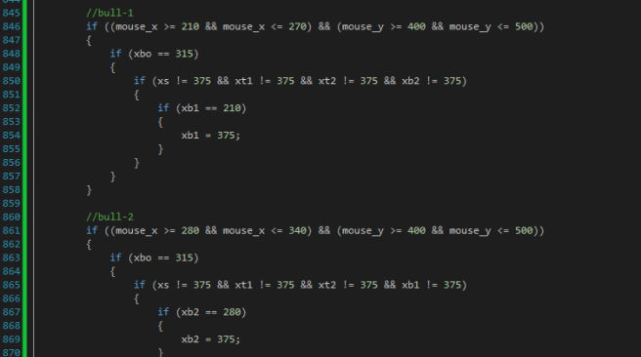
Lines below show that sheep will move from 920 x coordinates(from left boat) to left land ( position 1010) on clicking on the mouse_x and mouse_y coordinates for where the sheep is placed.
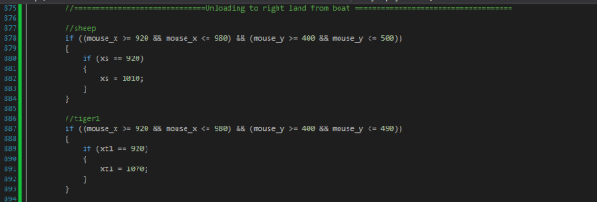

Winning Conditions
Player has to win the game by following the following set of rules:-
2 Tigers and 1 bull can’t be on one left bank while boat’s x coordinates becomes greater than 315 i.e. it moves to right and they also can’t be on the right bank when the boat’s x coordinates is less than 860.
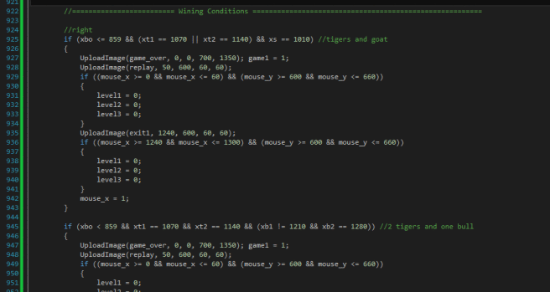
Sheep and either of the tigers cannot be also at either bank when the boat moves or the GAME OVER image be uploaded.

LEVEL 3
The main difference between this level and the previous ones is that now that a maximum of 2 and a minimum of 1 characters can be loaded onto the boat. This will require certain checks to be introduced.
From Line 1149, display function first clears the screen and then uploads all the images on the screen according to the following syntax:

UploadImage(image name, x coordinate,y coordinate, height, width)

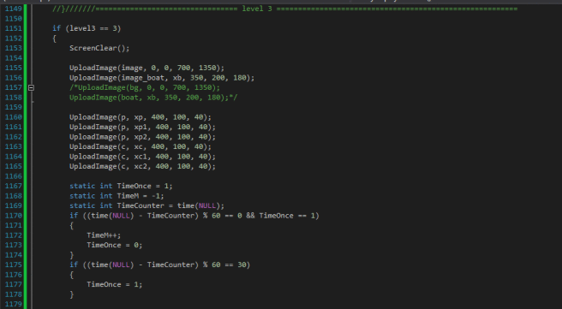
Then time counter is introduced.

How will the boat move backward/to the left?
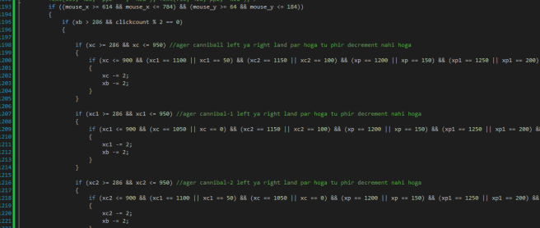
Lines 1193 onward show that if the user clicks between x coordinates in the range 614-784 and y coordinates 64 and 184,(the coordinates of the LET’S GO BUTTON) and if the boat is located on the left bank, then Clickcount % 2 == 0 ensures that boat returns to right bank after reaching the left bank once the user clicks the LET’S GO BUTTON again.
Line 1195 shows if before the boat reaches the right bank(at x coordinates 286) its x coordinates will be decremented until it reaches the left bank.
Line 1198 shows that if the cannibal is on the right land , and no character is on the boat i.e. the boat is EMPTY the it cannot move to the left.
The xc-=2 and xb-=2 indicate that the cannibal and boat will both move to the left with twice the speed as before(with double decrementation of x coordinates).
Line 874 shows that if cannibal 1, cannibal 2, priest 1 and priest 2 are on either of the banks , either left or right) then the cannibal ‘c’ –if present on the right boat(specified by x coordinates <=900)
Similar conditions are used for the rest of the characters.

Movement to the left when there are 2 characters in the boat
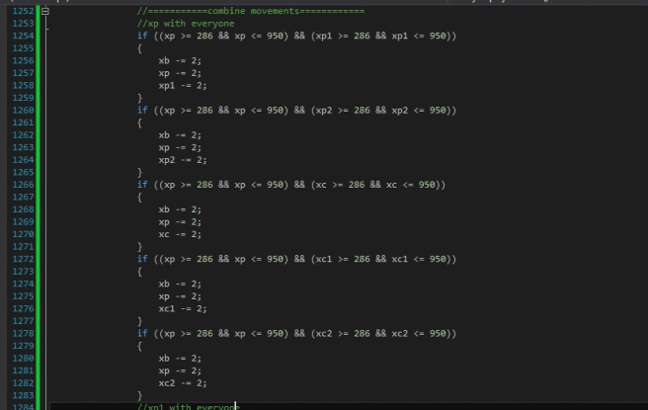
Lines 1242 onward show that if either priest ‘p’ or priest ‘p1’ are in the river, then the boat’s x coordinates are decremented along with p’s and p1’s. Thus, the boat cannot move to the left while it is empty.
Lines 1253 -1282 pair up the priest ‘p’ with every other character i.e priest p1 and p2, cannibals c, c1 and c2 one at a time along with the boat. So three objects are decremented at one time.

Remember that the boat can only move under 2 conditions:
- There is only 1 character in the boat
- There are 2 characters in the boat
While satisfying the winning conditions given at the end of this blog.
Similar conditons are used for the rest of characters.

How will the boat move forwards/to the right?
Lines below show that until the boat reaches the left bank (at the x coordinates 890)the that boat’s x coordinates will be incremented if the user clicks the LET’S GO button. Lines 1269 inwards show that if any character is in between the 286 and 950( x coordinates for left bank and right bank respectively) i.e. on the river and the user clicks the LET’S GO button then the boat will move to the right along with any character on the boat.
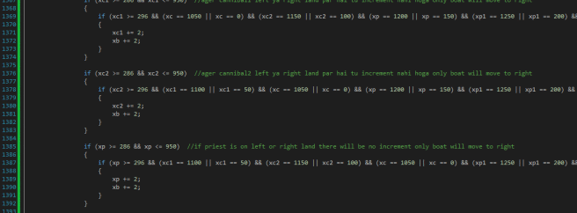
Similar conditions are used for the rest of characters.

Movement to the right when there are 2 characters in the boat
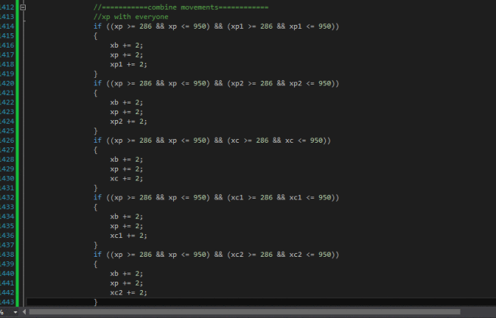
Lines 1242 onwards show that if either priest ‘p’ or priest ‘p1’ are in the river, then the boat’s x coordinates are incremented along with p’s and p1’s. Thus, the boat can’t move to the left while it is empty.
Lines pair up the priest ‘p’ with every other character i.e priest p1 and p2, cannibals c, c1 and c2 one at a time along with the boat. So three objects are incremented at one time.
Similar conditons are used for the rest of characters.

Remember that the boat can move under 2 condition:
- There is only 1 character in the boat
- There are 2 characters in the boat
While satisfying the winning conditions given at the end of this blog.
Similar conditons are used for the rest of characters.

However, Lines 1191-1194 show that if the boat is in the reaches any bank(left with x coordinates 286 and 890 coordinates at right), the clickcount will increase by 1 and hence clickcount%2 in line 42 will equal zero and movement will stop.

Checks for Boat Accomodation
If any character is on the right boat(at position 900) checkf1 will equal 1. If no character is on the right boat , checkf1 will be initialized to 0.
If no character is on the left boat(at position 296), checkf2 is initialized to 1.
If either of the characters is in the river, between the left and right bank, checkf2 is set to zero.
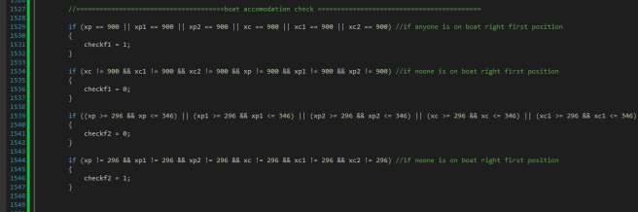

Cannibal C movements
Lines 1227-1245 show a portion of code for movements of the cannibal c. If boat has reached right bank (at position 890) and if cannibal c is located on the right land ( at poition 1050) and if checkf1==0(meaning no character is present on the right boat), then the character will move to the position 900. The value of checker for cannibal1 will decrease by 1 and the value of checker for cannibal2 will increase by 1.

However, if checkf1==1 I.e. some character is already present on the boat(at position 900) then cannibal will move to position 950 on boat, if the player clicks on the mouse_x and mouse_y coordinates of the cannibal present on the right land.
The value of checker for cannibal1 will decrease by 1 and the value of checker for cannibal2 will increase by 1.

Lines 1252-1265 show that if the player clicks on the mouse_x and mouse_y coordinates of the cannibal present on the left boat(at either position 296 or 336), it will move to the land on the left.
Lines 1271-1287 show that if the player clicks on the mouse_x and mouse_y coordinates of the cannibal present on the left land, it will move to either of the positions on the boat-depending on the values of checks.
Lines 1296-1312 show that that if the player clicks on the mouse_x and mouse_y coordinates of the cannibal present on either positions on the right boat(either 1000 or 1050 position), it will move towards the right land. The value of checker for cannibal1 will increase by 1 and the value of checker for cannibal2 will decrease by 1.

Movements for Cannibal 1
Lines 1318-1336 show a portion of code for movements of the cannibal c. If boat has reached right bank (at position 890) and if cannibal c1 is located on the right land ( at poition 1100) and if checkf1==0(meaning no character is present on the right boat), then the character will move to the position 900. The value of checker for cannibal1 will decrease by 1 and the value of checker for cannibal2 will increase by 1.
However, if checkf1==1 I.e. some character is already present on the boat(at position 900) then cannibal1 will move to position 950 on boat, if the player clicks on the mouse_x and mouse_y coordinates of the cannibal1 present on the right land.
The value of checker for cannibal1 will decrease by 1 and the value of checker for cannibal2 will increase by 1.

Lines 1343-1356 show that if the player clicks on the mouse_x and mouse_y coordinates of the cannibal1
present on the left boat(at either position 296 or 346), it will move to the land on the left.
Lines 1362-1378 show that if the player clicks on the mouse_x and mouse_y coordinates of the cannibal1 present on the left land, it will move to either of the positions on the boat-depending on the values of checks.

Lines 563-578 show that that if the player clicks on the mouse_x and mouse_y coordinates of the cannibal present on either positions on the right boat(either 990 or 950 position), it will move towards the right land(position 1100). The value of checker cc1 will increase by 1 and the value of checker cc2 will decrease by 1.

Movements for Cannibal 2
Lines 1408-1426 show a portion of code for movements of the cannibal c. If boat has reached right bank (at position 890) and if cannibal c1 is located on the right land ( at poition 1150) and if checkf1==0(meaning no character is present on the right boat), then the character will move to the position 900. The value of cc1 will decrease by 1 and the value cc2 will increase by 1.
However, if checkf1==1 I.e. some character is already present on the boat(at position 900) then cannibal1
2 will move to position 950 on boat, if the player clicks on the mouse_x and mouse_y coordinates of the cannibal2 present on the right land.
The value of cc1 will decrease by 1 and the value of checker for cc2 will increase by 1.
Lines 1433-1446 show that if the player clicks on the mouse_x and mouse_y coordinates of the cannibal2 present on the left boat(at either position 296 or 346), it will move to the land on the left.
Lines 1452-1470 show that if the player clicks on the mouse_x and mouse_y coordinates of the cannibal2 present on the left land, it will move to either of the positions on the boat-depending on the values of checks.

Lines 1477-1492 show that that if the player clicks on the mouse_x and mouse_y coordinates of the cannibal2 present on either positions on the right boat(either 900 or 950 position), it will move towards the right land(position 1150). The value of checker cc1 will increase by 1 and the value of checker cc2 will decrease by 1.

Movements for Priest
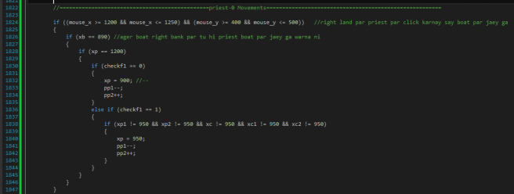
Lines above show a portion of code for movements of the cannibal c. If boat has reached right bank (at position 890) and if priest p is located on the right land ( at poition 1200) and if checkf1==0(meaning no character is present on the right boat), then the character will move to the position 900. The value of pp1 will decrease by 1 and the value pp2 will increase by 1.
However, if checkf1==1 I.e. some character is already present on the boat(at position 900) then priest p will move to position 950 on boat, if the player clicks on the mouse_x and mouse_y coordinates of the priest p present on the right land.
The value of pp1 will decrease by 1 and the value of checker for pp2 will increase by 1.

Lines below show that if the player clicks on the mouse_x and mouse_y coordinates of the priest p present on the left boat(at either position 296 or 346), it will move to the land on the left at position 150.
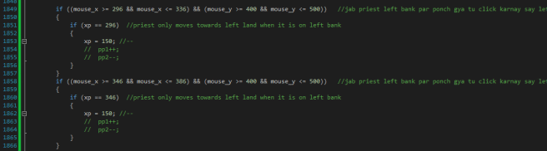
Lines below show that if the player clicks on the mouse_x and mouse_y coordinates of the priest p present on the left land, it will move to either of the positions on the boat-depending on the values of checks.

Lines below show that that if the player clicks on the mouse_x and mouse_y coordinates of the priest p present on either positions on the right boat(either 900 or 950 position), it will move towards the right land(position 1200). The value of checker pp1 will increase by 1 and the value of checker pp2 will decrease by 1.
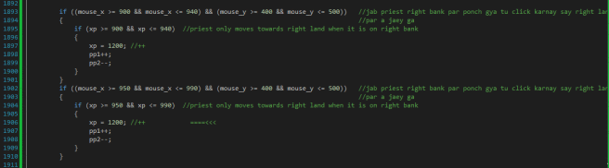

Losing Conditions
Lines below show which conditions will cause the player to lose the game. If the boat is located on the right or left bank or it moves while count of cannibals is greater than count of priests on that bank, then game over image be uploaded.

Warning Issued
Line below indicate that a text of Warning will be displayed if on either side of bank number of cannibals is greater than preists and the boat has not yet moved, while game-over text will be displayed if check cc1>cc2 and either of the priests is on the land and the boat moves.
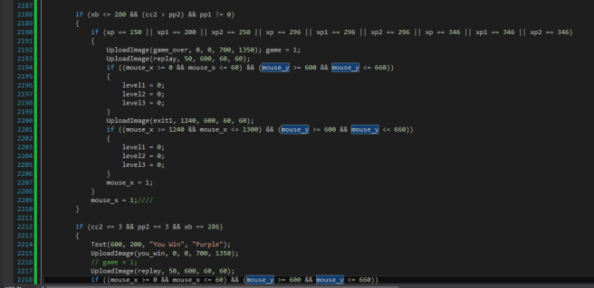Lines will cause the player to lose if cannibal count is greater than priest count. Lines 1842 onward cause the player to WIN if all the characters are present on the left bank and the boat reaches the left bank.

