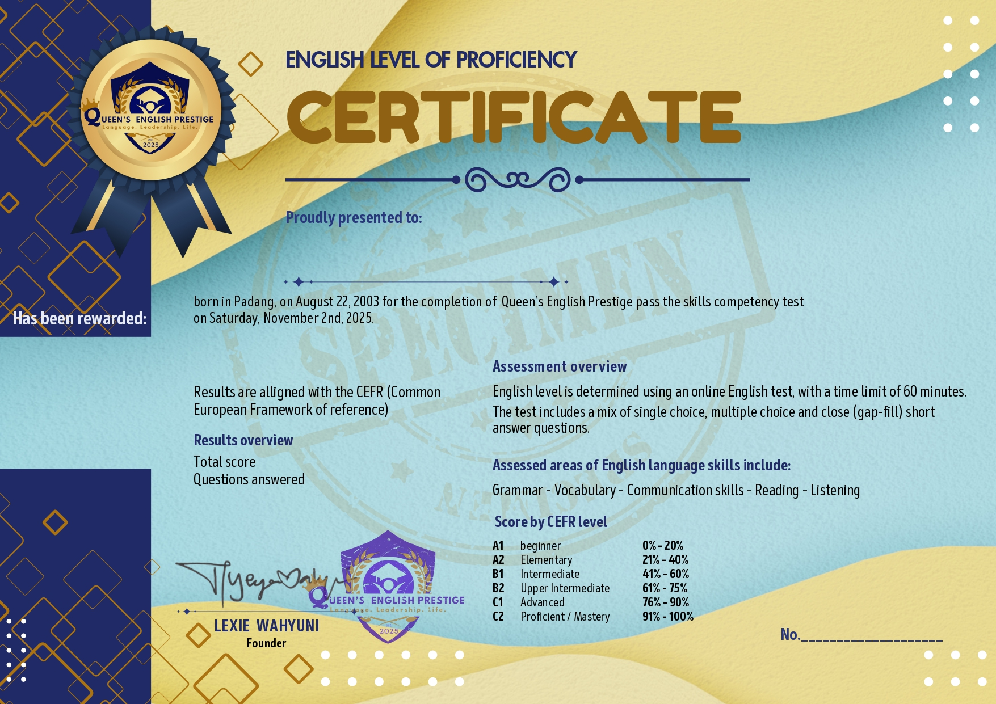

${nama}

${total_score}

${level}

${jawaban_pertanyaan}