

Mobile application

Pizza delivery Mobile app For Naryn

Students Name: Bashir, Arfan and Mirzo

Table of contents:

* Abstract ( mirzo)
* Introduction ( mirzo)
  + Aims and objectives ( mirzo)
  + Expected outcomes ( mirzo)
* Literature review ( Arfan)
* Methodologies( bashir)
  + Timeline ( bashir)
  + Requirements (bashir)
* Summary ( Arfan)

**Abstract**

**Introduction**

**Aims and objectives**

**Expected outcomes**

**Literature review**

With the advancement of technology, we need to do things online as it is very easy and convenient. Technology has changed the way we live, and it is making our daily lives more comfortable. Few decades ago, we were visiting a Pizza hut to eat a Pizza and enjoy the moment with our dears and nears. Now we can sit at our homes and order a Pizza and it delivers to us within some time. Below are listed some previous work done on the pizza delivery system.

Gupta and Shrivastav claim that with rapid development in technology the number of online businesses has increased swiftly. Online business is easier and less costly compared to offline. Now more people have started online businesses. The authors are suggesting having a web-based pizza ordering management system. The authors say that it is usually very dangerous to go out at night to eat pizza in a comfortable way. It is also cumbersome and inappropriate to go to a restaurant at unusual times to eat a pizza. It is better to sit at home and order a delicious pizza and enjoy it along with family members. One of the aims of the authors was to determine human behavior while ordering pizza. They wanted to know what type of pizzas are ordered by the customers (2021, Gupta and Shrivastav).

RestApp is one of the top ordering systems which also gets pizza orders and has a good delivery system. RestApp gets above 1.5 million orders daily and has more than 900 thousand users which is a very huge number. RestApp operates in almost 8 countries (RestApp, n.d.). Mojo pizza is one of the best pizzas cloud-based kitchen in India. It has more than 120 stores across some cities of India. During Covid-19 Mojo Pizza managed to sell more than 0.6 million pizzas. Mojo Pizza’s android app is available in Google Store (Mojo Pizza, n.d.). Moreover, Domino’s Pizza is an international company which has online delivery system, and it also has mobile app where one can order. Domino’s pizza is American company which operates in more than 90 countries, and it is the largest pizza company in the world (Domino’s Pizza, n.d.).

**Methodologies**

For this project, we will be using the waterfall method. The waterfall model is a breakdown of project activities into linear sequential phases, where each phase depends on the deliverables of the previous one and corresponds to a specialization of tasks. We first come up with an idea and then design the idea into an application.

We decided to have 6 different activities for our applications, each with different specifications and functionalities.

**Timeline**

As we have decided to have 6 different activities on our application, each activity is supposed to be finished in one week. The following table represents the overall timeline of our application.

NOTE: We have skipped week 8th and week 9th as there will be mid-term and break.

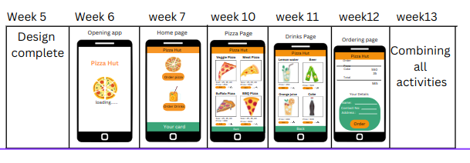

**Requirements**

We will build the mobile application using android studio. The primary language for back-end will be Java programming language. Moreover, we will be using GitHub to push and pull the project as we are working in a group on this project.

**Summary**

We are committed to build an android app for pizza delivery in Naryn. Our aim is to make a simple and user-friendly app which can be easily use by common people. There has already been a lot of work done related to online pizza delivery, but we could not find any apps or online pizza delivery platform in Naryn. This is a unique and noble idea in Naryn region.