Experiment 4: Simple Search Engine using Vector Space Model
Arfa Shaikh 231248
Information Retrieval
Computer Engineering
M.H. Saboo Siddik College of Engineering
Aim:
To implement a simple search engine using the Vector Space Model (VSM) and cosine similarity, which indexes a small collection of documents and ranks them for a user query.
Algorithm:
In the Vector Space Model, every document and the query are represented as vectors of term weights in the same vocabulary space. TF-IDF gives higher weight to terms that are frequent in a document but rare in the collection, and cosine similarity measures how close the query vector is to each document vector.
- Collect the documents to be searched (the corpus).
- Preprocess each document: convert to lowercase, remove punctuation, split into tokens and remove stop words.
- Build the index: create the vocabulary, count the document frequency df(t) of every term and compute its IDF value.
- Convert every document into a TF-IDF vector.
- Accept the user query, preprocess it in the same way and convert it into a TF-IDF vector.
- Compute the cosine similarity between the query vector and every document vector.
- Sort the documents in decreasing order of similarity and display the top three documents with a score greater than zero.
TF-IDF(t, d) = TF(t, d) × IDF(t)
Cosine similarity(q, d) = (q · d) / (||q|| × ||d||)
The program uses smoothed IDF: IDF(t) = ln((1 + N)/(1 + df(t))) + 1, where N is the number of documents. The vectors and cosine similarity are written from scratch using sparse dictionaries, so no external library is needed. Stemming and lemmatization are not applied.
Application:
- Search engines: Rank web pages or documents by their relevance to a keyword query.
- Digital libraries: Retrieve research papers, articles and books matching a query.
- Enterprise search: Search emails, notes, reports and files inside an organisation.
- Recommendation and text comparison: Find documents similar to a given text.
Example:
Query: python machine learning. After stop-word removal the query terms are python, machine and learning. D4 contains all three terms, D2 contains machine and learning, and D1 contains only python. The search engine calculates the TF-IDF cosine score of every document and ranks them as D4, D2 and D1.

Code:
Run this code in one Google Colab or Jupyter cell. Enter the query in the input box that appears after execution. Only the Python standard library is used (math, re and collections).
import math
import re
from collections import Counter

documents = {
"D1": "Python programming is used for software development.",
"D2": "Machine learning allows computers to learn from data.",
"D3": "Search engines retrieve information from documents.",
"D4": "Python is widely used in machine learning.",
"D5": "Healthy food and exercise improve physical health.",
"D6": "Information retrieval ranks documents for a search query.",
}

STOP_WORDS = {"a", "an", "the", "is", "are", "in", "for", "from", "to",
"and", "of", "used", "allows", "widely", "improve"}

def tokenize(text):
words = re.findall(r"[a-z]+", text.lower())
return [w for w in words if w not in STOP_WORDS]

# ---- Indexing: vocabulary, document frequency, IDF ----
doc_tokens = {d: tokenize(t) for d, t in documents.items()}
vocab = sorted({w for ts in doc_tokens.values() for w in ts})
N = len(documents)
df = {w: sum(1 for ts in doc_tokens.values() if w in ts) for w in vocab}
idf = {w: math.log((1 + N) / (1 + df[w])) + 1 for w in vocab}

def tfidf_vector(words):
tf = Counter(words)
return {w: tf[w] * idf[w] for w in tf if w in idf}

doc_vectors = {d: tfidf_vector(ts) for d, ts in doc_tokens.items()}

# ---- Cosine similarity between two sparse vectors ----
def cosine(q, d):
dot = sum(q[w] * d.get(w, 0.0) for w in q)
nq = math.sqrt(sum(v * v for v in q.values()))
nd = math.sqrt(sum(v * v for v in d.values()))
return dot / (nq * nd) if nq and nd else 0.0

# ---- Search: score every document and rank ----
def search(query, top_k=3):
q_vec = tfidf_vector(tokenize(query))
scores = [(d, cosine(q_vec, v)) for d, v in doc_vectors.items()]
scores.sort(key=lambda x: -x[1])
return [(d, s) for d, s in scores if s > 0][:top_k]

# ---- Run the search engine ----
print("Vocabulary size:", len(vocab), "| Documents:", N)
query = input("Enter your search query: ")
print("Query terms:", tokenize(query))
results = search(query)

print("\nTop matching documents:")
if not results:
print("No matching documents found.")
for rank, (doc_id, score) in enumerate(results, 1):
print(f"{rank}. {doc_id} | Similarity: {score:.3f}")
print(" " + documents[doc_id])
Output:
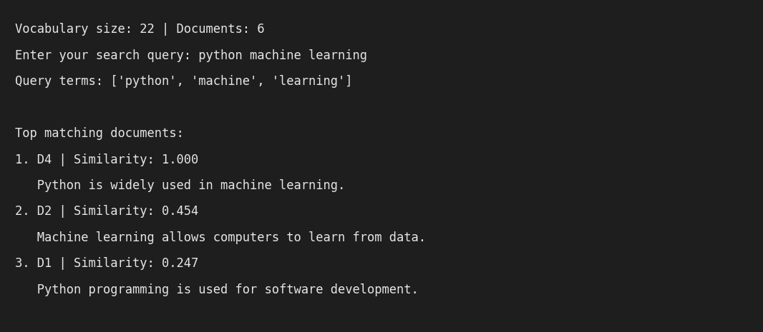
Conclusion:
A simple search engine was implemented using the Vector Space Model with TF-IDF weighting and cosine similarity. For the query "python machine learning" the engine retrieved D4, D2 and D1 in decreasing order of similarity (1.000, 0.454 and 0.247), while unrelated documents scored zero and were not shown. The model is easy to build and ranks documents by keyword relevance, but it does not understand meaning, synonyms or word order, and it was tested here only on a small six-document corpus.
Reference:
[1] C. D. Manning, P. Raghavan and H. Schütze, Introduction to Information Retrieval, Cambridge University Press, 2008.
https://nlp.stanford.edu/IR-book/
[2] Stanford NLP Group, "Tf-idf weighting" and "The vector space model for scoring", Introduction to Information Retrieval.
https://nlp.stanford.edu/IR-book/html/htmledition/tf-idf-weighting-1.html

