**INTRODUCTION**

“ONLINE VOTING SYSTEM” is an online voting technique. In this system people who have citizenship of India and whose age is above 18 years of age and any sex can give his\her vote online without going to any physical polling station. There is a database which is maintained in which all the names of voters with complete information is stored.

In “ONLINE VOTING SYSTEM” a voter can use his\her voting right online without any difficulty. He\She has to be registered first for him/her to vote. Registration is mainly done by the **system administrator** for security reasons. The system Administrator registers the voters on a special site of the system visited by him only by simply filling a registration form to register voter. Citizens seeking registration are expected to contact the system administrator to submit their details. After the validity of them being citizens of India has been confirmed by the system administrator by comparing their details submitted with those in existing databases such as those as the Registrar of Persons, the citizen is then registered as a voter.

After registration, the voter is assigned a secret Voter ID with which he/she can use to log into the system and enjoy services provided by the system such as voting. If invalid/wrong details are submitted, then the citizen will not registered to vote.

**PRESENTLY AVAILABLE SYSTEMS**

Voting in India is conducted by electronic voting machines or EVM, which was first introduced in 1982. More than 2.3 million EVMs will be used in 2019 elections as compared with 1.8 million ones in 2014.

To check for foul play, vehicles transporting the EVMs will be fitted with GPS devices to monitor their movements.

The EVMs allows vote counting to be completed in up to three hours compared with manual counting, which could take 30 to 40 hours.

The electoral body also uses digital cameras, videotaping of speeches and the use of wireless networks during the election process.

In the current elections, Voter Verifiable Paper Audit Trail (VVPAT) machines will be used along with EVMs at all polling stations after opposition parties questioned the EVMs' accuracy.

The VVPAT allows the voter to cross-check the votes.

"Ever since EVMs were introduced in 1982, they have been questioned and challenged, but they have stood judicial scrutiny and they stood the test of time," Quraishi, the former electoral body chief said.

"Now finally we have introduced VVPAT, which means a paper slip is generated, which you can use to crosscheck the figures in the machines."

The problems of the existing manual system of voting include among others the following:

1. **Expensive and Time consuming**: The process of collecting data and entering this data into the database takes too much time and is expensive to conduct, for example, time and money is spent in printing data capture forms, in preparing registration stations together with human resources, and there after advertising the days set for registration process including sensitizing voters on the need for registration, as well as time spent on entering this data to the database.
2. **Too much paper work**: The process involves too much paper work and paper storage which is difficult as papers become bulky with the population size.
3. **Errors during data entry:** Errors are part of all human beings; it is very unlikely for humans to be 100 percent efficient in data entry.
4. **Loss of registration forms:** Some times, registration forms get lost after being filled in with voters’ details, in most cases these are difficult to follow-up and therefore many remain unregistered even though they are voting age nationals and interested in exercising their right to vote.
5. **Short time provided to view the voter register:** This is a very big problem since not all people have free time during the given short period of time to check and update the voter register.
6. Above all, a number of voters end up being locked out from voting.

**NEED OF SUCH SYSTEM**

Online voting is an electronic way of choosing leaders via a web driven application. The advantage of online voting over the common “queue method” is that the voters have the choice of voting at their own free time and there is reduced congestion. It also minimizes on errors of vote counting. The individual votes are submitted in a database which can be queried to find out who of the aspirants for a given post has the highest number of votes.

This system is geared towards increasing the voting percentage in Kenya since it has been noted that with the old voting method {the Queue System}, the voter turnout has been a wanting case. With system in place also, if high security is applied, cases of false votes shall be reduced.

With the “ONLINE VOTING SYSTEM”, a voter can use his\her voting right online without any difficulty.

Internet voting systems are appealing for several reasons which include; People are getting more used to work with computers to do all sorts of things, namely sensitive operations such as shopping and home banking and they allow people to vote far from where they usually live, helping to reduce absenteeism rate.

Due to the everyday advancement in technology and software, we are constantly being provided with more and more advanced security mechanisms. These should be used for the betterment of the society and should be made available to even the smallest regions.

Some of the advanced resources that can be used to improve the security and integrity of the election process are listed below:

* Secure Databases
* Access control
* Flow control
* Data security
* Cryptography
* Backups
* Authentication
* System privileges
* Database activity monitoring
* Communication security

In order to get better results in this study we tried to understand the paper‐based polling system and the drawbacks of the system. We studied different voting system with their advantages and disadvantages. The system proposed in this thesis will not just convert the current manual or electric system to an equivalent but will be possible to run in parallel with the current system and thus make it easier for the people who do not cast their votes. This online system will be helpful for casting votes by different electronic ways. People will be able to cast votes through their home PC, Mobiles and Net‐cafes. This multitude of opportunities will make voting more accessible, and thereby hopefully create more attraction for those people who do not cast their vote.

**DETAILED PROBLEM STATEMENT**

*Online election system* is a software that is being designed to provide the citizens a safe and user friendly GUI through which selecting candidate and voting for the righteous candidate will be easy and enough as well as appropriate and verified results will be obtained.

**SOFTWARE AND**

**HARDWARE REQUIREMENTS**

**Software Requirements: -**

1. Operating systems (windows).

2. Language (Php, Html5, Css3, MySQL, JavaScript)

3. Database.

4. Browser (Any Mozilla or chrome).

5. Web server.

**Hardware Requirements: -**

**Following are hardware requirements for computer/laptop:**

1. Processor (at least Pentium 4 700 MHz or more)
2. Hard disc (Minimum 20GB)
3. RAM (128 MB or more)

**Following are hardware requirements for smart phones:**

1. 1 GHz or faster processor.
2. 1GB of RAM for 32-bit OS or 2GB of RAM for 64-bit OS.
3. 16GB of storage for 32-bit OS or 20GB for 64-bit OS.
4. 800 x 600 pixel or higher resolution display.

**SYSTEM DESIGN**

**Entity Relationship Diagram: -**

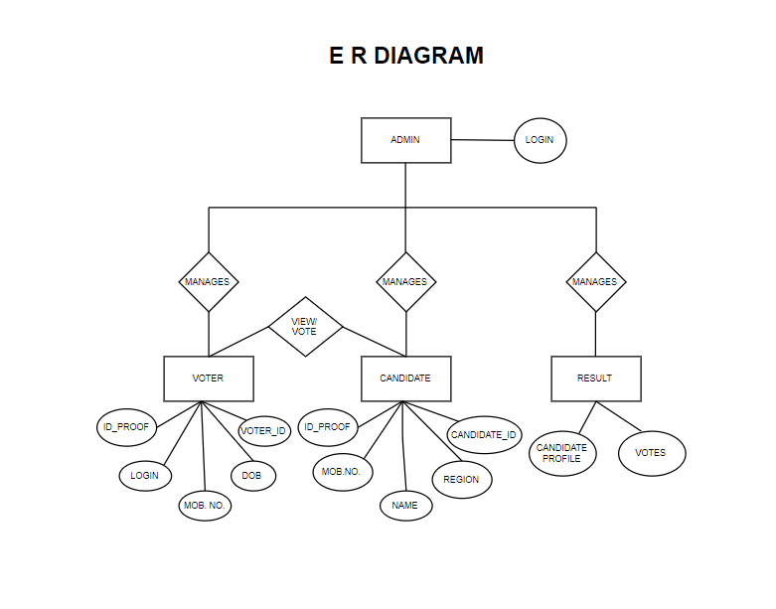

**Data Flow Diagrams: -**

**DFD LEVEL 0**

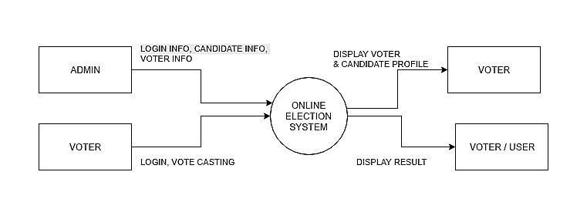

**DFD LEVEL 1**

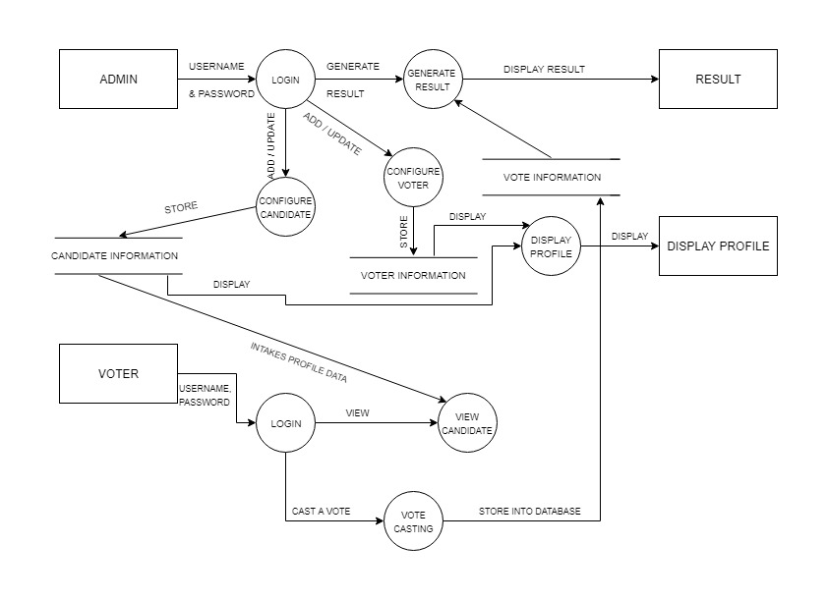

**DFD LEVEL 2**

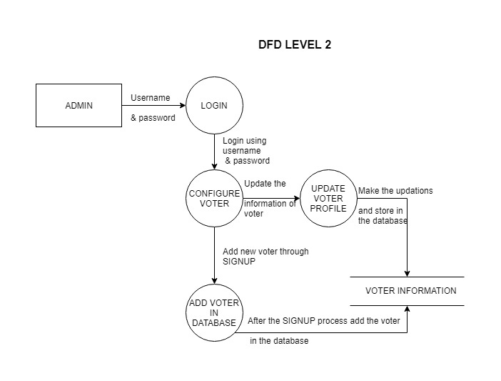

**Use Case Diagram: -**

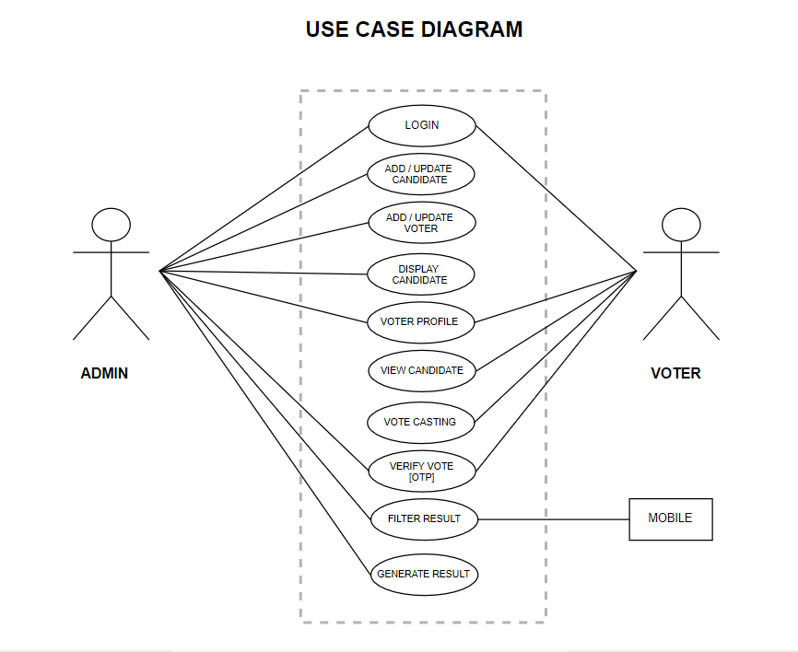

**Class Diagram: -**

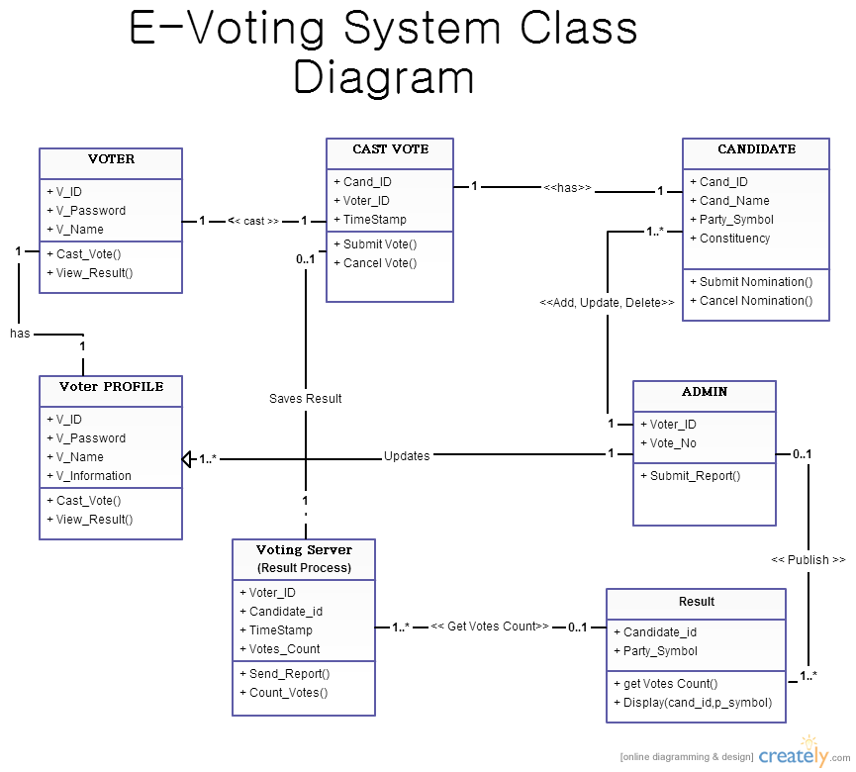

**Sequence Diagram: -**

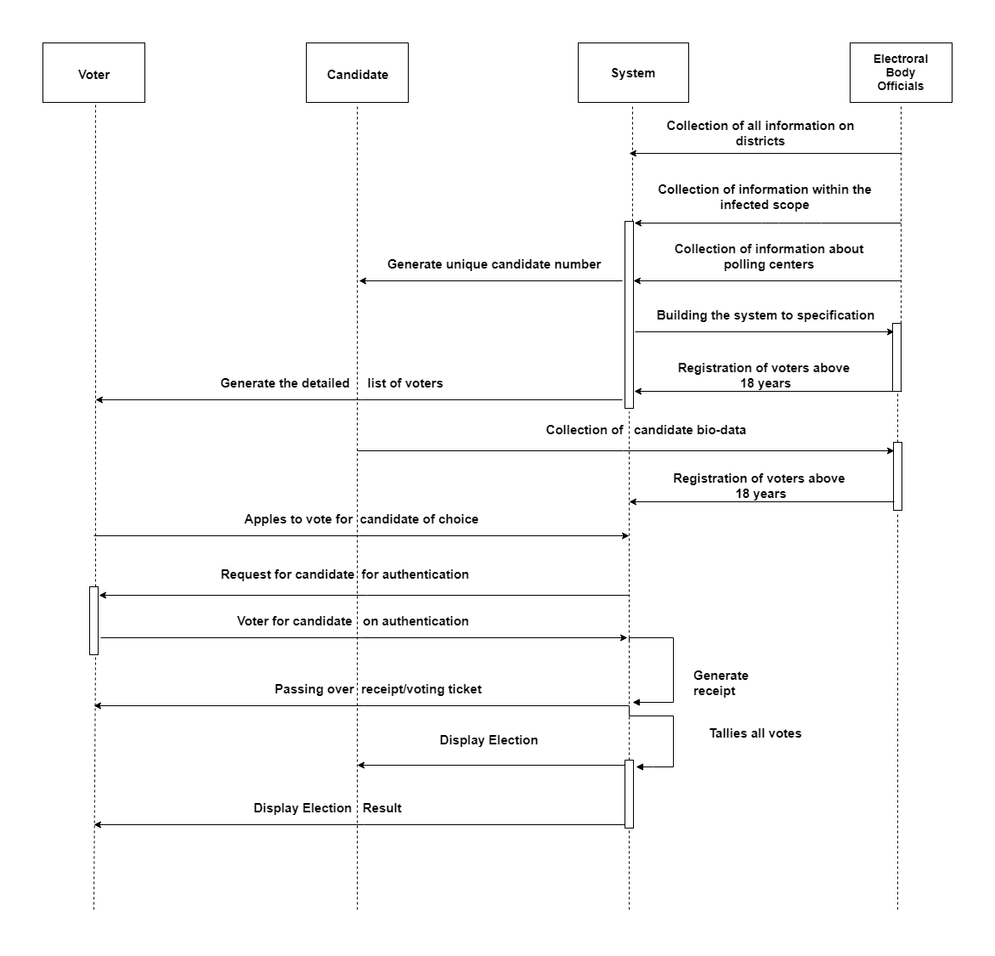

**Activity Diagram: -**

**ADMIN**

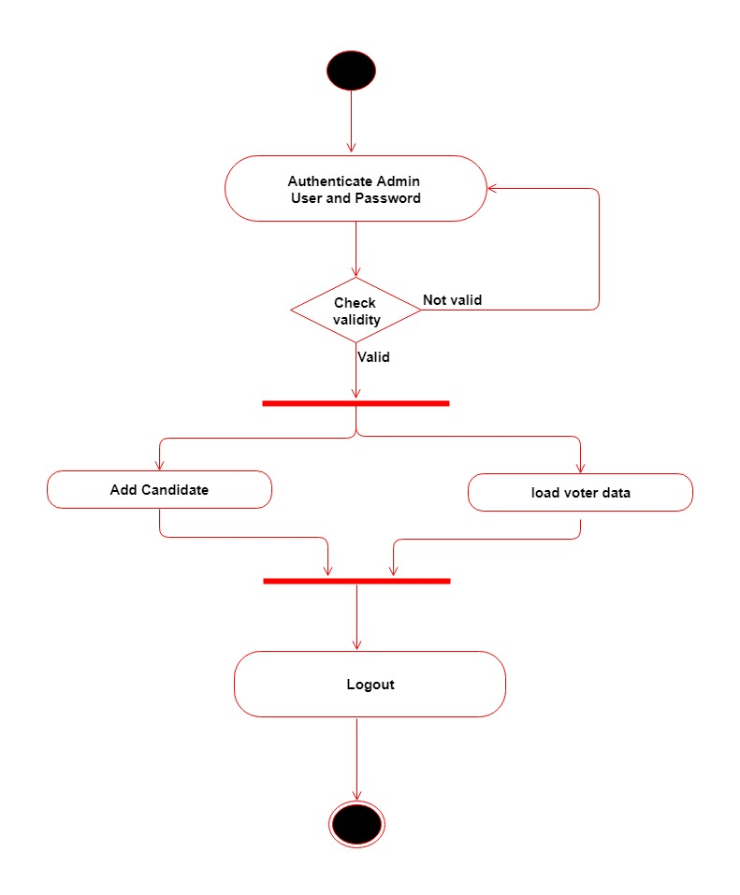

**USER**

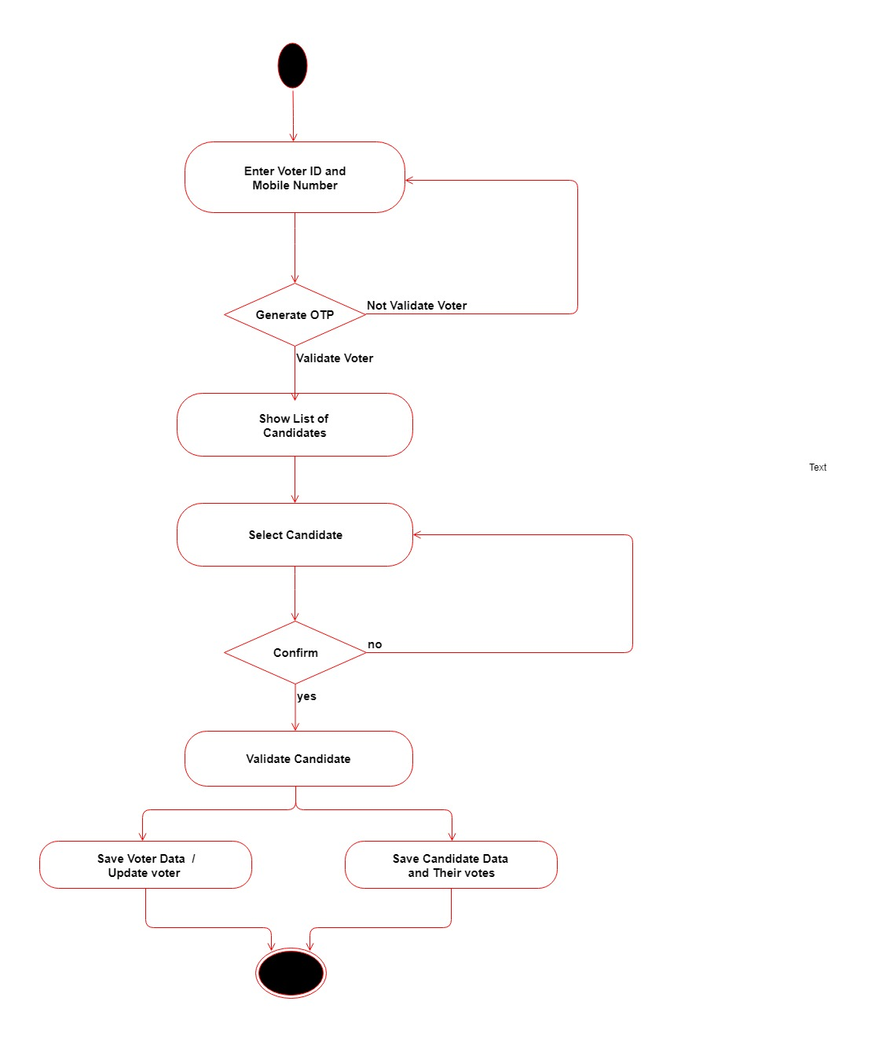

**State Diagram: -**

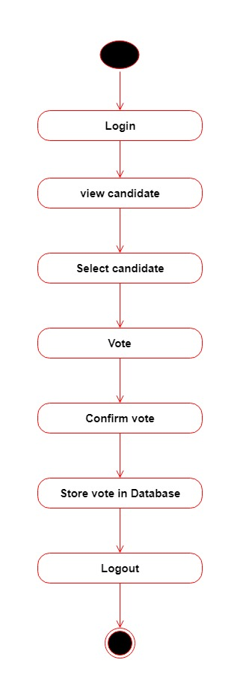

**Component Diagram: -**

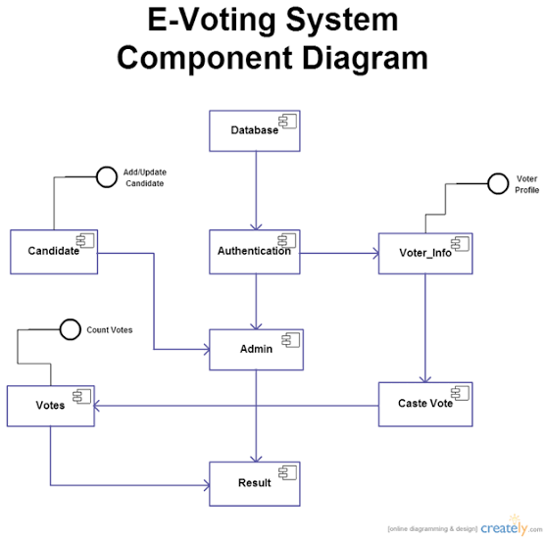

**Deployment Diagram: -**

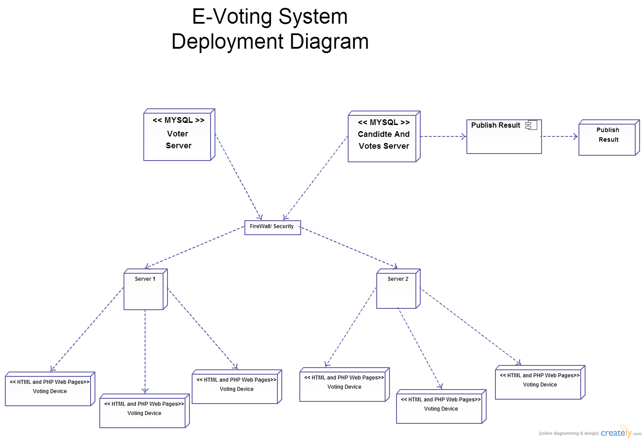

**APPLICATION PREVIEW**

WELCOME to the home page of OES INDIA website:

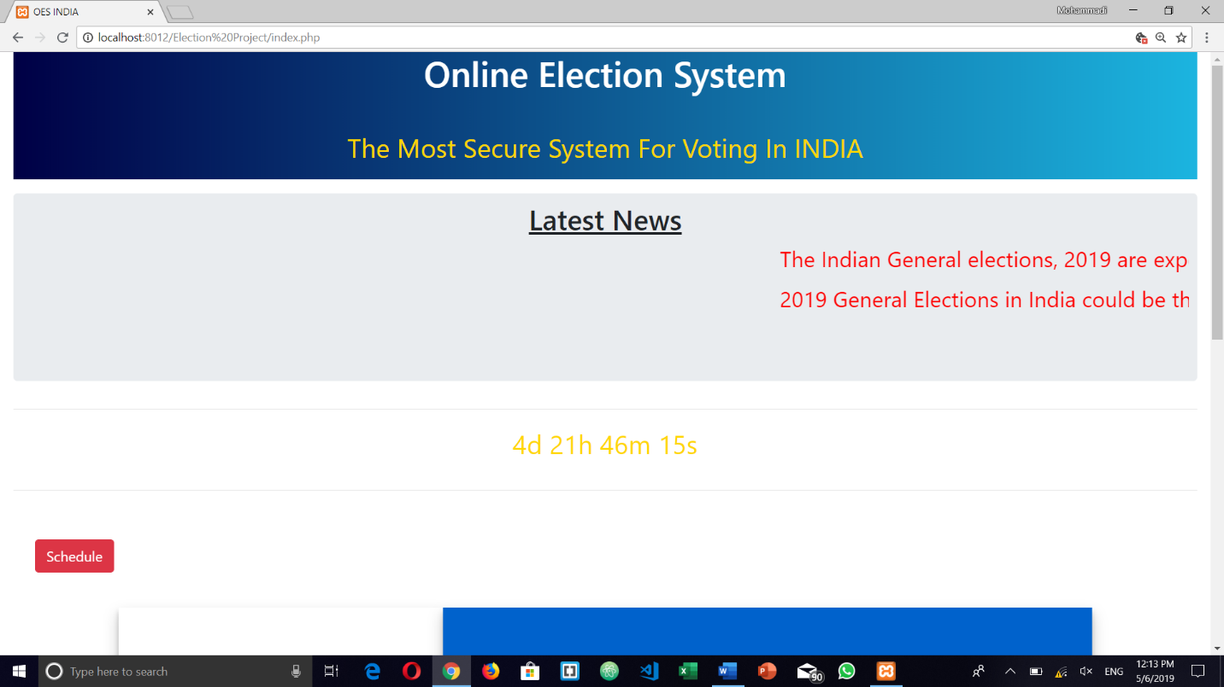

TRANSLITERATION of website for different regions in INDIA 🡪 Marathi:

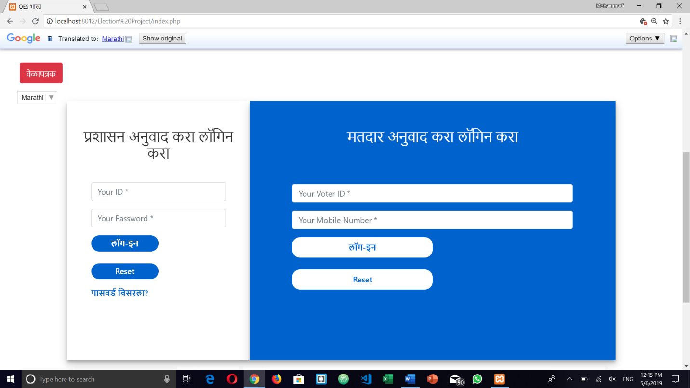

TRANSLITERATION of website for different regions in INDIA 🡪 Urdu:

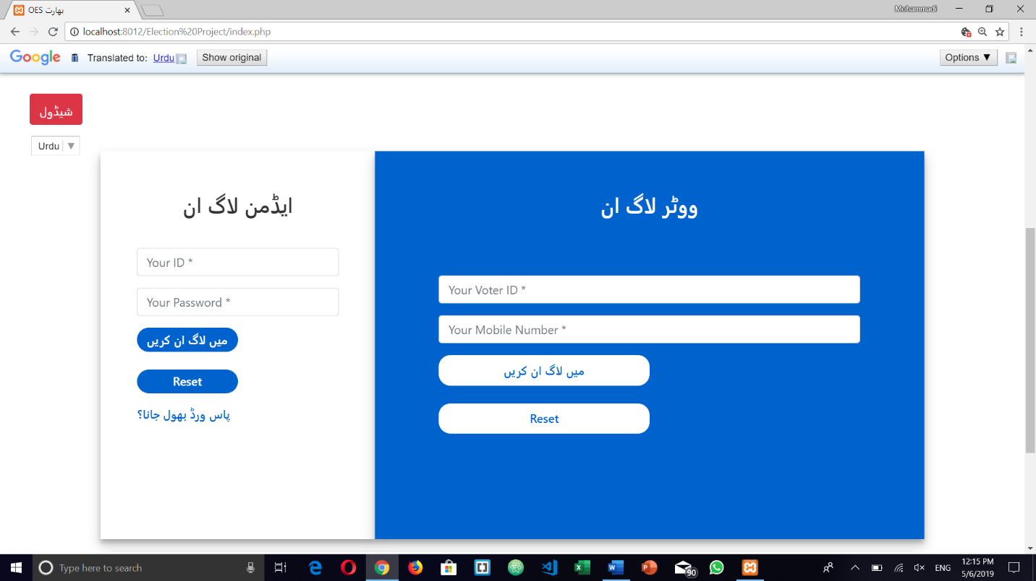

TRANSLITERATION of website for different regions in INDIA 🡪 Telugu:

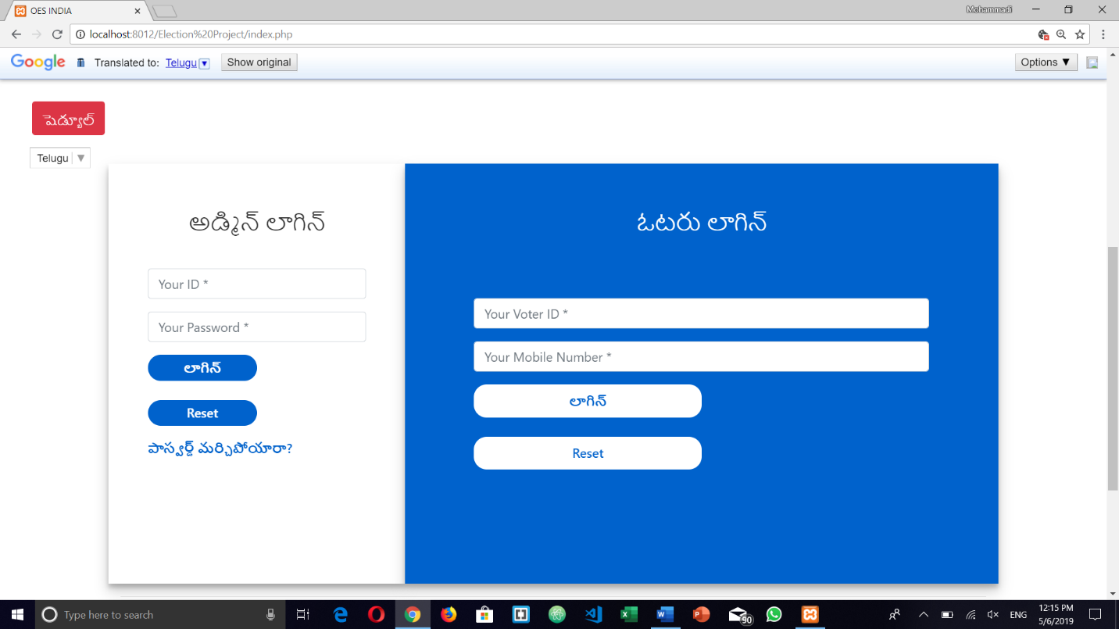

Functions of admin:

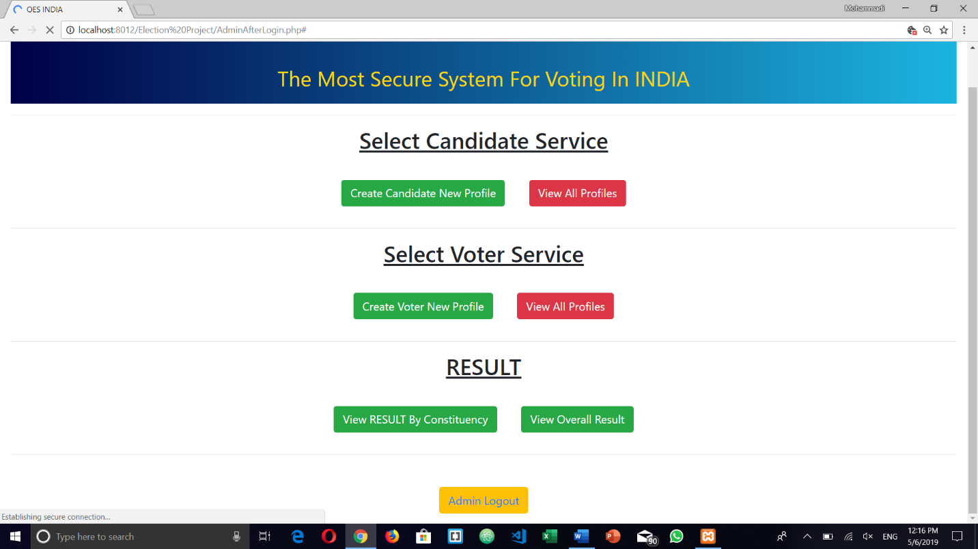

Search Candidate:

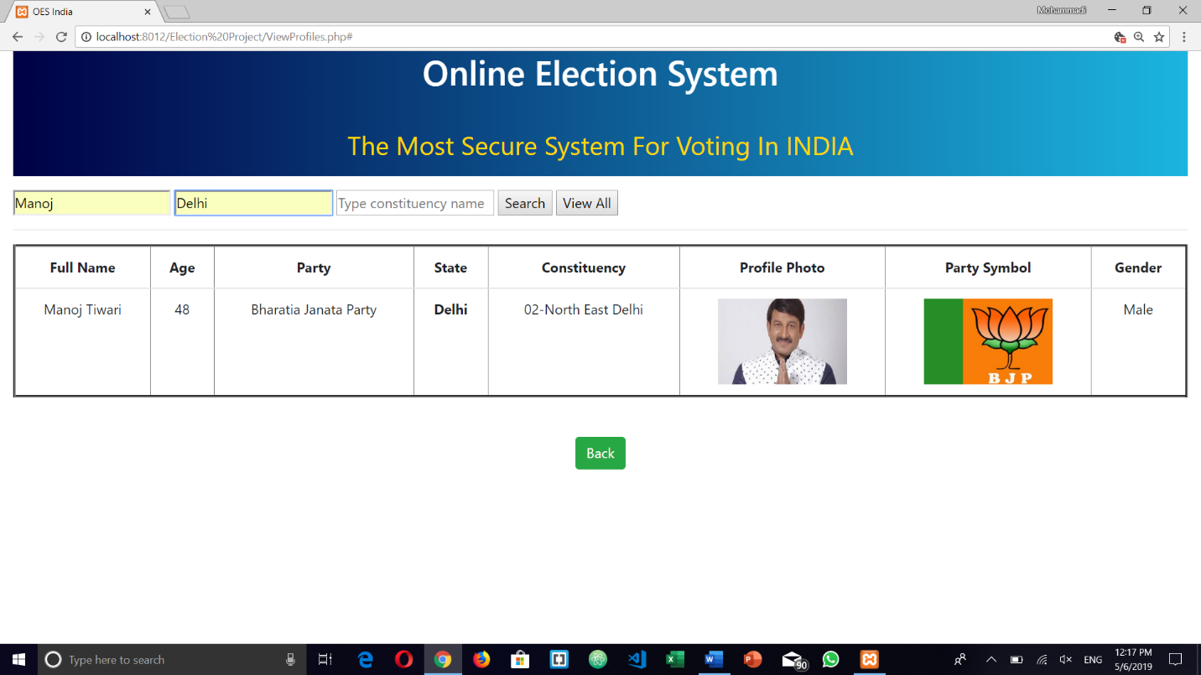

View all Candidates and also filter them according to constituency, state & name:

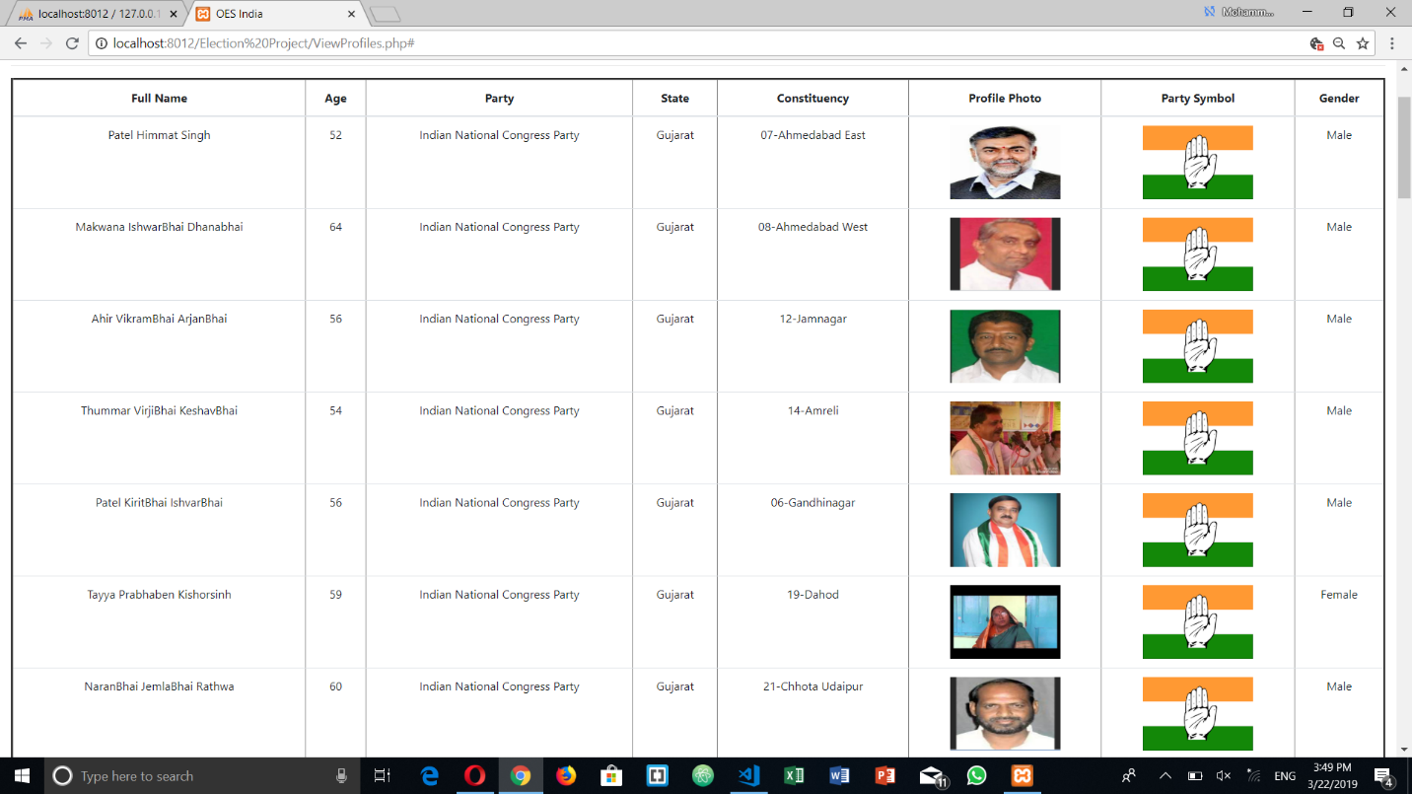

View all voters:

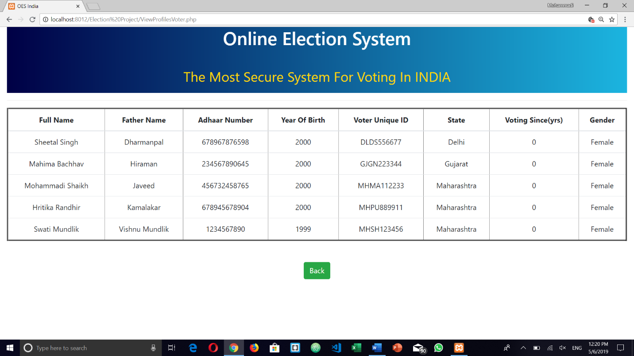

Voter Login:

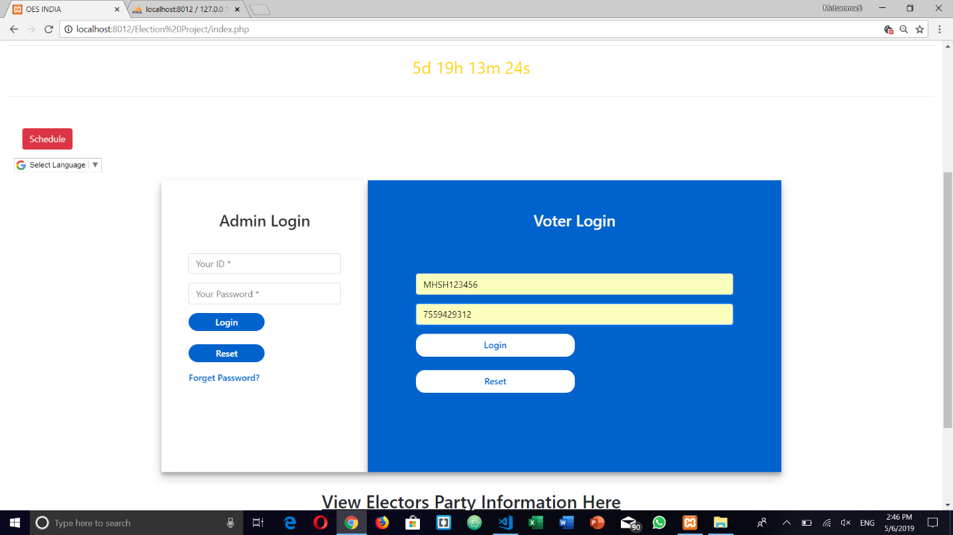

Voter Functions:

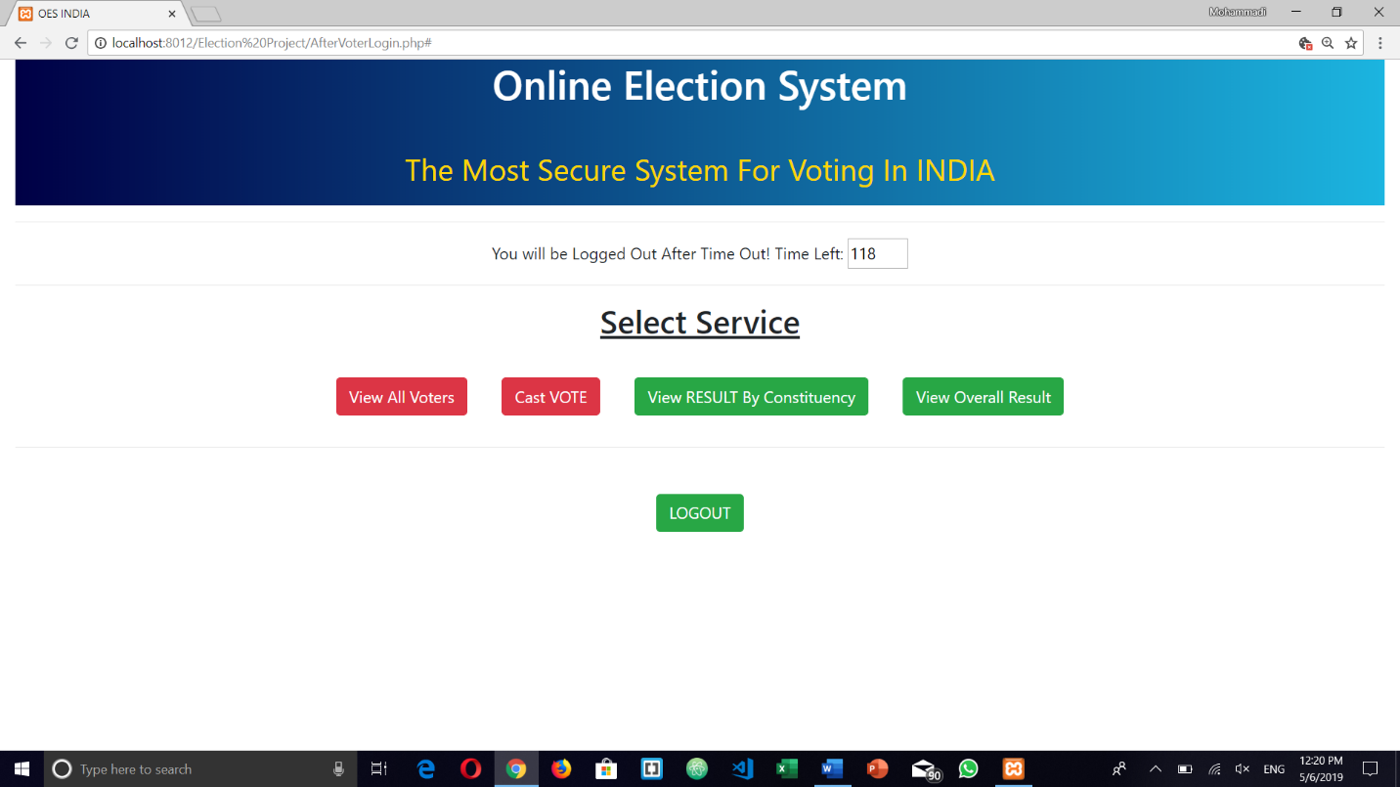

Vote Casting:

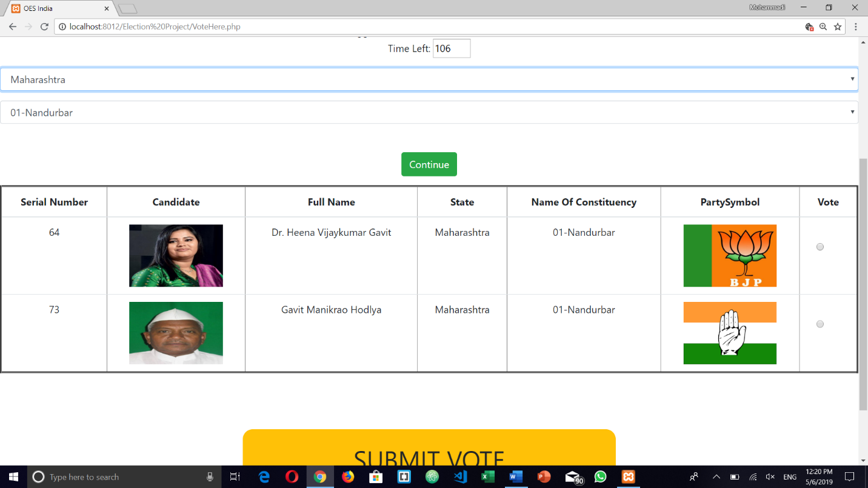

Vote conformation:

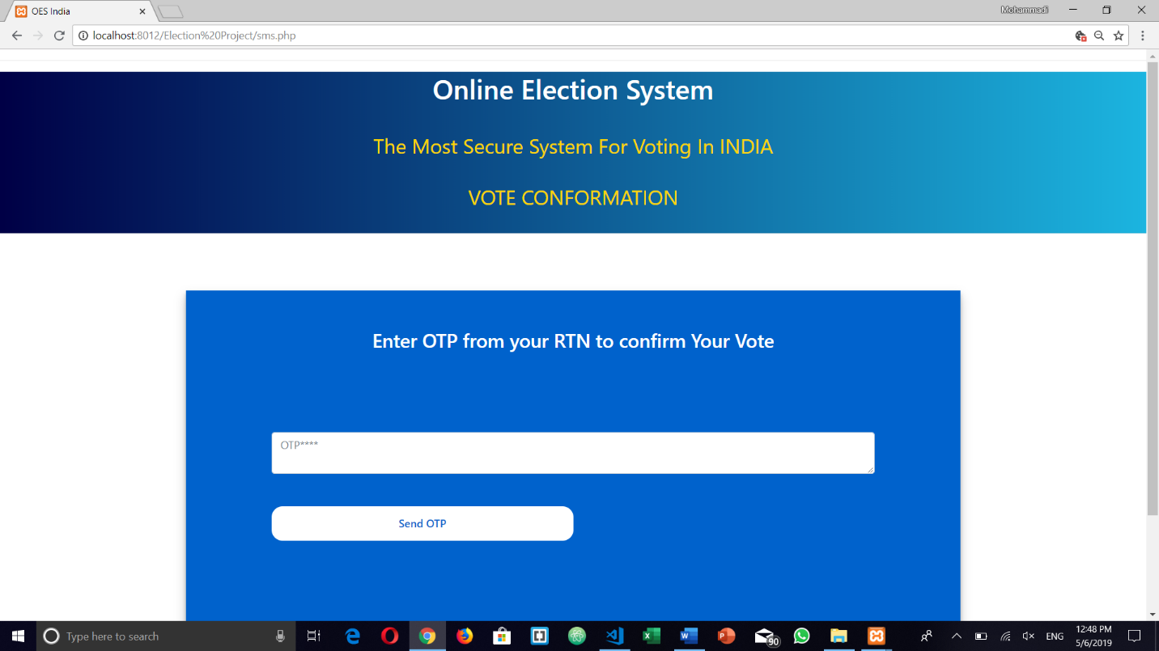

Automated Result Generation (Result by Constituency):

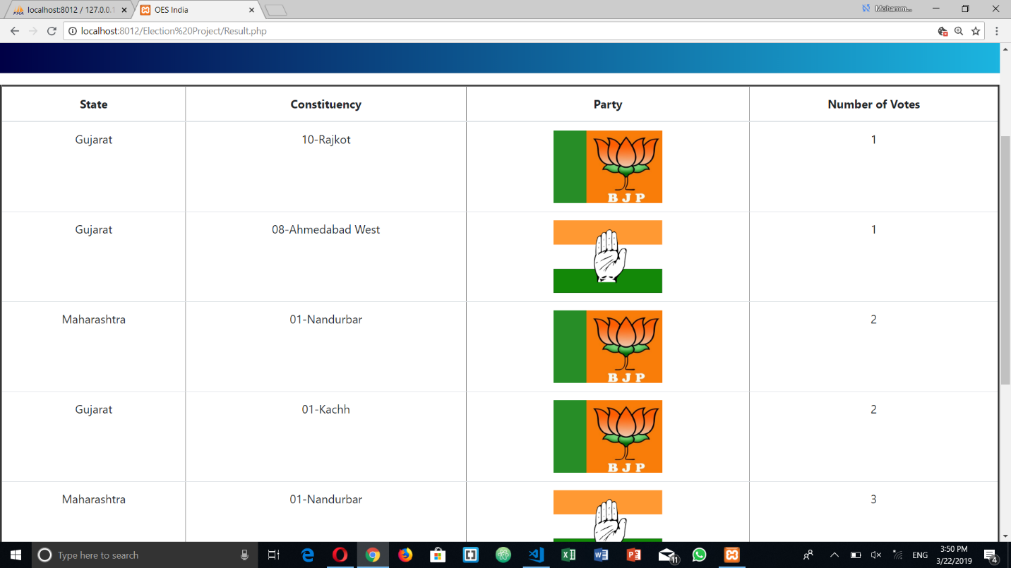

Automated Result Generation (Result by party overall country):

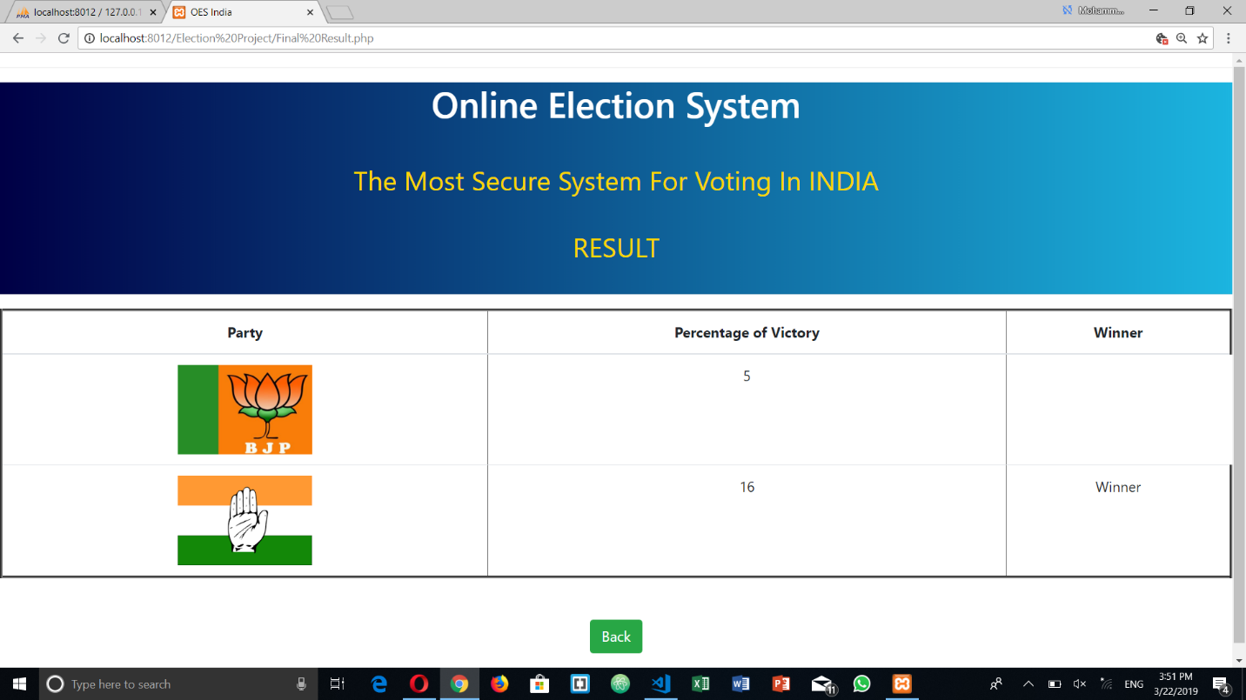

**SALIENT FEATURES**

Flexible ballot options are to be provided which can enable the users to easily understand and use the software. The developed software should be easy to administer and handle by the developer or the admin. It should provide better and efficienct developing modules.

The software should be recognised by the government and be officially handled under the government access.

The votes should be made authenticated by different ways inorder to assure no piracy and correct and righteous candidate should be elected.

As this software is being displayed online it is mandatory to make all the nominations online and display all the candidates profile so that the viewers can visit them.

The votes should be reverified by the voter through OTP on his/her registered mobile number.

The website has to be made available in different languages as different regions use different regional languages.The declaration of the results must be certified and completely authenticated by the admin as well as the government employees.

* Flexible ballot options
* Government authorised actions
* Secure website/application with https:/ protocol
* Compatible with different devices and platforms
* 99.9% Privacy and Integrity
* Transperancy to the voters
* 2 step verification of vote by voters
* Automated result generation
* Transliteration
* Customizable

**FUTURE PROSPECT**

While the system running successfully after its testing on a basic level will be implemente for he following features in future.

* Recognising the exact location of the voter from where he’s casting his vote. Whether at his home town or from a different location.
* Including the Face Recognition of voters to verify that it is the voter himself via his mobile camera.
* Including the Fingerprint scanner into the software as each mobile now a days has a fingerprint scanning mechanism.
* Looking forward to implement the entire website on a national level having the entire authorised control froom the central government.
* Providing 100% accuracy and precision of population of voters casting their vote.
* Including all the latest security keys and prevention of the website from theft or any misconduct.

**REFERENCES**

* <online_voting_report.doc>
* [Python Tutorial](https://www.tutorialspoint.com/python/)
* [PHP 5 Tutorial](https://www.w3schools.com/php/default.asp)
* [Online voting system for secure web ballots by ElectionsOnline](https://www.electionsonline.com/online-voting-system/)
* [Newest 'php' Questions - Stack Overflow](https://stackoverflow.com/questions/tagged/php)
* [Newest 'python' Questions - Stack Overflow](https://stackoverflow.com/questions/tagged/python)
* [How To Create a Countdown Timer](https://www.w3schools.com/howto/howto_js_countdown.asp)
* <http://www.tutorialspoint.com/javascript/>