**1. The essence of Calculus.**

Answer: Calculus is a branch of mathematics that deals with the study of rates of change and the accumulation of small changes. It has two main branches: differential calculus and integral calculus.

Differential calculus is concerned with the study of how one quantity changes in relation to another. It involves the concept of derivatives, which are used to measure the rate of change of a function at a particular point. Derivatives are important in physics, engineering, and other sciences where they are used to calculate velocities, accelerations, and other rates of change.

Integral calculus, on the other hand, deals with the accumulation of small changes. It involves the concept of integrals, which are used to calculate the area under a curve, the volume of a solid, and other quantities that involve accumulation. Integrals are used in many areas of science and engineering, such as physics, economics, and statistics.

The essence of calculus lies in its ability to analyze and model complex systems by breaking them down into smaller and more manageable parts. Calculus is used to solve problems that would be impossible or impractical to solve using algebraic methods alone. It provides a powerful tool for understanding the behavior of systems that change over time or space, and has many applications in fields such as physics, engineering, finance, and biology.

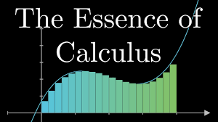

**2. The paradox of the derivative.**

The paradox of the derivative is a mathematical concept that arises from the definition of the derivative as the limit of the ratio of two quantities, as one of the quantities approaches zero. This definition implies that the derivative of a function at a point is a local property of the function, meaning that it depends only on the behavior of the function in the immediate vicinity of that point. However, the derivative also represents the slope of the tangent line to the function at that point, which is a global property of the function, meaning that it depends on the behavior of the function over a larger interval.

This paradox is resolved by recognizing that the derivative of a function is not just a local property, but also a global property that is determined by the behavior of the function over an entire interval. In other words, the derivative at a point is not just the limit of the ratio of two quantities as one of the quantities approaches zero, but also the limit of that ratio as the other quantity approaches zero. This second limit captures the global behavior of the function, and allows the derivative to represent the slope of the tangent line to the function over a larger interval.

The paradox of the derivative highlights the importance of understanding the fundamental concepts and definitions of calculus, and the need to approach mathematical concepts with care and precision in order to avoid misunderstandings and paradoxes.

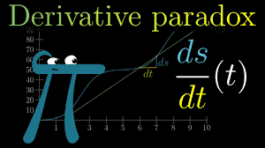

**3. Derivative formulas through geometry.**

The derivative of a function represents the slope of the tangent line to the function at a given point. This concept can be understood geometrically through the use of slopes and slopes of secant lines.

Given a function f(x), the derivative of the function at a point x = a can be calculated using the formula:

f'(a) = lim(h -> 0) [f(a + h) - f(a)] / h

This formula represents the slope of the secant line through the points (a, f(a)) and (a+h, f(a+h)). As h approaches zero, this secant line approaches the tangent line to the function at the point (a, f(a)).

Using this formula, the derivatives of basic functions can be calculated. For example:

* The derivative of a constant function f(x) = c is 0, since the function has a constant slope of 0.
* The derivative of a linear function f(x) = mx + b is m, since the function has a constant slope of m.
* The derivative of a power function f(x) = x^n is f'(x) = nx^(n-1), since the slope of the function at any point x is nx^(n-1).
* The derivative of an exponential function f(x) = a^x is f'(x) = ln(a)*a^x, since the slope of the function at any point x is proportional to the function value itself.
* The derivative of a logarithmic function f(x) = log_a(x) is f'(x) = 1/(x*ln(a)), since the slope of the function at any point x is inversely proportional to the function value itself.

By using these basic formulas and the rules of calculus, more complex derivatives can be calculated. The geometric interpretation of the derivative allows us to visualize and understand the behavior of functions and their derivatives.

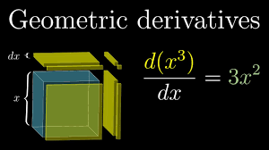

**4. Visualising the chain rule and product rule**

The chain rule and product rule are two important rules in calculus that allow us to find the derivatives of more complex functions. These rules can be visualized through geometric interpretations.

The chain rule states that the derivative of a composite function f(g(x)) is given by the product of the derivative of the outer function f'(g(x)) and the derivative of the inner function g'(x). Geometrically, we can think of the composite function as a composition of two functions, where the output of the inner function becomes the input of the outer function. The chain rule tells us that the slope of the tangent line to the composite function is the product of the slopes of the tangent lines to the individual functions at the corresponding points.

For example, consider the function f(x) = sin(x^2). We can think of this function as a composition of the outer function f(x) = sin(x) and the inner function g(x) = x^2. The chain rule tells us that the derivative of f(x) is given by:

f'(x) = cos(x^2)*2x

This formula tells us that the slope of the tangent line to f(x) at any point x is the product of the slope of the tangent line to g(x) = x^2 at that point (which is 2x) and the slope of the tangent line to f(x) = sin(x) at the point sin(x^2).

The product rule, on the other hand, allows us to find the derivative of a product of two functions f(x) and g(x). Geometrically, we can think of the product of two functions as the area of a rectangle, where the height is given by f(x) and the width is given by g(x). The product rule tells us that the slope of the tangent line to the product is the sum of the slopes of the tangent lines to the individual functions times their corresponding values, plus the product of the values of the functions times their corresponding slopes.

For example, consider the function f(x) = x^2*sin(x). The product rule tells us that the derivative of this function is given by:

f'(x) = 2x*sin(x) + x^2*cos(x)

This formula tells us that the slope of the tangent line to f(x) at any point x is the sum of the slopes of the tangent lines to the individual functions times their corresponding values, plus the product of the values of the functions times their corresponding slopes.

Visualizing the chain rule and product rule in this way can help us to understand and apply these rules more easily in solving more complex problems.

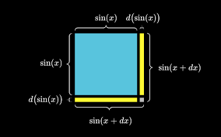 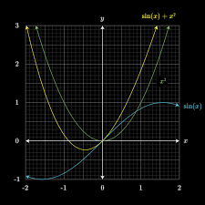

1. What's so special about Euler's number e?

Euler's number, denoted by the letter "e," is a mathematical constant that is approximately equal to 2.71828. Euler's number e is special because it arises naturally in a variety of mathematical contexts, and it has many important applications in mathematics, science, and engineering.

One of the most significant properties of e is its relationship with exponential functions. An exponential function is a function of the form f(x) = a^x, where a is a constant. When a = e, the resulting function is known as the natural exponential function, and it is denoted by the symbol e^x. The natural exponential function has many important properties, including the fact that its derivative is equal to itself. In other words, if f(x) = e^x, then f'(x) = e^x. This makes the natural exponential function a fundamental building block in calculus and many other areas of mathematics.

Euler's number also has important connections to logarithmic functions. The natural logarithm function, denoted by ln(x), is the inverse of the natural exponential function. In other words, if y = e^x, then x = ln(y). The natural logarithm function has many important properties, including the fact that its derivative is equal to 1/x. This makes the natural logarithm function an important tool for solving exponential growth and decay problems, as well as other types of problems in calculus and beyond.

Euler's number also appears in many other mathematical contexts, such as complex analysis, number theory, and probability theory. For example, e^(i*theta), where i is the imaginary unit and theta is an angle, is known as Euler's formula and is a fundamental result in complex analysis. Additionally, e is used as the base for many exponential distributions in probability theory.

In summary, Euler's number e is special because it is a fundamental mathematical constant that arises naturally in many different contexts, and it has many important applications in mathematics, science, and engineering.

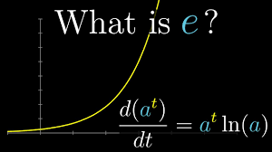Top of Form

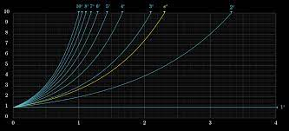

**6. Implicit differentiation**

Implicit differentiation is a technique used in calculus to find the derivative of a function that is not explicitly defined in terms of a single variable. This occurs when the function is defined by an implicit equation, where the variables are related to each other in a way that cannot be easily solved for one variable in terms of the other.

To perform implicit differentiation, we start by differentiating both sides of the implicit equation with respect to the variable we are interested in finding the derivative of. We then use the chain rule and product rule as necessary to simplify the resulting expression and isolate the derivative we are interested in.

For example, consider the implicit equation x^2 + y^2 = 25. To find the derivative of y with respect to x, we start by differentiating both sides of the equation with respect to x:

d/dx (x^2 + y^2) = d/dx (25)

Using the chain rule and product rule, we can simplify the left-hand side to get:

2x + 2y * (dy/dx) = 0

We can then isolate (dy/dx) to get:

dy/dx = -x/y

This tells us that the derivative of y with respect to x is equal to -x divided by y, where x and y are related by the equation x^2 + y^2 = 25.

Implicit differentiation is a powerful tool in calculus, and it allows us to find the derivatives of many functions that cannot be easily differentiated using traditional methods. It is particularly useful in solving problems involving curves and surfaces defined by implicit equations.

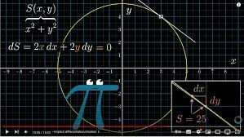

**7. Limits, L' Hopital's rule and epsilon delta definitions**

Limits are a fundamental concept in calculus that describe the behavior of a function as the input approaches a certain value or goes to infinity. The notation for a limit is given by:

lim (x → a) f(x) = L

This means that as x approaches a, the function f(x) approaches the value L.

L'Hopital's rule is a technique used to evaluate limits of certain indeterminate forms, such as 0/0 or infinity/infinity. The rule states that if the limit of the ratio of two functions is an indeterminate form, then the limit of the ratio of their derivatives will be the same as the original limit, provided the derivatives exist. In other words, if:

lim (x → a) f(x)/g(x) = 0/0 or ∞/∞

then:

lim (x → a) f(x)/g(x) = lim (x → a) f'(x)/g'(x)

This rule can be useful in evaluating limits that would otherwise be difficult to compute.

The epsilon-delta definition of a limit is a rigorous mathematical definition that formalizes the concept of a limit. The definition states that a limit of a function f(x) as x approaches a is L if, for any positive value of epsilon, there exists a positive value of delta such that if the distance between x and a (i.e., |x - a|) is less than delta, then the distance between f(x) and L (i.e., |f(x) - L|) is less than epsilon. Symbolically, we write:

lim (x → a) f(x) = L if and only if, for all epsilon > 0, there exists a delta > 0 such that if 0 < |x - a| < delta, then |f(x) - L| < epsilon.

This definition provides a rigorous foundation for the concept of limits and is used to prove many important results in calculus and beyond.

In summary, limits, L'Hopital's rule, and the epsilon-delta definition are all important concepts in calculus that are used to describe and evaluate the behavior of functions. Limits provide a way to describe the behavior of a function as its input approaches a certain value or goes to infinity. L'Hopital's rule is a technique used to evaluate certain types of limits. The epsilon-delta definition provides a rigorous foundation for the concept of a limit and is used to prove many important results in calculus and beyond.



**8. Integration and the fundamental theorem of Calculus.**

Integration is the process of finding the area under a curve or the accumulation of a quantity over a given interval. It is an important concept in calculus and is used in many fields, including physics, engineering, economics, and statistics.

The basic idea of integration is to divide the area under the curve into small, rectangular pieces, each of which has a width of dx and a height of f(x). The area of each rectangle is f(x)dx, and the total area under the curve is given by the sum of all the rectangles:

∫_a^b f(x) dx = lim (n → ∞) Σ_i=1^n f(x_i)Δx

where Δx = (b - a)/n is the width of each rectangle, and x_i = a + iΔx is the i-th point at which we evaluate the function f(x).

The Fundamental Theorem of Calculus connects integration and differentiation and is one of the most important theorems in calculus. It states that if a function f(x) is continuous on the interval [a,b], and F(x) is any antiderivative of f(x), then:

∫_a^b f(x) dx = F(b) - F(a)

In other words, the area under the curve of f(x) on the interval [a,b] is equal to the difference between the values of any two antiderivatives of f(x) at the endpoints of the interval.

The Fundamental Theorem of Calculus provides a powerful tool for evaluating integrals and is used extensively in calculus and other areas of mathematics. It allows us to compute integrals without having to resort to the basic definition of integration and can be used to derive many important results in calculus, including the derivative rules and techniques such as integration by substitution and integration by parts.

In summary, integration is the process of finding the area under a curve or the accumulation of a quantity over a given interval. The Fundamental Theorem of Calculus connects integration and differentiation and provides a powerful tool for evaluating integrals and deriving important results in calculus.

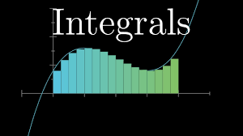

**9. What does area have to do with slope?**

The connection between area and slope is fundamental to the development of calculus and is embodied in the Fundamental Theorem of Calculus.

The basic idea is that the slope of a function at a point is related to the rate of change of the function at that point, which can be interpreted as the height of the function's derivative. In turn, the area under a curve represents the accumulation of the function over a given interval, and the derivative of the area with respect to the upper bound of the interval is equal to the height of the function at that point.

More specifically, if we consider the function f(x) and the slope of its tangent line at a point x, we can interpret the slope as the rate of change of the function at that point. We can approximate the area under the curve of f(x) on the interval [a,b] by dividing it into small rectangles and summing their areas. The width of each rectangle is Δx, and its height is f(x_i), where x_i is the i-th point at which we evaluate the function. The sum of all the rectangles then gives an approximation of the total area under the curve:

A ≈ Σ_i=1^n f(x_i)Δx

As we make the rectangles narrower and their number larger (i.e., as Δx approaches zero), this approximation becomes more and more accurate, and we can take the limit as Δx approaches zero to obtain the exact area under the curve:

A = ∫_a^b f(x) dx

Now, if we let A(x) be the area under the curve of f(x) from a to x, then the derivative of A(x) with respect to x is given by:

d/dx A(x) = f(x)

This means that the height of the derivative of the area function A(x) at a point x is equal to the value of the original function f(x) at that point. In other words, the derivative of the area function gives us the original function back.

This connection between area and slope is embodied in the Fundamental Theorem of Calculus, which states that differentiation and integration are inverse operations: if F(x) is an antiderivative of f(x), then:

∫_a^b f(x) dx = F(b) - F(a)

This theorem provides a powerful tool for evaluating integrals and computing areas under curves by relating them to the derivatives of antiderivatives of the original function.

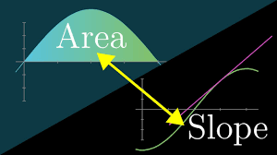Top of Form

**10. Higher order derivatives.**

In calculus, a derivative is a measure of how a function changes with respect to its input variable, typically denoted by x. Higher order derivatives extend this concept to measure how the rate of change of a function changes over time, or how the curvature of a curve changes.

The first derivative of a function f(x) with respect to x is denoted by f'(x) or dy/dx and represents the slope of the tangent line to the graph of f(x) at any given point x. The second derivative, denoted by f''(x) or d²y/dx², represents the rate of change of the slope of the tangent line at any given point x, or equivalently, the curvature of the graph of f(x) at that point. Higher order derivatives can be defined similarly, as the rate of change of the previous derivative.

The nth derivative of a function f(x) is denoted by f^(n)(x) or dⁿy/dxⁿ and can be defined recursively as follows:

f^(0)(x) = f(x) (the function itself) f^(n)(x) = (f^(n-1)(x))' (the derivative of the (n-1)th derivative)

Higher order derivatives can be useful in a variety of applications. For example, in physics, the second derivative of position with respect to time gives the acceleration of an object, while the third derivative gives the jerk. In economics, the second derivative of a utility function with respect to consumption gives the marginal utility of consumption, while the third derivative gives the marginal rate of substitution.

In summary, higher order derivatives extend the concept of the derivative to measure how the rate of change of a function changes over time, or how the curvature of a curve changes. They can be useful in a variety of applications and are defined recursively in terms of the previous derivative.

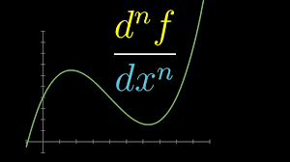

**11. Taylor series**

In calculus, a Taylor series is a representation of a function as an infinite sum of terms, each of which is a multiple of the function's derivatives evaluated at a particular point. The Taylor series provides a way to approximate a function with a polynomial that matches the function and its derivatives at a given point.

More specifically, suppose we have a function f(x) that is infinitely differentiable at a point x = a. Then the Taylor series of f(x) centered at a is given by:

f(x) = f(a) + f'(a)(x-a) + (1/2!) f''(a)(x-a)^2 + (1/3!) f'''(a)(x-a)^3 + ...

where f'(a), f''(a), f'''(a), ... are the derivatives of f(x) evaluated at x = a, and n! is the factorial of n.

The first term of the Taylor series is simply the value of the function at x = a. The second term is proportional to the first derivative of the function evaluated at x = a, and so on. Each term of the series represents a higher-order approximation of the function, taking into account more and more information about the behavior of the function and its derivatives at the point x = a.

The Taylor series can be truncated to any desired order by summing up the first n terms of the series, giving an nth-degree polynomial approximation of the function. This polynomial approximation can be a useful tool for approximating functions that are difficult to compute or analyze directly. One of the most famous examples of a Taylor series is the one for the exponential function e^x, which is given by:

e^x = 1 + x + (1/2!) x^2 + (1/3!) x^3 + ...

This series converges to e^x for all real numbers x, and is used extensively in calculus and other areas of mathematics.

In summary, the Taylor series provides a way to approximate a function with a polynomial that matches the function and its derivatives at a given point. The series represents the function as an infinite sum of terms, each of which is a multiple of the function's derivatives evaluated at that point. The Taylor series can be truncated to any desired order to obtain a polynomial approximation of the function.

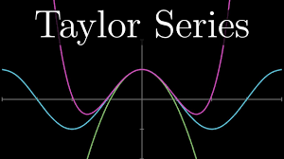Top of Form