ADVANCED ANALYSIS AND
REPORTING OF LANGUAGE TRENDS
USING NLP TECHNIQUES
WEEK 4 INTERNSHIP PROJECT
Submitted by
Arfat Shakil Sherkhan
B.Tech – Artificial Intelligence and Machine Learning
Sanjay Ghodawat University
Academic Year: 2026–2027

1. Abstract
This project focuses on analyzing language trends in news articles using Natural Language Processing (NLP) techniques. The HuffPost News Category Dataset was used to identify frequently occurring words, discover hidden topics, group similar documents and study changes in news themes over time. Text preprocessing was performed before applying word frequency analysis, Latent Dirichlet Allocation (LDA) and K-Means clustering. The analysis covered 209,497 valid articles, while advanced topic modeling and clustering were performed on a sample of 30,000 documents. The project demonstrates how NLP can convert large amounts of unstructured news text into useful patterns and insights.

2. Introduction
News articles contain large amounts of textual information about politics, society, health, entertainment and other subjects. Analyzing this information manually is time-consuming. Natural Language Processing provides techniques that help computers process human language and discover useful patterns from text.
This project applies NLP methods to understand common words, identify major topics and examine how the distribution of topics changes across different years.

3. Project Objectives
- To collect and analyze a large news article dataset.
- To clean and preprocess textual data.
- To identify the most frequently occurring words.
- To analyze yearly trends in news categories and topics.
- To discover hidden topics using LDA topic modeling.
- To group similar news documents using K-Means clustering.
- To evaluate the performance of the topic and clustering models.

4. Dataset Description
The project uses the HuffPost News Category Dataset v3, obtained from Kaggle. It contains news article information such as headlines, short descriptions, categories, publication dates, authors and links.
Dataset detail | Value
Total records loaded | 209,527
Valid articles analyzed | 209497
Number of categories | 42
Starting year | 2012
Ending year | 2022
Advanced analysis sample | 30000

Dataset source: Kaggle – HuffPost News Category Dataset v3
https://www.kaggle.com/datasets/rmisra/news-category-dataset

5. Tools and Technologies Used
- Python 3.12
- Pandas and NumPy for data processing
- Matplotlib and Seaborn for visualization
- Scikit-learn for NLP, LDA and K-Means
- TF-IDF and CountVectorizer for text representation
- python-docx for report generation

6. Methodology

Data loading
Loaded the JSON dataset using Pandas.

Text preprocessing
Converted text to lowercase, removed URLs and non-letter characters, removed English stop words and short tokens.

Word frequency analysis
Counted frequently occurring words and visualized the top 20 words.

Yearly trend analysis
Calculated yearly proportions of news categories.

Topic modeling
Applied LDA with five topics to discover hidden themes in news articles.

Topic trend analysis
Studied the yearly distribution of dominant LDA topics.

Document clustering
Used TF-IDF features and K-Means to group similar documents into five clusters.

Model evaluation
Calculated LDA perplexity and K-Means silhouette score.

7. Word Frequency Analysis
Word frequency analysis identifies the most common words in the news dataset. The word 'trump' was identified as the most frequent word, followed by 'new'. Other frequent words included people, time, photos, day and year.
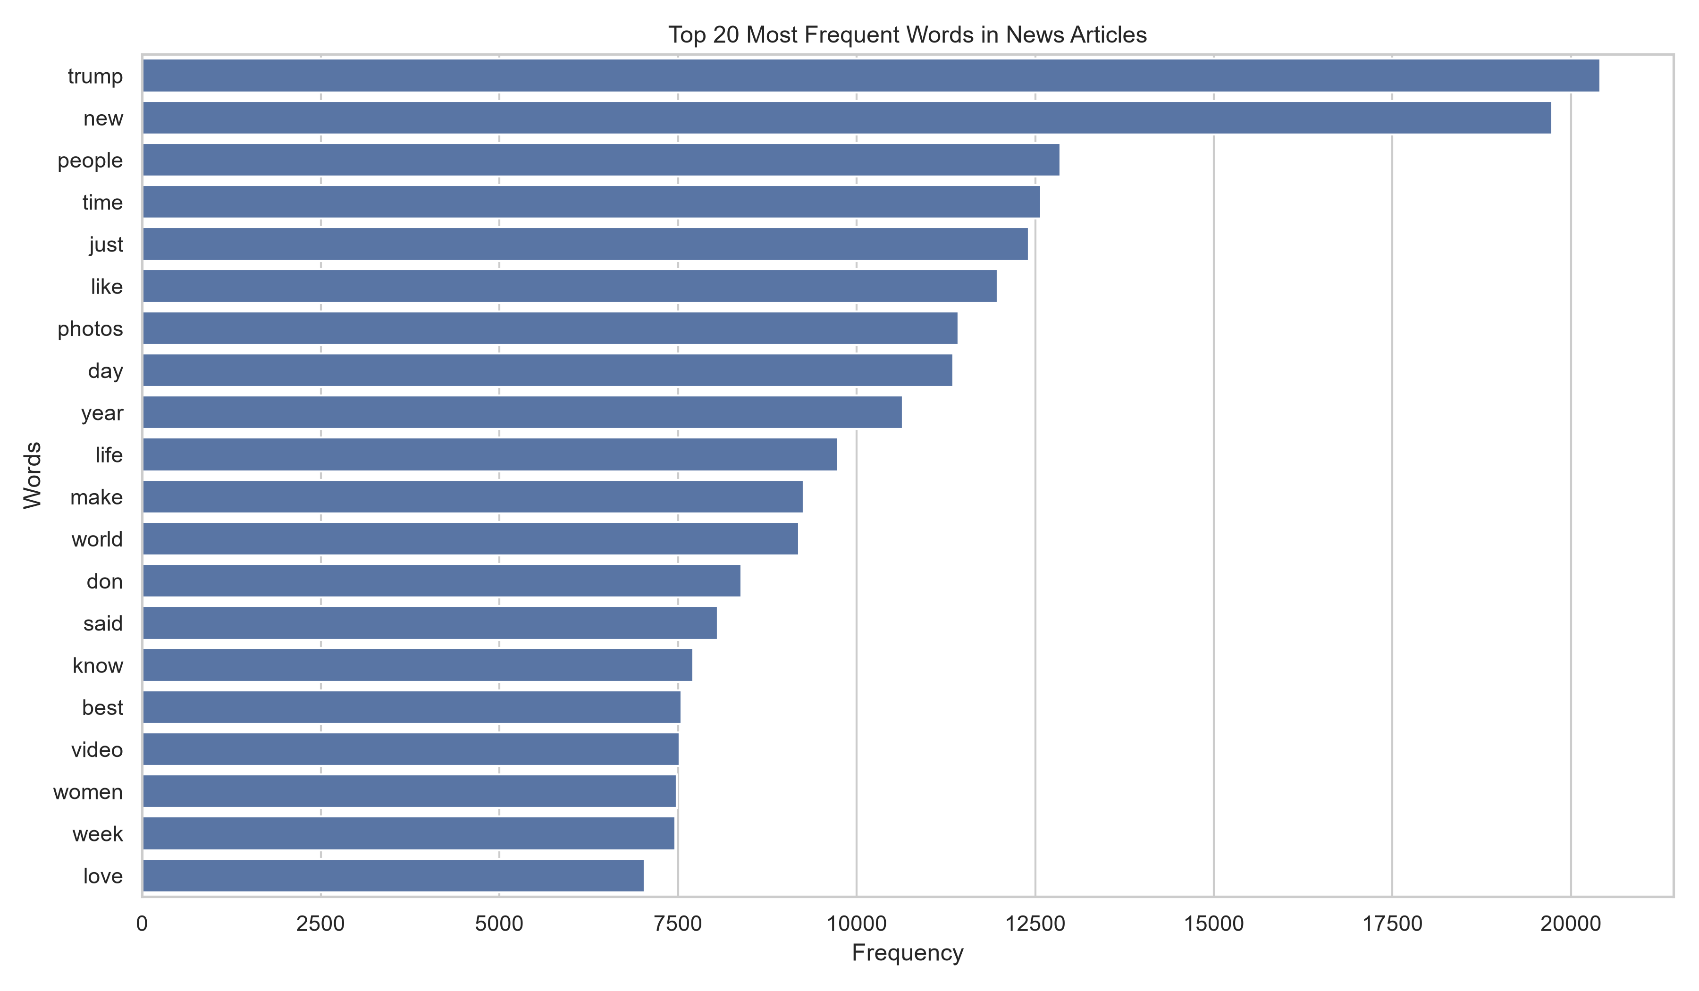
Figure 1: Top 20 most frequent words

8. Yearly Language and Category Trends
Yearly trend analysis was used to examine how the proportions of different news categories changed over time. The analysis helps identify variations in the subjects covered by the dataset.
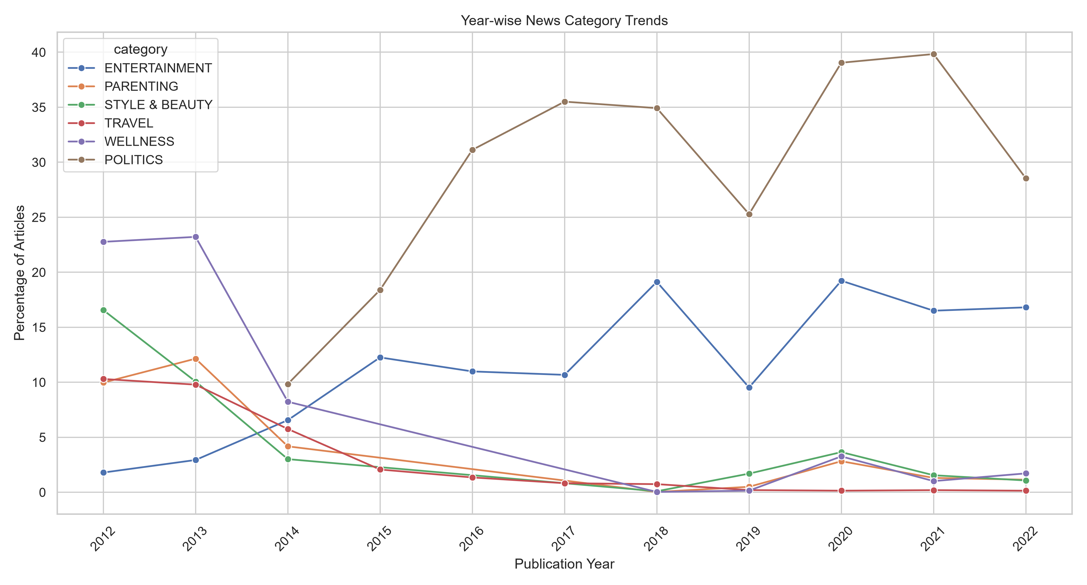
Figure 2: Yearly news category trends

9. LDA Topic Modeling
Latent Dirichlet Allocation (LDA) is an unsupervised topic modeling technique. It identifies groups of words that frequently occur together and uses them to discover hidden themes in documents. Five topics were identified in this project.
Topic | Top keywords
1 | trump, donald, president, obama, house, said, says, clinton, white, gop
2 | photos, new, week, style, video, photo, fashion, look, check, twitter
3 | new, people, women, police, said, american, state, health, death, says
4 | year, day, new, time, old, world, photos, just, best, like
5 | life, know, don, people, make, time, need, just, like, want

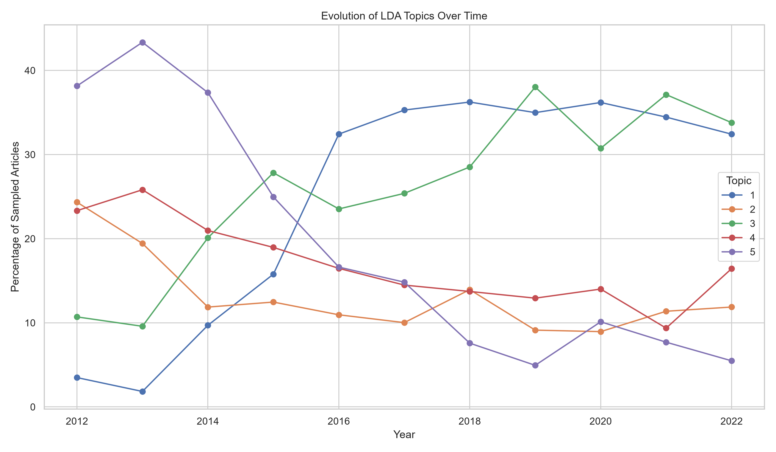
Figure 3: Evolution of LDA topics over time

10. K-Means Document Clustering
K-Means is an unsupervised machine learning algorithm that groups similar documents into clusters. TF-IDF was used to represent the documents numerically. Five clusters were generated.
Cluster | Top keywords
1 | people, photos, time, day, like, life, make, world, women, best
2 | trump, donald, president, said, says, white, house, campaign, clinton, gop
3 | just, know, don, need, like, time, people, want, day, things
4 | year, old, check, facebook, twitter, pinterest, huffpost, tumblr, new, want
5 | new, york, city, video, week, photos, study, fashion, time, people

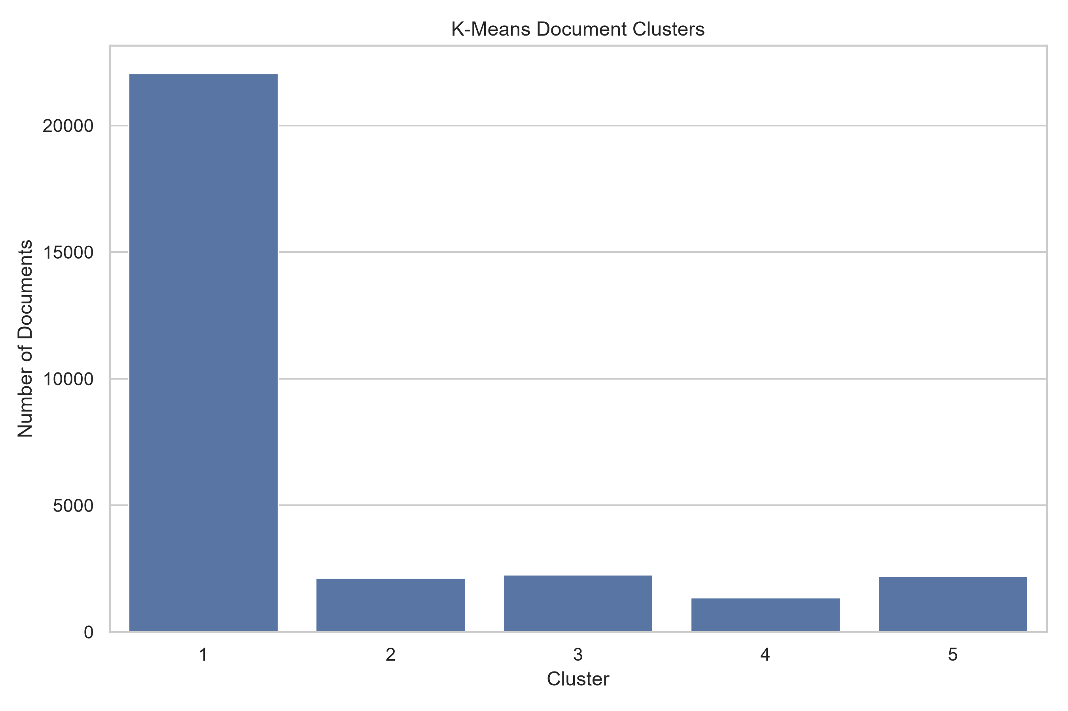
Figure 4: Distribution of documents across clusters

11. Model Evaluation
Model | Evaluation metric | Score
LDA | Perplexity | 2637.0153
K-Means | Silhouette Score | 0.0030

The LDA perplexity score was approximately 2637.02. Perplexity measures how well a topic model predicts unseen word patterns; lower values can indicate better predictive fit when models are compared under the same conditions.
The K-Means silhouette score was approximately 0.003. This value indicates weak separation between the generated clusters. The documents have overlapping language patterns, so further tuning and alternative clustering methods may improve the results.

12. Key Findings
- The most frequent word in the analyzed dataset was 'trump'.
- The LDA model identified five major topics.
- The discovered topics included politics, fashion and media, social issues, lifestyle and personal life.
- The dataset contained 42 news categories.
- The yearly topic chart showed changes in the proportions of topics over time.
- K-Means produced five clusters, but the silhouette score indicated weak cluster separation.

13. Limitations
- Advanced LDA and K-Means analysis used a random sample of 30,000 documents rather than the entire dataset.
- The dataset has uneven temporal coverage, which can affect comparisons between years.
- Word frequency does not identify the meaning or context of a word.
- The K-Means silhouette score indicates that the generated clusters are not clearly separated.
- LDA topics require human interpretation based on their keywords.

14. Conclusion
The project successfully demonstrated the application of Natural Language Processing techniques to a large news dataset. Word frequency analysis, yearly trend analysis, LDA topic modeling and K-Means clustering were used to identify patterns in news articles. The results revealed frequently occurring words and five major topics. Model evaluation also highlighted the need for further improvement in cluster separation. Overall, this project provided practical experience in text preprocessing, unsupervised learning, data visualization and analytical reporting.

15. References
- HuffPost News Category Dataset v3, Kaggle: https://www.kaggle.com/datasets/rmisra/news-category-dataset
- Scikit-learn Documentation: https://scikit-learn.org/
- Pandas Documentation: https://pandas.pydata.org/docs/
- Matplotlib Documentation: https://matplotlib.org/stable/
- Seaborn Documentation: https://seaborn.pydata.org/

