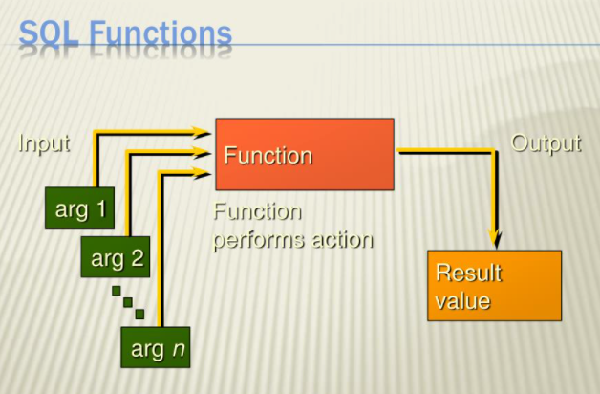

Functions

AssignmenT 07

Amy DeMorrow

**IT FDN 130 A Wi 21: Foundations of Databases & SQL Programming**

[arfazi/DBFoundations-Module07 (github.com)](https://github.com/arfazi/DBFoundations-Module07)

02/27/2021

Image Source: [PPT - SQL FUNCTIONS PowerPoint Presentation, free download - ID:6296690 (slideserve.com)](https://www.slideserve.com/chancellor-dale/sql-functions) (Links to External Site)

Introduction

The seventh module of this course discussed SQL Functions in greater depth. A function is a predefined formula which takes one or more arguments as input, processes the arguments, and then returns an output (Source: [SQL functions and references - w3resource](https://www.w3resource.com/sql/sql-functions.php#:~:text=Types%20of%20SQL%20functions%20%20%20%20SQL,or%20string%20function%20is%20a%20func%20...)). This paper will discuss when to use a user defined function and the differences between Scalar, Inline, and Multi-Statement Functions.

## when to use a sql User Defined Function (UDF)

A user defined function can simplify the code base by encapsulating complex logic into a saved formula and allowing reuse of that code elsewhere. A function can be used to return a scalar value or to return an entire table derived from a single or a series of inputs. Normally a View is probably a better choice than a table valued UDF, but a table valued function can be useful for JOIN operations when data needs to be pulled from different tables, and a calculation needs to be accomplished and an aggregation is returned.

## differences between Scalar, In-Line, and Multi-Statement FunctionS

The three types of functions in SQL are scalar, in-line, and multi-statement. Their differences are discussed below:

* Scalar – The scalar function can accept one or more inputs and is used to calculate and return a single scalar value. The function can return any data type except for text, ntext, image, cursor, and timestamp. A scalar function can accept logic code such as IF blocks and WHILE loops but cannot update the underlying data table. A scalar function can also call another function.
* In-line – The in-line function is a table valued function and returns a table as the output. The in-line function contains a single SELECT statement that dictates the structure of the return table. Because this function is treated similarly to a View by SQL, this function is better for performance compared to a multi-statement function. Finally, an in-line function can be used to update the underlying database table.
* Multi-statement – The multi-statement function allows the structure of the return table to be defined. This function contains BEGIN and END blocks in the syntax and is treated similarly to a stored procedure by SQL (causing slower performance). This function cannot be used to update the underlying database table.

The basic syntax for user defined functions are shown in Figure 1 below:

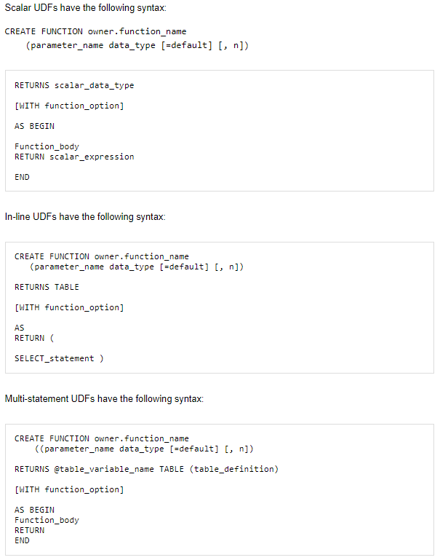

*Figure 1. Basic Syntax of Scalar, In-Line Table, and Multi-Statement Table Functions (Source:* [*UDF Syntax | SQL Server User-Defined Functions (UDFs) | InformIT*](https://www.informit.com/articles/article.aspx?p=31673&seqNum=2) *(Links to External Site)*

## Conclusion

This paper discussed when to use a user defined function (UDF) and the differences between Scalar, In-Line, and Multi-Statement functions. Functions can be very useful to capture and reuse common business logic but may or may not be a better choice to replace a View or a Stored Procedure. Of the three types of functions, the scalar function appears to provide the most useful functionality, but the functionality required for a given operation will best determine if a function is the best choice for the application.