

Views, Functions, and Stored Procedures

AssignmenT 06

Amy DeMorrow

**IT FDN 130 A Wi 21: Foundations of Databases & SQL Programming**

02/21/2021

Image Source: [What is SQL views? - Quora](https://www.quora.com/What-is-SQL-views) (Links to External Site)

Introduction

The sixth module of this course discussed SQL Views, Functions, and Stored Procedures. This paper will discuss when to use a view and the similarities and differences between Views, Functions, and Stored Procedures.

## when to use a sql view

A View is a virtual table created by a select statement that has been saved in the database under an associated name. Views can be used for:

* Fast access to commonly used queries.
* Streamlining and customizing user experience.
* Protecting data from unauthorized modification.
* Creating a backwards compatible interface for a table with an altered schema.
* Partitioning data and improving performance when copying data to and from the database.

A simple example of the syntax to create a View is shown in Figure 1 below:

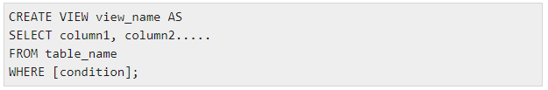

*Figure 1. Basic Syntax of a CREATE VIEW Statement (Source:* [*SQL - Using Views - Tutorialspoint*](https://www.tutorialspoint.com/sql/sql-using-views.htm) *(Links to External Site)*

Functions and Stored Procedures can also provide this functionality, and much more. They will be discussed in the following section.

## Similarities and differences between views, functions, and stored procedures

Views, Functions, and Stored Procedures all methods to save a query in a database for later use. Each has strengths and weaknesses, and the best choice depends on what you need your query to execute:

* View:
  + Does not accept parameters
  + Can be used as a building block for a larger query
  + Accepts only a single SELECT statement
  + Unable to perform modifications to a table, except in very limited circumstances.
  + Able in certain circumstances be used as the target of INSERT, UPDATE, or DELETE statements.
* Function:
  + Accepts only input parameters (maximum parameter limit is 1024)
  + Must return values
  + Only possible choice for use in filtering statements and creating joins
  + May be modified and called independently multiple times within a program
  + Improves network performance because it is already cached on the server
  + Returns scalar values as well as tables
  + Returns a single row set
  + Unable to accept INSERT, UPDATE, and DELETE statements
  + Unable to use non-deterministic built in functions (such as GETDATE())
* Stored Procedure:
  + Accepts both input and output parameters (maximum parameter limit is 21000)
  + May or may not return values
  + Can NOT be used as a building block for a larger query
  + Can contain multiple statements, loops, and logic statements
  + Able to perform modifications to one or more tables
  + Accepts INSERT, UPDATE, and DELETE statements
  + Unable to be used as a target of an INSERT, UPDATE, or DELETE statement
  + Improves network performance because it is already cached on the server
  + Provides additional security by blocking SQL injection attacks
  + Returns multiple row sets

Functions and Stored Procedures have more complex functionality than Views. More of their similarities and differences are shown in Figure 2 below:

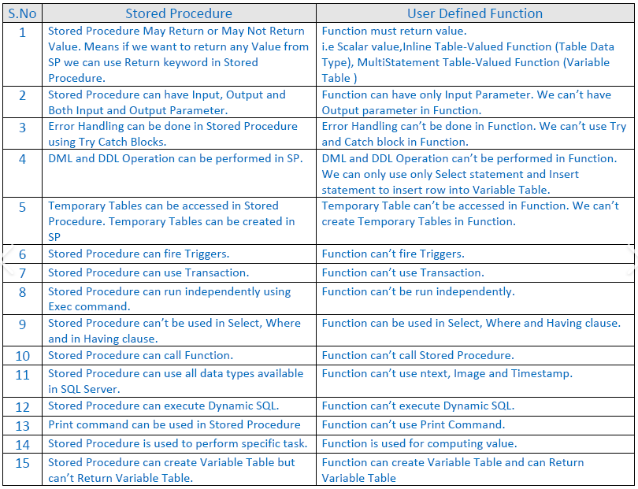

*Figure 3. Comparison Between Functions and Stored Procedures (Source*: [*Teach Me SQL SERVER: Difference between Stored Procedure and Function*](http://teachmesqlserver.blogspot.com/2014/07/what-is-difference-between-stored.html)*) (Links to External Site)*

## Conclusion

This paper discussed when to use a View, and the similarities and differences between Views, Functions, and Stored Procedures. The complexity and functionality required for a given query will determine which option is best suited for the application.