## Arfhan Ahmad

## Feb 22,2016

## Tutorial On Github, Git and Waffle.io

Home-Work # 3

**Part 1**

**Create and submit your GitHub username**

<https://github.com/arfhan786>

**Part 2**

**Install Git bash and browse through the documentation**

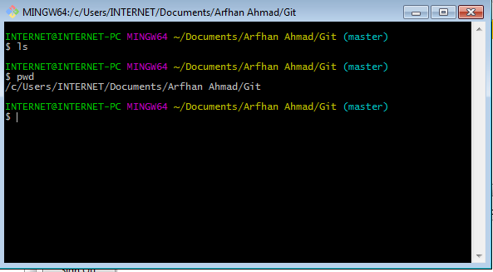

**Part 3**

**Answer the following Questions:**

**What is GitHub? When was it created? By Who? What similar platforms exist? Why would you use such a platform?**

Github is a web-based Git repository which offers revision control and source code management. The development of the GitHub platform began on October 1, 2007. The site was launched in April 2008 by Tom Preston-Werner, Chris Wanstrath and PJ Hyett. Similar platforms exist, to name a few: SourceForge, Bitbucket and Redmine. One would use these any of these platforms for group coding projects.

**Part 4a**

**Complete the Git Tutorial:**

git init - quickest way to initialize a repository

git status - to check if any changes were made in the repo

git add - add the contents of the repo to your local file

git commit - save the changes in the repo

git log - journal that remembers all the changes that was committed

git push - push local changes into original repo

git pull - pull any new changes that have occurred in the repo

**Part 4b**

* **Complete the tutorial on Lynda.com**

**Part 5**

**Define the following terms:**

* Repository - a central location in which data is stored and managed
* Commit - a message describing what we changed
* Push - push command tells Git where to put our commits when ready
* Branch - a copy (aka. branch) of their code they can make separate commits to
* Fork - A fork is a copy of a repository
* Merge - After you have finished implementing a new feature on a branch, you want to bring that new feature into the main branch, so that everyone can use it
* Clone - to clone a repository means that you will download the whole code of the repository
* Pull - Pull refers to when you are fetching in changes and merging them
* Pull request - Pull requests let you tell others about changes you've pushed to a repository on GitHub

**Part 6**

**Push the Word File in your github:**

**Part 7**

**Retrieve the Read Me File at:**

1. Fork and edit the file
2. Opened the Readme file
3. Added my name
4. Requested the owner to add my changes

**Part 8**

**Add an Issue:**

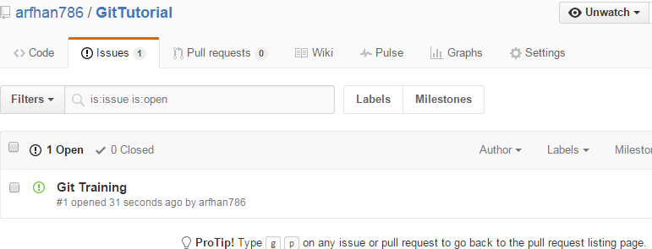

**Part 9**

**Edit the main page of wiki:**

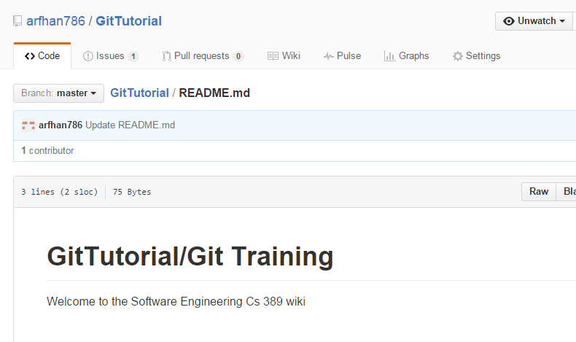

**Part 10**

**Log in to Waffle**