## Personal Document Management System (PDMS)

A Personal Document Management System (PDMS) is a digital system that allows you to store and manage your documents in one centralized location. With PDMS, you can easily categorize your documents based on parameters like type, date, or topic, making it easy to locate specific documents quickly. Its advanced search functions save you time and effort when looking for documents. PDMS also provides robust security features, including data encryption and user authentication, and allows for easy document sharing. By eliminating the need for physical storage space, PDMS can save you money on storage costs while improving document organization and enhancing security.

**Features of PDMS:**

***Document storage:*** The system allows users to store digital documents in a centralized location. This eliminates the need to store documents in multiple locations, making it easier to keep track of them.

***Document categorization:*** The system enables users to categorize their documents based on parameters such as type, date, or topic. This makes it easy to locate specific documents quickly.

***Search capabilities:*** The system allows users to search for particular documents by entering keywords or other search parameters. This makes it easy to find documents quickly and efficiently.

***Security:***The system provides robust security features, including data encryption and user authentication. This ensures that users' documents are secure and protected from unauthorized access.

***Sharing:*** The system allows users to share documents with other users or groups. This feature can be useful in a collaborative work environment where multiple users need access to the same documents.

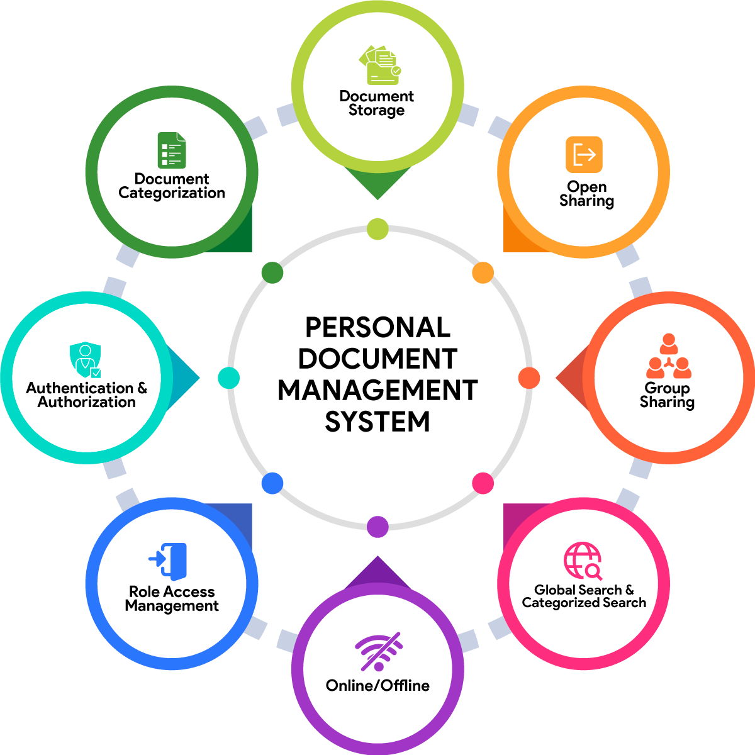

**Using a PDMS offers several benefits, including:**

***Improved document organization:*** A PDMS enables users to organize their documents more effectively, making finding and retrieving them easier.

***Time savings:*** With a PDMS, users can access their documents quickly and efficiently, saving time and effort.

***Enhanced security:*** A PDMS provides robust security features, protecting users' documents from unauthorized access or theft.

***Cost savings:*** By eliminating the need for physical storage space, a PDMS can save users money on storage costs.

### Some visual detail of the System

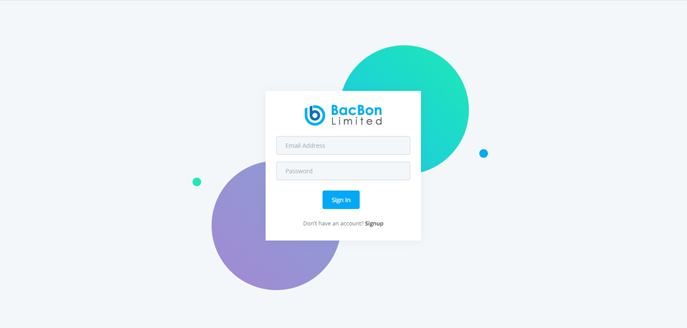

#1 This is the Login page here you login using your credentials.

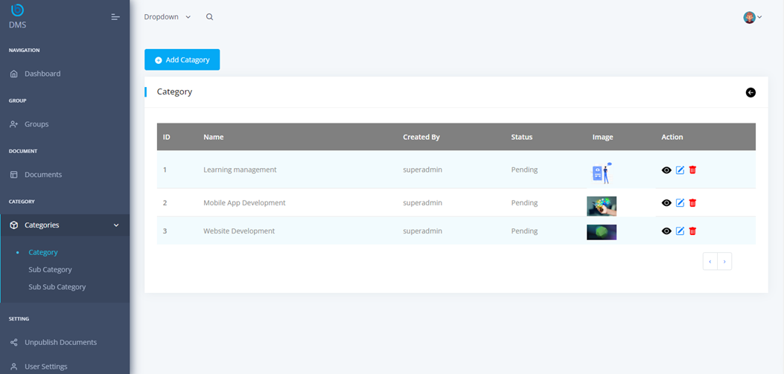

#2 Here You can Create Category / Folder, you can see the list of Category. Also, you can view, update, and delete the category.

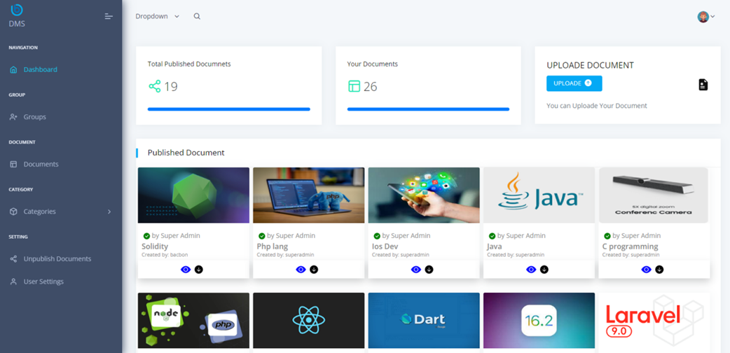

#3. This is a dashboard, Here You can view Total Publish documents, Your personal documents and you can Quickly upload Document.

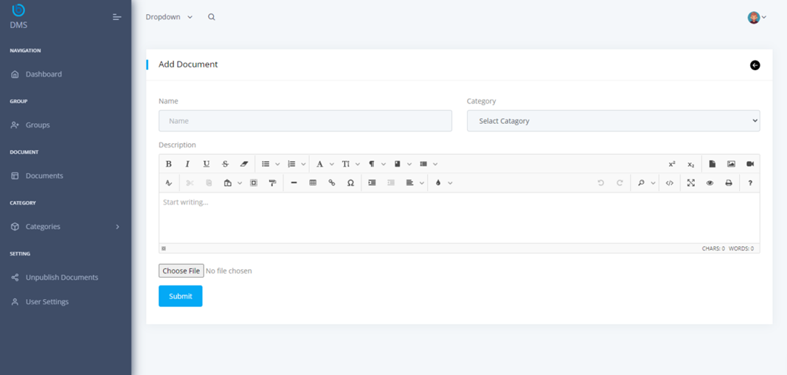

#4. Here You can upload documents, you need to add Doc Name, Select Category / Folder, and can write a description and choose your File to upload.

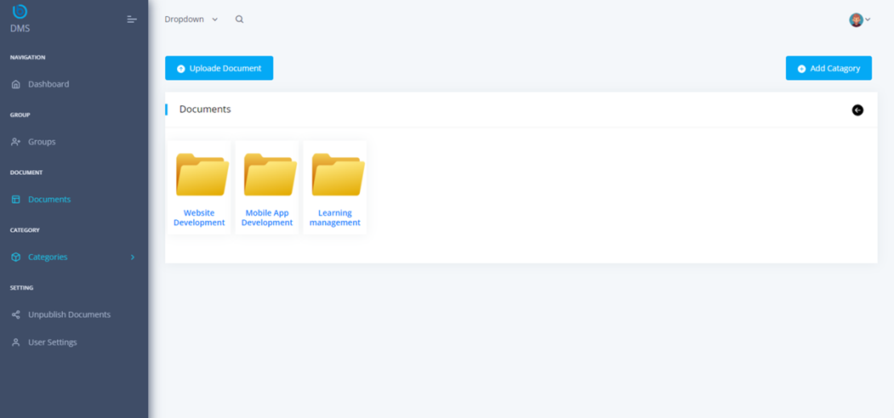

#5. You can see the folder Archives. Folders can be recursive and maintained easily in groups.

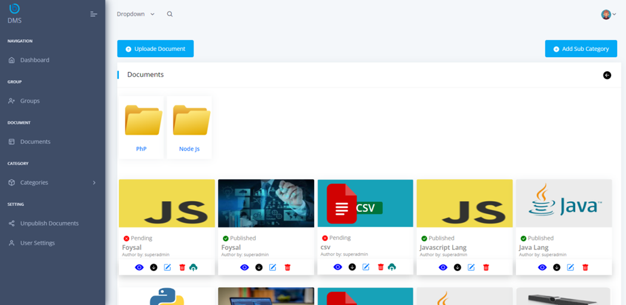

#6. Here you can see the documents inside the folders. Also you can view, download, edit, delete and share your documents from this page.

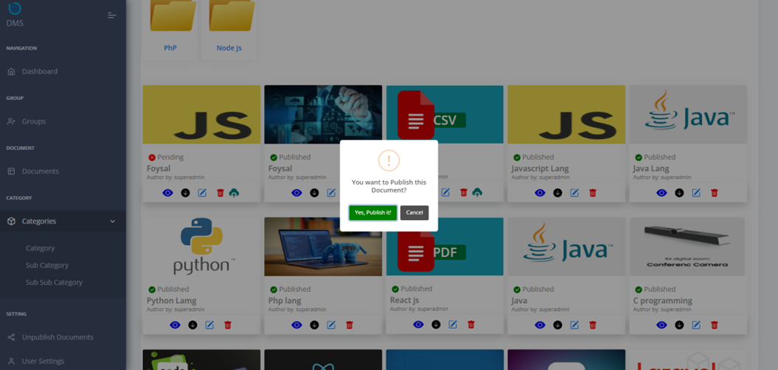

#7. Here you can Click the publish button and Publish your document/s for public access.

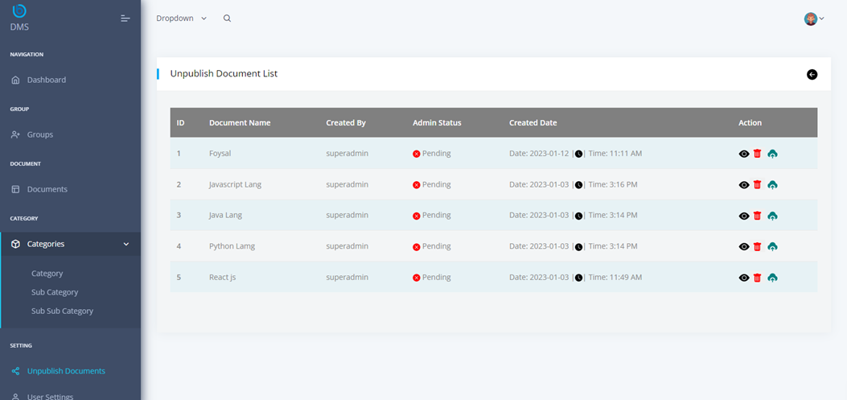

#8. Here you will see list of documents before publishing them.

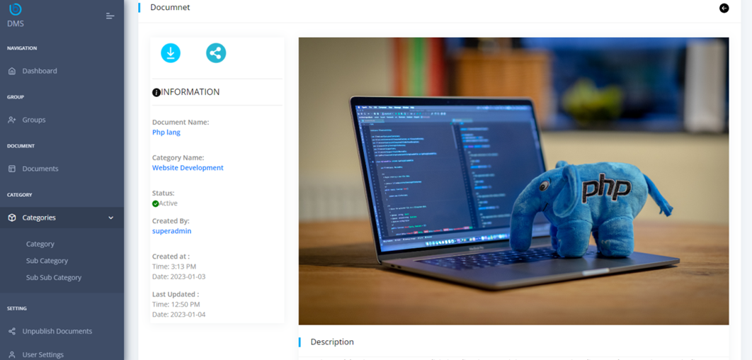

#9. Here can view each document details, also you can download and share your document with groups.

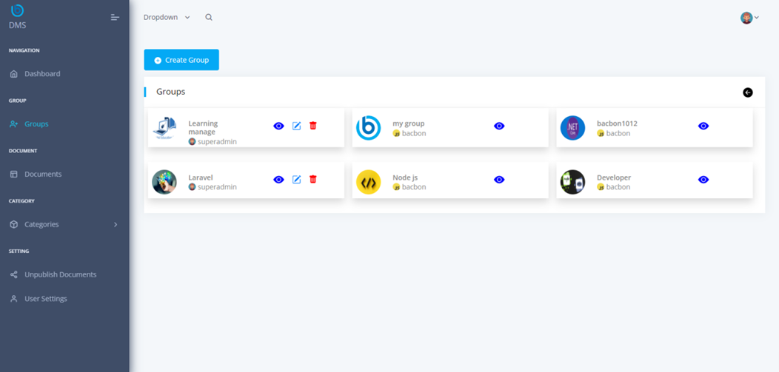

#10. Here you can create your groups and add members in the group. Also view, edit and delete any group as needed.

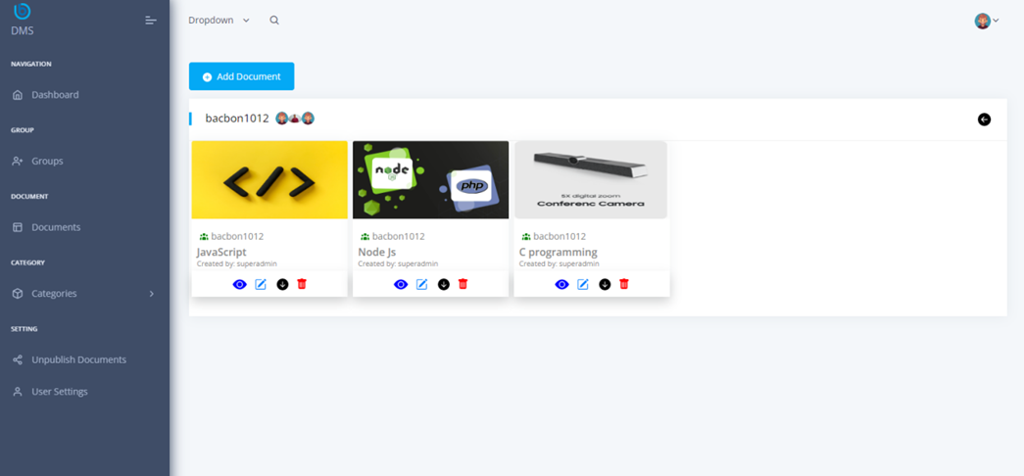

#11. Here on this page, you can view documents assigned to a particular group.

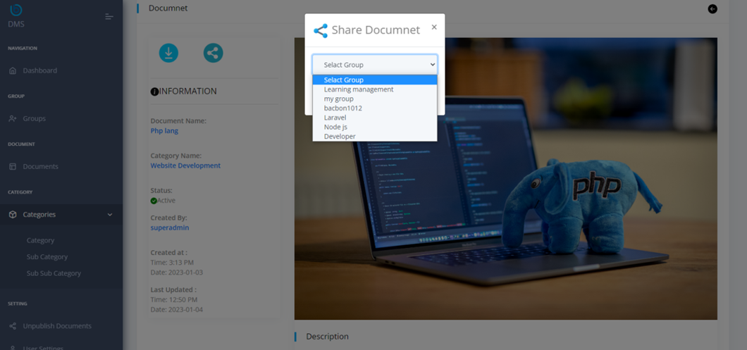

#12. Here You can share document in your group by selecting your group name.

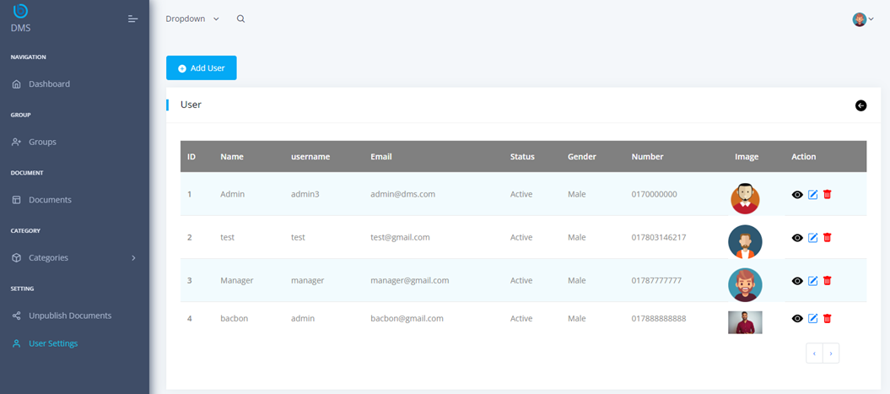

#13. Here Admin can see all the users and view, edit, delete if needed.