PETTY CASH MANAGEMENT
AND APPROVAL SYSTEM
Requirements Specification and Developer Implementation Guide
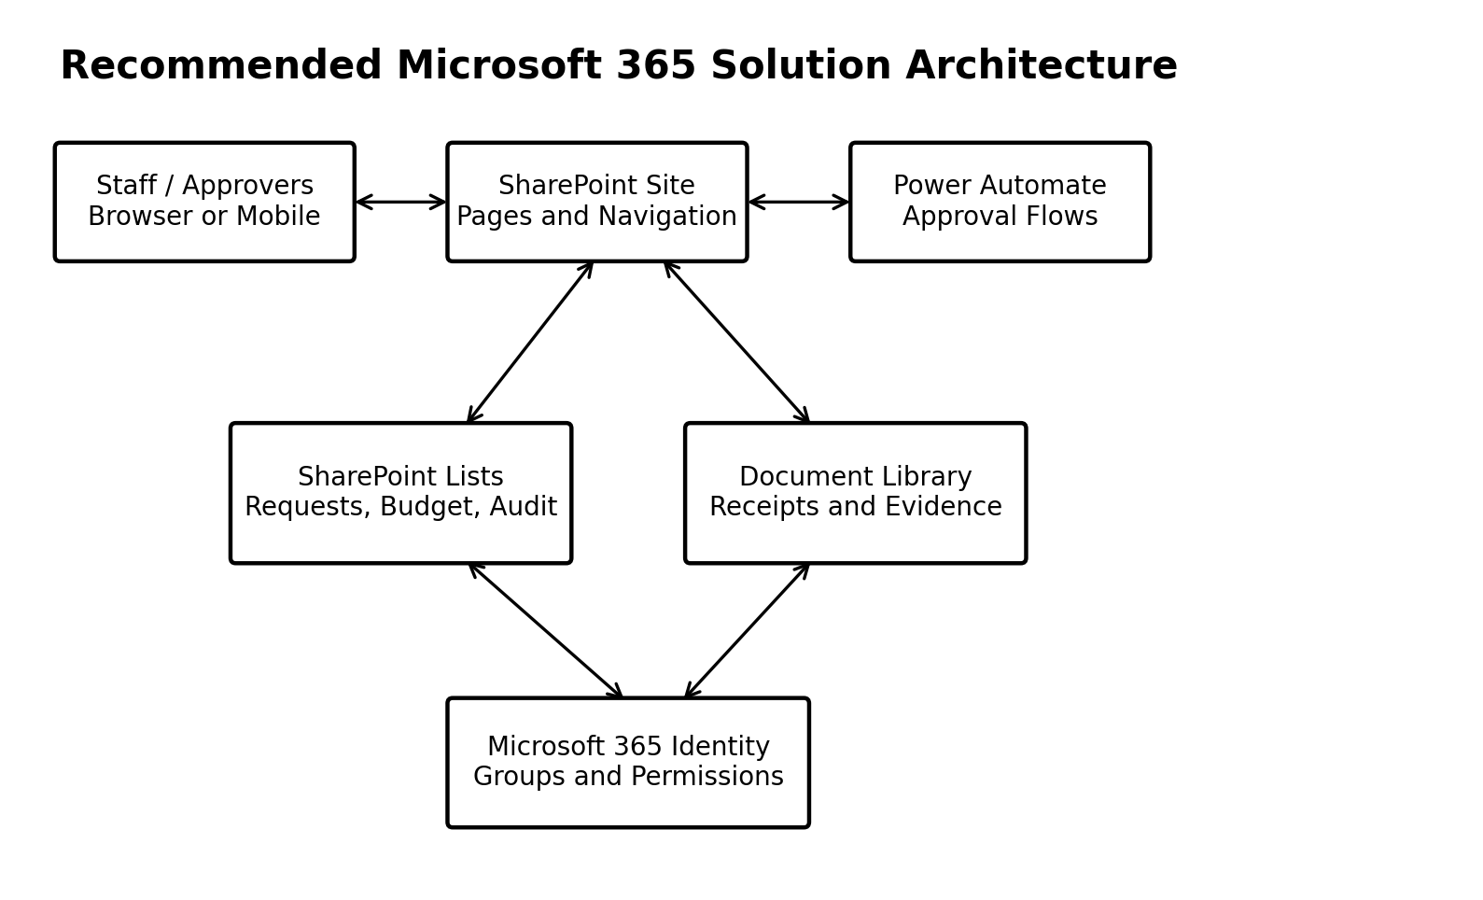
Platform: Microsoft SharePoint Online + Power Automate (Microsoft 365 A3)
Annual fund: PKR 1,000,000 (configurable per fiscal year)
Prepared for: Office of the Deputy Director
Version 2.0 (Comprehensive Implementation Edition) - July 2026

Document Control
Item | Details
Document title | Petty Cash Management and Approval System - Requirements and Implementation Guide
Version | 2.0 - Comprehensive Implementation Edition
Version 1.0 scope | Requirements specification (baseline)
Version 2.0 additions | Full flow-by-flow build logic (F-01 to F-10), technical column schema, voucher sequence concurrency pattern, delegation mechanism, budget threshold controls, fiscal-year carryforward rule, control-framework mapping (ISO 27001 / SOC 2)
Prepared for | Deputy Director / Director / Accounts / IT
Target platform | SharePoint Online, Microsoft Lists and Power Automate (Microsoft 365 A3 - standard connectors only, no premium license required)
Classification | Internal use
Owner | Designated departmental system owner
Review cycle | At implementation, after pilot, and annually

Approval of This Document
Role | Name | Signature / Digital Approval | Date
Deputy Director
Director
Accounts representative
IT / Microsoft 365 administrator

How to Use This Guide
This document has two purposes: (1) it is the formal requirements specification for the developer, and (2) it is a step-by-step implementation and acceptance guide for management. Requirements marked “Must” are mandatory for production acceptance. Requirements marked “Should” are recommended for the first release or a planned enhancement.
Version 2.0 extends the original specification into a build-ready implementation guide. Every Power Automate flow (F-01 through F-10) now has explicit step logic, every list has a technical column schema suitable for direct SharePoint configuration, and every open policy question from Appendix D of version 1.0 has been resolved into a concrete, configurable rule. Sections and appendices new or materially expanded in this version are marked with the note bar shown below.
IMPLEMENTATION NOTE Sections marked with this bar contain build-level detail added in Version 2.0 and were not present in the original requirements baseline.

Table of Contents
Document Control 2
Approval of This Document 2
How to Use This Guide 2
Table of Contents 3
1. Executive Summary 6
1.1 Expected Outcomes 6
1.2 Core Design Principles 6
2. Objectives, Scope and Assumptions 6
2.1 Business Objectives 6
2.2 In Scope - First Production Release 6
2.3 Out of Scope Unless Separately Approved 7
2.4 Assumptions and Dependencies 7
3. Roles and Governance 7
3.1 Governance Requirements 8
3.2 Delegation and Backup Approver Mechanism 8
3.2.1 Approver Configuration List 8
3.2.2 Flow Behaviour 8
4. Target Architecture 8
4.1 Components 8
4.2 Design Decision: Standard Forms First 9
5. Business Process and Approval Workflow 9
5.1 Main Process 9
5.2 Status Model 10
5.3 Return and Resubmission Rule 11
6. SharePoint Information Architecture 11
6.1 Proposed Site Structure 11
6.2 Required Views 11
7. Data Dictionary 11
7.1 Petty Cash Requests List 12
7.2 Supporting Lists 12
7.3 Evidence Library Metadata 13
7.4 Fiscal Years List — Technical Field Detail (new) 13
8. Power Automate Flow Specifications 13
8.1 Mandatory Flow Construction Rules 14
8.2 Flow F-01 — Initialize and Submit Request 14
8.3 Flow F-02 — Deputy Director Approval 15
8.4 Flow F-03 — Director Final Approval 15
8.5 Flow F-04 — Returned Request Resubmission 16
8.6 Flow F-05 — Payment and Settlement 16
8.7 Flow F-06 — Permission Management 16
8.8 Flow F-07 — Reminder and Escalation 16
8.9 Flow F-08 — Fiscal Year Closure 17
8.10 Flow F-09 — Cancellation / Amendment 17
8.11 Flow F-10 — Exception and Failure Monitor 17
8.12 Approval Card Content 18
8.13 Voucher Numbering — Concurrency-Safe Implementation Pattern 18
8.14 Budget Threshold Warning Logic (new) 18
9. Forms, Views and Wireframes 19
9.1 Staff Form Requirements 19
9.2 Reviewer Screen Requirements 19
9.3 Dashboard Requirements 19
10. Security, Permissions and Audit Controls 20
10.1 Microsoft 365 Groups 20
10.2 Required Controls 20
10.3 Audit Events 20
10.4 Record Locking and Amendments 21
10.5 Control Framework Mapping (new) 21
11. Budget and Financial Control Rules 21
11.1 Calculation Definitions 22
12. Notifications and Escalations 22
12.1 Notification Principles 23
13. Reports and Dashboard 23
13.1 Mandatory Reports 23
13.2 Export Requirements 23
14. Non-Functional Requirements 24
14.1 Technical Documentation Required from Developer 24
15. Testing and Acceptance 24
15.1 Test Environments 24
15.2 Mandatory Acceptance Test Cases 25
15.3 User Acceptance Sign-Off 25
16. Implementation Plan 26
16.1 Delivery Milestones 26
16.2 Change Control 26
17. Operations, Support and Handover 26
17.1 Daily / Weekly Operations 26
17.2 Handover Checklist 27
17.3 Manual Contingency Procedure 27
18. Future Enhancements 27
Appendix A - Logical Data Model / ERD 28
Appendix B - Permission Matrix 28
Appendix C - Developer Build Checklist 29
Appendix D - Management Decisions Required Before Build 29
Appendix E - Microsoft Reference Sources 30
Appendix F - Technical Implementation Reference (new in v2.0) 32
F.1 New Lists Summary 32
F.2 New Fields on Existing Lists 32
F.3 Voucher Sequence Pseudocode Summary 32
F.4 Summary of All Version 2.0 Additions 32

1. Executive Summary
The organization requires a controlled electronic system for managing petty cash expenditure from an annual allocation initially set at PKR 1,000,000. Staff currently incur expenditure and provide informal or incomplete records. The proposed system will standardize submission, require evidence, enforce sequential review by the Deputy Director and final approval by the Director, record payment and settlement, and preserve a transparent audit trail.
The recommended solution uses existing Microsoft 365 services: a SharePoint site, SharePoint lists, a document library, and Power Automate. The first release should use standard SharePoint/Microsoft Lists forms unless usability testing demonstrates a genuine need for Power Apps. This reduces development and maintenance risk while retaining the option to improve the interface later.

1.1 Expected Outcomes
- Every expense has a unique voucher number and supporting evidence.
- No transaction becomes an official expenditure until the Director gives final approval.
- Approvals, returns, rejections, amendments and payments are time-stamped and attributable to named users.
- Annual allocation, approved expenditure, pending commitments and remaining balance are visible at all times.
- Approved records cannot be silently edited or deleted.
- Management and auditors can export a complete petty cash register and approval history.

1.2 Core Design Principles
Principle | Required interpretation
Single source of truth | SharePoint lists and libraries are the authoritative record; email is notification only.
Separation of duties | Requester, Deputy Director, Director and Accounts perform distinct actions.
Evidence before approval | A receipt, invoice or approved exception must exist before submission.
Immutability after approval | Final records are locked; changes use amendment/cancellation workflow.
Least privilege | Users receive only the access needed for their role.
Traceability | Every material action is recorded in a protected audit list.

2. Objectives, Scope and Assumptions

2.1 Business Objectives
- Improve transparency and accountability for petty cash.
- Reduce incomplete, duplicate or unsupported claims.
- Shorten approval time while retaining management control.
- Provide a reliable fiscal-year balance and management reports.
- Create records suitable for internal and external audit.
- Use the organization's existing Microsoft 365 identity and services.

2.2 In Scope - First Production Release
- User and role management through Microsoft 365 groups.
- Expense request entry and document upload.
- Sequential Deputy Director and Director approvals.
- Return, rejection, cancellation and amendment handling.
- Annual allocation, category budget and balance calculations, including proactive threshold warnings.
- Accounts payment and settlement recording.
- Audit log, search, filters, dashboard and exports.
- Email or Teams approval notifications using standard Microsoft 365 connectors.
- Backup-approver delegation for Deputy Director and Director absence (new in v2.0).

2.3 Out of Scope Unless Separately Approved
- General ledger posting or full accounting.
- Procurement tendering and purchase-order management.
- Payroll, travel or asset management.
- External public users without organizational Microsoft 365 accounts.
- Premium Power Platform connectors, Dataverse or third-party paid services.
- Digital signature products beyond Microsoft approval records.

2.4 Assumptions and Dependencies
ID | Assumption / dependency
A-01 | Users have active organizational Microsoft 365 accounts.
A-02 | IT will create or authorize a SharePoint team site and required security groups.
A-03 | Standard SharePoint, Outlook and Approvals connectors are enabled in Power Automate. No premium connector or Dataverse license is required for the flows specified in Section 8.
A-04 | The organization will nominate a system owner and a backup owner.
A-05 | Financial policy will define document retention and whether pre-approval is required before spending (resolved in Appendix D).
A-06 | The developer will use a non-production environment or test lists before deployment.
A-07 | Microsoft 365 A3 licensing is confirmed for all requester, approver and Accounts users; A3 includes standard-connector Power Automate use rights at no additional cost (see Appendix E).

3. Roles and Governance
Role | Key responsibilities | System access
Staff requester | Create requests, upload evidence, answer queries, view own records. | Create; read own; edit draft/returned only.
Deputy Director | Verify need, evidence, budget head and amount; approve, return or reject. | Read all; update review fields through flow/form.
Director | Provide final approval, return or reject. | Read approved-by-DD requests; update final decision.
Accounts / Custodian | Record disbursement, payment reference, settlement and reconciliation. | Read approved records; update payment fields only.
System owner | Manage configuration, categories, fiscal years, reports and operational oversight. | Elevated business administration; no silent record changes.
Microsoft 365 administrator | Site provisioning, groups, service policies, recovery support. | Technical administration subject to audit.
Auditor / read-only reviewer | Inspect transactions, documents and logs. | Read-only access to approved records and reports.

3.1 Governance Requirements
- Production flows must have at least two co-owners: the developer and an authorized organizational owner.
- Connections used by production flows must not depend solely on a personal account that may be disabled.
- Configuration changes must be documented in a change log.
- No developer or administrator may alter an approved financial record without generating an audit event and following the amendment procedure.
- The Director, Deputy Director and Accounts roles must be assigned to named users or controlled Microsoft 365 groups.

3.2 Delegation and Backup Approver Mechanism
IMPLEMENTATION NOTE This subsection is new in Version 2.0. It resolves the open question in Appendix D ('who acts when DD or Director is on leave?') with a concrete, buildable pattern.
A stalled approval is the single most common failure mode of home-grown SharePoint approval systems. The design below prevents a request from waiting indefinitely because a named approver is unavailable, without weakening separation of duties.

3.2.1 Approver Configuration List
A new list, Approver Configuration, holds one row per approval role (Deputy Director, Director). Fields: RoleName (choice), PrimaryApprover (person), BackupApprover (person), DelegationActive (yes/no), DelegationStartDate (date), DelegationEndDate (date), UpdatedBy (person), UpdatedOn (date/time).

3.2.2 Flow Behaviour
- Before assigning CurrentApprover, F-02 and F-03 query Approver Configuration for the relevant role.
- If DelegationActive = Yes and today's date falls within DelegationStartDate and DelegationEndDate, the flow assigns the approval to BackupApprover instead of PrimaryApprover, and records which one acted in the Approval Actions list (ActorRole field retains 'Deputy Director' or 'Director' regardless of which named person acted).
- Only the System Owner (or the Primary Approver themselves) may toggle DelegationActive; this is enforced by list-level permissions, not just form guidance.
- A change to Approver Configuration writes an audit event (Access / administration category) automatically, using the same pattern as F-06.
- The backup approver receives the same approval card content as specified in Section 8.3, with an added banner: 'Acting for [Primary Approver name] under delegation dated [range].'
This mechanism satisfies BR-level control expectations because it never removes the requirement for a named, accountable decision-maker — it only changes who that named person is, and the change itself is auditable.

4. Target Architecture

4.1 Components
Component | Purpose
SharePoint team site | Secure departmental workspace and navigation.
Petty Cash Requests list | Main transaction register and current workflow status.
Fiscal Years list | Annual allocation, opening data, status, closure and carryforward.
Budget Heads list | Controlled expenditure categories and category limits, including threshold percentage.
Approval Actions list | Permanent record of each review decision and comment.
Audit Log list | Protected technical and business change history.
Payments list | Disbursement and settlement records; supports partial payment if enabled.
Evidence library | Receipts, invoices, quotations and other supporting files.
Approver Configuration list | Primary/backup approver mapping and delegation windows (new in v2.0).
Voucher Sequence list | Concurrency-safe counter used to generate voucher numbers (new in v2.0, detailed in Section 8.5).
Power Automate flows | Validation, approvals, permissions, notifications, numbering and logging.
SharePoint pages/views | Forms, queues, dashboard links and reports.

4.2 Design Decision: Standard Forms First
The developer should start with the modern SharePoint/Microsoft Lists form. Power Apps is not required for the first release unless the standard form cannot meet an agreed usability or validation requirement. Avoiding Power Apps initially reduces complexity, licensing uncertainty and maintenance. A customized Power Apps interface may be introduced after the workflow has operated successfully in a pilot.


5. Business Process and Approval Workflow

5.1 Main Process
- Staff creates a draft request and enters the expense information.
- Staff uploads at least one receipt or supporting document. An exception reason is required when policy permits missing evidence.
- On Submit, the system validates mandatory fields, fiscal year, amount and duplicate indicators.
- The system generates a unique voucher number and records submission time.
- The Deputy Director receives the request and chooses Approve, Return or Reject. Comments are mandatory for all decisions.
- Only an item approved by the Deputy Director proceeds to the Director.
- The Director chooses Final Approve, Return or Reject. Comments are mandatory.
- A finally approved request becomes read-only to staff and is made available to Accounts.
- Accounts records payment or reimbursement information and marks the item Paid or Settled.
- All decisions and changes are written to the Approval Actions and Audit Log lists.
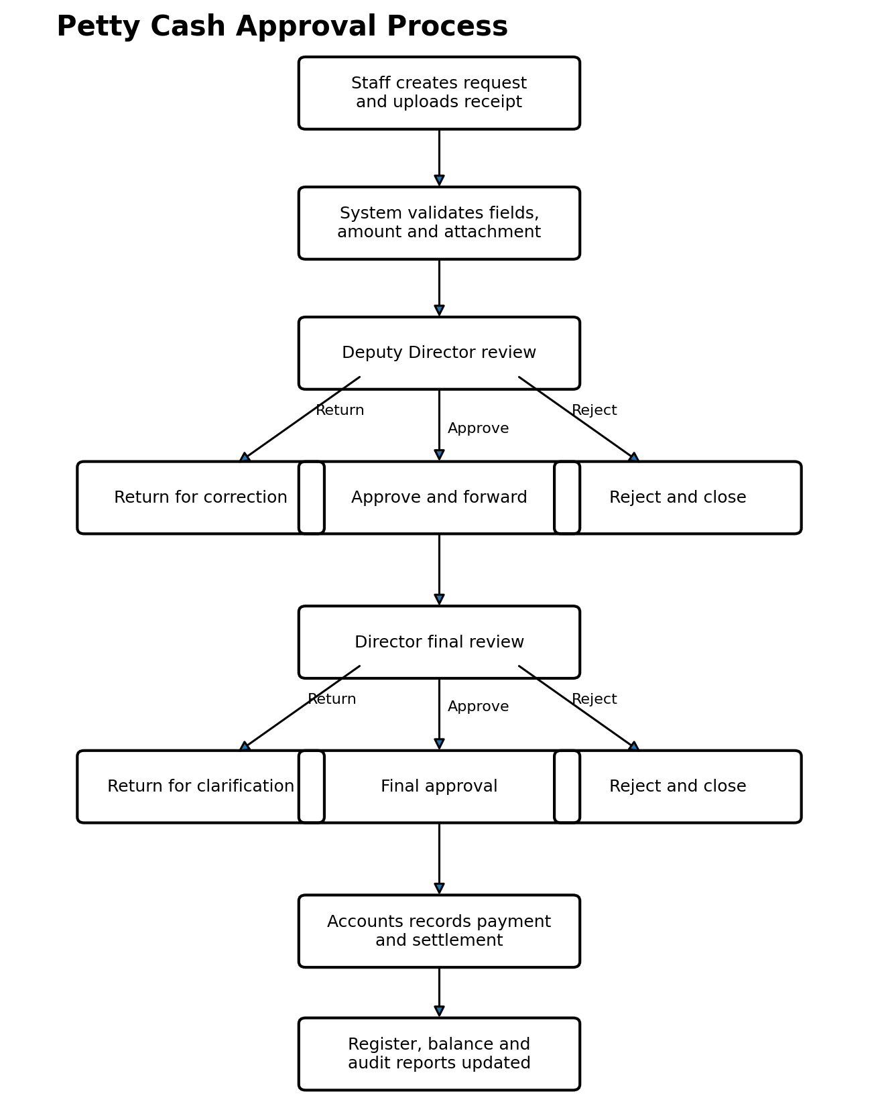

5.2 Status Model
Status | Set by | Next allowed status
Draft | Requester | Submitted, Cancelled
Submitted | System | Returned by DD, Rejected by DD, Approved by DD
Returned by DD | Deputy Director | Resubmitted, Cancelled
Rejected by DD | Deputy Director | Closed; new request required
Approved by DD | Deputy Director | Returned by Director, Rejected by Director, Finally Approved
Returned by Director | Director | Resubmitted to DD or Director according to policy, Cancelled
Rejected by Director | Director | Closed; new request required
Finally Approved | Director | Paid, Cancelled through approved cancellation only
Paid | Accounts | Settled, Amendment Pending
Settled | Accounts | Closed / archived
Cancelled | Authorized workflow | Closed; original retained

5.3 Return and Resubmission Rule
A returned request may be edited only in designated business fields. The original submission, previous values and return comments must remain visible in version history and the audit log. Resubmission creates a new approval cycle number. The developer must prevent a returned item from bypassing a required approver.

6. SharePoint Information Architecture

6.1 Proposed Site Structure
Object | Suggested name | Notes
Site | Petty Cash Management | Private team site; external sharing disabled unless explicitly approved.
Home page | Petty Cash Home | Summary cards, quick links and guidance.
List | Petty Cash Requests | Main transaction register.
List | Fiscal Years | One item per fiscal year, including carryforward fields.
List | Budget Heads | Controlled categories, including threshold percentage.
List | Approval Actions | Append-only business decision history.
List | Audit Log | Protected audit events.
List | Payments | Disbursement and settlement records.
List | Approver Configuration | Primary/backup approver mapping (new).
List | Voucher Sequence | Concurrency-safe counter, one item per fiscal year (new).
Library | Petty Cash Evidence | Files linked using Request ID and Voucher No.
Library | System Documentation | Requirements, SOPs, training and change log.

6.2 Required Views
View | Audience | Filter / purpose
My Drafts and Returns | Staff | Created By = current user; Draft or Returned.
My Submitted Requests | Staff | Created By = current user; not Draft.
Pending Deputy Director | Deputy Director | Status = Submitted or Resubmitted.
Pending Director | Director | Status = Approved by DD.
Approved Awaiting Payment | Accounts | Status = Finally Approved.
Open Payments | Accounts | Paid but not Settled.
Petty Cash Register | Management | Finally Approved, Paid or Settled; sorted by voucher/date.
Exceptions | Management | Missing evidence, overdue, amendment or cancellation.
Fiscal Year Archive | Authorized users | Closed fiscal years.
Near-Limit Budget Heads | Management / System owner | Budget heads where consumption ≥ configured threshold percentage (new).
Delegation Register | System owner | Approver Configuration items with DelegationActive = Yes (new).

7. Data Dictionary

7.1 Petty Cash Requests List
Field | Type | Owner | Requirement
RequestID | Number / SharePoint ID | System | Unique internal identifier.
VoucherNo | Single line text | System | Unique; format PC-FY-####.
FiscalYear | Lookup | Requester/System | Required; only Open fiscal year.
CycleNo | Number | System | Starts at 1; increments on resubmission.
Requester | Person | System | Defaults to Created By.
Department | Choice/Lookup | Requester | Required.
RequestDate | Date/time | System | Submission timestamp.
ExpenseDate | Date | Requester | Required; policy validation.
VendorPayee | Text | Requester | Required.
Purpose | Multiple lines | Requester | Required; minimum meaningful description.
BudgetHead | Lookup | Requester | Required.
RequestedAmount | Currency PKR | Requester | Required; greater than zero.
ActualAmount | Currency PKR | Accounts/Requester | Optional until settlement.
PaymentMethod | Choice | Accounts | Cash, bank transfer, reimbursement, other.
EvidenceStatus | Choice | System | Complete, Exception Requested, Incomplete.
Status | Choice | System/Flow | Controlled status model.
CurrentApprover | Person | System | DD, Director, Accounts or blank; may resolve to backup approver (Section 3.2).
DDDecision | Choice | Flow | Approve, Return, Reject.
DDComments | Multiple lines | Flow | Mandatory.
DDDecisionDate | Date/time | Flow | System timestamp.
DirectorDecision | Choice | Flow | Final Approve, Return, Reject.
DirectorComments | Multiple lines | Flow | Mandatory.
DirectorDecisionDate | Date/time | Flow | System timestamp.
PaymentStatus | Choice | Accounts/Flow | Not Paid, Part Paid, Paid, Settled.
CommitmentAmount | Calculated/Flow | System | Amount reserved after configured approval stage.
DuplicateKey | Text | System | Normalized vendor/date/amount indicator.
RecordLocked | Yes/No | System | Yes after final approval.
FlowInstanceID | Text | System | Operational trace reference.
BudgetThresholdFlag | Yes/No | Flow | Set to Yes when this request pushes its budget head past the warning threshold (new).

7.2 Supporting Lists
List | Essential fields
Fiscal Years | Name, StartDate, EndDate, OpeningAllocation, SupplementaryAllocation, TotalAllocation, Status, ClosedDate, ClosedBy, CarryforwardAmount, CarryforwardAppliedTo, CarryforwardApprovedBy (new fields in bold context, see 7.4).
Budget Heads | Code, Name, Description, AnnualLimit, Active, SortOrder, ThresholdPercent (new).
Approval Actions | RequestID, VoucherNo, CycleNo, Stage, Decision, Actor, ActorRole, ActionDate, Comments, ApprovalResponseID.
Audit Log | RequestID, VoucherNo, EventType, FieldName, OldValue, NewValue, Actor, Timestamp, SourceFlow, CorrelationID.
Payments | RequestID, VoucherNo, PaymentNo, PaidAmount, PaymentDate, Payee, Method, Reference, RecordedBy, SettlementStatus, SettlementDate.
Approver Configuration (new) | RoleName, PrimaryApprover, BackupApprover, DelegationActive, DelegationStartDate, DelegationEndDate, UpdatedBy, UpdatedOn.
Voucher Sequence (new) | FiscalYearCode, LastIssuedNumber, LastIssuedBy, LastIssuedOn, RowVersion (see 8.5 for concurrency use).

7.3 Evidence Library Metadata
Column | Requirement
RequestID | Required lookup or numeric reference to the request.
VoucherNo | Required after voucher generation.
DocumentType | Receipt, invoice, quotation, approval note, payment proof, other.
DocumentDate | Optional/required according to type.
UploadedBy | System person field.
EvidenceVersion | System or flow-managed sequence.
ActiveEvidence | Yes/No; previous documents retained, not overwritten silently.
FileSizeCheck (new) | Flow-enforced maximum of 25 MB per file; larger files are rejected with guidance to compress or split.
AllowedTypes (new) | PDF, JPG, PNG, HEIC, DOCX, XLSX only; other extensions blocked at upload by a library-level content type restriction.
IMPLEMENTATION NOTE Section 7.3's last two rows and Section 7.4 below are new in Version 2.0, closing the 'no evidence file constraints' gap identified during review.

7.4 Fiscal Years List — Technical Field Detail (new)
These fields resolve the fiscal-year carryforward question left open in Appendix D of the original specification. The recommended default (configurable, see BR-11 in Section 11) is that unspent balance does NOT automatically carry forward; it requires an explicit, approved carryforward transaction.
Field | Type | Purpose
CarryforwardAmount | Currency PKR | Unspent balance identified at year-end closure (calculated by F-08).
CarryforwardStatus | Choice | None, Proposed, Approved, Applied, Lapsed.
CarryforwardApprovedBy | Person | Director or higher authority who approved the carryforward.
CarryforwardAppliedToFY | Lookup | The subsequent Fiscal Years item that received the amount, once Applied.

8. Power Automate Flow Specifications
This section is substantially expanded in Version 2.0. Every flow (F-01 through F-10) now has explicit, numbered step logic suitable for direct build-out, not only a one-line purpose statement. All flows use standard connectors only (SharePoint, Approvals, Outlook, Teams) and remain within Microsoft 365 A3 use rights.
Flow ID | Flow name | Trigger | Purpose
F-01 | Initialize and Submit Request | Item created/modified with trigger condition | Validate submission, assign voucher, lock submission fields, log event, start DD approval.
F-02 | Deputy Director Approval | Called by F-01 or status condition | Start and wait for DD approval; update status and approval log.
F-03 | Director Final Approval | DD approved | Start and wait for Director; update status, lock record and notify Accounts.
F-04 | Returned Request Resubmission | Returned item resubmitted | Increment cycle; validate changes; restart correct approval stage.
F-05 | Payment and Settlement | Payment record created/updated | Update payment totals/status and audit log.
F-06 | Permission Management | Status change | Apply role-appropriate item/file permissions where required.
F-07 | Reminder and Escalation | Scheduled daily | Notify overdue approver and escalate after configured threshold.
F-08 | Fiscal Year Closure | Manual authorized trigger | Verify no unresolved transactions; close year; calculate carryforward; create archive snapshot.
F-09 | Cancellation / Amendment | Approved request for change | Route change through DD and Director; preserve original.
F-10 | Exception and Failure Monitor | Flow failure or scheduled check | Notify owner of failed/stuck flow; write technical event.

8.1 Mandatory Flow Construction Rules
- Use trigger conditions to prevent infinite loops when a flow updates the same SharePoint item.
- Store approver identities in configuration or Microsoft 365 groups; do not hard-code personal email addresses throughout multiple actions.
- Write the approval result to the Approval Actions list before updating the final business status.
- Use a correlation identifier combining RequestID, cycle and flow instance.
- Handle timeout, cancellation and connector failure explicitly.
- Do not rely solely on email messages as evidence; persist decisions in SharePoint.
- Use service-account or shared ownership arrangements approved by IT, with at least two flow co-owners.
- Use standard connectors unless a premium connector is formally approved.
- Every flow that changes CurrentApprover must first resolve delegation via Approver Configuration (Section 3.2) before assigning the Approvals task.

8.2 Flow F-01 — Initialize and Submit Request
- Trigger only when SubmitFlag changes to Yes and Status is Draft or Returned.
- Get fiscal-year record and confirm Status = Open.
- Validate mandatory values and at least one active evidence file (or an approved exception reason).
- Check amount is positive and does not exceed configured limits.
- Check duplicate indicators and flag for reviewer rather than automatically deleting.
- Generate voucher number using the atomic sequence mechanism in Section 8.5.
- Set Status = Submitted, RequestDate = UTC timestamp converted for display as needed.
- Resolve the Deputy Director approver via Approver Configuration (primary or active backup) and set CurrentApprover.
- Write audit event (Request lifecycle: Submitted) with CorrelationID = RequestID-Cycle-FlowInstanceID.
- Start F-02 (child flow call, passing RequestID and CorrelationID).

8.3 Flow F-02 — Deputy Director Approval
- Receive RequestID and CorrelationID from F-01 or F-04.
- Resolve current DD approver (primary/backup) from Approver Configuration.
- Build the approval card using the content model in Section 8.7 and start an Approvals connector 'Start and wait for an approval' action (Approve/Reject type, first-to-respond not applicable as there is one assigned approver).
- On response, require Comments to be non-blank; if blank, re-prompt once, then escalate to F-10 if still blank after timeout.
- Write the decision, actor, stage and comments to Approval Actions before touching Status.
- If Approve: set Status = Approved by DD, DDDecisionDate = now, CommitmentAmount = RequestedAmount (or per BR-configured commitment stage), CurrentApprover = Director (resolved via Approver Configuration); call F-03.
- If Return: set Status = Returned by DD, CurrentApprover = Requester; notify requester with comments; do not advance further.
- If Reject: set Status = Rejected by DD, RecordLocked-for-editing = Yes (closed, not the same as post-final-approval lock); notify requester.
- Write audit event (Approval category) with response ID for non-repudiation.

8.4 Flow F-03 — Director Final Approval
- Receive RequestID and CorrelationID from F-02.
- Resolve current Director approver (primary/backup) from Approver Configuration.
- Recompute available balance for the relevant Budget Head and Fiscal Year immediately before presenting the approval card (not using a stale cached figure).
- If projected approved expenditure would exceed the authorized available balance, block Final Approve in the flow logic (return an error/warning action to the approver rather than relying on the approver to notice) per BR-05, unless an approved override process is separately configured.
- If Budget Head consumption after this request would cross ThresholdPercent (Budget Heads list), set BudgetThresholdFlag = Yes and include a warning line on the approval card.
- Start and wait for an approval (Approvals connector); require mandatory comments as in F-02.
- Write the decision to Approval Actions before updating Status.
- If Final Approve: set Status = Finally Approved, DirectorDecisionDate = now, RecordLocked = Yes, CurrentApprover = Accounts; call F-06 to reset item permissions to read-only for Requester and DD; notify Requester, DD and Accounts.
- If Return: set Status = Returned by Director, CurrentApprover = Requester or DD per configured policy; notify accordingly.
- If Reject: set Status = Rejected by Director; RecordLocked-for-editing = Yes; notify Requester and DD.
- Write audit event (Approval + Financial changes if amount displayed differs from requested amount).

8.5 Flow F-04 — Returned Request Resubmission
- Trigger when a Returned item's SubmitFlag changes to Yes again.
- Increment CycleNo by 1.
- Preserve the prior cycle's field values and comments in a version-history-friendly manner (do not overwrite Approval Actions rows; append a new row for the new cycle).
- Re-run the validation subset of F-01 (mandatory fields, evidence, amount, duplicate check) against the edited values only.
- Restart approval at the correct stage: if the return originated from the Deputy Director, restart at F-02; if from the Director, restart at F-03 or F-02 according to the organization's configured resubmission policy (Appendix D).
- Write audit event (Request lifecycle: Resubmitted) referencing both the old and new CycleNo.

8.6 Flow F-05 — Payment and Settlement
- Trigger on Payments list item created or modified.
- Validate the related Petty Cash Requests item has Status = Finally Approved (or already Paid, for part-payments).
- Sum PaidAmount across all Payments rows for the RequestID; block if the running total would exceed the Finally Approved amount, per BR-10, unless an approved amendment exists.
- Update PaymentStatus on the parent request (Not Paid / Part Paid / Paid) based on the running total versus approved amount.
- When SettlementStatus = Settled is recorded, update the parent Status = Settled.
- Write audit event (Financial changes) recording old/new PaymentStatus and the payment reference.
- Notify Requester and relevant management per Section 12.

8.7 Flow F-06 — Permission Management
- Trigger on Status change on Petty Cash Requests.
- While Draft or Returned: ensure only Requester (Created By) and System Owner have edit access; break inheritance only where required, preferring group-based permission through views and column-level formatting over per-item unique permissions.
- On transition to Submitted: remove Requester edit rights on system/approval fields (enforced primarily through form field visibility and column permissions, not solely through list-level permission breaks, per Section 10.2).
- On Finally Approved: set the item and its linked evidence files to read-only for all roles except Accounts (payment fields only) and System Owner (via amendment procedure only).
- Log every permission change to Audit Log (Access / administration category).
- Prefer Microsoft 365 group membership changes over large-scale unique item permissions; the developer must not create unique permissions on more than a small, tested subset of items without documented justification.

8.8 Flow F-07 — Reminder and Escalation
Scheduled daily (recommended: once each working morning).
- Query all items where Status is Submitted or Approved by DD (i.e., awaiting a human decision) and DDDecisionDate/DirectorDecisionDate is blank.
- Calculate business days pending using a working-day calculation (exclude weekends and configured holidays).
- If pending ≥ the configured reminder threshold (recommended default: 2 working days) and no reminder sent today, send a reminder to CurrentApprover (respecting delegation resolution from Section 3.2).
- If pending ≥ the configured escalation threshold (recommended default: 5 working days), notify the System Owner and the approver's next-level supervisor with the outstanding item and its age, per Section 12.
- Write audit event (Technical: reminder sent / escalation triggered).

8.9 Flow F-08 — Fiscal Year Closure
Manual, authorized trigger only (e.g., button flow restricted to System Owner / Accounts group).
- Confirm the requesting user is a member of PC-SystemOwners or PC-Accounts.
- Verify there are no items in Submitted, Approved by DD, or Returned status for the fiscal year being closed; if any exist, halt and list them for resolution before closure can proceed.
- Calculate CarryforwardAmount = Total allocation − Approved expenditure (as defined in Section 11.1), for information only.
- Set CarryforwardStatus = Proposed and notify the Director/management for an explicit carryforward decision (per BR-11); closure of the fiscal year does not, by itself, move any balance.
- On explicit approval recorded against the Fiscal Years item, set CarryforwardStatus = Approved, and if applied, create or update the subsequent year's OpeningAllocation and set CarryforwardStatus = Applied, CarryforwardAppliedToFY = the new year.
- Set the closing fiscal year's Status = Closed, ClosedDate = now, ClosedBy = actor.
- Create an archive snapshot (a protected, read-only export or a designated 'Fiscal Year Archive' view/library item) capturing the register, approval history and reports as of closure.
- Write audit event (Request lifecycle / Financial changes: Fiscal year closed).

8.10 Flow F-09 — Cancellation / Amendment
- Trigger on a new Amendment/Cancellation request linked to an existing finally-approved RequestID (a lightweight linked item, not an edit to the original).
- Validate the linked original exists and is Finally Approved, Paid or Settled.
- Route the amendment through Deputy Director and Director approval using the same approval-card pattern as F-02/F-03, but labelled clearly as an amendment so approvers do not confuse it with a new request.
- On approval, apply the financial effect only to a new, separate record (or clearly-flagged delta), and update rollup totals; never overwrite the original RequestedAmount/ApprovedAmount fields on the original item.
- Set the original item's status note/flag to indicate an approved amendment exists, with a link to the amendment record.
- Write audit event (Financial changes: amendment/cancellation approved) referencing both RequestIDs.

8.11 Flow F-10 — Exception and Failure Monitor
- Configure Power Automate's built-in 'When a flow run fails' or per-flow failure/timeout handling (Configure run after) on F-01 through F-09.
- On failure, capture flow name, RequestID (if available), failure time, error detail and a diagnostic link.
- Notify the developer and System Owner immediately (Teams and/or email).
- Write a technical audit event so failures are visible in the same Audit Log used for business events, not only in Power Automate's own run history.
- Provide a documented, tested manual reprocessing procedure (e.g., resubmitting the trigger condition, or a 'Reprocess' button flow) so a stuck item is not left indefinitely without human review.

8.12 Approval Card Content
Section | Content
Title | Voucher number, requester and amount.
Summary | Expense date, vendor, purpose, budget head, available balance and duplicate warning.
Budget warning (new) | Displayed when BudgetThresholdFlag would be set by this decision — shows current consumption percentage against ThresholdPercent.
Delegation banner (new) | Displayed only when the acting approver is a resolved backup, per Section 3.2.
Evidence | Direct secure link to request and supporting files.
History | Prior cycle decisions and comments.
Actions | Approve, Return, Reject (Director uses Final Approve).
Comments | Required; flow must reject a blank response where the approval action permits validation logic.

8.13 Voucher Numbering — Concurrency-Safe Implementation Pattern
IMPLEMENTATION NOTE This subsection replaces the single-paragraph note in the v1.0 baseline with an implementable pattern.
Required format: PC-[fiscal-year code]-[four-digit sequence], for example PC-2026-0001. Counting existing items and adding one is not acceptable because simultaneous submissions can generate duplicates. The recommended pattern uses the Voucher Sequence list and an optimistic-concurrency retry loop:
- Maintain one item per fiscal year in the Voucher Sequence list (FiscalYearCode, LastIssuedNumber, RowVersion/ETag).
- In F-01, use 'Get item' (not a cached value) to read the current LastIssuedNumber and its ETag for the relevant fiscal year.
- Attempt 'Update item' using the SharePoint HTTP action with an If-Match header set to the ETag just read, incrementing LastIssuedNumber by 1.
- If the update succeeds (HTTP 200/204), the new LastIssuedNumber is this request's sequence value; format it as PC-[FY]-[####] and write it to VoucherNo.
- If the update fails with HTTP 412 (Precondition Failed) — meaning another simultaneous submission updated the row first — retry the Get/Update pair (recommended: up to 5 retries with a short randomized delay) before failing to F-10.
- This pattern guarantees uniqueness even under near-simultaneous submissions, satisfying acceptance test AT-03, without requiring Dataverse or a premium connector.

8.14 Budget Threshold Warning Logic (new)
Each Budget Heads item carries a ThresholdPercent field (recommended default 80%). Before Director final approval (F-03) and on the management dashboard (Section 13), the flow/report calculates: (Approved expenditure for that Budget Head ÷ AnnualLimit for that Budget Head) × 100. When this value would meet or exceed ThresholdPercent as a result of the request being approved, BudgetThresholdFlag is set to Yes on the request, the approval card displays a warning (Section 8.12), and the Near-Limit Budget Heads view (Section 6.2) surfaces the category to management proactively, before an overrun occurs rather than only blocking it at the point of breach (BR-05).

9. Forms, Views and Wireframes
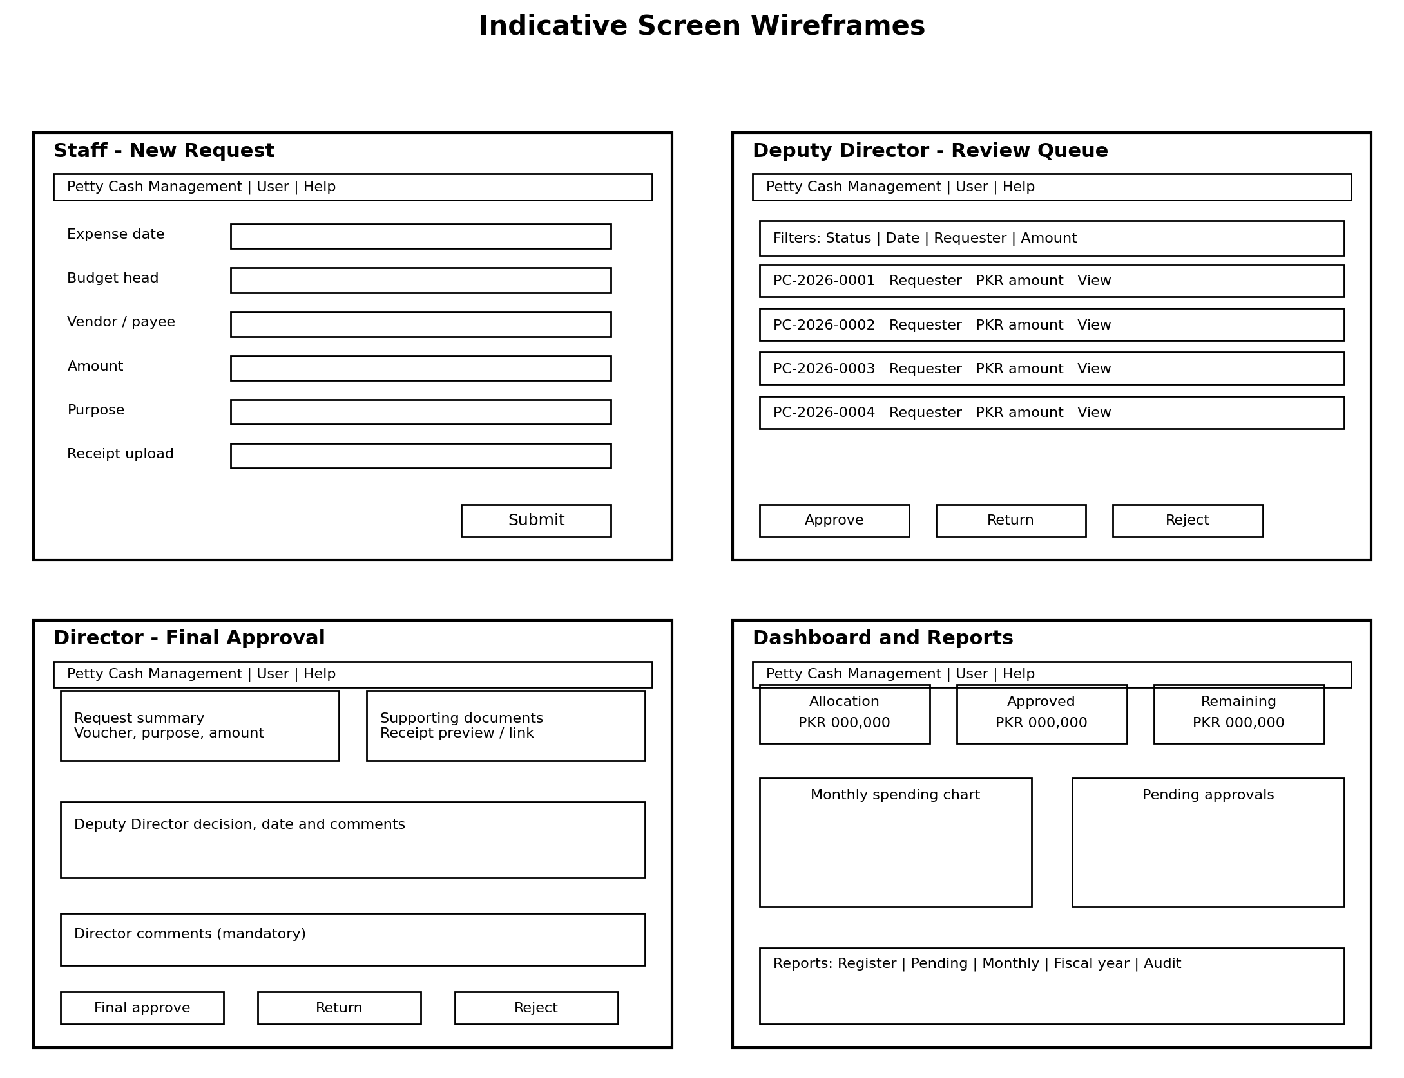

9.1 Staff Form Requirements
- Show only fields required for request creation.
- Display policy guidance beside Amount, Purpose and Evidence.
- Do not expose approval, lock, audit or system fields for editing.
- Save as Draft and Submit must be distinct actions.
- Show the generated voucher number and current status after submission.
- Allow editing only while Draft or formally Returned.
- Display accepted evidence file types and the 25 MB size limit inline on the upload control (new).

9.2 Reviewer Screen Requirements
- Display the complete request, remaining budget, attachments, prior decisions and duplicate warning on one review page or with clear links.
- Require comments for Approve, Return and Reject.
- Prevent approvers from editing requester-entered financial information directly.
- Display who is currently responsible and how long the request has been pending.
- Display the budget-threshold warning and delegation banner where applicable (new, see 8.12).

9.3 Dashboard Requirements
Card / visual | Definition
Annual allocation | Opening allocation plus approved supplementary allocation plus any Applied carryforward.
Approved expenditure | Sum of finally approved amounts, adjusted only by approved cancellation/amendment.
Paid expenditure | Sum of payment records.
Pending commitments | Submitted or DD-approved amounts according to policy.
Available balance | Total allocation minus approved expenditure (or approved commitments if policy chooses).
Approval queues | Counts and values pending with DD and Director.
Monthly trend | Approved spending by month.
Category analysis | Approved spending by budget head, with threshold-percentage indicator (new).
Exceptions | Overdue, missing evidence, rejected, returned, amended and cancelled items.
Near-limit categories (new) | Budget heads at or above ThresholdPercent consumption.

10. Security, Permissions and Audit Controls

10.1 Microsoft 365 Groups
Group | Suggested access
PC-Requesters | Create items; view and edit own Draft/Returned items only.
PC-DeputyDirector | Read all requests and evidence; execute DD actions.
PC-Director | Read all relevant requests and evidence; execute final approval.
PC-Accounts | Read approved requests; create/update payment records.
PC-Auditors | Read-only approved records, evidence and audit logs.
PC-SystemOwners | Manage lists, views and configuration; tightly limited.
PC-SiteAdmins | Technical full control; access monitored.

10.2 Required Controls
- External sharing must be disabled unless expressly approved.
- Staff must not browse other staff requests unless policy allows it.
- Finally approved requests and active evidence must be protected from requester editing or deletion.
- Audit and Approval Actions lists must not allow ordinary users to edit or delete entries.
- The developer should prefer group-based permissions and avoid large-scale unique item permissions unless necessary and tested.
- Version history must be enabled for transaction lists and the evidence library.
- Sensitive administrative fields must be hidden from standard forms and protected by permissions, not merely hidden visually.
- Production lists must not grant broad Design or Full Control permissions to ordinary users.
- Approver Configuration list edits are restricted to PC-SystemOwners; approvers may only view their own row (new).
- Evidence library enforces the file type and size constraints in Section 7.3 at upload, not only through form guidance (new).

10.3 Audit Events
Event category | Examples
Request lifecycle | Draft created, submitted, returned, resubmitted, rejected, finally approved, cancelled.
Financial changes | Amount, budget head, fiscal year, payee or payment data changed; carryforward proposed/approved/applied.
Evidence | File uploaded, replaced, deactivated or downloaded where logs support it.
Approval | Approver, decision, date, comments and approval response ID.
Access / administration | Group membership change, permission change, configuration update, flow ownership change, delegation activated/deactivated.
Technical | Flow failed, retry, timeout, manual reprocessing.

10.4 Record Locking and Amendments
After final approval, the original request and evidence are treated as immutable business records. Corrections must create an Amendment or Cancellation request linked to the original RequestID. The workflow must record the reason, approvals and financial effect. The original record must remain visible and must never be overwritten to conceal the earlier state.

10.5 Control Framework Mapping (new)
IMPLEMENTATION NOTE Added in Version 2.0 to make the security design directly recognizable against the standards this organization already maps to elsewhere.
System control | ISO/IEC 27001:2022 Annex A reference | SOC 2 (2017 Trust Services, as amended) reference
Role-based access via M365 groups (10.1) | A.5.15 Access control; A.5.18 Access rights | CC6.1, CC6.2 — Logical access controls
Least privilege / no broad Design-Full Control (10.2) | A.5.15; A.8.2 Privileged access rights | CC6.3 — Access removal/restriction
Separation of duties (requester/DD/Director/Accounts) | A.5.3 Segregation of duties | CC5.1, CC5.2 — Control activities
Audit Log list, protected from edit (10.3, 10.2) | A.8.15 Logging; A.8.16 Monitoring activities | CC7.2 — System monitoring
Record locking after final approval (10.4) | A.8.4 Access to source code / A.5.33 Protection of records (analogous control intent for records) | CC6.1; PI1.3 — Processing integrity, data completeness/accuracy
Amendment-not-edit workflow (10.4, F-09) | A.5.33 Protection of records | PI1.4, PI1.5 — Processing integrity
Version history enabled (10.2) | A.8.15 Logging | CC7.2
Delegation with audit trail (3.2) | A.5.18 Access rights (review/change) | CC6.2, CC6.3
Duplicate detection (BR-08) | A.8.29 Security testing / general control design intent | PI1.2 — Processing integrity
Manual contingency procedure (17.3) | A.5.29 Information security during disruption | A1.2 — Availability
This mapping is indicative, intended to accelerate an internal control walkthrough or a future formal certification effort; it does not itself constitute a certified control assessment and should be validated against the organization's chosen scope statement.

11. Budget and Financial Control Rules
Rule ID | Rule
BR-01 | Default annual allocation is PKR 1,000,000 but must be configurable by fiscal year.
BR-02 | Only one fiscal year may be marked as the default Open year, unless management approves parallel operation.
BR-03 | A request cannot be submitted against a Closed fiscal year.
BR-04 | Amount must be greater than zero and use PKR currency precision.
BR-05 | Final approval must be blocked if it would exceed the authorized available balance, unless a separately approved override process exists. The block is enforced in flow logic (F-03), not left to approver judgement alone.
BR-06 | Supplementary allocations require an authorized entry and audit event.
BR-07 | Approved expenditure, paid expenditure and pending commitment must be displayed separately.
BR-08 | Duplicate indicators must compare at least requester, vendor, date and amount; reviewers decide whether it is a true duplicate.
BR-09 | A cancelled approved transaction reverses the approved commitment only after the cancellation is approved.
BR-10 | Payment total must not exceed the finally approved amount without an approved amendment.
BR-11 (new) | Unspent fiscal-year balance does not carry forward automatically. At closure (F-08), the system calculates the unspent amount and sets CarryforwardStatus = Proposed; it becomes part of the next year's OpeningAllocation only after an explicit, separately recorded approval, per organizational financial policy. This default may be reversed to automatic carryforward if management formally decides otherwise (Appendix D).
BR-12 (new) | Each Budget Head has a configurable ThresholdPercent (default 80%). Crossing this threshold does not block spending but must trigger the warning behaviour in Sections 8.12 and 8.14, giving management visibility before BR-05's hard block is reached.

11.1 Calculation Definitions
Measure | Calculation
Total allocation | Opening allocation + supplementary allocation + Applied carryforward (if any) - authorized reduction.
Approved expenditure | Sum of active Finally Approved/Paid/Settled request amounts, net of approved cancellations.
Paid expenditure | Sum of valid payment records.
Pending commitment | Configured sum of Submitted and/or Approved by DD requests.
Available balance | Total allocation - approved expenditure.
Cash to reconcile | Paid/disbursed amount - settled or supported amount, according to office policy.
Budget Head consumption % (new) | (Approved expenditure for that Budget Head ÷ AnnualLimit for that Budget Head) × 100, compared against ThresholdPercent.

12. Notifications and Escalations
Event | Recipient | Message requirement
Submission | Deputy Director; requester confirmation | Voucher, amount, purpose, due date, secure link.
DD return/reject | Requester | Decision and mandatory comments.
DD approval | Director; requester status update | Summary, DD comments, link to evidence.
Director return/reject | Requester and DD | Decision and comments.
Final approval | Requester, DD and Accounts | Final approval details and next action.
Budget threshold crossed (new) | System owner and Deputy Director | Budget head name, consumption percentage, remaining balance.
Payment recorded | Requester and relevant management | Amount, date and payment reference.
Overdue approval | Current approver (resolved for delegation) | Reminder after configurable working days.
Escalation | System owner / designated supervisor | Outstanding item and age.
Delegation activated (new) | Backup approver and system owner | Role, date range and primary approver being covered.
Flow failure | Developer and system owner | Flow name, request ID, failure time and diagnostic link.

12.1 Notification Principles
- Notifications must contain links, not sensitive document attachments unless policy approves attachments.
- Email must not be the only place where approval comments are retained.
- Reminder frequency must avoid excessive messages and should be configurable.
- The system should use business-day thresholds where practical.

13. Reports and Dashboard

13.1 Mandatory Reports
Report | Minimum fields
Petty Cash Register | Voucher, date, requester, payee, purpose, budget head, approved amount, payment status, running/report balance.
Pending Approvals | Voucher, amount, current stage, approver (including delegation indicator), submission date, days pending.
Monthly Expenditure | Opening balance, approved expenditure, payments, closing balance, category breakdown.
Fiscal-Year Summary | Allocation, supplementary allocation, carryforward applied, approved, paid, pending, remaining and transaction count.
Approval History | Every action, actor, stage, decision, comments and timestamp.
Payment and Settlement | Approved amount, paid amount, payment reference, settlement status and difference.
Exception Report | Missing evidence, duplicates, overdue, amendments, cancellations and failed flows.
Audit Extract | Event, old/new values, actor, timestamp, request and correlation ID.
Budget Head Utilization (new) | Budget head, annual limit, approved expenditure, consumption percentage, threshold status.
Delegation Log (new) | Role, primary approver, backup approver, date range, activated by, items decided while active.

13.2 Export Requirements
- Users with permission can export list views to Excel.
- Formal monthly and fiscal-year reports should have a printable PDF layout or a documented Excel-to-PDF procedure.
- Exports must show the report generation date, fiscal year and filters applied.
- Personal or restricted fields must not appear in broad management exports unless required.

14. Non-Functional Requirements
Category | Requirement
Usability | A trained staff member should submit a normal request in under five minutes.
Compatibility | Modern supported desktop and mobile browsers; responsive standard SharePoint pages.
Performance | Normal list views and forms should open within an acceptable office-network time; index commonly filtered columns (RequestID, VoucherNo, Status, FiscalYear, BudgetHead).
Availability | Dependent on Microsoft 365 service availability; document a manual contingency procedure (Section 17.3).
Accessibility | Use clear labels, keyboard-accessible controls and sufficient contrast; avoid information conveyed by color alone.
Maintainability | Use descriptive names, comments, solution documentation and reusable child flows where appropriate.
Scalability | Design for multiple fiscal years and at least several thousand transactions without restructuring.
Localization | Currency PKR; dates displayed in the organization's agreed format and timezone.
Recovery | Document list/library restoration, flow export and configuration backup procedures.
Privacy | Collect only necessary personal data; restrict evidence and reports to authorized users.
File handling (new) | Evidence uploads limited to 25 MB and the file types listed in Section 7.3; enforced at upload, not only documented.
Automation entitlement (new) | All flows must operate within the Microsoft 365 A3 standard-connector daily request allowance (approx. 6,000/day tenant-wide); the developer should monitor consumption once in production and avoid unnecessary polling triggers.

14.1 Technical Documentation Required from Developer
- Site and list inventory with URLs and owners.
- Column data dictionary and choice values.
- Flow inventory, diagrams, triggers, conditions, connections and error handling.
- Security group and permission matrix.
- Configuration values and where they are maintained.
- Deployment and rollback instructions.
- Backup/export procedure and recovery test record.
- Known limitations and future backlog.

15. Testing and Acceptance

15.1 Test Environments
The developer must build and test in a dedicated development or test site/list set before production. Sample records must not contain real sensitive financial documents unless the test environment has equivalent protection. Production deployment requires management approval after user acceptance testing.

15.2 Mandatory Acceptance Test Cases
ID | Test | Acceptance
AT-01 | Staff creates Draft and cannot see another staff member's private request. | Pass
AT-02 | Submission without mandatory receipt is blocked or follows approved exception workflow. | Pass
AT-03 | Unique voucher number is generated under near-simultaneous submissions (Section 8.13 retry pattern). | Pass
AT-04 | Deputy Director can approve, return and reject with mandatory comments. | Pass
AT-05 | Director receives only requests approved by Deputy Director. | Pass
AT-06 | Final approval records actor, date, comments and response ID. | Pass
AT-07 | Finally approved record cannot be edited or deleted by requester. | Pass
AT-08 | Budget overrun is blocked at final approval (BR-05). | Pass
AT-09 | Returned request resubmits through the required approval stage and preserves history. | Pass
AT-10 | Accounts records payment and system prevents payment above approved amount. | Pass
AT-11 | Amendment/cancellation preserves the original and updates financial totals correctly. | Pass
AT-12 | Audit log cannot be edited by ordinary users. | Pass
AT-13 | Required reports reconcile to test transaction totals. | Pass
AT-14 | Flow failure generates an operational alert and can be safely reprocessed. | Pass
AT-15 | A second owner can administer flows if the developer account is unavailable. | Pass
AT-16 (new) | Delegation: activating a backup approver correctly routes new approvals to the backup and records the acting role in Approval Actions. | Pass
AT-17 (new) | Budget threshold: a request that pushes a budget head past ThresholdPercent sets BudgetThresholdFlag and appears on the Near-Limit Budget Heads view without blocking approval. | Pass
AT-18 (new) | Fiscal-year closure: F-08 refuses to close a year with unresolved Submitted/Approved-by-DD items, and correctly proposes (not applies) the carryforward amount. | Pass
AT-19 (new) | Evidence upload of a disallowed file type or a file over 25 MB is rejected at upload with a clear message. | Pass

15.3 User Acceptance Sign-Off
Area | Reviewer | Result / comments | Date
Staff submission
Deputy Director workflow
Director workflow
Accounts and reconciliation
Security and permissions
Reports and audit trail
Delegation mechanism (new)
Budget threshold warnings (new)

16. Implementation Plan
Week | Deliverable | Management checkpoint
1 | Confirm policy, roles, site, lists, naming and wireframes. Resolve all Appendix D decisions, including the carryforward default (BR-11) and threshold percentage (BR-12). | Approve requirements and data model.
2 | Build lists, library, groups, fields, views and test data, including Approver Configuration and Voucher Sequence lists. | Review forms and permissions.
3 | Build submission, voucher numbering (Section 8.13) and Deputy Director flow (F-01, F-02). | Demonstrate staff-to-DD process.
4 | Build Director approval, logging, record locking and delegation resolution (F-03, F-06, Section 3.2). | Demonstrate full approval chain including a delegated approval.
5 | Build payments, budget controls, threshold warnings, reports and reminders (F-05, F-07). | Reconcile sample fiscal-year totals; demonstrate threshold warning.
6 | Build fiscal-year closure and amendment/cancellation flows (F-08, F-09); security testing, user acceptance, fixes and documentation. | Approve pilot deployment.
7 | Pilot with selected staff and real low-risk transactions. | Pilot review and go-live decision.
8 | Production stabilization, training and handover. | Final acceptance and support plan.

16.1 Delivery Milestones
- M1 - Requirements and screen design approved.
- M2 - SharePoint structure and permissions demonstrated.
- M3 - End-to-end approval workflow demonstrated with test records, including voucher-number concurrency test.
- M4 - Budget, threshold warnings, reports, audit and payment functions reconciled.
- M5 - User acceptance completed and defects resolved.
- M6 - Documentation, ownership and support handover completed.

16.2 Change Control
Any request outside this approved scope must be recorded in a change log with description, reason, priority, effect on schedule, security/licensing impact and approval by the system owner. The developer should not add unreviewed features directly to production.

17. Operations, Support and Handover

17.1 Daily / Weekly Operations
Frequency | Activity | Owner
Daily | Review failed flows and stuck approvals (F-10 alerts). | Developer / system owner
Weekly | Review overdue requests, permission exceptions and active delegations. | Deputy Director / system owner
Monthly | Reconcile register, payments, evidence and allocation; review Budget Head Utilization report. | Accounts + Deputy Director
Quarterly | Review group membership, site owners, flow owners and Approver Configuration entries. | IT + system owner
Fiscal year-end | Close year (F-08), verify open items, decide and record carryforward, archive reports and open new year. | Accounts + management
Annually | Review controls, retention, categories, threshold percentages and user training. | Management + IT

17.2 Handover Checklist
- Management and IT have site-owner access.
- At least two organizational users are flow co-owners.
- All connections are documented and not dependent on an unmanaged personal account.
- Developer provides exported flow packages where organizational policy permits.
- List schemas, choice values, formulas and configuration are documented, including the Voucher Sequence and Approver Configuration lists.
- Administrator and user guides are stored in the System Documentation library.
- A restore/recovery procedure has been demonstrated.
- Known issues and enhancement backlog are signed off.
- The developer conducts training for staff, approvers, Accounts and system owner, including how to activate/deactivate delegation.

17.3 Manual Contingency Procedure
If Microsoft 365 or the flow is unavailable, staff may use a controlled temporary form and sequential email approval approved by management. Each contingency transaction must receive a temporary reference and must be entered into the SharePoint system immediately after service restoration, with the original approval evidence attached and an audit note explaining the delay.

18. Future Enhancements
- Power Apps customized mobile interface after successful pilot.
- Power BI dashboards if licensing and governance permit.
- QR code on voucher/report for quick lookup.
- Integration with procurement, inventory or general ledger systems.
- Category-specific approval thresholds or additional approvers beyond the DD/Director chain.
- Automated receipt data extraction, subject to privacy, accuracy and licensing review.
- Department-wide modules using the same approval and audit framework.
- Automatic carryforward option, if management later reverses the BR-11 default.

Appendix A - Logical Data Model / ERD
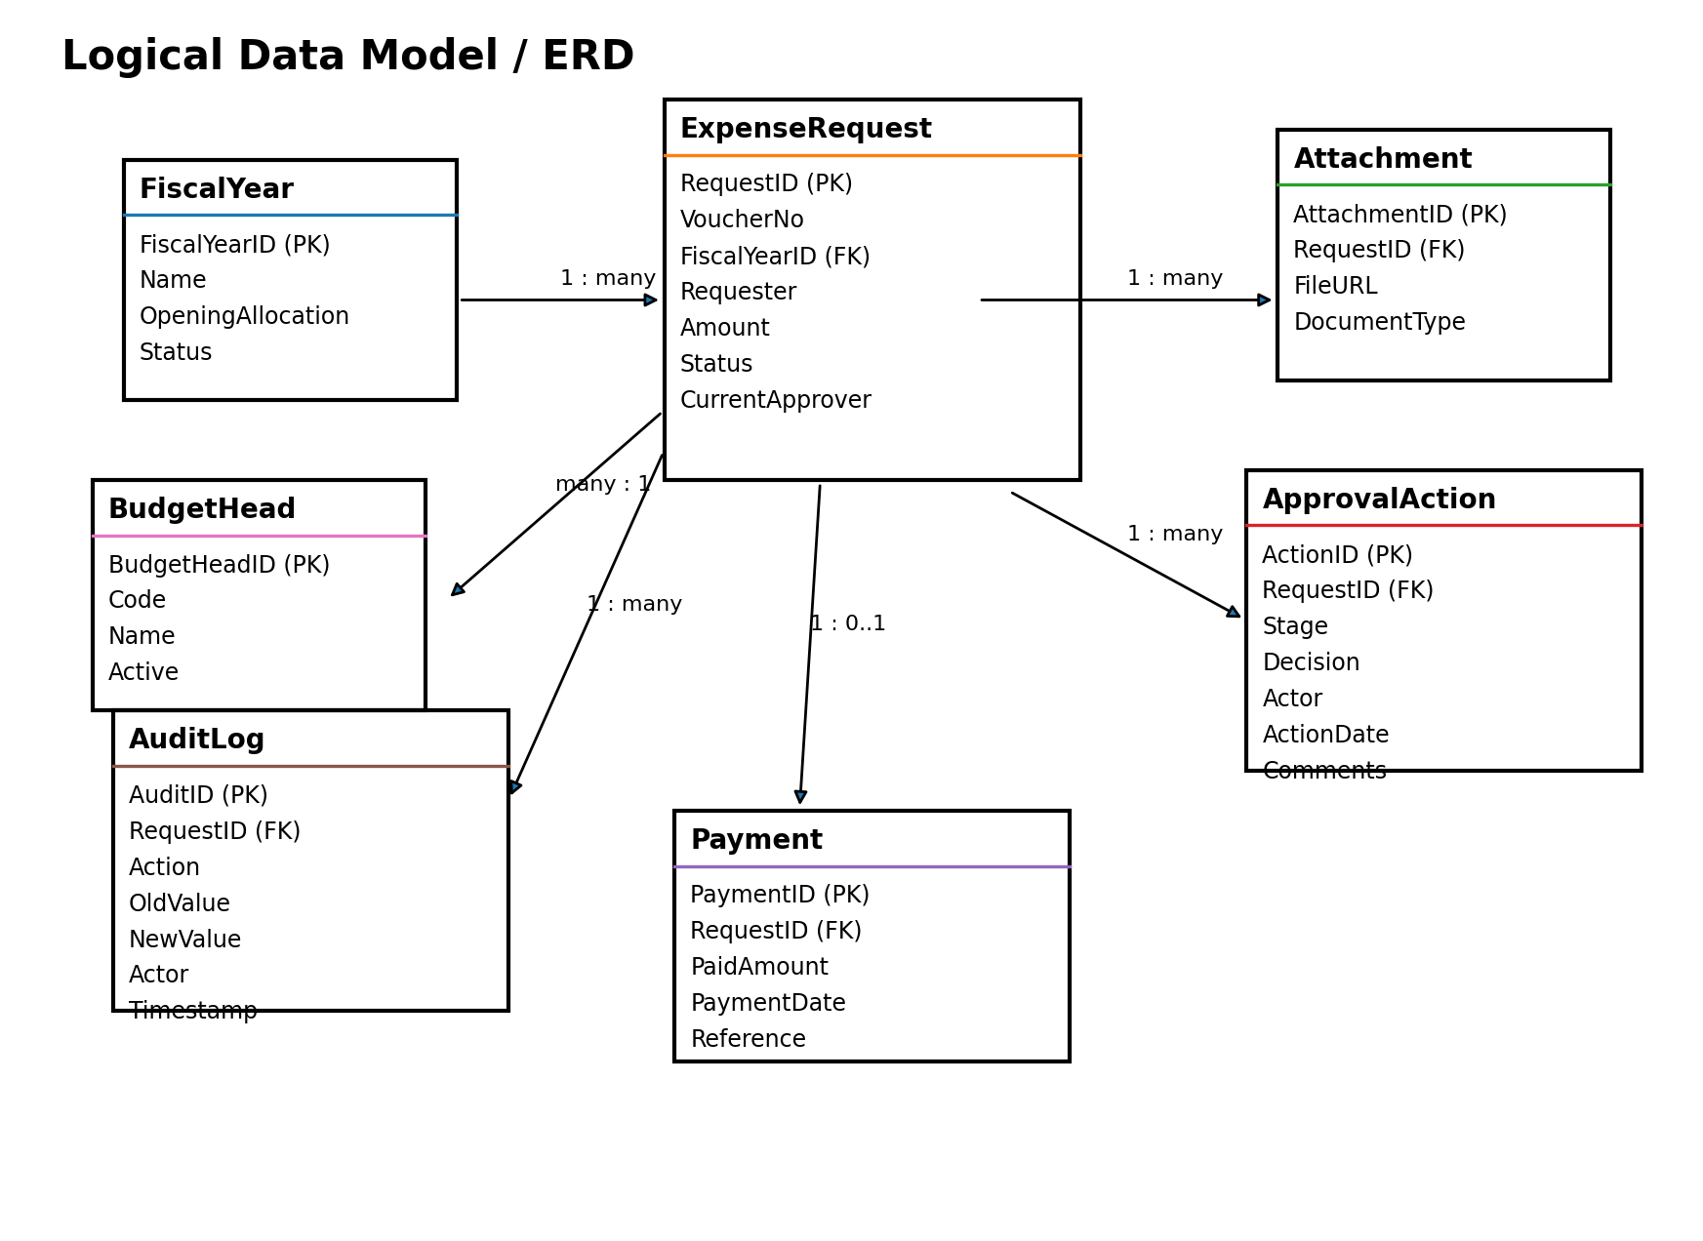
The ERD is logical rather than a physical SQL design. SharePoint lookup columns and stored identifiers implement the relationships. The developer must avoid circular lookups and excessive lookup columns that make list views difficult to maintain. Version 2.0 adds two entities to the logical model: Approver Configuration (one row per approval role) and Voucher Sequence (one row per fiscal year), both referenced by Petty Cash Requests but not by lookup column — they are read by flow logic rather than by list relationship, to avoid additional lookup-column overhead on the main register.

Appendix B - Permission Matrix
Action | Staff | Deputy Director | Director | Accounts | Auditor | System Owner
Create request | Yes | Yes if requester | Yes if requester | No | No | As needed
View own request | Yes | Yes | Yes | Yes | Read approved | Yes
View all requests | No | Yes | Yes | Approved onward | Approved only | Yes
Edit Draft/Returned | Own only | No direct edit | No direct edit | No | No | Controlled
DD decision | No | Yes | No | No | No | No
Director decision | No | No | Yes | No | No | No
Record payment | No | No | No | Yes | No | Controlled
Edit approved record | No | No | No | Payment fields only | No | Amendment only
View audit log | Own limited optional | Yes | Yes | Yes | Yes | Yes
Manage Approver Configuration (new) | No | Own row, view only | Own row, view only | No | No | Yes
Delete financial record | No | No | No | No | No | No direct deletion

Appendix C - Developer Build Checklist
- Create private SharePoint site and document owners.
- Create Microsoft 365 security groups.
- Create lists, library, columns and indexes, including Approver Configuration and Voucher Sequence (new).
- Enable and configure version history.
- Configure forms and views, including Near-Limit Budget Heads and Delegation Register (new).
- Build the voucher sequence concurrency mechanism per Section 8.13.
- Build F-01 through F-10 per the detailed logic in Section 8, or document approved consolidation.
- Configure error handling and monitoring (F-10).
- Test item/file permissions and record locking.
- Test the delegation mechanism (Section 3.2) end to end.
- Test the budget threshold warning path (Section 8.14).
- Load test data and complete acceptance cases, including AT-16 through AT-19 (new).
- Prepare training, SOP and technical documentation.
- Deploy pilot, obtain sign-off and move to production.

Appendix D - Management Decisions Required Before Build
Version 1.0 left these as open questions. Version 2.0 proposes a recommended default for each so the developer is not blocked; management may override any recommendation before build begins.
Decision | Options / question | Recommended default (v2.0)
Spending timing | Must staff obtain approval before spending, or is this post-spend reimbursement/recording? | Post-spend recording with evidence, consistent with the workflow described in Section 5; pre-approval may be layered in later as an enhancement.
Missing receipt policy | Always blocked, or permitted with signed exception? | Permitted with a documented exception reason, captured in EvidenceStatus = Exception Requested and visible to both approvers.
Commitment definition | Reserve balance at submission, DD approval or final approval? | Reserve at DD approval (CommitmentAmount set in F-02), giving early visibility without over-restricting Draft/Submitted items.
Approval delegation | Who acts when DD or Director is on leave? | Resolved via the Approver Configuration / backup-approver mechanism in Section 3.2.
Accounts settlement | What evidence closes a transaction as Settled? | A recorded PaymentDate, PaidAmount matching or below the approved amount, and a Reference value in the Payments list (F-05).
Retention | How many years must records and receipts be retained? | No default proposed; this is a policy/legal decision the organization must confirm (commonly 5-7 years for financial records, but this must be set locally).
Category limits | Is each budget head capped or only total annual allocation? | Both: AnnualLimit per Budget Head plus the overall fiscal-year TotalAllocation, with ThresholdPercent warnings per BR-12.
Payment model | Single payment only or partial payments permitted? | Partial payments permitted, tracked cumulatively in Payments and validated against BR-10.
Confidentiality | May staff see only own requests or departmental requests? | Own requests only by default (tighter option), consistent with AT-01; can be relaxed per department if management prefers.
Fiscal year format | Calendar year or organization-specific start/end dates? | Organization-specific, configured per Fiscal Years list item (StartDate/EndDate), to match the organization's actual budget cycle.
Fiscal-year carryforward (new) | Does unspent balance roll into next year automatically or only on approval? | Only on approval (BR-11); this is the safer default and prevents silent balance inflation.
Budget threshold percentage (new) | At what consumption percentage should management receive an early warning? | 80% (BR-12), adjustable per Budget Head.

Appendix E - Microsoft Reference Sources
Manage sequential approvals with Power Automate:
https://learn.microsoft.com/en-us/power-automate/sequential-modern-approvals
Create and test an approval workflow with Power Automate:
https://learn.microsoft.com/en-us/power-automate/modern-approvals
Trigger approvals from Microsoft Lists:
https://learn.microsoft.com/en-us/power-automate/trigger-sharepoint-list
Trigger approvals from a SharePoint document library:
https://learn.microsoft.com/en-us/power-automate/trigger-sharepoint-library
Use SharePoint and Power Automate to build workflows:
https://learn.microsoft.com/en-us/power-automate/sharepoint-overview
Understanding permission levels in SharePoint:
https://learn.microsoft.com/en-us/sharepoint/understanding-permission-levels
Manage list item and file permissions with Power Automate:
https://learn.microsoft.com/en-us/sharepoint/dev/business-apps/power-automate/guidance/manage-list-item-file-permissions
Power Automate licensing FAQ:
https://learn.microsoft.com/en-us/power-platform/admin/power-automate-licensing/faqs
Microsoft 365 Education A3 license overview:
https://learn.microsoft.com/en-us/microsoft-365/education/guide/0-start-standard/standard-license
Licensing and tenant configuration can change. The Microsoft 365 administrator must confirm available services, connectors, retention settings and policies before production deployment. This guide's licensing statements (Section 2.4, A-07 and Appendix E) were verified against current Microsoft documentation as of July 2026; A3/education and standard commercial Microsoft 365 plans include Power Automate use rights for standard-connector flows at no additional cost, which covers every flow specified in Section 8.

Appendix F - Technical Implementation Reference (new in v2.0)
This appendix consolidates the build-level technical detail introduced in Version 2.0 into a single quick-reference for the developer.

F.1 New Lists Summary
List | Key columns | Referenced by
Approver Configuration | RoleName, PrimaryApprover, BackupApprover, DelegationActive, DelegationStartDate, DelegationEndDate | F-02, F-03, F-07 (approver resolution)
Voucher Sequence | FiscalYearCode, LastIssuedNumber, RowVersion/ETag | F-01 (voucher generation, Section 8.13)

F.2 New Fields on Existing Lists
List | New field | Purpose
Petty Cash Requests | BudgetThresholdFlag | Marks requests that push a budget head past its warning threshold.
Budget Heads | ThresholdPercent | Configurable warning threshold, default 80% (BR-12).
Fiscal Years | CarryforwardAmount, CarryforwardStatus, CarryforwardApprovedBy, CarryforwardAppliedToFY | Implements the resolved carryforward rule (BR-11).
Evidence library | FileSizeCheck / AllowedTypes (enforced, not a stored column) | Upload-time validation, Section 7.3.

F.3 Voucher Sequence Pseudocode Summary
Get(VoucherSequence, FY) → ETag, LastIssuedNumber → Update(LastIssuedNumber+1, If-Match: ETag) → on 412 retry (max 5) → on success format PC-FY-#### → write to VoucherNo. Full detail in Section 8.13.

F.4 Summary of All Version 2.0 Additions
- Section 3.2 — Delegation and Backup Approver Mechanism.
- Section 7.3 / 7.4 — Evidence file constraints; Fiscal Years carryforward fields.
- Section 8 — Full step logic for F-02 through F-10; voucher sequence concurrency pattern (8.13); budget threshold logic (8.14).
- Section 10.5 — ISO 27001 / SOC 2 control framework mapping.
- Section 11 — BR-11 (carryforward) and BR-12 (threshold percentage).
- Section 12 — Budget threshold and delegation notifications.
- Section 13 — Budget Head Utilization and Delegation Log reports.
- Section 15 — AT-16 through AT-19 acceptance tests.
- Appendix D — Recommended defaults for every open management decision, including the two new decisions on carryforward and threshold percentage.
- Appendix F — This consolidated technical reference.

