Process for PaaS environment jump server access –

Open ARC tool through below link

<https://workspace2.vodafone.com/Group/TDO-UAM/default.aspx>

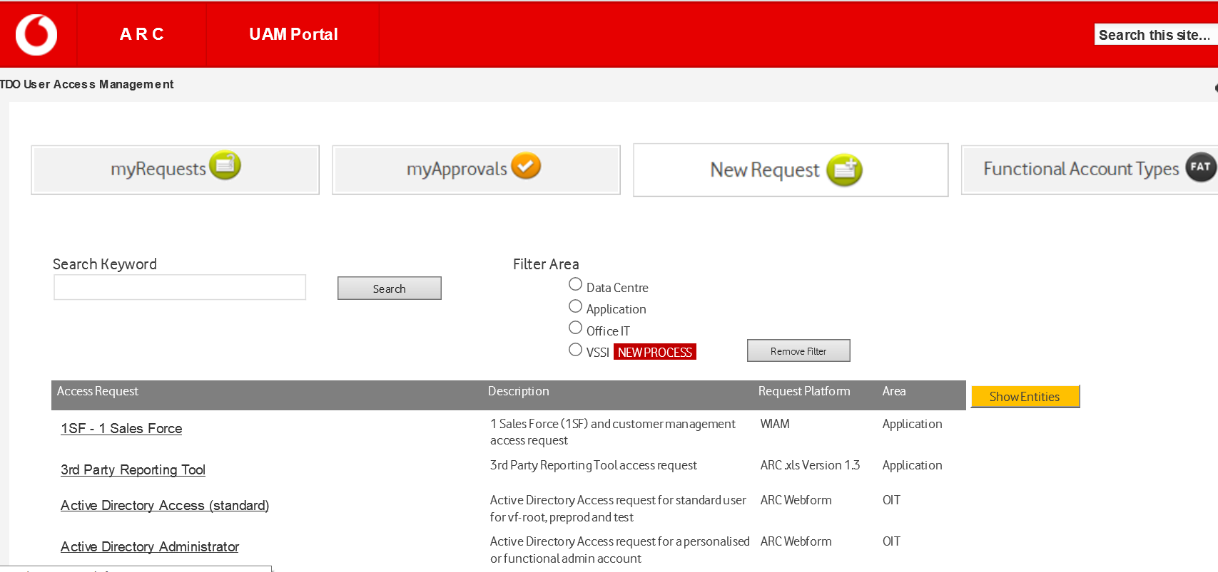

Search word ‘Security Group Membership’ and select

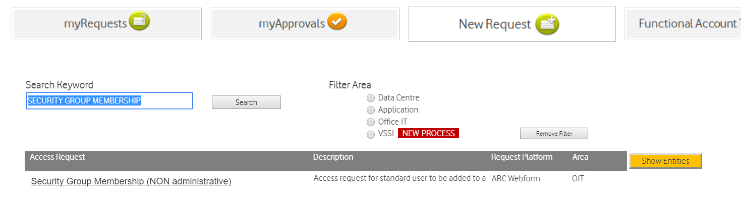

Click on [Security Group Membership (NON administrative)](https://workspace2.vodafone.com/Group/TDO-UAM/_layouts/listform.aspx?PageType=8&ListId=%7bBD939FAE-2668-4434-AD9D-EEF283CF94FD%7d&RootFolder=)

Ans select as per below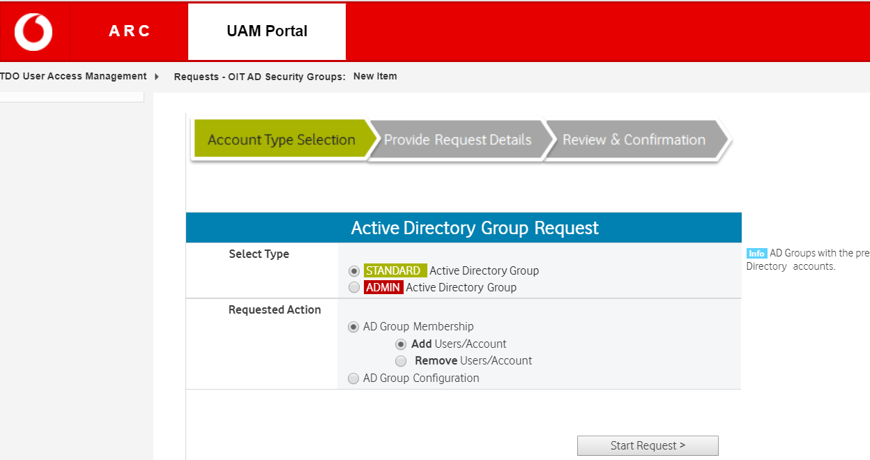

Start request

Security group name : FSA-Remote_JUMP_OPENSTACK_TSS-R

Owner details : [rahul.chaudhari@vodafone.com](mailto:rahul.chaudhari@vodafone.com)

Check name

User name : < type mail id of requester>

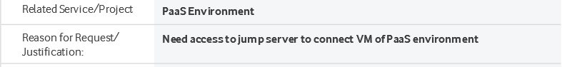

Submit the form.