DOKUMENTASI BACKEND API JELAJAH-IN
ARIEF RACHMAN SAHERTIAN

Base URL = “http://localhost:3000/api”

- Auth
- Register User
Method: “POST”
Endpoint: “/auth/register/user”
Mendaftarkan akun baru untuk user
Request Body (application/json)
Parameter | Type | Keterangan
name | String | Nama Lengkap Pendaftar (wajib)
email | String | Alamat email (wajib)
password | String | Password pendaftar minimal 8 karakter (wajib)

Response:
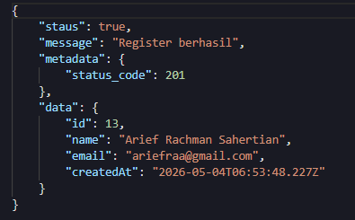

- Login User
Method: “POST”
Enpoint: “/auth/login/user”
Masuk ke akun user dan mendapatkan JWT Token.
Request Body (application/json)
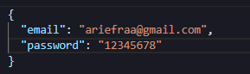

Response:
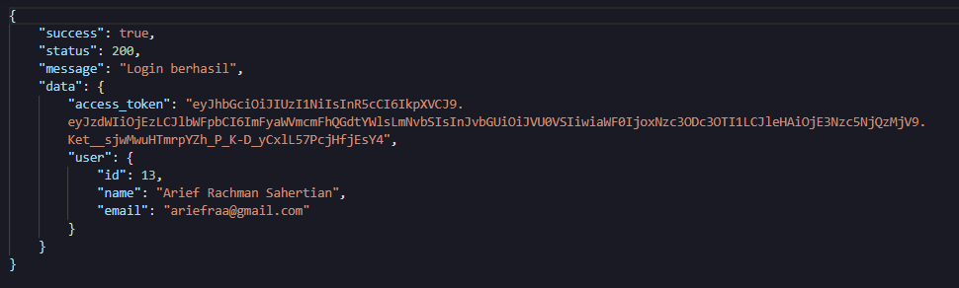

- Login Admin
Method: “POST”
Enpoint: “/auth/login/admin”
Masuk ke akun user dan mendapatkan JWT Token.
Request Body (application/json)
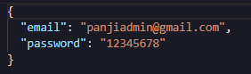

Response:
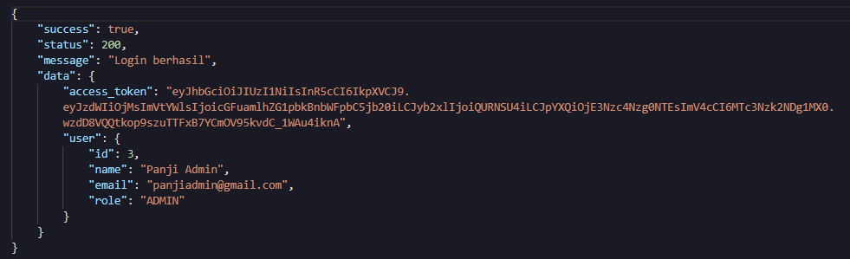

- Update User
Method: “PATCH”
Enpoint: “/auth/update”
Authorization: Bearer <token>
Request Body (application/json)
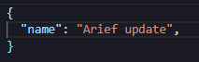
“Update bisa name atau password”

Response:
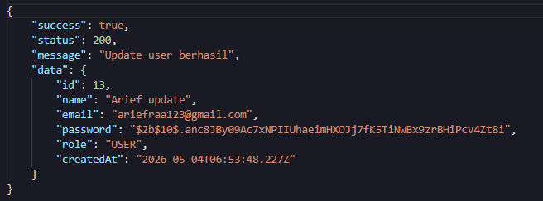

- Update User by admin dan menggunakan id user
Method: “PATCH”
Enpoint: “/auth/update/:id”
Authorization: Bearer <token>
Request Body (application/json)
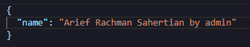

Response:
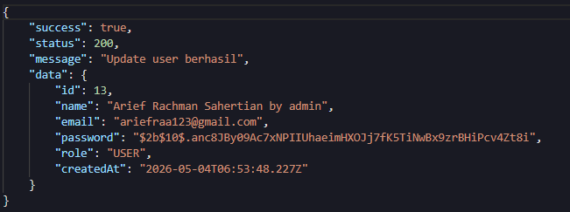

- Mengambil semua data user
Method: “GET”
Enpoint: “/auth/ users”
Authorization: Bearer <token>
Response:
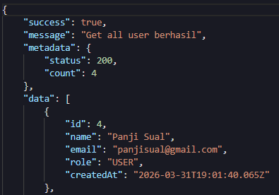

- Mengambil semua data admin
Method: “GET”
Endpoint: “auth/admins”
Authorization: Bearer <token>
Response:
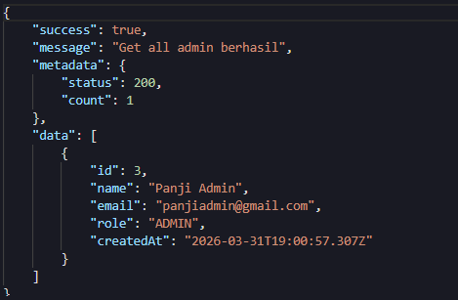

- CRUD Paket Wisata
- Create Paket
Method: “POST”
Enpoint: “/packages”
Authorization: Bearer <token>
Request Body (application/json)
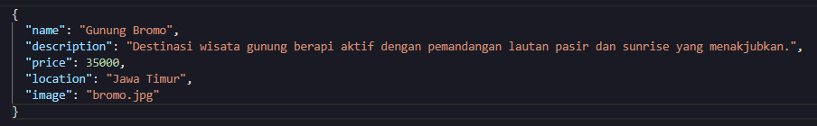

Response:
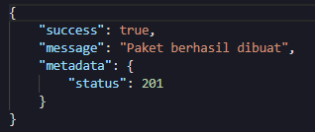

- Mengambil semua data paket
Method: “GET”
Enpoint: “/packages”
Response:
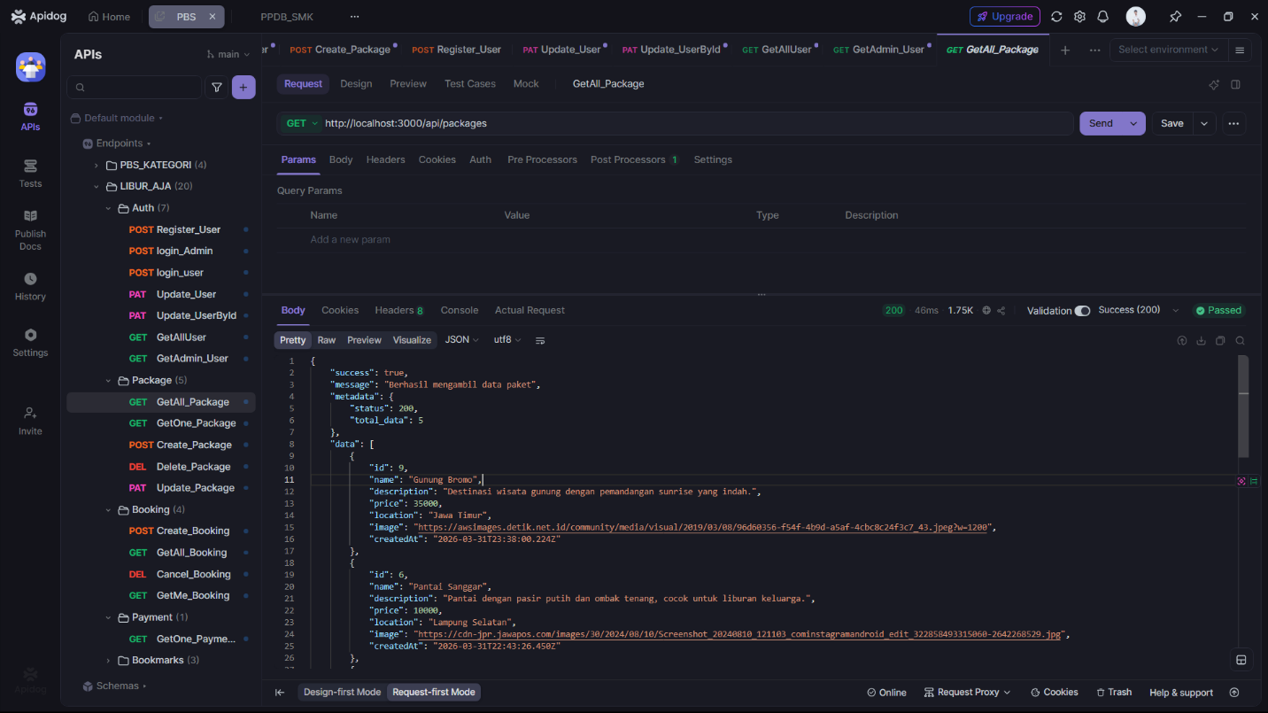

- Update paket
Method: “PATCH”
Enpoint: “/packages/:id”
Authorization: Bearer <token>
Request Body (application/json)
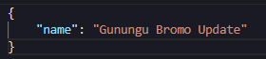
Resonse:
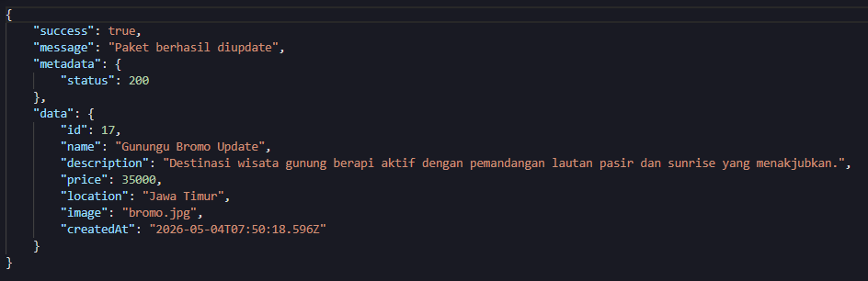

- Delete Paket
Method: “DELETE”
Enpoint: “/packages/:id”
Authorization: Bearer <token>
Response:
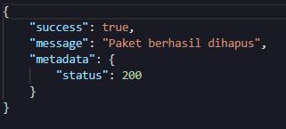

- Ambil 1 data paket
Method: “GET”
Enpoint: “/packages/:id”
Response:
