**B. Experiments** In this system, all nouns are defined for subjects or objects and all verbs are defined for actions that have been seen within a triplet. Parser is a program that automatically works out which words are referred to subjects or objects of a verb. By using Stanford Parser, I have extracted a list of all SVO triplets in a story but one of the main problem with the parser is to recognize identical triplets. To be more specific, in the sentence” I voted for Mr. Trump because he was most aligned with my values” she said. Here I, my and she refers to the same person where Mr. Trump, he to another. In order to solve this problem, before extracting the triplets I prepared by hands rewriting in a correct form. From the Stanford Parser output I extract words tagged with S (subject), V (verb), and O (object of the verb) relations. A SVO triplet is formed out of these words if the S, V, O relations have been found in the sentence in this chronological order. And chose ”Dr. Heidegger’s Experiment” for my implementation; it is a short story by Nathaniel Hawthorne, about a doctor who invites friends to participate in an experiment, in his mysterious study.

**C. Results** Figure 1 provides a general context for understanding the data-set. It reveals all the subjects, verbs and objects in a time series (time is represented on the x-axis by the number of sentences in the story). Respectively all the characters are represented on the y-axis, the actions performed by each character and the object of each action are shown as a small rectangle with different colors (the most occurred from red color to least occurred in green colors). When the user hovers the mouse over the screen all SVO triplets will be displayed automatically as shown in (1) together with displaying the actual sentences within in the story, and these sentences are enumerated for time entity. In addition, for removing unnecessary information from the view and for further investigation system provides zoom-in operation by excluding unimportant aspects of the representation (2). It is easy to see and identify the key characters of the story from figure 1; since, characters Dr. Heidegger, Mr. Medbourne, Colonel Killigrew and Widow Wycherley have large domination in SVO triplets over other characters in the list. From this perspective general overview can provide assistance in understanding the stories.

Figure 2, is displayed after clicking on one of the characters/subjects from the y-axis in Figure 1. As you can see this window gives all the objects which have been used by selected character in this case Dr. Heideggers.

Figure 3, is displayed after clicking on VERB in Figure 2. This graph reveals all the verbs/actions performed by selected character. From these figures, we can easily detect some important actions performed by key characters and the objects of actions as they have higher values.

Figure 4 is displayed as a result of clicking on one of the rectangles from Figure 1. Which shows all subjects together that has used same object word. In this case Dr. Heidegger, Mr. Medbourne, Colonel Killigrew and Widow Wycherley, all of them used an object glass.This representation allows user to view relationships between important actors where comparisons could be made among the actors and their objects. All in all, users can easily return to previous states in the data representations. Comparing current state and previous states may give better understanding the story

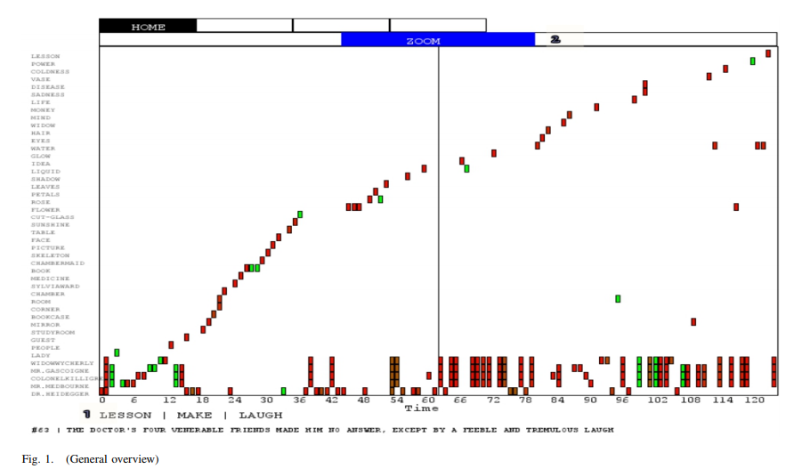

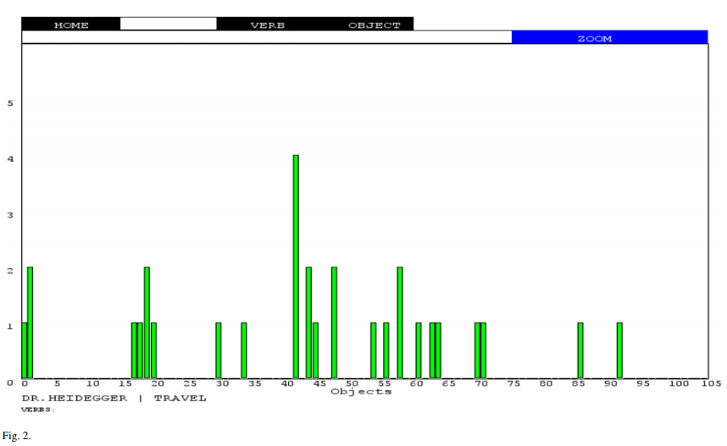

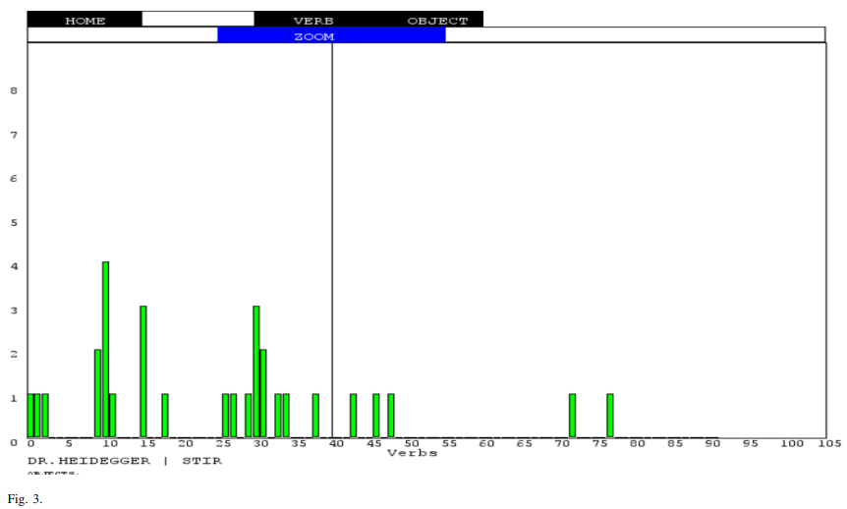

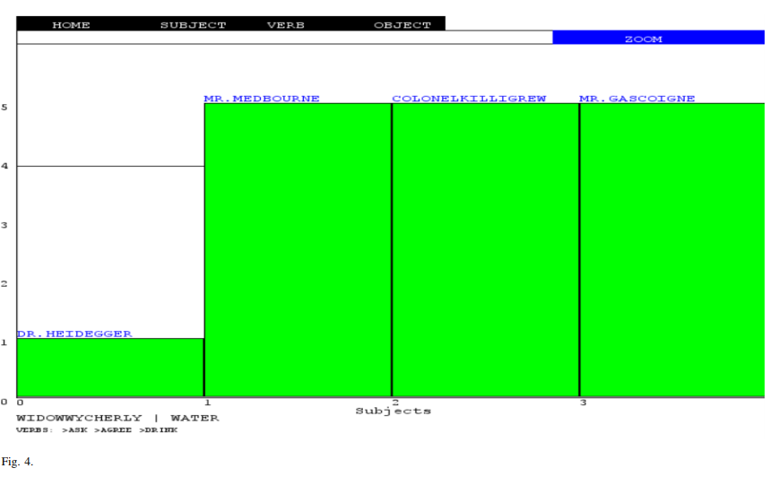

※ References

[1] [Yangqiu Song, et al., 2011] Yangqiu Song, Haixun Wang, Zhongyuan Wang, Hongsong Li and Weizhu Chen. Short Text Conceptualization Using a Probabilistic Knowledgebase. 2011

[2] Hendrik Strobelt, Daniela Oelke, Christian Rohrdantz, Andreas Stoffel,Daniel A. Keim, and Oliver Deussen , Document Cards: A Top Trump Visualization for Documents, IEEE InfoVis, 2008.

[3] Lorand Dali, Delia Rusu, Blaz Fortuna, Dunja Mladenic, and Marko Grobelnik. Question answering based on semantic graphs. In Proceedings of the workshop on semantic search (sem-search 2009), 2009

[4] Delia Rusu, Lorand Dali, Blaz Fortuna, Marko Grobelnik, and Dunja Mladenic. Triplet extraction from sentences. In Proceedings of the 10th International Multiconference” Information Society-IS, pages 812, 2007

[5] Gregor Leban, Blaz Fortuna, Janez Brank, and Marko Grobelnik. Event registry: learning about world events from news. In Proceedings of the companion publication of the 23rd international conference on World Wide Web companion, pages 107110. International World Wide Web Conferences Steering Committee, 2014.

[6] Liu, S., Zhou, M. X., Pan, S., Song, Y., Qian, W., Cai, W., and Lian, X. 2012. TIARA: Interactive, topic-based visual text summarization and analysis. ACM Trans. Intell. Syst. Technol. 3, 2, Article 25 (February 2012), 28 pages

[7] Brock Craft, Paul Cairns, Beyond Guidelines: What Can We Learn from the Visual Information Seeking Mantra?, IEEE Computer Society, July 8,2005

[8] Marit Theune and Nanda Slabbers and Feikje Hielkema, The Narrator: NLG for digital storytelling, Proceedings of the Eleventh European Workshop on Natural Language Generation, 2007