ADAPER - %vadper

Purpose of this document: detail each step of the gadam macro %vadper.
%vadper R:\general\biostat\gadam\_library\vadper.sas

Author: Pascale Schrauben
Date: Sept 2022

Table of Contents
1 Extract exposure information from SDTM.EX and keep first start and last end exposure dates 2
2 Concomitant treatments during same time period 6
3 Exposure character date into numeric imputed date/datetime format 7
4 Sub-periods 8
4.1 TREATMENT-ROUTE subperiod 8
4.2 TREATMENT subperiods 8
4.1 OVERALL TREATMENT subperiod 8
4.1 3 MONTHS subperiods 9
1 Compute Period duration and List treatments taken during subperiods 10
1.1 Compute Period duration 10
1.2 List treatments taken during subperiods 12
2 Compute ASP(MX or 60 or 90)DT(M) 13
2.1 OVERALL TREATMENT subperiod 13
2.2 3 MONTHS subperiod 13
2.3 TREATMENT and TREATMENT-ROUTE subperiods 14
3 Summary on an complex case 15

Extract exposure information from SDTM.EX and keep first start and last end exposure dates

- Keep first start and last end exposure dates of each treatment-route
- If last end exposure date is missing then it will be imputed to start exposure date
- Put ‘qcfail_crit’ message in ADAPER monitor if first or last exposure date is partial

- abbreviation for routes: 'INTRAMUSCULAR' => 'IM'; 'INTRAVENOUS'=> 'IV'; 'SUBCUTANEOUS'=>'SC'
- harmonize treatment names
  - uppercase of EXTRT
  - 'ARGX-113' => 'EFGARTIGIMOD'; 'PH20' => 'RHUPH20'; 'BLIND'=>'BLINDED';
  - xx mg / kg => xx MG/KG (uppercase and no blank)
  - if missing or like 'treatmentA/treamentB'
and tsparmcd="TBLIND" and tsval='DOUBLE BLIND' and actarmcd='' => 'BLINDED'
- if still missing then set to ‘Unknown IMP’ and put ‘qcfail_crit’ message in ADAPER monitor

First ‘qcfail_crit’ cannot be validated as no partial exposure date in current data on LSAF: date part was complete in dates:

libname sdtm113 'R:\clinical\argx-113\x-ind\argx-113-0000\biostat\staging\data_received\sdtm_last';
where length(EXSTDTC) < 8 and EXSTDTC ne ''
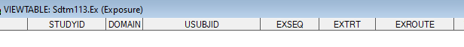

libname sdtm110 'R:\clinical\argx-110\aml\argx-110-0000\biostat\staging\data_received\sdtm_last';
where length(EXSTDTC) < 8
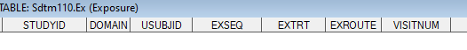
libname sdtm117 'R:\clinical\argx-117\x-ind\argx-117-0000\biostat\staging\data_received\sdtm_last';
where length(EXSTDTC) < 8
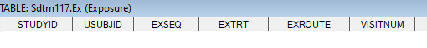

In study argx-110\aml\1003: where length(EXSTDTC) < 8
Second ‘qcfail_crit’ cannot be validated as no unknown IMP in current data on LSAF.

Example: multiple routes (ORAL and INTRAVENOUS=>IV and SUBCUTANEOUS=>SC) and one treatment with last end exposure date missing

Input SDTM.EX: 74494550AML1003-10010404 for extrt= VENETOCLAX and CUSATUZUMAB
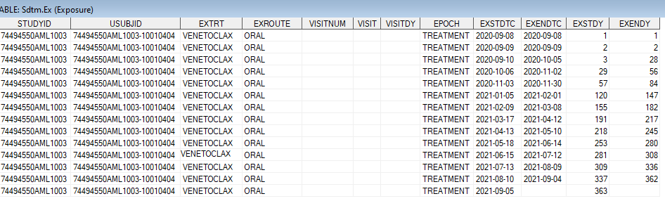

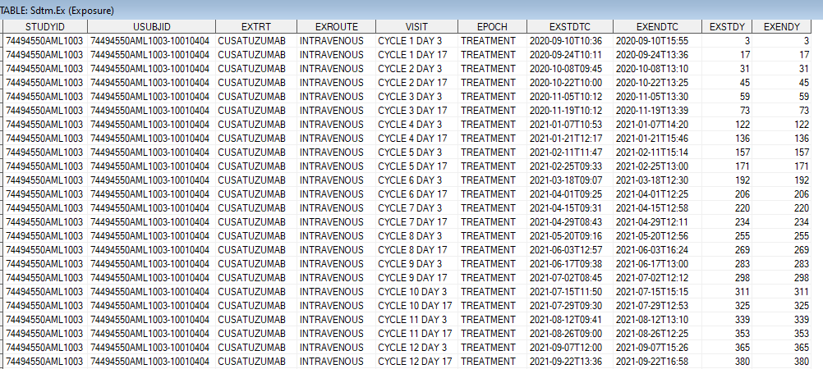

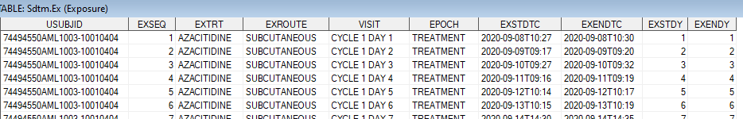
...

macro working dataset:
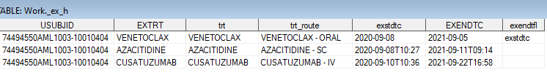

Example: EXTRT = ARGX-113 10mg/kg => EFGARTIGIMOD 10MG/KG

Input SDTM.EX: ARGX-113-1603/381-002
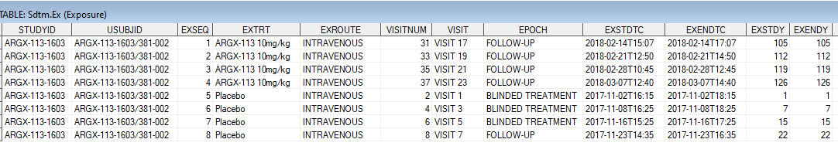
macro working table:

Example: EXTRT = EFGARTIGIMOD PH20=> EFGARTIGIMOD RHUPH20

Input SDTM.EX: ARGX-113-1704-BEL0001-027 in third study ARGX-113-2002
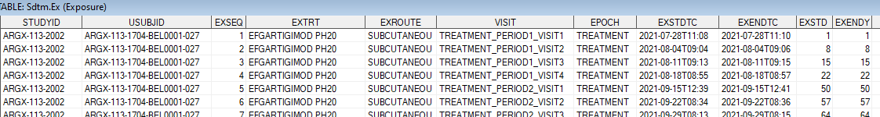
...
macro working table:

Example: Missing EXTRT => BLINDED

Input SDTM.EX: ARGX-113-2004-0010045-178
Input SDTM.DM: Input SDTM.TS:
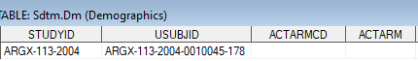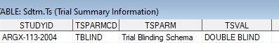

macro working table:

Example: EXTRT= EFGARTIGIMOD/PLACEBO => BLINDED
Input SDTM.EX: ARGX-113-1904-0010087-080
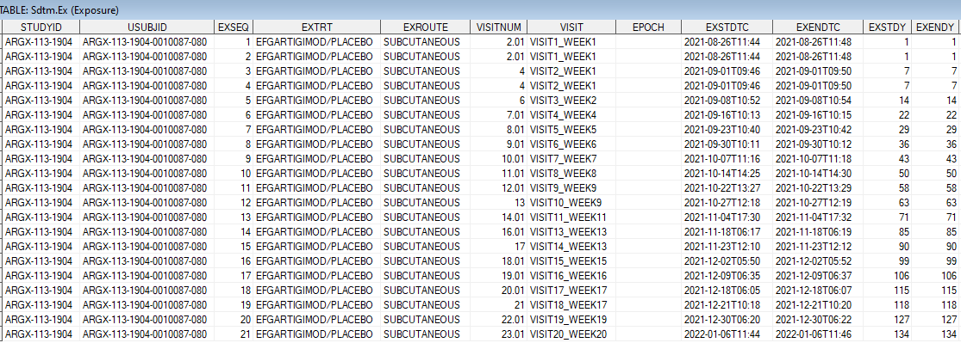
Input SDTM.DM: Input SDTM.TS:
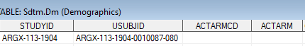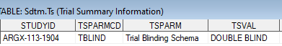
macro working table:

Concomitant treatments during same time period

- if a subject received concomitant treatments at same time (same start and end exposure dates) => only one combined record kept

Example: concomitant treatments during same time period

Input SDTM.EX: ARGX-113-1901-0310003-001

macro working table:

Exposure character date into numeric imputed date/datetime format

Syntax of Exposure dates: yyyy-mm-ddThh:mm:ss

DATE

- Extract date part: keep part before character ‘T’ and then keep first 10 characters

- Imputation and numeric conversion:

If syntax=yyyy-mm-dd then conversion in numeric date format.

Else if syntax = yyyy-mm then start date imputed to yyyy-mm-01, end date imputed to last day of the month: yyyy-mm-31, yyyy-mm-30, yyyy-mm-29 or yyyy-mm-28. Then conversion in numeric date format with aspsdtf or aspedtf = ‘D’ (for day).

Else if syntax = yyyy then start date imputed to yyyy-01-01, end date imputed to yyyy-12-31. Then conversion in numeric date format with aspsdtf or aspedtf = ‘M’ (for month).

If exendtc is empty then it will take value of exstdtc before numeric conversion.

DATETIME

- Imputation and numeric conversion:

If syntax=yyyy-mm-ddThh:mm:ss then conversion in numeric datetime format
Else if syntax = yyyy-mm-ddThh:mm then imputation to yyyy-mm-ddThh:mm:00 with aspstmf or aspetmf = ‘S’ (for second).

Else if syntax = yyyy-mm-ddThh then start datetime imputed to yyyy-mm-ddThh:00:00 and end datetime imputed to yyyy-mm-ddThh:59:00 with aspstmf or aspetmf = ‘M’ (for minute).
Else if syntax = yyyy-mm-dd then start date imputed to yyyy-mm-ddT00:00:00 and end date imputed to yyyy-mm-ddT23:59:00 with aspstmf or aspetmf = ‘H’ (for hour).

Else if previous imputed exposure date is not missing then start date imputed to yyyy-mm-ddT00:00:00 and end date imputed to yyyy-mm-ddT23:59:00.

Example: start and end exposure datetimes – seconds and hours imputation
Input SDTM.EX: ARGX-113-2004-0610012-083 in study ARGX-113-2005
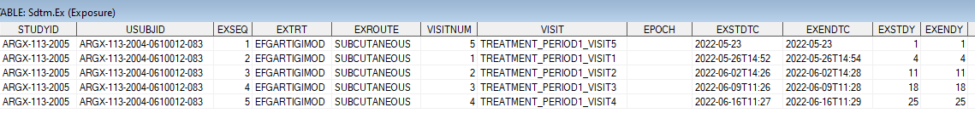

macro working table:

Sub-periods

At this step of the vadper macro, the last working dataset contains 1 record for each treatment-route with first start and last end exposure dates/datetimes in numeric format.

Example of a subject enrolled in study argx-110-aml-1003 that contains concomitant treatments:
where usubjid='74494550AML1003-10011006'

- ! Subject took AZACITIDINE at different time periods and with different routes !
AZACITIDINE started and ended in IV route

TREATMENT-ROUTE subperiod

Only renaming of variable TRT_ROUTE=ASPERC and creation of ASPER in chronological order and starting from 2001.

Example: where usubjid='74494550AML1003-10011006'

TREATMENT subperiods

Combined treatments when a same treatment was taken in several routes => keep first start and last end exposure dates by treatment. Creation of ASPER in chronological order and starting from 1001.

Example: where usubjid='74494550AML1003-10011006'

OVERALL TREATMENT subperiod

For each subject, extract first start exposure date/datetime and last end exposure date/datetime

Example: where usubjid='74494550AML1003-10011006'

3 MONTHS subperiods

- Computation only when dates available: in previous working dataset for overall treatment period: aspsdt ne . and aspsdtf=''

- First subperiod: 0-3M: starts from first exposure start date (see in overall treatment subperiod)
If date and hour info available in start date then subperiod ends after 90*24*60-1 minutes,
Else if only date info available in start date then subperiod ends after 90 days (date will be imputed with ‘T23:59:00’.

- Subperiods: 4-6M or 7-9M or 10-12M or ... => (i*3-2)-(i*3)M where i=2,3,4,...100
If date and hour info available in start date then subperiod starts after (i-1)*90*24*60 minutes and ends after 90*24*60 minutes.
Else if only date info available in start date then subperiod starts after (i-1)*90 days (date will be imputed with ‘T00:00:00’ and ends after 90 days (date will be imputed with 'T23:59:00').

- Last subperiod will be truncated to last exposure end date (see in overall treatment subperiod).

Example: where usubjid='74494550AML1003-10011006' (start has no time info) => 3 subperiods for 3 MONTHS

Previous Overall treatment subperiod dataset:

- 3 months subperiods dataset:

Example: where usubjid=' ARGX-113-1704-BEL0001-027' in second study ARGX-113-1705 (start has time info)

Previous Overall treatment subperiod dataset:

- 3 months subperiods dataset:
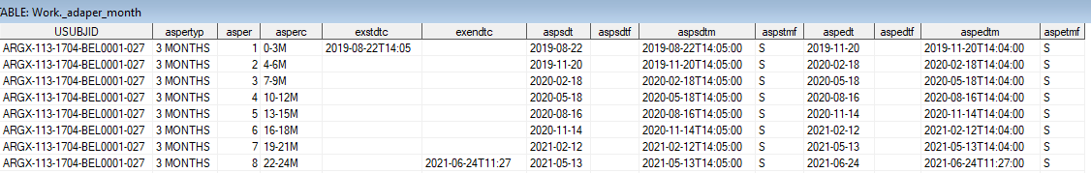

Compute Period duration and List treatments taken during subperiods

At this step of the vadper macro, after appending each subperiod datasets, the working dataset contains 1 record for each subperiod value.

Example of a subject enrolled in study argx-110-aml-1003 that contains concomitant treatments:
where usubjid='74494550AML1003-10011006'
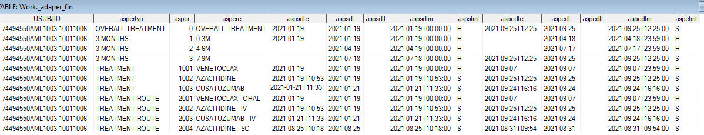

Compute Period duration

- Add period duration ASPDURD: duration between imputed start and end datetimes computed in minutes and then divided by 60*24 to have value in days.

- Add period duration variable ASPDURC:
if duration is less than 60 minutes then aspdurc=’xx MINUTES’
else if duration is less than 24 hours then aspdurc=’xx HOURS’
else aspdurc=’xx DAYS
For 3 months subperiods that are not the last subperiod then ASPDURD=90 and ASPDURC=90 DAYS.

Example: '74494550AML1003-10011006' – duration in DAYS
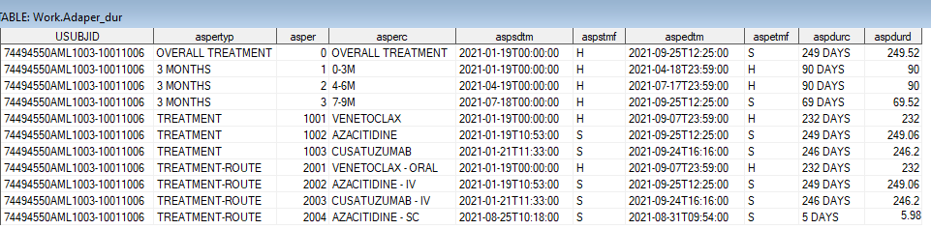

Example: ARGX-113-2102-0310003-124 – duration in DAYS and MINUTES
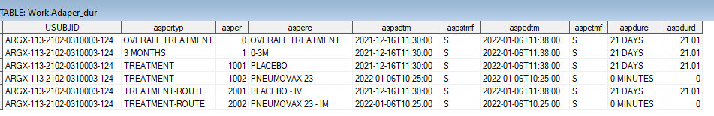

Example: ARGX-113-1501-01-101 – duration in DAYS and HOURS
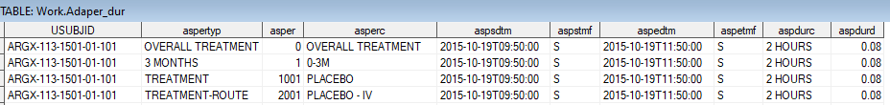

List treatments taken during subperiods

- Add treatments in TRTA: TRTA lists the treatments administered during the corresponding subperiod in a chronological order, each treatment is separtated by ‘ + ‘. Overall treatment subperiod should contains all treatments taken during the study. Treatment and treatment-route subperiods should contain treatments from ASPERC. And 3 months subperiods contains treatments depending on dates.

- Add active treatment in TRTAG1:
if index(trta,'EFGARTIGIMOD')>0 then trtag1='EFGARTIGIMOD'; %* argx-113;
else if index(trta,'CUSATUZUMAB')>0 then trtag1='CUSATUZUMAB'; %* argx-110;
else if index(trta,'ARGX-117')>0 then trtag1='ARGX-117'; %* argx-117;
else if index(trta,'BLINDED')>0 then trtag1='BLINDED';
else if index(trta,'unknown IMP')>0 then trtag1='unknown IMP';
else trtag1='COMPARATOR';

Example: ARGX-113-1603/381-002 – sequential treatments

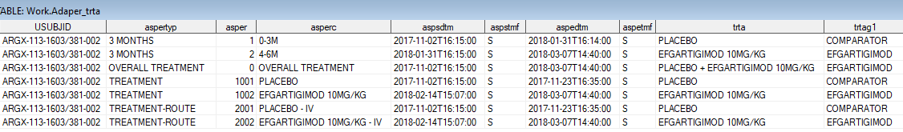

Example: '74494550AML1003-10011006' – concomitant treatments

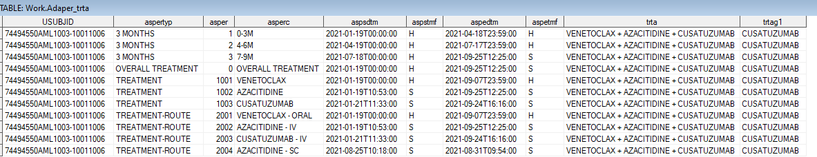

Example: ARGX-113-1802-0010006-317– EFGARTIGIMOD + BLINDED

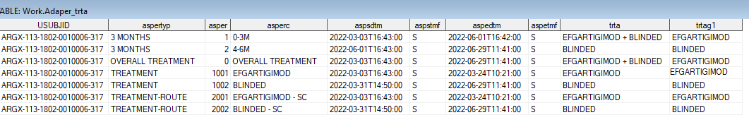

Compute ASP(MX or 60 or 90)DT(M)

- Add ASPMXDT(M) variables for end date(time) of the follow-up subperiod: ends just before next value of subperiod. If latest value of subperiod then ends at maximum of end subperiod date and last contact date.
Note: last contact date = lstcndt from ADSL and last contact datetime is lstcndt imputed to ‘T23:59:00’

- Add ASP60DT(M): idem ASPMXDT(M) but restricted to 60 days after latest treatment date (aspedtm+59*24*60*60)

- Add ASP90DT(M): idem ASPMXDT(M) but restricted to 90 days after latest treatment date (aspedtm+89*24*60*60)

OVERALL TREATMENT subperiod

As only one record OVERALL TREATMENT subperiod, the variable values are set to:
ASPMXDT(M) = last contact date(datetime).

Example1: ARGX-113-1603/381-002

3 MONTHS subperiod

As 3 MONTHS subperiods are sequential:
ASPMXDT(M) for last subperiod = last contact date(datetime).
Else ASPMXDT(M) = 1 minute before start of next subperiod.

Example1: 2 subperiods: ARGX-113-1603/381-002

v

Example2: 3 subperiods: ARGX-113-1603/381-002
v

TREATMENT and TREATMENT-ROUTE subperiods

when subperiods are sequential:
ASPMXDT(M) for last subperiod = last contact date(datetime).
Else ASPMXDT(M) = 1 minute before start of next subperiod.

Example: sequential treatments: ARGX-113-1603/381-002
v
v
v
v
v
v

when subperiods are combined:
ASPMXDT(M) for last subperiod = last contact date(datetime).

Example: sequential treatments: 74494550AML1003-10011006
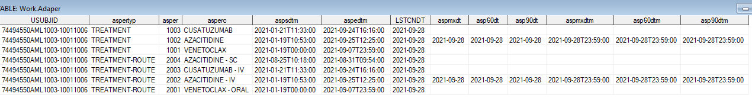
v

Summary on an complex case
Input SDTM.EX: 74494550AML1003-10011006 that has a last contact day set to 2021-09-28
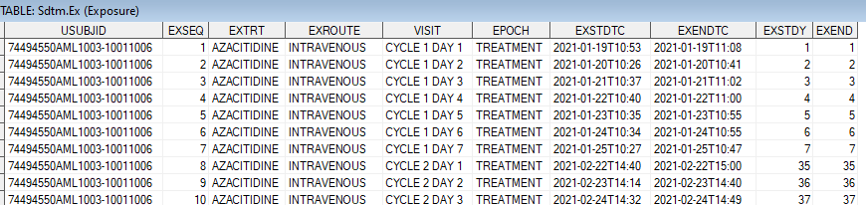
...
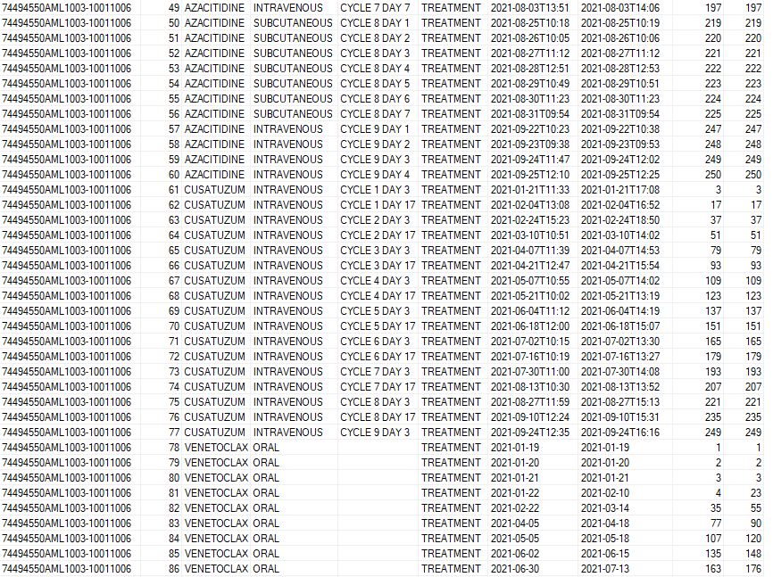
OUPUT – print screen of some variables
