ADAPER - %vadper

Purpose of this document: detail each step of the gadam macro %vadper.

%**vadper** R:\general\biostat\gadam\_library\vadper.sas

Author: Pascale Schrauben

Date: Sept 2022

Table of Contents

1 Extract exposure information from SDTM.EX and keep first start and last end exposure dates 2

2 Concomitant treatments during same time period 6

3 Exposure character date into numeric imputed date/datetime format 7

4 Sub-periods 8

4.1 TREATMENT-ROUTE subperiod 8

4.2 TREATMENT subperiods 8

4.1 OVERALL TREATMENT subperiod 8

4.1 3 MONTHS subperiods 9

1 Compute Period duration and List treatments taken during subperiods 10

1.1 Compute Period duration 10

1.2 List treatments taken during subperiods 12

2 Compute ASP(MX or 60 or 90)DT(M) 13

2.1 OVERALL TREATMENT subperiod 13

2.2 3 MONTHS subperiod 13

2.3 TREATMENT and TREATMENT-ROUTE subperiods 14

3 Summary on an complex case 15

# Extract exposure information from SDTM.EX and keep first start and last end exposure dates

* **Keep first start and last end exposure dates of each treatment-route**
* If last end exposure date is missing then it will be imputed to start exposure date
* **Put ‘qcfail_crit’ message in ADAPER monitor if first or last exposure date is partial**
* **abbreviation for routes:** 'INTRAMUSCULAR' => 'IM'; 'INTRAVENOUS'=> 'IV'; 'SUBCUTANEOUS'=>'SC'
* **harmonize treatment names**
  + uppercase of EXTRT
  + 'ARGX-113' => 'EFGARTIGIMOD'; 'PH20' => 'RHUPH20'; 'BLIND'=>'BLINDED';
  + xx mg / kg => xx MG/KG (uppercase and no blank)
  + if missing or like 'treatmentA/treamentB'

and tsparmcd="TBLIND" and tsval='DOUBLE BLIND' and actarmcd='' => 'BLINDED'

* if still missing then set to ‘Unknown IMP’ and p**ut ‘qcfail_crit’ message in ADAPER monitor**

*First* **‘qcfail_crit’** *cannot be validated as no partial exposure date in current data on LSAF: date part was complete in dates:*

libname sdtm113 'R:\clinical\argx-113\x-ind\argx-113-0000\biostat\staging\data_received\sdtm_last';

where length(EXSTDTC) < 8 and EXSTDTC ne ''



libname sdtm110 'R:\clinical\argx-110\aml\argx-110-0000\biostat\staging\data_received\sdtm_last';

where length(EXSTDTC) < 8



libname sdtm117 'R:\clinical\argx-117\x-ind\argx-117-0000\biostat\staging\data_received\sdtm_last';

where length(EXSTDTC) < 8



In study argx-110\aml\1003: where length(EXSTDTC) < 8



*Second* **‘qcfail_crit’** *cannot be validated as no* unknown IMP *in current data on LSAF.*

*Example: multiple routes (ORAL and INTRAVENOUS=>IV and SUBCUTANEOUS=>SC) and one treatment with last end exposure date missing*

*Input SDTM.EX: 74494550AML1003-10010404 for extrt=* *VENETOCLAX and CUSATUZUMAB*

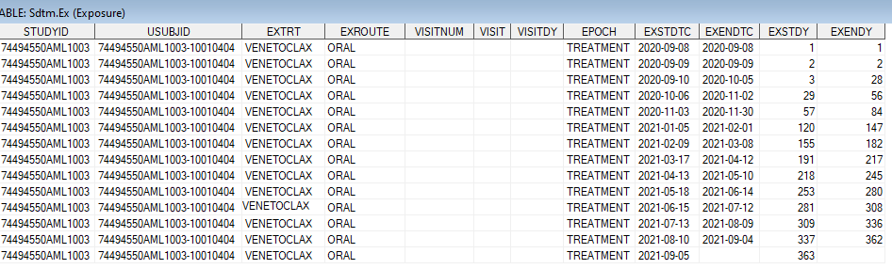

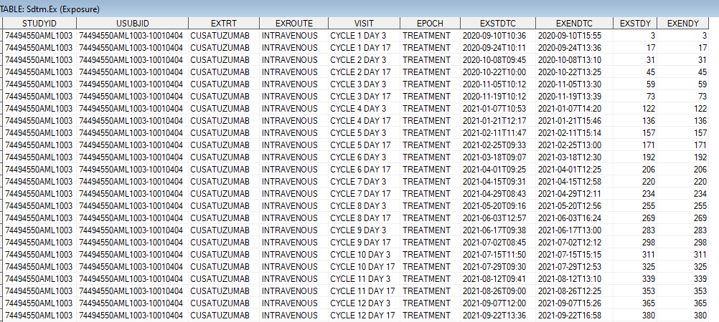

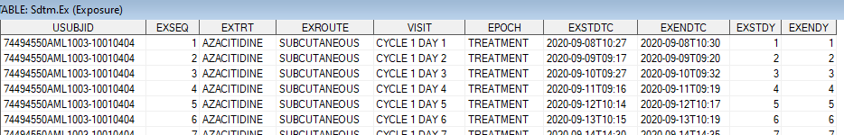

*...*

**

*macro working dataset:*

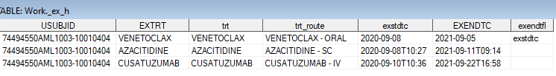

*Example: EXTRT = ARGX-113 10mg/kg => EFGARTIGIMOD 10MG/KG*

*Input SDTM.EX: ARGX-113-1603/381-002*

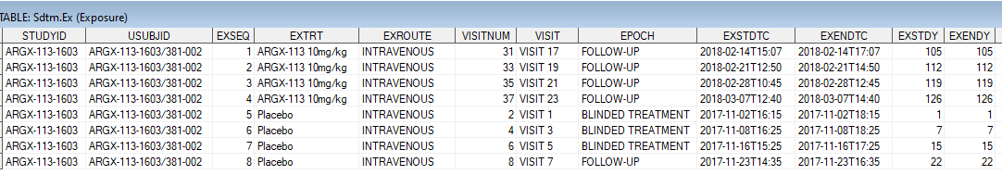

*macro working table:*

**

*Example: EXTRT = EFGARTIGIMOD PH20=> EFGARTIGIMOD RHUPH20*

*Input SDTM.EX: ARGX-113-1704-BEL0001-027 in third study ARGX-113-2002*

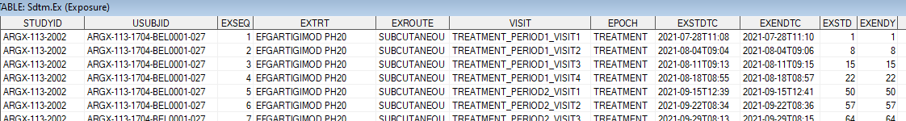

*...*

**

*macro working table:*

**

*Example: Missing EXTRT => BLINDED*

*Input SDTM.EX: ARGX-113-2004-0010045-178*



*Input SDTM.DM: Input SDTM.TS:*

* *

*macro working table:*

**

*Example: EXTRT=* *EFGARTIGIMOD/PLACEBO => BLINDED*

*Input SDTM.EX: ARGX-113-1904-0010087-080*

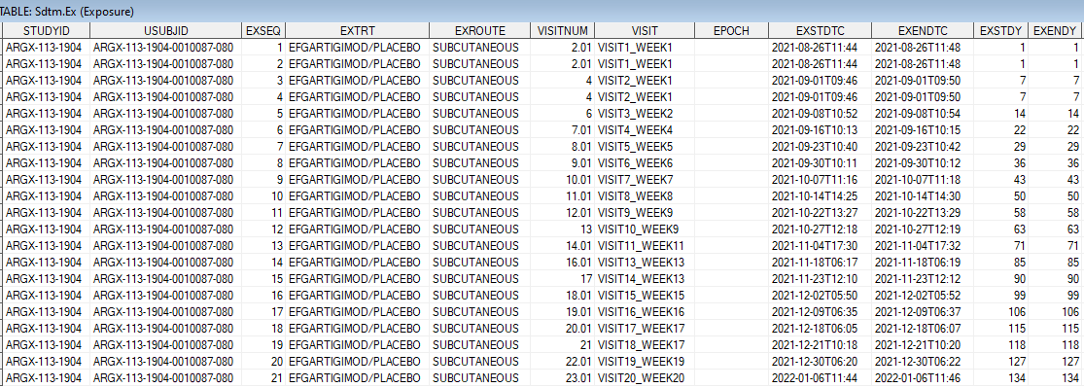

*Input SDTM.DM: Input SDTM.TS:*

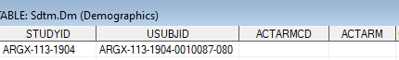 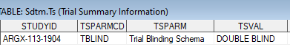

*macro working table:*

**

# Concomitant treatments during same time period

* **if a subject received concomitant treatments at same time (same start and end exposure dates) => only one combined record kept**

*Example: concomitant treatments* *during same time period*

*Input SDTM.EX:* **ARGX-113-1901-0310003-001**



*macro working table:*



# Exposure character date into numeric imputed date/datetime format

Syntax of Exposure dates: **yyyy-mm-dd**Thh:mm:ss

DATE

* Extract date part: keep part before character ‘T’ and then keep first 10 characters
* **Imputation and numeric conversion:**

If syntax=**yyyy-mm-dd** then conversion in numeric date format.

Else if syntax = **yyyy-mm** then start date imputed to **yyyy-mm-01,** end date imputed to last day of the month: **yyyy-mm-31, yyyy-mm-30, yyyy-mm-29** or **yyyy-mm-28.** Then conversion in numeric date format with aspsdtf or aspedtf = ‘D’ (for day).

Else if syntax = **yyyy** then start date imputed to **yyyy-01-01,** end date imputed to **yyyy-12-31.** Then conversion in numeric date format with aspsdtf or aspedtf = ‘M’ (for month).

If exendtc is empty then it will take value of exstdtc before numeric conversion.

DATETIME

* **Imputation and numeric conversion:**

If syntax=**yyyy-mm-ddThh:mm:ss** then conversion in numeric datetime format

Else if syntax = **yyyy-mm-ddThh:mm** then imputation to **yyyy-mm-ddThh:mm:00** with aspstmf or aspetmf = ‘S’ (for second).

Else if syntax = **yyyy-mm-ddThh** then start datetime imputed to **yyyy-mm-ddThh:00:00** and end datetime imputed to **yyyy-mm-ddThh:59:00** with aspstmf or aspetmf = ‘M’ (for minute).

Else if syntax = **yyyy-mm-dd** then start date imputed to **yyyy-mm-ddT00:00:00** and end date imputed to **yyyy-mm-ddT23:59:00** with aspstmf or aspetmf = ‘H’ (for hour).

Else if previous imputed exposure date is not missingthen start date imputed to **yyyy-mm-ddT00:00:00** and end date imputed to **yyyy-mm-ddT23:59:00**.

*Example: start and end exposure datetimes – seconds and hours imputation*

*Input SDTM.EX: ARGX-113-2004-0610012-083 in study ARGX-113-2005*

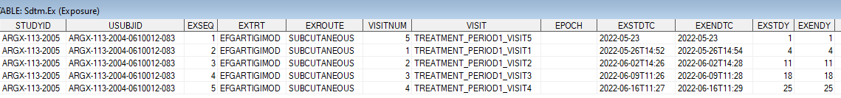

*macro working table:*

**

# Sub-periods

At this step of the vadper macro, the last working dataset contains 1 record for each treatment-route with first start and last end exposure dates/datetimes in numeric format.

*Example of a subject enrolled in study argx-110-aml-1003 that contains concomitant treatments:*

*where usubjid='74494550AML1003-10011006'*



* ! Subject took AZACITIDINE at different time periods and with different routes !

AZACITIDINE started and ended in IV route

## TREATMENT-ROUTE subperiod

Only renaming of variable TRT_ROUTE=ASPERC and creation of **ASPER in chronological order and starting from 2001.**

*Example: where usubjid='74494550AML1003-10011006'*



## TREATMENT subperiods

**Combined treatments when a same treatment was taken in several routes => keep first start and last end exposure dates by treatment. Creation of ASPER in chronological order and starting from 1001.**

*Example: where usubjid='74494550AML1003-10011006'*



## OVERALL TREATMENT subperiod

**For each subject, extract first start exposure date/datetime and last end exposure date/datetime**

*Example: where usubjid='74494550AML1003-10011006'*



## 3 MONTHS subperiods

* **Computation only when dates available**: in previous working dataset for overall treatment period: aspsdt ne . and aspsdtf=''
* **First subperiod: 0-3M: starts from first exposure start date** (see in overall treatment subperiod)

**If date and hour info available in start date then subperiod ends after 90*24*60-1 minutes,**

**Else if only date info available in start date then subperiod ends after 90 days (date will be imputed with ‘T23:59:00’.**

* **Subperiods: 4-6M or 7-9M or 10-12M or ... => (i*3-2)-(i*3)M where i=2,3,4,...100**

**If date and hour info available in start date then subperiod starts after (i-1)*90*24*60 minutes and ends after 90*24*60 minutes.**

**Else if only date info available in start date then subperiod starts after (i-1)*90 days (date will be imputed with ‘T00:00:00’ and ends after 90 days (date will be imputed with 'T23:59:00').**

* **Last subperiod will be truncated to last exposure end date** (see in overall treatment subperiod).

*Example: where usubjid='74494550AML1003-10011006' (start has no time info) => 3 subperiods for 3 MONTHS*

*Previous Overall treatment subperiod dataset:*



* *3 months subperiods dataset:*

**

*Example: where usubjid='* *ARGX-113-1704-BEL0001-027' in second study ARGX-113-1705 (start has time info)*

*Previous Overall treatment subperiod dataset:*



* *3 months subperiods dataset:*

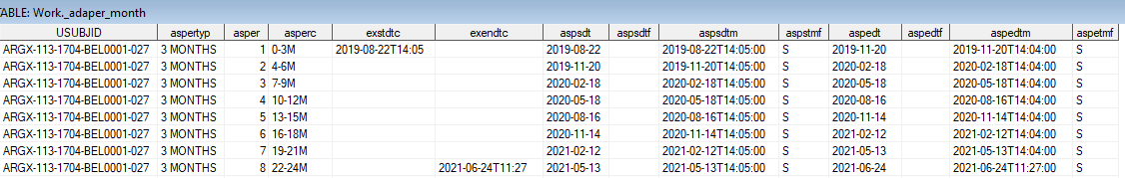

# Compute Period duration and List treatments taken during subperiods

At this step of the vadper macro, after appending each subperiod datasets, the working dataset contains 1 record for each subperiod value.

*Example of a subject enrolled in study argx-110-aml-1003 that contains concomitant treatments:*

*where usubjid='74494550AML1003-10011006'*

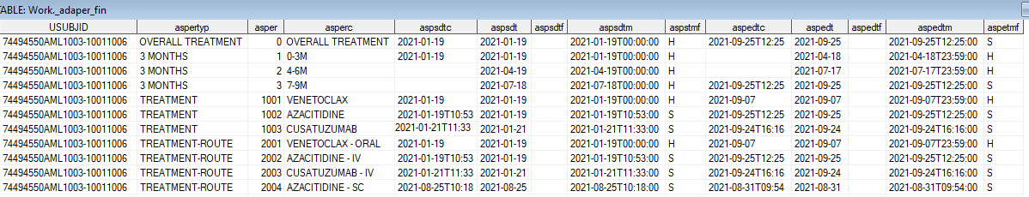

## Compute Period duration

* **Add period duration ASPDURD:** duration between imputed start and end datetimes computed in minutes and then divided by 60*24 to have value in days.
* **Add period duration variable ASPDURC:**

if duration is less than 60 minutes then aspdurc=’xx MINUTES’

else if duration is less than 24 hours then aspdurc=’xx HOURS’

else aspdurc=’xx DAYS

For 3 months subperiods that are not the last subperiod then ASPDURD=90 and ASPDURC=90 DAYS.

*Example: '74494550AML1003-10011006' – duration in DAYS*

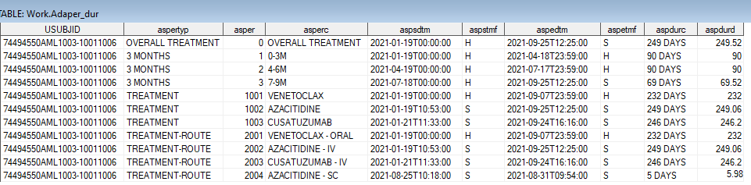

*Example: ARGX-113-2102-0310003-124 – duration in DAYS and MINUTES*

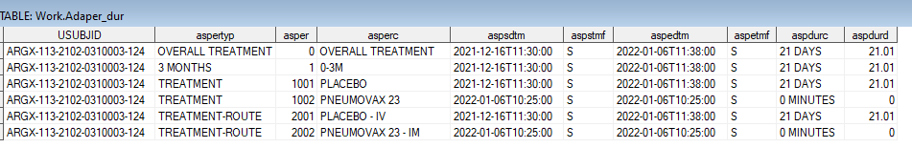

*Example: ARGX-113-1501-01-101 – duration in DAYS and HOURS*

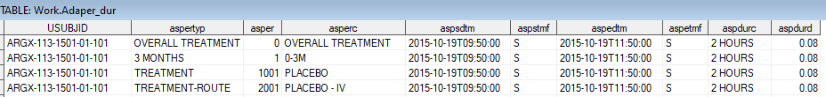

## List treatments taken during subperiods

* **Add treatments in TRTA:** TRTA lists the treatments administered during the corresponding subperiod in a chronological order, each treatment is separtated by ‘ + ‘. Overall treatment subperiod should contains all treatments taken during the study. Treatment and treatment-route subperiods should contain treatments from ASPERC. And 3 months subperiods contains treatments depending on dates.
* **Add active treatment in TRTAG1:**

if index(trta,'EFGARTIGIMOD')>0 then trtag1='EFGARTIGIMOD'; %* argx-113;

else if index(trta,'CUSATUZUMAB')>0 then trtag1='CUSATUZUMAB'; %* argx-110;

else if index(trta,'ARGX-117')>0 then trtag1='ARGX-117'; %* argx-117;

else if index(trta,'BLINDED')>0 then trtag1='BLINDED';

else if index(trta,'unknown IMP')>0 then trtag1='unknown IMP';

else trtag1='COMPARATOR';

*Example: ARGX-113-1603/381-002 – sequential treatments*

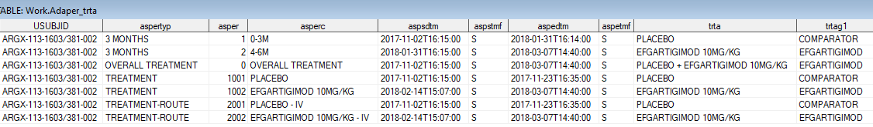

*Example: '74494550AML1003-10011006' – concomitant treatments*

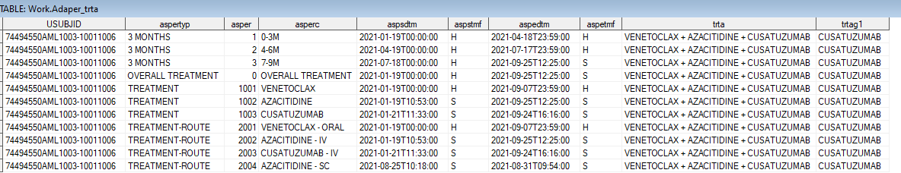

*Example: ARGX-113-1802-0010006-317– EFGARTIGIMOD + BLINDED*

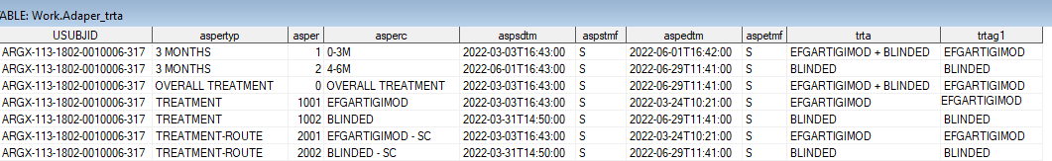

# Compute ASP(MX or 60 or 90)DT(M)

* **Add ASPMXDT(M) variables for end date(time) of the follow-up subperiod: ends just before next value of subperiod. If latest value of subperiod then ends at maximum of end subperiod date and last contact date.**

Note: last contact date = lstcndt from ADSL and last contact datetime is lstcndt imputed to ‘T23:59:00’

* **Add ASP60DT(M): idem ASPMXDT(M) but restricted to 60 days after latest treatment date** (aspedtm+59*24*60*60)
* **Add ASP90DT(M): idem ASPMXDT(M) but restricted to 90 days after latest treatment date** (aspedtm+89*24*60*60)

## OVERALL TREATMENT subperiod

As only one record OVERALL TREATMENT subperiod, the variable values are set to:

ASPMXDT(M) = last contact date(datetime).

*Example1: ARGX-113-1603/381-002*



## 3 MONTHS subperiod

As 3 MONTHS subperiods are sequential:

ASPMXDT(M) for last subperiod = last contact date(datetime).

Else ASPMXDT(M) = 1 minute before start of next subperiod.

*Example1: 2 subperiods: ARGX-113-1603/381-002*



v

*Example2: 3 subperiods: ARGX-113-1603/381-002*



v

## TREATMENT and TREATMENT-ROUTE subperiods

when subperiods are sequential:

ASPMXDT(M) for last subperiod = last contact date(datetime).

Else ASPMXDT(M) = 1 minute before start of next subperiod.

*Example: sequential treatments: ARGX-113-1603/381-002*



v

v

v

v

v

v

when subperiods are combined:

ASPMXDT(M) for last subperiod = last contact date(datetime).

*Example: sequential treatments: 74494550AML1003-10011006*

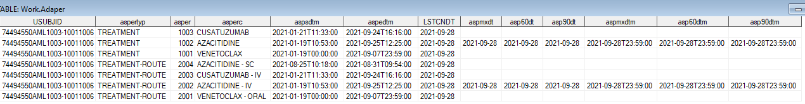

v

# Summary on an complex case

*Input SDTM.EX: 74494550AML1003-10011006 that has a last contact day set to 2021-09-28*

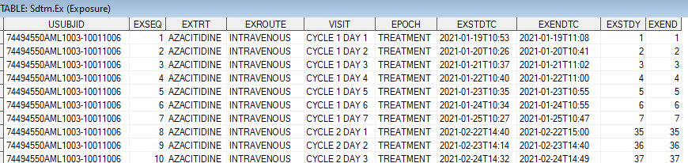

*...*

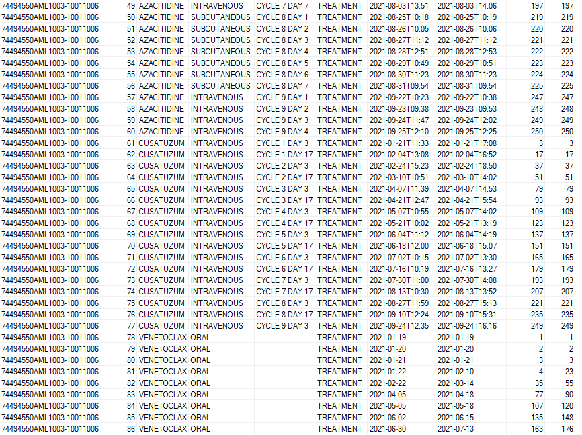

**

*OUPUT – print screen of some variables*

