**C# project – Chat Application**

Link git : <https://github.com/argett/Csharp-Chatting-app.git>

The already existing accounts in the program are :

id= **li** & password= **fg** ; id= **oui** & password= **non** ; id= **a** & password= **b**

**I / Functions implemented**

The project implements all mandatories functions : creation of a new profile, login, topics with public messages and private messages.

I have added several functionalities to the main ones :

- First a user can send private messages only to his friends. To be friend with someone, the user must go to the friend menu and select someone. Then, both users are going to be friend and each one will be able to send private messages with the other.

- The user can give a personalized surname (write /rename xxx) to his friend via command in a private message (or see /help in the private message section).

- Every user can see who has entered which topic writing /users in a topic. Those messages are not stored in the database.

- A database. This is not technically a database, but a class named “database”. The access of this class in non atomic, which means that a semaphore allows only one request after one.

- A save/load method. When a user disconnects using the existing functionalities (not the X in the top right-hand corner of the window) are saved into 2 files named “dbs-profiles.out” and “dbs-topics.out”. The method load is called every time the server is turned on.

**II / Functions not implemented**

I have implemented everything mandatory.

**III / Possible improvement**

I could have done a bit more in order to have a better user experience by adding :

- The graphical interface.

- A possible multi-client at the same time. I can open many different client, log in on each client but if 2 clients make requests at the same time (for example one asks to go to a private message whereas the other ask to go to the friend section), then the server crashes. I think it is because the program receives 2 requests from 2 different clients, and it doesn’t know how to handle that. And I don’t understand because I used the calculator base, which creates a thread for each client, and it is supposed to differentiate each one.

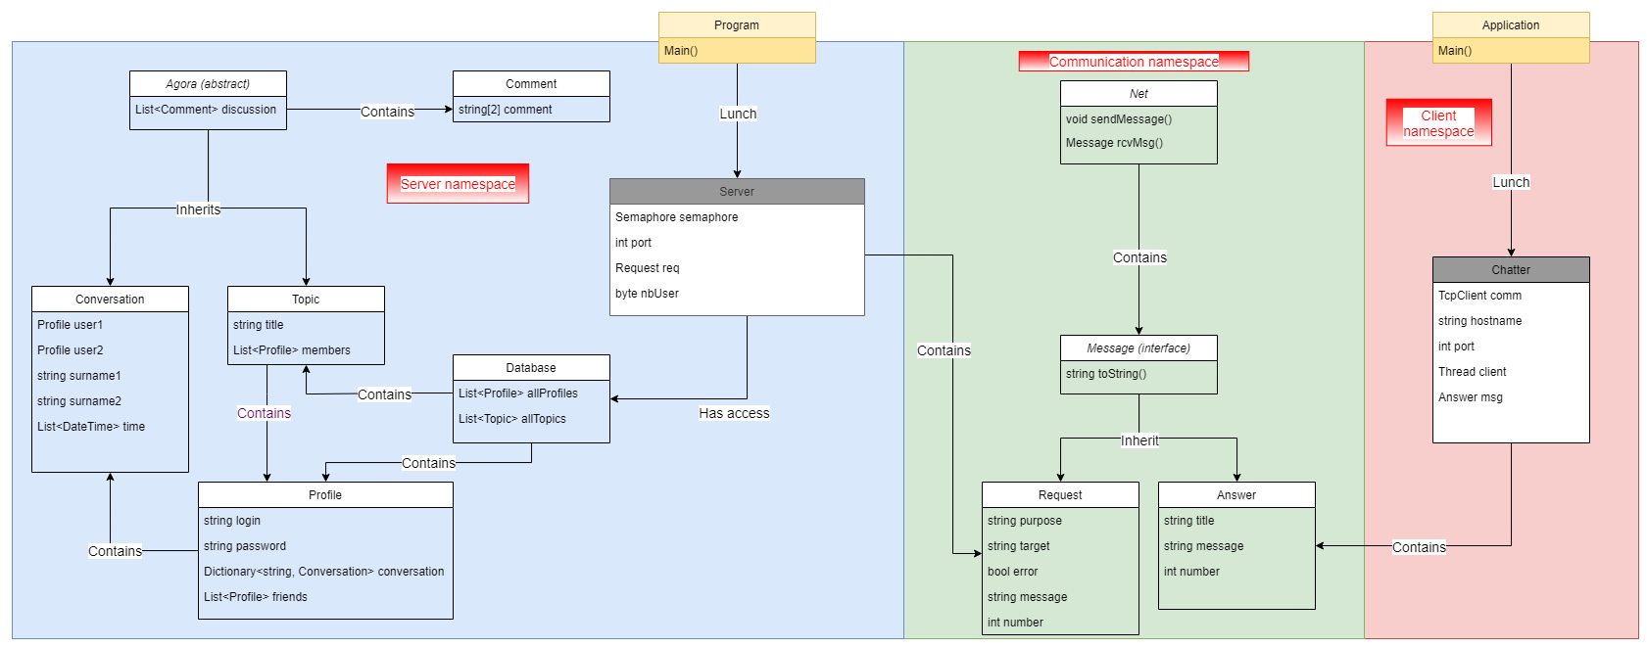**IV / Design**

**V / Screenshots**

First, you have to choose between creating a new account or connect to an existing one. Enter e or n.



So, either I create a new account:

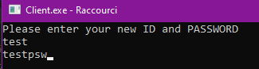

And I connect

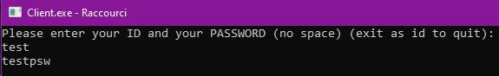 Either I enter directly the ID and the Password.

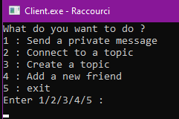 Then the user has access to the home menu :

Here just enter the number of the page you want to go.

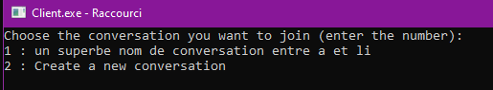If a choose to send a private message, then I need to choose to join a conversation or create a new one.

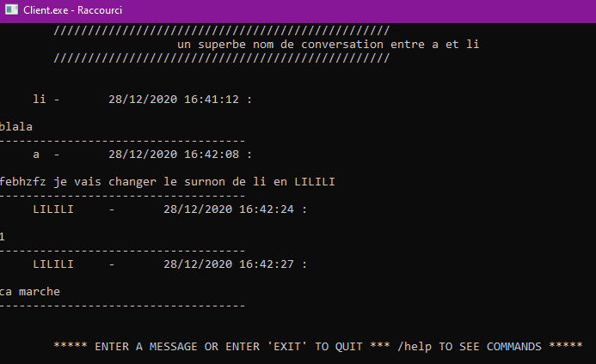

An example of conversation between a user named “a” and “li” (here the surname has been changed to “LI”)

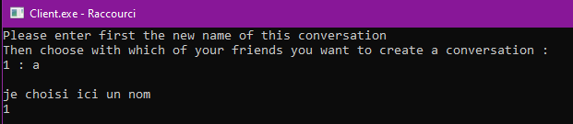

If I want to create a new conversation, first enter the name, then enter the number of the friend in the list displayed.

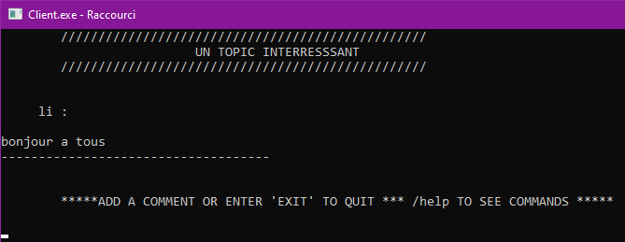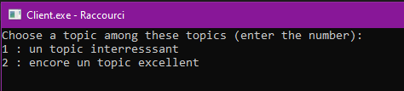In the menu home we can choose the topic section. Here is displayed a list of the topics :

Just enter the number of the topic you want to join.

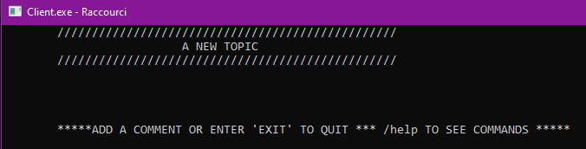From the menu we can create a new topic too, just enter the name :

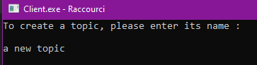Then the newly created topic will be displayed

From the menu we can add a new friend. Like the others page, enter the number of the friend in the list of the users diplayed

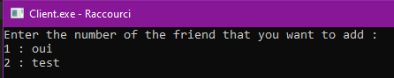

If the user enters 5 in the homepage, the client will be closed.