**Market Analysis to Boost Small E-Commerce Businesses**

Arghadeep Das

**Problem Statement**

E-commerce has changed the way people shop and consume products and services. It has become a new pathway to support businesses development. Through e-commerce, businesses can get access to a wider market presence by providing cheaper and more efficient distribution channels for their products or services. Many people are turning to their computers or smart phone devices to order goods, which can easily be delivered to their homes & offices as per their convenience.

* **Definition of Business development**

The activity of pursuing strategic opportunities for a particular business or organization by cultivating partnerships or other commercial relationships, or identifying new markets for its products or services (Wikipedia).

**Market/Customer/Business need assessment**

The success of a business in a competitive environment depends on its ability to acquire, store, and utilize information. Data is one of the main sources of information. Therefore, data analysis is an important activity for acquiring new and useful information.

**Goal**

1) Past sales trend over the last few months,

2) Frequently purchased products and the customer group that is most interested in such products,

3) Product purchase frequency per transaction,

4) Which customers are most active in purchasing and proving to be more profitable for the company,

5) Ultimate aim of the data analysis is to understand how business-strategies can be improved.

**Target specification and characterization**

Almost all business runs on the 80-20 rules where 80% of the business-revenue will be generated through only 20% of the potential customers. Mostly companies acquiring this prototype will be a small business company finding their way of stabilizing their business. Target buyers are all regular buyers who order good online regularly. Tapping this faithful customer market will be a challenge.

**External search**

1) <https://bannerwitcoff.com/_docs/library/articles/ecommerce.pdf>

2) Wikipedia

3) Amazon business case studies ( <https://www.computerworld.com/article/2595565/patents-in-e-commerce.html> )

**Dataset**

I have used UK e-commerce dataset from Kaggle (<https://www.kaggle.com/datasets/gabrielramos87/an-online-shop-business> ).This is a one-year sales-transaction dataset of a London-based shops selling gifts and homewares to adults and children through their website since 2007.

**Exploring the dataset**

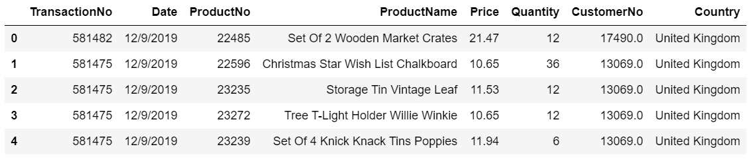

**Information about the dataset Basic statistics of the dataset**

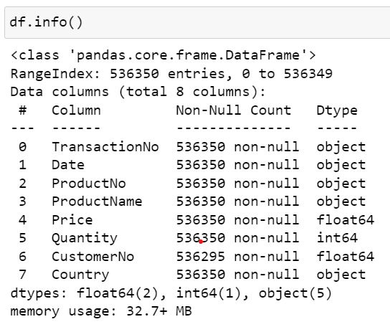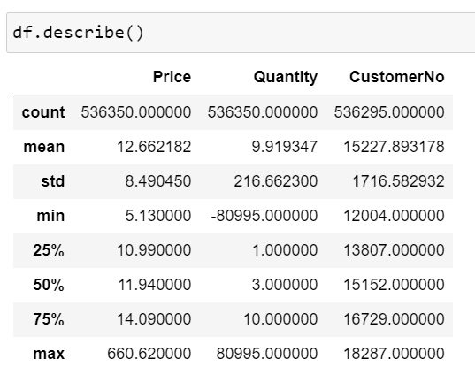

**Applicable Patents**

Patent is a method of buying or selling something (including goods and services) over the Internet. Examples include so-called electronic shopping carts; Web sites that employ auction-like techniques to sell goods; and computer screen designs that make it easier to transact business on the Internet.

Although the number of software patents has skyrocketed in recent years, patents covering so-called “methods of doing business” have emerged as a special breed, and have gained new momentum as a result of recent court cases. The Court of Appeals for the Federal Circuit, which hears all appeals in patent infringement lawsuits, recently ruled that a business method can be patented if it produces a useful, concrete, and tangible result.

i) Sales and Purchasing techniques: Some patents cover specific techniques for purchasing goods or services over the Internet. These inventions make it faster, easier, and more enjoyable for consumers to make electronic purchases.

ii) Online auctions: Conventional scheme for conducting an auction has been automated, tweaked, and moved into the world of the Internet.

iii) Financial Transactions: Some patents relate to financial transactions such as banking and securities trading on the Internet,

iv) Consumer reward systems: Some patents cover methods of rewarding consumers for participating in on-line activities such as advertising or game playing. The more advertisements a consumer views, the more he or she is paid. Some consumers have earned thousands of rupees doing this; at least a few have been able to circumvent the requirement that they view the advertisements by employing computerized mouse-clickers that simulate browsing on the Internet.

**Applicable regulations**

1) Ensuring customer data-protection,

2) Ensuring fulfilment of the government regulations (if any) applicable for the e-commerce business,

3) Strict rules against false advertisement,

**Applicable constraints**

It is the pre-assumed part of the business model that most of its users are well accustomed with online-shopping and most of the consumers have accessibility to smart-phones and internets. If this criterion isn’t met, the

**Business Opportunity**

The e-commerce business market has predominantly tapped by some very big companies like Amazon, flipkart and leaving the small to very small-scale businesses out of it. For small business companies who are still yet to find a ground in this competition, can use this business model to analyse their customer database, improve their products or business ideas accordingly and start their jounrney towards flourishment.

**Final Product Prototype**

The final product will be a consultancy service that will advise the small e-commerce ventures about their existing market-strength, requirements of the market, strategy to access the potential consumers through advertisement.

**Conclusion**

More e-commerce companies are trying to discover ways of using business analysis models to gain useful insights into associations and hidden relationships. But this extension for small e-commerce businesses will present a great opportunity to improve sales and help these businesses grow.