EV Market Segmentation

Report

Arghadeep Das

Problem Statement:

Context of the problem is to work towards launching an Electric vehicle startup. The startup is still deciding in which vehicle / customer space it will develop its EV. The task is to analyse the EV market in India using segmentation analysis and come up with a feasible strategy to enter the market, targeting the segments most likely to use EVs.

We will analyse the EV market in India using segments like region(statewise), price of the vehicle, types of the vehicle (2W,3W,4W etc), charging facility, brands, bodytypes etc.

Fermi estimation:

Employment rate =

According to the reports of Technical Group of Population Projections for India and the states 2011-2036, approximately 60.7% of the population falls under the working age (18-60 years) category.

(<https://theprint.in/india/imminent-end-of-demographic-dividend-share-of-indias-working-age-population-set-to-fall-by-2036/1451773/> )

The current Indian population is approx. 1.4 billion people. This implies that among those, approximately 0.84 billion people are falling under the working category.

Now as of 2023 only 45% of the workable people has the employment, the no. of working people falls around 378 million.

Now, taking into account the socio-economic distribution of this 378 million working-class people, only the upper middle class people will be inclined towards buying an EV and that number is approx. 10 million people which is drastically small keeping in mind the population of India.

Assuming Em(x) be the employment rate for the year x (%) and Pop(x) be the population / census measured at that year, Wor(x) be the number of available workforce for the year x, then –

Emp(x) =

Where r is the ratio of workable population(18-60 years) to the total population of India.

Exploratory Data Analysis (EDA):

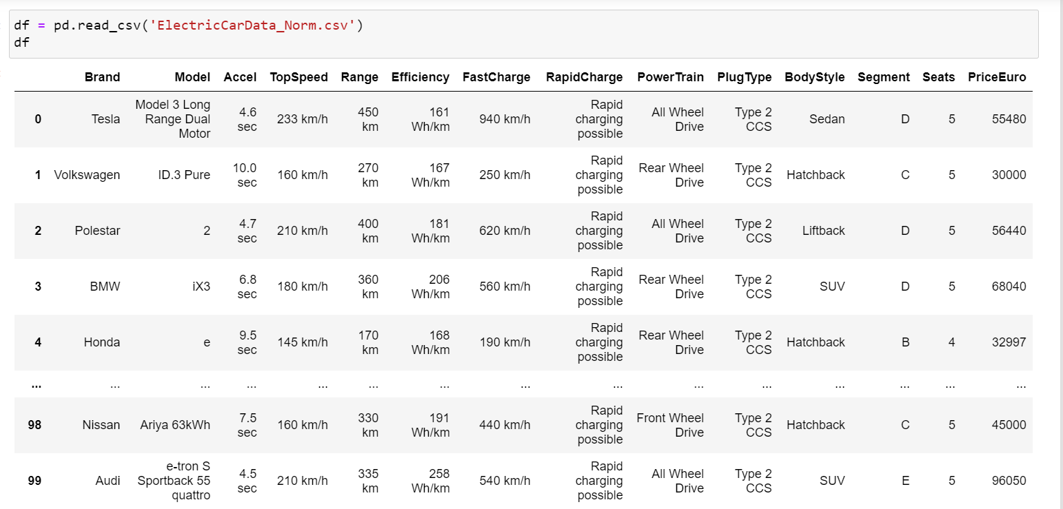

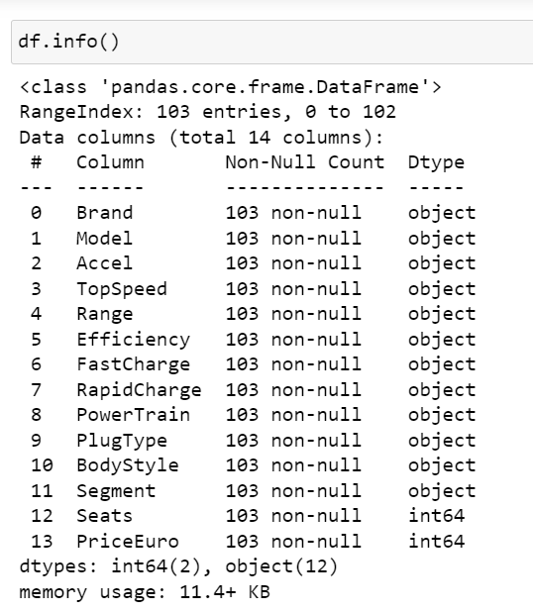

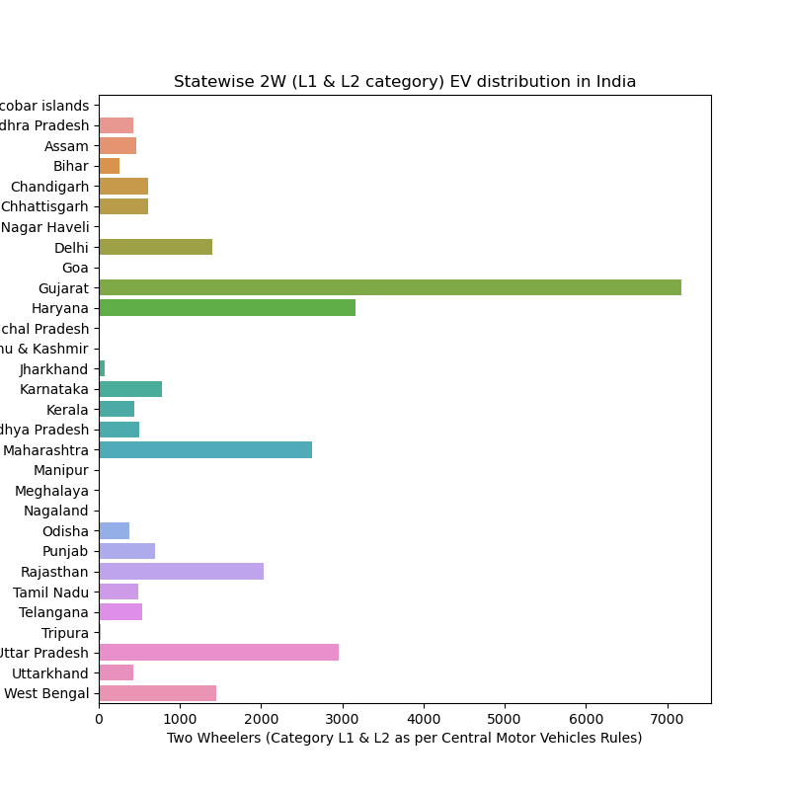

Fig 1: Statewise 2-wheeler (L1-L2 category) distribution in India

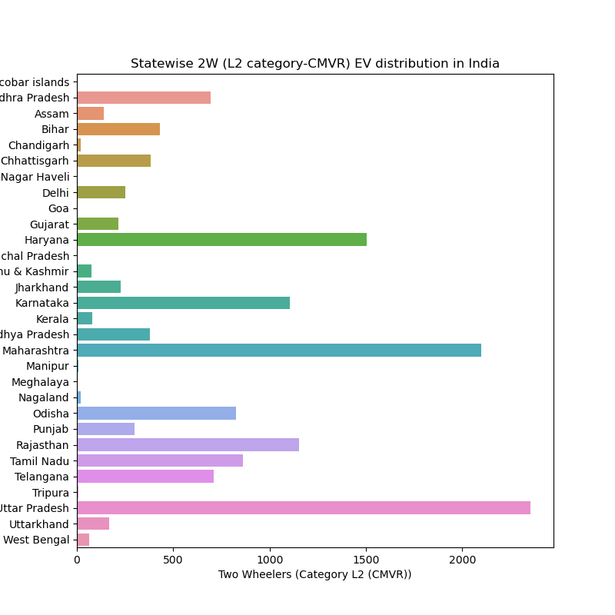

Fig 2: Statewise 2-wheeler (L2-CMVR) distribution in India

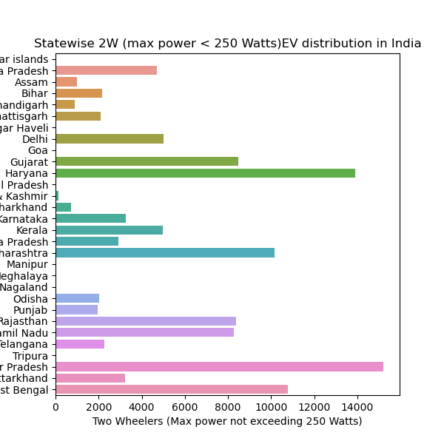 Fig -3: 2-wheeler (max power < 250 watts) distribution in India

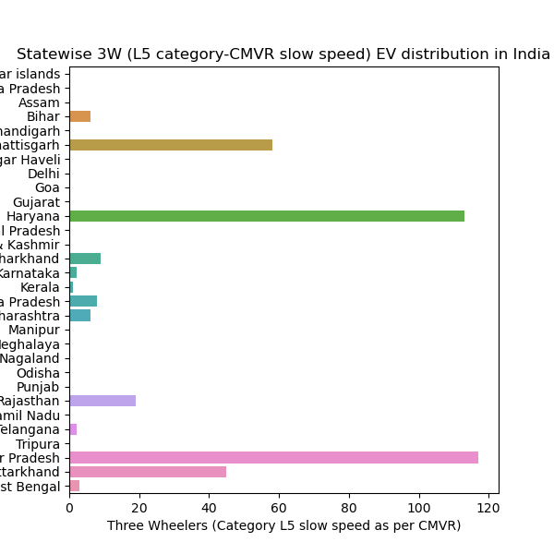

Fig 4: Statewise 3-wheeler(L5) CMVR distribution in India

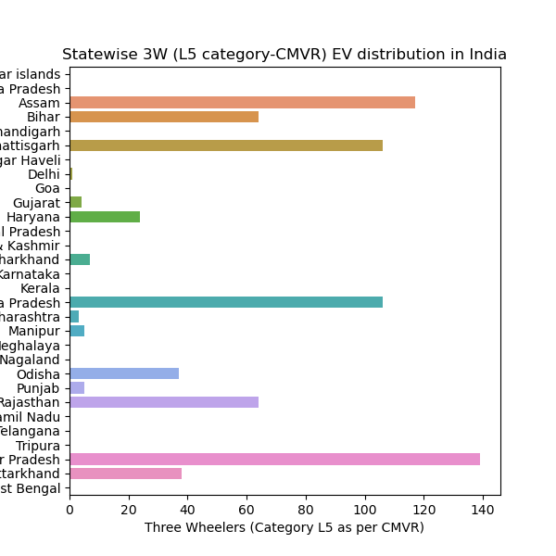

Fig 5: Statewise 3-wheeler (L5) distribution in India

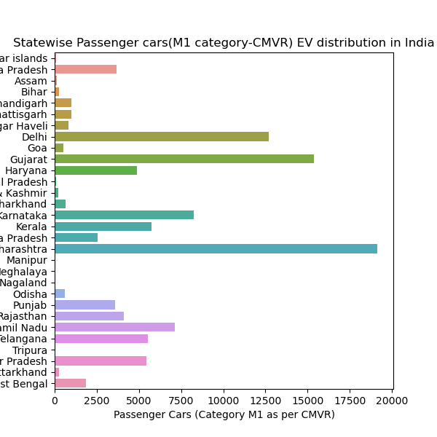

Fig 6: Statewise passenger cars distribution in India

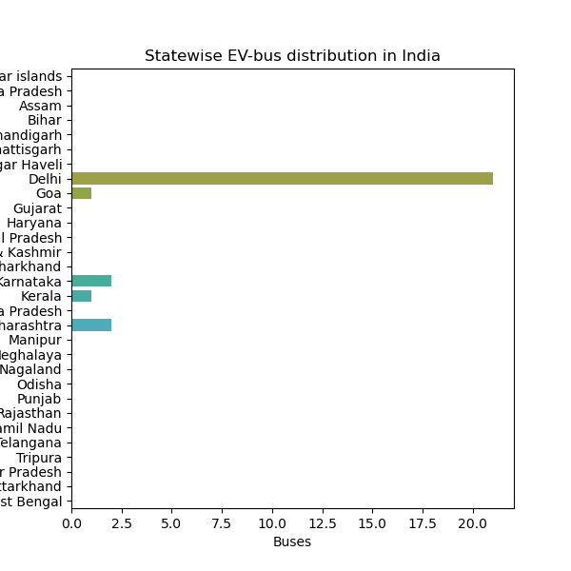

Fig 7 : Distribution of buses in India

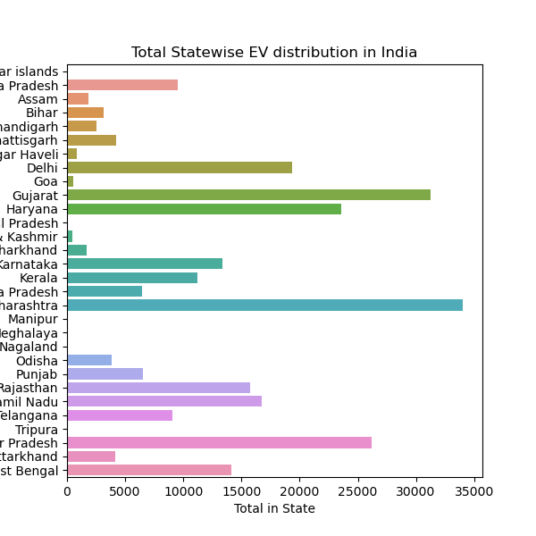

Fig 8: Overall statewise EV distribution in India

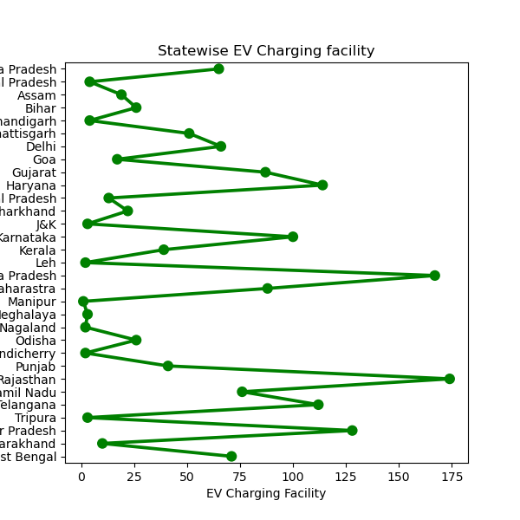

Fig 9 : Statewise EV charging-facility distribution in India

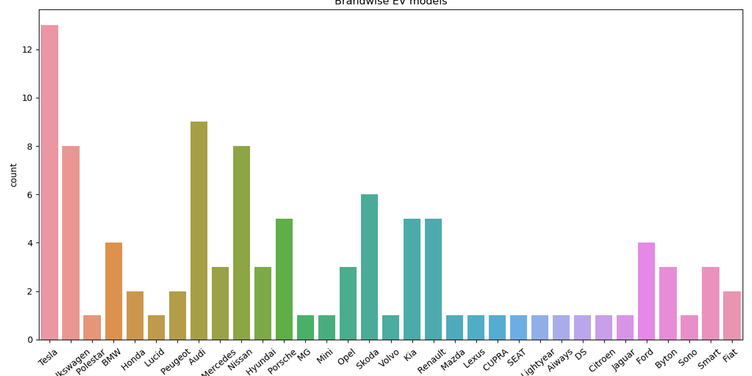

Fig 10 – Brandwise EV distribution

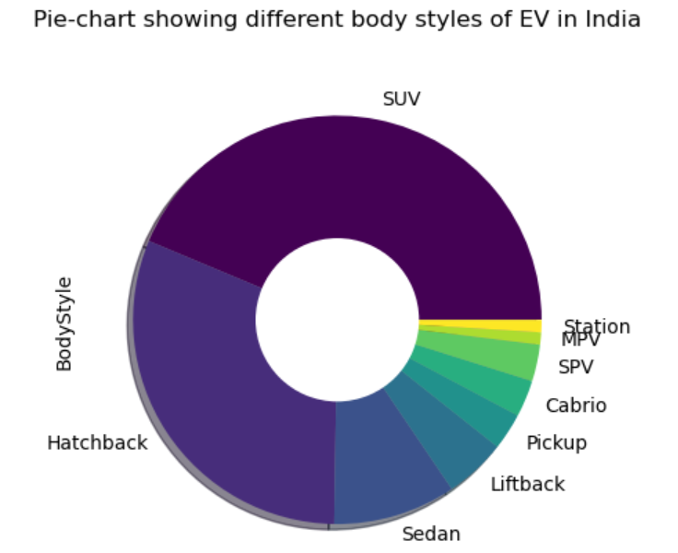

Fig 11: Pie diagram showing different body-styles of EVs

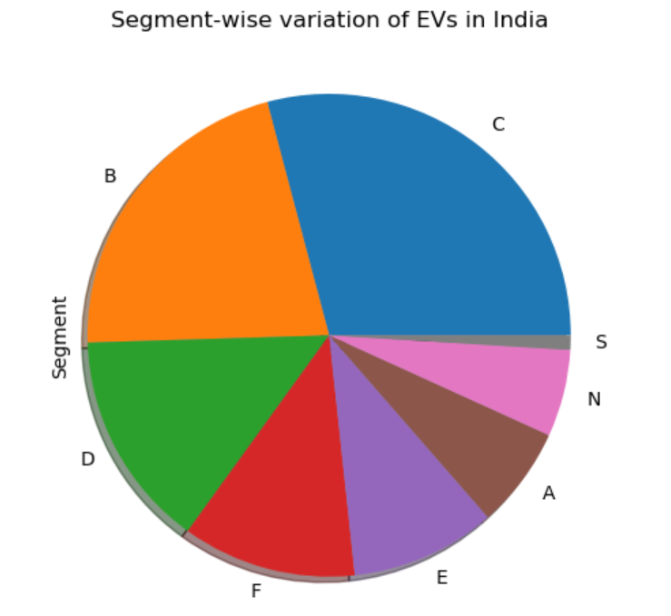

Fig 12: Pie diagram showing segment wise EV variation

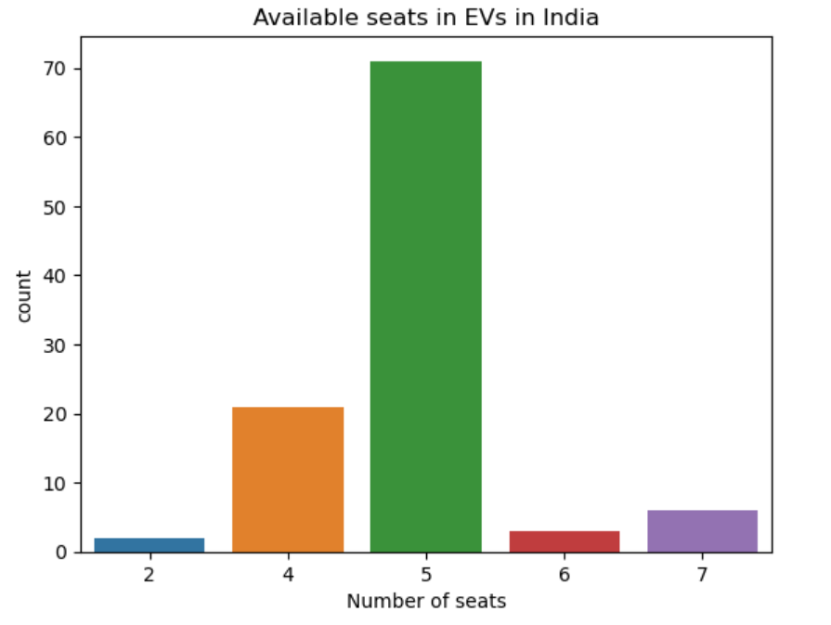

Fig 13: Barplot showing no. of seats distribution in EVs

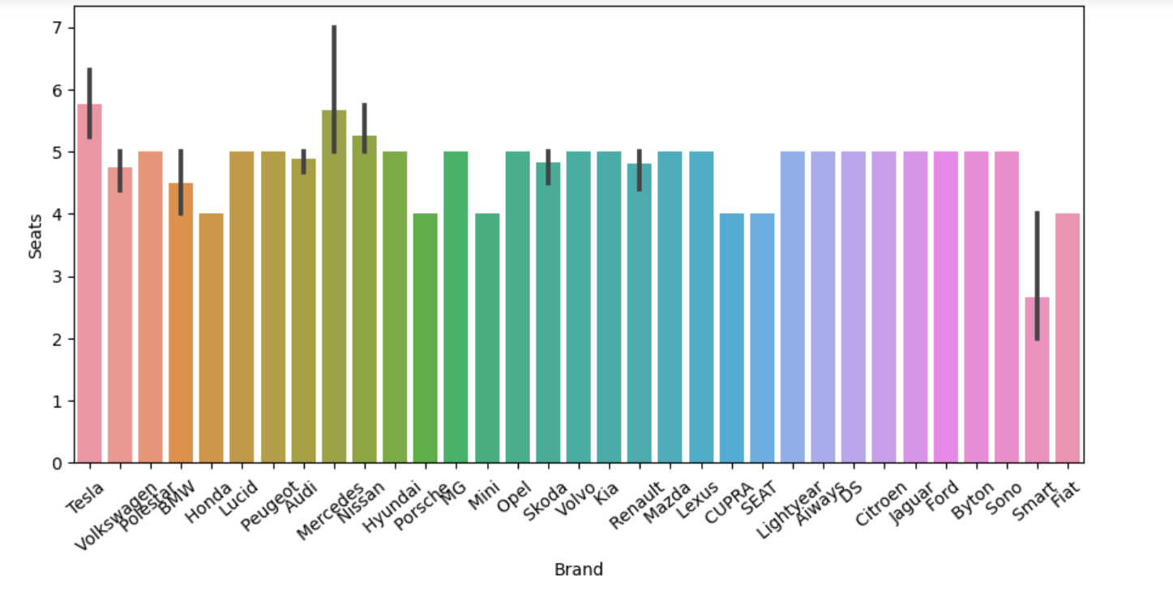

Fig 14: barplot showing brandwise variation in no. of seats in EVs.

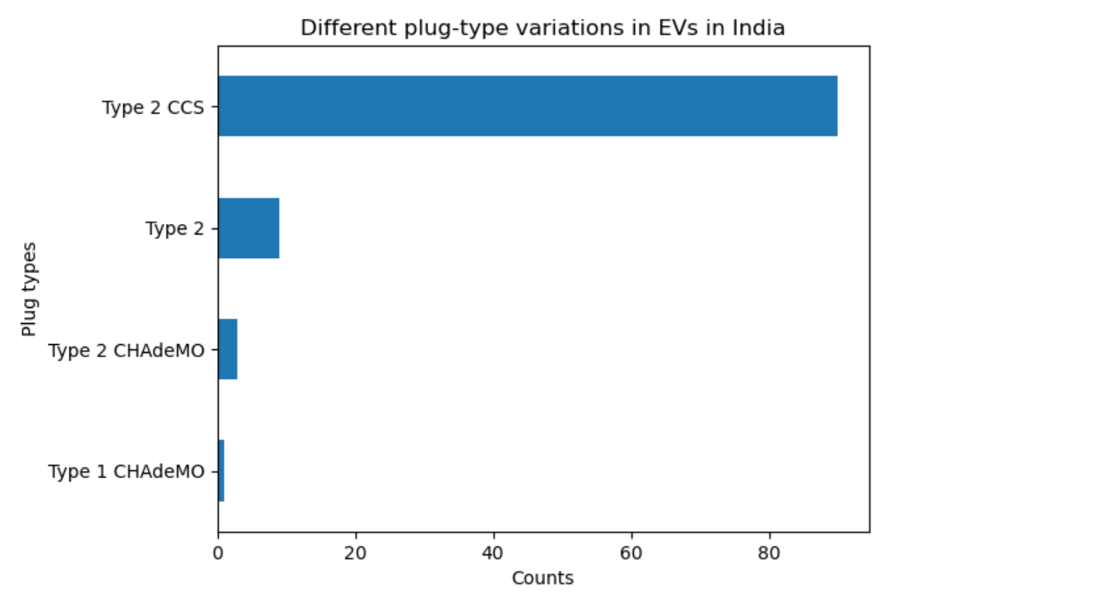

Fig 15: Distribution of different plug-types in EVs.

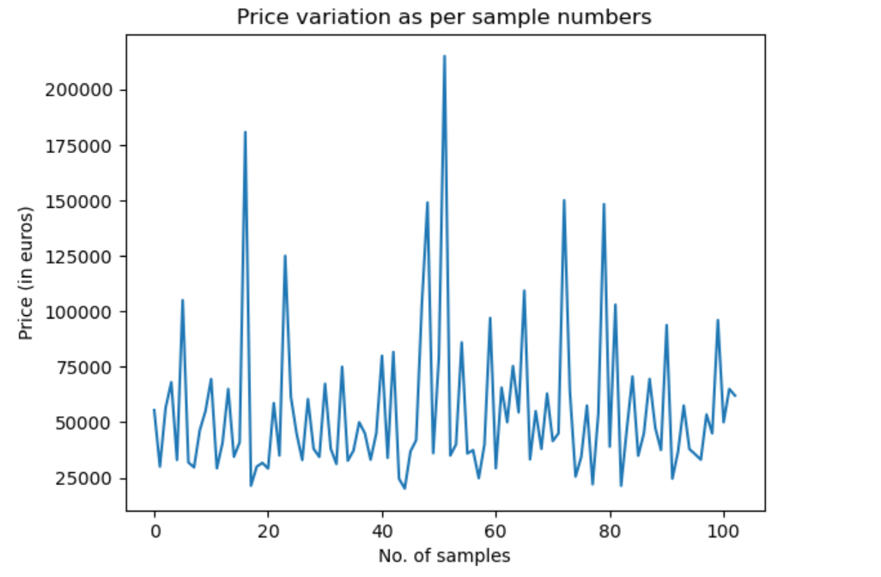

Fig 16: Graph showing number of sample-wise price distribution in EVs.

Segment Extraction:

K-Means clustering is an important unsupervised algorithm to segregate the unlabelled data into clusters based on similarity features. For n number of unlabelled multivariate datasets, various features are like -

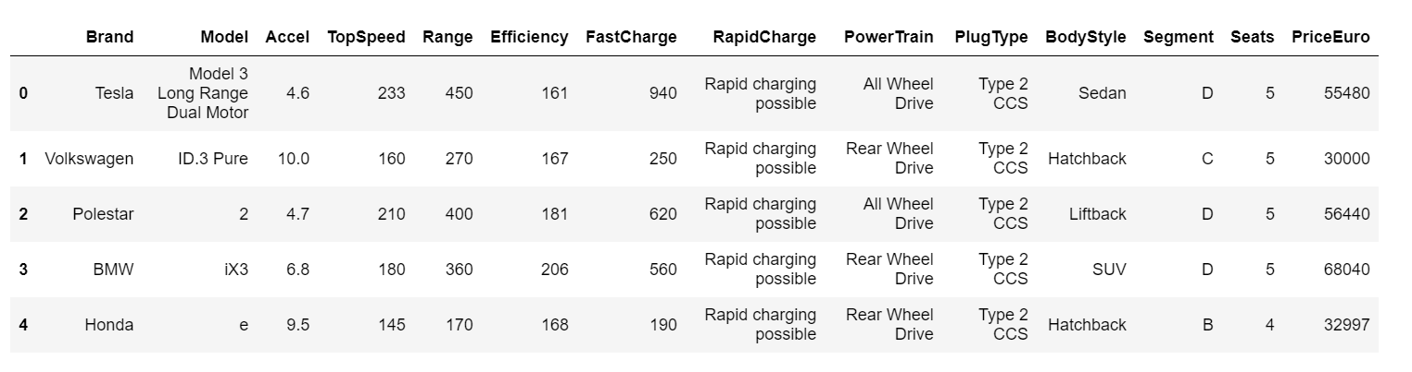

Data Preprocessing

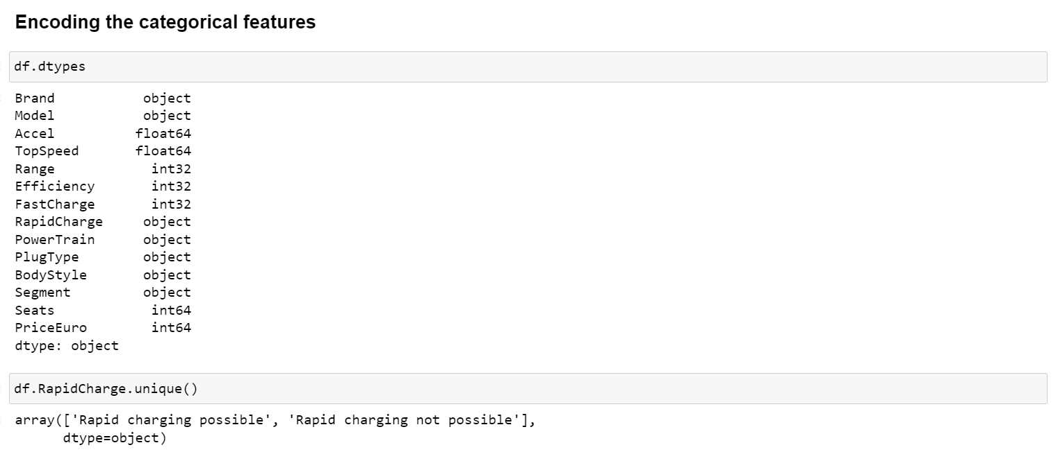

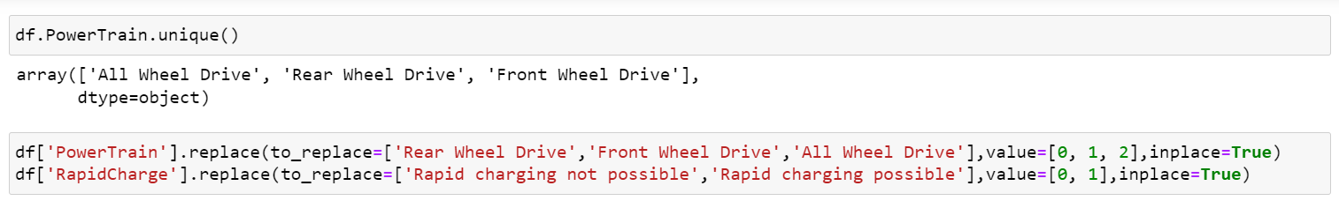

Feature Selection:



Among the 14 features given in the datasets, 9 features are selected based on the relevance.

Correlation matrix is given by –

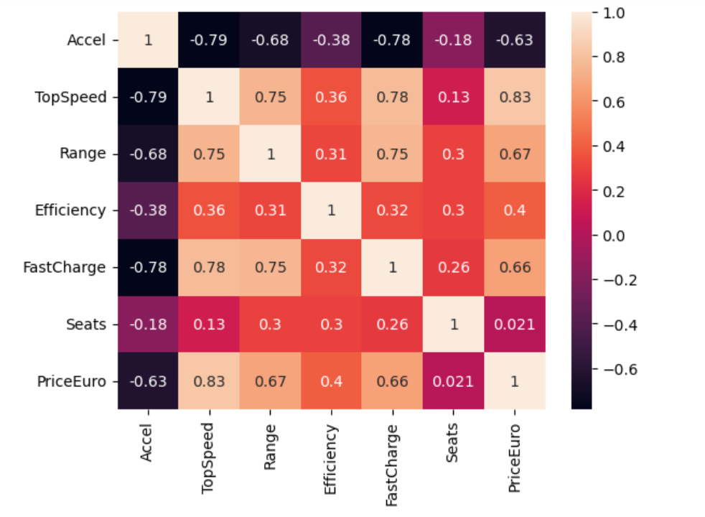

Fig 18: Correlation matrix of the features

The Elbow method:

The elbow method calculates the WCSS (Within Cluster sum of squares) with actually varying the number of clusters from 1 to 10. For each point of a particular cluster, WCSS is the sum of squares of distances between the point and the centroid of that cluster.

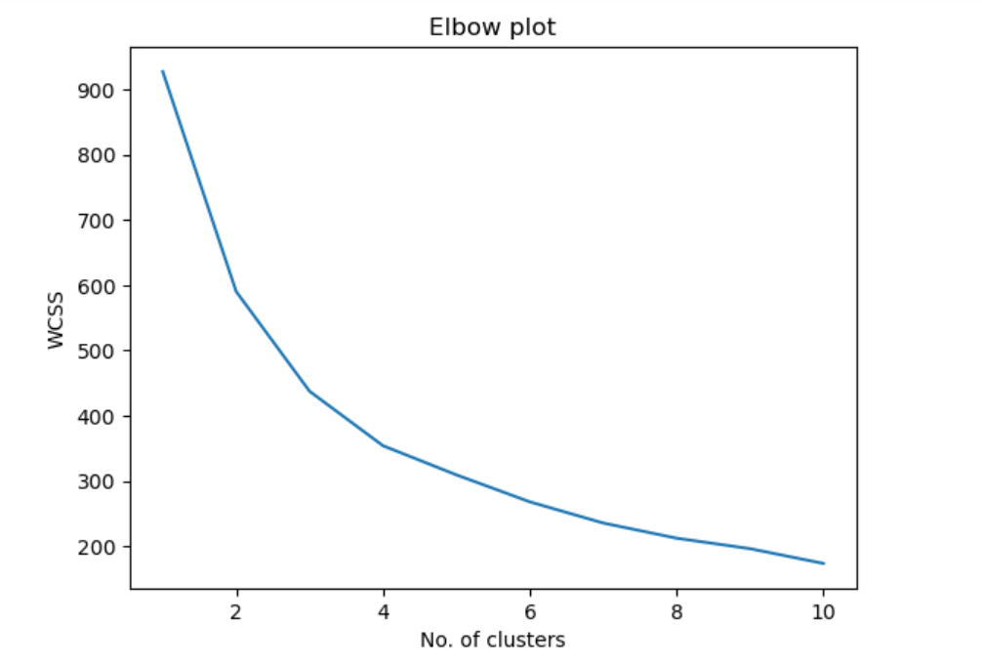

Fig 20: Elbow plot.

By plotting the WCSS-no. of clusters graph, we get a curve having an elbow shape. At cluster = 4, the slope of the curve becomes gentle and the curve becomes almost parallel to X-axis. Hence, the elbow method provides the optimal number of clusters as 4.

Potential Segments:

Behavioural Segmentation – market segmentation based on customer behaviour aspects,

Psychometric Segmentation – market segmentation based on socio-psychological aspects,

Fig -21: Flow chart showing behavioural segmentation

Fig – 22: Flow chart showing psychographic segmentation.

Geographic segmentation:

Fig – 22: Flow chart showing geographic segmentation

Behavioural study:

Behavioural study for in-depth market research to know about spending patterns, product preferences, prices, requirements of automobiles etc.

Datasets

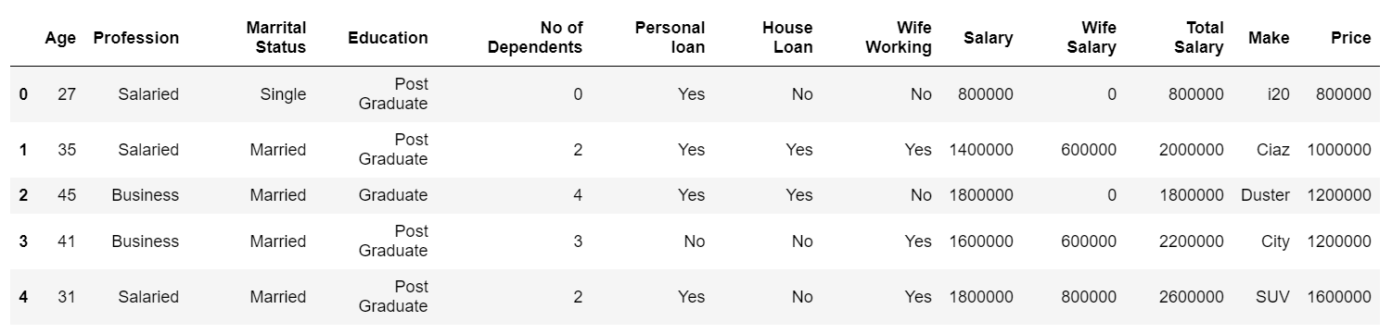

Fig 23: Datasets for population behavioural study

Correlation matrix

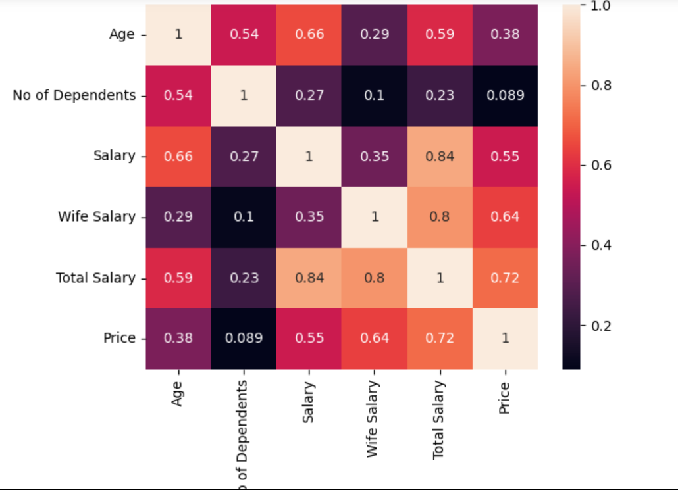

Fig – 24: Correlation matrix.

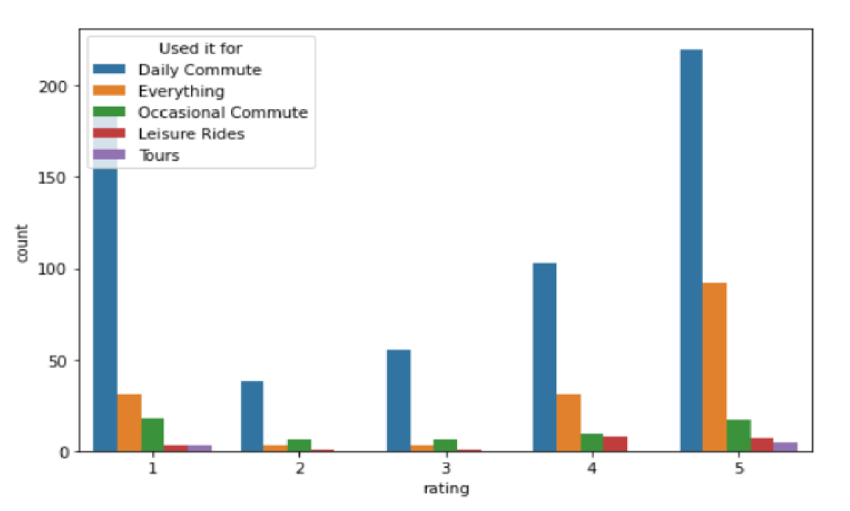

Fig 25: barplot showing major usages of EVs in India

Irrespective of all the available ratings, the barplot shows that the major usage of EVs in India is for daily commutes.

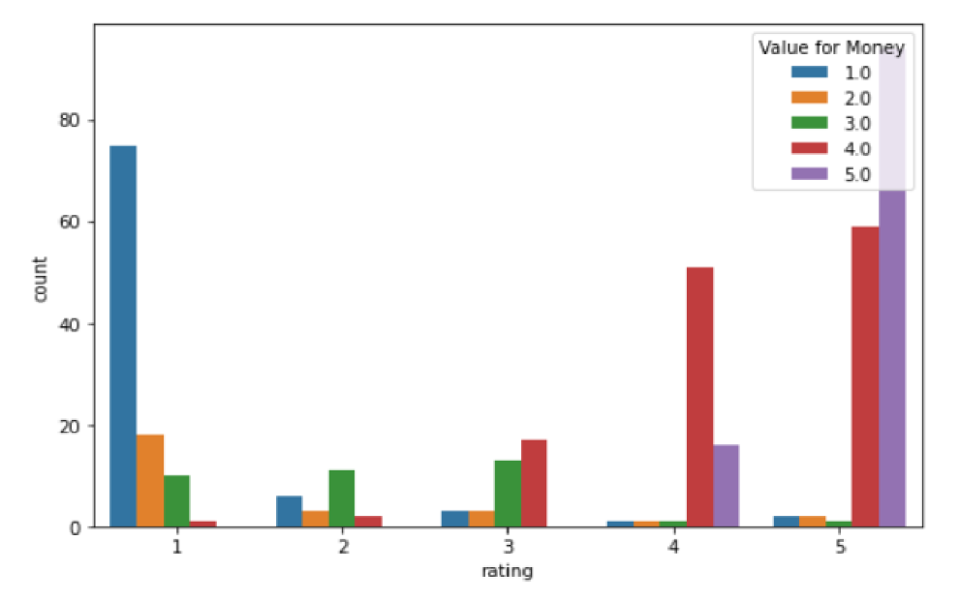

Fig-26 (a): barplot showing ratings of EV rides with a perspective of value for money.

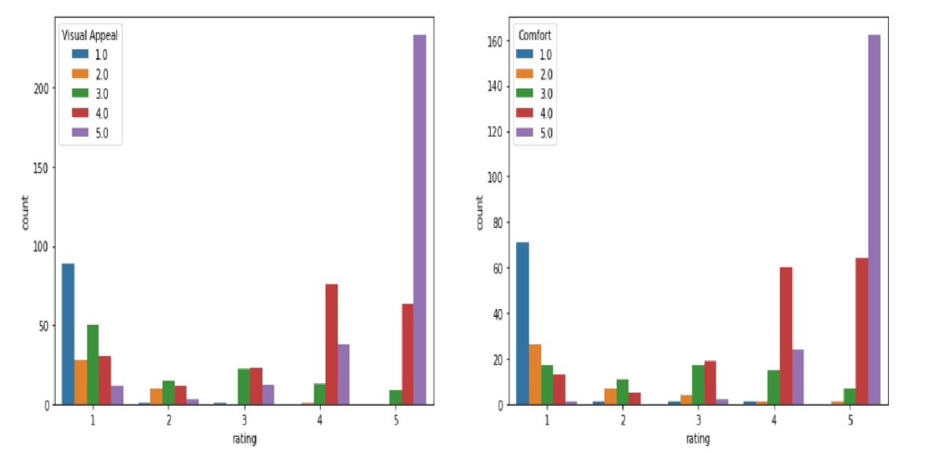

Fig 26 (b): barplot showing rating with perspective of visual appeal and comfort respectively.

The barplot clearly shows that psychographic factors to consider are – comfort, value for money and visual appeal.

Target segments:

1) Psychographic factors like comfort, value for money,

2) behavioural factors like suitable price range, good acceleration,

3) Geographic factors such as market friendly states.

We have shown previously with analysis that Maharastra, Karnataka,Tamil Nadu are some states to invest in the EV-industry point of view.

Marketing Mix:

Setting prices for our products is both an art and a science. Most importantly, you must know and understand your cost of production. From there you can adjust based on product characteristics, a specific pricing strategy, customer price sensitivity, customer values, and other factors. Price contributes to the perception of your product, that is, when consumers see a product price it sends signals to them about quality, match with the market outlet, expectations for assistance, etc. Keeping accurate and complete records accounting for all steps – production, packaging, storage, promotion, transportation/distribution, and sales – will assist you in setting a price and making adjustments as necessary.

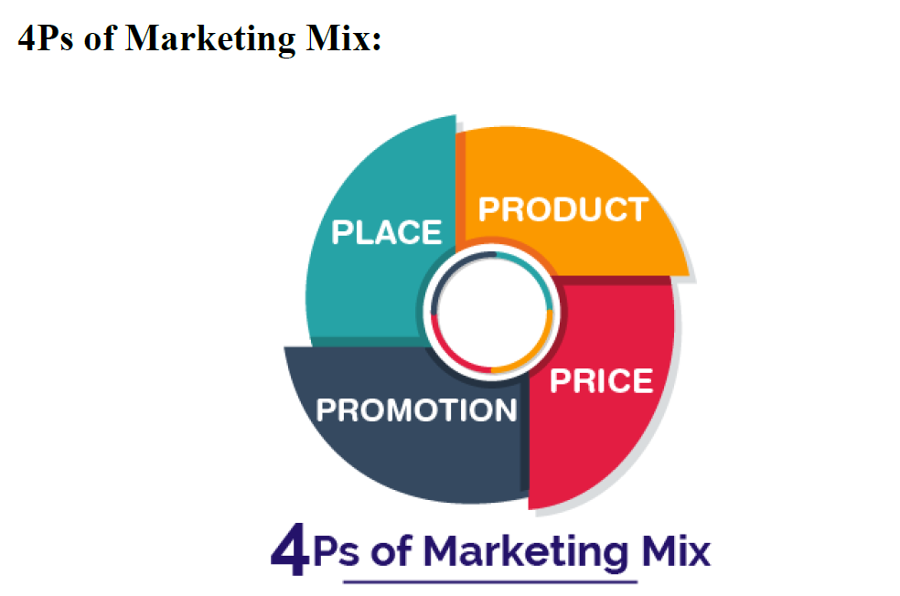

The 4Ps helps companies to review and define key issues that affect the marketing of its products and services and are often now referred to as the 7Ps framework for the digital marketing mix.

Marketing as a whole relies on all seven Ps**:**

It is essential to consider them as a whole, and not in isolation. Customers must experience a coherent view of your company and your product, and that can only come from viewing the customer experience from end-to-end across all seven Ps.

Importance of Marketing Mix:

It helps understand what our product or service can offer to our customers and helps plan a successful product offering. Helps with planning, developing and executing effective marketing strategies. Help determine whether your product or service is suitable for your customers.

Product:

Since the company is starting with the Electric vehicles, the battery quality, mileage per single charge, 0-60 speed/time all these affect the perception of the product as India is fairly new to this product.

**Price:** We can take reference from global market but that won’t be applicable to India as its demographic is too diverse.

**Place:** It depends on the government schemes and the concession they provide to promote the production of the electric vehicles.

**Promotion:** Promotion can be based on the analysis. More offers & promotions can be given to the segments that are more valuable to the company.

Github Link:

<https://github.com/argha009/EV-market-segmentation>

References:

1) <https://www.smev.in/ev-industry>

2) <https://www.statista.com/statistics/1234761/india-electric-vehicle-sales-by-type>

3) <https://www.mordorintelligence.com/industry-reports/india-electric-vehicle-market>

4) <https://en.wikipedia.org/wiki/Electric_vehicle>