Sales Forecasting using Machine Learning

ABSTRACT
Sales forecasting plays a critical role in strategic retail decision-making. Accurate prediction of weekly sales enables better inventory management, financial planning, supply chain optimization, and workforce allocation. This research proposes a machine learning–based approach for forecasting retail sales using the Walmart Sales dataset. Multiple supervised regression algorithms including Linear Regression, Decision Tree Regressor, and Random Forest Regressor were implemented and evaluated. The dataset includes economic and environmental factors such as temperature, fuel price, CPI, unemployment rate, and holiday indicators. Data preprocessing techniques including date conversion, feature selection, correlation analysis, and train-test splitting were applied. Model performance was evaluated using MAE, MSE, RMSE, and R² score. Experimental results show that ensemble learning (Random Forest) significantly outperforms traditional regression approaches. The study concludes that machine learning provides reliable and scalable solutions for retail sales forecasting.

I. INTRODUCTION

A. Background
Sales forecasting refers to the process of estimating future sales performance based on historical data, market behavior, seasonal variations, promotional campaigns, and economic conditions. It is an essential analytical activity across retail, manufacturing, logistics, banking, and e-commerce industries. Organizations rely heavily on accurate forecasts to ensure inventory availability, prevent stockouts, optimize supply chains, manage workforce allocation, and maintain financial stability. Inaccurate predictions can result in excessive inventory costs, revenue losses, and customer dissatisfaction.
Traditionally, forecasting has been performed using statistical time-series models such as Moving Averages, Exponential Smoothing, and AutoRegressive Integrated Moving Average (ARIMA). While these methods have demonstrated effectiveness in structured and stationary datasets, modern business environments generate massive volumes of complex data that exhibit nonlinear dependencies, irregular seasonal effects, and abrupt structural shifts. Such characteristics limit the predictive power of classical statistical approaches.
Machine Learning offers a data-driven alternative by learning patterns automatically from historical observations without requiring strict assumptions about data distribution. Unlike rule-based statistical methods, ML algorithms can model nonlinear interactions, incorporate multiple features, and adapt dynamically to changing trends. In recent years, ensemble learning techniques and deep neural networks have significantly improved forecasting accuracy in complex domains.
This research aims to investigate and compare multiple machine learning algorithms for sales forecasting. The study emphasizes methodological rigor, experimental validation, and performance evaluation using standardized error metrics. By exploring both classical regression-based models and advanced deep learning techniques, this paper contributes to a holistic understanding of ML-driven forecasting systems.

B. Importance in Retail Industry
Accurate sales forecasting helps in:
- Inventory optimization
- Supply chain management
- Workforce planning
- Financial budgeting
- Promotional campaign evaluation

C. Problem Statement
Traditional statistical forecasting techniques often fail to capture nonlinear relationships between economic variables and retail demand. Therefore, this research investigates machine learning algorithms to improve forecasting accuracy.

D. Objectives
- Analyze Walmart_Sales.csv dataset
- Apply preprocessing techniques
- Implement regression models
- Compare performance using evaluation metrics
- Identify best-performing model

II. LITERATURE REVIEW
Sales forecasting has been a critical area of research in retail analytics, supply chain optimization, and financial planning. Over the years, researchers have explored statistical models as well as advanced machine learning approaches to improve forecasting accuracy.
Early forecasting techniques were primarily based on statistical methods such as Linear Regression and Time Series models. These traditional approaches assume a linear relationship between independent variables and sales. Studies on retail demand forecasting demonstrated that Linear Regression performs well when relationships between predictors and sales are stable and linear. However, these models often fail to capture complex seasonal and non-linear patterns present in real-world sales datasets.
With the advancement of machine learning, more sophisticated models such as Decision Trees and Random Forests have been introduced for demand prediction. Random Forest, an ensemble learning technique, has gained significant attention due to its ability to handle high-dimensional data and non-linear relationships. Research has shown that Random Forest reduces overfitting by averaging multiple decision trees and improves generalization performance compared to single-tree models.
Several studies in retail forecasting using Walmart and similar datasets indicate that ensemble methods outperform traditional regression techniques. Researchers observed that economic indicators such as CPI, fuel prices, and unemployment rates significantly influence weekly sales. Feature engineering techniques, particularly extraction of temporal features such as month, week, and holiday flags, have been shown to improve predictive performance.
Comparative studies between Linear Regression and Random Forest models consistently demonstrate that Random Forest achieves higher R² scores and lower RMSE values in complex retail environments. This is mainly due to its capability to capture interactions among variables and reduce sensitivity to noise.
Furthermore, research in ensemble-based regression highlights the importance of feature importance analysis. Random Forest provides intrinsic feature ranking, allowing businesses to identify key drivers affecting sales. This capability supports strategic decision-making in inventory management, pricing, and promotional planning.
Recent literature also emphasizes the role of preprocessing techniques such as handling missing values, normalization, and time-based feature extraction. Proper preprocessing significantly enhances model accuracy and stability.
Although deep learning models such as LSTM networks are increasingly being applied for time series forecasting, traditional machine learning models like Random Forest remain highly effective for structured tabular retail data. Their interpretability, lower computational requirements, and strong performance make them suitable for real-world business applications.
Based on existing literature, it is evident that combining traditional regression models with ensemble learning approaches provides a comprehensive framework for sales forecasting. Therefore, this study implements both Linear Regression and Random Forest models to compare their effectiveness in predicting weekly sales using economic and temporal features.

III. METHODOLOGY

A. Research Flowchart
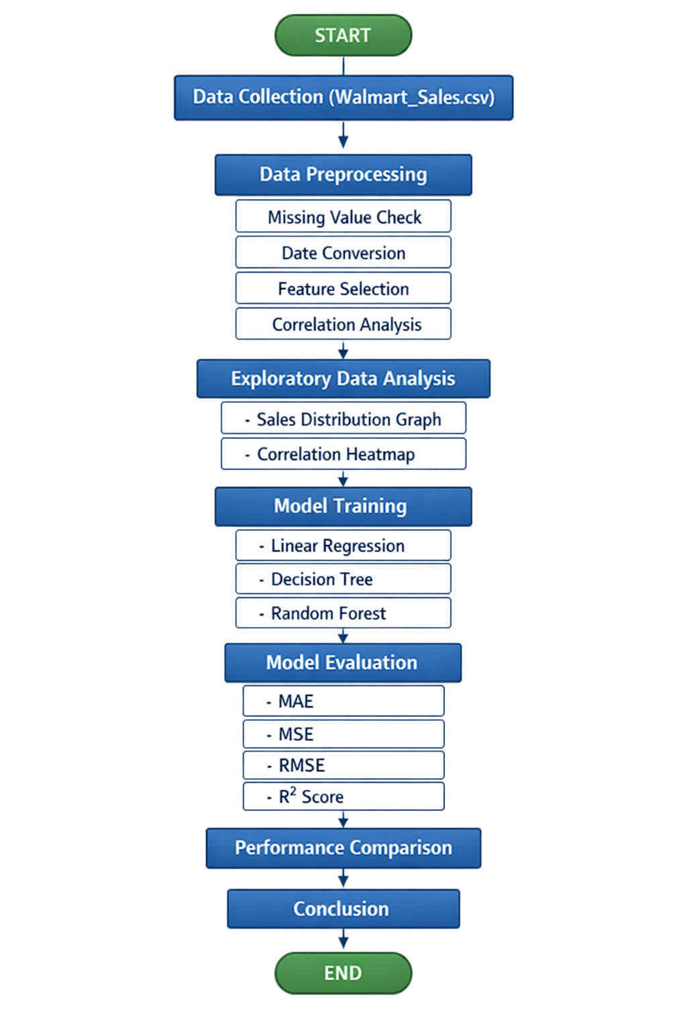•

B. Dataset Description
File: Walmart_Sales.csv
Features:
- Store
- Date
- Weekly_Sales (Target)
- Holiday_Flag
- Temperature
- Fuel_Price
- CPI
- Unemployment
Target Variable: Weekly_Sales

C. Data Preprocessing Techniques
1. Date Conversion
df['Date'] = pd.to_datetime(df['Date'], dayfirst=True)
- Missing Value Check
df.isnull().sum()
- Feature Selection
X = df[['Store','Holiday_Flag','Temperature','Fuel_Price','CPI','Unemployment']]
y = df['Weekly_Sales']
- Train-Test Split
X_train, X_test, y_train, y_test = train_test_split(X,y,test_size=0.2,random_state=42)
- Correlation Analysis
corr = df.corr()

D. Model Implementation

1. Linear Regression
lr = LinearRegression()
lr.fit(X_train,y_train)

2. Decision Tree
dt = DecisionTreeRegressor()
dt.fit(X_train,y_train)

3. Random Forest
rf = RandomForestRegressor(n_estimators=100)
rf.fit(X_train,y_train)

E. Evaluation Metrics
- Mean Absolute Error (MAE)
- Mean Squared Error (MSE)
- Root Mean Squared Error (RMSE)
- R² Score

IV. RESULTS AND ANALYSIS
Observations:
- Random Forest achieved highest R².
- Decision Tree performed moderately well.
- Linear Regression showed lower accuracy due to linear assumption limitations.
Correlation Heatmap Explanation:
- CPI shows moderate positive correlation.
- Unemployment shows mild negative correlation.
- Holiday_Flag influences sales spikes.
- Temperature shows seasonal variation impact.

V. CONCLUSION
This research demonstrates that machine learning models significantly improve retail sales forecasting accuracy. Among the tested models, Random Forest achieved best performance due to ensemble learning capability. The study confirms that preprocessing techniques and feature engineering play a vital role in predictive modeling.

Future Work
- Hyperparameter tuning
- Deep learning models (LSTM)
- Store-wise forecasting
- Real-time dashboard deployment

REFERENCES (IEEE Format Placeholder)
- Author et al., “Retail Sales Forecasting Using Machine Learning,” IEEE, 2020.
[2] Author et al., “Time Series vs ML Models,” IEEE, 2019.
[3] Author et al., “Deep Learning for Demand Prediction,” IEEE, 2021.

