**TU BERLIN**

**GEODESY AND GEOINFORMATION SCIENCE**

**GEO DATABASE**

**HOMEWORK 3**

Name: Arghadeep Mazumder

Matriculation Number: 378554

**TASK 1**

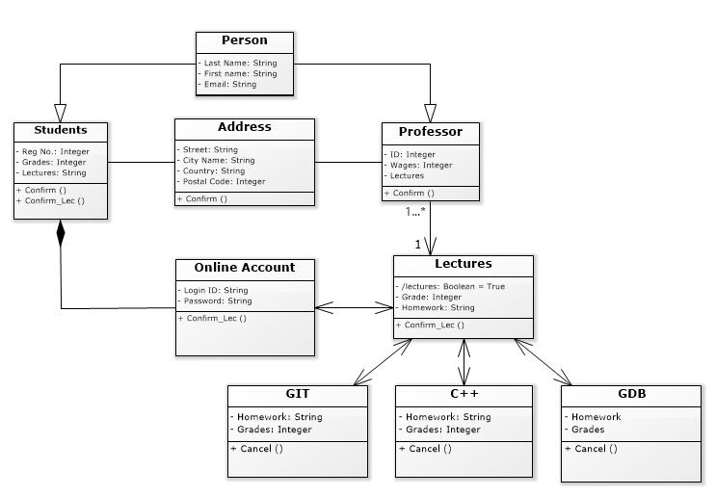

**TASK 2**

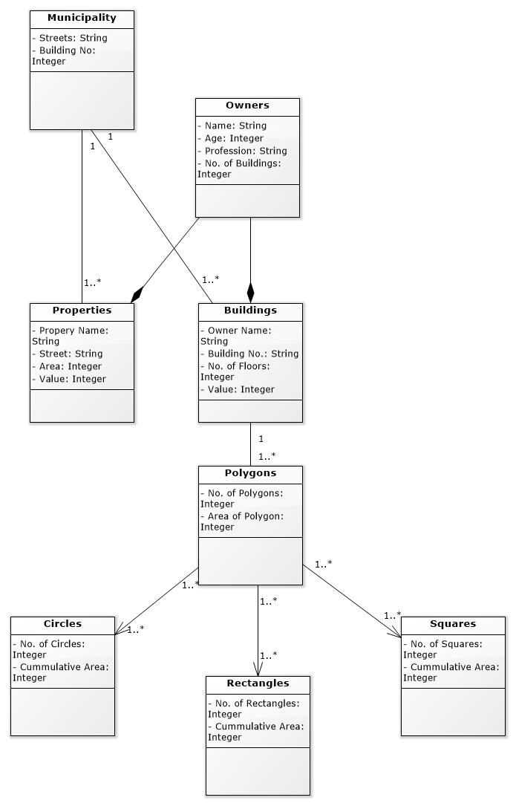

**TASK 3**

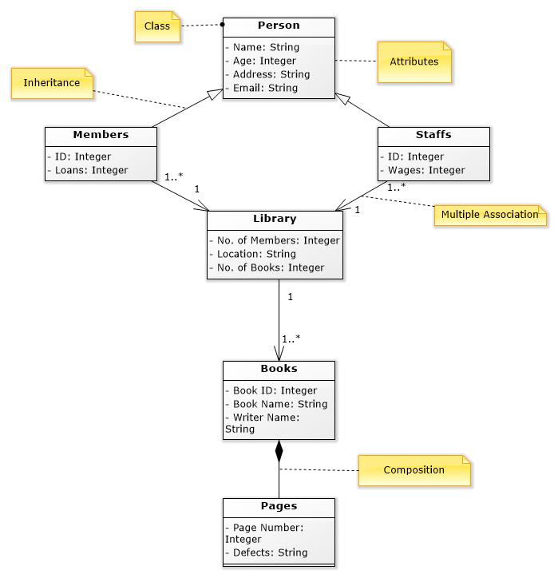

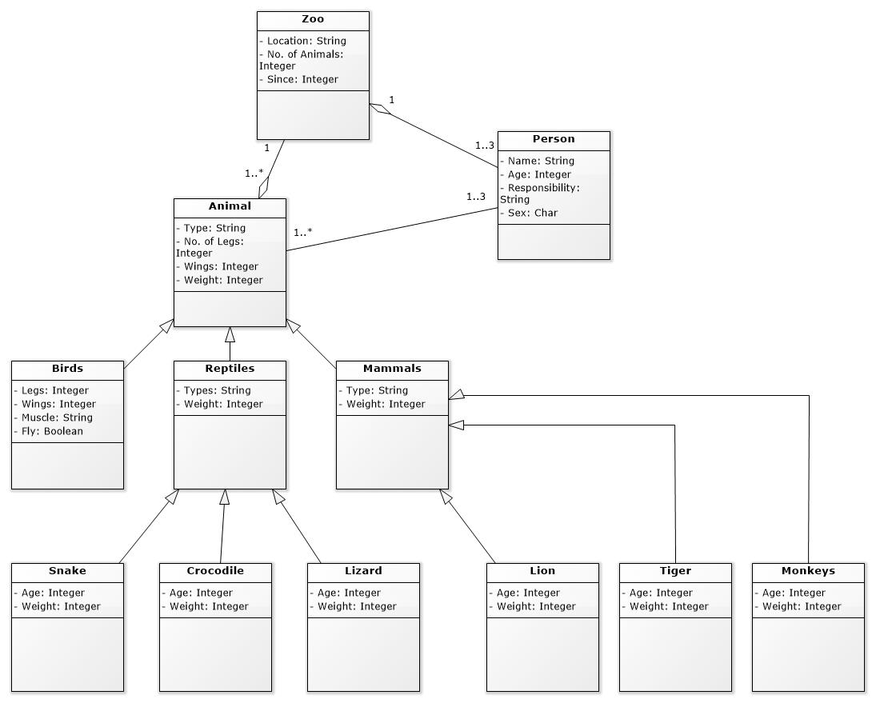**TASK 4**