SUPPLY CHAIN ANALYTICS PROJECT REPORT
Supply Chain Intelligence: Shipment Performance and Delivery Risk Analytics
DataCo Smart Supply Chain dataset | Python, MySQL, Power BI
Author: Arghadeep Ghosh, Data Analytics Consultant
Date: November 2026
Scope: 180,519 order-item records, 65,752 orders, January 2015 to January 2018
What this report is
A record of the actual analytical work: how the data was cleaned and validated, what was found, what each SQL query and dashboard visual does, and where the evidence stops. Each finding is labelled as observed, interpreted, or recommended, and recommendations are never presented as implemented actions.

Contents
1. Executive summary
2. Evidence base and verification
3. Project background and data structure
4. Python workflow
5. Order-level dataset and financial aggregation audit
6. Business questions and findings
7. SQL analysis
8. Power BI dashboard
9. Business problems and recommended actions
10. Technical skills demonstrated
11. Final business conclusion
12. Limitations and analytical integrity
Appendix A. Reproducibility notes and fixes
Appendix B. Significance test code

1. Executive summary
The project asks why 57% of delivered orders in the DataCo dataset arrive after the promised date, and whether the delivery promises themselves are realistic. The work covers data cleaning and validation in Python, 25 business questions in MySQL, and a Power BI dashboard.

Headline results (delivered orders only)
Measure | Result
Orders analysed | 62,897 delivered orders (65,752 in total; 2,855 canceled or suspected-fraud orders excluded from delivery KPIs)
Late delivery rate | 57.31% (36,048 orders); late orders average 1.62 days past the promise
Average promised vs actual days | 2.94 promised vs 3.50 actual (average delay 0.57 days)
Late rate by shipping mode | First Class 100.00%, Second Class 79.99%, Same Day 48.37%, Standard Class 39.85%
Share of late orders | First and Second Class are 34.8% of orders but 53.8% of late orders
Late rate by market, segment, month | Markets 56.55-57.68%; segments 57.08-57.59%; months 55.04-59.86%. None differs significantly (chi-square p between 0.10 and 0.97)
Net revenue and profit | 31.64M net revenue, 3.81M profit (12.03% margin)
Revenue lost to canceled/fraud orders | 1.41M, which is 4.26% of all net revenue

What the analysis concludes
- Observed: lateness depends almost entirely on the shipping mode. First Class promises 1 day and every order takes 2 days, so all 9,602 First Class orders are late.
- Observed: Standard Class averages 3.99 days against a 4-day promise, yet 39.85% of its orders are late, because delivery time is spread evenly from 2 to 6 days. An average hides this.
- Interpreted: the promised delivery times, not geography or season, are the main lever. Re-basing First Class to 2 days and Second Class to 4 days would lower the late rate from 57.31% to 34.26% in a what-if simulation.
- Recommended (not implemented): realistic promises per mode, reduction of the 5 to 6 day tail in Second and Standard Class, and monthly tracking of promise accuracy by shipping mode.
Data integrity note
The delivery pattern is unusually regular (uniform delivery days inside each mode, almost no regional or category effect). This suggests the dataset is simulated. The findings describe this dataset and demonstrate the method; they should not be presented as real-world logistics performance.

2. Evidence base and verification
Every figure in this report was checked against the supplied files. The table shows what was inspected and how.
File | Status | How it was used
Supplychain_analysis.ipynb | Inspected | 60 cells read in execution order; code, outputs and intermediate results documented in Sections 4 to 6
Supply chain sql work.sql | Inspected | All 25 questions read; techniques listed only where present in the code (Section 7)
supply_chain_dashboard_final.pbix | Inspected (visuals) | Page layout, visual types, fields, titles and slicers read from the report definition. The DAX measures sit in the compressed data model, which could not be read directly; the measure formulas in Section 8 are those written during the build
SUPPLY CHAIN DASHBOARD SS.pdf | Inspected | Dashboard screenshot compared with the PBIX definition
Questions PDF (25 questions) | Inspected | Wording and numbering of the questions
README_SUPPLY.md | Inspected | Cross-checked against notebook results; corrections listed in Appendix A
DataCoSupplyChainDataset.csv | Recomputed | Raw file re-processed with the notebook cleaning steps to produce a replica of the cleaned data
dataco_clean.csv | Not supplied | Not attached in this session. The replica reproduces every figure shown in the notebook outputs, and was used for the checks in Section 8.3

Items not present in the supplied files are not claimed. In particular, no predictive model was built and the SQL file contains no JOIN.

3. Project background and data structure
The DataCo Smart Supply Chain dataset describes orders, customers, products, shipping, delivery outcomes and financial values. The raw file has 180,519 rows and 53 columns. It was read with Latin-1 encoding because it contains non-UTF-8 characters.

Why granularity matters
Each row is an order item, not an order. The file has 180,519 distinct Order Item IDs but only 65,752 distinct Order IDs, about 2.75 items per order. Shipping mode, region, scheduled and actual days and delivery status are identical for every item in one order, so a delivery is an order-level event.
Counting rows would count a multi-item order several times and would weight orders by how many items they contain. The item-level late rate is 57.29% and the order-level late rate is 57.31%, so the difference here is small, but the order count (172,765 delivered items against 62,897 delivered orders) would be badly wrong. All delivery metrics in this report are computed on one row per order.

4. Python workflow
The steps below follow the order of the notebook.

4.1 Loading and first inspection
The CSV was read with pandas using encoding latin1. Shape (180,519, 53), head(), info(), dtypes and a numbered column list gave the first picture of the data: order and shipping fields, customer and product fields, delivery status, financial fields and geography. A data-dictionary table combined each column with its type, missing count and missing percentage.

4.2 Data quality assessment
Check | Result | Decision
Product Description | 100% missing (180,519) | Dropped: no content
Order Zipcode | 86.24% missing (155,679) | Dropped: mostly empty and not needed for the analysis
Customer Lname | 8 missing | Dropped with the other personal fields
Customer Zipcode | 3 missing | Dropped with the other personal fields
Fully duplicated rows | 0 | No action
Duplicated Order Item ID | 0 | Confirms one row per item
Unique Order IDs | 65,752 | Basis for order-level analysis

Not every missing value needs imputation. The two largely empty columns carried no information for a delivery study, and the tiny gaps were in fields that were removed for privacy reasons. Imputing them would add assumptions without improving the analysis.

4.3 Column selection and privacy
Thirteen columns were dropped. Before dropping four columns, the notebook asserted that each was identical to a retained column (Benefit per order = Order Profit Per Order, Product Price = Order Item Product Price, Product Category Id = Category Id, Sales per customer = Order Item Total), so no information was lost.
Group | Columns dropped and why
Empty or unneeded (3) | Product Description, Order Zipcode, Product Image
Personal data (6) | Customer Email, Password, Fname, Lname, Street, Zipcode. The email and password columns each held a single value across the whole file, so they carried no analytical value; removing personal fields is good practice in a portfolio project
Exact duplicates (4) | Benefit per order, Product Price, Product Category Id, Sales per customer

4.4 Dates and text
The order and shipping date strings were converted to datetime. Orders run from 2015-01-01 to 2018-01-31. Text columns were stripped of leading and trailing spaces and repeated spaces were collapsed, which fixed values such as "West of USA " and "US Center " so that grouping works. Spanish country names (for example Alemania, Brasil) were mapped to English using a 103-row translation file, leaving 164 countries with no non-English names.

4.5 Feature engineering
Feature | Definition and purpose
order_year, order_month | Year and first day of the month of the order, for time grouping
delay_days | Actual minus scheduled shipping days. Positive: late. Zero: on schedule. Negative: early
is_canceled | 1 when Order Status is CANCELED
is_suspected_fraud | 1 when Order Status is SUSPECTED_FRAUD
in_scope | 1 unless Delivery Status is "Shipping canceled"; defines the delivered population for delivery KPIs

The original text date columns and a temporary helper column were then dropped and all columns were renamed to snake_case. The final dataset has 180,519 rows and 46 columns: 53 original, minus 13 dropped, minus 2 text dates, plus 2 parsed dates and 6 engineered columns.

4.6 Cancellation and fraud investigation
A crosstab of real-versus-scheduled days against the late-delivery flag found 4,423 rows where actual days exceeded scheduled days but the flag was 0. Every one of them had Delivery Status "Shipping canceled" (2,107 CANCELED rows and 2,316 SUSPECTED_FRAUD rows). These orders never completed a delivery, so a late flag of 0 is correct and they do not belong in delivery performance.
They were flagged rather than deleted. In total 7,754 item rows (2,855 orders) are out of scope. They are excluded from delivery KPIs and kept for the separate lost-revenue analysis (Section 6.6).

4.7 Validation
- Delivery Status and Late_delivery_risk align perfectly: Late delivery maps to flag 1 (98,977 rows); Advance shipping (41,592), Shipping on time (32,196) and Shipping canceled (7,754) all map to 0.
- For the in-scope rows, the flag equals "actual days greater than scheduled days". An earlier assumption that this held for all rows was corrected by the 4,423 canceled and fraud exceptions above.
- Within every in-scope order the late flag has exactly one distinct value (62,897 of 62,897 orders), so one value per order is safe to use.
- Rows per month fall from 5,189 (September 2017) to 2,255 (October 2017). Orders per month stay between 1,585 and 2,124; the fall is a change in items per order (3.00 to 1.02), not in order volume (Section 6.5).
Why this matters for modelling
Delivery Status and the late flag describe the delivery outcome. They cannot be used as inputs to a model that predicts lateness before delivery, because they contain the answer (target leakage). The same applies to delay_days. No predictive model was built in this project.

5. Order-level dataset and financial aggregation audit
The item-level table was grouped by order_id into a 65,752 x 16 order table. Shipping fields were taken once per order, the late flag with max(), the item count with size(), and sales, net sales (Order Item Total) and profit were summed across items. The same logic is implemented in SQL as the orders_delivery view.

Audit of the profit aggregation
The brief asked whether Order Profit Per Order repeats across item rows, which would make summing inflate profit. It does not. In 45,902 of the 65,752 orders the column holds different values for different items in the same order, so it is an item-level amount. Summing it per order is correct; taking it once per order would understate profit.
Sales is gross (price times quantity) and Order Item Total is net (sales minus discount, matching to within a cent). Revenue in this report is net revenue unless stated.
Measure (delivered orders) | Value | Source
Gross sales | 35,214,430 | Python, cell 52
Net revenue | 31,644,665 | Python, cell 52 (SQL: 31,644,664.75)
Profit | 3,806,421 | Sum of item profit
Profit margin on net revenue | 12.03% | Profit / net revenue
Average net revenue per order | 503.12
Average profit per order | 60.52

6. Business questions and findings

6.1 Overall delivery performance
Element | Detail
Business problem | How often are orders delivered after the promised date, and by how much?
Approach | Order-level KPIs on the 62,897 delivered orders
Result | 36,048 late orders (57.31%). On time or early: 26,849 (42.69%), made of 15,127 early (24.05%) and 11,722 exactly on time (18.64%). Average actual days 3.50, scheduled 2.94, average delay 0.57 days; late orders average 1.62 days late
Interpretation | The business promises delivery faster than it delivers, on average by about half a day, and most orders miss the promise
Recommended action | Treat promise accuracy as a tracked KPI (Section 9)
Limitation | Descriptive only; the data does not include carrier or route detail

6.2 Shipping mode performance
Shipping mode | Orders | Promised days | Actual days | Late orders | Late rate | Share of late orders
First Class | 9,602 | 1.00 | 2.00 | 9,602 | 100.00% | 26.6%
Second Class | 12,256 | 2.00 | 4.00 | 9,803 | 79.99% | 27.2%
Same Day | 3,407 | 0.00 | 0.48 | 1,648 | 48.37% | 4.6%
Standard Class | 37,632 | 4.00 | 3.99 | 14,995 | 39.85% | 41.6%
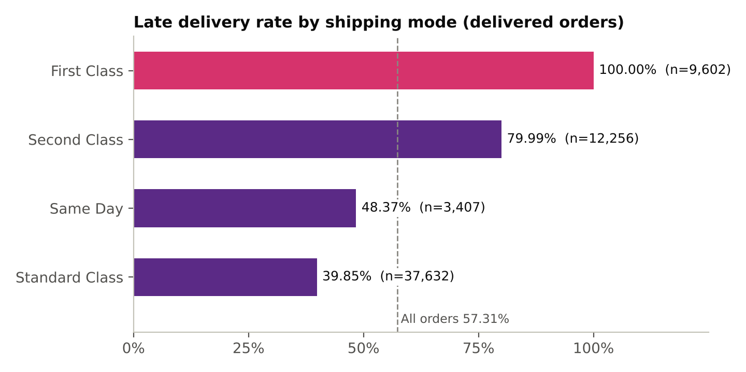
Figure 1. Late delivery rate by shipping mode
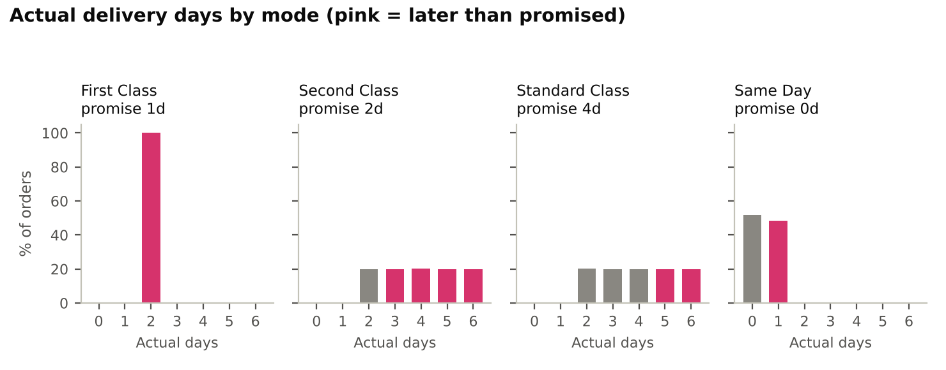
Figure 2. Distribution of actual delivery days by shipping mode
The distribution crosstab explains the rates. First Class always takes 2 days against a 1-day promise. Second Class takes 2, 3, 4, 5 or 6 days with about 20% each against a 2-day promise. Standard Class takes 2 to 6 days with about 20% each against a 4-day promise, so the 5 and 6 day orders (40%) are late. Same Day takes 0 days (1,759 orders) or 1 day (1,648 orders, late).
Element | Detail
Observed | First Class and Second Class are 34.8% of orders but 53.8% of late orders. Standard Class is 59.8% of orders and 41.6% of late orders
Interpretation | The promise set for each mode is the likely cause: the First Class promise is shorter than the delivery time it actually achieves, and the Second Class promise is half of its average delivery time. The data does not show why delivery itself is slow, so no operational cause is claimed
Recommended action | Review First and Second Class service-level commitments; investigate the operational reasons for Second Class transit times

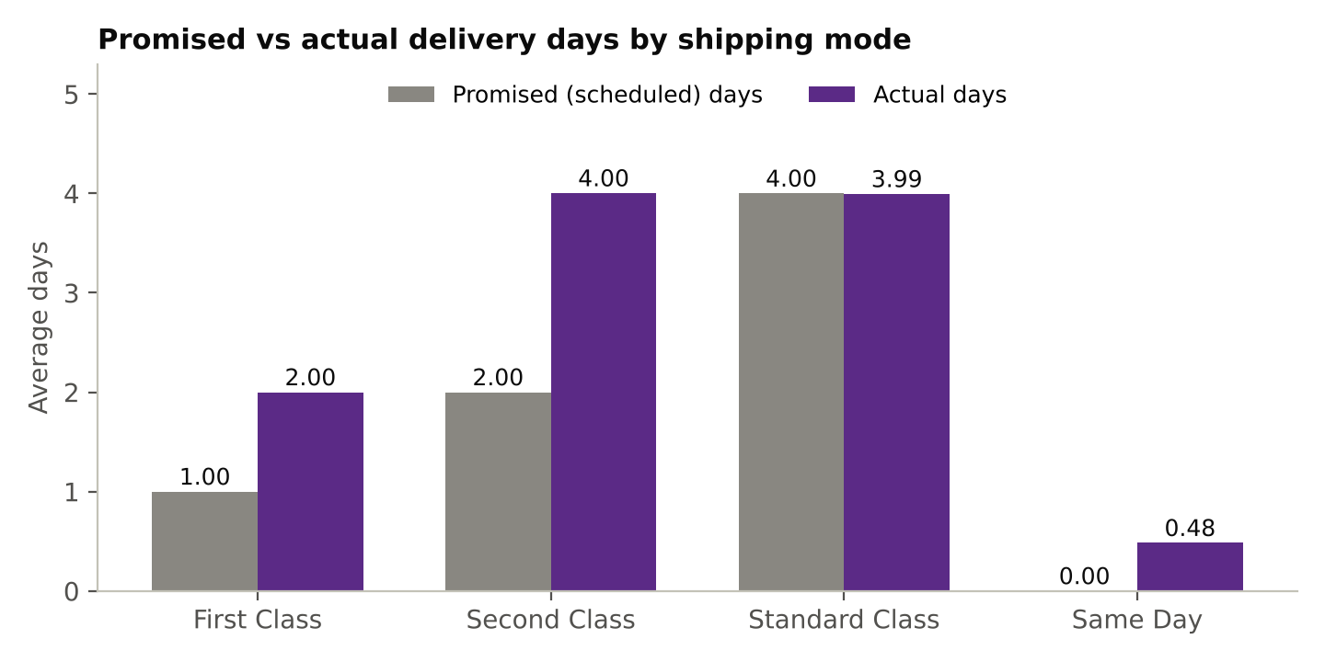
Figure 3. Promised versus actual delivery days

6.3 Regional, market, category and segment analysis
Late rates are close to the overall 57.31% in every cut of the data.
Dimension | Groups | Late-rate range | Note
Market | 5 | 56.55% to 57.68% | Pacific Asia 57.68% (16,853 orders), USCA 57.52%, Europe 57.42%, LATAM 56.90%, Africa 56.55% (3,689 orders)
Order region | 23 | 52.58% to 60.04% | Extremes are small groups: Canada 291 orders, Central Africa 533 orders. Regions with 1,000+ orders range 53.32% (West Africa) to 58.83% (South of USA)
Customer segment | 3 | 57.08% to 57.59% | Home Office 57.59%, Consumer 57.31%, Corporate 57.08%
Product category | 50 | Varies | Categories with 1,000+ items: 56.9% to 59.75% (Accessories). Golf Bags & Carts shows 68.85% on only 61 items

Regions with the most late orders are simply the largest: Western Europe (5,585 late orders), Central America (5,156), South America (2,696), Southeast Asia (2,421) and Oceania (2,382). By volume the same pattern holds for categories (Cleats, Men's Footwear, Women's Apparel).
Whether these differences are meaningful was tested (Section 8.3). The overall region difference is not statistically significant (p = 0.10), and the apparent extremes sit inside their sampling uncertainty: the 95% interval for Canada is 46.8% to 58.2% and for Central Africa 55.8% to 64.1%, both containing the overall rate.

6.4 Monthly and seasonal analysis
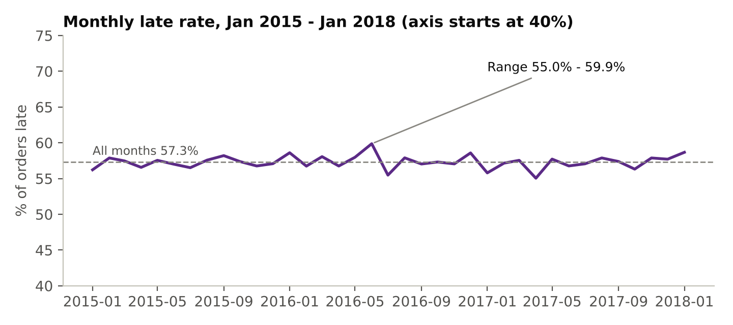
Figure 4. Monthly late rate (37 months)
Across 37 months the late rate ranges from 55.04% (April 2017) to 59.86% (June 2016). Year averages are 57.17% (2015), 57.61% (2016) and 57.03% (2017); 2018 contains January only (58.66%). The month with the most late orders is January 2018 (1,195 of 2,037 orders), which reflects volume, not a worse rate. A chi-square test across the 37 months (p = 0.97), across the 12 calendar months (p = 0.76) and a linear trend test (slope +0.004 points per month, p = 0.77) found no evidence of seasonality or a trend. This is a test result for this dataset, and an absence of detectable variation does not prove there is none.

6.5 Revenue, profit and the October 2017 structural change
Segment | Net revenue | Share | Note
Consumer | 16.42M | 51.9% | Largest segment (32,614 orders)
Corporate | 9.62M | 30.4% | 19,017 orders
Home Office | 5.61M | 17.7% | 11,266 orders

Late and on-time orders earn almost the same: average profit 59.37 for late and 62.06 for on-time orders, margin 11.83% against 12.29%. Margin by shipping mode ranges from 11.65% to 12.68%. The data therefore does not support a claim that lateness reduces profit.
From October 2017 items per order drop from 3.00 to 1.02 and average net revenue per order from 536.61 to 271.35, while orders per month stay steady. Monthly revenue trends across that date are not comparable and should not be read as a business decline.

6.6 Cancellations and suspected fraud
Canceled orders account for 668,245 of net revenue and suspected-fraud orders for 741,492, together 1,409,737 or 4.26% of all net revenue (33,054,402). At order level 2.08% of orders are canceled and 2.26% are flagged as suspected fraud. This is reported separately from delivery KPIs because these orders never reached delivery.

7. SQL analysis
The SQL file contains 25 numbered questions in MySQL 8 against the dataco_clean table and the orders_delivery view (one row per order). Techniques listed below are those found in the code.
Q | Business question | SQL techniques used | Finding
1 | Total orders | COUNT, SUM on order-level view | 65,752 orders; 62,897 in scope
2 | Total revenue | SUM, ROUND, WHERE filter | Net revenue 31,644,664.75 (gross about 35.2M)
3-4 | Average actual and scheduled days | AVG, ROUND | 3.50 actual, 2.94 scheduled
5 | Percentage late | Ratio of SUM to COUNT | 57.31%
6 | On-time shipments | COUNT with filter; window SUM() OVER () | 26,849 on time or early; status split 57.31 / 24.05 / 18.64%
7 | Shipping methods | DISTINCT, GROUP BY | Four modes; Standard Class is 59.8% of orders
8 | Region with most orders | GROUP BY, ORDER BY, LIMIT | Western Europe, 10,010 orders (all statuses)
9 | Highest late % by mode | GROUP BY, conditional ratio | First Class, 100%
10 | Regions with most delays | GROUP BY, HAVING (1,000+ orders) | By count Western Europe 5,585; by rate South of USA 58.83%
11 | Average shipping time by mode | AVG, GROUP BY | Promised 1 / 2 / 0 / 4 vs actual 2.00 / 4.00 / 0.48 / 3.99
12 | Categories with most delays | GROUP BY, HAVING (1,000+ items) | By count Cleats 13,496; by rate Accessories 59.75%
13 | Month with most delayed deliveries | GROUP BY order_month, two rankings | January 2018 by count (1,195); June 2016 by rate (59.86%)
14 | Segment with most revenue | SUM, window SUM(SUM()) OVER () | Consumer, 16.42M (51.9%)
15 | Shipping duration vs delay | Multi-column GROUP BY, AVG | Late % by actual days: 0 d 0%, 1 d 100%, 2 d 48.83%, 3 d 24.37%, 4 d 24.77%, 5-6 d 100%. Lateness depends on actual versus promised days, not duration alone
16 | Top 10 regions by late rate | ORDER BY, LIMIT | Central Africa 60.04% first; range across regions 52.58% to 60.04%
17 | Modes where actual exceeds scheduled | HAVING on aggregate comparison | First +1.00, Second +2.00, Same Day +0.48; Standard (-0.005) excluded
18 | Delivery-time difference by region | AVG, GROUP BY | Average delay 0.43 to 0.64 days across regions
19 | High revenue, poor delivery regions | CTE, scalar subqueries, CASE | Western Europe and Southeast Asia flagged; gap to overall rate is under 1.1 points
20 | Top five categories by delivery risk | HAVING, ORDER BY, LIMIT | Accessories, Electronics, Golf Gloves, Girls' Apparel, Shop By Sport (57.6% to 59.75%)
21 | Monthly performance and seasonality | MONTH(), YEAR(), GROUP BY | Monthly 55.04% to 59.86%; years 57.0% to 57.6%
22 | Biggest contributors to late orders | CTE, window SUM() OVER () | Standard 41.6% of late orders on 59.8% of volume; First + Second 53.8% on 34.8%
23 | Regions x shipping methods | Conditional aggregation, AVG(CASE ...) | First Class 100% late in all 23 regions
24 | Do some methods consistently underperform? | Year pivot; CTE with RANK() OVER (PARTITION BY) | First Class worst in all 23 regions and in all four years
25 | Three improvements | Nested CASE what-if; COUNT(DISTINCT CASE ...) | Late rate 57.31% to 34.26% (scenario 1) or 15.89% (scenario 2); 19,903 orders take 5-6 days

Techniques present in the file: aggregation, GROUP BY, HAVING, CASE, CTEs, scalar subqueries, window functions (SUM() OVER, RANK() OVER PARTITION BY), date functions (MONTH, YEAR), DISTINCT, COUNT(DISTINCT CASE). Not present: JOINs (the analysis uses one table and one view), so none are claimed.
Two file-level issues are worth fixing before publishing (Appendix A): the CREATE VIEW statement for orders_delivery is not in the file, and line 3 runs SELECT * on the full table.

8. Power BI dashboard

8.1 What the dashboard contains
One report page, "Delivery Performance" (1920 x 1080), connected to the orders_delivery view in MySQL. Objective: let a supply-chain manager see how often delivery promises are missed and which shipping modes cause it.
Visual | Fields | Purpose
Five KPI cards | Orders (63K), Late Rate % (57.31%), Late Orders (36K), Avg Actual Days (3.50), Avg Promised Days (2.94) | Headline delivery health
Clustered bar chart | Late Rate % by shipping_mode; First Class highlighted | Shows First Class at 100% and Second Class at 79.99%
Clustered column chart | Avg Promised Days and Avg Actual Days by shipping_mode | Shows the promise gap per mode
Line chart | Late Rate % by order_month | Shows a flat monthly trend
Two dropdown slicers | Market, Customer_segment | Filter every visual
Header and takeaway text | Title band and one-line conclusion | Orientation and message

The measures are filtered to delivered orders (in_scope = 1): Orders uses COUNTROWS, Late Orders uses SUM of is_late, Late Rate % uses DIVIDE of the two, and the two average-day measures use AVERAGE of days_real and days_sched, each inside CALCULATE.

8.2 How it supports decisions
A manager can read the overall rate, see immediately that First Class and Second Class are the problem, check the gap between promised and actual days, and confirm with the slicers that the pattern holds in every market and segment. The Python analysis produced the same numbers, so the dashboard and the notebook cross-check each other.

8.3 Validation of the dashboard headline
The takeaway line reads: "Late deliveries are driven by shipping mode and unrealistic promises, not by region, segment or season." The brief asked whether the analysis supports it. A chi-square test of independence between late/not late and each dimension was run on the delivered orders. This test is not in the notebook; it was added during this review and the code is in Appendix B.
Dimension | Chi-square | df | p-value | Cramer's V | Reading
Shipping mode | 14,530.8 | 3 | < 0.001 | 0.481 | Strong association
Market | 3.2 | 4 | 0.53 | 0.007 | No significant difference
Order region | 30.7 | 22 | 0.10 | 0.022 | No significant difference
Customer segment | 1.1 | 2 | 0.59 | 0.004 | No significant difference
Month (37) | 21.6 | 36 | 0.97 | 0.019 | No significant difference
Calendar month (12) | 7.4 | 11 | 0.76 | 0.011 | No seasonality detected

Region differences also stay small after accounting for each region's mix of shipping modes: all but three regions sit within 1.4 points of the rate expected from their mode mix. Canada (minus 5.6 points, 291 orders), Central Africa (plus 2.4 points, 533 orders) and West Africa (minus 2.0 points, 1,174 orders) are the exceptions, and the first two are small samples.
Assessment
The claim is supported by this dataset as a statement about association, so it does not need removing. Two wording improvements are advisable: "driven by" implies cause, which a descriptive analysis cannot prove, and "no seasonality" should be tied to the test. Suggested replacement for the takeaway: "Late rate depends on shipping mode (39.85% to 100%). It shows no statistically significant variation by market, customer segment or month in this dataset." Suggested line-chart title: "Monthly late rate stays between 55% and 60% with no significant trend or seasonality".

9. Business problems and recommended actions
These are recommendations drawn from the findings. None of them was implemented in the project; Q25 simulated their effect in SQL.
Business problem | Evidence | Recommended action | Expected benefit
Unrealistic First Class promise | 100% late; promise 1 day, actual always 2 days; late in all 23 regions and all years | Reset the First Class promise to 2 days or shorten real transit time | Late rate falls from 57.31% to 42.05% for this change alone (to 34.26% together with the Second Class change)
Poor Second Class performance | 79.99% late; promise 2 days, average 4.00; spread 2 to 6 days | Reset the promise to 4 to 5 days; investigate the causes of the 5 to 6 day orders | Second Class late rate falls from 79.99% to 40.0% with a 4-day promise, or 20.0% with a 5-day promise
Wide transit-time spread in Standard Class | 39.85% late despite an average of 3.99 days; 40% of orders take 5 to 6 days | Reduce the slow tail or promise 5 days | Late rate near 20% for the mode with a 5-day promise
High overall late rate | 57.31% (36,048 orders); average delay 0.57 days | Promise at about the 80th percentile of actual time per mode | Modelled late rate 15.89%
No promise-accuracy monitoring | Averages (2.94 vs 3.50) hide the mode-level problem | Monthly KPI: late rate and actual minus promised days by mode, with an alert threshold | Earlier detection of drift
Cancellations and suspected fraud inside delivery KPIs | 7,754 item rows; 1.41M (4.26%) of net revenue | Keep them out of delivery KPIs; track them as a separate loss metric | Cleaner KPIs; visibility of 1.41M loss
Trade-off of longer promises | Not measurable in this data | Test customer reaction to longer promises before rollout | Avoids lost sales from less competitive promises

Note on the expected-benefit figures: the First Class row isolates one change. Re-basing only First Class to 2 days removes its 9,602 late orders, leaving 26,446 late orders of 62,897 (42.05%) when nothing else changes; the 34.26% figure applies both First and Second Class changes together.

10. Technical skills demonstrated
Area | Demonstrated in this project
Python | pandas (read_csv with encoding, groupby and agg, crosstab, to_datetime, string cleaning, value mapping), data validation with assertions and equality checks, feature engineering, order-level aggregation, matplotlib charts, loading data into MySQL with SQLAlchemy and PyMySQL, load verification. NumPy is imported but used little
SQL (MySQL 8) | Aggregation, GROUP BY, HAVING, CASE, conditional aggregation, CTEs, scalar subqueries, window functions (SUM OVER, RANK OVER PARTITION BY), date functions, a what-if scenario query, an order-level view, table design with typed columns and indexes
Power BI | Connecting to MySQL, DAX measures (CALCULATE, COUNTROWS, SUM, AVERAGE, DIVIDE), KPI cards, bar, column and line charts, slicers, custom theme colours, layout and visual storytelling
Analytical skills | Data quality assessment, granularity awareness (order versus item level), scope definition for KPIs, delivery performance measurement, revenue and profit analysis, scenario modelling, recommendations with stated trade-offs
Not demonstrated | JOINs and multi-table data modelling, Power Query transformations, predictive modelling, statistical testing inside the notebook (added only as a review check)

11. Final business conclusion
The project set out to find why more than half of delivered orders miss the promised date. The answer in this dataset is clear: lateness is a property of the shipping mode and its promise. First Class and Second Class carry promises that their delivery times cannot meet, and Standard Class delivers on average but with a wide spread. Geography, customer segment and time of year do not explain the late rate.
Priority areas for supply-chain decision-makers are the First Class and Second Class commitments, which hold 53.8% of late orders on 34.8% of volume, and the 5 to 6 day tail in Standard and Second Class. A what-if simulation shows that realistic promises alone could reduce the late rate from 57.31% to between 34% and 16% without any operational change, at the cost of longer promised times.
The dashboard supports ongoing monitoring of the late rate and of promised against actual days by mode. Further analysis would add carrier and route data, a customer-reaction test for longer promises, and an order-level model that predicts the delivery date from information available at order time, which would replace one fixed promise per shipping mode.

12. Limitations and analytical integrity
Category | Statement
Observed findings | Late rates by mode, region, market, segment and month; promised versus actual days; revenue and profit figures; the 4.26% canceled and fraud revenue share; the October 2017 change in items per order
Analytical interpretations | Promises, not geography or season, are the main lever on lateness; First Class and Second Class commitments are unrealistic; lateness has no measurable profit effect in this data
Recommendations | Re-base promises; reduce the transit-time tail; track promise accuracy monthly; keep canceled and fraud orders out of delivery KPIs. None was implemented
Unverified hypotheses | Why Second Class transit is slow; how customers react to longer promises; whether the patterns hold in real operations

- The data is historical and appears simulated (uniform delivery days within each mode, almost flat regional, category and segment effects). It cannot show real-world performance.
- There is no carrier, route or shipment-tracking detail, so the operational cause of slow transit cannot be established. Descriptive analysis cannot prove causation.
- The late flag is derived from actual and scheduled days, so it is partly a function of the promise. That is why the headline finding is about promises.
- Small groups give unreliable extreme rates (Canada 291 orders, Central Africa 533 orders, Golf Bags & Carts 61 items). Findings that rely on them are not reported as conclusions.
- The October 2017 change in order structure means monthly revenue trends are not comparable across that date.
- The what-if scenarios assume actual transit times stay the same and ignore any effect of longer promises on demand.
- The tokenized access-log file is a web clickstream that cannot be joined to orders and was not used.

Appendix A. Reproducibility notes and fixes
- SQL file: add the CREATE OR REPLACE VIEW orders_delivery statement at the top so the file runs from a fresh database, and remove the exploratory SELECT * on line 3.
- Notebook: the file combines cleaning, EDA and the MySQL load in one notebook. Two paths are hard-coded to a personal folder (the country translation file and the cleaned CSV); use relative paths and place the translation file in the repository. Empty trailing cells and duplicate to_csv calls can be removed. The MySQL password is entered with getpass and is not stored in the notebook.
- README: describes two notebooks; the project has one. Rename it to supply_chain_analysis.ipynb in a notebooks folder and update the repository tree.
- Dashboard: the PBIX reads from a local MySQL database, so viewers cannot refresh it. Include the PDF and PNG exports in the repository. Apply the headline wording in Section 8.3.
- Data files: do not commit the 72.5 MB cleaned file or the 95.9 MB raw file; the repository should explain how to obtain the dataset.

Appendix B. Significance test code
Add this cell to the notebook after the order table is built. It uses the delivered orders table with is_late. To test segment as well, add customer_segment=("customer_segment","first") to the order aggregation.
from scipy import stats
import numpy as np

d = delivered.copy()
d["calendar_month"] = d["order_month"].dt.month

for col in ["shipping_mode", "market", "order_region", "order_month", "calendar_month"]:
ct = pd.crosstab(d[col], d["is_late"])
chi2, p, dof, _ = stats.chi2_contingency(ct)
v = np.sqrt(chi2 / (ct.values.sum() * (min(ct.shape) - 1)))
print(f"{col:15s} chi2={chi2:9.1f} dof={dof:3d} p={p:.3g} Cramers V={v:.3f}")

