mocol data documentation
This contains documentation specific for the mocol dataset – Markus Siegel’s motion/color categorization/discrimination task. Subjects were Rex and Paula. For more information on this dataset, see Siegel et al. 2015 Science, Brincat et al. 2018 PNAS, and Sandhaeger et al. 2019 eLife (each of which includes only a subset of all the data in this dataset).

For general info about the Miller Lab data format, see MillerLabDataFormatSummary.docx

Unique features
- Recording from many areas at multiple hierarchical levels across ventral stream (V4, PIT/TEO), dorsal stream (MT, LIP), and frontal/cognitive areas (FEF, lateral PFC)
- Categorization/discrimination task with multiple decision boundaries instructed by rule cue
- Densely-sampled parametric stimuli
- Ambiguous stimuli lying on category boundaries

Task design
There are two different versions of the main “mocol” motion/color task (Fig. 1A–C) in this study. The first is a motion/color categorization task, with the relevant perceptual dimension instructed on each trial by a symbolic cue. On each trial, a field of colored moving dots (“stimulus”), all moving in a single direction and with a single color, is shown. Across trials, this stimulus samples a 2D space comprising 7 distinct colors × 7 distinct motion directions. Immediately preceding the stimulus (i.e. with no delay) in each trial is one of a set of four symbolic cues; two of these cues indicate to categorize the subsequent stimulus based on its color (red vs. green), while two other cues indicate to categorize based on the stimulus motion direction (up vs. down). The monkey reports its chosen category with a left or right saccade, and is allowed to respond at any time during the stimulus presentation.
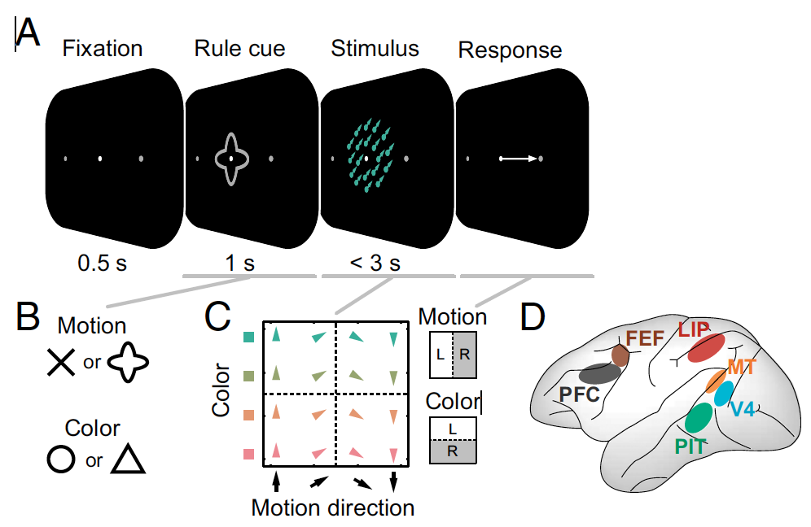
The second version is a motion/color discrimination task, which is nearly identical to the categorization version, with the only difference in the precise nature of the color/motion stimuli. Instead of a field of dots with a homogeneous color and motion direction, the stimuli here contained a fraction of coherent dots, all with 1 of 2 colors (red or green) and directions (up or down), embedded within incoherent dots (with random colors and directions). Thus, this task can be characterized as discrimination of color/motion signals within noise, rather than categorization. Across trials, the stimuli again samples a 2D space comprising 7 distinct color/color coherence values × 7 distinct direction/direction coherence values.
In addition to the main task, one or more preliminary mapping tasks were often run in each session. “delsac” – combines a traditional delayed-saccade (spatial working memory) task with a passive fixation task with an RSVP moving dot stimulus to map color/direction tuning (task sequence: several frames of color/motion “pulses” (1.2 s or 0.96 s on different sessions) fixation delay (0.5 s) saccade target (0.1 s) working memory delay (0.7) saccade to remembered location (see Sandhaeger et al. 2019 eLife). “flamap” – receptive field mapping task with flashed stimuli. “retmap” – receptive field mapping task with color/motion dot field stimuli.

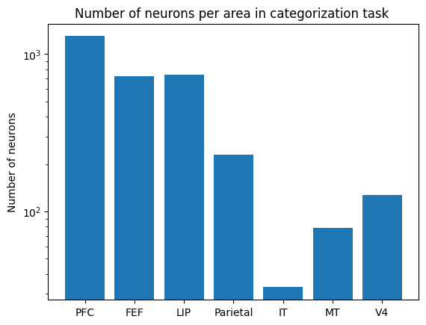
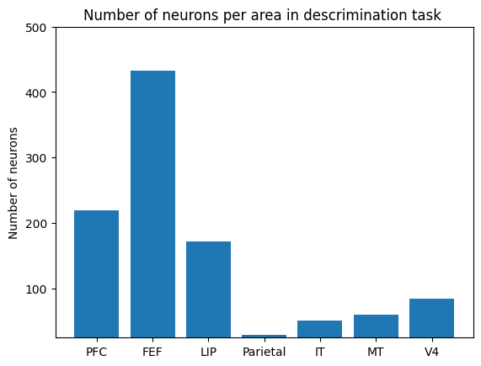
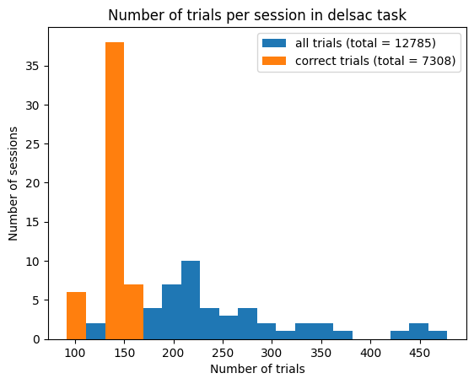
There are 8 sessions for the motion/color discrimination task, 45 sessions for the motion/color categorisation task, and 53 sessions and 7308 trials for for the “delsac”. “delsac” trials were done before each task, so the number of neurons is the sum of categorisation and discrimination tasks.

Recorded areas
Recordings targeted lateral prefrontal cortex, frontal eye fields (FEF), posterior parietal cortex (LIP), and (in a subset of sessions) MT, V4, and inferotemporal cortex (IT/TEO; Fig. 1D).

Recording setup
All data was recorded with FHC “F” or “G” single tungsten/paralyene electrodes. Recordings were performed acutely—electrodes (typically either 58 or 123) were inserted and removed each session. This means there is no connection between recording sites across sessions, and all cross-electrode analyses (e.g. cross-correlation) must be performed separately within each session.
Half the data was recorded with the Plexon Recorder system and half with the Plexon Omniplex system, and behavioral was controlled using MonkeyLogic. Spike thresholds were manually set online, and spikes manually sorted offline (Plexon OfflineSorter). LFPs were recorded at 1 kHz and raw broadband analog signals were recorded at 40 kHz.

Datafile organization
All data is contained in Matlab MAT-files in two folders. The unsorted folder contains data from all spikes crossing a manually-set amplitude threshold, so each channel effectively represents the pooled activity from all neurons recorded on a given electrode (this is similar to the multi-unit signal used in the 2015 Science paper). The sorted folder contains spikes sorted into distinct single neurons, including both well-isolated single units and less isolated multi-units (these are labeled in the unitInfo table-like struct; see below). A few sessions appear only in the unsorted folder, as sorted data is not available for them.
Within each directory, each file contains all the simultaneously-acquired spiking, LFP, and behavioral data recorded in a single experimental session (with the filename being the lab designation for the session), and associated metadata. All data is temporally aligned to the ‘stimOn’ event in each trial—for the mocol task, this is the onset of the random-dot stimulus; for the mapping task, this is the onset of the first mapping stimulus. The data format is described in detail below.

Task/behavioral data organization
Variable trialInfo
Type Struct, where each field contains info about all trials of one session task: mocol (motion/color task), delsac (delayed saccade task), or flamap/retmap (receptive field mapping); there’s also an allTasks field, with basic info about all session trials.
Each field contains a table-like struct, where each struct field (column) is a numerical/logical/cell-of-strings vector of size [task trials × 1] (or sometimes a [trials × n] array)
Description A complete record of all trial event times and other descriptors of per-trial task/behavioral data, for each trial in a session. Each variable has a corresponding description in trialInfo.<task>.Properties.VariableDescriptions. The important ones, with a bit more description, are:
task Which task run on each session trial: ‘mocol’, ‘delsac’, ‘flamap’, or ‘retmap’
outcome Indicates whether the monkey chose the correct saccade target/category (‘correct’) , chose the incorrect target (‘choiceErr’), or make some other error (no response, fixation break, etc. trials are removed from this data)
correct Binary indicator of correct trials (1) vs any error (0).
trialRefTimes System clock time (t=0 is session start) that each trial’s timing is referenced to. Add these back to each trial’s times to get absolute times.

rule The categorization/discrimination rule for each trial: ‘color’ or ‘motion’
ruleCue Which one of two rule cues for given rule was shown
color Color (hue angle in deg.) of stimulus for each trial: -90 = red, +90 = green, 0 = yellow (category boundary).
direction Motion direction (deg.) of stimulus for each trial: -90 = down; +90 = up; 0 = right (category boundary)
colorCoherence Coherence of stimulus color (0–1; for discrimination task)
directionCoherence Coherence of stimulus motion (0–1; for discrimination task)
expectedResponse Correct response for each trial (‘R’=right, ‘L’=left, ‘N’=on category boundary)
chosenResponse Response actually chosen by monkey
cueOn Time of onset of rule cue (s rel. to stimOn)
stimOn Time of onset of stimulus, and simultaneous offset of rule cue
responseTime Time of start of saccadic response (s rel. to “stimOn”)
badTimingTrials Labels trials where event timing deviates > 5 ms from expected values. Analyze with caution, esp. for analysis of fine-grained timing.

Variable sessionInfo
Type Struct, where each field contains info about all trials of one session task: mocol, delsac, or flamap/retmap; also an allTasks field, with basic info about all session trials. Each field contains a struct of numerical/string scalars
Description Record of per-session task/behavioral data. Variables should be self-explanatory.

Metadata
Session datafiles also include table-like structs with recording metadata. Two of these—electrodeInfo and unitInfo—are intended to be useful for channel selection and analysis. The rest contain more detailed, archival information about recording parameters.
Variable electrodeInfo
Type Table-like struct [electrodes × variables/columns] of numerical/logical/cell vectors
Description Per-electrode metadata about each electrode recorded in an experimental session. Important variables:
electrode Electrode number
area Area the electrode recorded from: ‘PFC’ (lateral prefrontal), ‘LIP’, ‘Parietal’ (all non-LIP posterior parietal sites), ‘MT’, ‘V4’, or ‘IT’. Empty (‘’) for ambiguous/unclassified sites.
numUnits Number of neurons (single-units and multi-units) recorded on electrode
well Recording chamber electrode was in: ‘frontal’, ’parietal’, or ‘temporal’
gridLoc Each row contains [row,column] locations within the recording grid. We don’t yet have a solid mapping from these to stereotaxic coordinates, but you can at least get the relative positions of recorded electrodes from these

Variable unitInfo
Type Table-like struct [neurons × variables/columns] of numerical/logical/cell vectors
Description Per-neuron metadata about each neuron (single-units and multi-units) recorded in an experimental session. Important variables:
electrode Electrode number the given unit was recorded on.
unit Unit number on electrode (1–#units on electrode; 0=unsorted spikes)
isolated Binary variable indicating whether given unit was judged to be an isolated single-unit (1) or a non-isolated “multi-unit” (0). If you want to analyze only isolated single-units, you should select the appropriate units out of “spikeTimes” data using this variable as a filter (ie, unitInfo.isolated == true).
timeRange Most neurons were present and well-isolated in the recording for less than the full time range of a session. This gives the range of times (absolute time in s, rel. to session clock start) that each unit was estimated to remain isolated in recording.
trialIdxRange Same as above, but expressed as trial indexes (ie into the trial dimensions of the spikeTimes data variables). This is probably the most useful, as you can limit analysis for each neuron to the isolated range simply using spikeTimes(trialIdxRange(unit,1):trialIdxRange(unit,2)).
trialRange Same as above, but expressed as the original trial numbers (cf. those listed in spikeTimesSchema.index{1})
Other metadata structs contain more detailed information about the recordings, probably not relevant for most analysis.

Caveats
Electrode numbers and sampled areas differ greatly across sessions. Temporal areas (V4, MT, and especially IT) were sampled in a fairly small subset of sessions, with fewer electrodes than in frontoparietal cortex. As mentioned above, the exact set of tasks (and versions of those tasks) run also differ across sessions.
Many units in the dataset were not held for the duration of the session. The estimated period over which each unit was isolated is given in unitInfo.isoTrialIdxRange as trial indexes (into the spikeTimes and trialInfo variables) corresponding to the estimated start and end of a given unit’s isolation.

Data organization on lab server
/data/common/datasets/mocol/mat_sorted | Preprocessed data with sorted units in lab standard format
/data/common/datasets/mocol /mat_sorted_spikesOnly | As above, but with spiking data only (no LFPs). Much smaller in size
/data/common/datasets/mocol /metadata | Excel sheet listing sessions and their attributes

Extensive variable description

Delsac
"trial:" Overall trial number in session (1-nSessionTrials)
"taskTrial:" Trial number within each task block (1-nTaskTrials)
"bhvTrial:" Original behavioral system trial number
"condition:" Condition number
"task:" Task ID
"outcome:" Trial outcome
"correct:" Correct trial (1) | any error (0)
"reactionTime:" Reaction time (responseTime - fixptOff)
"numRewards:" Number of juice drops obtained
"mapColors:" Sequence of colors in passive mapping stimulus (deg. hue angle: -90=red, 0=yellow, +90=green)
"mapDirections:" Sequence of motions directions in passive mapping stimulus (deg.: -90=down, 0=right, +90=up)
"targetPos:" Saccade target location in polar coord's [eccentricity(dva),polar angle(deg)]
"trialStart:" Start of trial
"fixptOn:" Fixation point onset
"fixationTime:" Fixation acquisition time
"fixptOn2:" Fixation point color change: blue -> white
"stimOn:" Motion/color stimulus onset
"stimOff:" Motion/color stimulus offset
"targetOn:" Saccade target onset
"targetOff:" Saccade target offset
"fixptOff:" Fixation point offset / Response "GO" cue
"responseTime:" Saccade start (eye leaves fix win)
"responseDone:" Saccade end (eye enters target win)
"holdTgtOn:" Saccade target post-response onset (to facilitate holding)
"holdTgtOff:" Saccade target post-response offset (to facilitate holding)
"responseHeld:" Gaze held on target
"outcomeTime:" Time error/correct outcome registered
"rewardOn:" Onset of each juice reward pulse
"rewardOff:" Offset of each juice reward pulse
"feedbackOff:" Offset of error feedback stimulus
"trialEnd:" End of trial
"session:" SessionID string
"trialRefTimes:" Absolute reference time for each trial (s rel. to session clock start)
"badTimingTrials:" Trials with unexpected event timing
"badTrials:" Trials to exclude from analysis

Mocol
"trial:" Overall trial number in session (1-nSessionTrials)
"taskTrial:" Trial number within each task block (1-nTaskTrials)
"bhvTrial:" Original behavioral system trial number
"condition:" Condition number
"task:" Task ID
"outcome:" Trial outcome
"correct:" Correct trial (1) | any error (0)
"reactionTime:" Reaction time (responseTime - fixptOff)
"numRewards:" Number of juice drops obtained
"mapColors:" Sequence of colors in passive mapping stimulus (deg. hue angle: -90=red, 0=yellow, +90=green)
"mapDirections:" Sequence of motions directions in passive mapping stimulus (deg.: -90=down, 0=right, +90=up)
"targetPos:" Saccade target location in polar coord's [eccentricity(dva),polar angle(deg)]
"trialStart:" Start of trial
"fixptOn:" Fixation point onset
"fixationTime:" Fixation acquisition time
"fixptOn2:" Fixation point color change: blue -> white
"stimOn:" Motion/color stimulus onset
"stimOff:" Motion/color stimulus offset
"targetOn:" Saccade target onset
"targetOff:" Saccade target offset
"fixptOff:" Fixation point offset / Response "GO" cue
"responseTime:" Saccade start (eye leaves fix win)
"responseDone:" Saccade end (eye enters target win)
"holdTgtOn:" Saccade target post-response onset (to facilitate holding)
"holdTgtOff:" Saccade target post-response offset (to facilitate holding)
"responseHeld:" Gaze held on target
"outcomeTime:" Time error/correct outcome registered
"rewardOn:" Onset of each juice reward pulse
"rewardOff:" Offset of each juice reward pulse
"feedbackOff:" Offset of error feedback stimulus
"trialEnd:" End of trial
"session:" SessionID string
"trialRefTimes:" Absolute reference time for each trial (s rel. to session clock start)
"badTimingTrials:" Trials with unexpected event timing
"badTrials:" Trials to exclude from analysis

