CITYBRAIN
AI-Based Emergency Response Coordination
Chennai SUMO Digital Twin and 3D Visualization

Final Project Report · Version 3.2
Krishna Verma
Project contributions: Argh Sahai (original Core/SUMO foundation); Subhashini (agents/planner)
18 October 2026
Research software prototype. Not an emergency-response service.

Contents
1. Abstract 3
2. Introduction 3
3. Problem Statement 3
4. Objectives and Scope 3
5. Related Work / Background 4
6. System Architecture 4
7. SUMO Digital Twin and Chennai Network 5
8. Agent Architecture and Planning 5
9. Dynamic Replanning and Stability Guard 5
10. External Traffic Provider Architecture 5
11. Cesium Dashboard and Visualization 6
12. Experimental Methodology 6
13. Results and Analysis 7
14. Failure Handling and Validation 8
15. Privacy and Data Boundaries 8
16. Limitations 8
17. Future Work 8
18. Conclusion 9
19. References 9
20. Appendix: Reproduction and Demo Instructions 10

1. Abstract
CityBrain is a research prototype that links a Chennai-area, OpenStreetMap-derived road network to SUMO microscopic traffic simulation, a preserved emergency-planning runtime, and a Cesium/SVG dashboard. The project evaluates whether an integrated digital-twin workflow can observe simulated road conditions, assess ambulance plans, execute a selected route through TraCI, and verify the physical route read-back before accepting the logical plan. A Chennai soft-change confirmation guard reduces route churn while hard invalidations retain their safety handling.
The preregistered V3.1 study contains 60 matched synthetic SUMO trials: three scenarios (S05, S06, S08), ten seeds, and static/dynamic arms. Completion outcomes were S05 7/10 versus 10/10, S06 0/10 versus 0/10, and S08 0/10 versus 10/10. In the seven S05 matched successful pairs, response times were equal (mean and median difference 0 seconds). These small, scenario-specific observations do not establish general superiority. Provider adapters exist, but genuine HERE/TomTom responses and real-world coverage were not verified. External traffic is advisory; signals, incidents, demand and hospital availability are simulated. A SUCCESS means arrival at a configured simulated hospital access road, not clinical or driveway validation [1–4].

2. Introduction
Emergency routing depends on conditions that can change after dispatch. This project builds a controlled software environment for examining how a route-planning workflow interacts with a microscopic traffic simulator and how the evidence can be inspected by a human operator. SUMO supplies simulated vehicle motion and signal phases; CityBrain observes the simulation through TraCI and visualizes state on an OSM-derived Chennai network [5–7].
The scope is deliberately bounded: this is an integrated research prototype and not a live dispatch service. The study tests existing static and dynamic planning configurations under selected synthetic scenarios. The optional traffic advisor is not an arm of the controlled study. No evidence here establishes operational benefit in Chennai streets.

3. Problem Statement
A precomputed route may become unsuitable if its edges become blocked or travel costs change. A system that replans on every short-lived change can also oscillate, consume compute, and complicate execution. The engineering problem addressed is how to connect simulated road observations to a planning/execution loop while distinguishing transient cost changes from confirmed invalidation, and how to retain auditable evidence for each decision.
The project does not claim that this problem is novel. Its contribution is an integration and validation artifact: a bounded Chennai SUMO scenario, an existing planner connected to verified route execution, a confirmation guard for soft changes, and a display layer that separates synthetic, replayed and external-data provenance.

4. Objectives and Scope
- Integrate an OSM-derived Chennai network with SUMO vehicle and signal simulation.
- Preserve CityBrain Core, agents, planner and historical controlled results while connecting runtime perception and route execution.
- Expose plan decisions, vehicle state, signals, roads and provenance through Cesium with an SVG/2D fallback.
- Keep external traffic and signal-priority suggestions advisory, with no direct planner-cost writes, route commits or physical signal control.
- Report the V3.1 matched study with failures retained in the completion denominator.
Team attribution follows the repository contribution map: Krishna Verma’s integration and research tooling; Argh Sahai’s original Core architecture and SUMO assets; and Subhashini’s agents and planner [2]. Affiliation is not stated because the reviewed source materials do not verify a formal institutional attribution.

5. Related Work / Background
The project’s technical background is documented through primary software and data references rather than a formal peer-reviewed literature review. SUMO is an open-source microscopic, multi-modal traffic simulator; TraCI provides a client interface for inspecting and controlling a running simulation [5,6]. OpenStreetMap contributes the base road data under its stated attribution and ODbL terms [7]. CesiumJS provides browser-side 3D geospatial visualization primitives [8].
Commercial flow APIs expose provider-specific traffic information, but API availability is not evidence of coverage or accuracy on the study corridor. HERE Flow and TomTom Flow Segment documentation describe their respective request/response contracts [9,10]. CityBrain includes adapters for these contracts; the final evidence package contains no genuine provider response. Accordingly, this report does not compare CityBrain with published emergency-routing algorithms or claim a literature-derived novelty result. A future academic extension should add a systematic literature review and a real-world calibration protocol.

6. System Architecture
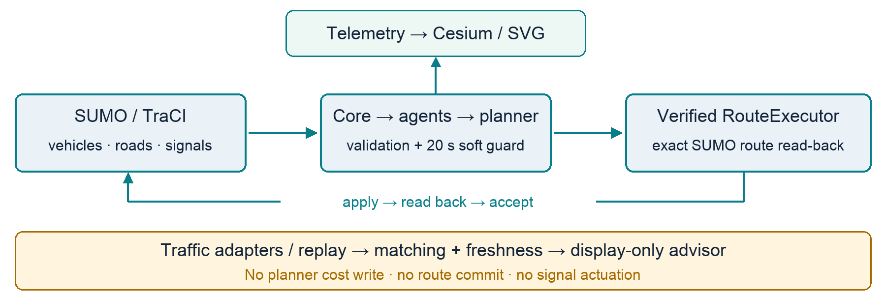
Figure 1. Runtime control path and separate advisory traffic sidecar. External/replay observations do not enter canonical planner costs.
The runtime’s control path is CityBrainRuntime → state observation → existing planner and validation → RouteExecutor → SUMO route read-back → logical acceptance. The verified read-back is a gate: if the physical simulator does not reflect the requested route, the logical plan is not accepted as though execution had succeeded. Telemetry and dashboard updates run as a failure-isolated observation path. External traffic is ingested and normalized in a separate sidecar; the optional evaluator may display an advisory candidate, but it does not call the production planner or commit a route [1,3].

7. SUMO Digital Twin and Chennai Network
The network is derived from OSM road geometry for a bounded Chennai study corridor and converted to SUMO network assets. Runtime vehicles, trips, road occupancy, congestion, incidents, signals and hospital availability are simulation inputs or state. The map geometry is geographically anchored; vehicle motion and operational state are simulated. OSM-derived geography must not be mistaken for live traffic telemetry.
The fresh seed-17 smoke runs recorded a terminal SUCCESS at 704 simulated seconds (51 seconds to dispatch and 653 seconds of travel) in both default simulation and replay-assisted mode. This is a reproducibility/smoke observation, not one of the 60 preregistered trials. The output’s provenance records a simulated SUMO source. The replay provider status is REPLAY and its observation source is SYNTHETIC_SAMPLE; no HERE or TomTom request was made [1].

8. Agent Architecture and Planning
The runtime organizes responsibilities across Traffic, Ambulance, Hospital, Police and Signal agents. Agents contribute assessments to a planning context; the existing planner scores candidate paths and validation checks constraints before the execution layer acts. The dashboard exposes agent assessments and candidate validity for inspection. A provider observation is not a direct route-score input in this release.
Plan outcomes are represented as KEEP, REPLAN or NO_ROUTE. KEEP retains the accepted physical route when current conditions do not justify a verified change. REPLAN proposes a replacement subject to planning validation, Chennai stability policy and verified route execution. NO_ROUTE indicates no valid candidate and is handled as a genuine planning failure rather than silently presenting a route as accepted [1,11].

9. Dynamic Replanning and Stability Guard
The Chennai 20-second confirmation guard applies to soft route-cost changes: a candidate change must remain confirmed before it can displace the current route. This dampens reaction to short-lived fluctuations. A confirmed hard failure or route invalidation retains immediate safety handling; the guard is not a blanket delay for hard failures. Route execution remains subject to physical SUMO read-back before logical acceptance [1,3].
This guard is part of the integrated runtime behavior and is not the treatment tested by the V3.1 static-versus-dynamic legacy harness. That harness measures outcomes from its configured policy arms; it does not establish the isolated causal effect of the guard. Separate dynamic evidence is the preserved synthetic S08 grid demo: P0/P1/P2 at 301/311/316 s and SUCCESS at 425 s. Each acceptance follows exact physical read-back. It is not the Chennai seed-17 run, not a test of its guard, and not an added research trial. The archive and verification command are documented in the final demo checklist.

10. External Traffic Provider Architecture
HERE and TomTom adapters, normalization, freshness classification, directed road matching, bounded caching and offline replay are implemented. Live-provider mode is explicitly gated by an authorization flag because a request may incur account usage or cost. Credentials are not required for simulation or replay and are not committed. The documented adapter default timeout is five seconds (bounded to 30 seconds), response size is capped, redirects are rejected, and provider failures are surfaced without exposing credential values [4,9,10].
No real API response was obtained for this submission. Provider coverage, accuracy, cost/account limits and corridor support remain unverified. Unknown source time is not equivalent to a fresh timestamp; unknown direction cannot establish directional road applicability. Replay records are labeled REPLAY / SYNTHETIC_SAMPLE, not live. The optional traffic evaluator is opt-in and display-only; external observations do not silently alter production planner scores or trigger ambulance replanning [1,4].

11. Cesium Dashboard and Visualization
The browser dashboard combines OSM-derived roads, SUMO vehicle positions, the ambulance and accepted route, simulated incidents, hospital markers, traffic signals, congestion and optional external-flow/incident overlays. Source and freshness labels communicate whether a record is SUMO_SIMULATED, REPLAY, SYNTHETIC_SAMPLE, LIVE, UNKNOWN, STALE or EXPIRED. Dashboard telemetry and output writes are isolated from simulation correctness; an SVG/2D view remains available when the Cesium/WebGL view cannot run [1,12].
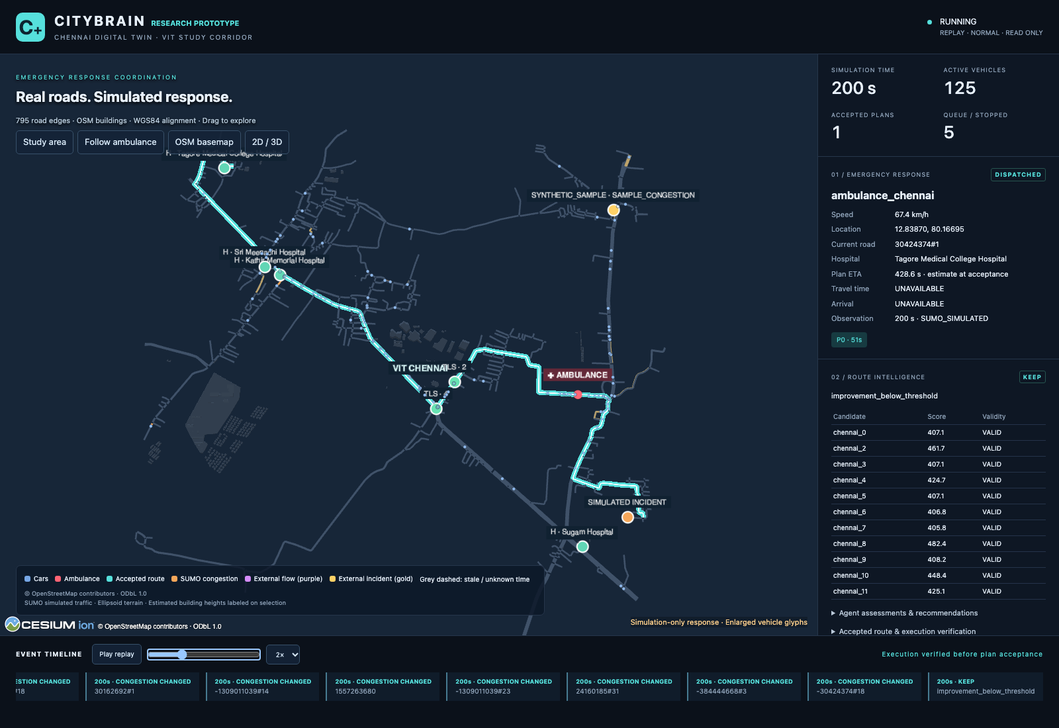
Figure 2. Fresh current-dashboard capture at 200 simulated seconds from a completed local synthetic replay. The recorded ambulance, accepted route, hospital markers and replay provenance are visible.
The image is a fresh capture of the final dashboard from the separately validated local seed-17 replay-assisted output. It shows an active recorded ambulance at t=200, not live traffic. At terminal SUCCESS (704 s), the dashboard removes the active vehicle and explicitly explains that the route is recorded history, with no current vehicle fix. No provider request was made.

12. Experimental Methodology
The preregistered comparison consists of 3 scenarios × 10 fixed seeds × 2 policy arms = 60 trial cells. The profile is NORMAL and all stimuli/traffic are synthetic SUMO conditions. The arms are labelled static and dynamic. The experimental traffic advisor, provider observations, GPS runtime input and signal actuation were not evaluated. Trial outcomes are reported for all runs; TELEPORTED is a failure, not successful arrival. Response-time summaries are conditional on SUCCESS, and matched response-time differences use only seeds for which both policies succeeded [13].
For completion rates, the report uses 95% Wilson intervals as recorded in the analysis. The sample is small (n=10 per scenario/arm) and intervals are broad. The study is not powered to support city-wide or general algorithm superiority claims. Smoke tests and dashboard demonstrations are excluded from the formal trial count.

13. Results and Analysis
Scenario | Policy | SUCCESS | TELEPORTED | Success 95% Wilson CI | Mean successful response
S05 | Static | 7/10 | 3/10 | 39.7%–89.2% | 35.0 s (n=7)
S05 | Dynamic | 10/10 | 0/10 | 72.2%–100.0% | 35.0 s (n=10)
S06 | Static | 0/10 | 10/10 | 0.0%–27.8% | NA
S06 | Dynamic | 0/10 | 10/10 | 0.0%–27.8% | NA
S08 | Static | 0/10 | 10/10 | 0.0%–27.8% | NA
S08 | Dynamic | 10/10 | 0/10 | 72.2%–100.0% | 124.5 s (n=10)

Scenario | Matched successful pairs | Static − dynamic mean | Median | Bootstrap 95% interval
S05 | 7 | 0.0 s | 0.0 s | [0.0, 0.0]
S06 | 0 | Unavailable | Unavailable | No matched successes
S08 | 0 | Unavailable | Unavailable | No matched successes

The dynamic arm has higher observed completion in S05 and S08 in this sample; S06 has zero successes in either arm. Among seven S05 pairs with success in both arms, successful response time was equal. S06 and S08 have no matched successful pairs, so a paired response-time comparison is unavailable. Failures remain visible in the completion denominator. These data describe the configured synthetic cases and do not prove broad superiority or real-world benefit [13].

14. Failure Handling and Validation
Final QA independently reran the full suite: 447 pytest tests passed in 38.38 seconds, and all ten compatibility scripts passed. Fresh clean-provenance normal and replay-assisted seed-17 runs both reached SUCCESS at 704 s with zero route changes and zero telemetry/dashboard write failures. Chrome 155 checks passed with no page errors or failed local HTTP responses, covering geometry, movement, signals, guarded KEEP, closure/timestamp recovery, consented location emulation and 800/390 px layouts. All 2,172 historical entries and all 426 V3.1 study files were unchanged. These evidence classes do not add research trials [15].
Runtime outcomes, dashboard output failures and telemetry failures are kept in output evidence. Provider outages and invalid records are isolated from the default planning/control path. Simulation SUCCESS requires the configured hospital access-road arrival condition; this validation does not cover hospital driveway access, clinical capacity, or real-world emergency operations.

15. Privacy and Data Boundaries
The browser location marker is consented and tab-local. It is a visualization convenience, not a GPS feed into runtime state, route scoring or dispatch. The final system does not add a location receiver or transport. Provider credentials are optional, unnecessary in simulation/replay, and excluded from repository history. A future deployment would require data minimization, retention controls, access governance and jurisdiction-specific privacy review; this prototype does not establish those controls for operational data [1,14].

16. Limitations
- Live HERE/TomTom coverage, response quality, freshness behavior and account cost on the target corridor are unverified; no genuine provider response is evidenced.
- Traffic replay is synthetic sample data. The experimental traffic advisor remains advisory and was not a formal study arm.
- SUMO vehicles, traffic demand, incidents, congestion, signal programs and hospital availability are simulated; real-world calibration is absent.
- Hospital arrival is verified at a configured simulated access road, not at a clinical entrance or available treatment capacity.
- Signal recommendations are not actuated. The network’s reviewed signal programs lack a verified movement/phase compatibility, required clearance and restoration contract.
- The 60-trial study is small, scenario-specific and has wide uncertainty; it does not show universal improvement.
- Production emergency dispatch, field validation, clinical/municipal integration, safety certification, security review and multi-emergency coordination are outside scope.

17. Future Work
Future work should proceed as separately reviewed stages: (1) formal related-work review and stronger preregistered scenarios; (2) simulation calibration against independently sourced local observations; (3) provider contract and corridor coverage evaluation using a cost-authorized account and recorded raw/normalized provenance; (4) signal movement, clearance, priority and restoration safety design before any actuation; (5) hospital access/capacity model validation; (6) privacy, cybersecurity, human-factors and safety assessment; and (7) controlled field studies with appropriate institutional, municipal and emergency-service oversight. None of these tasks is complete in this release.

18. Conclusion
CityBrain demonstrates an integrated Chennai-area simulation, a preserved planning/execution path with physical route verification, a 20-second confirmation guard for soft changes, and a browser visualization with an advisory traffic-data boundary. The V3.1 study reports mixed scenario outcomes and equal matched successful response times for S05. Synthetic trials and replay validate software paths, not actual Chennai traffic routing. The result is a bounded research prototype suitable for academic demonstration and further evaluation, not a production emergency-response system.

19. References
[1] CityBrain repository, “V3.1 Implementation Report,” 18 Oct 2026. Internal implementation and validation record. https://github.com/arghsahai/CityBrain/blob/feature/citybrain-v3-roadmap/docs/V31_IMPLEMENTATION_REPORT.md
[2] CityBrain repository, “Contribution Map” and “V3.1 Viva Q&A.” Internal attribution and project documentation. https://github.com/arghsahai/CityBrain/tree/feature/citybrain-v3-roadmap/docs/krishna
[3] CityBrain repository, “Final Integration” and “Chennai Digital Twin.” Internal runtime and route-execution documentation. https://github.com/arghsahai/CityBrain/tree/feature/citybrain-v3-roadmap/docs
[4] CityBrain repository, “Chennai Live Traffic.” Internal provider, matching, freshness and safety contract documentation. https://github.com/arghsahai/CityBrain/blob/feature/citybrain-v3-roadmap/docs/CHENNAI_LIVE_TRAFFIC.md
[5] Eclipse SUMO, “SUMO at a Glance.” https://sumo.dlr.de/docs/SUMO_at_a_Glance.html
[6] Eclipse SUMO, “TraCI.” https://sumo.dlr.de/docs/TraCI/
[7] OpenStreetMap Foundation, “Copyright and License.” https://www.openstreetmap.org/copyright
[8] Cesium, “CesiumJS Scene API” and “Creating Entities.” https://cesium.com/learn/cesiumjs/ref-doc/Scene.html ; https://cesium.com/learn/cesiumjs-learn/cesiumjs-creating-entities/
[9] HERE Technologies, “Traffic API v7 — Flow.” https://docs.here.com/traffic-api/reference/traffic-api-v7-getflow
[10] TomTom, “Traffic Flow Segment Data.” https://docs.tomtom.com/traffic-api/documentation/tomtom-maps/v1/traffic-flow/flow-segment-data
[11] CityBrain repository, “V3.1 Demo Script” and runtime docs. https://github.com/arghsahai/CityBrain/blob/feature/citybrain-v3-roadmap/docs/V31_DEMO_SCRIPT.md
[12] CityBrain repository, dashboard validation report and dashboard docs. https://github.com/arghsahai/CityBrain/tree/feature/citybrain-v3-roadmap/docs/krishna
[13] CityBrain repository, “V3.1 Matched SUMO Experiment Analysis,” preregistered 60-cell synthetic study. https://github.com/arghsahai/CityBrain/blob/feature/citybrain-v3-roadmap/data/output/v3-experiments/v31-matched-sumo-10seed-20261018/v31-analysis.md
[14] CityBrain repository, “V3 Setup” and “V3.1 Implementation Report,” consent and data-boundary notes. https://github.com/arghsahai/CityBrain/blob/feature/citybrain-v3-roadmap/docs/V3_SETUP.md
[15] CityBrain, “Final Project Status” and compact final QA evidence, 18 Oct 2026. https://github.com/arghsahai/CityBrain/blob/feature/citybrain-v3-roadmap/docs/FINAL_PROJECT_STATUS.md

20. Appendix: Reproduction and Demo Instructions
Prerequisites: documented Python dependencies, SUMO 1.27.1 with TraCI bindings, and a browser with WebGL for the 3D view. The commands below are local. Simulation and replay do not need credentials and do not call traffic providers.
Terminal | Command | Purpose
1 | ./tools/run_chennai.sh --mode replay-assisted --experimental-traffic-evaluation | Interactive synthetic replay-assisted dashboard; no provider request
2 | venv/bin/python -m pytest -q | Software regression suite
2 | venv/bin/python -m citybrain.chennai.validate --historical | Read-only 2,172-entry historical evidence verification
1 (fallback) | ./tools/run_chennai.sh --mode replay --events /path/to/completed-chennai-output --port 8773 --no-browser | Serve completed local replay read-only

For a fresh non-research smoke, use a unique temporary output and the supported launcher; never write into official result directories. For separate saved replanning evidence, run venv/bin/python tools/verify_saved_replan.py, then the safe extraction and read-only dashboard commands in FINAL_DEMO_CHECKLIST.md. The saved S08 archive checksum and execution-before-acceptance evidence are verified; original generated input hashes are recorded but cannot be recomputed because those input files are absent from the compact archive. Use Ctrl-C for shutdown.
Five-minute final walkthrough: (0:00–0:40) problem and architecture; (0:40–1:40) Demo A, Chennai map, dispatch, recorded motion and KEEP; (1:40–2:40) explicitly switch to separate saved S08 grid Demo B, P0/P1/P2 and SUCCESS; (2:40–3:20) source/freshness, signals and SVG fallback; (3:20–4:20) formal study outcomes and matched-pair limits; (4:20–5:00) external-data, clinical and production limitations. The final demo checklist also supplies a two-minute fallback and exact safe extraction/viewer commands.

