CDU-100 Digital Twin — POC demo script
Oct 2, 2026 · @Arghya Chakraborty
A 12-minute live demo of the refinery digital twin: what to say, what to click, and how to recover if something misbehaves. Words to speak are in quotes; actions are marked Do.

Before you start
Get to a clean, warmed-up state 15 minutes before the audience arrives. The app needs internet for the 3D library and fonts.
- ☐ Close any Unreal Editor windows; open the Ollama app.
- ☐ Double-click START.bat in the DigitalTwin folder and wait until Chrome opens http://localhost:8000.
- ☐ Press F11 in Chrome for full screen; zoom the page so the left list, 3D view and right panel all fit.
- ☐ Warm up the AI: in Assistant, ask “Which assets need attention?” and wait for the answer. The first answer after a restart is the slowest.
- ☐ Click Reset sim, then ×300. Every asset should show green or blue.
- ☐ Choose Sunset sky and Labels: smart, then click Skyline. This is your opening frame.
- ☐ Refresh the page (F5) to clear the warm-up chat, then click Skyline again (a refresh resets the camera).
- ☐ Keep the Wi-Fi on, notifications off, and the laptop on charger (the 3D view uses the GPU).

Run of show
Twelve minutes, eight segments; the failure story and the assistant carry the demo, so protect their time.
Time | Segment | On screen
0:00–1:00 | Opening hook | Skyline view, Sunset sky
1:00–2:30 | The problem and the idea | Overview camera
2:30–4:30 | Tour of the twin | Pumps camera, column C-101, Asset panel
4:30–7:00 | Predictive maintenance: P-101A | P-101A charts, alert ticker, Events tab
7:00–9:30 | AI assistant | Assistant tab, camera follows the answer
9:30–10:30 | What-if: exchanger fouling | Assistant tab, E-102
10:30–11:30 | How it is built | Architecture diagram in this doc
11:30–12:00 | Close and the ask | Skyline view

1. Opening hook (0:00–1:00)
Do: Start on the Skyline view with the Sunset sky. Let it sit for three seconds before speaking.
“What you are looking at is not a video and not a rendering. It is a live, working model of a crude distillation unit — the heart of any refinery. Every pump, exchanger, the heater and the column you see is connected to live sensor data, and it is watching its own health.”
“In the next twelve minutes I will show you how this twin spots a pump failure days before it happens, explains it in plain English, and lets us test what-if scenarios without touching the real plant.”

2. The problem and the idea (1:00–2:30)
Do: Click Overview. Point at the pump bay and the column while you talk.
“Refineries lose the most money when something stops without warning. An unplanned stop of a crude unit costs far more in lost throughput than the repair itself, and the root cause is often small — a worn bearing in a charge pump.”
“The data to catch it usually exists: vibration, temperature, pressure, flow. The problem is that it sits in separate screens and historians, and someone has to notice the pattern in time.”
“A digital twin puts that data back onto the equipment it belongs to. You do not read a tag list — you look at the plant. And because it is software, we can add predictions and an AI assistant on top.”
Note: This POC uses a fictional unit, CDU-100, with simulated sensor data. Say so if asked; it is a strength, not a weakness — nothing here needed access to a real plant.

3. Tour of the twin (2:30–4:30)
Do: Click Pumps. Hover over a pump so its outline lights up.
“Every 3D model here was generated in Blender and every texture is capped at 2K, so it runs smoothly in an ordinary browser. The ring on the ground under each asset is its live status: green is healthy, blue is a standby spare, amber is a warning, red is an alarm.”
Do: Point at the legend, bottom left. Then click C-101 in the left list; the camera flies to the column.
“On the left is every monitored asset with its health score. Clicking one flies us to it and opens its live record on the right: health, estimated remaining life, an anomaly score, live trend charts and every sensor reading.”
Do: Point at the sim clock in the header and the ×300 button.
“To fit days of plant behaviour into a short meeting, simulated time runs 300 times faster than real time. Every reading is also logged, which becomes the training data for the machine-learning models.”
Do: Click Labels: all for two seconds, then back to Labels: smart.
“Labels stay out of the way by default: you only see them when you are close, when something needs attention, or when you select an asset.”

4. Predictive maintenance: the P-101A story (4:30–7:00)
At ×300 the whole arc takes about 90 seconds: amber in roughly 15 s, red in roughly 45 s, trip and spare start-up in roughly 90 s. Timing varies a little each run, so narrate the state you see.
Do: Click P-101A in the left list. The camera flies to the crude charge pump.
“This is P-101A, the crude charge pump. It feeds the whole unit, so if it stops, the unit stops. Right now it is healthy: about 2 mm/s vibration, normal bearing temperature.”
Do: Click Simulate bearing wear in the Asset panel.
“I have just started a bearing wear fault in the simulation. Watch the vibration chart — the dashed amber line is the ISO 10816 warning limit at 4.5 mm/s, the red line is the alarm limit at 7.1.”
Do: Wait for the ring and label to turn amber and the alert to appear bottom right.
“There — amber. The twin has not just raised an alarm; it has estimated the remaining useful life in hours. That number is the whole point: it turns a surprise breakdown into a planned job.”
Do: Wait for red. Point at the pulsing glow and the bearing temperature chart.
“Now it is in alarm. Vibration and bearing temperature are rising together — the classic signature of a failing bearing.”
Do: Wait for the trip. Click P-101B in the list, then open the Events tab.
“The pump has tripped, and the spare, P-101B, started automatically — it has turned from blue to green. The Events tab is the full audit trail: warning, alarm, trip, spare start, each with a timestamp. In the real plant, the warning would have reached maintenance hours to days before this trip.”

5. The AI assistant (7:00–9:30)
The local model takes about 30–60 seconds per answer. Ask, then talk through the wait — the lines below are written to fill it.
Do: Open the Assistant tab and type: Why did P-101A trip, and what should maintenance do now?
“Dashboards answer ‘what’. Engineers need ‘why’ and ‘what next’. So we added an assistant built with LangGraph — an agent framework. It does not guess: it has tools that read the twin’s live data — asset status, sensor trends, a diagnosis against the healthy baseline, the event log — and every number it states must come from one of those tools.”
“It runs on a local language model through Ollama, on this laptop. No plant data leaves the machine. For production we can switch to a larger hosted model with one setting.”
Do: When the answer arrives, point at the grey tool chips under it, then at the 3D view.
“Under the answer you can see exactly which tools it used. And notice the camera: when the assistant talks about an asset, it flies the 3D view to it. The answer itself reads like a reliability engineer: what happened, the failure mode, and the recommended actions.”
Do (only if ahead of time): Click the suggestion Which assets need attention?
“The same assistant gives a plant-wide view in one question — a shift handover in seconds.”

6. What-if: exchanger fouling (9:30–10:30)
Use the button, not the assistant, here — it responds instantly and keeps you on time.
Do: Click E-102 in the list, then Simulate fouling.
“A twin is also a safe place to ask ‘what if’. Here I foul heat exchanger E-102. Watch the crude outlet temperature fall and the shell-side pressure drop rise. That lost heat has to be made up in the fired heater — more fuel, more emissions.”
“This only changes the simulation, never the plant. The assistant can run the same scenario from a plain-English request, which is how planners would use it to decide when cleaning pays for itself.”
Do: Click Reset in the Asset panel to return E-102 to healthy.

7. How it is built (10:30–11:30)
Do: Switch to this doc and show the diagram, or describe it while the Skyline view is on screen.
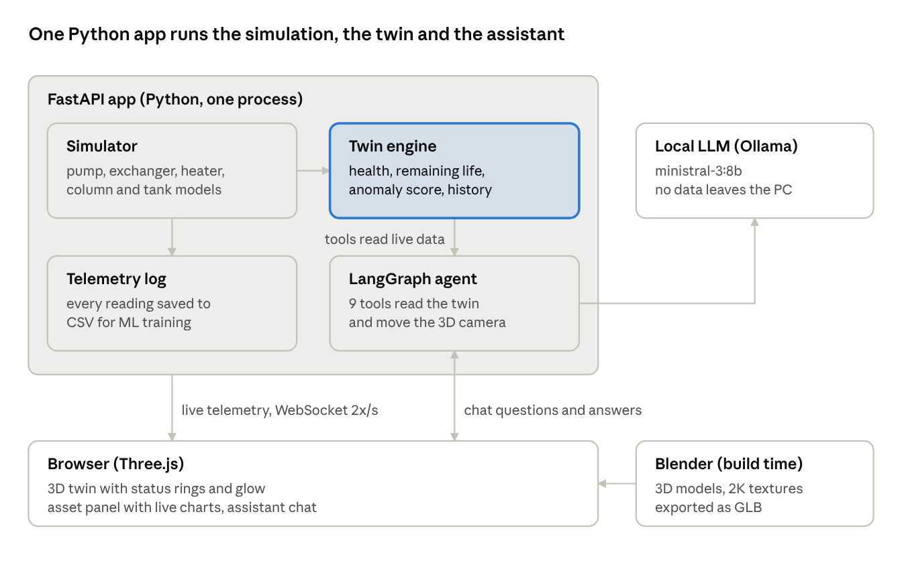
POC architecture · one app, six parts
“It is deliberately simple. The 3D models were generated by script in Blender. One Python FastAPI application runs the plant simulation, keeps the twin’s state and history, and hosts the AI agent. The browser draws the plant with Three.js and receives live data twice a second over a WebSocket.”
“Everything is open-source and runs on a single laptop with an RTX 5060. Replacing the simulator with a real data feed is a change in one module; the 3D view and the assistant do not change.”

8. Close and the ask (11:30–12:00)
Do: Click Skyline and stop touching the mouse.
“So in twelve minutes we saw a refinery unit we can walk around in a browser, a pump failure caught early with a remaining-life estimate, the spare taking over, an assistant that explains it from real data, and a what-if test that never touched the plant.”
“The next steps are clear:”
- “Connect one real unit, read-only, through the plant historian or OPC UA.”
- “Train the anomaly and remaining-life models on real history and validate them against past failures.”
- “Give the assistant the maintenance manuals and SOPs, and let it draft work orders for an engineer to approve.”
“What I am asking for today is [fill in: e.g. read-only data access for one unit and four weeks to run a pilot]. Thank you — I am happy to take questions, and you are welcome to drive the twin yourselves.”

Likely questions
Keep answers to two sentences, then offer to show it live.
Question | Short answer
Is this real plant data? | No — CDU-100 is fictional and the sensors are simulated with physics-style models. The design keeps the data feed in one module so a real historian can replace it.
How accurate is the remaining-life number? | Today it is a trend extrapolation, good enough to show the workflow. The next phase trains ML models on real failure history and measures accuracy before anyone relies on it.
Can the AI make things up? | Every number must come from a tool that reads the twin, and the tools used are shown under each answer. It can only change the simulation, never the plant.
Where does our data go? | Nowhere: the model runs locally through Ollama on this laptop. A hosted model is optional and a single setting.
Would it connect to our control system? | Read-only, from the historian or an OPC UA server in the plant DMZ. It never writes to the control system.
Does it scale to a whole refinery? | Each unit is a layout file plus 3D models; adding units is repeatable work. The web 3D view already runs on an ordinary laptop GPU.
Why not Unreal Engine? | An Unreal Engine 5 version exists as an optional cinematic path. The browser version needs no install, so anyone can open it, which matters more for a POC.
What did it cost? | Open-source tools on one laptop; the effort was the build itself. [Fill in your hours if asked.]

If something goes wrong
Stay calm and narrate; the audience cannot tell a plan B from plan A.
Problem | What to do
Assistant takes more than a minute | Keep talking (section 5 lines), or use the Ask assistant button on the Asset panel next time. Ollama must be running before START.bat.
Assistant says the language model failed | It still answers from plant data in offline mode — read that answer out; it is accurate.
P-101A does not turn amber | Check the speed is ×300; click Simulate bearing wear again.
You pressed Reset sim by mistake | That also stops the built-in slow fault; just use Simulate bearing wear as scripted.
3D view is blank or stuck on “Loading” | No internet (the 3D library loads online): connect to a hotspot and press F5.
Page shows “offline” top right | The server window was closed: run START.bat again and press F5.
Labels feel cluttered | Click Labels: smart, or Labels: none for a clean shot.

