AI Financial Chatbot Knowledge Base (Simplified)

Goal of This Knowledge Base
This document summarizes major investment options available to individuals.
It explains their risk levels, expected returns, liquidity, time horizon, and suitable investor types.
This information will be used by the AI financial chatbot (RAG-LLM system) to recommend appropriate financial products based on user profiles.

Investment Categories Overview
1. Cash & Safe Savings – Very low risk, used for emergency funds.
2. Fixed Income – Low to medium risk, provides stable income.
3. Equities – High risk, used for long-term growth.
4. Real Assets – Medium to high risk, often used as inflation hedges.
5. Retirement Products – Long-term wealth building for retirement.
6. Alternatives – High to very high risk, diversification or speculation.
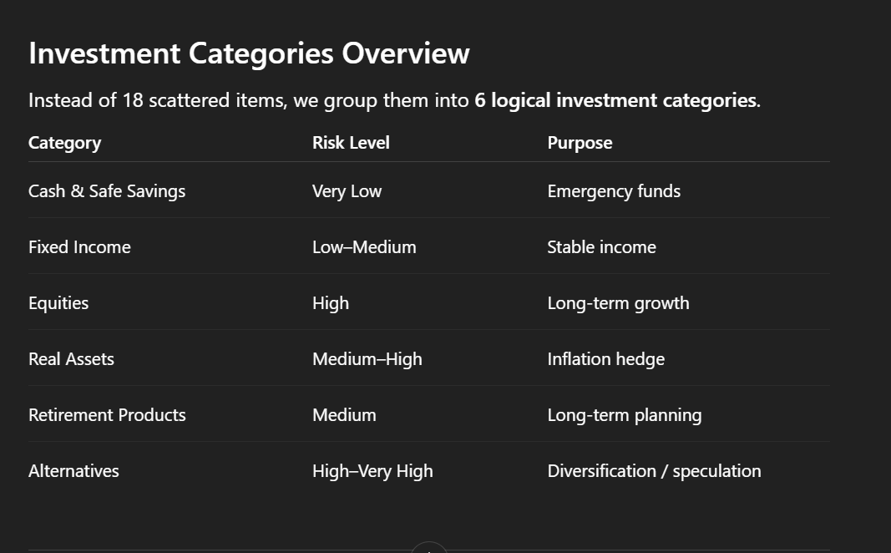

1. Cash & Safe Savings
Examples: Savings accounts, money market funds, treasury bills.

Risk: Very Low
Return: 1–4% annually
Liquidity: Very High

Best Use:
- Emergency funds
- Short-term expenses
- Temporary parking of cash

2. Fixed Income Investments
Examples:
- Fixed Deposits (FD)
- Certificates of Deposit (CD)
- Government savings schemes (PPF, NSC, SCSS)
- Government bonds
- Corporate bonds
- Debt mutual funds

Risk: Low–Medium
Returns: ~3–8% depending on product

Best For:
- Conservative investors
- Stable income generation
- Medium-term goals

3. Equity Investments
Examples:
- Individual stocks
- Equity mutual funds
- ETFs
- Index funds

Risk: High
Returns: ~7–12% long-term market average

Advantages:
- High growth potential
- Inflation hedge
- Ownership in companies

Downside:
- Market volatility
- Requires long-term horizon

4. Hybrid / Balanced Funds
Examples:
- Balanced funds
- Asset allocation funds
- Target-date funds

Risk: Medium
Returns: ~6–9%

Advantages:
- Diversification
- Automatic rebalancing
- Suitable for moderate-risk investors

5. Real Asset Investments
Examples:
- Real estate (residential or commercial property)
- REITs (Real Estate Investment Trusts)
- Gold and commodity ETFs

Risk: Medium–High

Advantages:
- Inflation hedge
- Tangible assets
- Portfolio diversification

6. Retirement Investments
Examples:
- National Pension System (NPS)
- Employee Provident Fund (EPF)
- Pension plans

Returns: ~6–10% long-term

Advantages:
- Tax benefits
- Long-term retirement planning
- Disciplined investing

7. Insurance-linked Investments
Examples:
- ULIPs
- Endowment plans

Risk: Varies

Note:
These combine insurance with investments but often have higher fees compared to investing separately.

8. Annuities
Purpose:
Provide guaranteed income for life.

Risk: Low

Best For:
Retirees who want stable, predictable income streams.

9. Alternative Investments
Examples:
- Private equity
- Venture capital
- Hedge funds

Risk: High–Very High

Characteristics:
- Illiquid investments
- Potentially very high returns
- Usually accessible only to high-net-worth investors

10. Crypto Assets
Examples:
- Bitcoin
- Ethereum
- DeFi tokens

Risk: Extremely High

Characteristics:
- Very volatile
- Speculative investment
- Should only represent a small part of a diversified portfolio

How This Helps the AI Chatbot
The AI chatbot will:
1. Collect user profile information (age, income, risk tolerance, goals).
2. Match user profiles with suitable investment categories.
3. Generate personalized investment explanations and suggestions.

Example:
Low risk users → FDs, PPF, bonds
Moderate risk users → Hybrid funds, REITs
High risk users → Equity funds, stocks
Very high risk users → Alternatives, crypto
