**OBJECTIVE:**

To study the performance of various types of controllers used to control the temperature of an oven.

**RUN 1: Identification of Oven Parameters**

Data: <https://docs.google.com/spreadsheets/d/12pg4PivhFpfRCq2VLuUwybyu2IgI_gQ5/edit?usp=drive_link&ouid=114018343652852839620&rtpof=true&sd=true>

Plot:

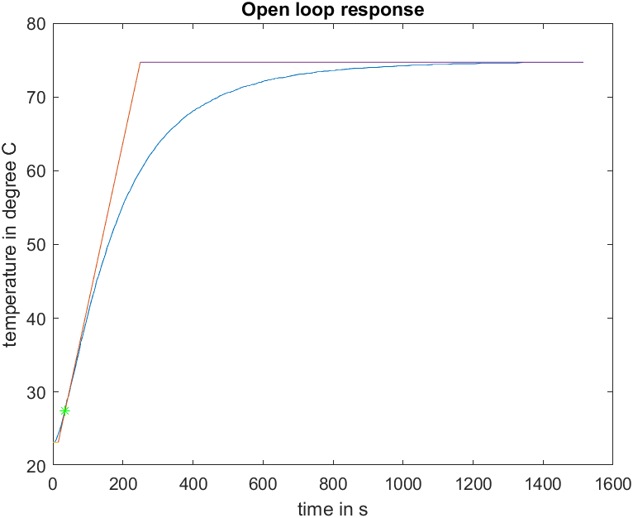

$$K=\frac{Final temperature of oven - Ambient temp. }{Input (Volts) }=103$$

$$T_{1} = 234.0909$$

$$T_{2} = 15.4545$$

**RUN 2: P control**

Data: <https://docs.google.com/spreadsheets/d/1DeY-AUtg7b9NyJHn6HFC3SKDNS2YkUCm/edit?usp=drive_link&ouid=114018343652852839620&rtpof=true&sd=true>

P-setting determination:

$$K_{p}=\left(\frac{1}{K}\right)∙\frac{T_{1}}{T_{2}}=0.1471 V/℃$$

$$K_{p_{max}}=20 ×0.01=0.2 V/℃$$

$$p-setting= \frac{K_{p}}{K_{p_{max}}}=\frac{0.1471}{0.2}=0.7353$$

Plot:

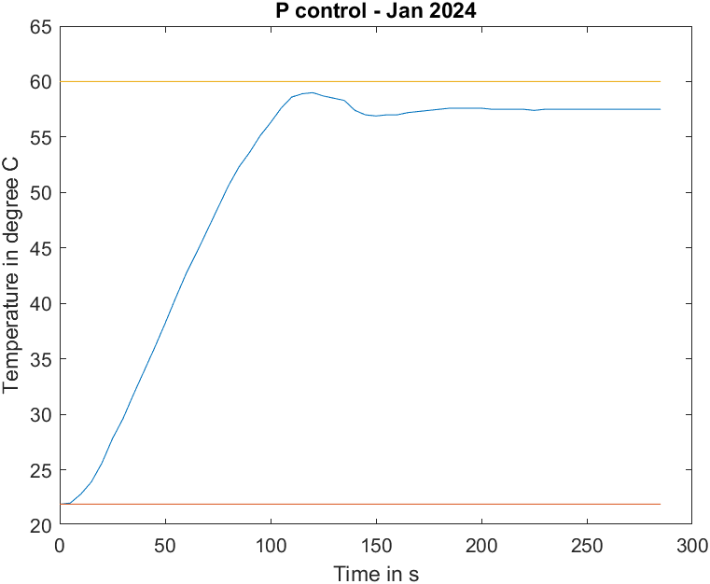

**RUN 3: PI control**

Data: <https://docs.google.com/spreadsheets/d/1Fr97d8wlCcBbTfJPKrKAxnZwwKDxmddB/edit?usp=drive_link&ouid=114018343652852839620&rtpof=true&sd=true>

P & I setting determination:

$$K_{P}=\left(\frac{0.9}{K}\right)∙\frac{T_{1}}{T_{2}}=0.1324 V/℃$$

$$K_{P_{max}}=20 ×0.01=0.2 V/℃$$

$$P-setting= \frac{K_{P}}{K_{P_{max}}}=\frac{0.1324}{0.2}=0.6618$$

$$K_{I}=\frac{1}{{3.3T}_{2}}=0.0196$$

$$K_{I_{max}}=0.0357$$

$$I-setting= \frac{K_{I}}{K_{I_{max}}}=0.5490$$

Plot:

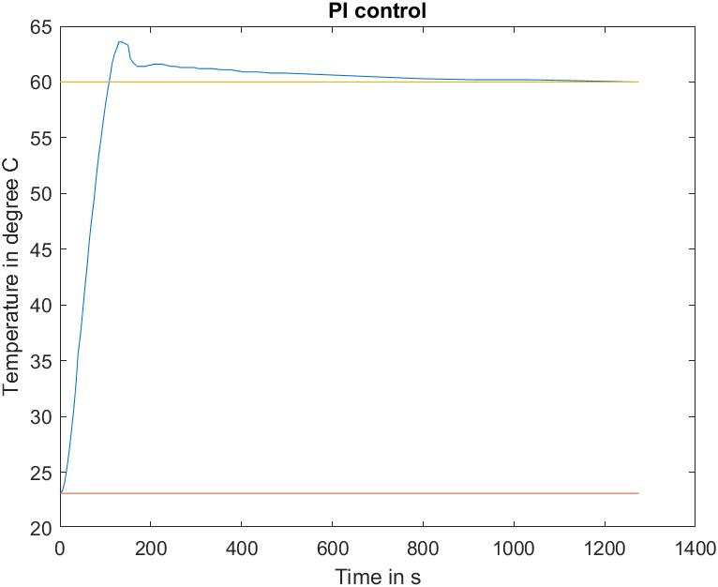

**RUN 4: PID control**

Data: <https://docs.google.com/spreadsheets/d/13uNA5jYbIO_HD7LKZGugZnTSOWXX3aZm/edit?usp=drive_link&ouid=114018343652852839620&rtpof=true&sd=true>

P, I & D setting determination:

$$K_{p}=\left(\frac{1.2}{K}\right)∙\frac{T_{1}}{T_{2}}=0.1765 V/℃$$

$$K_{p_{max}}=20 ×0.01=0.2 V/℃$$

$$P-setting= \frac{K_{p}}{K_{p_{max}}}=\frac{0.1765}{0.2}=0.8824$$

$$K_{I}=\frac{1}{{2T}_{2}}=0.0324$$

$$K_{I_{max}}=0.0357$$

$$I-setting= \frac{K_{I}}{K_{I_{max}}}=0.9059$$

$$K_{D}=0.5 T_{2}=7.7273$$

$$K_{D_{max}}=23.5$$

$$D-setting= \frac{K_{D}}{K_{D_{max}}}=\frac{7.7273}{0.223.5}=0.3288$$

Plot:

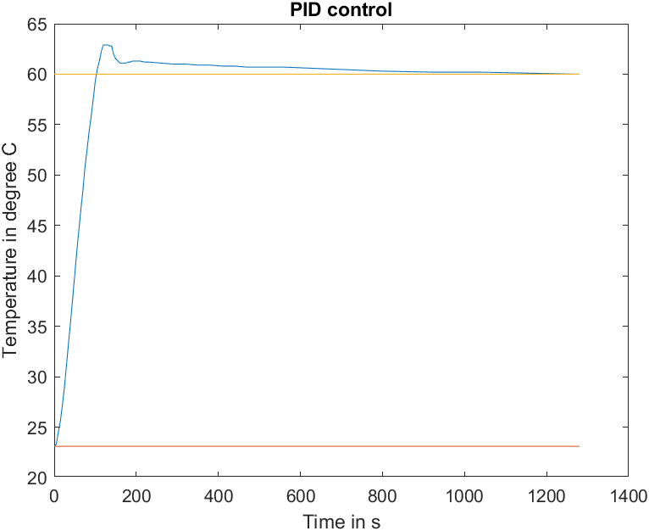

**RUN 4: ON – OFF control**

Low Hysteresis: <https://docs.google.com/spreadsheets/d/1xJjDLkC70b6td6O58dDFGxTDkxoY8DsZ/edit?usp=drive_link&ouid=114018343652852839620&rtpof=true&sd=true>

High Hysteresis: <https://docs.google.com/spreadsheets/d/1Sa0XeGKLTibhW1D3F7IlCNa55NufWP8v/edit?usp=drive_link&ouid=114018343652852839620&rtpof=true&sd=true>

Plot:

