WEEK 1 TASK REPORT
Agribusiness Data Collection and Cleaning
Dataset: Agriculture Dataset | Records: 50 | Original Variables: 10

1. Executive Summary
This report documents the collection, inspection, cleaning, validation, statistical analysis, and preparation of the supplied agribusiness dataset. The data describes farms using variables such as crop type, farm area, irrigation type, fertilizer use, pesticide use, crop yield, soil type, season, and water usage. The purpose of the cleaning stage was to produce a reliable dataset suitable for exploratory analysis and future machine-learning work.
The supplied file contains 50 records and 10 variables. No missing values and no exact duplicate rows were detected. IQR-based analysis found no numerical outliers, so no legitimate observations were removed. A cleaned dataset in original units and a separately standardized dataset were produced.

2. Dataset Description
The dataset is an agribusiness/farm-level dataset. Each row represents a farm and includes operational and production characteristics. The uploaded archive contained the file `agriculture_dataset.csv`. The archive did not contain a source URL or attribution file, so no external source URL has been invented in this report; the dataset should be accompanied by its original public-source URL when submitting if the internship coordinator requires explicit provenance.

3. Dataset Schema
Variable | Type | Description
Farm_ID | Identifier | Unique farm identifier
Crop_Type | Categorical | Crop cultivated on the farm
Farm_Area(acres) | Numerical | Farm area in acres
Irrigation_Type | Categorical | Irrigation method
Fertilizer_Used(tons) | Numerical | Fertilizer quantity used
Pesticide_Used(kg) | Numerical | Pesticide quantity used
Yield(tons) | Numerical | Crop production/yield
Soil_Type | Categorical | Soil category
Season | Categorical | Growing season
Water_Usage(cubic meters) | Numerical | Water consumption

4. Data Quality Assessment
The following checks were performed:
Check | Result
Dataset dimensions | 50 rows × 10 columns
Missing values | 0 missing values in every column
Exact duplicates | 0 duplicate rows
Data types | 5 numerical and 5 categorical/object fields
Categorical consistency | Values were inspected and surrounding whitespace was removed
Numerical conversion | Numerical fields were safely converted to numeric types
Outlier detection | IQR method; 0 outliers across all numerical variables

5. Cleaning and Preprocessing Procedure

5.1 Column-name standardization
Converted column names to lowercase, underscore-separated names so they can be used reliably in Python and ML pipelines.

5.2 Text cleaning
Removed leading/trailing whitespace from categorical fields and converted common empty/missing tokens such as NA and N/A to null values.

5.3 Numeric validation
Converted non-categorical fields to numeric values using safe coercion. No problematic numeric values were found.

5.4 Missing-value handling
No missing values were present, therefore imputation was not required. For a future version, median imputation could be considered for numerical fields and mode/Unknown handling for categorical fields.

5.5 Duplicate handling
Exact duplicate rows were checked. 0 duplicates were removed.

5.6 Outlier handling
The IQR rule was applied to every numerical variable. Because zero outliers were detected, observations were retained rather than artificially deleting potentially meaningful farm-level variation.

5.7 Normalization/standardization
The cleaned master file remains in original units for interpretability. A separate standardized dataset was generated using z-score standardization for potential ML algorithms that are sensitive to feature scale.

6. Statistical Summary
Variable | Count | Mean | Std. Dev. | Min | Max
farm_area_acres | 50.000 | 254.964 | 139.418 | 12.500 | 483.880
fertilizer_used_tons | 50.000 | 4.905 | 2.733 | 0.500 | 9.960
pesticide_used_kg | 50.000 | 2.398 | 1.439 | 0.140 | 4.990
yield_tons | 50.000 | 27.059 | 13.346 | 3.860 | 48.020
water_usage_cubic_meters | 50.000 | 56724.296 | 27264.992 | 5869.750 | 94754.730

7. Categorical Summary
farm_id: F001 (1), F002 (1), F003 (1), F004 (1), F005 (1), F006 (1), F007 (1), F008 (1), F009 (1), F010 (1), F011 (1), F012 (1), F013 (1), F014 (1), F015 (1), F016 (1), F017 (1), F018 (1), F019 (1), F020 (1), F021 (1), F022 (1), F023 (1), F024 (1), F025 (1), F026 (1), F027 (1), F028 (1), F029 (1), F030 (1), F031 (1), F032 (1), F033 (1), F034 (1), F035 (1), F036 (1), F037 (1), F038 (1), F039 (1), F040 (1), F041 (1), F042 (1), F043 (1), F044 (1), F045 (1), F046 (1), F047 (1), F048 (1), F049 (1), F050 (1)
crop_type: Cotton (7), Barley (7), Tomato (6), Rice (5), Soybean (5), Sugarcane (5), Carrot (4), Wheat (4), Potato (4), Maize (3)
irrigation_type: Drip (15), Flood (13), Sprinkler (9), Rain-fed (7), Manual (6)
soil_type: Clay (14), Loamy (11), Sandy (11), Silty (10), Peaty (4)
season: Zaid (23), Kharif (16), Rabi (11)

8. Outlier Analysis
Variable | Q1 | Q3 | IQR | Outliers
farm_area_acres | 135.710 | 368.108 | 232.398 | 0
fertilizer_used_tons | 2.438 | 6.885 | 4.447 | 0
pesticide_used_kg | 0.972 | 3.417 | 2.445 | 0
yield_tons | 16.190 | 37.860 | 21.670 | 0
water_usage_cubic_meters | 37818.152 | 82240.033 | 44421.880 | 0
The absence of IQR outliers does not prove that the data contains no unusual real-world values; it only indicates that none fall outside the conventional 1.5×IQR fences. Domain validation would be required before declaring a farm value unrealistic.

9. Feature Engineering for Agribusiness Analysis
Four optional derived indicators were demonstrated in the notebook: yield per acre, fertilizer used per acre, pesticide used per acre, and water used per acre. These measures help compare farms of different sizes and can be useful for resource-efficiency analysis.

10. Visual Analysis
The following plots were generated during validation:
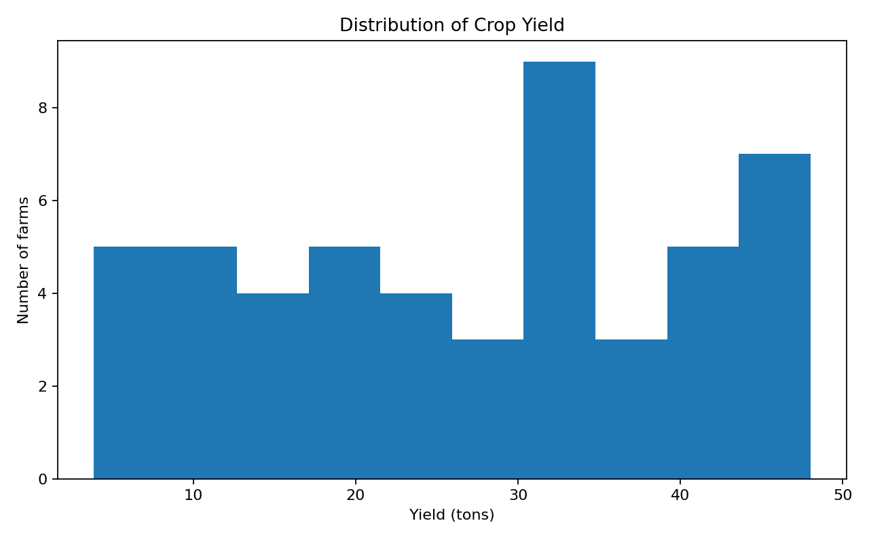
Figure 1. Distribution of crop yield
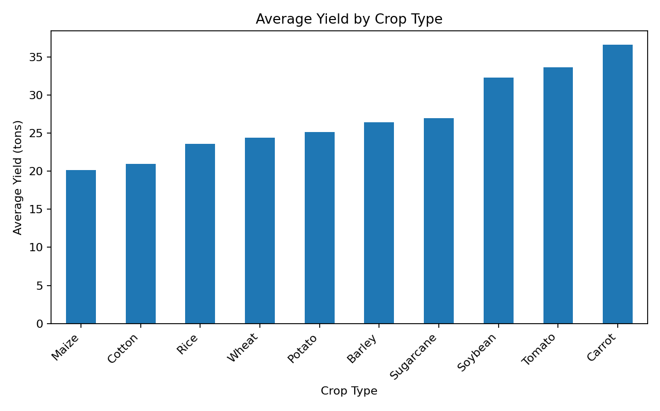
Figure 2. Average yield by crop type
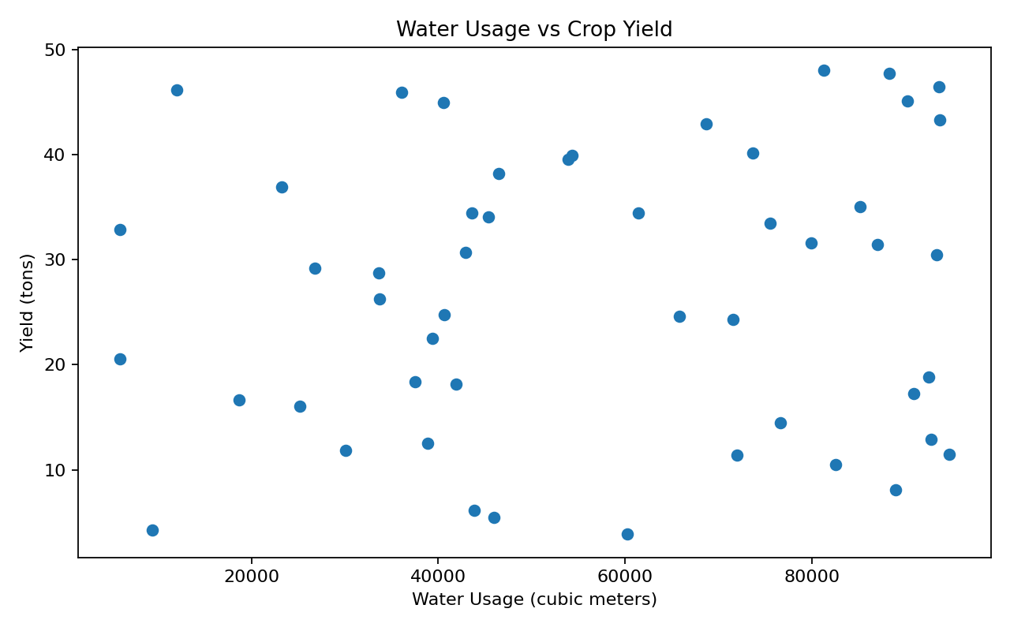
Figure 3. Water usage versus crop yield

11. Challenges Encountered and Solutions
Challenge | Why it matters | Solution
Small sample size | Only 50 farms are available. | Treat conclusions as exploratory and avoid claiming population-wide relationships.
No source metadata in archive | The uploaded archive contains the CSV but no URL/README. | Report the supplied file as the working dataset and add the original public-source URL if available from the internship instructions.
Outlier ambiguity | Agricultural extremes may be legitimate. | Use IQR as a detection rule and avoid automatic deletion; retain all observations when no statistical outliers are detected.
Different feature scales | Area, fertilizer, pesticide, yield and water usage have different units/scales. | Keep original-unit data for reporting and create a separate standardized copy for ML.

12. Final Dataset Files
The submission package contains the original supplied dataset, the cleaned dataset, a standardized analytical copy, and the Jupyter notebook documenting the full workflow.
- agriculture_dataset.csv
- cleaned_agriculture_dataset.csv
- standardized_agriculture_dataset.csv
- Week1_Agribusiness_Data_Cleaning.ipynb

13. Conclusion
The Week 1 data-cleaning workflow successfully converted the supplied farm dataset into a validated and analysis-ready form. The data was checked for missing values, duplicates, inconsistent text, numeric validity, and outliers. No records required deletion because the dataset contained no missing values, duplicates, or IQR outliers. The final cleaned dataset preserves original agribusiness units, while a standardized copy is available for future machine-learning tasks. The accompanying notebook makes the workflow reproducible and auditable.

14. Reproducibility Note
Run the notebook with Python 3 and the packages pandas, numpy, matplotlib, and Jupyter Notebook/JupyterLab. Place `agriculture_dataset.csv` in the same folder as the notebook, run all cells from top to bottom, and the cleaned and standardized CSV files will be regenerated.

