WEEK 2 TASK REPORT
Exploratory Data Analysis — Agribusiness Dataset
50 farm records | Based on Week 1 cleaned dataset

1. Objective
The objective of this Week 2 task is to perform detailed Exploratory Data Analysis on the cleaned agribusiness dataset from Week 1. EDA is used to understand distributions, categorical composition, relationships, correlations, trends, and possible anomalies before applying machine-learning models. The analysis combines descriptive statistics with visual techniques so that numerical patterns can be interpreted in an agricultural context.

2. Dataset Overview
The dataset contains 50 farm-level observations and 10 variables. Numerical variables include farm area, fertilizer usage, pesticide usage, crop yield, and water usage. Categorical variables describe crop type, irrigation type, soil type, and season. The Week 1 cleaning process found no missing values or exact duplicate records, providing a consistent base for EDA.

3. Statistical Summary
Variable | Mean | Std Dev | Min | Median | Max
farm_area_acres | 254.964 | 139.418 | 12.500 | 281.980 | 483.880
fertilizer_used_tons | 4.905 | 2.733 | 0.500 | 5.045 | 9.960
pesticide_used_kg | 2.398 | 1.439 | 0.140 | 2.330 | 4.990
yield_tons | 27.059 | 13.346 | 3.860 | 28.970 | 48.020
water_usage_cubic_meters | 56724.296 | 27264.992 | 5869.750 | 54097.075 | 94754.730

4. Numerical Distribution Analysis
Histograms were generated for farm area, fertilizer use, pesticide use, crop yield, and water usage. They show the spread and concentration of observations and help identify skewness or unusual values.
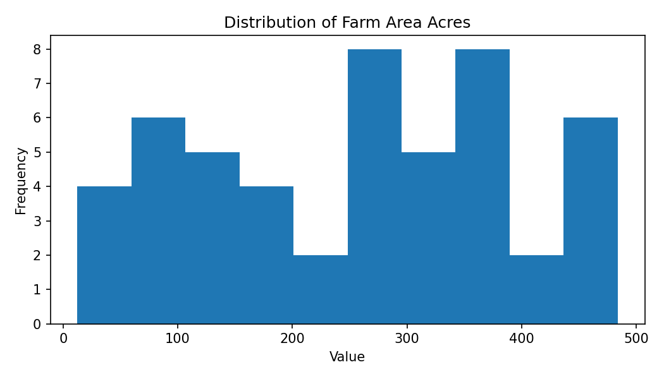
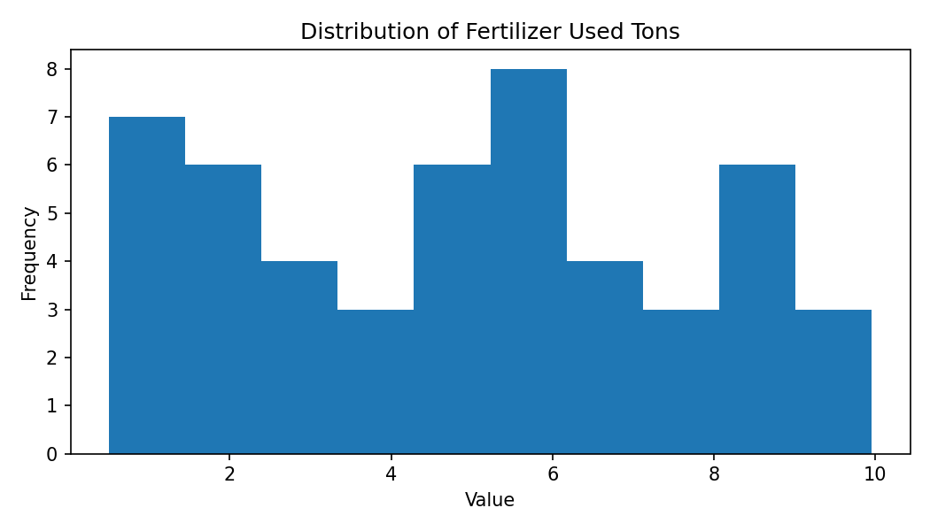
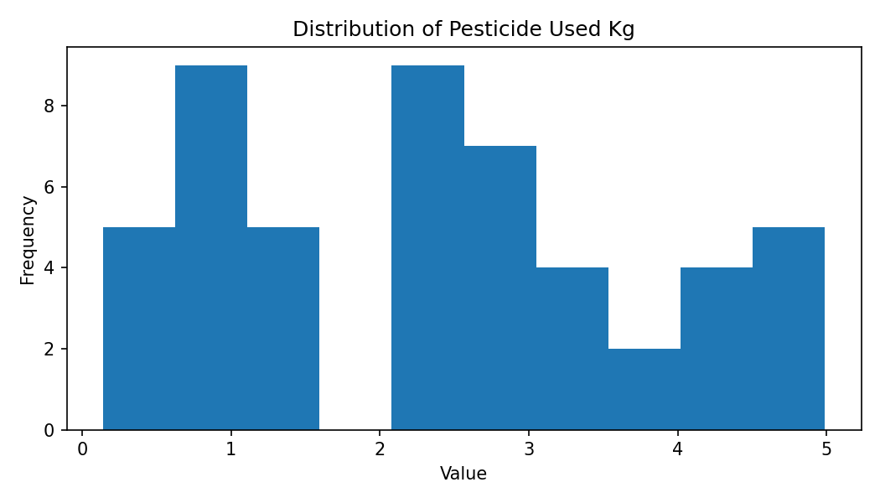
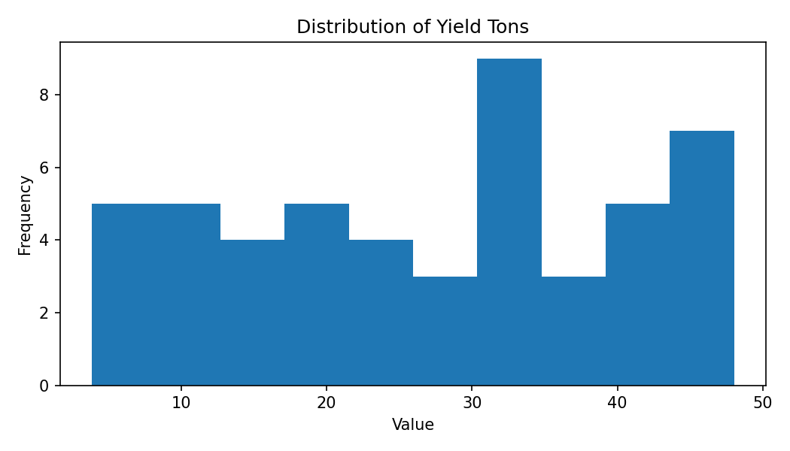
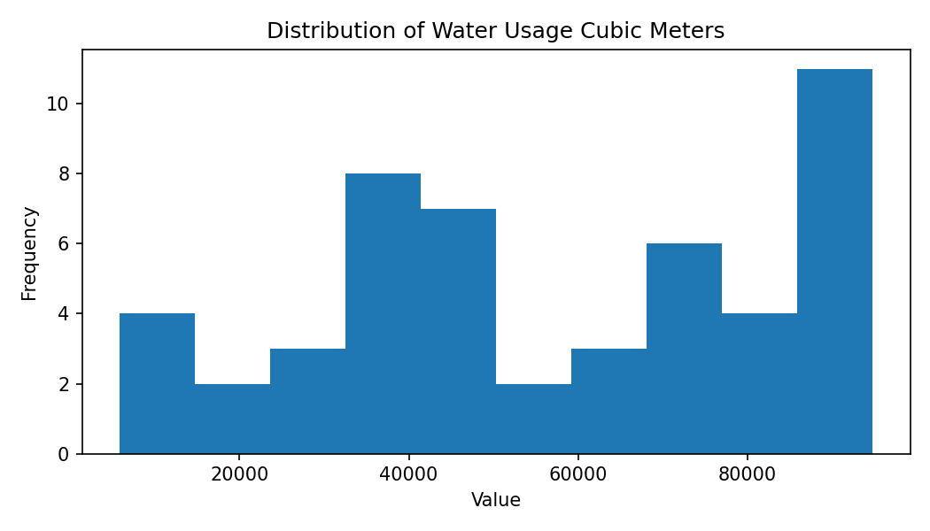

5. Categorical Distribution Analysis
Crop Type: Cotton (7), Barley (7), Tomato (6), Rice (5), Soybean (5), Sugarcane (5), Carrot (4), Wheat (4), Potato (4), Maize (3)
Irrigation Type: Drip (15), Flood (13), Sprinkler (9), Rain-fed (7), Manual (6)
Soil Type: Clay (14), Loamy (11), Sandy (11), Silty (10), Peaty (4)
Season: Zaid (23), Kharif (16), Rabi (11)
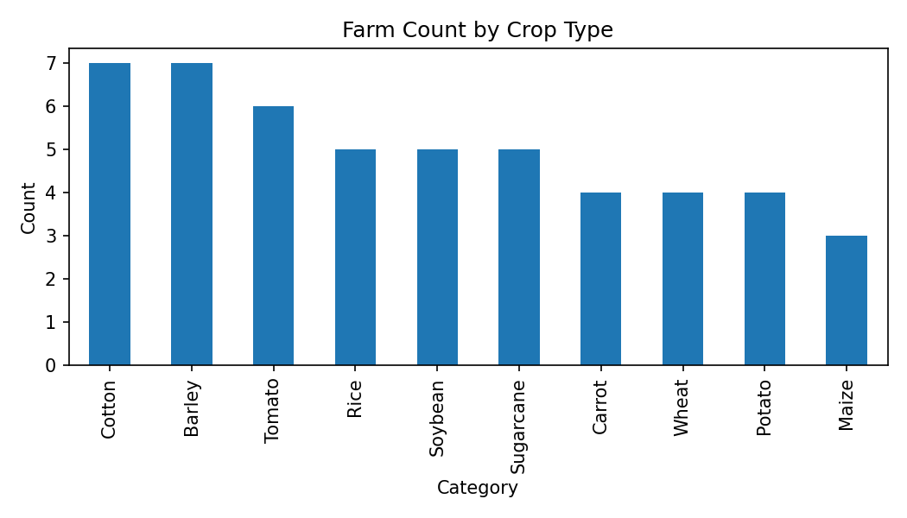
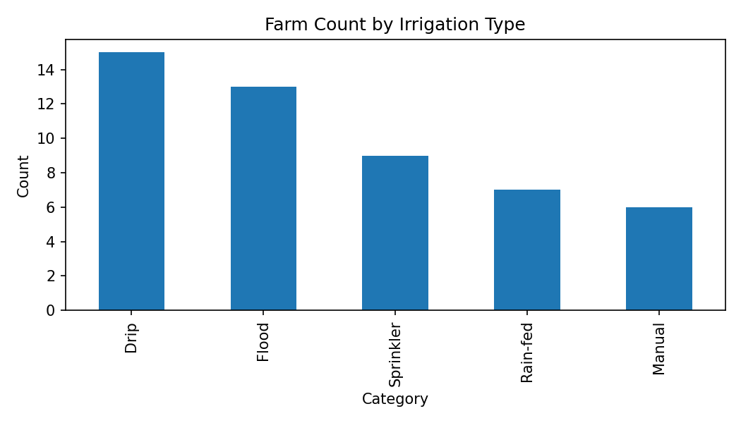
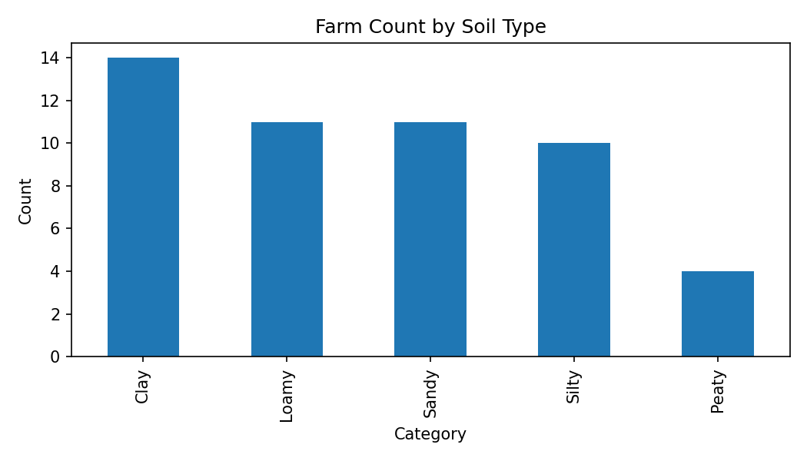
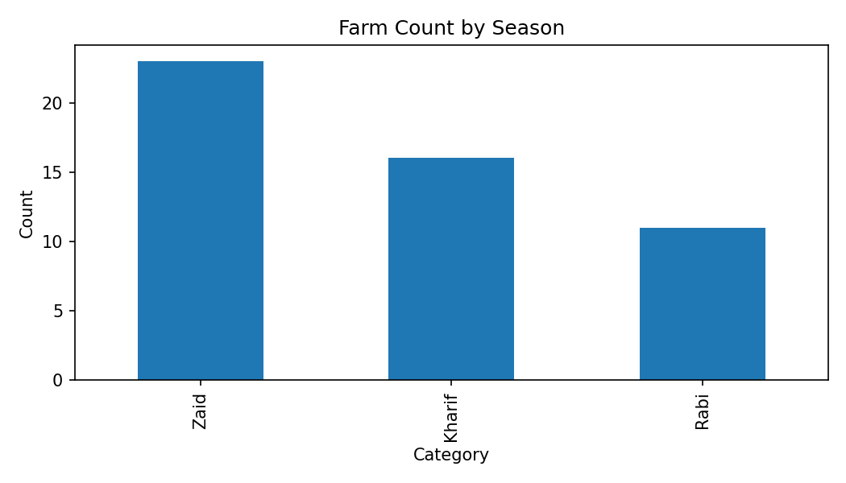

6. Average Yield by Farm Characteristics
Crop Type — Carrot: 36.63 tons, Tomato: 33.63 tons, Soybean: 32.31 tons, Sugarcane: 26.95 tons, Barley: 26.40 tons, Potato: 25.16 tons, Wheat: 24.42 tons, Rice: 23.59 tons, Cotton: 20.97 tons, Maize: 20.16 tons
Irrigation Type — Manual: 34.16 tons, Rain-fed: 31.98 tons, Sprinkler: 27.89 tons, Drip: 26.77 tons, Flood: 20.89 tons
Soil Type — Silty: 30.89 tons, Loamy: 27.48 tons, Sandy: 27.03 tons, Clay: 25.04 tons, Peaty: 23.47 tons
Season — Zaid: 28.00 tons, Kharif: 27.34 tons, Rabi: 24.67 tons
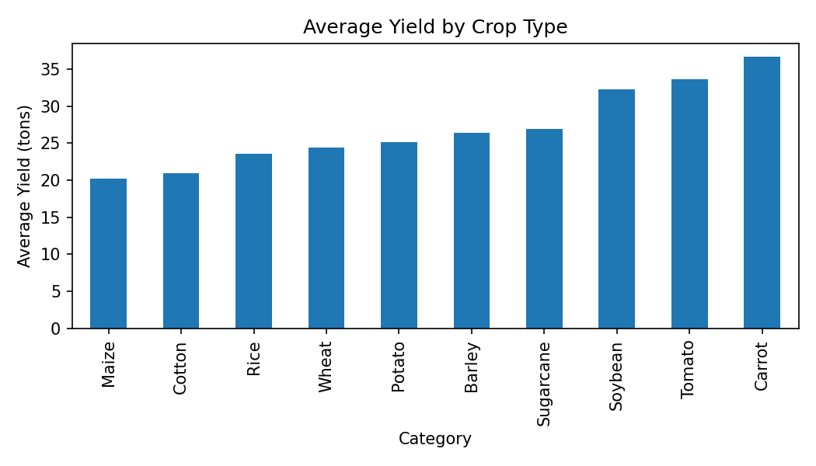
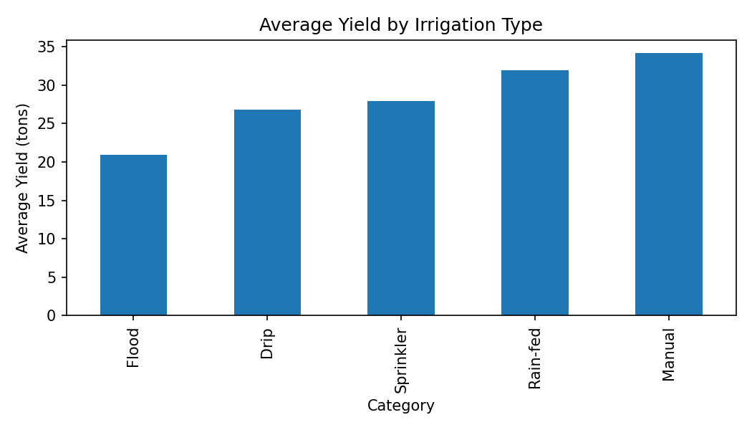
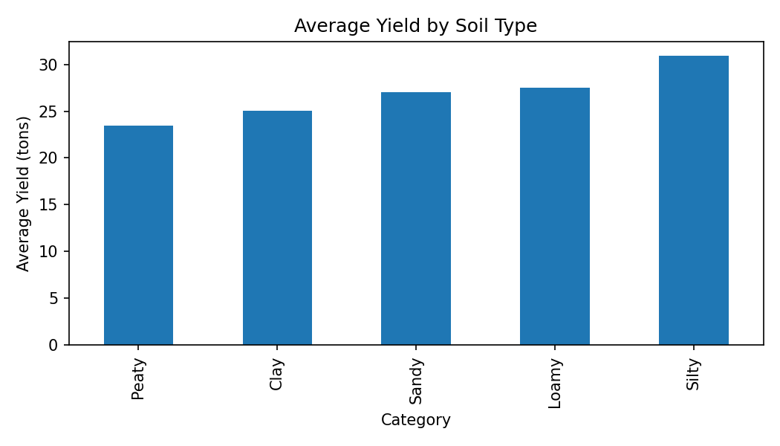
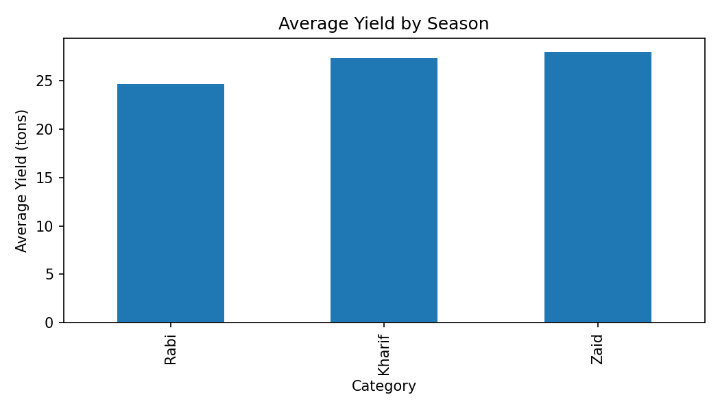

7. Correlation and Relationship Analysis
Pearson correlation was calculated for selected numerical variables against crop yield. A correlation coefficient describes the direction and strength of a linear association. Scatter plots with fitted trend lines were used to visually inspect these relationships. Correlation indicates association and does not establish causation.
Relationship | Pearson r | Description
Water Usage Cubic Meters vs Yield | 0.108 | weak positive linear association
Fertilizer Used Tons vs Yield | 0.045 | weak positive linear association
Farm Area Acres vs Yield | 0.153 | weak positive linear association
Pesticide Used Kg vs Yield | -0.090 | weak negative linear association
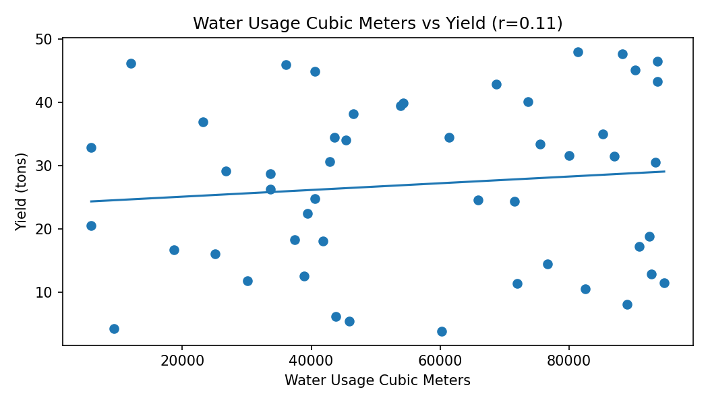
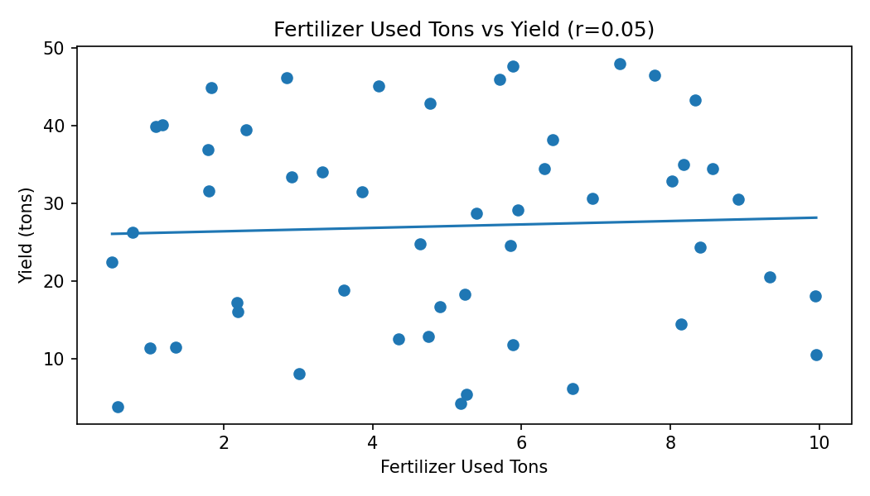
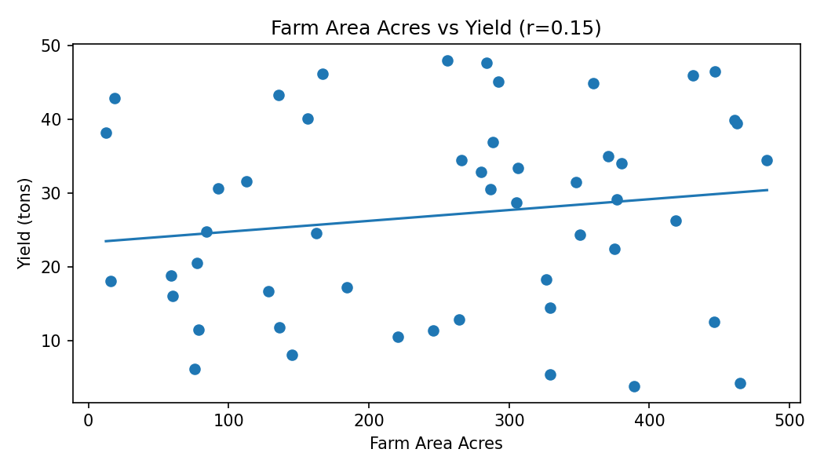
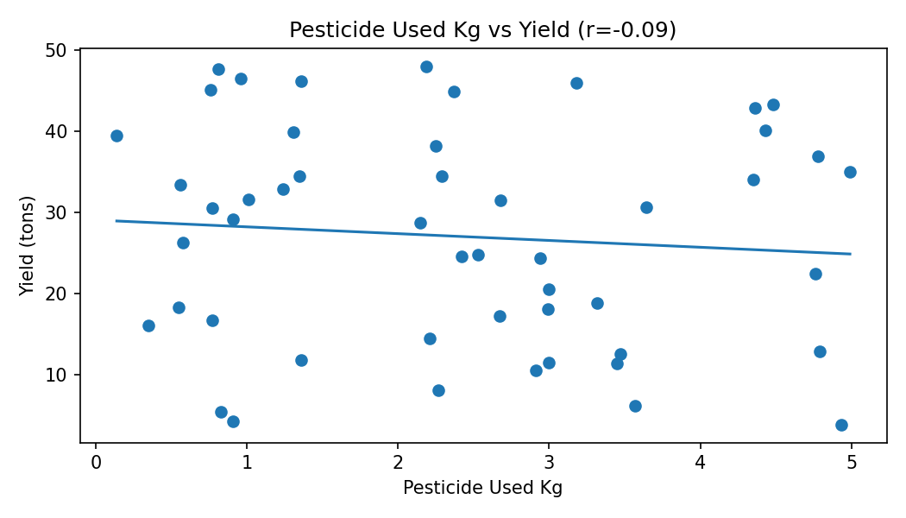
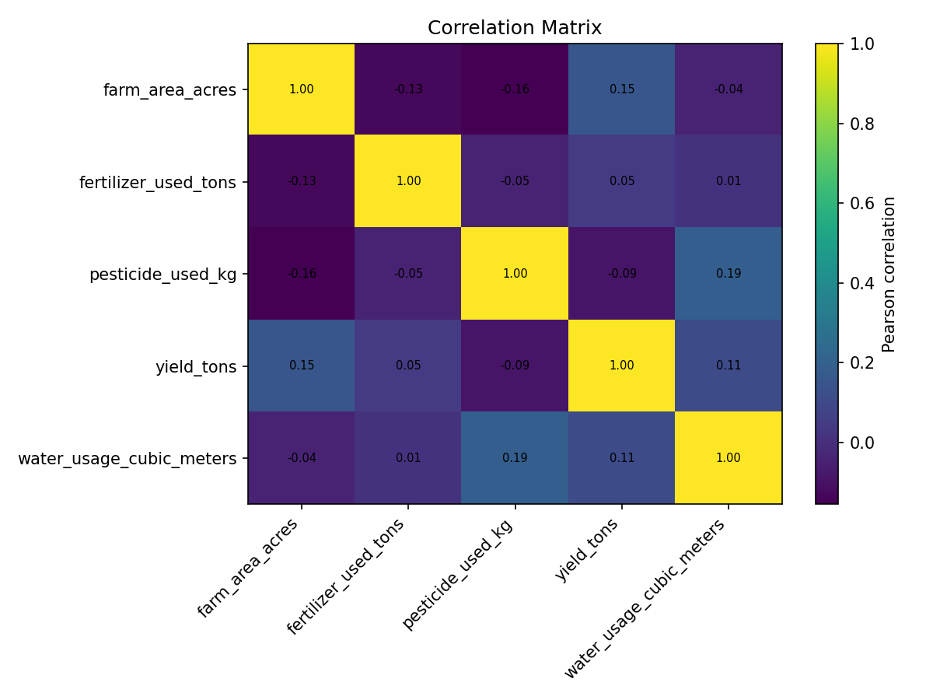

8. Agribusiness Efficiency Analysis
Four derived indicators were calculated: yield per acre, fertilizer used per acre, pesticide used per acre, and water used per acre. These measures make comparisons between farms of different sizes more meaningful and provide a basis for later resource-efficiency analysis.
Indicator | Mean | Std Dev | Min | Max
yield_per_acre | 0.250 | 0.534 | 0.009 | 3.054
fertilizer_per_acre | 0.052 | 0.116 | 0.001 | 0.635
pesticide_per_acre | 0.024 | 0.047 | 0.000 | 0.234
water_per_acre | 483.308 | 796.087 | 20.216 | 3719.038

9. Anomaly Analysis
The IQR method was used as a statistical anomaly check. No IQR-based outliers were detected in the cleaned numerical variables. This does not prove that every observation is realistic in a real agricultural setting; domain knowledge and external agronomic benchmarks would be required to identify genuinely abnormal farm conditions.

10. Key Findings and Insights
- Numerical distributions show variation in farm size, agricultural inputs, water usage, and crop yield.
- Crop, irrigation, soil, and seasonal categories can be compared using their observed average yields.
- Pearson correlations quantify linear associations between yield and selected numerical variables.
- Scatter plots show whether relationships appear approximately linear and whether individual observations influence the visible pattern.
- Yield per acre provides a more comparable productivity measure than total yield when farm sizes differ.
- Per-acre resource indicators provide a useful basis for future resource-efficiency studies.
- No IQR-based numerical anomalies were detected in the cleaned Week 1 dataset.
- With only 50 farms, the results should be treated as exploratory rather than representative of all agricultural farms.

11. Limitations
The principal limitation is sample size. The dataset also lacks potentially important variables such as detailed weather history, geographic location, seed variety, soil nutrient measurements, labor input, and market conditions. Therefore, observed relationships cannot establish causation. A larger multi-region and multi-season dataset would support stronger statistical and predictive conclusions.

12. Conclusion
The Week 2 EDA provides a structured understanding of the cleaned agribusiness dataset. Distribution analysis describes numerical variability, categorical analysis describes farm composition, grouped analysis compares observed yield across agricultural characteristics, and correlation analysis identifies linear associations. Efficiency indicators add useful agricultural context. The resulting findings and visualizations provide a foundation for future feature selection, predictive modeling, and deeper statistical analysis.

