Title
Markdown lets you write content as plain text and later convert it into many output formats such as HTML, PDF, and DOCX.
A common tool for performing these conversions is Pandoc.

Headings

Heading 1

Heading 2

Heading 3

Heading 4

Heading 5

Heading 6

Emphasis
Italic text or italic text
Bold text or bold text
Bold and italic text
Strikethrough text

Lists
- List item 1
- List item 2
- List item 3
  - Nested item A
  - Nested item B

Ordered List
- First item
- Second item
- Third item

Task List
- Completed task
- Incomplete task
- Another incomplete task

Links and Images
Inline link
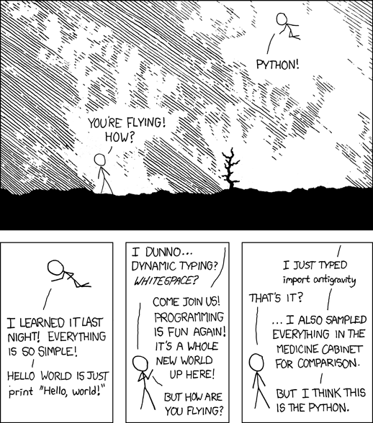

Blockquotes
This is a blockquote.
It can span multiple paragraphs.
Nested blockquotes are also possible.

Horizontal Rule

Mathematics
LaTeX-style mathematics can be embedded directly in Markdown:
$\int_{0}^{1}{d}x sin(αx)$
Display-style equations can also be written on their own line:
$$E=mc^{2}$$

Code
Inline code can be written like this.
Code blocks can be included with syntax highlighting:
import math
console.log("Hello, world!");

Tables
Name | Language
Pandoc | Haskell
Jekyll | Ruby

Escaping Characters
Use a backslash to escape special characters, e.g. *not italic*.

