# Final Report

Scatter Plot-

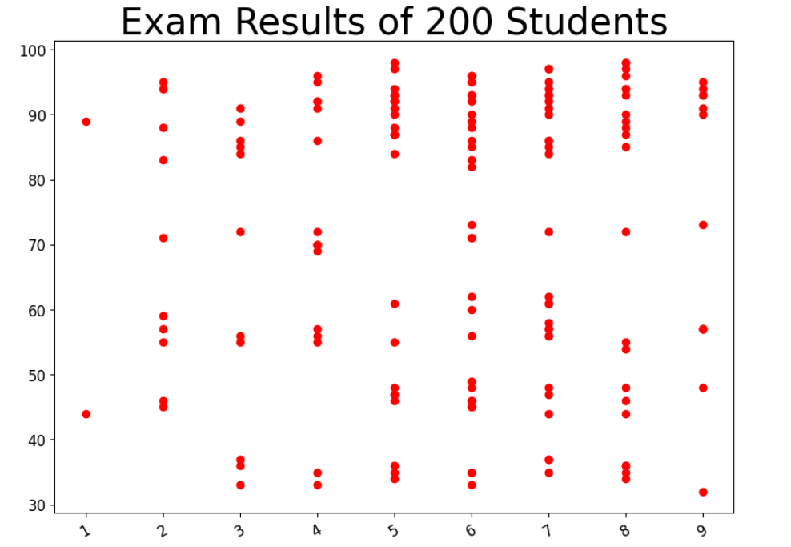

Line Graph-

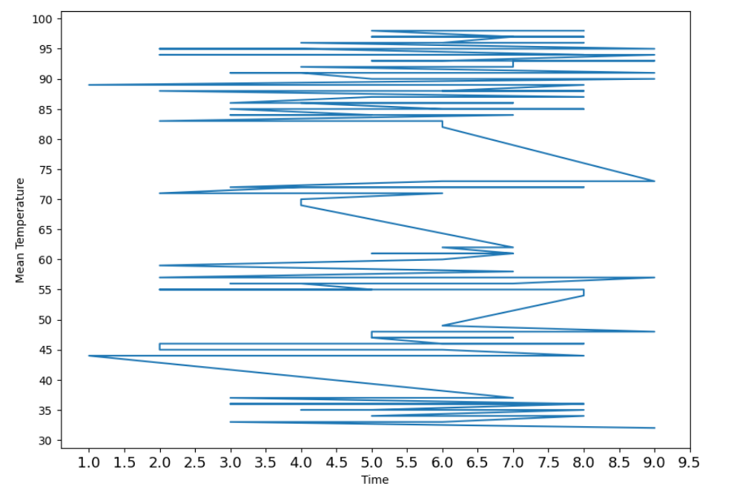The relation between the Avg. Percentage and Avg Hours is

