Table of Contents

1.Introduction 2
2.Problem Statement 2
3.Objectives 2
4.Methodology 2
4.1Requirement Identification 3
4.1.1.Study Of Existing System 3
4.1.2.Requirement Analysis 3
4.2 Feasibility Study 4
4.2.1 Technical Feasibility 4
4.2.2 Operational Feasibility 4
4.2.3 Economic Feasibility 4
4.2.4 Schedule Feasibility 4
4.3 High Level Design of Project 5
5.Expected Outcome 6
References…………………………………………………………………………………………………………………..

Introduction
Information Technology has become an essential part of modern society and plays a vital role in improving efficiency, accuracy, and productivity in almost every sector. Educational institutions such as schools and colleges are increasingly adopting computerized systems to manage academic and administrative activities. Libraries are an important part of any educational institution, providing access to books, journals, and digital resources that support learning and research.
Traditionally, libraries have been managed using manual methods such as registers and record books. These methods require significant human effort and are prone to errors, data redundancy, and loss of records. With the growth of information and the increasing number of library users, manual systems are no longer sufficient.
This project proposal presents the development of a Library Management System, which aims to automate the core functions of a library. The system will help librarians manage book records, member details, and issue–return transactions efficiently. The proposed system will improve accuracy, save time, and provide better services to library users.

Problem Statement
The existing manual library management system suffers from several limitations, which create difficulties for both librarians and users. Some of the major problems include:
- Maintaining book and member records manually is time-consuming and inefficient,
- Difficulty in tracking issued and available books accurately,
- High chances of data inconsistency, duplication, and human error,
- Manual calculation of fines and records increases workload,
- Searching for books or member details takes more time,

Objectives
The main objectives of developing the Library Management System are:
- To automate the day-to-day library activities including book and member management.,
- To maintain accurate and organized records of books, members, and issue-return transactions while reducing manual work and human errors.,
- To provide fast searching, reporting, and efficient book issue and return facilities.,

Methodology
The development of the Library Management System will be carried out in a structured and systematic manner. The methodology is divided into different phases to ensure proper planning and implementation of the project.

Requirement Identification
Study of existing system and requirement analysis are performed for requirement identification.

Study Of Existing System
There are many existing Library Management Systems currently in use in educational institutions, organizations, and libraries. Studying these existing systems is necessary to understand their functionalities, strengths, and limitations. This study helps in identifying the gaps and problems present in current systems, which in turn assists in designing a better and more efficient Library Management System.
Some of the existing library management systems similar to the proposed system are discussed below:
- Nepal Kasthamandap College Online Library (Librarika)
This system allows users to search books and view availability online. It provides basic catalog and member management features but offers limited customization and reporting options [1].

- DWRI Library Management System
This is a government library system used for cataloging and managing library resources. It mainly focuses on book records and lacks advanced features such as automated fine calculation [2].

- e-School Library Management System (Nepal)
This system is integrated with school management software and supports book issue, return, and fine calculation. It is suitable for schools but has limited flexibility for general libraries.
From the study of these systems, it is clear that most existing systems provide basic library functions but lack flexibility and customization. The proposed system aims to overcome these limitations [3].

Requirement Analysis
Based on the study of the existing system, the following requirements are identified:

Software Requirements:
- system, like Windows, Linux, Mac, Android, iOS etc.
- Technology: Reactjs,Tailwind, PHP
- Database: MySQL

Hardware Requirements:
- Processor: Dual Core or higher
- RAM: 2 GB Storage: 500 MB or More HDD/SSD
- Display: 1024*768 Resolution Display
- During development of this project XAMPP are used as local web server.

4.2 Feasibility Study
Feasibility study helps in determining whether the proposed system is practical and achievable within available resources.

4.2.1 Technical Feasibility
The project is technically feasible as it uses commonly available technologies such as php, web technologies, and MySQL. These technologies are well-supported and suitable for developing the system.

4.2.2 Operational Feasibility
The system will be user-friendly and easy to operate. Librarians with basic computer knowledge can use the system with minimal training, making it operationally feasible.

4.2.3 Economic Feasibility
The project is economically feasible since it uses open-source tools and does not require additional hardware or software investment.

4.2.4 Schedule Feasibility
Schedule feasibility refers to whether the project can be completed within the given academic time frame. The Library Management System project is planned in a structured manner by dividing the total work into different phases such as requirement analysis, design, coding, testing, and deployment. Each phase is allocated sufficient time to ensure quality development and timely completion. Since the project scope is well-defined and the technologies used are familiar, the project can be successfully completed within the scheduled duration.

Table 1: Gantt Chart for the Project
Development Phase | 4 Months |  |  |  |  |  |  |  |  |  | Duration
 | 0-20 | 20-40 |  | 40-60 |  | 60-80 |  | 80-100 |  | 100-120
Requirement gathering |  |  |  |  |  |  |  |  |  |  | 14
Designing |  |  |  |  |  |  |  |  |  |  | 30
Coding |  |  |  |  |  |  |  |  |  |  | 40
Testing |  |  |  |  |  |  |  |  |  |  | 20
Implementation & Deployment |  |  |  |  |  |  |  |  |  |  | 16
Total | 14 |  | 30 |  | 40 |  | 20 |  | 16 |  | 120

4.3 High Level Design of Project
The Library Management System is designed as a centralized system where all library- related activities are managed through a single application. The system consists of different modules that work together to perform library operations efficiently. The librarian or administrator logs into the system and performs tasks such as managing books, managing members, issuing and returning books, and generating reports. All data is stored securely in a database and retrieved whenever required.
The high-level operations of the system include:
- Login system
- Book record management
- Member record management
- Book issue and return processing
- Report generation
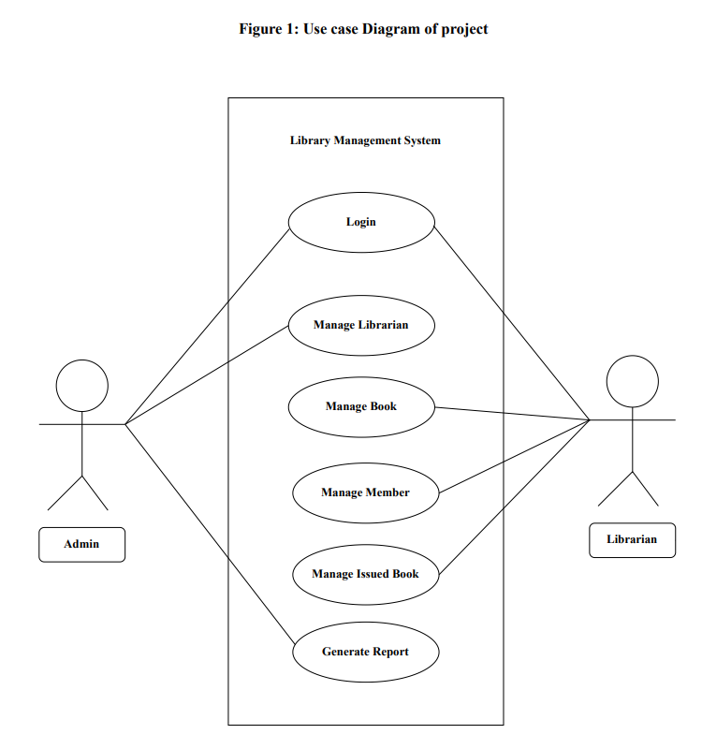

Expected Outcome
After the development of the project, following outputs are expected which will minimize the problems as well as solve the existing problems:
- Efficient and automated management of library operations,
- Reduced paperwork and manual effort,
- Faster access to book and member information,
- Improved accuracy and data security,
- Better service for library users,

Interface design:

Figure 2: Interface Design of the Project
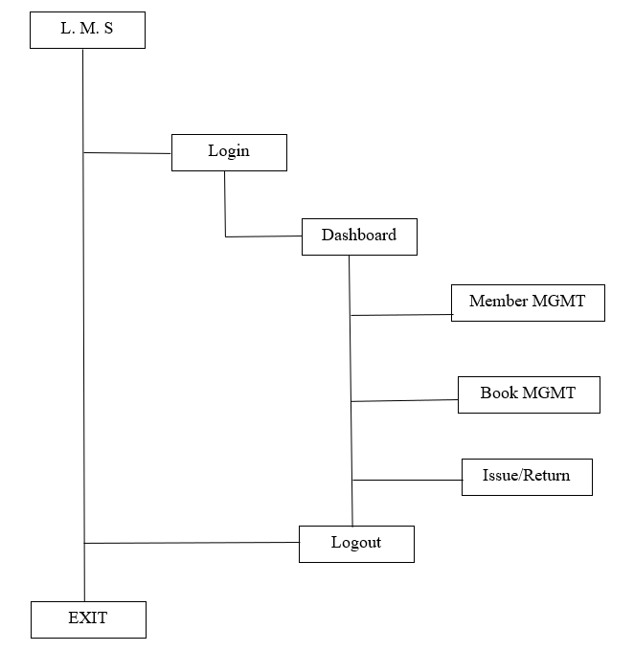

References

[1] | Librarika, "Nepal Kasthamandap College Online Library," [Online]. Available: https://nkc.librarika.com/. [Accessed 19 Mar 2025].
[2] | D. o. W. R. a. Irrigation, "DWRI Library Management System," [Online]. Available: https://library.dwri.gov.np. [Accessed 20 Mar 2025].
[3] | Librarika, "Nepal Medical College Central Library," [Online]. Available: https://kunmcl.librarika.com. [Accessed 19 Mar 2025].

