Appointment System of Wind Team

**UML Class Diagram**

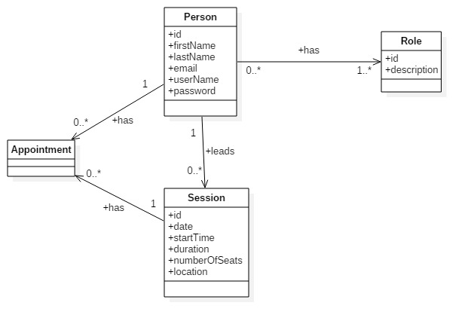

**Architectural Design and Technologies**

* Service Oriented Architecture
* RESTful Microservices
* JSON for request/response
* Spring Framework (Boot, Security, Validation, Data):
  + MVC (Front Controller/REST Controllers)
  + DI (Singleton/Eager/Annotated Beans)
  + AOP (Proxy Weaving)
* XA Transactions (2 Phase Commit, Service Propagation, Isolation Level Customization)
* E-mail sending (AOP with Async approach)
* Hibernate ORM (Session Factory Singleton, Thread Local Pattern)
* MySQL Database