Messenger

Development Documentation

V1.0
Table of Contents
Introduction 3
Document Identifier 3
Overview 3
Requirements 3
Platform 3
Functional 3
Implementation 3
Performance 3
Project Management 3
Schedule 3
Use cases 4
Using First Time 4
Registering 4
Logging In 4
Logging Out 4
Sending message 4
Functionality Description 4
Registration 4
Login 5
Chat Fragment 5
Main Server 6

Introduction

Document Identifier
This document includes all the project requirements, description of the use cases, functionality description, architecture overview.

Overview
Messenger – program which gives opportunity to communicate with other users using local network. Program allows us to detect other all registered users in local network and set up communication with them.

Requirements

Platform
Local Network - LAN
OS – Android 4.0.3
Memory – RAM 1Gb
CPU - 1GHz

Functional

At first program shows GUI which consists of :
- fragment for login/authorization
- list of online users
- chat fragment
  - message text box
  - short dialog history

Implementation
Java, thread, socket

Performance
Receiving and sending message shouldn't take more than a second. Also the online users list should be updated every 5 seconds. The process of registration and login shouldn't be more than 1 second.

Project Management

Schedule
- Milestone 1: Shell version + Development Documentation – 2016-Sep-20
- Milestone 2: Prototype – 2016-Sep-25
- Milestone 3: Beta version – 2016-Sep-27
- Milestone 4: Release - 2016-Sep-30

Use cases

Using First Time
Before running messenger we should choose a computer for installing the Main Server. After running Messenger user can register or login. After login in main window user can see list of users , choose one of them and chatting with him. He can also see their dialog history.
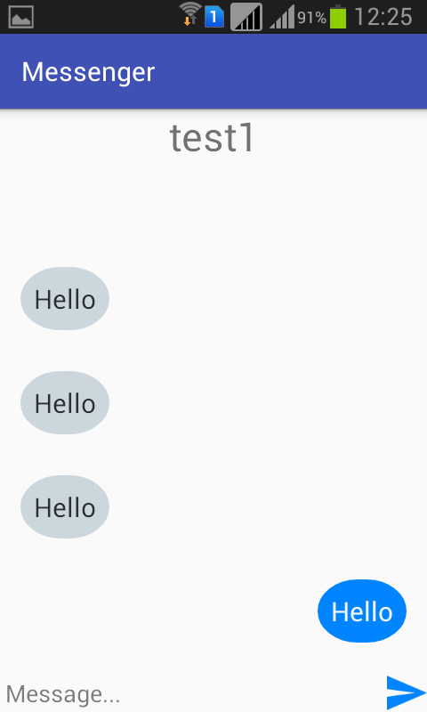
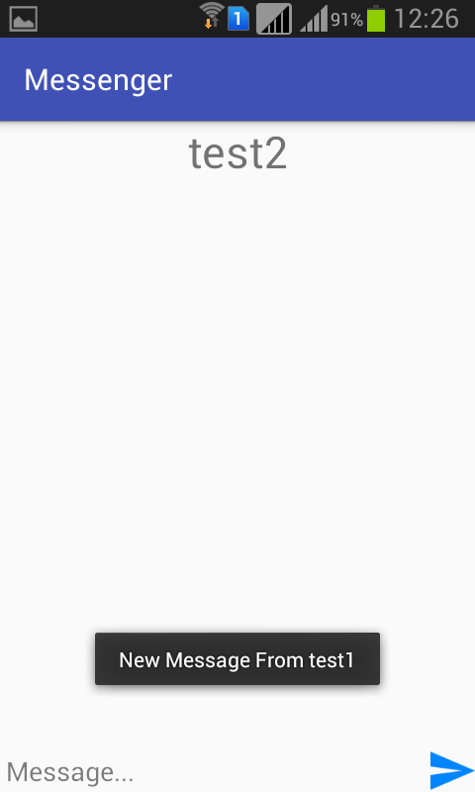
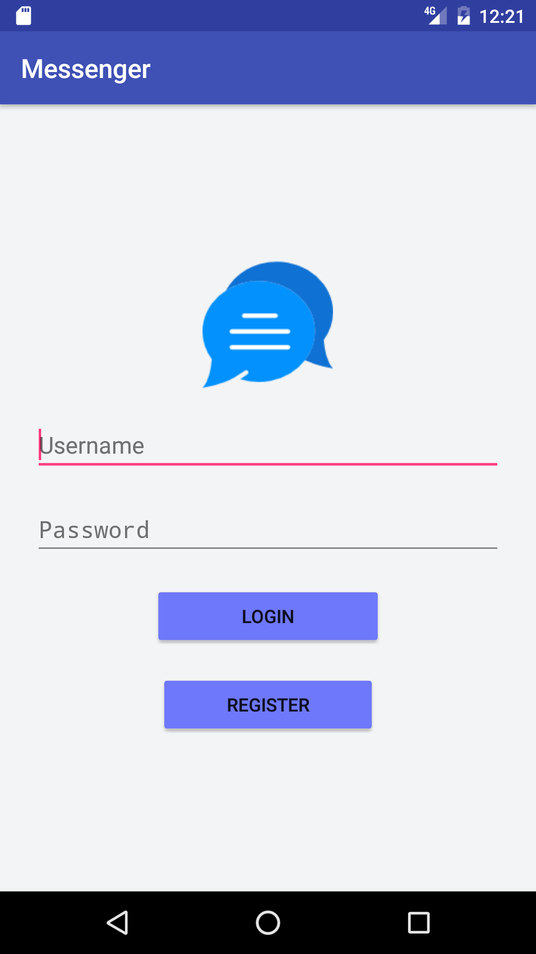
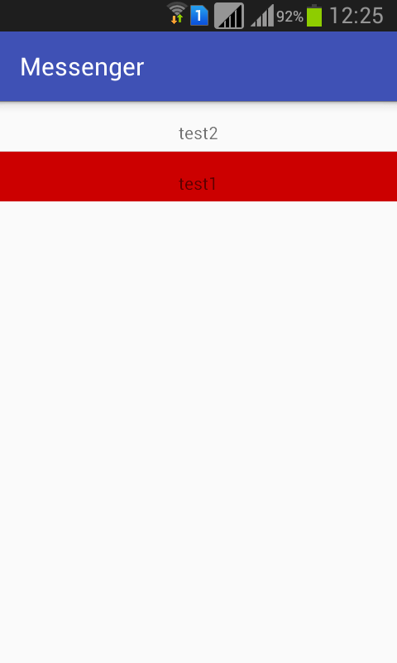

Registering
For registering user must fill name, password and confirm password fields, then click on Registration button.

Logging In
For logging in user must fill name and password fields, then click on Login button. After that user list will be shown, using which user can communicate with other users of the list.

Logging Out
For logging out user must click on Logout button from menu. After that window for login will appear.

Sending message

For sending message user must input text in text box and click on Send button.

Functionality Description

Registration
GUI should support registration of new messenger clients. This should be supported with a login GUI fragment. On the login window the user should specify:
- user name – this is an identifier string containing all literals, digits, special characters except ';'
- password – this is a string which shouldn't contain only spaces
- confirm password – this is a string which should coincide with password
Wrong input of the user shouldn't be accepted. The user should be warned. Will appear toast message and device should vibrate.
In case of proper syntax of the user name and password the user should be successfully registered. The user list should open, with the just registered user logged in.
Once the user has registered, next time when he opens the messenger, the login fragment should open for the user to login.
In case if the user tries to register with a name which already exists in the system, he should get a toast message and will have to retype the user name.
Unregistering is not supported in this version of the messenger.

Login
GUI should support registration of new messenger clients. This should be supported with a login GUI fragment. On the login fragment the user should specify:
- user name – this is an identifier string containing all literals, digits, special characters except ';'
- password – this is a string which shouldn't contain only spaces
Wrong input of the user shouldn't be accepted. The user should be warned. The user should be warned. Will appear toast message and device should vibrate.
In case of proper syntax of the user name and password the user should be successfully registered. The user list should open, with the just registered user logged in.
Once the user has registered, next time when he opens the messenger, the login fragment should open for the user to login.
In case if the user tries to register with a name which already exists in the system, he should get a toast message and will have to retype the user name.

List of online users
Window should contain:
- List of the online users – the list is refreshed every 5 seconds. If a new message is received from the user, which is not the current one, it is highlighted. The highlighting should disappear when pressing on the highlighted user.

Chat Fragment
Window should contain:
- Chat text area – this text area contains all the messages (received and sent). The name of the user with show the chatting is in progress is displayed on top of the text area.
- Typing text area – the message is sent when pressing on the “send” button near the text area.
- Logout button should be available on the menu.
When a message is sent to a user who has disconnected while typing or after pressing “Send”, notification should be received.
TODO: add a screenshot.

Logout
When the user logs out with the logout button, the online users/Chat fragment should close and the Registration/Login fragment should appear.

Main Server
It is run once before starting the messenger. The messenger should use the IP of the main server. Connection to the main server is required for user management. All the information about the registered and online users should be controlled by the main server.
When the main server goes down all the opened messengers will get a notification, that the main server is down. The messengers will still be able to chat with the users, but the online users list will not be updated, i.e. the user should be aware that the info on the online users is not up to date.

