**Lai Ye Qi**

**DIT/FT/1B/05**

**P2222189**

**Endpoint 1: GET /actors/:actorID**

**Response 200 when actor with ID 56 was retrieved successfully**

**Response 204 when no actor exists**

**Endpoint 2: GET /actors**

**Response 200 with actors from limit=3 and offset=2**

**Response 200 with no actors from limit=10 and offset=5000**

**Response 200 with default queries**

**Endpoint 3: POST /actors**

**Response 200 when actor retrieved successfully**

**400 When “last_name” is missing**

**Endpoint 4: PUT /actors/:actor_id**

**Response 200 when actor with id 210’s first name is edited successfully**

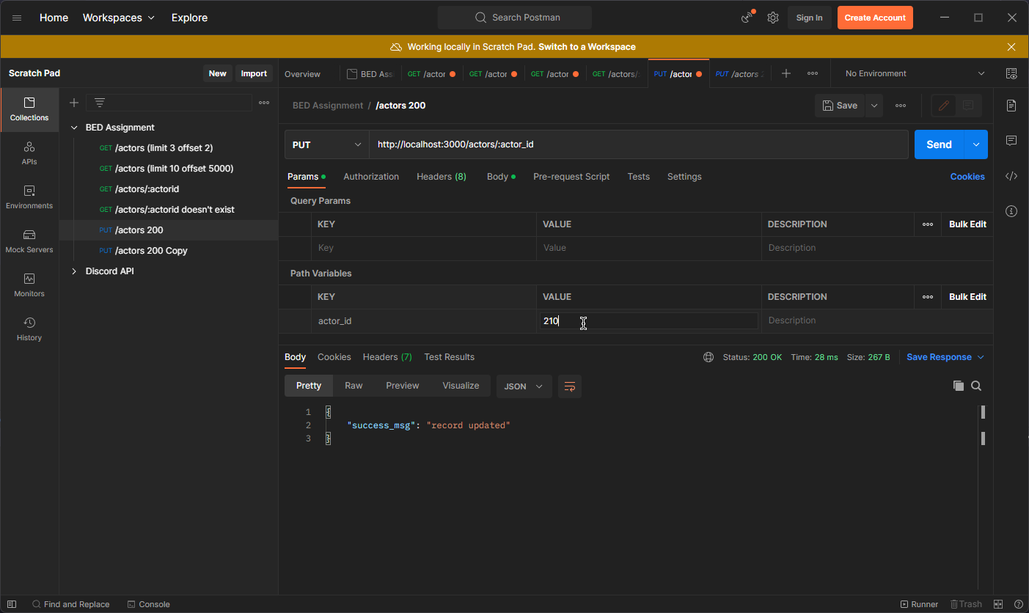

**Response 204 when non-existing actor ID is provided**

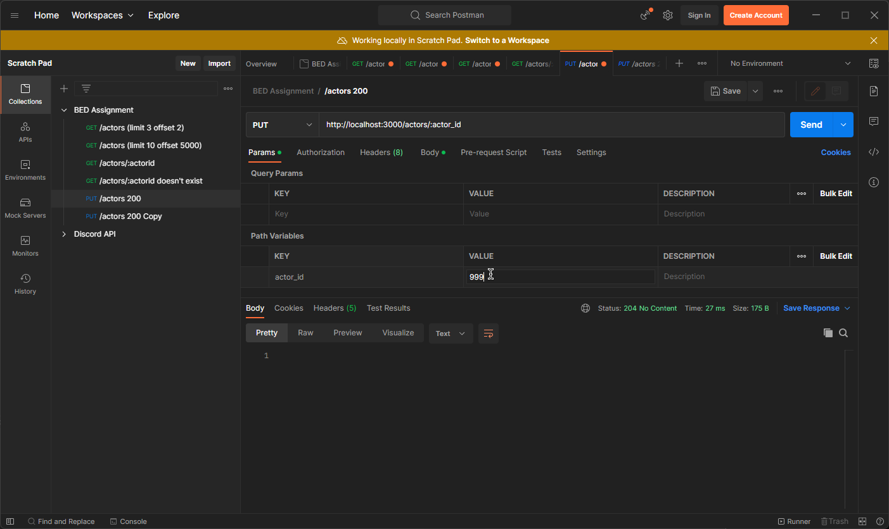

**400 when neither first_name or last_name is provided**

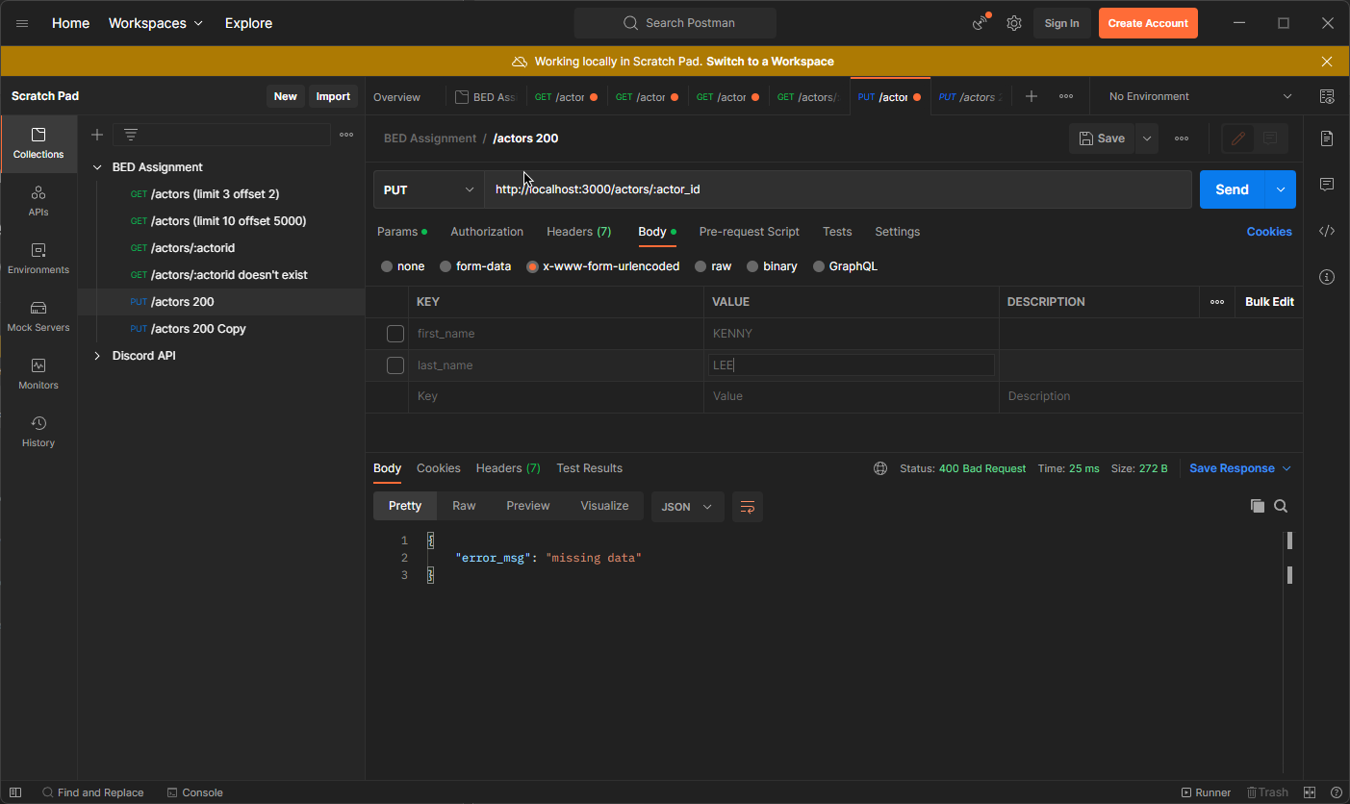

**Endpoint 5: DELETE /actors/:actor_id**

**Response 200 when deleting actor ID 210**

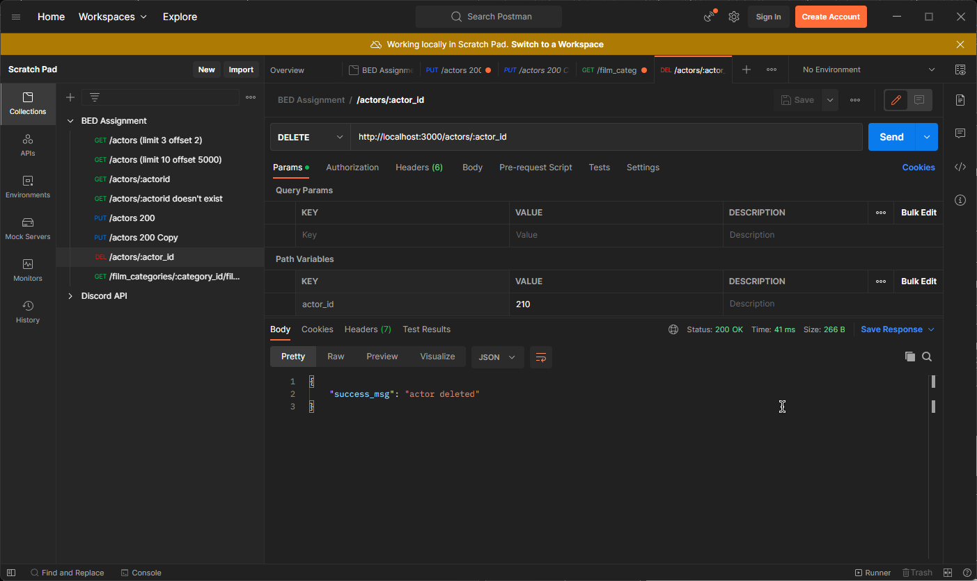

**Response 204 when attempting to delete same actor**

**Endpoint 6: GET /film_categories/:category_id/films**

**Response 200 when getting films of category ID 8**

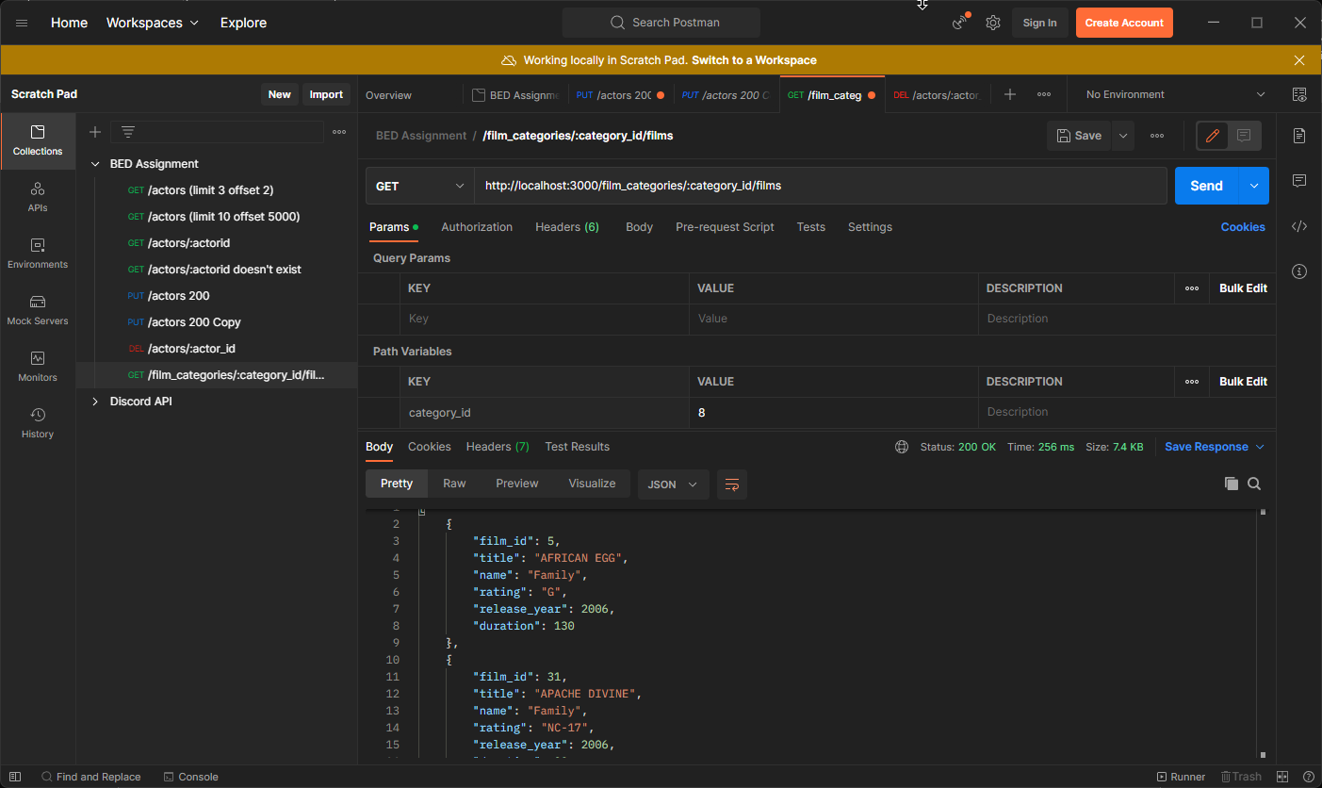

**Response 200 but no films when searching category ID 9999**

**Endpoint 7: GET /customer/:customer_id/payment**

**Response 200 returning payment details of customer with ID 5 during 2005-06-01 and 2005-06-30**

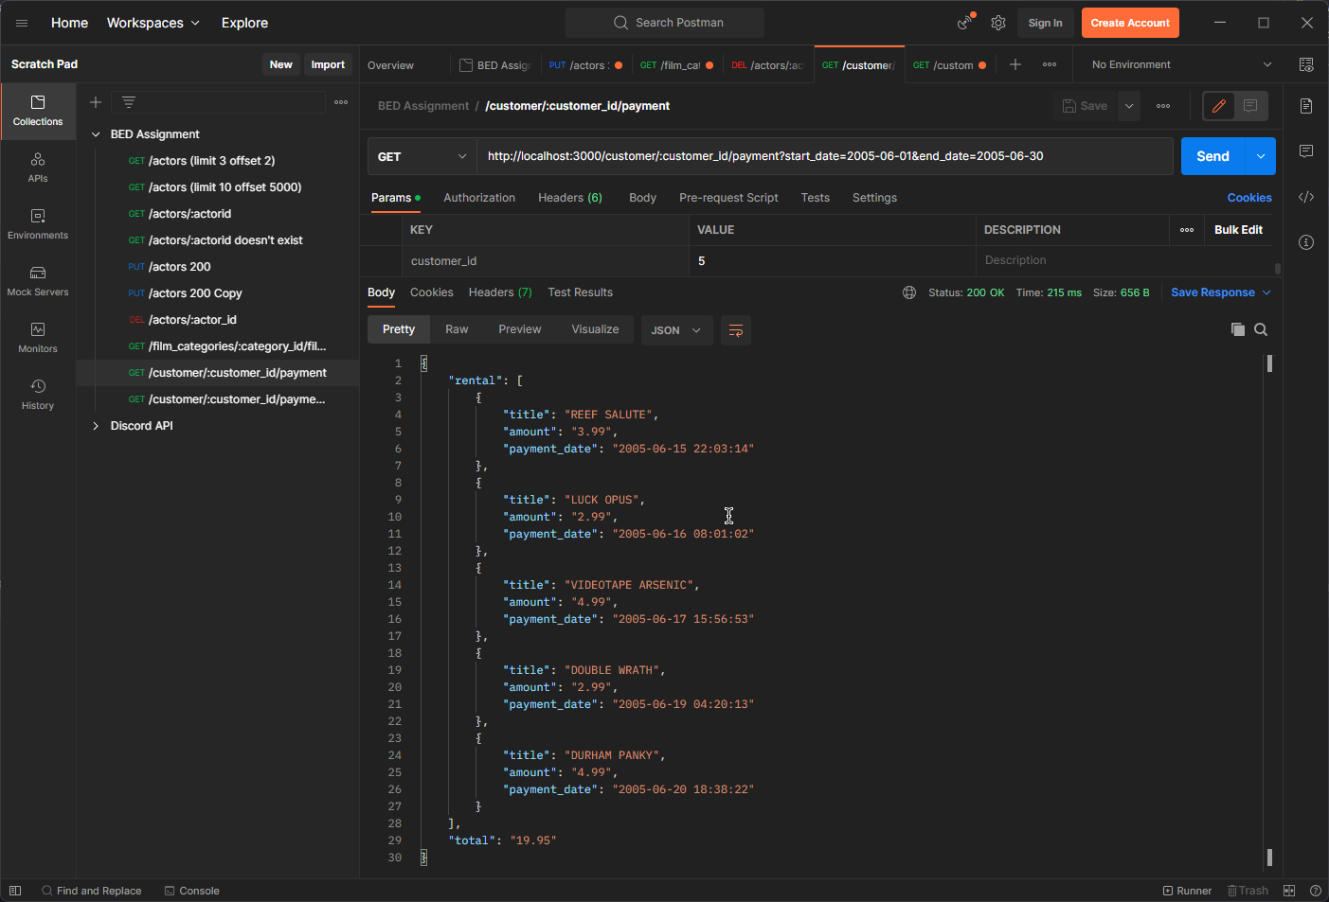

**Response 200 returning no payment details of customer between 2022-12-25 and 2022-12-26**

**Endpoint 8: POST /customers**

**Response 201 with successful customer creation**

**Response 400 when email or address_line1 is missing**

**Response 409 when email already exists**

