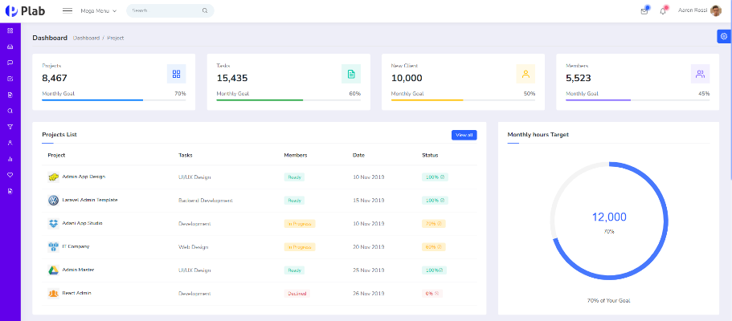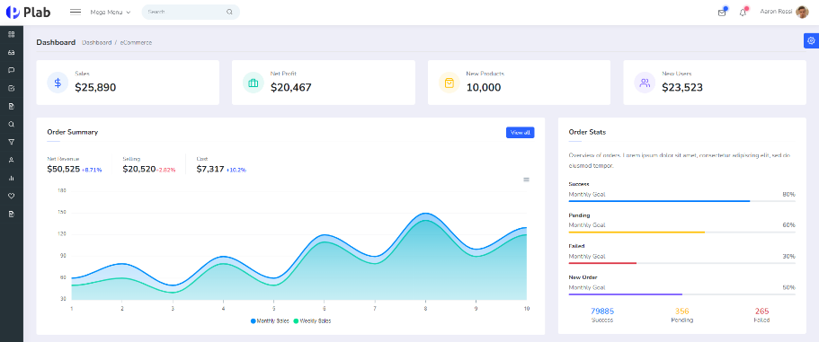

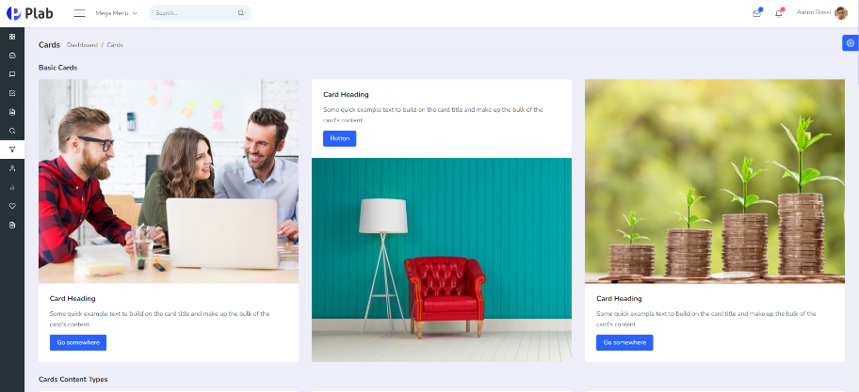

<https://plab-ng.envytheme.com/dashboard-eCommerce>

I am a senior mern stack developer.

Here, I design button, table, card and progress bar UI components in 15 days.

This template is popular so I am proud of this project.