



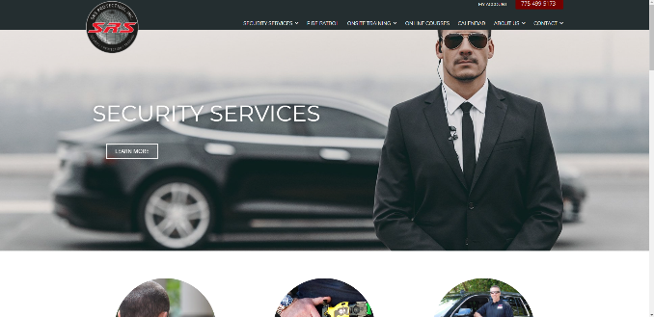



My another project in WordPress. Basically I had created reporting application on this Website. Which involves 3 types of users. 1) Admin 2) Security Officers 3) Supervisor. Admin: Admin can basically view overall operations happening within this application, they can view all the reports being submitted to other officers in their location as an alert over SMS and EMAIL. Admin can create the groups/ add location and add members. Security Officers: Officers can take pictures of their location, add text as well. Prepare all of it as a report and submit to other officers within their jurisdiction or area code only. To alert all the guards within their group. Supervisors: Supervisors can edit security officers report and verify the report before it is sent to other officers of that location.

**https://www.srsprotection.com/**