Quantum Hopfield Network
Dimitri Vinci February 8, 2022

Abstract
In this document is reported a brief analysis of the proposal of implementation of Quantum Hopfield Neural Network (QHNN) for the course Quantum Machine Learning of University of Trento(UniTn). This architecture was one of the first neural network that has been tried to be implemented and it is considered commonly a basic building block for a lot of different deep learning algorithms. In the spirit of the influential paper of Schuld et al. [28] implementation are analyzed following formal criteria, historical perspective and background idea in an attempt to partially extend the aforementioned paper towards present day.

Introduction
In this dissertation we try to put forward an analysis that could be able to underline two major trends of implementation of a particular neural network architecture: Hopfield neural network. Without pretend to be absolutely complete we limit ourselves to literature freely accessible. In the core part of the dissertation two particular models of implementation will be analyzed:
- Implementation of Rebentrost, P., Bromley, T., Weedbrook, C., Lloyd, S. in Quantum Hopfield neural network(2018) [25]
- Analysis and Implementation of Seddiqi, H., Humble, T.S. in Adiabatic Quantum Optimization for Associative Memory Recall(2014)[ 30]
The choice of these two papers as mainly subject is motivated by
- Necessity of be concise. These two architectures make us able to underline and make reference to other architectures that were developed
- Didactical purpose, this architecture are the best of choice for exploit the content of the course of quantum machine learning and papers are sufficiently complex to deserve a concise explanation of the content
- Representativity, of the main trends that will be underlined of quantum circuit and AQO
- Number of references toward the beforementioned papers
For sake of conciseness it was necessary to put some of the material in appendix. Eventually the direct reference to that material will be done. To be precise the following terms will be defined (more information about description and relevant properties demonstration for Hopfield Neural Networks are given in Appendix A)
- Neural Networks(NN) are models of interconnected units based on biological neurons feeding signals into one another [28]
- Quantum Neural Networks(QNN) are models that combine features of quantum theory with the properties of neural networks [28]
- Associative memory is defined as the ability to learn and remember the relationships between unrelated items [33]. For an artificial network is the ability to retrieve the network state out of P stored network states which is closest to the input pattern in terms of Hamming distance
- Associative networks are neural networks implementing associative memory. The goal of associative networks is to associate known input vectors with given output vectors. These networks are typically called continuous mapping because neighborhood of a input vector x (representing a memories) should be mapped to y (the target memory) and not to a neighborhood of y itself
- Content addressable memory (CAM) is a form of associative memory that recalls information by value [15]
- Autoassociative Networks, tries to associate a memory vector with itself [26]
- Bidirectional associative memory(BAM), is a type of associative memory (also called resonance network) in which two layers are connected by bidirectional edges
An Hopfield network (HNN) is a bidirectional associative memory of $n$ interconnected neurons $s_{1},s_{2},…,s_{n}$ each of which is a bipolar threshold unit (this choice is due to make statistically estimable some properties, see appendix A)

$$s_{i}=sign⁡\left(w_{i}^{⊤}s-θ_{i}\right)$$
where the vector $s∈\{-1,+1\}^{n}$ denotes the global state of the whole network. If the $n×n$ weight matrix $W$ of a Hopfield network is symmetric and hollow, i.e. has a diagonal of all $0 s$, (trivially not having a 0 diagonal cause network to oscillate between states), and if the network’s neurons update asynchronously (typically by definition, see Appendix A), then the energy
$$H\left(s_{t}\right)=-\frac{1}{2}s_{t}^{⊤}Ws_{t}+θ^{⊤}s_{t}$$
of the network at time t can never increase. As there are only finitely many, namely $2^{n}$ distinct states (trivially from all possible combinations of polar values for each neuron) for the network to be in, this is to say that it reaches a (local) energy minimum (called attractor) after finitely many updates (being monotonically decreasing and a Lyapunov function, see Appendix A) [15][4]. The number of stored memories greatly influences the radius of attraction for each stable point [18]

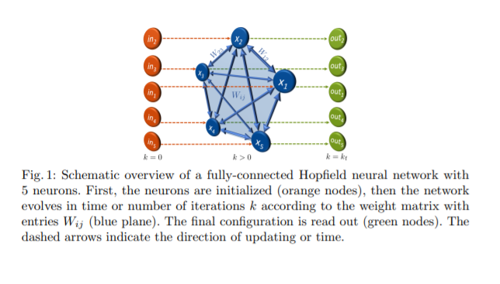
Schematic evolution of an Hopfield model of 5 neurons. The neurons are initialized (orange nodes) then the networks evolves to the final configuration (green nodes) [20]
The useful phenomena of quantum computation that are exploited in the following implementations are
- Entanglement
The potential for quantum states to exhibit correlations that cannot be accounted for classically. Mathematically, states that cannot be factorized (as a tensor product) are said to be entangled, while those that can be factorized are not. There are different degrees of entanglement: quantum states that are superpositions of only those basis states that are maximally far apart in terms of Hamming distance are those states with the greatest entanglement. The amount of information contained in an entangled state of N qubits grows exponentially instead of linearly, which is the case for classical bits. This lead to the following phenomenon.
- Quantum parallelism
as long as a set of n qubits maintains its quantum coherence, it can be considered to be all 2^{n} possible binary patterns at once. Thus any operation performed on the qubits is performed on all 2^{n} patterns in parallel.
- Operators
on a Hilbert space describe how one wave function is changed into another. All properties are represented as operators whose eigenvalues are the quantum allowed values for that property. All this operators must be linear
- Coherence and Decoherence
A quantum system is said to be coherent if it is in a linear superposition of its basis states. If a system that is in a linear superposition of states interacts in any way with its environment, the superposition is destroyed. This loss of coherence is called decoherence and is governed by wave function [32]
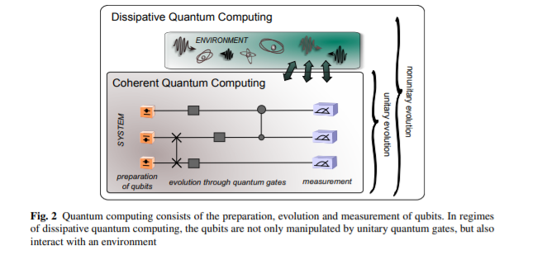
The problem of noise [28]

In fact, in NISQ era the implementation is hardened by noise and quantum errors [29]. Quantum physics is a linear theory, meaning that maps of one state onto another are executed by linear operators. In fact, the current challenge in the implementation of a quantum computer lies in the difficulty to maintain coherence in a multiple qubit system in order to simulate unitary dynamics (that preserve probabilities). Real systems interact with an environment, thus introducing effects of dissipation (loss in the population of quantum states) and decoherence (destruction of quantum state correlations). [28]. So, it’s relevant to underline that no of papers analyzed try to implement the proposed algorithm in hardware resorting to simulation (an exception described in appendix is [29]).
We must also underline however that the states of [28] must be quoted and is still valid nowadays:
“QNN research remains an exotic conglomeration of different ideas under the umbrella of quantum information”.
This because we could not find in literature
- uniform evaluation metrics
- hardware implementation
- a single trending idea
- same properties stated as fundamental
So in future could be useful to take into account comparisons between architectural choices and also properties of the developed architecture itself. This should also take into account recent developments in classical algorithms (like exponential storage capacity for new Hopfield learning rule ) and different learning rules in quantum implementation properties (see section 3).
Necessary question to be answered is why implement quantum Hopfield neural network:
- Hebbian learning and the Hopfield network were one of the early neural networks methods and fast quantum algorithm and could be used as a building block for more advanced quantum networks [25]
- Hopfield networks become intractable to compute classically due to their fully connected nature, though a recent paper claims “Hopfeld networks is all you need [29][24]. This tendency was already underlined in [28]
- There actually no way to escape local minima and errors of classical Hopfield neural networks [26][ 30]
- Randomized strategy for problems (like quantum computing) are a way to break complexity and polynomial nondeterministic algorithms are often more powerful than deterministic counterparts [34]
- For many authors (i.e. [34]) analog computation like AQO could be a solution to high complexity problem (this argument will be developed further in AQO section).
As we saw in the quantum machine learning course there are two main distinct quantum computing paradigms (a deeper explanation is given in Appendix B):
- quantum gate computing, meaning sequences of quantum mechanical operators to manipulate quantum registers and thus to perform computations (like Grover search)
- adiabatic quantum computing that exploits a phenomenon summarized by the adiabatic theorem. It basically states that if a quantum system starts out in the ground state of a Hamiltonian operator which then gradually changes over a period, the system will end up in the ground state of the resulting Hamiltonian [4].
Three still valid analysis requirements are proposed by [28]:
1. The initial state of the quantum system encodes any binary string of length N. The QNN produces a stable output configuration encoding the one state of 2^{M} possible output binary strings of length M which is closest to the input by some distance measure.
2. The QNN reflects one or more basic neural computing mechanisms (attractor dynamics, synaptic connections, integrate & fire, training rules, structure of a NN). This generality allows for broader approaches analysis
3. The evolution is based on quantum effects, such as superposition, entanglement, and interference, and it is fully consistent with quantum theory.
And a criticality from the same:
a fundamental challenge appears in the integration of the nonlinear, dissipative dynamics of attractor based NNs and linear, unitary quantum theory. In neural computing, the incoming signal $∑_{j=1}^{N} w_{ji}x_{j}$ of the $N$ neurons $x_{j},j≠i$ connected to neuron $x_{i}$ by weights $w_{ij}$ gets mapped to the output of neuron $x_{i}$ by a nonlinearity. This nonlinearity leads to the attractor-like dynamics fundamental for associative memory (without nonlinearity an eigenvalue dominate all attraction field, see Appendix A). Practical this is called dissipative behavior because nonlinearity loss some information and this is important to filter out patterns. If we introduce quantum mechanics, we necessarily look at firing probabilities instead of deterministic values. However, mapping firing probabilities onto one another by a nonlinear function contradicts the basic principle of the linear evolution in quantum theory, where linear superpositions of solutions of the Schrödinger equation play an important role. One apparent exception are measurements, which can be understood as a probabilistic step-function processes (see Appendix C, and for a characterization of the invariant [34]).

A quantum circuit implementation
The majority of implementations of QNN architectures are in fact based on the concept of ‘quron’ meaning qubit neuron [28] (see Appendix C). This setting implicitly assumes a quantum circuit implementation. Another possibility that uses the concept of quantum circuit is underlined in the following presented paper and allows to codify the network inside the amplitude of the quantum system. Paper of 2018 from Rebentrost, Bromley, Weedbrook, Lloyd exploits this possibility intertwined with the naturally visible structure of Hopfield networks which allows a simple encoding of the information into the amplitudes of a quantum state. With such an encoding, techniques applied to realize quantum Hopfield neural network such as quantum phase estimation and matrix inversion can be applied with exponentially fast run and the network is able to store an exponential number of patterns. However also in this case the high gate complexity of the quantum neuron becomes a significant problem for the overall error rate of the system. As errors occur in each gate, the large number of gates leads to significant error in the overall output of the system as errors cascade from one gate operation to the next. hardware execution of a circuit as complex as an associative memory requires low circuit complexity to be successfully implementable in hardware. Reducing gate complexity thus becomes a very important factor to the design of a QHAM. And in fact, this proposal is not implemented in hardware [29]. Another critique that will become apparent is the fact that this implementation does not consider the dissipative dynamics of neural networks resorting only on quantum operation carried by unitary operators. However, this paper showed a clear exposition clearly deriving complexity and showing application and the authors approach is a good example of usage of well-established concepts and algorithms i.e.
- Sparse Hamiltonian simulation
- Phase estimation
- Swap test
- qRAM

Implementation
In the article is presented a method to construct a quantum version of the Hopfield network (qHop) where the network state is embedded into the amplitudes of a quantum system composed of a register of quantum bits (qubits)
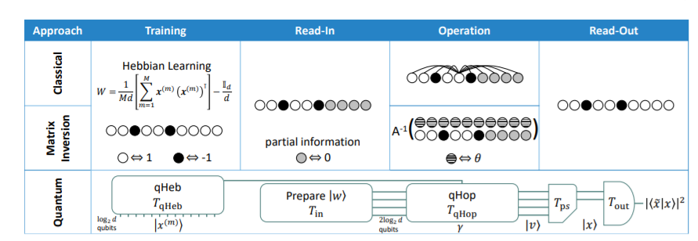

The picture above shows a comparison between classical method and the architecture proposed. qHeb is used to set the weights (whereby the symmetric graph weighting matrix can be associated to a density matrix stored in a qubit register) and to evolve the network (via matrix inversion approach) to the output when a new incomplete pattern is given. To this end they considered a normalized weight matrix as
$$W=\frac{1}{Md}\left[\sum_{m=1}^{M}{ } x^{(m)}{\left(x^{(m)}\right)}^{⊤}\right]-\frac{I_{d}}{d},$$
with $I_{d}$ the $d$-dimensional identity matrix, $M$ is the training set of activation patterns $x^{(m)}$ (meaning training pattern) with $m∈\{1,2,…,M\}$ (used to obtain zero diagonal). Consider any $d$-dimensional vector $x:={\left\{x_{1},x_{2},…,x_{d}\right\}}^{⊤}$. They associate it to the pure state $|x⟩$ of a $d$-level quantum system according to $x→|x|_{2}|x⟩$, with $|x|_{2}=\sqrt{∑_{i=1}^{d} x_{i}^{2}}$ the $l_{2}$-norm of $x$ and $|x⟩:=\frac{1}{|x|_{2}}∑_{i=1}^{d} x_{i}|i⟩$ written with respect to the standard basis such that $⟨x∣x⟩=1$. For bipolar vector the normalization is $|x|_{2}^{2}=d$. Given that the weight matrix is the mixed state
$$ρ:=W+\frac{I_{d}}{d}=\frac{1}{M}∑_{m=1}^{M} \left|x^{(m)}\right\rangle \left\langle x^{(m)}\right|$$
Where $\left|x^{(m)}\right\rangle \left\langle x^{(m)}\right|$are the projector of the m-stored memory (in analogy with the Hebb rule, see Appendix A).

2.1.1 Qheb
$ρ$ as defined before can be used to efficiently simulate $e^{iρt}$ and estimate the eigenvalues and eigenstates of $ρ$ to precision $ϵ$ through the quantum phase estimation algorithm. Defining the set of $M$ unitary operators ${\left\{U_{k}\right\}}_{k=1}^{M}$ acting on an $N+1$ register of qubits according to
$$U_{k}:=|0⟩⟨0|⊗I+|1⟩⟨1|⊗e^{-i\left|x^{(k)}\right\rangle \left\langle x^{(k)}\right|Δt}.$$
The unitaries apply the different memory pattern projectors $\left|x^{(k)}\right\rangle \left\langle x^{(k)}\right|$ conditionally and for a small time $Δt$. To implement them, let $S$ be the swap matrix between the subsystems for $σ$ and $\left|x^{(k)}\right\rangle$
$$\begin{matrix}U_{S} & =e^{-i|1⟩⟨1|⊗SΔt} \\ & =|0⟩⟨0|⊗I+|1⟩⟨1|⊗e^{-iSΔt}\end{matrix}$$
where $|1⟩⟨1|⊗S$ is sparse and efficiently simulatable (for example with Lloyd et al. method seen for quantum PCA during lecture, or as in the analyzed paper using quantum walk algorithm of Berry et al.). For sparse Hamiltonian simulation Berry algorithm can be used with a constant number of oracle calls (to operate quantum steps) and run time $\overline{O}(log⁡d)$ (this notation omit polylogarithmic factors in $O$). The trace over the second subsystem is given by:
$$\begin{matrix}{tr}_{2}⁡\left\{U_{s}\left(|q⟩\left\langle q|⊗|x^{(k)}\right)\left\langle x^{(k)}\right|⊗σ\right)U_{S}^{†}\right\} \\ \left.=U_{k}(∣q>⟨q|⊗σ\right)U_{k}^{†}+O\left(Δt^{2}\right)\end{matrix}$$
So the subsystem of ancilla qubit and $σ$ undergoes time evolution with $U_{k}$. Applying $M$ unitaries $U_{k}$ sequentially for $n$ repetitions
$$U_{t}:={\left(\prod_{k=1}^{M}{ } U_{k}\right)}^{n}$$
With small time steps $Δt=t/nM$. Using SuzukiTrotter method (expresses the Hamiltonian as a sum of easy to simulate Hamiltonians and then approximates the total evolution as a sequence of these simpler evolutions) on $U_{t}$ authors find an approximation error in simulating $e^{iρt}$ requiring $n∈O\left(\frac{t^{2}}{ϵ}\right)$ repetitions of $U_{t}$, with each repetition requiring $M$ sparse Hamiltonian simulations ($U_{k})$. The overall run time considering all factors involved is $T_{qHeb}∈O($ poly $\left.\left(log⁡d,t,M,\frac{1}{ε}\right)\right)$. The quantum phase estimation algorithm can then be implemented to find the eigenvalues of $ρ$. Preparing a register of $T$ qubits (that sets the precision of phase estimation algorithm as seen in lecture with $2^{T}∈O(1/ϵ)$) in the composite state $∑_{t=1}^{2^{T}} |t⟩⊗|ψ⟩$ for some arbitrary $|ψ⟩.$ Applying the controlled unitaries $U_{t}$ on$\left|ψ\right\rangle$ a simulation of the evolution operator is carried out and with phase estimation obtain eigenvalues. This results in an overall run time $T_{\text{eigenvalues }}∈O($ poly $\left.\left(log⁡d,\frac{1}{ϵ},M\right)\right)$.

2.1.2 Qhop
The embedding method for quantum neural networks discussed in Appendix A (5.3.3.) defines a system of linear equations for minimizing energy in a pattern retrieval situation
$$\begin{matrix}A & :=\left(\begin{matrix}W-γ{\overset{‾}{I}}_{d} & P \\ P & 0\end{matrix}\right) \\ v & :=\left(\begin{matrix}x \\ λ\end{matrix}\right), w:=\left(\begin{matrix}θ \\ x^{(\text{inc })}\end{matrix}\right)\end{matrix}$$
This can be written in terms of pure quantum states as $A|v|_{2}|v⟩=|w|_{2}|w⟩$, with $P$ as (diagonal) projector to subspace of known neuron values, $P=∑_{i∈L} |i⟩⟨i|$, and
$$\begin{matrix}|v⟩ & :=\frac{1}{|v|_{2}}\left(|x|_{2}|0⟩⊗|x⟩+|λ|_{2}|1⟩⊗|λ⟩\right), \\ |w⟩ & :=\frac{1}{|w|_{2}}\left(|θ|_{2}|0⟩⊗|θ⟩+{\left|x^{(inc)}\right|}_{2}|1⟩⊗\left|x^{(inc)}\right\rangle \right),\end{matrix}$$
being pure states of $N+1$ qubits. $\left|x^{(\text{inc })}\right\rangle$ is the normalized quantum state corresponding to the incomplete activation pattern and ${\left|x^{(\text{inc })}\right|}_{2}^{2}=l$. It is possible to prepare $A^{-1}|w⟩$ with a potential run time logarithmic in the dimension of $A$. The objective is to use the quantum matrix inversion algorithm of Wiebe et al. . This algorithm requires the ability to perform quantum phase estimation using efficient Hamiltonian simulation of $A$. To do that, one can simulate $e^{iAt}$ by concurrently executing the simulation of a sparse Hamiltonian linked to the projector $P$ as well as $qHeb$ to a fixed error $ϵ$ for arbitrary $t$. Rewriting A as sum of three matrices (simply substituting relation between W and $ρ$)
$$\begin{matrix}A & =\left(\begin{matrix}ρ-\left(γ+\frac{1}{d}\right)I_{d} & P \\ P & 0\end{matrix}\right) \\ & =\left(\begin{matrix}0 & P \\ P & 0\end{matrix}\right)+\left(\begin{matrix}-γ^{'}I_{d} & 0 \\ 0 & 0\end{matrix}\right)+\left(\begin{matrix}ρ & 0 \\ 0 & 0\end{matrix}\right) \\ & =:B+C+D,\end{matrix}$$
with $γ^{'}=γ+\frac{1}{d}$. Splitting as before the simulation time $t$ into $n$ small time steps $Δt$, i.e. so that $t=nΔt$, the time evolution $e^{iAΔt}$ can be simulated by using applications of $e^{iBΔt},e^{iCΔt}$, and $e^{iDΔt}$ via the standard Suzuki-Trotter method. Suppose that one has operators $U_{B}(Δt),U_{C}(Δt)$, and $U_{D}(Δt)$ that simulate $e^{iBΔt},e^{iCΔt}$, and $e^{iDΔt}$ to errors at most $O\left(Δt^{2}\right)$, respectively, and so $e^{iBΔt}e^{iCΔt}e^{iDΔt}$ is simulated to error also $O\left(Δt^{2}\right)$ . Using the Taylor expansion over $e^{iAΔt}$ they obtain that with, $n$ repetitions of $U_{B}(Δt)U_{C}(Δt)U_{D}(Δt)$ , they can simulate $e^{iAt}$ to an error of $ϵ∈O\left(nΔt^{2}\right)$ (as before with error calculation on Suzuki-Trotter). The run time of performing one such repetition depends on three evolution operator simulations:
- Consider the block matrix $B$. $P$ is a diagonal projector, $B$ is a 1-sparse self-adjoint matrix. Berry et al. shows that sparse Hamiltonian simulation for a simulation time $t$ to error $ϵ$ can be performed with a run time $T_{B}∈\overset{˜}{O}(tlog⁡(d)/ϵ)$. For the maximum matrix element of $B$ (being bipolar and diagonal) we have $∥B∥_{max}=1$ and $∥B∥=O(1)$.
- The operator $U_{C}(Δt)$ is treated as $U_{B}(Δt)$
- Simulating the operator $U_{D}(Δt)$ is achieved using Hebbian learning (qHeb without eigenvalues extraction)
The spectral decomposition of $A$
$$\begin{matrix}A= & \sum_{j:\left|μ_{j}(A)\right|≥μ}{ } μ_{j}(A)\left|v_{j}(A)\right\rangle \left\langle v_{j}(A)\right| \\ & +\sum_{j:\left|μ_{j}(A)\right|<μ}{ } μ_{j}(A)\left|v_{j}(A)\right\rangle \left\langle v_{j}(A)\right|\end{matrix}$$
Where two separate sums dependent upon the size of the eigenvalues $μ_{j}(A)$ are obtained in comparison to a fixed user-defined number $μ>0$. the chosen value of $μ$ is a trade-off between the run time and the error in calculating the pseudoinverse. The matrix inversion algorithm returns
$$A^{-1}|w⟩=\sum_{j:\left|μ_{j}(A)\right|≥μ}{ }\frac{β_{j}}{μ_{j}(A)}\left|v_{j}(A)\right\rangle$$
where $β_{j}=\left\langle v_{j}(A)∣w\right\rangle$. Preparing the input state $|w⟩$ (via for example qRAM) and consider it in the eigenbasis of $A$, i.e. so that $\left|w\right\rangle =∑ β_{j}\left|v_{j}\left(A\right)\right\rangle$, qHeb algorithm is then used to perform quantum phase estimation, allowing to ob$tain⁡$an approximation of the eigenvalue $μ_{j}(A)$ to precision $ϵ$ in a subset limited to eigenvalues larger than $μ$ . The output of qHop algorithm is the pure state $|v⟩$) (obtainable measuring the first qubit in the $N+1$ qubit register and post-select on $|0⟩$ ).

Algorithm efficiency and comparison
The efficiency of the algorithm is dependent on three phases
- Input
- Computation
Realized by qHop and qHeb computation which require
- Estimation of A with run time $T_{\text{phase }}$
- filtering and amplification operations to select the eigenvalues of A requiring a run time $T_{\text{filter }}$.
- Output
meaning use the information contained in $|x⟩$ for a given task
Regarding the first phase one could
- Reading directly states of other quantum computation
- Using a QRAM
The $d$-level quantum system can be implemented by a register of $N=\left\lceil \log_{2}⁡d\right\rceil$ qubits in a qRAM and read in an activation pattern amounts to preparing the quantum state $\left|x\right\rangle$. $T_{1}$ is considered run time to prepare each $\left|x^{(m)}\right\rangle$ (that is poly(log d))
Computation phase is composed by
- Phase estimation requires to perform $O\left(\frac{1}{ϵ^{3}}\right)$ calls to $e^{iAt}$
  - One can decompose $A$ into three block matrices $B,C$, and $D$ . applying for $n$ short times $Δt$ the unitaries $U_{B/C/D}$ generated by these block matrices, resulting in an error $ϵ∈O\left(\frac{t^{2}}{n}\right)$ or equivalently requiring a number of steps $n=O\left(t^{2}/ϵ\right)$. The decomposition require

    - Since both $B$ and $C$ are 1-sparse matrices, they use efficient sparse Hamiltonian simulation techniques to evaluate $U_{B/C}(Δt)$ with run time $T_{B/C}∈$ $O\left(\right.$ poly $\left.\left(Δt,log⁡d,log⁡\left(\frac{1}{ϵ}\right)\right)\right)$.
    - For the matrix $D$, they use the quantum Hebbian learning techniques discussed earlier to simulate for a time $Δt$, requiring a run time $T_{D}∈O\left(\right.$ poly $\left.\left(Δt,M,\frac{1}{ϵ},log⁡d\right)\right)$
$T_{D}$ is the dominant run time compared to $T_{B/C}$
- The run time for filtering and amplification adds an additional overhead $T_{\text{filter }}∈O\left(\frac{1}{μ}\right)$
They hence achieve an overall algorithm run time of
$$T_{qHop}∈O\left(poly⁡\left(M,log⁡d,\frac{1}{ϵ},\frac{1}{μ}\right)\right)$$
The linear dependence on M of the quantum algorithm due to Hebbian learning means that for achieving a logarithmic dependency on the dimension, qHop has to be operated substantially below the maximum capacity. To extend the range, they consider a scenario when the density weight matrix is directly given via oracle accesses to the matrix elements and is sparse , so they can directly using qHop without requiring the Hebbian learning procedure and the M dependence is absorbed into the oracle

Regarding output phase one could
- read-out the amplitudes of $|x⟩$ by performing tomography. However, even for pure states, tomographical techniques can introduce an overhead that scales polynomially with the dimension $d$
- using other approaches, which typically act globally on $|x⟩$ rather than directly accessing each of the $d$ amplitudes. As example
  - measure the fidelity with another state $|\overset{‾}{x}⟩$, such as one of the training states, which can be achieved by performing a swap test with success probability $P_{\text{swap }}=$ $\frac{1}{2}\left(1-|⟨\overset{˜}{x}∣x⟩|^{2}\right).$
  - one may have access to a set of $p$ binary valued observables, corresponding to membership of some classification categories.
- one can view the state $A^{-1}|w⟩$ (or the post-selected activation pattern state $|x⟩)$, as the final output of the algorithm. In this case he can reconstruct a quantum state from an incomplete superposition based on the memory stored in $ρ$ with no overhead
so this limitation become evident
- one must be able to read-in activation patterns. For general usage this translate into having an implemented qRAM which is not actually practical
- one must be able to carry efficiently all computation involved meaning implementing it in quantum gates. For this aspect the observations we have done before are still valid
- the usage of qHeb has a complexity dependent on memory stored requiring higher number of neurons to be used in comparison of the data (the exponential storage is so limited in some way)
on the other hand in comparison to other approaches
- in respect to classical Hopfield network given large d number of neurons the approach obtains an exponential speedup in logarithm of d (an improvement respect Ventura and Martinez algorithm explained in class)
- in respect of works like [2] (explained in Section 3) complexity is clearly calculated and not dependent on physical implementation
- in respect of AQO approach (as we will see in section 3) complexity is clearly understood
as final observations shared also by authors given appropriate quantum hardware this approach could be suitable for particular problems (meaning given number of neurons and specific tasks). This leads to next section which present a specific application.

Application
As an application, they have shown how the matrix inversion-based Hopfield network can be utilized for identifying genetic segments of RNA in viruses. the H1N1 strain of the influenza A virus has 8 RNA segments that code for different functions in the virus. The segments are composed of a string of RNA-bases: A, C, G, and U. Each segment can in turn be converted (as in the picture of left belove) to a double sized binary string which can be stored in the weighting matrix of a Hopfield network. Given partial information on a RNA sequence the aim is verify whether it belongs to the H1N1 virus. They store the first 50 RNA-bases from each of the 8 segments of the influenza A H1N1 strain (i.e., so that $d=100,M=8$ ) in the weighting matrix $W$ using the Hebbian learning rule. For this small example, the weighting matrix is filled to classical Hebb capacity to stress imperfect recoveries. They then generate incomplete data from the first segment of H1N1 randomly selecting $l/2$ known RNA-bases for $l/2∈\{1,2,…,50\}$. The Hamming distance measured between the result and the original pattern is used to measure differences in performance between classical and quantum Hopfield network. This is averaged over 1000 repetitions of random choices of $l/2$ RNA-bases as known bases. As showed right belove both the conventional approach (dotted line) to the Hopfield network and the new matrix inversion-based approach (solid line) have comparable performances, with each able to recover the input segment for a suitably large known RNA-bases. By using qHop to perform the matrix inversion based approach, they could operate with a run time logarithmic in the system dimension and hence increase the dimension far beyond $d=100$ (maintaining performances logarithmic)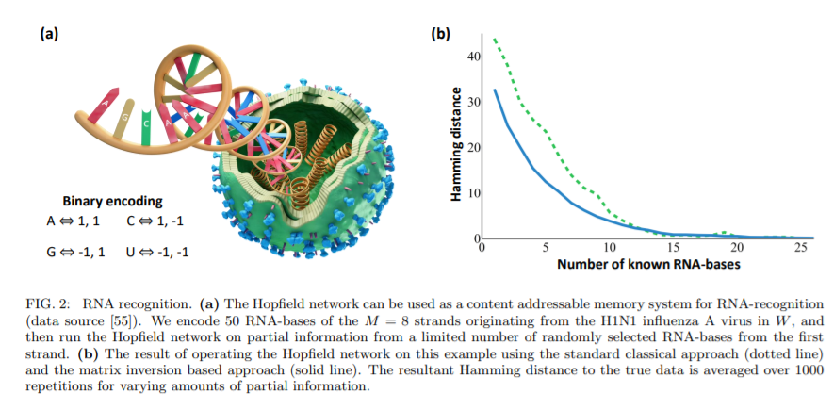

Hopfield model and AQO
Historically Akazawa paper faces possibilities and underline the problem of global minimum finding in QHNN [2]. The basic Hopfield network has many states of locally minimum energy, in addition to the globally minimum state. In most cases the network will get stuck in a local minimum and a solution will not be reached. This local-minima problem is a natural result of the fact that each occurrence of state transition in the threshold elements is independent of all others. The author proposed a single-electron circuit that changes its state to decrease its free energy (here depicted a likely circuit design)
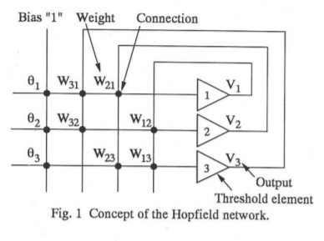

A tunnel junction with an excess electron is used as a threshold element (representing neurons). The tunneling effect is a quantum phenomenon that allows carriers to cross a potential barrier without jumping over it. If the barrier is thin enough and empty sites are available in the right range of energies, carriers from one side can tunnel to these empty sites. The author defines the state of the tunnel junction as "1" if the electron is on the right of the junction and as “0” if it is on the left. The connection between two tunnel junctions can be established by a pair of coupling capacitors
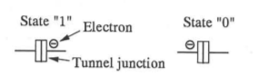

the free energy for this circuit is given by the author by

$$E=A-1/2∑_{i≠j} B_{ij}N_{i}N_{j}-∑_{i} C_{i}N_{i}$$
where $N_{i}$ is the state of each tunnel junction, and that the coefficients $A,B_{ij}$, and $C_{i}$ can be set at any desired value, based on the connection pattern and the capacitance values of the tunnel junctions, connection capacitors, and ground capacitors. There is a direct mathematical isomorphism of this formulation with that of Hopfield model and the internal state is expressed as $\left(N_{1},N_{2},N_{3}\right)$. The global minimum is founded by the author in state $(0,0,0)$. To visualize each solid arrow in the figure belove indicates the possible occurrence of a state transition due to a tunneling event. States (1, 0, 1) and $(0,1,1)$ act as a local minima

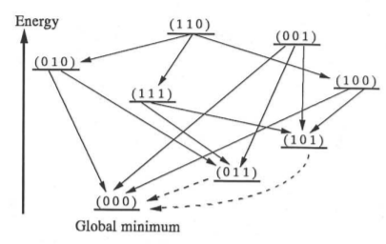
The local-minima problem comes from the fact that each of the electron tunneling through the tunnel junctions occurs independently. To overcome this, he proposed building a single-electron Hopfield network such that the co-tunneling phenomenon occurs frequently. Co-tunneling is a phenomenon in which two or more tunneling events occur simultaneously in a form of coherent combination. Cotunneling can be induced by increasing the tunnel junction conductance. It is certain so that, starting at a given initial state, the global minimum state can always be established. the network calculates simultaneously many energy values for all possible combinations of the junction states to find the minimum energy state. An open question by author admission is whether it would be practical to build actual devices to perform such quantum network operation, however the possibility to find a global minimum is stated and AQO as we will see apparently let us to obtain this result.
Instead, usage of analog computation like AQO was put forward by various works. In particular Behrman paper [6] was important because of the practical demonstration on the fact that every quantum system with an evolution dependent on the initial state and with appropriate parameters is some kind of analogous of classical computing devices for a given problem (see appendix C) . It’s interesting to point out some concepts underlined by papers like [34] that sets the difference between continuous computation (meaning simulation) and discrete computation (classical computation). In particular
- It’s claimed augmenting possibility of classical computation with continuous computation via the possibility of finding a physical phenomenon isomorphic to a complex problem
- In cases of problems (like NP-complete problems) where complex analytical structure simulation is often superior
- Neurocomputing is in fact a methodology to translate a problem in continuous term (i.e. synapses inside a neural network)
In fact, AQO answer to our requests. AQO represents a novel approach to optimization that leverages quantum computational primitives for minimizing the energy of a system of coupled spin states. AQO recovers the spin state that corresponds with the global minimum in energy.[30]. Adiabatic quantum computers determine minimum energy states of what physicists call Ising models. In other words, they are tailored towards solving the following kind of optimization problem
$$s^{*}=\underset{s∈\{-1,+1\}^{n}}{argmin}s^{⊤}Qs+q^{⊤}s.$$
Just as for the energy of a Hopfield network, the 2^{n} bipolar vectors s over which to minimize in, represent possible global states of a system of n entities each of which might be in one of two local states (either +1 or −1). The coupling matrix Q ∈ R^{n×n} model internal interactions whereas the vector q ∈ R^{n} models external influences [4].

Isomorphism with Ising Model
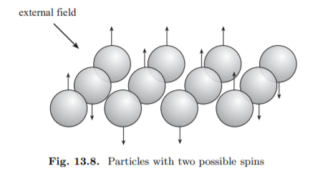
Particles with two possible spins [26]

In general, the Ising model can be used to describe those systems made of particles capable of adopting one of two states. In the case of ferromagnetic materials, their atoms can be modeled as particles of spin 1/2 (up) or spin −1/2 (down). The spin points in the direction of the magnetic field. All tiny magnets interact with each other. This causes some of the atoms to flip their spin until equilibrium is reached and the total magnetization of the material reaches a constant level. The total magnetic field $h_{i}$sensed by the atom i in an ensemble of particles is the sum of the fields induced by each atom and the external field $h^{*}$ (if present), that is

$$h_{i}=∑_{j=1}^{n} w_{ij}x_{j}+h^{*}$$
where $w_{ij}$represents the magnitude of the magnetic coupling between the atoms labeled i and j. The potential energy E of a certain state of an Ising material has the form
$$E=-\frac{1}{2}∑_{i,j}^{n} w_{ij}x_{i}x_{j}+∑_{i}^{n} -h^{*}x_{i}$$
Both Hopfield and Ising system are dynamically equivalent, but only in the case of zero temperature, since the system behaves deterministically at each state update (variant temperature lead to Boltzman machines as talked in lectures) [26] Ising models are a special case of Markov networks, since the associated probability measure, the Gibbs measure [9] has the Markov property. In probability theory and statistics, the term Markov property refers to the memoryless property of a stochastic process. A stochastic process has the Markov property if the conditional probability distribution of future states of the process (conditional on both past and present values) depends only upon the present state; that is, given the present, the future does not depend on the past. A process with this property is said to be Markovian or a Markov process. [10] The probability for a given spin $σ_{k}$ to be in state s could, in principle, depend on the states of all other spins in the Ising system. Thus, we may write the probability as
$$P\left(σ_{k}=s∣σ_{j},j≠k\right).$$
However, in an Ising model with only finite-range interactions (for example, nearest-neighbor interactions), we actually have
$$P\left(σ_{k}=s∣σ_{j},j≠k\right)=P\left(σ_{k}=s∣σ_{j},j∈N_{k}\right),$$
where $N_{k}$ is a neighborhood of the site $k$. That is, the probability at site $k$ depends only on the spins in a finite neighborhood[9] . As previously underlined by [28] Nishimori e Nomura analyzed a x−y quantum Ising model simulating a neural network. They concluded that quantum fluctuations play the same role as thermal fluctuations and are consequently not able to influence the macroscopic behavior of the network other than a classical model with nonzero temperature would do. [13]

Analogy with Grover Search
An interesting analogy is furthermore made clear by Fahri et al. [11]. They present a quantum algorithm for the satisfiability problem (and other combinatorial search problems) that works on the principle of quantum adiabatic evolution. Their Hamiltonian is defined by
$$H(t)=H_{C_{1}}(t)+H_{C_{2}}(t)+⋯+H_{C_{M}}(t)$$
where each $H_{C_{a}}$ depends only on clause $C_{a}$ and acts only on the bits in $C_{a}.H(t)$ is defined for $t$ between 0 and $T$ and is slowly varying. The initial state, which is always the same and easy to construct, is the ground state of $H(0)$. For each $a$, the ground state of $H_{C_{a}}(T)$ encodes the satisfying assignments of clause $C_{a}$. The ground state of $H(T)$ encodes the satisfying assignments of the intersection of all clauses. Clause $C$ is associated with the 3 bits labeled $i_{C},j_{C}$, and $k_{C}.$ For each clause $C$ they define an energy function
$$h_{C}\left(z_{i_{C}},z_{j_{C}},z_{k_{C}}\right)=\left\{\begin{matrix}0, & \text{ if }\left(z_{i_{C}},z_{j_{C}},z_{k_{C}}\right)\text{ satisfies clause }C \\ 1, & \text{ if }\left(z_{i_{C}},z_{j_{C}},z_{k_{C}}\right)\text{ violates clause }C.\end{matrix}\right.$$
They then define the total energy $h$ as the sum of the individual $h_{C}$ 's,
$$h=\sum_{C}{ }h_{C}.$$
They replace the bit $z_{i}$ by a spin- $\frac{1}{2}$ qubit labeled by $\left|z_{i}\right\rangle$ where $z_{i}=0,1$ and construct base Hamiltonian $H_{P}$ accordingly. For a given problem, specifying $H_{P}$ is straightforward but finding its ground state may be difficult so they consider an $n$-bit Hamiltonian $H_{B}$ that is straightforward to construct but whose ground state is simple to find. Let $H_{B}^{(i)}$ be the 1-bit Hamiltonian acting on the $i$-th bit
$$H_{B}^{(i)}=\frac{1}{2}\left(1-σ_{x}^{(i)}\right) \text{ with } σ_{x}^{(i)}=\left(\begin{matrix}0 & 1 \\ 1 & 0\end{matrix}\right)$$
so
$$H_{B}^{(i)}\left|x_{i}=x\right\rangle =x\left|x_{i}=x\right\rangle$$
$$\left|x_{i}=0\right\rangle =\frac{1}{\sqrt{2}}\left(\begin{matrix}1 \\ 1\end{matrix}\right)\text{ and }\left|x_{i}=1\right\rangle =\frac{1}{\sqrt{2}}\left(\begin{matrix}1 \\ -1\end{matrix}\right)\text{. }$$
Continuing to take 3 -SAT as working example, clause $C$ is associated with the bits $i_{C},j_{C}$, and $k_{C}$. Now define
$$H_{B,C}=H_{B}^{\left(i_{C}\right)}+H_{B}^{\left(j_{C}\right)}+H_{B}^{\left(k_{C}\right)}$$
and
$$H_{B}=\sum_{C}{ }H_{B,C}.$$
The ground state of $H_{B}$ is $\left|x_{1}=0\right\rangle \left|x_{2}=0\right\rangle ⋯\left|x_{n}=0\right\rangle$. This state, written in the $z$ basis, is a superposition of all $2^{n}$ basis vectors $\left|z_{1}\right\rangle \left|z_{2}\right\rangle ⋯\left|z_{n}\right\rangle$,
$$\left|x_{1}=0\right\rangle \left|x_{2}=0\right\rangle ⋯\left|x_{n}=0\right\rangle =\frac{1}{2^{n/2}}\sum_{z_{1}}{ }\sum_{z_{2}}{ }⋯\sum_{z_{n}}{ }\left|z_{1}\right\rangle \left|z_{2}\right\rangle ⋯\left|z_{n}\right\rangle$$
and
$$H_{B}=\sum_{i=1}^{n}{ }d_{i}H_{B}^{(i)}$$
where $d_{i}$ is the number of clauses in which bit $i$ appears in the instance of 3-SAT being considered.
After that they considered the Grover problem casted in the fashion of SAT problem. It has a single (generalized) clause, $h_{G}$, which depends on all $n$ bits with a unique (but unknown) satisfying assignment $w=w_{1},w_{2},…,w_{n}$. Corresponding to $h_{G}$ is a problem Hamiltonian
$$\begin{matrix}H_{P}|z⟩ & =\left\{\begin{matrix}|z⟩, & z≠w \\ 0, & z=w\end{matrix}\right. \\ & =1-|z=w⟩⟨z=w|\end{matrix}$$
where $|z⟩=\left|z_{1}\right\rangle \left|z_{2}\right\rangle …,\left|z_{n}\right\rangle$. So, they construct $H(t)=\tilde{H}(t/T)$ with $H_{B}$ given with $d_{i}=1$ for all $i$ from 1 to $n$. evolving using $H(t)$. The problem is "oracular," that is, it uses no knowledge about the structure of $H_{P}$ which could aid in finding $w$ . Writing $\tilde{H}(s)$ explicitly
$$\tilde{H}(s)=(1-s)\sum_{j=1}^{n}{ }\frac{1}{2}\left(1-σ_{x}^{(j)}\right)+s(1-|z=w⟩⟨z=w|).$$
From the application of this and the result of [12] they found a minimal gap of $2^{\frac{-n}{2}}$and an adiabatic evolution time equal at least to $2^{\frac{n}{2}}$. This result is also confirmed in [3] when they applied a time variant schedule to speed up evolution where the spectral gap is not at its minimum. Hopfield networks have tasks like finding an unknown value in an unsorted database (the network memory). An Hopfield neural network that uses AQO for memory recall is therefore equivalent to these Grover search implementations when the oracle is expressed via a one-memory network (the Hebb rule is in fact based on projection operation as in Appendix A). A Hopfield network extends search in a general context where the oracle must discriminate between tagged and untagged keys (stored patterns and a new pattern). This is expected to influence the spectral gap and minimum adiabatic time (being greater than $2^{\frac{-n}{2}}$). [30] However not all authors seem aware of these constraints. In [4] authors state that when numbers of minima are lower than total states (n! << $2^{n}$) an adiabatic evolution time of $2^{\frac{n}{2}}$ is commonly a good choice (they use this claim to assert the possible speed up advantage of AQO)

Use Hopefield for Problem Solving
The paper of 2020 of Bauckhage, Sanchez and Sifa [4] relaunched the usage of Hopfield network to solve problems via it’s isomorphism with ising model and direct translation in AQO setting. The basic idea is to devise an energy function H whose minimizers encode solutions to the problem at hand. One of the challenges in adiabatic quantum computing is devise suitable problem Hamiltonians. If the problem at hand is a minimization problem that can be tackled by a Hopfield network, this challenge is minor because it is easy to construct Hamiltonians for the energy functions of Hopfield networks. This is interesting because Hopfield networks are well known to the neurocomputing community and allow for solving a wide range of typically hard discrete optimization problem. Also a lot of problems (NP) could be expressed within energy minimization framework [16] As we saw during course if it is possible to express the solution to a problem in terms of minima of a Hamiltonian or energy function such that the problem can be solved on an adiabatic quantum computer, then the problem can also be solved on a quantum gate computer [1] . They stress how an adiabatic quantum computer performs a global or exhaustive search. This is due to the quantum mechanical phenomenon of superposition which causes all potential solutions to be considered simultaneously. This, in turn, makes it unlikely that a suboptimal solution will be found. They consider the k-rooks problem as a canonical example of an energy minimization solvable problem. It asks for a placement of k rooks on a k × k chessboard such that they do not threaten each other and therefore constitutes a constrained subset selection problem where k out of n = k x k fields need to be identified. Modeling the configuration or state of the chessboard in terms of a bipolar k × k matrix S with entries
$$s_{ij}=\left\{\begin{matrix}+1 & \text{ if a rook is placed on field }(i,j) \\ -1 & \text{ otherwise }\end{matrix}\right.$$
a valid solution is a configuration of S such that all its row and column sums amount to 1 ·(+1) + (k −1)·(−1) = 2−k. Vectorizing the matrix $S∈\{-1,+1\}^{k×k}$ by concatenating its rows into a vector $s∈\{-1,+1\}^{k^{2}}$, a configuration that obeys these constraints can be found by running a Hopfield network. The rook problem is a 2-d extension of the multiflop network: Assume that we are looking for a binary vector of dimension n whose components are all zero with the exception of a single 1.

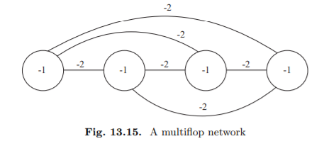
A multiflop network [26]

The weights for this network can be deduced from the following considerations. Let $x_{1},…,x_{n}$ denote the binary states of the individual units. Our task is to find a minimum of
$$E\left(x_{1},…,x_{n}\right)={\left(∑_{i=1}^{n} x_{i}-1\right)}^{2}$$
This expression can also be written expanding square
$$E\left(x_{1},…,x_{n}\right)=∑_{i=1}^{n} x_{i}^{2}+∑_{i≠j}^{n} x_{i}x_{j}-2∑_{i=1}^{n} x_{i}+1$$
For binary states it holds that x_{i} = x_{i} ² and therefore
$$E\left(x_{1},…,x_{n}\right)=∑_{i≠j}^{n} x_{i}x_{j}-∑_{i=1}^{n} x_{i}+1$$
which can be rewritten as
$E\left(x_{1},…,x_{n}\right)=-\frac{1}{2}∑_{i≠i}^{n} (-2)x_{i}x_{j}+∑_{i=1}^{n} (-1)x_{i}+1$ [26]
The k rooks with k=4 is instead depicted as
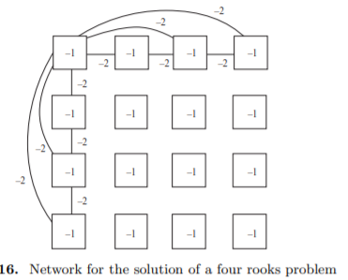
Similar to multiflop each row is a chain of cells and only one of them can be set to 1. In the case of each column has only one 1 each we have that the function to be minimized is
$$E_{1}\left(x_{11},…,x_{nn}\right)=∑_{j=1}^{n} {\left(∑_{i=1}^{n} x_{ij}-1\right)}^{2}$$
An alternative (as done by the paper authors) is that we may consider the identity matrix $I$, the matrix of all zeros $0$, and the matrix $J={11}^{⊤}-I$ all of size $4×4$ in order to define a $16×16$ weight matrix
$$W_{r}=-2\left[\begin{matrix}J & 0 & 0 & 0 \\ 0 & J & 0 & 0 \\ 0 & 0 & J & 0 \\ 0 & 0 & 0 & J\end{matrix}\right]$$
Together with a 16-dimensional threshold vector
$$θ_{r}=-2(2-k)1$$
this yields the energy function $H_{r}=-\frac{1}{2}s^{⊤}W_{r}s+θ_{r}^{⊤}s$ of a Hopfield network that would place one rook per row. For columns the energy is instead
$$E_{2}\left(x_{11},…,x_{nn}\right)=∑_{i=1}^{n} {\left(∑_{j=1}^{n} x_{ij}-1\right)}^{2}$$
Leading to matrix formulation of
$$W_{c}=-2\left[\begin{matrix}0 & I & I & I \\ I & 0 & I & I \\ I & I & 0 & I \\ I & I & I & 0\end{matrix}\right]$$
$$θ_{c}=-2(2-k)1$$
$$H_{c}=-\frac{1}{2}s^{⊤}W_{c}s+θ_{c}^{⊤}s$$
Hence, a Hopfield network with energy function
$$H=H_{r}+H_{c}$$
solves the problem. And in fact, the term inside the first summation of energy functions corresponds to a multiflop problem. The weights for the edges in each column can be set to −2, as was done before in the multiflop problem. The same is done for each row: the weights between any unit and its row partners are set to −2. Only the thresholds must be selected with a little more care. The simple juxtaposition of a row-multiflop with a column-multiflop at each field will give us a threshold of −1+(−1) = −2. This would mean that each row or column can contain up to two elements whose state is 1. This is avoided by setting the thresholds of the units to −1.
Translating in AQO algorithm we may let
$$Q=-\frac{1}{2}\left(W_{r}+W_{c}\right) \\ q=θ_{r}+θ_{c}$$
we consider a time dependent system of n = 16 qubits
$$|ψ(t)⟩=∑_{i=0}^{2^{n}-1} a_{i}(t)\left|ψ_{i}\right\rangle$$
which is in a superposition of 65.536 basis states $\left|ψ_{i}\right\rangle$. If this system evolves under the influence of a timedependent Hamiltonian H(t), its behavior is governed by the Schrodinger equation
$$\frac{d}{dt}|ψ(t)⟩=-iH(t)|ψ(t)⟩$$
Using this, we consider a period ranging from t = 0 to t = τ and assume the Hamiltonian of the Schrödinger equation to be a convex combination of two static Hamiltonian
$$H(t)=\left(1-\frac{t}{τ}\right)H_{B}+\frac{t}{τ}H_{P}$$
Here, HB is the beginning Hamiltonian whose ground state is easy to construct, and HP is the problem Hamiltonian whose ground states encode the solution to our problem
$$H_{P}=∑_{i=1}^{n} ∑_{j=1}^{n} Q_{ij}σ_{z}^{i}σ_{z}^{j}+∑_{i=1}^{n} q_{i}σ_{z}^{i}$$

Evolving the system from t =0 to τ and after evolution measuring it , probabilities ${|a}_{i}\left(t\right)|$² of obtain $\left|ψ_{i}\right\rangle$ will be finded. Being in $H_{P}$is easier found $\left|ψ_{i}\right\rangle$ corresponding to ground state of $H_{P}$encoding the solution (belove an image obtained via QuTip with τ =100)
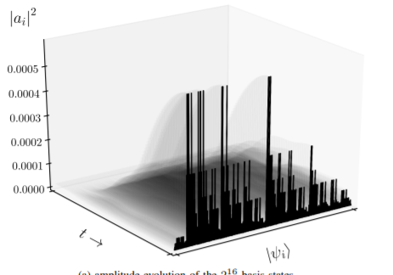

AQO could be excessive for simple problems like rook problems. But for complex ones classical Hopfield network is no more an option. In eight queen problem, we add a constraint also to diagonals.
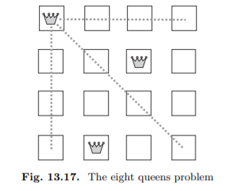
A trivial extension of solution of Rook problem for eight queen problems is done modifying weights, which are set to w_{ij} = −2, when unit i is different from unit j and belongs to the same row, column or diagonal as unit j. Otherwise we set w_{ij} to zero. The thresholds of all units are set to −1. But this extension does not lead to global minima given the fact that the network could insert less queen then the requested value (local minima). The problem is the necessity to codify three different constraints that lead to a compromise to satisfy them all. Eight queen is not NP. On the contrary TSP is a NP problem already analyzed in Hopfield model. Hopfield and Tank were the first to try to solve the TSP using a neural network but multiple constraints of TSP problem plus optimization of the path cost resort to another tradeoff parameter inside the energy function. Bruck and Goodman [7] showed that a polynomial bounded network (on the size of the problem) is unable to find the global minimum of the energy function of NP-complete problems (encoded as Hopfield networks) with a 100% guarantee. if we try to transform all local minima of the Hopfield network into an optimal solution of the combinatorial problem, the size of the network explodes exponentially.
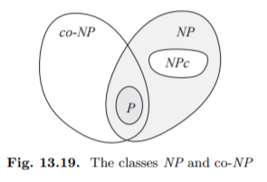
A depiction of NP and co-NP classes

The class which contains the complement of all NP problems is called co-NP. It is generally assumed that NP is different co-NP. This inequality is somewhat strong, since it implies that P is different from NP.
In fact, if there is an NP-complete problem X whose complement X^{c} belongs to NP, then NP = co-NP. Also, the following statement is proved: Let L be an NP-complete decision problem and H a Hopfield network with several weights bounded by a polynomial on the size of the problem. If H can solve L (100% success rate) then NP = co-NP. The demonstration (trivial) of precedent statements could be found in [26]. Same author suggests that Hopfield network could be competitive for problem resolution with usage of special hardware (like AQO). And in fact, the beforementioned proposition do not hold for BQP complexity class (since is not the same of NP problems).

A more focused analysis of recall capabilities of HNN implemented via AQO
The motivation of robustness to noise and parallelism are the leading motivation of the paper of Seddiqi et al. To obtain this robustness accurate recall is necessary. So they formulated memory recall in terms of global energy minimization by AQO to avoid minima. In this paper different Hopfield learning rules where also compared (see Appendix A to an exposition of Hopfield Learning Rules). This paper answer to a precedent publication that asked for this learning rule comparison [22].
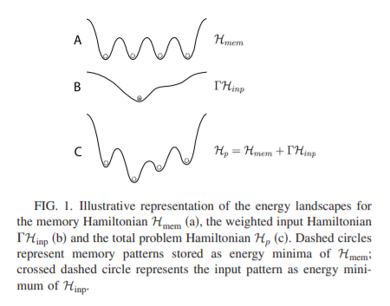
Illustration of the energy landscapes for memory and input hamiltonians

In order to apply AQC to the computational task of (associative) pattern recognition, Neigozven et al. encode the complete problem in the Hamiltonian
$$H_{p}=H_{\text{mem }}+ΓH_{\text{inp }}$$
with $H_{mem}$ representing the knowledge about stored patterns, $H_{\text{inp }}$ representing the computational input and an appropriate weight factor $Γ>0$. Since the problem is directly encoded into the final Hamiltonian $H_{p}$, no ancilla qubits are required. Whereas the classic Hopfield network utilizes dynamics defined by the memory patterns alone, the dynamics of the equation before depends on both memory and input information (leading to both information exploitation). Furthermore, the encoding of the final adiabatic Hamiltonian as a sum of two independent terms offers an advantage with respect to the practical implementation of the process. Using appropriate approximations, the computational evolution of the system can be approximated by separate periods of unitary evolution each according to the individual terms building the total instantaneous Hamiltonian. So the dynamics according to the input Hamiltonian H_{inp} can be obtained and imposed independently of memory pattern dynamic (computed only once).
$$H_{\text{inp }}=\sum_{i}{ }ξ_{i}^{\text{inp }}σ_{i}^{z}$$
For a given state $|ξ⟩$ representing a pattern $ξ$, the energy corresponding to $H_{\text{inp }}$ is given by $E^{inp}(ξ)=-n+2\overset{ˆ}{h}$ and depends on the Hamming distance $\overset{ˆ}{h}=0,…,n$ between ${\overset{ˆ}{ξ}}^{\text{inp }}$ and $\overset{ˆ}{ξ}=\left[ξ_{1},…,ξ_{n}\right]$, i.e., the number of positions for which the corresponding entries are different. The external field defined by $H_{\text{inp }}$ thus creates a scalar metric proportional to the Hamming distance between $ξ^{\text{inp }}$ and memory patterns. Similarly, Seddiqi used an analog $H_{p} but$set the activation thresholds in place of initializing the network to a known initial state. So, they formally define the energy minimization condition as
$$z=arg⁡\min_{z^{'}} E\left(z^{'};θ\right)$$
in which the vector θ represents the activation thresholds θ_{i} = Γz_{0, i} and Γ is an energy scale for the applied bias(as done in [22]). The activation threshold θ therefore serves as an energetic bias towards network states that best match the input z₀. The behavior for Neigozven et al. network is recovered by initializing the state of all neurons to an indeterminate value, i.e., z_{i} = 0, and using the first update to prepare the state z₀. The bias usage was considered for breaking energy symmetry (so not storing spurious patterns and consequently reducing number of minima, see Appendix A). The hyperparameter gamma is regulated to point towards stored memory (and some bounds could be analytically derived). Similar to beforementioned cases:

$$H(t)=\left(1-\frac{t}{τ}\right)H_{B}+\frac{t}{τ}H_{P}$$
$$H_{P}=∑_{i=1}^{n} ∑_{j=1}^{n} Q_{ij}σ_{z}^{i}σ_{z}^{j}+∑_{i=1}^{n} q_{i}σ_{z}^{i}$$
With h_{i} = θ_{i} and J_{ij} = w_{ij} . They choose the computational basis in terms of tensor product states of the +1 and −1 eigenstates of operators $σ_{z}^{i}$. In this basis, the correspondence between the binary spin label s_{i} ∈ {0, 1} and the bipolar spin configuration label is z_{i} = 2s_{i} − 1. The authors recognize that the exact scaling for the minimal T with respect to Ising model size and parametrization is not clear. After preparation of the final register state ψ(T), each qubit is measured in the computational basis. Because the final Hamiltonian H₁ is diagonal in the computational basis, measurement results represent the prepared (ground) state. The measurements may be directly related to a valid spin configuration of the Hopfield network. The state of the i-th qubit is measured in the z_{i} basis and the resulting label z_{i} is the corresponding spin configuration for the i-th neuron. The accuracy with which a memory is recalled using the AQO algorithm can be measured in terms of the probability that the correct (expected) network state is recovered. They define a measure of the probabilistic recall success
$$f_{x}=\left\{\begin{matrix}1,P_{\text{ans }}≥x \\ 0,P_{\text{ans }}<x\end{matrix}\right.$$
where P_{ans} is the probability to recover the correct memory and x ∈ [0, 1] is an a-priori threshold probability. Denoting the correct memory state as φ_{ans}, the probability to recover the correct memory can be computed from the simulated register state as
$$P_{ans}={\left|\left\langle ϕ_{ans}∣ψ(T)\right\rangle \right|}^{2}$$
From this definition for probabilistic success, they consider average success for an ensemble of N problem instances as
$$\left\langle f_{x}\right\rangle =\frac{1}{N}∑_{i=1}^{N} f_{x}^{i}$$
where $f_{x}^{i}$ represents the probability for success of the i-th problem instance of n neurons storing p memories. This is a binomial distribution with variance $\left\langle {∆f}_{x}\right\rangle$ =$\left\langle f_{x}\right\rangle ($1$-\left\langle {∆f}_{x}\right\rangle ).$They use the statistic $\left\langle f_{x}\right\rangle$to characterize accuracy for the ensemble of simulated recall operations. They use numerical simulations of the time-dependent Schrodinger equation to compute the register state ψ(T) prepared by the AQO algorithm. In these calculations, the action of the $j$ th time-evolution operator onto the appropriate state vector is calculated directly. Simulated problem instances are detailed below. in general input parameters include
- number of neurons $n$
- number of stored patterns $p$
- the applied learning rule (Hebb, Storkey, or projection)
- the annealing time $T$
- the applied bias $Γ$
- the input key $z_{0}$
Note that the large number of simulations limit the authors to a small number of neurons(this and the simulation make debatable the fulfillment of the first two criteria exposed in [28]). The results of these simulations (see Appendix D for a description in detail) Clearly show the dependence of recall capabilities by learning rule also for AQO adding another parameter to be evaluated in quantum implementation of HNN.

Bibliography
[1] Aharanov, D., van Dam, W., Kempe, J., Landau, Z., Lloyd, S., Regev, O., Adiabatic Quantum Computation Is Equivalent to Standard Quantum Computation, 2008
[2] Akazawa, M., Quantum Hopfield Betwork Using Single-Electron Circuits, 1997
[3] Amin, M.H.S., Effect of Local Minima on Adiabatic Quantum Optimization
[4] Bauckhage, C., Sanchez, R., Sifa, R., Problem Solving with Hopfield Networks and Adiabatic Quantum Computing, 2020
[5] Beer, K., Bondarenko, D., Farrelly, T., Osborne, T.J., Salzmann, R., Wolf, R., Efficient Learning for Deep Quantum Neural Networks, 2019
[6] Behrman, E.C., Nash, L.R., A Quantum Hopfield Network, 2000
[7] Bruck, J., On the Convergence Properties of the Hopfield Model
[8] Cao, Y., Guerreschi, G., Aspuru-Guzik, A., Quantum Neuron: an elementary building block for machine learning on quantum computers
[9] De Ly, A., Introduction to Generalize (Gibbs) measures, 2008
[10] Dodge, Yadolah. (2006) The Oxford Dictionary of Statistical Terms, Oxford University Press. ISBN 0-19-850994-4
[11] Fahri, E., Goldstone, J., Gutmann, S., Sipser, M., Quantum computation by adiabatic evolution
[12] Fahri, E., Gutmann, S., An Analog Analogue of a Digital Quantum Computation, 1998
[13] H. Nishimori, Y. Nonomura, quantum effects in neural networks, 1996
[14] Harrow, A.W., Hassidim, A., Lloyd, S., Quantum algorithm for linear system of equations
[15] Hopfield, J.J., Neural networks and physical systems with emergent collective computational abilities (1982)
[16] Lucas, A., Ising Formulation of Many NP Problems
[17] McEliece, R., Posner, E., Rodemich, E., Venkatesh, S.: The capacity of the Hopfield associative memory. IEEE Transactions on Information Theory 33(4), 461–482 (Jul 1987)
[18] McEliece, R., Posner, E.C., Rodemich, E.R., Venkatesh, S.S., The capacity of the Hopfield Associative Memory, 1987
[19] Meinhardt, N., Neumann, N.M., Philpson, F., Quantum Hopfield Neural Networks A New Approach and Its Storage Capacity, 2020
[20] Meinhardt, N., Neumann, N.M.P., Philipson, F., Quantum Hopfield Neural Networks A New Approach and Its Storage Capacity, 2020
[21] Moulin, N., Amara, M., Mandorlo, F., Lemiti, M., Tunnel Junction I (V) characteristics: Review and a new model for p-n homojunctions, 2019
[22] Neigozven, R., Neves, J.L., Sollacher, R., Glaser, S.J., Quantum pattern recognition with liquid-state nuclear magnetic resonance, 2009
[23] Perus, M., Neural networks as a basis for quantum associative networks, 2000
[24] Ramsauer, H., Schaff, B., Lehner, J., Seidl, P., Widrich, M., Adler, T., Gruber, L., Holzleitner, M., Pavlovic, M., Sandve, G.K., Greiff, V., Kreil, D., Kopp, M., Klambauer, G., Brandstetter, J., Hochreiter, S., Hopfield Networks is All You Need, 2021
[25] Rebentrost, P., Bromley, T., Weedbrook, C., Lloyd, S., Quantum Hopfield neural network, 2018
[26] Rojas, R., Neural Networks A Systematic Introduction, Springer (1996)
[27] S.C. Kak, Advances in Imaging and Electron Physics 94, 259 (1995)
[28] Schuld,M., Sinayskiy, I., Petruccione, F., The quest for a Quantum Neural Network
[29] Miller, E. N., Mukhopadhyay, S., A quantum Hopfield associative memory implemented on an actual quantum processor, 2021
[30] Seddiqi, H., Humble, T.S., Adiabatic Quantum Optimization for Associative Memory Recall(2014)
[31] Storkey, J.A., Valabregue, R., The Basins of Attraction of a New Hopfield Learning Rule
[32] Ventura, D., Martinez, T., Quantum Associative Memory with Exponential Capacity, 1998
[33] Wendy, S., Associative Learning and the Hippocampus, Psychological Science Agenda, American Psychological Association, 2005, https://www.apa.org/science/about/psa/2005/02/suzuki
[34] Zak, M., Williams, C.P., Quantum neural nets, 1997

Appendix A – Description of Hopfield Neural Network
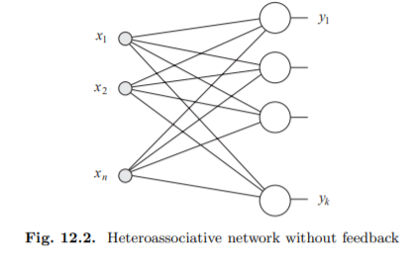
An example of eteroassociative networks without feedbacks

Practically there are three kinds of associative networks [26]
- Heteroassociative networks, map m input vectors
$x^{1},x^{2},…,x^{m}$in n-dimensional space to m output vectors $y^{1},y^{2},…,y^{m}$in k dimensional space so that $x^{i}↦y^{i}$
- Autoassociative networks, vector is associated with itself i.e. $x^{i}$=$y^{i}$
- Pattern recognition networks. Each vector $x^{i}$is associated with the scalr i
Let $w_{ij}$ be the weight between input site i and unit j. Let $w_{ij}$ be the weight between input site $i$ and unit $j$. Let $W$ denote the $n×k$ weight matrix $\left[w_{ij}\right]$. The row vector $x=\left(x_{1},x_{2},…,x_{n}\right)$ produces the excitation vector $e$ through the computation
$$e=xW.$$
The activation function is computed next for each unit. If it is the identity, the units are just linear associators and the output $y$ is just $xW$. In general, $m$ different $n$-dimensional row vectors $x^{1},x^{2},…,x^{m}$ have to be associated with m k-dimensional row vectors $y^{1},y^{2},…,y^{m}$

CAM
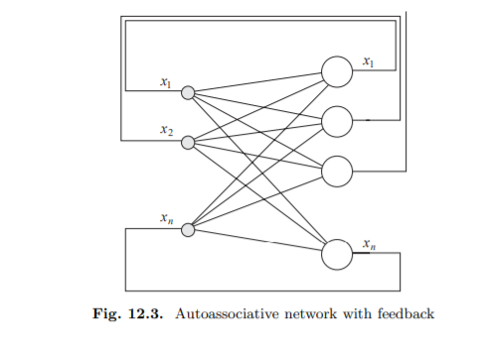
Autoassociative network with feedback

In the case of auto associative network with feedback a $n×n$ matrix $W$ has at most $n$ linear independent eigenvectors and $n$ eigenvalues. The eigenvectors $x^{1},x^{2},…,x^{n}$ satisfy the set of equations
$$x^{i}W=λ_{i}x^{i} \text{ for }i=1,…,n,$$
where $λ_{1},…,λ_{n}$ are the matrix eigenvalues.
Each weight matrix with a full set of eigenvectors defines a kind of "eigenvector automaton". Assume $\left|λ_{1}\right|>\left|λ_{i}\right|$ for $i≠j$. Let $λ_{1}>0$ and pick randomly a non-zero $n$-dimensional vector $a_{0}$. This vector can be expressed as a linear combination of the $n$ eigenvectors of the matrix $W$ :
$$a_{0}=α_{1}x^{1}+α_{2}x^{2}+⋯+α_{n}x^{n}.$$
Assume that all constants $α$ are non-zero. After the first iteration with the weight matrix $W$ we get
$$\begin{matrix}a_{1} & =a_{0}W \\ & =\left(α_{1}x^{1}+α_{2}x^{2}+⋯+α_{n}x^{n}\right)W \\ & =α_{1}λ_{1}x^{1}+α_{2}λ_{2}x^{2}+⋯+α_{n}λ_{n}x^{n}.\end{matrix}$$
After $t$ iterations the result is
$$a_{t}=α_{1}λ_{1}^{t}x^{1}+α_{2}λ_{2}^{t}x^{2}+⋯+α_{n}λ_{n}^{t}x^{n}.$$
It is obvious that the eigenvalue $λ_{1}$, the one with the largest magnitude, dominates this expression for a big enough $t$. The vector $a_{t}$ can be brought arbitrarily close to the eigenvector $x^{1}$ (with respect to the direction and without considering the relative lengths). In each iteration of the associative network, the vector $x^{1}$ attracts any other vector $a_{0}$ whose component $α_{1}$ is non-zero and it is called an attractor. We want to use associative networks as dynamical systems, whose attractors are exactly those vectors we would like to store. In the case of the linear eigenvector automaton, unfortunately just one vector absorbs almost the whole of input space. To do this we must introduce a nonlinearity in the activation of the network units so that the dynamical system becomes nonlinear. use a step function as nonlinearity. The main advantage of bipolar coding is that bipolar vectors have a greater probability of being orthogonal than binary vectors.
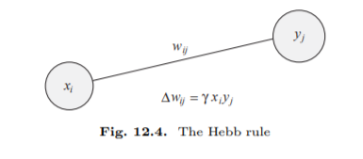
the idea of Hebbian learning (the main learning algorithm for associative networks) is that two neurons which are simultaneously active should develop a degree of interaction higher than those neurons whose activities are uncorrelated. In the latter case the interaction between the elements should be very low or zero. Hebbian learning is applied, updating the weight $w_{ij}$ by $Δw_{ij}.$ This increment measures the correlation between the input $x_{i}$ at site $i$ and the output $y_{j}$ of unit $j$. During learning, both input and output are clamped to the network and the weight update is given by
$$Δw_{ij}=γx_{i}x_{j}.$$
The factor $γ$ is a learning constant in this equation. The weight matrix $W$ is set to zero before Hebbian learning is started. In general, if we want to associate $mn$-dimensional non-zero vectors $x^{1},x^{2},…,x^{m}$ with $mk$-dimensional vectors $y^{1},y^{2},…,y^{m}$, we apply Hebbian learning to each input-output pair and the resulting weight matrix is
$$W=W^{1}+W^{2}+⋯+W^{m},$$
where each matrix $W^{l}$ is the $n×k$ correlation matrix of the vectors $x^{l}$ and $y^{l}$, i.e.,
$$W^{l}={\left[x_{i}^{l}y_{j}^{l}\right]}_{n×k}.$$
If the input to the network is the vector $x^{p}$, the vector of unit excitations is

$$\begin{matrix}x^{p}W & =x^{p}\left(W^{1}+W^{2}+⋯+W^{m}\right) \\ & =x^{p}W^{p}+∑_{l≠p}^{m} x^{p}W^{l} \\ & =y^{p}\left(x^{p}⋅x^{p}\right)+∑_{l≠p}^{m} y^{l}\left(x^{l}⋅x^{p}\right)\end{matrix}$$
Having $x^{p}⋅x^{p}$>0 then sgn($y^{p}$ ($x^{p}⋅x^{p}$))= $y^{p}$ and the contribution on the right is called crosstalk. Crosstalk become 0 only when the patterns are mutually orthogonal
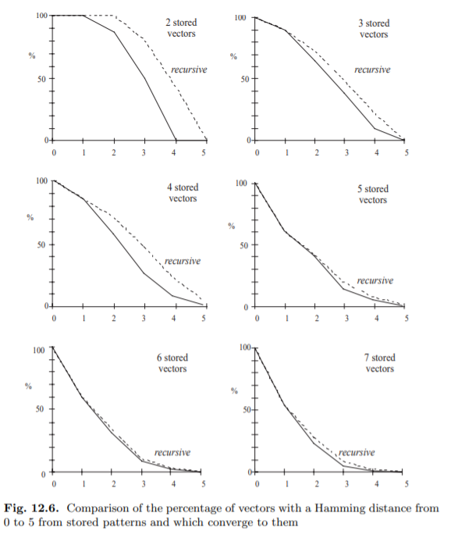
Comparison of the percentage of vectors with a Hamming distance from 0 to 5

In order to measure the size of the basins of attraction we must use a suitable metric. This will be the Hamming distance between bipolar vectors, which is just the number of different components which both contain. In image above an experiment involving ten randomly chosen vectors in 10-dimensional space stored in the weight matrix of an associative network using Hebbian learning is showed. The weight matrix was computed iteratively, first for one vector, then for two, etc. After each update of the weight matrix the number of vectors with a Hamming distance from 0 to 4 to the stored vectors, and which could be mapped to each one of them by the network, was counted. The Hamming distance has a maximum of 4, because vectors with a Hamming distance greater than 5 are mapped not to x but to −x, when x is one of the stored patterns (because sign is a odd function) and are called spurious state (doubling in fact the number of patterns stored in a network). The continuous line summarizes the results for a single iteration. Comparison of the “single shot” method and the recurrent computation show that the latter is more effective at least as long as not too many vectors have been stored. When the capacity of the weight matrix begins to be put under strain, the differences between the two methods disappear. As all these comparisons show, the size of the basins of attraction falls very fast. This can be explained by remembering that five stored vectors imply at least ten stored patterns, since together with x the vector −x is also stored. Additionally, distortion of the basins of attraction produced by Hebbian learning leads to the appearance of other spurious stable states. Spurious states other than the negative stored patterns appear because the crosstalk becomes too large. An alternative way to minimize the crosstalk term is to use another kind of learning rule. The experiment aforementioned have shown that the basins of attraction of stored patterns deteriorate every time new vectors are presented to an associative network. If the crosstalk term becomes too large, it can even happen that previously stored patterns are lost, because when they are presented to the network one or more of their bits are flipped by the associative computation. We would like to keep the probability that this could happen low, so that stored patterns can always be recalled. Depending on the upper bound that we want to put on this probability some limits to the number of patterns m that can be stored safely in an auto associative network with an n × n weight matrix W will arise. This is called the maximum capacity of the network and an often-quoted rule of thumb is m ≈ 0.18n (it is the upper bound probability for one bit failure posed on 0.01 on a gaussian that represent the m and n selection as random)

5.2 BAM
The synchronization of the output was achieved by requiring that all computing elements evaluate their inputs and compute their output simultaneously. Under this assumption the operation of the associative memory can be described with simple linear algebraic methods. The excitation of the output units is computed using vector-matrix multiplication and evaluating the sign function at each node. the disadvantage, from the point of view of both biology and physics, that global information is needed, namely a global time. Whereas in conventional computers synchronization of the digital building blocks is achieved using a clock signal, there is no such global clock in biological systems. In an asynchronous network each unit computes its excitation at random times and changes its state to 1 or −1 independently of the others and according to the sign of its total excitation. The probability of two units firing simultaneously is zero. Consequently, the same dynamics can be obtained by selecting one unit randomly, computing its excitation and updating its state accordingly. There will not be any delay between computation of the excitation and state update. We adopt the additional simplification that the state of a unit is not changed if the total excitation is zero. This means that we leave the sign function undefined for the argument zero. We have already discussed recurrent associative networks in which the output of the network is fed back to the input units using additional feedback connections. However, there is another way to define a recurrent associative memory made up of two layers which send information recursively between them. The input layer contains units which receive the input to the network and send the result of their computation to the output layer. The output of the first layer is transported by bidirectional edges to the second layer of units, which then return the result of their computation back to the first layer using the same edges. Such a network is known as a resonance network or bidirectional associative memory (BAM).
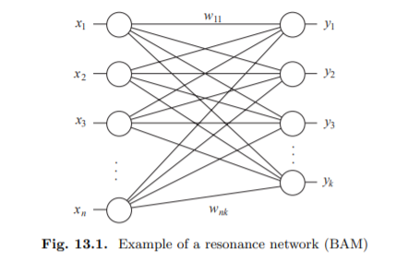
Example of a resonance network

The network in Figure maps an $n$-dimensional row vector $x_{0}$ to a $k$ dimensional row vector $y_{0}$. We denote the $n×k$ weight matrix of the network by $W$ so that the mapping computed in the first step can be written as
$$y_{0}=sgn⁡\left(x_{0}W\right)$$
In the feedback step $y_{0}$ is treated as the input and the new computation is
$$x_{1}^{T}=sgn⁡\left(Wy_{0}^{T}\right)$$

After $m$ iterations the system has computed a set of $m+1$ vector pairs $\left(x_{0},y_{0}\right),…,\left(x_{m},y_{m}\right)$ which fulfill the conditions
$$y_{i}=sgn⁡\left(x_{i}W\right)$$
and
$$x_{i+1}^{T}=sgn⁡\left(Wy_{i}^{T}\right).$$
The question is whether after some iterations a fixpoint $(x,y)$ is found. This is the case when both
$$y=sgn⁡(xW) \text{ and } x^{T}=sgn⁡\left(Wy^{T}\right)$$
hold. Hebbian learning can be used to compute an adequate matrix $W$. If $W$ is defined as $W=x^{T}y$, as prescribed by Hebbian learning, then
$$y=sgn⁡(xW)=sgn⁡\left(xx^{T}y\right)=sgn⁡\left(∥x∥^{2}y\right)=y$$
and also
$$x^{T}=sgn⁡\left(Wy^{T}\right)=sgn⁡\left(x^{T}yy^{T}\right)=sgn⁡\left(x^{T}∥y∥^{2}\right)=x^{T}.$$
For a set of $m$ vector pairs the matrix $W$ is set to
$$W=x_{1}^{T}y_{1}+x_{2}^{T}y_{2}+⋯+x_{m}^{T}y_{m}.$$

If $y_{0}$is now used for a new iteration from the right, excitation of the units in the left layer can be summarized in an excitation vector e computed according to

$$e^{T}=Wy_{0}.$$
The vector pair $\left(x_{0},y_{0}\right)$ is a stable state of the network if $sgn⁡(e)=x_{0}.$ All vectors $e$ close enough to $x_{0}$ fulfill this condition. These vectors differ from $x_{0}$ by a small angle and therefore the product $x_{0}e^{T}$ is larger than for other vectors of the same length but further away from $x_{0}$. The product
$$E=-x_{0}e^{T}=-x_{0}Wy_{0}^{T}$$
is therefore smaller (because of the minus sign) if the vector $Wy_{0}^{T}$ lies closer to $x_{0}$. The scalar value $E$ can be used as a kind of index of convergence to the stable states of an associative memory. We call $E$ the energy function of the network.
$$E\left(x_{i},y_{i}\right)=-\frac{1}{2}x_{i}Wy_{i}^{T}$$

Adding thresholds is equivalent to the introduction of an additional unit with constant output 1 into each layer. The weight of each edge from a constant unit to each one of the others is the negative threshold of the connected unit. It is straightforward to deduce that the energy function of the extended network can be written as
$$E\left(x_{i},y_{i}\right)=-\frac{1}{2}x_{i}Wy_{i}^{T}+\frac{1}{2}θ_{r}y_{i}^{T}+\frac{1}{2}x_{i}θ_{l}^{T}.$$

The row vector of thresholds of the k units in the left layer is denoted in the above expression by θ. The row vector of thresholds of the n units in the right layer is denoted by θr. Using the energy function it can be shown that a BAM arrives at a stable state after a finite number of iterations the energy function can be written in the two equivalent forms (resolving in different order the products)
$E(x,y)=-\frac{1}{2}∑_{i=1}^{k} e_{i}y_{i}$ and $E(x,y)=-\frac{1}{2}∑_{i=1}^{n} g_{i}x_{i}$

The state of unit $i$ on the left layer will change only when the excitation $g_{i}$ has a different sign than $x_{i}$, the present state. The state is updated from $x_{i}$ to $x_{i}^{'}$, where $x_{i}^{'}$ now has the same sign as $g_{i}$. Since the other units do not change their state, the difference between the previous energy $E(x,y)$ and the new energy $E\left(x^{'},y\right)$ is
$$E(x,y)-E\left(x^{'},y\right)=-\frac{1}{2}g_{i}\left(x_{i}-x_{i}^{'}\right)$$
Since both $x_{i}$ and $-x_{i}$ have a different sign than $g_{i}$ it follows that
$$E(x,y)-E\left(x^{'},y\right)>0.$$

Hopfield Networks
In the Hopfield model it is assumed that the individual units preserve their individual states until they are selected for a new update. The selection is made randomly. A Hopfield network consists of n totally coupled units, that is, each unit is connected to all other units except itself. The network is symmetric because the weight w_{ij} for the connection between unit i and unit j is equal to the weight w_{ji} of the connection from unit j to unit i. self-connection are not allowed (this corresponds to weight matrix having diagonal of zeros, a necessary condition to convergence). This can be interpreted as meaning that there is a single bidirectional connection between both units
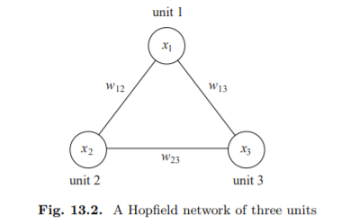
Hopefield network with three units

Let W denote the weight matrix of a Hopfield network of n units and let θ be the n-dimensional row vector of units’ thresholds. The energy E(x) of a state x of the network is given by
$$E(x)=-\frac{1}{2}xWx^{T}+θx^{T}$$
The factor 1/2 is used because the identical terms w_{ij}x_{i}x_{j} and w_{ji}x_{j}x_{i} are present in the double sum.
In the same way it could be demonstrated that the network eventually reaches a stable state at a local minimum (given the fact that the number of states is finite)

For a sufficient single update, the weight matrix could be denoted by

$$W_{1}=x_{1}^{T}x_{1}-I$$
where I denotes the $n×n$ identity matrix. Subtraction of the identity matrix guarantees that the diagonal of $W$ becomes zero, since for any bipolar vector $x_{i}$ it holds that $x_{k}^{i}x_{k}^{i}=1$. Obviously $W_{1}$ is a symmetric matrix. The minimum of the energy function of a Hopfield network with the weight matrix $W_{1}$ is located at $x_{1}$ because
$$E(x)=-\frac{1}{2}xW_{1}x^{T}=-\frac{1}{2}\left({xx}_{1}^{T}x_{1}x^{T}-{xx}^{T}\right)$$
and ${xx}^{T}=n$ for bipolar vectors. This means that the function
$$E(x)=-\frac{1}{2}{∥xx_{1}^{T}∥}^{2}+\frac{n}{2}$$
has a local minimum at $x=x_{1}$.
$$W=x_{1}^{T}x_{1}+x_{2}^{T}x_{2}+⋯+x_{m}^{T}x_{m}-mI$$
If the network is initialized with the state $x_{1}$, the vector $e$ of the excitation of the units is
$$\begin{matrix}e & =x_{1}W \\ & =x_{1}x_{1}^{T}x_{1}+x_{1}x_{2}^{T}x_{2}+⋯+x_{1}x_{m}^{T}x_{m}-mx_{1}I \\ & =(n-m)x_{1}+\sum_{j=2}^{m}{ } α_{1j}x_{j}\end{matrix}$$
The constants $α_{12},α_{13},…,α_{1m}$ represent the scalar products of the first vector with each one of the other $m-1$ vectors $x_{2},…,x_{m}$. The state $x_{1}$ is stable when $m<n$ and the perturbation term $∑_{j=2}^{m} α_{1j}x_{j}$ is small. The best results are achieved with Hebbian learning when the vectors are orthogonal or close to orthogonal. The energy function is commonly considered to be a Lyapunov function. A point is stable (Ljapunov stable) if every orbit of the system sufficiently close to the stable point remain in the nearance of the stable point.

5.3.1 Evaluating Performance of Hopfield Networks
Paper of Meinhardt, Neumann, Philipson [19] introduce an interesting method of evaluating performance of HNN that is important to be quoted. In particular underlying the importance of evaluating different HNN architecture by their common characteristic meaning its capacity. To do that they introduce and formalize three error measures implicitly developing an evaluation method that can be used generally and is at least partially founded in majority of literature

$$\begin{matrix}{SER}_{n,m} & :=1-1\left[∀p∈\{1,…,m\},∀j∈\{1,…,n\}:x_{j}^{(p)}=f{\left(x^{(p)}\right)}_{j}\right] \\ {MER}_{n,m,η} & :=\frac{1}{mN_{\text{vic }}}\sum_{p=1}^{m}{ } \sum_{p_{k}=1}^{N_{\text{vic }}}{ } \left(1-1\left[∀j∈\{1,…,n\}:x_{j}^{(p)}=f{\left(x_{η}^{\left(p_{k}\right)}\right)}_{j}\right]\right) \\ {BER}_{n,m,η} & :=\frac{1}{mN_{\text{vic }}}\sum_{p=1}^{m}{ } \sum_{p_{k}=1}^{N_{\text{vic }}}{ } \frac{1}{n}H\left(x^{(p)},f\left(x_{η}^{\left(p_{k}\right)}\right)\right)\end{matrix}$$
where $n$ is the input size and $m$ the number of distinct stored patterns, with $m≤2^{n}$. $1[⋅]$ is the indicator function, which is one if its argument is true, and zero otherwise. The SER only considers the patterns the HNN should memorize and equals one if at least one bit of any memory pattern cannot be retrieved. This definition corresponds to the one given in [17]. SER is not an appropriate measure for the attractiveness of memory patterns. This follows as the noisy probe samples are randomly generated and might therefore not be part of the memories basin of attraction. The MER uses $N_{\text{vic }}$ noisy probe vector $x_{η}^{\left(p_{k}\right)}$for each memory $x^{(p)}$. These probe vectors are random noisy versions of the memory patterns, generated with noise parameter $η$ thus not influenced by previously stored pattern. The MER equals the fraction of the probe vectors from which $x^{(p)}$ cannot be recovered exactly.
the BER also uses the probe vectors $x_{η}^{\left(p_{k}\right)}$. The BER considers all bits separately that cannot be retrieved correctly (so it’s less conservative). For $η=0$, these three error rates are decreasingly strict: SER $≥$ MER $≥$ BER. A systematic way to estimate capacity given a threshold t
$$m_{max}^{t}(n,ER):=m{ }\left\{m∈\left\{1,…,2^{n}\right\}∣ER(n,m)≤t\right\}.$$
The capacity $C_{t}$ of an HNN is given by normalizing $m_{max}^{t}$ by $n$. For large system sizes, $m_{max}^{t}(n$, SER $)$ is independent of $t$. For classical HNNs with Hebbian learning the capacity is given by $n/(4log⁡n)$. They also underline that capacity of an HNN cannot be determined accurately with only a single set of random memory patterns. Therefore, the error rate for r different random sets of memory patterns should be averaged to better approximate the error rates

5.3.2 Learning rules
Setting the synaptic weights w_{ij} for a Hopfield network is done using a specific choice of learning rule that in turn generates a different Ising model. Learning rules represent a form of unsupervised learning in which the memories are stored in the network without any corrective back-action. In the limit of orthogonal memories, all three learning rules reduce to the Hebb rule.
Hebb rule:

$$w_{ij}=\frac{1}{n}\sum_{μ=1}^{p}{ }ξ_{i}^{μ}ξ_{j}^{μ}$$
for a set of $p$ memories $\left\{ξ^{1},ξ^{2},…,ξ^{p}\right\}$, each of length $n$ with bipolar elements $ξ_{i}^{μ}∈\{±1\}$. Geometrically, each summand corresponds to the projection of the neuron configuration into the $μ$-th memory subspace. These projections are orthogonal if all $p$ patterns are mutually orthogonal. In the asymptotic limit for the number of neurons, the capacity of the Hebb rule is $c_{n}=n/2ln⁡n$ under conditions of perfect recall, i.e., no errors in the retrieved state. It is worth noting that the Hebb rule is incremental as it is a sum over individual patterns (meaning you could add new patterns without retrain all synaptic weights). The rule is also local since the synaptic weights depend only on the value of the adjacent neurons.

Storkey rule:
defines the synaptic weights in an iterative fashion as
$$w_{ij}^{ν}=w_{ij}^{ν-1}+\frac{1}{n}ξ_{i}^{ν}ξ_{j}^{ν}-\frac{1}{n}ξ_{i}^{ν}h_{ji}^{ν}-\frac{1}{n}h_{ij}^{ν}ξ_{j}^{ν}$$
where $ξ^{ν}$ is the memory to be learned in the $ν$-th iteration for $ν=1$ to $p$ and
$$h_{ij}^{ν}=\sum_{k=1,k≠i,j}{ }w_{ik}^{ν-1}ξ_{k}^{ν}$$
is the local field at the $i$-th neuron [31]. The final synaptic weight storing $p$ memories is given by $w_{ij}=w_{ij}^{p}$. The Storkey rule is found to more evenly distribute the fixed points and increases the capacity of the network. The asymptotic Storkey capacity under prefect recall is $n/\sqrt{2ln⁡n}$, which represents an improvement over the Hebb rule. As with the Hebb rule, the Storkey rule is incremental and permits the addition of new memories.

Projection rule

$$w_{ij}=\frac{1}{n}\sum_{μ,μ^{'}=1}^{p}{ }ξ_{i}^{μ}C_{μμ^{'}}^{-1}ξ_{j}^{μ^{'}}$$
where $C_{μμ^{'}}=\frac{1}{n}∑_{k=1}^{n} ξ_{k}^{μ}ξ_{k}^{μ^{'}}$ is the covariance matrix and $C^{-1}$ is the inverse of $C$. This rule has a theoretical capacity of $n$ for linearly independent patterns and approximately $n/2$ for interfering memories $.$The projection rule is neither local nor incremental as adding memories to the network requires resetting each element using knowledge of all other memories. HNNs can be implemented as feed forward NNs by regarding each update step as a new layer of neurons. In the feed-forward interpretation, the weight matrix is layer depended on and can be written as $W^{(l)}$. Depending on whether the HNN is updated synchronously or asynchronously, the weights might differ between layers. In the former case, the weights $W_{ij}^{(l)}$ are exactly as $W_{ij}$ of the usual HNN. Hence, the weights are symmetric in both the subscripts and the layers and the superscript $l$ can be omitted. Note that HNNs have no self-connections, such that $W_{ii}=0$ for all $i$. Therefore, the interpretation of an HNN with synchronous updating as a feedforward $NN$ is valid. The number of layers $l$ can be seen as a time parameter for HNN. the advantage of the feed-forward interpretation is that we can use existing proposals to translate classical NNs to a gate-based quantum analog. [20]
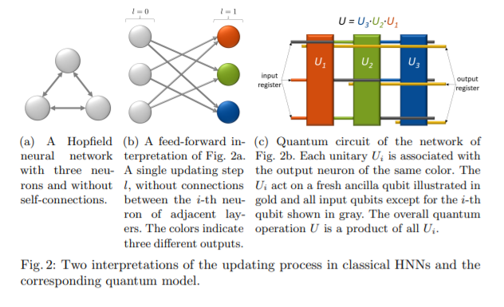
On the left an Hopfield network with three neurons. On the right a feed-forward interpretation of the network on the left. A single updating step l, the colors indicate different output [20]

5.3.3 Hebb learning rule with incomplete patterns
Suppose that we are supplied with incomplete data on a neuronal activation pattern such that we only know the values $l<d$ neurons with labels $L⊂\{1,2,…,d\}$. We can initialize our activation pattern to be $x^{(\text{inc })}:=$ ${\left\{x_{1}^{(\text{inc })},x_{2}^{(\text{inc })},…,x_{d}^{(\text{inc })}\right\}}^{⊤}$ with $x_{i}^{(\text{inc })}=x_{i}^{(\text{new })}$ if $i∈L$ and $x_{i}^{(\text{inc })}=0$ otherwise. Our objective is to use the trained Hopfield network to recover the original activation pattern $x^{\text{(new). }}$. Minimizing the energy $E$ subject to the constraint that $Px=x^{\text{(inc). }}$, the Lagrangian for this optimization is
$$L=-\frac{1}{2}x^{⊤}Wx+θ^{⊤}x-λ^{⊤}\left(Px-x^{(inc)}\right)+\frac{γ}{2}x^{⊤}x$$
Using a Lagrange multiplier vector $λ∈R^{d}$ and a fixed regularization parameter $γ≥1$(serves to minimize the l2-norm $|x|_{2}$ of x.). The firstorder derivative conditions for optimization are evaluated as
$$\begin{matrix} & \frac{∂L}{∂x}=\left(γI_{d}-W\right)x+θ-Pλ\overset{!}{=}0, \\ & \frac{∂L}{∂λ}=-Px+x^{(\text{inc })}\overset{!}{=}0.\end{matrix}$$

Or equivalently consider this as a system of linear equations $Av=w$
$$\begin{matrix}A & :=\left(\begin{matrix}W-γI_{d} & P \\ P & 0\end{matrix}\right) \\ v & :=\left(\begin{matrix}x \\ λ\end{matrix}\right), w:=\left(\begin{matrix}θ \\ x^{(\text{inc })}\end{matrix}\right).\end{matrix}$$
The solution of this system then provides a vector $v$ consisting of $x$ and $λ$, where $x$ extremizes the energy $E$ subject to $Px=x^{\text{(inc) }}$. the elements of the resultant vector x are continuous valued. This can be interpreted as a larger positive/negative value indicating a stronger confidence for the activation ±1, respectively. For a particular neuron, the value can then be projected to the nearest element ±1 to obtain a prediction for the activation of that neuron. [25]

Appendix B – More notion on quantum computing

Here will be clarified some recurring aspects of quantum computing for the main paradigms quoted in this document

6.1 Quantum Systems Notion
Quantum systems are described by a wave function ψ that exists in a Hilbert space. In the Hilbert space there exists a set of states, $\left|ϕ_{i}\right\rangle$, that form a basis, and the system is described by a quantum state $|ψ⟩$
$$|ψ⟩=∑_{i} c_{i}\left|ϕ_{i}\right\rangle$$
$|ψ⟩$is said to be in a linear superposition of the basis states $\left|ϕ_{i}\right\rangle$and in the general case, the coefficients $c_{i}$ may be complex. Coherence and decoherence (two aspect named in introduction) are closely related to the idea of linear superposition. A quantum system is said to be coherent if it is in a linear superposition of its basis states. If a system that is in a linear superposition of states interacts in any way with its environment, the superposition is destroyed. This loss of coherence is called decoherence and is governed by the wave function ψ. The coefficients $c_{i}$are called probability amplitudes, and |$c_{i}$|² gives the probability of $\left|ψ\right\rangle$collapsing into state $\left|ϕ_{i}\right\rangle$if it decoheres. In the Dirac notation, the probability that a quantum state $|ψ⟩$ will collapse into an eigenstate $\left|ϕ_{i}\right\rangle$is written |$〈ϕ_{i}|ψ〉$|² and is analogous to the dot product (projection) of two vectors. Operators on a Hilbert space describe how one wave function is changed into another and they are typically denoted by a capital letter, such as $\overset{ˆ}{A}$, and they may be represented as matrices acting on vectors. Using operators, an eigenvalue equation can be written $\overset{ˆ}{A}\left|ϕ_{i}\right\rangle =a_{i}\left|ϕ_{i}\right\rangle$ where $a_{i}$is the eigenvalue. The solutions $ϕ_{i}$to such an equation are called eigenstates and can be used to construct the basis of a Hilbert space as discussed above. In the quantum formalism, all properties are represented as operators whose eigenstates are the basis for the Hilbert space associated with that property and whose eigenvalues are the quantum allowed values for that property. It is important to note that operators in quantum mechanics must be linear operators. For computational purposes, the most commonly used quantum system is the spin-1/2 system which is referred to as a quantum bit or qubit

6.2 AQO

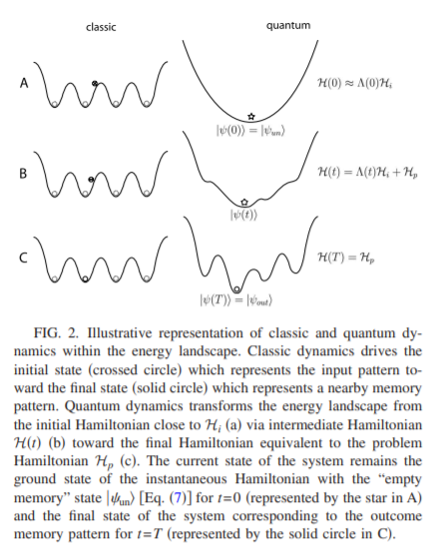
Representation of classic and quantum dynamics within the energy landscape. Classic dynamics drive initial state (crossed circle) toward local minima (void circle). Quantum dynamics actively transforms the energy landscape from initial Hamiltonian close to Hi toward problem Hamiltonian Hp remaining in the ground state [22]

The quantum adiabatic evolution should not be confused with cooling. This is done in simulated annealing, a classical algorithm that attempts to find the lowest energy configuration of the system by generating the stochastic distribution proportional to β, the inverse temperature, and gradually lowering the temperature to zero. In contrast, quantum adiabatic evolution forces the state of the system to remain in the ground state of the slowly varying H(t). A quantum system evolves according to the Schrödinger equation
$$i\frac{d}{dt}|ψ(t)⟩=H(t)|ψ(t)⟩$$
and the adiabatic theorem [1] tells us how to follow this evolution in the case that $H(t)$ is slowly varying. Note that for purpose of computation H(t) must encode the problem we are trying to solve. Consider a smooth one-parameter family of Hamiltonians $\tilde{H}(s),0≤s≤1$, and take
$$H(t)=\tilde{H}(t/T)$$
so that $T$ controls the rate at which $H(t)$ varies. Define the instantaneous eigenstates and eigenvalues of $\tilde{H}(s)$ by
$$H(s)|l;s⟩=E_{l}(s)|l;s⟩$$
with
$$E_{0}(s)≤E_{1}(s)≤⋯≤E_{N-1}(s)$$
where $N$ is the dimension of the Hilbert space. Suppose $|ψ(0)⟩$ is the ground state of $\tilde{H}(0)$, that is,
$$|ψ(0)⟩=|l=0;s=0⟩$$
According to the adiabatic theorem, if the gap between the two lowest levels, $E_{1}(s)-E_{0}(s)$, is strictly greater than zero for all $0≤s≤1$, then
$$\lim_{T→∞} |⟨l=0;s=1∣ψ(T)⟩|=1.$$
This means that the existence of a nonzero gap guarantees that $|ψ(t)⟩$ remains very close to the instantaneous ground state of $H(t)$ of the form $H(t)=\tilde{H}(t/T)$ for all $t$ from 0 to $T$ if $T$ is big enough. Let us define the minimum spectral gap by
$$g_{min}=\min_{0≤s≤1} \left(E_{1}(s)-E_{0}(s)\right).$$
A closer look at the adiabatic theorem tells us that taking
$$T≫\frac{E}{g_{min}^{2}}$$
where
$$E=\max_{0≤s≤1} \left|\left\langle l=1;s\left|\frac{d\tilde{H}}{ ds}\right|l=0;s\right\rangle \right|$$
can make
$$|⟨l=0;s=1∣ψ(T)⟩|$$
arbitrarily close to 1. [11]

Appendix C – Other models and proposal

7.1 Quron approach


Depiction of quron approach [28]

A natural way to implement QNNs is to replace the McCulloch-Pitts neuron $x=\{-1,1\}$ by a 'quron' $|x⟩$ of the twodimensional Hilbert space $H^{2}$ with basis $\{|0⟩,|1⟩\}$. The state $|ψ⟩$ of a network with $N$ qurons thus becomes a multiparticle quantum state of the $2^{N}$-dimensional Hilbert space $H^{2^{N}}=H^{2}⊗…⊗H^{2}$ with basis $\{|0,0,…,0⟩,…,|1,1,…,1⟩\}$ reading
$$|ψ⟩=\sum_{i=1}^{2^{N}}{ }a_{i}{\left|x_{1}x_{2}…x_{N}\right\rangle }_{i}$$
where the $a_{i},i∈\left\{1,…,2^{N}\right\}$ refer to the complex amplitudes assigned to the respective network basis states.[28] Initially this implementation is coupled with quantum search and uses also qutrits. The paper of 1998 from Ventura and Martinez[32] propose a quantum associative memory (QuAM) with a storage capacity of O($2^{n}$), while using only n neuron. It is considered one of the first quantum implementation of Hopfield networks. The exposed aim of the authors is showing the usage of means of quantum computation, in particular interference and coherence, to make easy implementation of neural networks (historically it was AI winter for neural network). Therefore, the authors are interested in augmenting capacity of Hopfield network. The quantum associative memory proposed consists of a set of spin systems, each of which may be thought of as the quantum analog of a simple 2 or 3 state artificial neuron. The patterns to be learned are viewed as operators that act on the spin systems. Following definitions for training phase are provided:
$\vec{x}$ as a binary input vector of length $n$, whose elements can have the values 0 or 1,
$\vec{z}$ as a ternary feature vector of length $n$, whose elements can have the values 0,1, or $*$, with $*$ representing a "don't care" state,
$\vec{o}$ as a binary output class vector of length $s$ associated with an input vector $\vec{x}$,
$\vec{p}$ as a binary output class vector of length $s$ associated with a feature vector $\vec{z}$
$T$ as a set of patterns ${\vec{x}}_{i}→{\vec{o}}_{i},1≤i≤q$ to be learned.
While for test phase
$\vec{y}$ as a binary input vector to be classified (possibly could have error)
A feature vector $\vec{z }$is said to match an input vector $\vec{x}$ if and only if ∀j, $z_{j}$ = $x_{j }$or $z_{j}$ = ∗. Further, if the number of elements $z_{j}$≠ ∗ is r, then the feature vector $\vec{z }$ is of order r, or $\vec{z }$ is said to be an r-th order feature. The matching functions m and w compute an hamming score between an input and feature vector

$$m(x,z)=\left\{\begin{matrix}1 & \text{ if }z=* \\ ρ & \text{ if }x=z \\ 0 & \text{ otherwise. }\end{matrix}\right. \\ w(\vec{x},\vec{z})=\left\{\begin{matrix}0 & \text{ if }∃j,m\left(x_{j},z_{j}\right)=0 \\ Π_{j}m\left(x_{j},z_{j}\right) & \text{ otherwise. }\end{matrix}\right.$$

As it could be seen m act on single elements while w is zero if at least an element is not equal. $ρ$ is a free parameter. To construct the network, they propose use of a slightly more complex spin-1 system (3 states) whose eigenstates are labeled $\left.|0\right\rangle \left.|1\right\rangle \left.|*\right\rangle$. A coherent set of n such quantum systems would be represented as a superposition of all $3^{n}$ eigenstates. They now define the quantum system for learning associative pattern completion:
$$|ψ⟩=∑_{\vec{z}\vec{p}} c_{\vec{z}\vec{p}}|\vec{z}\vec{p}⟩$$
This represents a QuAM with the ability to represent $3^{n}$×$2^{n}$different patterns where eigenstates are labelled as a feature vector ($\vec{z})$paired with a binary output ($\vec{p})$. ). Each spin-1 system can be thought of as a neuron (non-bipolar). Each basis state corresponds to a possible pattern or partial pattern, and a superposition of states corresponds to a superposition of different patterns and partial patterns. the information learned from the training set will be encoded in the coefficients $c_{\vec{z}\vec{p}}$ via a set of unitary operators (representing training set) that operate on ψ.
The learning phase of the patterns in T by the QuAM may be summarized as follows.
- Prepare $|ψ⟩=Σ_{z\vec{p}}c_{\vec{z}}|\vec{z}\vec{p}⟩$ such that the $c_{\overset{‾}{z}\vec{p}}$ represent a uniform distribution.
- Calculate the operator $\overset{ˆ}{T}$.
- Apply the operator $\overset{ˆ}{T}$ to $|ψ⟩$.

The patterns to be learned are considered as operators, with each pattern producing two operators then used subsequently ${\overset{ˆ}{A}}_{{\vec{x}}_{i}{\vec{o}}_{i}}$ and ${\overset{ˆ}{B}}_{{\vec{x}}_{i}{\vec{o}}_{i}}$ . For all q patterns we combine these operators
$\overset{ˆ}{A}$ as the operator $∑_{i=1}^{q} {\overset{ˆ}{A}}_{{\vec{x}}_{i}{\vec{o}}_{i}}$,
$\overset{ˆ}{B}$ as the operator $∑_{i=1}^{q} {\overset{ˆ}{B}}_{{\vec{x}}_{i},{\vec{D}}_{i}}$, and
$\overset{ˆ}{T}$ as the operator $\overset{ˆ}{A}\overset{ˆ}{B}$.
Consider the operators as matrices that are indexed by column and row by a quadruple. The definition of the entry $z_{1},{\vec{p}}_{1},{\vec{z}}_{2}{\vec{p}}_{2}$ for ${\overset{ˆ}{A}}_{{\vec{x}}_{i}{\vec{o}}_{i}}$ (meaning entry for a matrix for a training pattern characterized ${\vec{o}}_{i}$ and ${\vec{p}}_{1})$
$$a_{z_{1},{\vec{p}}_{1},{\vec{z}}_{2}{\vec{p}}_{2}}=\left\{\begin{matrix}0 & \text{ if }{\vec{z}}_{1}\text{ does not match }{\vec{x}}_{i} \\ w\left({\vec{x}}_{i},{\vec{z}}_{1}\right) & \text{ if }{\vec{z}}_{1}={\vec{z}}_{2}\text{ and }{\vec{o}}_{i}={\vec{p}}_{1}={\vec{p}}_{2}.\end{matrix}\right.$$
The $\overset{ˆ}{A}$ operators increase the probability amplitudes of those eigenstates in $\left.|ψ\right\rangle$associated with features that match the input vectors in the training set. An $\overset{ˆ}{A}$ operator increases the probability amplitude for only those eigenstates whose features match its associated input training vector and whose output class matches the output training class.
With same consideration second set of operators, ${\overset{ˆ}{B}}_{{\vec{x}}_{i}{\vec{o}}_{i}}$
$$b_{z_{1}{\vec{p}}_{1},{\vec{2}}_{2}{\vec{p}}_{2}}=\left\{\begin{matrix}0 & \text{ if }{\vec{z}}_{1}\text{ does not match }{\vec{x}}_{i} \\ -w\left({\vec{x}}_{i},{\vec{z}}_{1}\right) & \text{ if }{\vec{z}}_{1}={\vec{z}}_{2}\text{ and }{\vec{o}}_{i}≠{\vec{p}}_{i} \\ w\left({\vec{x}}_{i},{\vec{z}}_{1}\right) & \text{ if }{\vec{z}}_{1}={\vec{z}}_{2}\text{ and }{\vec{o}}_{i}={\vec{p}}_{i}.\end{matrix}\right.$$
The $\overset{ˆ}{B}$ operators, on the other hand, are constructed to cause interference (constructive or destructive depending upon the output class) between the amplitudes of competing eigenstates. They increase the probability amplitudes (positively or negatively) of those eigenstates that correspond to features that match their associated input training vector regardless of output class.
pattern completion/retrieval phase can be summarized as
- Apply the operator $\overset{ˆ}{Y}$ to $\left|ψ\right\rangle$ after $\overset{ˆ}{T}|ψ⟩$ is applied
- Observe the quantum spin- $1/2$ systems associated with the output vector causing it to choose a single eigenstate, and the values observed for the spin- $1/2$ systems associated with the output pattern are the completion of $\vec{y}$.
The $\overset{ˆ}{Y}$ operator defined as the matrix
$$y_{{\vec{z}}_{1}{\vec{p}}_{1},{\vec{z}}_{2}{\vec{p}}_{2}}=\left\{\begin{matrix}0 & \text{ if }{\vec{z}}_{1}\text{ does not match }{\vec{y}}_{i} \\ w\left({\vec{y}}_{i},{\vec{z}}_{1}\right) & \text{ if }{\vec{z}}_{1}={\vec{z}}_{2}\end{matrix}\right.$$

it makes non-zero the probability amplitudes for those eigenstates whose features match the input vector to be classified; obviously output class cannot be considered. They test it on three datasets from the UCI repository (lenses, Hayes, led). The LED data set is an artificially generated representation of the 10 digits of an LED display with 25% noise. Due to the exponential nature of simulating quantum systems on a classical computer they select only small data sets. For the Lenses data set, the QuAM uses 5 neurons (3- state qubits) to represent 23 patterns; for the Hayes data set, the QuAM uses 8 neurons to represent 83 patterns; and for the LED data set, the QuAM uses 7 neurons to represent 200 (noisy) patterns. These data sets were obviously converted to binary representation before simulation. Tenfold cross validation was used to obtain results, and ten trials for each data split were run to get a more accurate picture of the results.
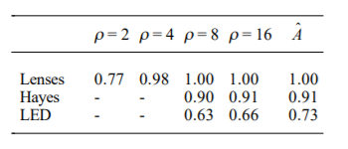
The first four columns of the table above, labeled with their respective values for ρ, show that as ρ increases in value, pattern recall accuracy improves. This is due to the nature of the m function and the length of the input vector x. The ability to memorize and correctly recall this many patterns with so few neurons is classically not possible. notice that for the LED data set the results are not as good. This is due to the noise in the data set producing harmful interference patterns through operator $\overset{ˆ}{B}$ (because the erroneous labels are also probability amplified). The fifth column shows recall accuracy using the $\overset{ˆ}{A}$ operator instead of the $\overset{ˆ}{T}$ operator. In this case, results for LED are also near optimum but there is less interference. The definition of $\overset{ˆ}{T}$ includes the $\overset{ˆ}{B}$ operator for the purpose of utilizing interference between contradictory features to improve generalization. This is accomplished by having features that are good predictors of the output vector reinforced and by having features that are bad predictors eliminated. However, the interference in $\overset{ˆ}{B}$ sometimes overcompensates and becomes detrimental to generalization by reinforcing bad features. Table belove supports this by giving generalization results using the operator ˆ A alone (no interference) and the full operator $\overset{ˆ}{T}$ .
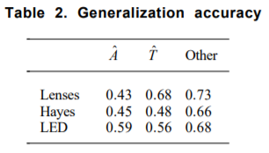
[31]
It should be noted that this proposal was not actually implemented (and do not take into account the problem of dissipative behavior). As an interesting proposal of actual implementation of codifying neurons in qubit approach is the 2000 article of Behrman and Steck [6] . The main interest connected with quantum implementation of Hopfield networks rely on parallelism of asynchronous learning rule (as previously said computation capabilities were a concern and Hopefield was saw as a mean to solve NP complete problems) that could be enhanced with quantum parallelism itself. As historical note this approach was than employed in the field of dissipative quantum computation as pointed out by Schuld et al. (but here is not considered because it was applied to feedforward neural networks. However, it should be noted that there is a formal equivalence between Hopfield and feedforward that could led to exploit some of this results). To describe it they used quantum dot molecules that are nearby groups of islands of metal (in group of four as a dice) deposited on a semiconducting substrate. in case of two dots close enough excess electrons deposited on the dots can tunnel between islands. In absence of environmental potential this leads to a two-level system in which electron occupy opposite corner (A) or lie in either of the two equivalent dots (in a dipole)
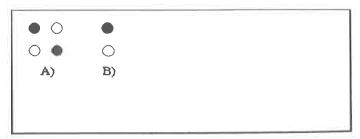
To represent an Hopfield net they used an array of molecules where each molecule represents a node. Setting the initial states of each of the node they evolve in time toward some state. From the partition function of the entire array, they calculated a discretized path integral for each molecule (using a very short unit of time). The state of one of the quantum dot in the discretized quantum path integral (by a Feynman path integral which sums over all possible paths $ϕ(t)$ propagating the system from $ϕ^{0}$ to $ϕ^{'}$ ) . an example is showed belowe (the loop is composed by a p number of point, in infinite number under the approximation they chosen). This is a direct application of Peruš' notion of the formal similarity between the updating function and the evolution of a quantum state.

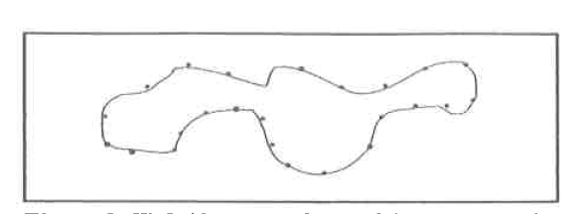
In the classical limit the loop shrinks to a single dot, but quantum mechanically is a superposition of up and down. The Hamiltonian of the system represents interaction between points of different loops (and in the loop itself). The isomorphism is given by the exponential term resulting in their approximation being a Lyapunov function. The network can be trained by a common backpropagation rule, in which the 'weights' are corrected according to the output error gradient. The synaptic weights are then engineered by the interaction of the 2-level quron with an environment. In other words, instead of updating the state of a neuron $x_{i}$ ,$i∈\{1,…,N\}$, by the state of $N-1$ others, the state of one neuron at time $iΔt$ is $-$ in different intensities-influenced by its state at times $0,…,(i-1)Δt$ before. The exponential function has also the role according to Behrman of mimic the nonlinearity of Hopfield neural network but the same admits that for larger computations a spatial-array model is needed and finding parameter for concrete mimicking neural networks is not trivial. The first criteria of Schuld et al. is not met, also the second criteria is not clearly met given the complexity of testing further properties analog to HNN. [6]. Same porpoises lead Masamichi Akazawa in 1997, inspired also by “ultrahigh-speed computation” of quantum Turing machine (authors says due to quantum parallelism), but with another architecture and underlying aspect of global minimum state finding (see AQO section).[ Akazawa, M., Quantum Hopfield Network Using Single-Electron Circuits, 1997]. In the model of Akazawa tunneling junction have the roles of neurons. For Akazawa model the implementation constrains the memory stored and there is not a clearcut parallelism to neural architecture (make debatable satisfaction of second point of Schuld et al.). First actual implementation of Hopfield model in quantum hardware is in the work of Miller and Mukhopadhyay and based on concept of quron [29]in IBMQ. Authors consider the effects of quantum errors in simulation via the IBMQ QASM simulator as well as in IBMQ hardware devices of up to 15 qubits, specifically on ibmq_16_melbourne, the largest publicly available IBMQ hardware device at the time of this work with 15 qubits. They based their system on the quantum neuron developed by Cao et al. [8] and modify their structure for implementation in IBMQ in a single, uninterrupted quantum circuit.

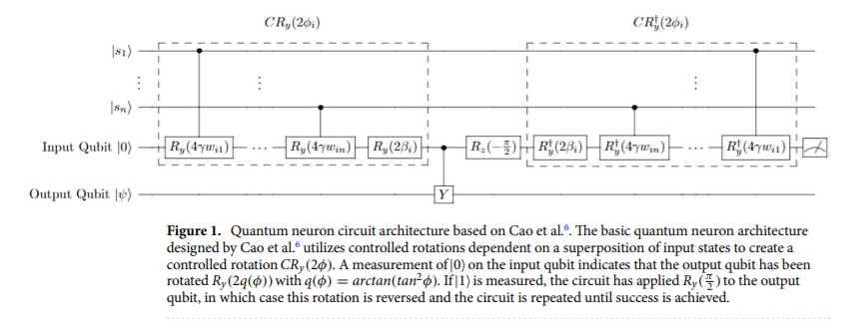
Architecture of Cao et al.

They map each classical neuron state $x_{i}$ to a qubit in state $|0⟩$ or $|1⟩$. Mapping each neuron state to the probability of measuring $|1⟩$ in the qubit, $x_{i}=-1$ corresponds to a pure $|0⟩$ state $(P(|1⟩)=0)$ and $x_{i}=1$ corresponds to a pure $|1⟩$ state $(P(|1⟩)=1)$. The full quantum system is thus represented by $|s⟩=\left|s_{1}s_{2}…s_{n}\right\rangle$. In order to mimic the attractor dynamics of a classical Hopfield network, update rule which can update the state of a single quantum neuron $\left|s_{i}\right\rangle$ based on the interaction of $w_{ij}$ and $|s⟩$ compared to a given threshold, Cao et al. consider the quantum circuit shown above which produces a rotation on a target qubit of $R_{y}\left(2arctan⁡\left(\tan^{2}⁡ϕ\right)\right)$ if the input qubit measures $|0⟩$, where $R_{y}$ represents a rotation generated by the Pauli $Y$ operator around the Y-axis of the Bloch sphere. This rotation, when applied to an initial $|0⟩$ state, produces a $|1⟩$ measurement probability of $P(|1⟩)=\frac{\sin^{4}⁡(ϕ)}{\sin^{4}⁡(ϕ)+\cos^{4}⁡(ϕ)}$ on the output qubit (Y). This output probability is used as an analog to the classical neuron, in which $ϕ>\frac{π}{4}$ produces $P(|1⟩)$ close to 1 and $ϕ<\frac{π}{4}$ produces a $P(|1⟩)$ close to 0, corresponding to the classical $x_{i}=±1$ states. The parameter $ϕ$ relates to the classical $θ$ parameter by:
$$ϕ=γθ+\frac{π}{4}$$
where $γ$ is a normalization factor such that $0<ϕ<\frac{π}{2}$. The function chosen for $γ$ is:
$$γ=\frac{\frac{π}{4}}{w_{max}n}$$
The $CR_{y}\left(2ϕ_{i}\right)$ rotation gate in the circuit in figure above is composed of rotations of the neuron state $\left|s_{i}\right\rangle$ controlled by each $\left|s_{j}\right\rangle$ which depend on the neural interconnection matrix elements $w_{ij}$, followed by a rotation dependent on the bias term $β$. The bias term $β$ is set by:
$$β_{i}=\frac{π}{4}-γ\left(\sum_{j=1}^{n}{ } w_{ij}\right)$$
When these rotations are combined, the resulting operation is a rotation $R_{y}\left(2ϕ_{i}\right)$ on the target qubit. This circuit operates in a Repeat-Until-Success (RUS) manner wherein a measurement of |0$⟩$ on the input qubit indicates that the rotation of $R_{y}\left(2arctan⁡\left(\tan^{2}⁡ϕ\right)\right)$ has been successfully applied to the output qubit. If the input qubit measures $|1⟩$, this indicates that a rotation of $R_{y}\left(\frac{π}{2}\right)$ has been applied instead, in which case $R_{y}\left(-\frac{π}{2}\right)$ is applied to reverse the initial rotation and the circuit is repeated. T. The RUS circuit design presents difficulty for implementation in quantum hardware due to its requirement of mid-circuit measurement and reset operations that could lead to decoherence. The midcircuit measurements are used to perform the check for success and the reset operations are used to recycle the output qubit for successive updates. So, they
- modify quantum neuron to simply be a CRy(2φ) rotation controlled by all other qubits in the system
- set thresholds to 0
- the update phase is done swapping the results with the corresponding qubit iteratively for every update required. the qubit used to perform the update is not recycled in order avoid reset operations. Avoiding reset operations improves the accuracy of the neuron and allows for implementation in hardware which does not support reset operations
- In the original work of Cao, a majority vote of many measurements of the updated qubit is used to reassign the state to pure state immediately after being updated to achieve a binary activation function. Instead, they leave the updated qubits in their state produced by the update between evaluation steps. not produce a true binary result there will be an inherent error rate with respect to the true classical Hopfield update. Multiple updates are performed in succession to reach a desired endpoint of the circuit, after which the majority vote method can used to extract the result to a classical output
the gate complexity of our design is only (10n − 3) u, where n is the size of the associative memory and u is the number of updates performed. The simulation and hardware accuracy of the simplified quantum neuron is shown belove. they observe that their updated design is more resilient to noise and hardware errors than the RUS design. The hardware measurements show degradation particularly in the φ > π 4 regime, but this hardware error is much lower than the simulated error in the RUS design.
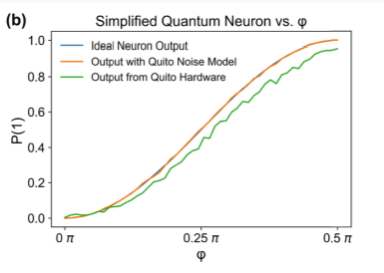
In the original design, an activation function was applied to the rotation angle of the output state, namely arctan(tan2(φ)), whereas in our design, we allow for the rotation around the Bloch sphere itself to act as an activation function. This reduction results in a more gradual activation function but allows for uninterrupted execution in a single quantum circuit and reduces the qubit overhead and gate complexity of the circuit. However, this more gradual slope of the activation function can reduce the accuracy of update steps where φ is close to its midpoint of π /4 (as apparent in figure). To test the capacity, they create random training vectors of length n and a probe vector defined to be p x n (where p is a predefined value) hamming distant from one of the stored memory patterns. They used an hyperparameter u to decide the number of updates before qubit readings. The results show however that performances degrade rapidly increasing number of patterns in real hardware implementation compared to simulated noise. This implementation however not consider at all the dissipative nature of neural network (it is irrelevant per se the usage of a nonlinearity)

7.2 Measurement approach
A measurement would 'collapse' the superposition of a quron state onto one of the basis vectors $\{|0⟩,|1⟩\}$ with probability $|α|^{2},|β|^{2}$ respectively. This operation is dissipative by definition. However, if a quantum equivalent of a perceptron would be constructed to simply induce measurements, the dynamics would evolve classically as quantum mechanical effects would be destroyed in every updating step. This point were underlined and faced by Subhash K. Kak [27]. He interprets the condition for a stable state $x^{0}=\left(x_{1}^{0},…,x_{N}^{0}\right)$ in a 'Hopfieldlike' network defined by the weight matrix $w$ with entries $w_{ij}$,
$$sgm⁡\left(wx_{0}\right)=x_{0},$$
as an eigenvalue equation of a quantum system, $\overset{ˆ}{w}\left|x_{0}\right\rangle =λ\left|x_{0}\right\rangle$. The weight matrix $w$ thereby becomes an operator with eigenvector $\left|x_{0}\right\rangle$ and eigenvalue $λ=1$. Updating a network then corresponds to a quantum measurement that selects the eigenstates of a system. However, this idea were only sketched and no actual proposal of a network was done. After Kak, Mitja Perus[23] emphasizes the analogy between what he calls a 'Hopfield-like' network and quantum theory, comparing an updating function without threshold or sigmoid function,
$$x_{i}\left(t_{2}\right)=\sum_{i=1}^{n}{ }w_{ij}x_{j}\left(t_{1}\right)$$
with the time evolution of a quantum state (with the wave-functions $Ψ=Aexp⁡(iφ)$, given by Quantum Mechanics and Path Integrals By Feynman , R.P., and Hibbs, A.R.),
$$ψ\left(r_{2},t_{2}\right)=\iint{ }G\left(r_{1},t_{1},r_{2},t_{2}\right)ψ\left(r_{1},t_{1}\right)dr_{1}dt_{1}.$$
Combining it with the expression for the parallel-distributed interactive transformation of the quantum system, $G$ , that is a projection operator defined as $G=∑_{l=1}^{k} ψ^{l*}\left(r_{1},t_{1}\right)ψ^{l}\left(r_{2},t_{2}\right),$ where $r_{1},r_{2}$are position and $t_{1},t_{2}$ time variables, and $\left\{ψ^{l}(r,t)\right\}$ is a complete basis of the quantum system. Supposing having encoded some information in the basis state, then G (called interactor) constitutes the quantum memory (it’s element representing interaction between states of quantum system) .They underlined following parallelism
$q⇔Ψ, q^{'}⇔Ψ^{'}, v^{k}⇔ψ^{k}, J⇔G$ or $J⇔G$
By analyzing memory recall of an Hopfield network without nonlinearities. The memory recall is done by ${\vec{q}}_{\text{output }}=J{\vec{q}}_{\text{input }}=J{\vec{q}}^{'}.$ This can be analyzed as follows:
$$q\left({\vec{r}}_{2},t_{2}=t_{1}+δt\right)=∫J\left({\vec{r}}_{1},{\vec{r}}_{2}\right)q\left({\vec{r}}_{1},t_{1}\right)d{\vec{r}}_{1}=\int{ }\left[\sum_{k=1}^{P}{ } v^{k}\left({\vec{r}}_{1}\right)v^{k}\left({\vec{r}}_{2}\right)\right]q^{'}\left({\vec{r}}_{1},t_{1}\right)d{\vec{r}}_{1}$$

Where J is the Hebb dynamical equation for synaptic connections (${\vec{r}}_{2} is the destination of the synapse)$. at the same time if we operate quantum memory recall realized by wave-function collapse
$$Ψ\left({\vec{r}}_{2},t_{2}=t_{1}+δt\right)=∫G\left({\vec{r}}_{1},{\vec{r}}_{2}\right)Ψ^{'}\left({\vec{r}}_{1},t_{1}\right)d{\vec{r}}_{1}=∫\left[∑ψ^{l}{\left({\vec{r}}_{1}\right)}^{*}ψ^{l}\left({\vec{r}}_{2}\right)\right]Ψ^{'}\left({\vec{r}}_{1},t_{1}\right)d{\vec{r}}_{1}$$
A valid input state $Ψ^{'}$ for the authors is supposed to be almost orthogonal to all memorized vectors (or basis states) $ψ^{l}$ except from one vector $ψ^{j}(l≠j)$, so that $G$ applied to the input retrieves $ψ^{j}$ with a high probability ${\left|ψψ^{j}\right|}^{2}$.
A QNN approach along the lines of quantum measurements has been proposed after that by Zak and Williams [34]. The authors try to capture dissipation and nonlinearity, by replacing the step-or sigmoid-activation function with a quantum measurement. In particular

$$|ψ(0)⟩→U|ψ(0)⟩→σ_{1}\{U|ψ(0)⟩\}=|ψ(t+1)⟩$$
which is a formal representation of an evolving not observed quantum system, observed in t+1, with $σ_{1}$ denoting a "quantum" sigmoid function (the observation). In order to continue this sequence, we have to reset the quantum device considering the resulting eigenstate as a new input. For a set of neurons, we arrive at the following neural net:
$$a_{i}(t+1)=σ_{1}\left\{\sum{ }U_{ij}a_{j}(t)\right\}, i=1,2,…,n$$
which has a form similar to a stochastic version of neural nets. By replacing sgn with a stochastic rule S (given by a random generator not probabilistic nature of quantum mechanics)
$$\begin{matrix}x_{i}(t+1)=S\sum{ }T_{ij}x_{j}(t) \\ S=\left\{\begin{matrix}+1 & \text{ with probability }f\left(\sum{ }T_{ij}x_{j}\right) \\ -1 & \text{ with probability }1-f\left(\sum{ }T_{ij}x_{j}\right)\end{matrix}\right.\end{matrix}$$

(note that here the weight matrix or unitary operator has exponential dimension). These measurements must be repeated to obtain reliable state vector estimations. If we could synchronize two measurements, we could measure at the same time bot forward and backward connection
$$\begin{matrix}a_{i}^{(1)}(t+1)=σ_{l_{1}l_{2}}\left\{U_{ij}^{(1)}a_{j}^{(1)}(t)\right\}, & i=1,2,…,n_{1} \\ a_{i}^{(2)}(t+1)=σ_{l_{2}l_{1}}\left\{U_{ij}^{(2)}a_{j}^{(2)}(t)\right\}, & i≠1,2,…,n_{2}\end{matrix}$$

Here, the evolution matrix $U$ is of dimension $2^{N}×2^{N}$ and contains the probabilities of transitions between network basis states $\left|x_{1},…,x_{N}\right\rangle$. The operation is required to be unitary. The authors do not give a derivation of $U$ from a given Hopfield network that shows its characteristic dynamics. A major problem in such approaches is also the global coherence between the qurons. Zak and Williams remark that the coherence only has to be kept up between two measurement processes for a sufficiently small-time window $Δt$ the high dimension of neural networks simulating brain functions make it a challenge to maintain global coherence. All this model is reported not being implemented in a fully functional network failing first Schuld et al. criteria and were not developed for Hopfield model afterwards. On the other hand, they have contributed to underline the importance of time evolution in calculating synaptic weights.

7.3 Network in operator
An interesting approach not covered previously to create an HNN is presented in the work of Meinhardt, Neumann, Philpsonn of 2020 [20] which aims to find exponential storage capacity in case of qubits in a formal way taking directly into account Schuld criteria. They follow a proposal of deep quantum neural networks [5] and applied it to feed forward analogy of HNN.
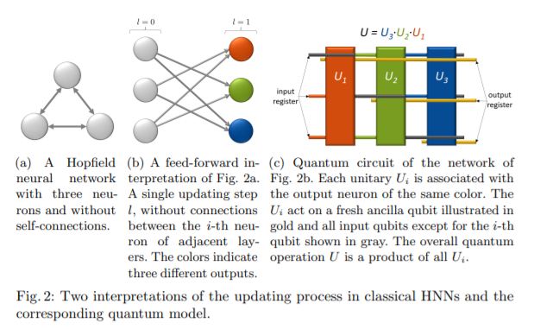

They define a quantum perceptron to be a general unitary operator $U_{i}$acting on $n$ input qubits and $m$ output qubits. The input qubits are initialized in a possibly unknown mixed state $ρ^{\text{in }}$ and the output qubits in a fiducial product state $|0⋯0⟩_{\text{out }}$. Such an arbitrary unitary operator depends on ${\left(2^{m+n}\right)}^{2}-1$ parameters, which incorporate the weights and biases of previous proposals in a natural way . QNN so is a quantum circuit of quantum perceptrons organized into $L$ hidden layers of qubits, acting on an initial state $ρ^{\text{in }}$ of the input qubits, and producing an, in general, mixed state $ρ^{\text{out }}$ for the output qubits according to
$$ρ^{\text{out }}≡{tr}_{in,hid}⁡\left(U\left(ρ^{in}⊗|0⋯0⟩_{\text{hid,out }}⟨0⋯0|\right)U^{†}\right)$$
where $U≡U^{\text{out }}U^{L}U^{L-1}…U^{1}$ is the QNN quantum circuit, $U^{l}$ are the layer unitaries, comprised of a product of quantum perceptrons acting on the qubits in layers $l-1$ and $l$. A crucial property of this QNN definition is that the network output may be expressed as the composition of a sequence of completely positive layer-to-layer transition $maps⁡E^{l}:$
$$ρ^{\text{out }}=E^{\text{out }}\left(E^{L}\left(…E^{2}\left(E^{1}\left(ρ^{\text{in }}\right)\right)…\right)\right)$$however thereafter only a single synchronous update and only one output qubit is considered. Using the qubit encoding scheme, a classical bit string $\left(x_{1},…,x_{n}\right)$ is encoded in the corresponding computational basis state $\left|x_{1}…x_{n}\right\rangle .$ In HNNs, neurons can only take the values $±1$ and they identify $+1↔|0⟩$ and $-1↔|1⟩$. Consequently, the classical input layer is replaced by state initialization of the quantum input register. The figure above on the right gives an example of this quantum analogue for three neurons and a single update. The colors correspond with those of the classical neurons of the classical network in the left and the golden lines represent the ancilla qubits. The only output qubit affected by unitary $U_{i}$ is ancilla qubit $i$ and the output state corresponds to the output of classical neuron $i$. To retrieve a classical output from the quantum system, ancilla qubits are measured at the end of the circuit. Using a majority vote over multiple measurement rounds, the most likely outcome is chosen as updated state. The original input qubits are discarded after an update. In general 2n qubits are needed for an update. The goal is now to train the unitaries, opposed to variational quantum circuits, where classical gate parameters are trained and the gates themselves remain the same. Given a training set of $N$ input states $\left|ϕ_{k}^{in}\right\rangle$ for training and their desired output states $\left|ϕ_{k}^{\text{out }}\right\rangle$, for $k=1,…,N.$ Let $ρ_{k}^{\text{in }}=\left|ϕ_{k}^{\text{in }}\right\rangle \left\langle ϕ_{k}^{\text{in }}\right|$ and let $ρ_{k}^{\text{out }}=U\left|ϕ_{k}^{\text{in }}\right\rangle \left\langle ϕ_{k}^{\text{in }}\right|U^{†}$ be the actual output of the quantum circuit $U$ with input $\left|ϕ_{k}^{\text{in }}\right\rangle .$ the fidelity of the circuit (a measure of closeness for pure quantum states) be given by
$$\left.F\left(U\left|ϕ_{k}^{in}\right\rangle ϕ_{k}^{in}\left|U^{†},\right|ϕ_{k}^{out}\right\rangle \left\langle ϕ_{k}^{out}\right|\right)=\left\langle ϕ_{k}^{out}|U|ϕ_{k}^{in}\right\rangle \left\langle ϕ_{k}^{in}\left|U^{†}\right|ϕ_{k}^{out}\right\rangle .$$
To evaluate the performance of the QNN in learning the training data, i.e., how close is the network output $ρ_{k}^{\text{out }}$ for the input $\left|ϕ_{k}^{\text{in }}\right\rangle$ to the correct output $\left|ϕ_{k}^{\text{out }}\right\rangle$, they defined a cost function to be the fidelity between the QNN output and the desired output averaged over the training data:
$$C=\frac{1}{N}\sum_{k=1}^{N}{ }\left\langle ϕ_{k}^{\text{out }}\left|ρ_{k}^{\text{out }}\right|ϕ_{k}^{\text{out }}\right\rangle$$
The cost function varies between 0 (worst) and 1. To optimize $C$, they train the unitary operations $U_{j}(s)$, parametrized by $s$ as a measure of the training iterations (and j meaning the perceptron considered). After a time, step $ε$, the unitaries are then updated according to
$$U_{j}(s+ε)=e^{i∈K_{j}(s)}U_{j}(s),$$
where the $K_{j}(s)$ are Hermitian matrices that includes all parameters of the corresponding perceptron unitary given by
$$K_{j}(s)=\frac{i2^{n+1}}{2Nλ}\sum_{k}{ }{Tr}_{\text{rest }}⁡\left[M_{j}^{k}(s)\right].$$
Here $1/λ$ is a learning rate. These $K_{j}(s)$ can be estimated by taking a partial trace of matrices $M_{j}^{k}$ that act on the whole space $H_{2}^{2n}$ of all input and output qubits. This partial trace Tr rest traces out all qubits not related to the unitary $U_{j}$. These qubits are all other ancilla qubits and the $j$-th input qubit if self-connections are removed. The $M_{j}^{k}$ can be calculated from all unitaries, input and output training states as
$$\begin{matrix}M_{j}^{k}(s)= & \left[U_{j}\left(s\right)…U_{1}\left(s\right)ρ_{k}^{\text{in }}⊗\left|0…0\right\rangle <0…0∣U_{1}^{†}(s)…U_{j}^{†}(s),\right. \\ & \left.U_{j+1}^{†}(s)…U_{n}^{†}(s)1⊗\left|ϕ_{k}^{\text{out }}\right\rangle \left\langle ϕ_{k}^{out}\right|U_{n}(s)⋯U_{j+1}(s)\right],\end{matrix}$$
where $[A,B]=AB-BA$ is the commutator of two operators $A$ and $B$. At this point, the layer structure of the network comes in handy: To evaluate $K_{j}^{l}$ for a specific perceptron in a specific layer l, we only need the output state of the previous layer, $ρ^{l-1}$ (which is obtained by applying the layer-to-layer channels $E^{1},E^{2}…E^{l-1}$ to the input state), and the state of the following layer $σ^{l}$ obtained from applying the adjoint channels to the desired output state up to the current layer . So in each iteration, all $M_{j}^{k}$ are estimated and $K_{j}$ is obtained by tracing out all unrelated qubits. Using third equation the unitaries are consequently updated in small time steps $ε$. The derivation of the following equations involves Tayloring the exponential around $ε=0$ to the first order All calculation of paper afterword supouse that training set is generated varying hamming distance from 0 to d (apriori parameter) over a prefixed number of starting patterns. This led to a training dataset that contains all combinations of every memorized pattern at every distance between 0 and d. regarding model complexity, the algorithm must
- estimate $K_{j}$, in each iteration, using Tr _{rest} $\left[M_{j}^{k}\right]$ for each training pair $k$ (meaning input and output) . Hence, the duration of training is linear in the number of training samples $N_{\text{train }}(m,d)$ and the time required to estimate ${Tr}_{\text{rest }}⁡\left[M_{j}^{k}\right]$ is denoted by $t_{M_{j}^{k}}$.
- update $U_{j}$ for each unitaries n according to time evolution equation, denoted as $t_{\text{upd}}$
- $N_{\text{iter }}$ as number of iteration steps
The total training duration is thus given by
$$t_{\text{tot }}=N_{\text{iter }}n\left(t_{\text{upd }}+N_{\text{train }}(m,d)t_{M_{j}^{k}}\right).$$
They tested their implementation with following constraint
- the unitaries are initialized uniformly at random
- chose λ = 1 based on an estimation of the MER with varying λ ∈ [0.01, 50] for system size n = 4
- 50 training iterations
- 100 repetitions
- training sets include all samples at a distance d ≤ 1 around the respective memory patterns
- They repeat this estimation with systems of size n ≤ 5 and m ≤ 2 n memories for all repetition.
- they sample the error rates 500 times for n ∈ {3, 4}, and up to 1200 times for n = 5, to reduce the confidence intervals to a reasonable level.
The results presented here are at 99% confidence level
- error rates retrieving stored memory patterns in quantum implementation
SER tend to increase fastly when the number of patterns increase while MER (and BER) tend to remain stable. SER is confirmed to be stricter because of it evaluate perfect stored pattern retrieved
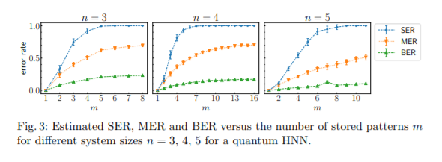
- error rates retrieving not stored memory patterns in quantum implementation
(Parameter of error distribution η ∈ {0.1, 0.2, 0.3})
MER and BER augment both for increasing stored pattern (due to interference probabily) . the difference is lower when number of stored memories is higher meaning that interference hurts also single bit recall
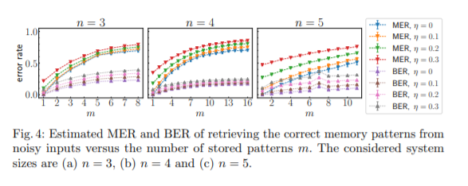

- error rate for classical Hopfield implementation for memory stored patterns
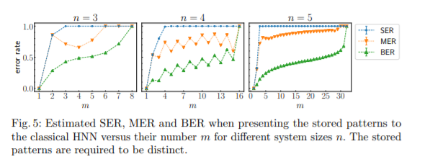

For even n, both the MER and SER fluctuate for different m and are higher if m is even. In contrast, for odd n there is a smooth evolution. The SER increases to 1 rapidly for all n (more than quantum). The results for MER are similar to those for the SER.

- error rate for classical Hopfield implementation for not stored patterns
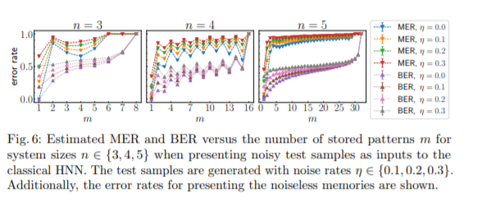
When presenting noisy input states to the HNN, we see different behavior. As previously there are less fluctuations for increasing n. Errors increase earlier in the noisy case than in the noiseless case, as expected.
- Comparison of capacity between (theorical) classical and quantum implementations

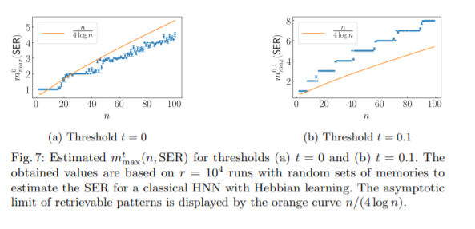
The results for the MER are similar to those of the SER. The theoretical capacity n/(4 log n) is shown as an orange line. There is stepwise behavior for all shown results and we see that the results for t = 0 correspond relatively well with the theoretical limit.

- Comparison of error rate between classical and quantum implementations

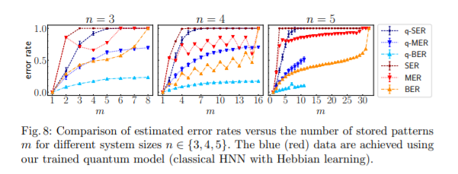
For all n, the MER and BER of the quantum model are smaller than for the classical HNN. They also find that the SER of the quantum model is smaller than the classical SER for small m and reaches one only for higher values of m. While the MER and BER fluctuate like a saw-tooth for even n for the classical HNN, they do not find this behavior for the quantum model [20]

Appendix D – Seddiqi results detailed presentation
Considering the case of p orthogonal memories ( n-dimensional Hadamard matrix for n = 2k) to prepare the synaptic weights and corresponding Ising Hamiltonians. Orthogonal memories are a special case for which all learning rules prepare the same synaptic weights. The energy spectrum is the same as displayed in the image belove. In the absence of any bias, it’s expect recall to recover each of the p encoded memories with uniform probability (being all orthogonal).
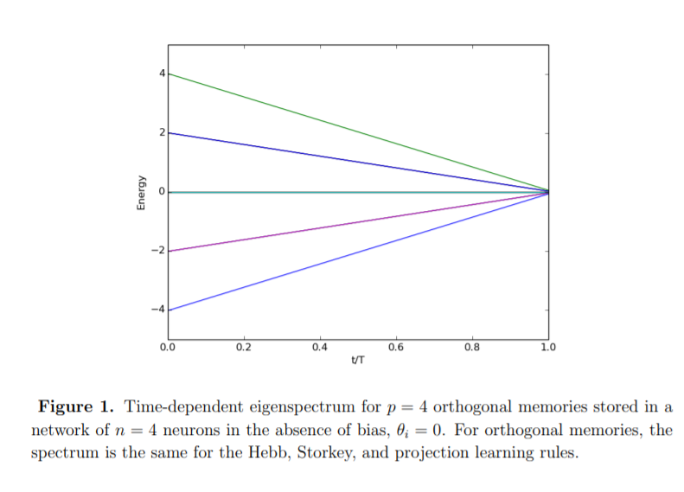
The same case but with θ set to the first memory and Γ = 1 The presence of the bias removes the ground state degeneracy and, not apparent from the figure, the prepared ground state matches the biased input state Also in this case the spectrum are the same.

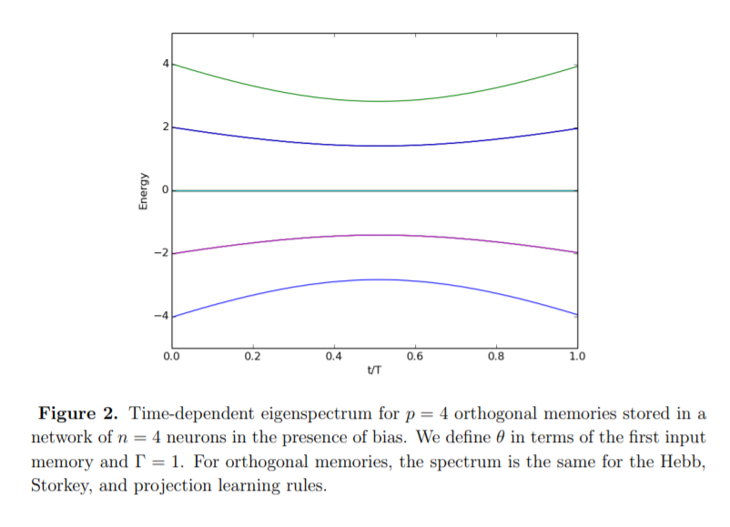
They next consider an instance of non-orthogonal memories. Interference is expected to cause failure during recall when the applied bias is insufficient to distinguish between similar states. For these simulations, we found the annealing time T = 1000 was sufficiently long to yield convergence in the prepared quantum state. Next figures plot the probability to successfully recall the answer as a function of the applied bias Γ ∈ [0, 1]. The inset for each figure shows the semi-log plot of recall error under the same conditions. Recall probability q varies with input bias, number of memories, and learning rule as expected.

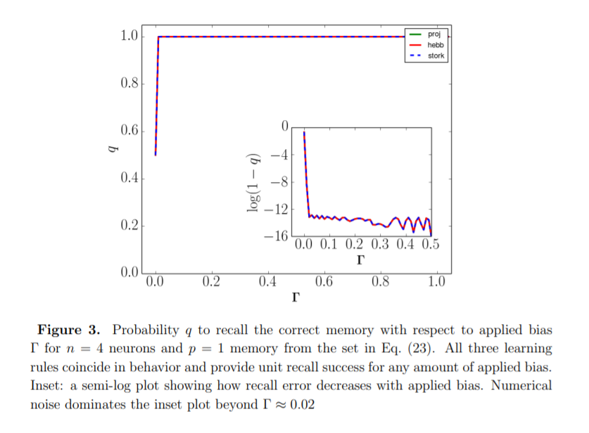
In the figure above there is only one memory stored in the network and any non-zero bias distinguishes between the memory and its complement.

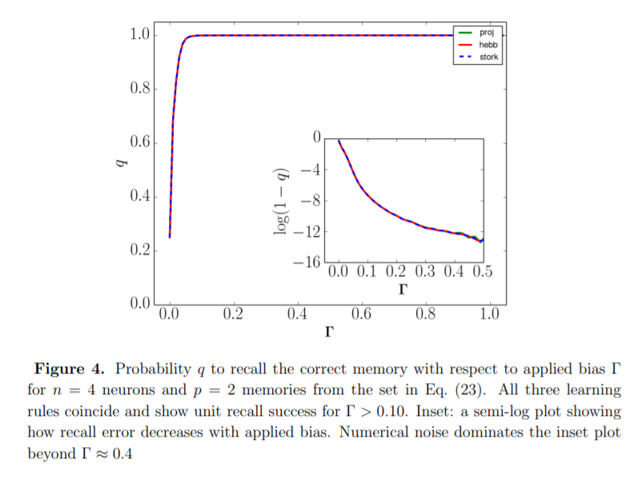
Similarly, all three rules behave the same for the case of two memory stored. This is because there are not significant energetic differences between the rules. The Hebb and Storkey rules coincide exactly, while the projection rule is identical only for the lowest energy eigenstate.

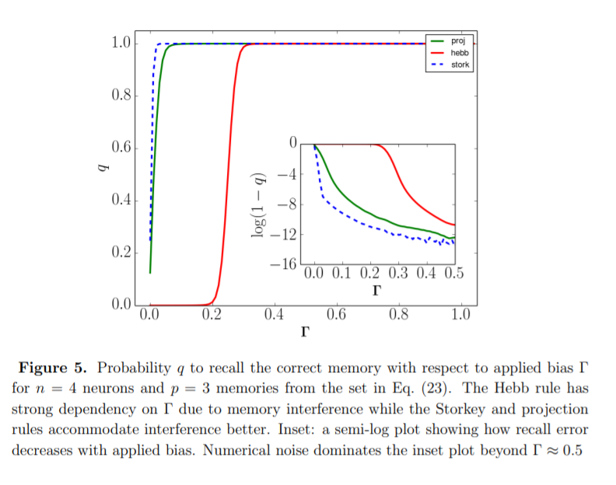
for the case of p = 3 there is a distinction between all three rules. the Hebb rule shows a shift to larger bias. This shift is due to the added memory creating an energy basin that is lower than the unbiased answer state. Larger bias must be applied to lower the answer state below that of the new memory. In contrast, the Storkey shifts to smaller bias because of memory addition. This is because the Storkey rule attempts to mitigate interference by using the local field calculation.

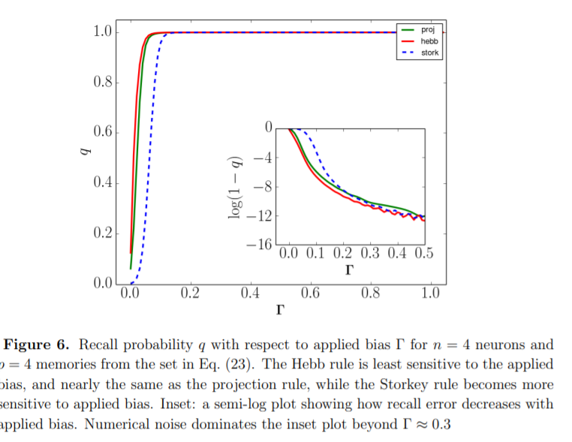
with the addition of another memory, p = 4, the Hebb rule becomes more evenly distributed in energy across the degenerate memory states while the Storkey rule shows a slight shift to larger bias and the projection rule again remains unchanged. The average success probability was used to eliminate dependency on pattern stored. They first investigate average AQO recall behavior with respect to the bias Γ. An ensemble of problem instances is constructed for n = 5 neurons in which each instance consists of p memories with elements sampled uniform random from {±1}. Among the p memories, one is selected as the answer state while all other memories are distinct from the answer state. The selected answer state is then chosen as the input state. This defines the activation threshold for some choice of Γ. The simulation computes the full quantum state using an annealing time T = 1000. The probability to occupy the expected answer state is then computed with a threshold x = 2/3. 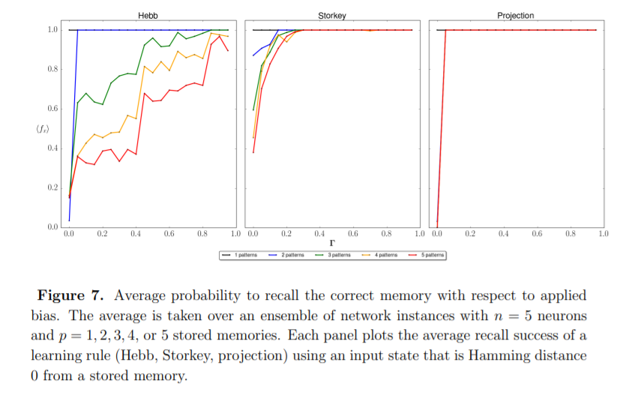
Figure above shows the average recall success for recovering the answer state as the bias Γ increases from 0 to 1. Each panel represents the results of a single learning rule, and each line represents a network storing p = 1, 2, 3, 4 or 5 memories. For the Hebb rule there is a stepwise decrease in success as the number of memories increases, indicating greater interference during recall. A much-weakened version of this dependency is seen for the Storkey rule at values of Γ below about 0.25. Above this threshold the Storkey rule recovers unit success for every memory set. The projection rule shows a complete lack of interference during recall. The better performance of both the Storkey and projection rules is a result of how they exploit correlations between memories. They also investigate AQO recall accuracy when a noisy input state is provided. They used procedure of previous tests but selecting one memory as the answer state while creating all other memories at least Hamming distance 2 away from this answer state. They select an input state that is Hamming distance 1 away from the answer state by randomly flipping a bit in the answer state. This construction ensures that the noisy input state is closest to the answer state.

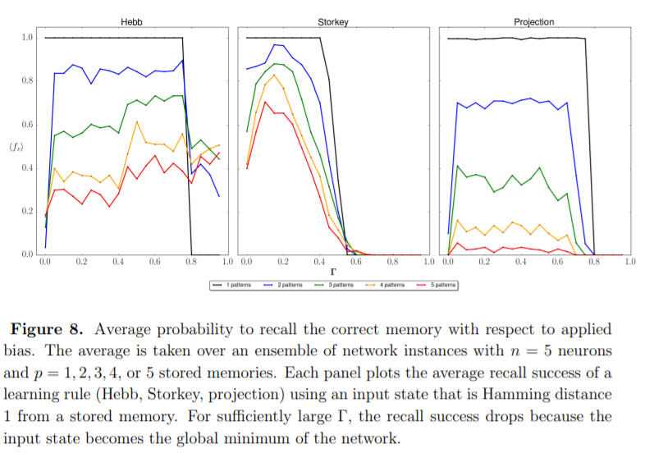
the recall success for the noisy input test is plotted with respect to Γ and number of memories for each learning rule. For the Hebb rule, there is again a stepwise decrease in recall success as the number of stored memories is increased. This behavior indicates that the energy basin representing the answer state is not narrow with respect to the Hamming distance between spin configurations. As the stored memories increase, there is a greater chance that the applied bias lowers the energy of non-answer states. As the bias Γ increases beyond about 0.75, the input state is over biased. The Storkey rule exhibits a different behavior with respect to noisy input. Recall accuracy again decreases with the addition of new memories but much weaker than was observed with the Hebb rule. The recall success also tends to vanish as the bias is increased. These differences underlie the fact that the Storkey rule distributes stored memories better than Hebb, such that an over-biased input is well separated from the expected answer state. Finally, they have investigated the role of the annealing time T on recall success. Because the state dynamics must be adiabatic relative to the minimum energy gap, the diversity of instances used are also likely to support a diversity of the minimal gap. This implies that there may be some maximum T for the ensemble which ensures every instance is quasi-adiabatic
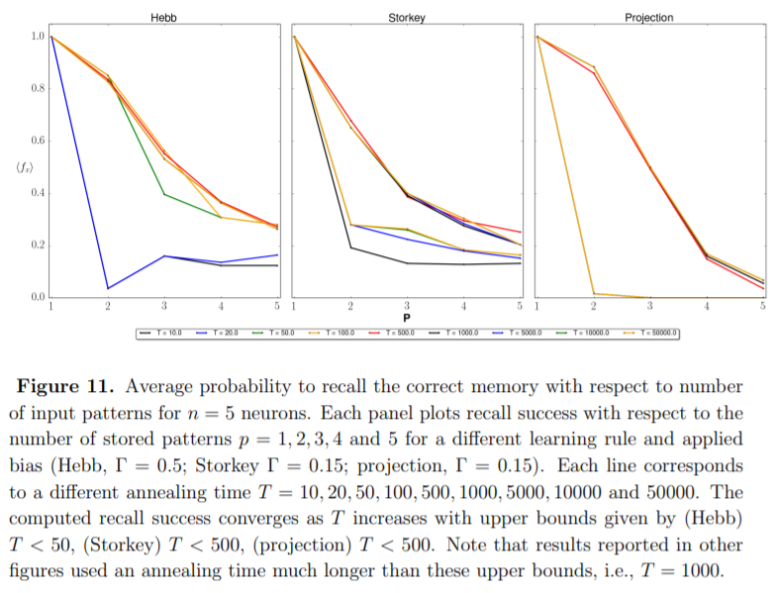
Above is showed a series of recall averages for different annealing times. For small values of T, the average success is low, especially as p approaches n. This suggests that many instances do not meet the x = 2/3 threshold for success. As T increases, the average success also increases but only up to a limit that depends on each learning rule. For the Storkey and projection rule, this limit is before T = 500, while for the Hebb rule the limit occurs before T = 50. Annealing times larger than these limits do not lead to significant changes in the average recall success (assuming a linear annealing schedule). Thus the annealing time is not the limiting factor in recall success and the adiabatic condition has been met for these problem instances. the shortest annealing time is found for the Hebb rule, but this rule also exhibits the most interference during memory recall. By contrast, the projection and Storkey rule require an order of magnitude increase in annealing time to ensure adiabaticity, but these rules also exhibit greater accuracy during memory recall. So, they demonstrate a significant dependence on the learning rule of the annealing time T. Energy basins prepared by the projection rule are known to be better separated than by either the Hebb or Storkey rules. Consequently, the projection rule provides the best performance with respect to AQO recall accuracy. However, better performance is not due to the avoidance of local minima but rather to the reduced interference between the stored memories and the biased input. Because the shape of the energy basins also influences the spectral gap of the time-dependent Hamiltonian, we anticipate that learning rules can provide a form of energetic control over AQO scaling.

This definition is in G.G. Rigatos, S.G. Tzafestas, Integrated Computer-Aided Engineering 14(3), 225 (2007) . is not generally shared but is useful for topic comprehension
like that presented in Ramsauer et al., Hopfield Networks is All You Need, 2021 (https://arxiv.org/abs/2008.02217)
This section and the reference contained are based on [25] unless otherwise noted
Berry,D.W., Childs, A.M., Kothari, R., Hamiltonian Simulation with nearly optimal dependence on all parameters
Wiebe, N., Kapoor, A., Svore, K. M., Quantum deep learning, 2016
Berry,D.W., Childs, A.M., Kothari, R.., Hamiltonian Simulation with nearly optimal dependence on all parameters
Moulin, N., Amara, M., Mandorlo, F., Lemiti, M., Tunnel Junction I (V) characteristics: Review and a new model for p-n homojunctions, 2019
Unless otherwise noted all images and reference come from [30]
All content inside the Appendix A and images exposed has as reference [Rojas, R., Neural Networks A Systematic Introduction, Springer (1996)] unless otherwise noted
This section is drawn from [30]

