Supporting information for

**Synergetic Effect of N3-, In3+ and Sn4+ ions in TiO2 towards Efficient Visible Photocatalysis**

Zijian Lana, Yanlong Yua, Sai Yana, Enjun Wangb, Jianghong Yao a* and Yaan Caoa*

a MOE Key Laboratory of Weak-Light Nonlinear Photonics, Ministry of Education, TEDA Applied Physics Institute and School of Physics, Nankai University, Tianjin 300457, China

b Hefei Institutes of Physical Science, Chinese Academy of Sciences, Hefei 230031, China

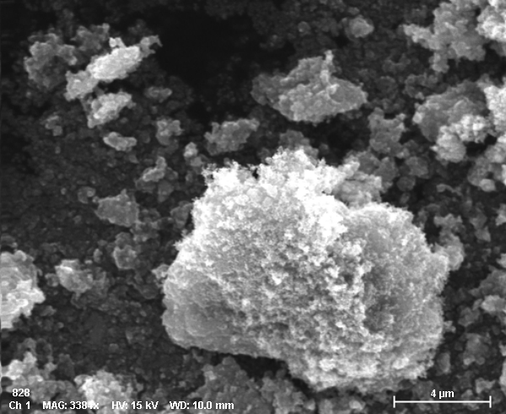

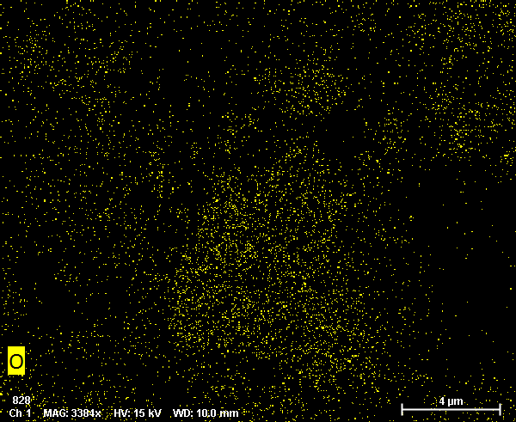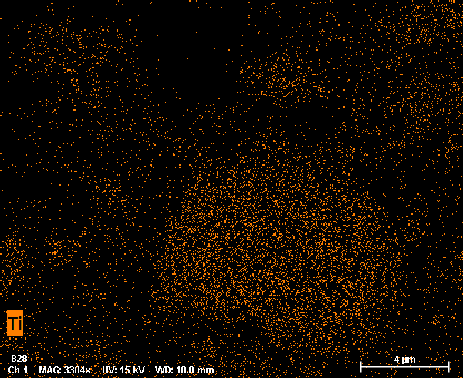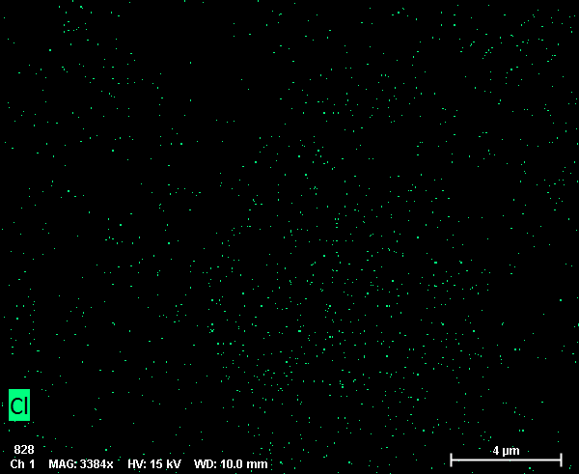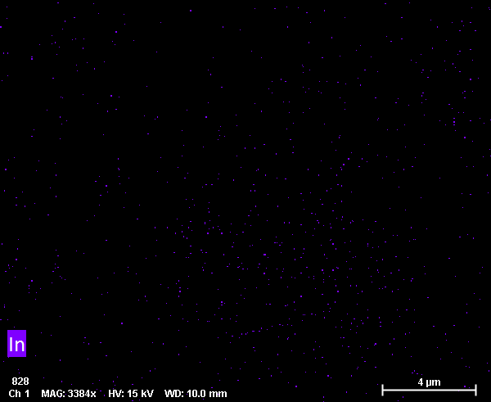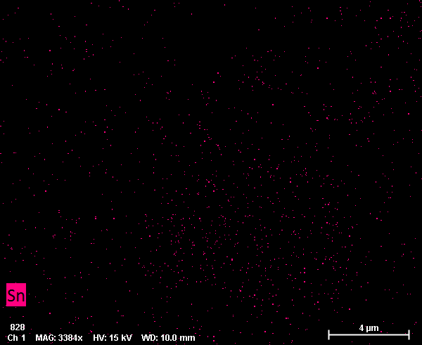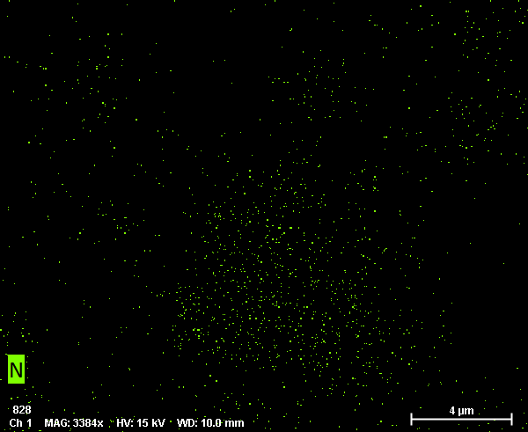

Fig.S1. SEM and elemental mapping of Ti, O, Cl, In, Sn and N for TiO2-N-In-Sn.

The morphology structure of TiO2-N-In-Sn samples are characterized by SEM and elemental mapping analyzer. Figure S1 shows the typical SEM image of the TiO2-N-In-Sn samples. The small nanoparticles agglomerate together to form microspheres with several micrometers in length. The elemental maps show that the TiO2-N-In-Sn samples were evenly composed of Ti and O elements, with a small amount of N, In, Cl and Sn.



Fig.S2. XPS Sn 3d, In 3d and N 1s spectra of TiO2-N-In-Sn after 0-4 min of 4keV Ar+ sputtering.

Although the Sn 3d signal decreased after 0-4 min of 4keV Ar+ sputtering, it becomes steady from 1 min to 4min, suggesting the Sn ions are doped into TiO2 lattice in substitutional mode. However, the peak intensity of In 3d decreases with the sputtering time from 1 min to 4min and the N 1s signal is almost completely removed after 1 min of etching. These suggest that the In and N are surface species on TiO2, which is in good agreement with discussion in main articles.