## 30 Useful Eclipse Keyboard Shortcuts for Java Programmers

Here is my list of 30 chosen Eclipse IDE keyboard shortcuts for Java developers. It's useful for both core Java developer and Java web application developer using Eclipse IDE for web development.

1)      **Ctrl + Shift + T** for finding class even from jar

This keyboard shortcut in Eclipse is my most used and favorite shortcut. While working with a high-speed trading system which has a complex code, I often need to find classes with the just blink of the eye and this eclipse keyboard shortcut is just made for that. No matter whether you have class in your application or inside any JAR, this shortcut will find it.

2)      **Ctrl + Shift + R**for finding any resource (file) including config xml files

This is similar to above *Eclipse shortcut* with only difference that it can find out not only Java files but any files including XML, configs, and many others, but this eclipse shortcut only finds files from your workspace and doesn’t dig at jar level.

3)      **Ctrl + 1**for quick fix

This is another beautiful Eclipse shortcut which can fix up any error for you in Eclipse. Whether it’s missing declaration, missing semi-colon or any import related error this eclipse shortcut will help you to quickly sort that out.

4)      **Ctrl + Shift + o** for organize imports

Another Eclipse keyboard shortcut for fixing missing imports. Particularly helpful if you copy some code from other file and what to import all dependencies.

### Eclipse Shortcut for Quick Navigation

In this section, we will see some eclipse keyboard shortcut which helps to quickly navigate within the file and between file while reading and writing code in Eclipse.

7) **Ctrl + o** for quick outline going quickly to method

9) **Alt + right**and **Alt + left** for going back and forth while editing.

12) **Alt + Shift + W**for show in package explorer

13) **Ctrl + Shift + Up**and down for navigating from member to member (variables and methods)

15) **Ctrl + k**and **Ctrl + Shift +K**for find next/previous

24) Go to a type declaration: **F3**, This Eclipse shortcut is very useful to see function definition very quickly.

### Eclipse Shortcut for Editing Code

These Eclipse shortcuts are very helpful for editing code in Eclipse.

5) **Ctrl + /**for commenting, uncommenting lines and blocks, see [here](http://javarevisited.blogspot.com/2012/10/eclipse-shortcut-to-remove-all-unused-imports-java.html) for live example.

6) **Ctrl + Shift + /** for commenting, uncommenting lines with block comment, see [here](http://javarevisited.blogspot.com/2012/12/eclipse-shortcut-to-comment-uncomment.html)for example.

8) Selecting class and pressing **F4** to see its Type hierarchy

10) **Ctrl + F4 or Ctrl + w** for closing current file

11) **Ctrl+Shirt+W for** closing all files.

14) **Ctrl + l**go to line

16) Select text and press **Ctrl + Shift + F** for formatting.

17) **Ctrl + F** for find, find/replace

18) **Ctrl + D** to delete a line

19) **Ctrl + Q** for going to last edited place

### Miscellaneous Eclipse Shortcuts

These are different *Eclipse keyboard shortcuts* which doesn’t fit on any category but quite helpful and make life very easy while working in Eclipse.

20) **Ctrl + T** for toggling between supertype and subtype

21) Go to other open editors: **Ctrl + E**.

22) Move to one problem (i.e.: error, warning) to the next (or previous) in a file: **Ctrl +.**For next, and Ctrl +, for the previous problem

23) Hop back and forth through the files you have visited: **Alt +**← **and Alt +**→**,** respectively.

25) **CTRL+Shift+G**, which searches the workspace for references to the selected method or variable

26) **Ctrl+Shift+L** to view listing for all Eclipse keyboard shortcuts.

27) **Alt + Shift + j**to add Javadoc at any place in java source file.

28) **CTRL+SHIFT+P**to find closing brace. Place the cursor at the opening brace and use this.

29) **Alt+Shift+X, Q**to run Ant build file using keyboard shortcuts in Eclipse.

30) **Ctrl + Shift +F** for Autoformatting.

Here is the nice image to remember these useful Eclipse shortcuts for Java programmers:

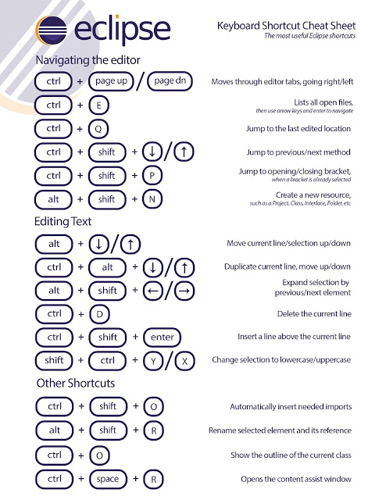

Read more: [http://javarevisited.blogspot.com/2010/10/eclipse-tutorial-most-useful-eclipse.html#ixzz4sYbfqpql](http://javarevisited.blogspot.com/2010/10/eclipse-tutorial-most-useful-eclipse.html" \l "ixzz4sYbfqpql)