REPORT

Step 1-3: I added the dataset to Workbench, I used the following query as seen below and export the csv file that I uploaded to github.

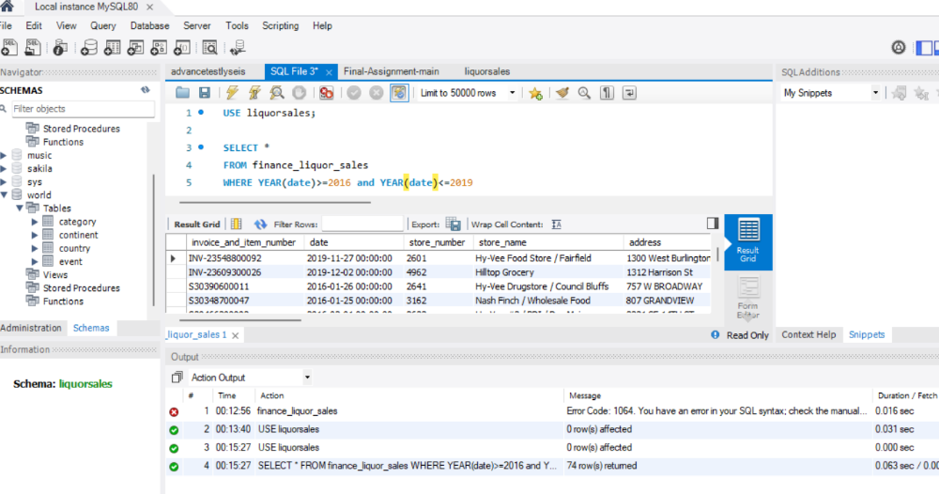
Step 4: I used Python and Pandas to Aggregate the CSV data so we can get the most popular item sold based on zip code and percentage of sales per store.
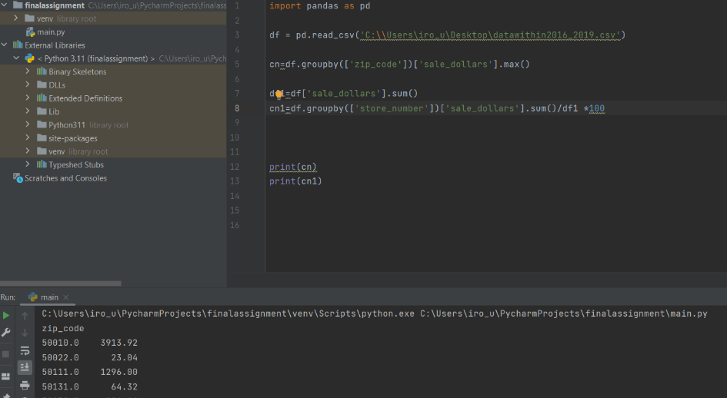
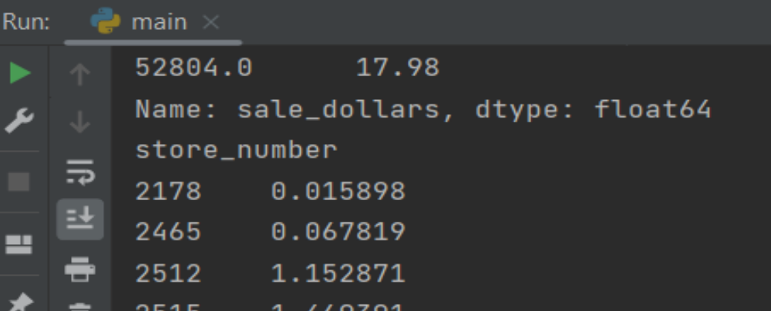
Step 5. I used Tableau in the new csv file to present Data and see the result below. I uploaded this in github.

Step 6. I didn’t face special difficulties. One difficulty was to learn how to run python in pycharm because I hadn’t done this before as all the exercises run in the platform that you provided to me.

