SMARTSPEND
AN EXPENSE TRACKER

Submitted by:
Name: Arhaan Kumar
Registration No.: 25BA10294
Course: B.Tech (CSE)
Year: 2nd Year

INTRODUCTION
SmartSpend – An Expense & Budget Management System is a Java-based console application designed to help students manage and monitor their daily expenses and monthly budgets.
The application allows users to record expenses by category, view and delete existing expenses, search for expenses, sort them by amount, set a monthly budget, check their budget status, and generate a spending report.
The project uses Object-Oriented Programming (OOP) concepts along with Java collections such as ArrayList and HashMap. It also uses file I/O to store expenses and budget information, ensuring the data remains available even after the application is closed.
The main goal of SmartSpend is to provide a simple, structured, and user-friendly solution for students to keep track of their spending and make better financial decisions.

Technologies Used
- Programming Language: Java
- IDE: Visual Studio Code
- Data Storage: CSV and TXT files
- Collections: ArrayList, HashMap
- Date Handling: Java LocalDate
- Concepts: OOP, Exception Handling, Input Validation, File Handling, Searching and Sorting

Problem Statement
People often make frequent small expenses on food, transportation, education, entertainment, shopping, and other daily activities. Without proper tracking, it can become difficult to know how much money has been spent, where it has been spent, and whether the monthly budget is being exceeded.
The SmartSpend – Student Expense & Budget Management System addresses this problem by providing a simple application for recording, organising, searching, and analysing personal expenses.
The system also allows students to set a monthly budget and check their current spending against it. Expense and budget data are stored in files so that the information is preserved between program sessions.
Scope of the Project
The project focuses on:
- Recording and managing student expenses.
- Categorising expenses.
- Searching and sorting expense records.
- Setting and monitoring a monthly budget.
- Generating a summary of spending.
- Storing expense and budget data using files.
Target Users
The primary target users are college and university students who want a simple way to track their personal expenses and manage their monthly budget.
Objectives
The main objectives of the SmartSpend – Student Expense & Budget Management System are:
- To record expenses with details such as amount, category, description, and date.
- To organise expenses into different categories such as Food, Transport, Education, Shopping, and Entertainment.
- To provide expense management through viewing, searching, sorting, and deleting records.
- To allow budget management by setting a monthly spending limit.
- To monitor budget usage and provide warnings when spending reaches a significant portion of the budget.
- To generate spending reports showing total expenditure and category-wise spending.
- To store data persistently using CSV and text files so that records are available when the application is reopened.
- To demonstrate Java programming concepts such as OOP, collections, file handling, exception handling, validation, searching, and sorting.

Functional Requirements
The SmartSpend system shall provide the following functional requirements:
FR1 — Add Expense
The system shall allow the user to enter and store:
- Expense ID
- Amount
- Category
- Description
- Date
FR2 — View Expenses
The system shall display all previously recorded expenses with their complete details.
FR3 — Delete Expense
The system shall allow the user to delete an expense using its unique ID.
FR4 — Search Expenses
The system shall allow users to search expenses:
- By category
- By date
FR5 — Sort Expenses
The system shall allow expenses to be sorted according to their amount in descending order.
FR6 — Set Monthly Budget
The system shall allow the user to enter and save a monthly spending budget.
FR7 — Check Budget Status
The system shall calculate the amount spent and remaining budget and provide a warning when spending reaches or exceeds defined budget levels.
FR8 — Generate Spending Report
The system shall generate a report containing:
- Total spending
- Category-wise spending
- Highest expense
FR9 — Data Persistence
The system shall save expenses and budget information to files and load the saved information when the application starts.
FR10 — Input Validation
The system shall validate user input and handle invalid values such as negative amounts, invalid IDs, empty descriptions, and invalid dates.

Non-Functional Requirements
NFR1 — Usability
The application should provide a simple and easy-to-understand console interface so that students can use it without extensive technical knowledge.
NFR2 — Reliability
The system should handle invalid inputs and file-related errors without unexpectedly terminating the application.
NFR3 — Performance
The system should perform common operations such as adding, searching, sorting, and viewing expenses efficiently.
NFR4 — Maintainability
The program should use separate classes and modular components so that individual features can be easily modified or extended.
NFR5 — Data Persistence
Expense and budget information should remain available after the application is closed and restarted.
NFR6 — Security & Data Integrity
The system should validate user inputs and prevent invalid expense amounts, IDs, descriptions, and other incorrect values from being stored.
NFR7 — Portability
The application should be able to run on systems that have a compatible Java Development Kit (JDK) installed.

System Design & Architecture
6.1 System Architecture
SmartSpend follows a modular, class-based architecture in which different responsibilities are handled by separate Java classes.
The main components of the system are:
- Main.java – Controls the application flow and provides the console menu.
- Expense.java – Represents an individual expense using its ID, amount, category, description, and date.
- Category.java – Defines the available expense categories.
- ExpenseManager.java – Handles adding, viewing, deleting, searching, sorting, and calculating expenses.
- BudgetManager.java – Handles monthly budget setting, remaining budget calculation, and budget-status checking.
- ReportGenerator.java – Generates spending summaries and category-wise reports.
- FileManager.java – Saves and loads expenses and budget information from files.
- InputValidator.java – Validates user input and prevents invalid data.
6.2 Working Flow
The general workflow of the application is:
Start → Load Saved Data → Display Menu → Select Operation → Validate Input → Perform Operation → Save Data if Required → Display Result → Return to Menu → Exit
The system loads previously saved expenses and budget information when it starts. The user can then select an operation from the menu. After completing an operation, the result is displayed and the user can continue using another feature or exit the application.
6.3 Data Storage
SmartSpend uses simple file-based storage:
data/expenses.csv
Stores expense records containing:
ID, Amount, Category, Description, Date
data/budget.txt
Stores the user's monthly budget.
This approach provides data persistence without requiring a separate database.
6.4 Design Approach
The project uses Object-Oriented Programming principles by dividing the application into independent classes with specific responsibilities. This makes the code easier to understand, test, maintain, and extend.

Design Rationale
7.1 Modular Design
The application is divided into multiple classes, with each class responsible for a specific task. This avoids putting all functionality into a single class and makes the program easier to understand and modify.
7.2 Object-Oriented Design
The Expense class represents an individual expense as an object. Other classes manage expenses, budgets, reports, files, and validation. This demonstrates the use of classes, objects, encapsulation, and abstraction.
7.3 Use of Collections
An ArrayList is used to store multiple expense objects dynamically. A HashMap is used in report generation to calculate category-wise spending.
7.4 File-Based Storage
CSV and TXT files were selected for storage because the project is a lightweight console application and does not require the complexity of a database. This also demonstrates Java file-handling concepts.
7.5 Input Validation
A separate InputValidator class handles validation of important inputs. This improves reliability and prevents invalid values from being processed.

Implementation
8.1 Implementation Modules
1. Expense Management
The Expense class stores the details of an expense, including ID, amount, category, description, and date.
The ExpenseManager class provides operations to:
- Add expenses
- View expenses
- Delete expenses
- Search expenses
- Sort expenses
- Calculate total spending
- Find the highest expense
2. Budget Management
The BudgetManager class manages the user's monthly budget. It calculates the remaining budget and percentage of the budget already used. It also provides warnings when spending reaches important budget levels.
3. Report Generation
The ReportGenerator class analyzes stored expenses and generates a spending report containing total expenditure, category-wise expenditure, and the highest expense.
4. File Management
The FileManager class provides persistent storage using:
- expenses.csv for expense records
- budget.txt for the monthly budget
Data is loaded when the application starts and saved when relevant changes are made.
5. Input Validation
The InputValidator class checks whether values such as expense amounts, budgets, IDs, descriptions, and menu choices are valid.
6. User Interface
Main.java provides the console-based menu through which the user interacts with all the application features.
8.2 Java Concepts Used
The implementation demonstrates:
- Classes and Objects
- Encapsulation
- Enum
- ArrayList
- HashMap
- File Handling
- Exception Handling
- Input Validation
- LocalDate
- Searching
- Sorting
8.3 Project Structure
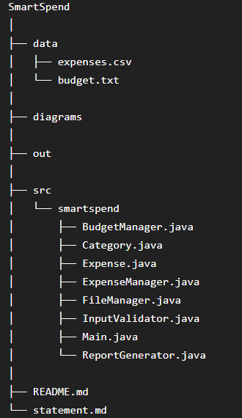

Screenshots & Results
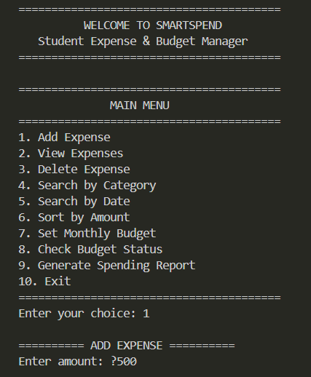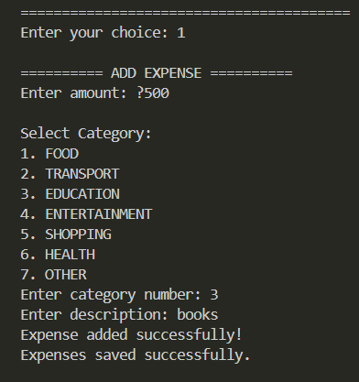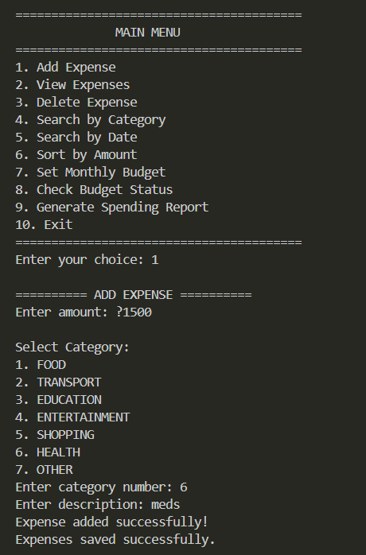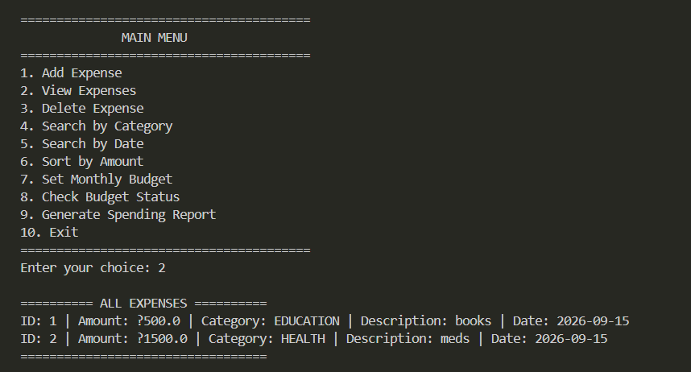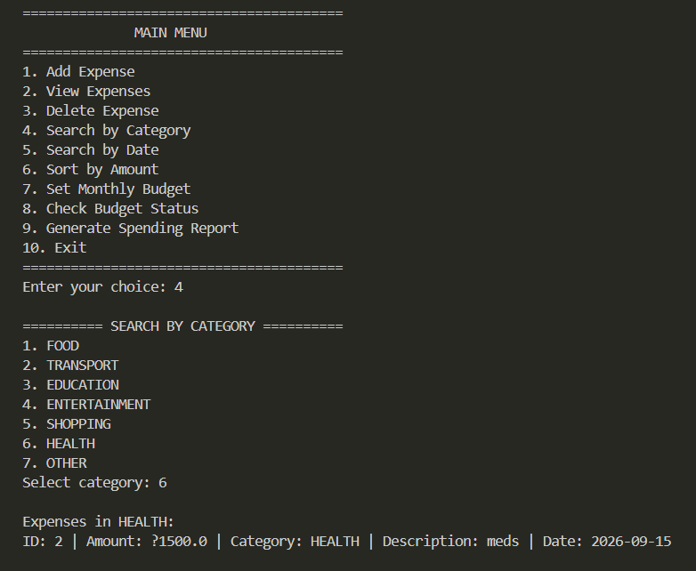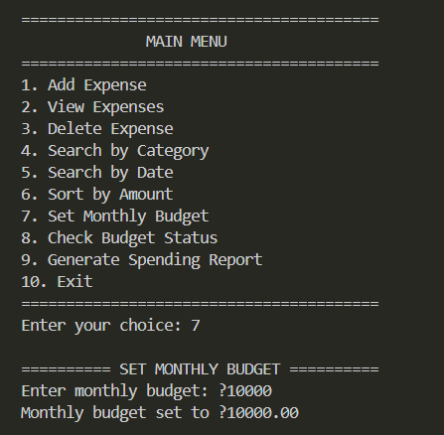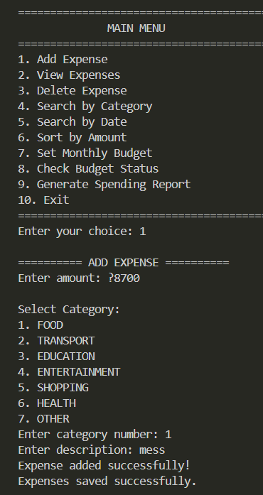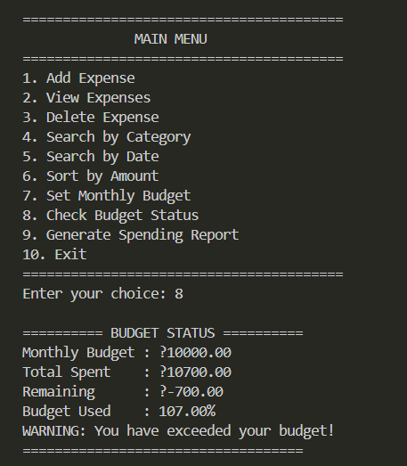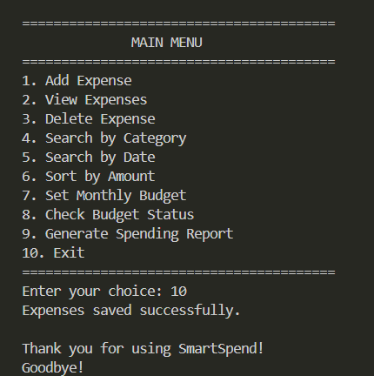

Challenges Faced
10.1 Input Validation
Handling incorrect user input such as negative amounts, invalid IDs, empty descriptions, and invalid menu choices required proper validation. A separate InputValidator class was implemented to handle these cases.
10.2 File Handling
Saving and loading expense data using CSV files required careful handling of file reading, writing, and parsing. Exception handling was added to prevent the application from terminating unexpectedly when a file-related problem occurs.
10.3 Data Persistence
Ensuring that expenses and budget information remained available after restarting the application was another challenge. The FileManager class was used to save and reload the required data.
10.4 Searching and Sorting
Implementing category/date-based searching and amount-based sorting required appropriate use of Java collections and comparators.
10.5 Maintaining Modular Code
As more features were added, keeping the code organized became important. Different responsibilities were separated into individual classes such as ExpenseManager, BudgetManager, ReportGenerator, and FileManager.

Learnings
12.1 Technical Learnings
- Gained practical understanding of Object-Oriented Programming (OOP).
- Learned how to divide a large application into independent and reusable classes.
- Improved understanding of Java ArrayList, HashMap, Enum, and Comparator.
- Learned to work with dates using LocalDate.
- Improved knowledge of exception handling and input validation.
- Learned to implement searching and sorting operations.
12.2 Software Development Learnings
- Learned the importance of modular programming.
- Understood how to identify and fix compilation and runtime errors.
- Learned the importance of testing both valid and invalid inputs.
- Gained experience in documenting a software project using README.md and statement.md.

12.3 Overall Learning
The project helped connect theoretical Java concepts with a practical real-world application. It also improved problem-solving, debugging, program organization, and software development skills.
Future Enhancements
The current version of SmartSpend provides the core features required for expense and budget management. The following improvements can be added in future versions:
- Graphical User Interface (GUI)
Replace the console interface with a Java Swing or JavaFX-based GUI for a more user-friendly experience.
- Expense Editing
Add an option to modify the amount, category, description, or date of an existing expense.
- Advanced Reports
Add monthly and yearly reports along with graphical representations of spending patterns.
- Budget Categories
Allow users to set separate budgets for categories such as food, transport, and entertainment.
- User Accounts
Add login and user-account functionality so that multiple users can maintain separate expense records.
- Export Reports
Allow users to export spending reports in formats such as PDF or Excel.
- Notifications and Alerts
Provide automatic notifications when spending approaches or exceeds the monthly budget.

References
- Oracle Java Documentation — Java language, classes, collections, file handling, exception handling, and LocalDate.
- Oracle Java Tutorials — Object-Oriented Programming and Java programming concepts.
- Visual Studio Code Documentation — Development environment and Java project setup.
- Project Assignment/Instruction Document — Requirements and evaluation criteria provided for the project.
- Java Development Kit (JDK) — Used to compile and execute the application.
References Used During Development
- Java documentation for ArrayList, HashMap, Comparator, LocalDate, file handling, and exception handling.
- Course/project instructions provided by the instructor.
- Development and testing performed using Visual Studio Code and JDK.

