Pathnoding // Desert Fox

Introduction
This tutorial explains the basics of pathnoding as well as some advanced techinques. If your just a beginner, or someone who has pathnodes and wants to know more about them, you should read this. I assume that you have a level (Hopefully a good one) and a basic idea of the paths your bots are going to take through the level. You should also know how to use the classes menu, and know how to use the editor (Duh...)

Basic Pathing
Ok, lets just start saying that you want a bot to move through a simple, strait hallway-for simplicity purposes. Go to the classes menu. Open "Actor->NavigationPoint->Pathnode". Select "Pathnode". These are the basic elements of bot-support in your level. You add them in the 3D view of your level in the path you want your bots to take. Don't put them too close together, or bots will get confused and run back and forth and inbetween them, causing them to get "stuck" at that point in the level. Don't place them too far apart because they will not connect to each other that way and your bots will not use the hallway. I have taken a picture from my level CTF-Castles to show you an example of pathnoding in a simple hallway.
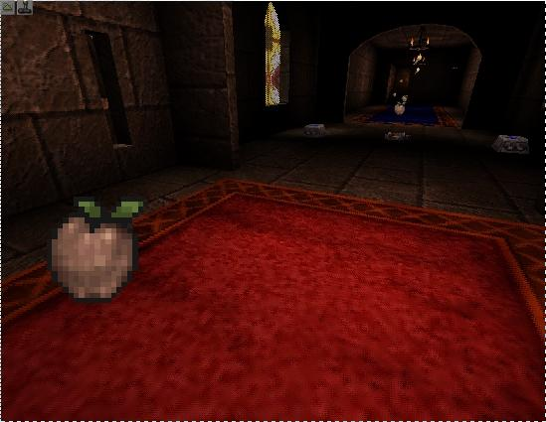 | Here is what your hall should look like with pathnodes added to it so far. Open the menu at the top of your 3D view. If its not there, hit the little green arrow in the upper left hand corner. Select the "View" menu. From it choose "Show Paths". Nothing will happen yet, but it will in a second. Now go into the rebuilder (hit F8). Select the lighting tab. You will notice a button that says "Paths Define". Hit this button, it will connect your pathnodes. It shouldn't take long. When its done, you will notice a blue, or red line going in-between your pathnodes. If you did everything right, it should look like the picture below.
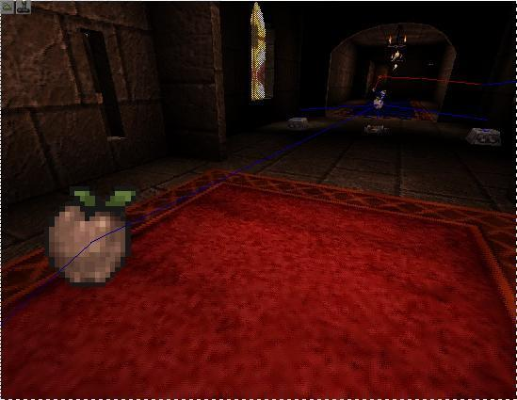 | You will notice that some paths may be red. This really isn't THAT big of a problem. Bots will move along blue and red paths, but they prefer to use the blue ones. Try moving obstructions out of the way, although, don't completely change your level around because you got a red path. If some of the paths are connected in the wrong order than try moving them farther apart. Example: You have three pathnodes, they are all connected to each other in a triangle formation, but they are supposed to be a one way line. Just move them apart. In some cases, you won't be able to do this, don't worry about them either. Once the bot runs in a circle once, the computer will figure out that its not supposed to do this and correct its self. If you have inventory items like I do here, you will notice lines going from the pathnode to a spot just above the items. This is normal as well. All inventory items (weapons, ammo, powerups, health) have a navigationpoint property so that the bots know to go to them even if you don't have pthatnodes right on top of them. Which brings me to another thing. Try not to put pathnodes too close to items. Bots sometimes get stuck on them. What I did in this picture is a sin in level design, but it didn't pose any problems for me, so I just left it.
And that my friends, is how you do basic pathnoding. I do have a few more notes I would like to add. When placing pathnodes, they must have a line of site to each other. In other words, they have to see each other. Pathnodes can see through anything that you can see through in the normal game, so making them go through zone-barriers wont pose a problem. Rebuild your level, and test it out! But now, I would like to get into some of the more advanced pathing methods.

Advanced Pathing
Advanced pathing is just as simple as basic pathing, only more complicated. There are several nifty things you will be able to use to make your level better. These are all under "Actor->NavigationPoint->...".
AlternatePath: This is used in conjunction with normal pathnodes to make the bot change his path randomly at an intersection. Say you have a CTF level and there is a fork in the road at one place. You want the bot to randomly decide which way to go. Take an AlternatePath, and place it on the first path point on each fork of the main road. If this confuses you, do this. Hold up your hand. Yeah you heard me. Say you have one pathnode in the palm of your hand, and the road forks into each of your fingers. You would place one AlternatePath at the base of each finger, and then add normal PathNodes all the way to the end of each finger, or wherever they might lead to. Get it? Good.
AmbushPoint: This you can place at any strategic point in your level where you would want a bot to wait for an enemy and then chase them when they come by. Easy huh? Say you want a sniper point. Just open the AmbushPoint's advanced properties and open the AmbushPoint heirarchy. Set the "bSniping" property to "True". This will make it so the player does not run after a target when it is spotted. They will stay there and shoot from afar.
DefensePoint: Same as above, only used primarily for defense purposes in Assault levels. If you open the "DefensePoint" heirarchy in the advanced properties menu, you will see a few assault related tags. The "FortTag" is the tag name of the fort that this defense point is defending. The "DefensePriorety" tag shows which is more important to defend. The one with the higher value here will be defended more importantly than the one with the lower value. If you didn't understand any of that, than you might want to read our Assault Level tutorial if you are planning on making those types of levels.
Thats about all I'm going to put in this tutorial about Pathnoding. Have fun making lots and lots of bot-support!

