“PREDICTING THE BULLWHIP EFFECT IN A 4-STAGE SUPPLY CHAIN MODEL USING MACHINE LEARNING”
A DISSERTATION
SUBMITTED IN PARTIAL FULFILLMENT OF THE REQUIREMENTS
FOR THE AWARD OF DEGREE
OF
BACHELOR OF TECHNOLOGY
IN
MECHANICAL ENGINEERING

Submitted by:
Abhinav Dikshit (2K17/ME/008)
Abhirup Poddar (2K17/ME/009)
Arham Anwar (2K17/ME/059)

Under the supervision of
Dr. Girish Kumar

Mechanical Department
DELHI TECHNOLOGICAL UNIVERSITY
(Formerly Delhi College of Engineering)
Bawana Road, Delhi 110042

JUNE 2021

CANDIDATE’S DECLARATION
We, Abhinav Dikshit (2K17/ME/008), Abhirup Poddar (2K17/ME/009), Arham Anwar (2K17/ME/059), students of B.Tech (Mechanical Engineering), hereby certify that the work which is presented in the Major Project entitled “Predicting the bullwhip effect in a 4-Stage supply chain model using machine learning” in fulfilment of the requirement for the award of the Degree of Bachelor of Technology in Mechanical Engineering and submitted to the Department of Mechanical Department, Delhi Technological University, Delhi is an authentic record of our own, under the supervision of Dr. Girish Kumar. The matter presented in this report has not been submitted by us for the award of any other degree of this or any other Institute/University. The work has been accepter in a Scopus indexed journal with the following details:

Title of the Paper: Predicting the bullwhip effect in a 4-Stage supply chain model using machine learning
Author names (in sequence as per research paper): Girish Kumar, Abhirup Poddar, Abhinav Dikshit, Arham Anwar
Name of Conference: 3^{rd.} International conference on Advances in Management and Technological innovations Impacting Industries, 19th-21th of March, 2021, Allahabad, India

Status of paper: Accepted

ABHINAV DIKSHIT
Date of paper communication: 15 March 2021

Date of paper acceptance: 8 April 2021

ABHIRUP PODDAR
Date of paper conference: 21 April 2021
Place: Delhi

Date: 30 May 2021

ARHAM ANWAR

SUPERVISOR CERTIFICATE

To the best of my knowledge, the above work has not been submitted in part or full for any Degree or Diploma to this University or elsewhere. I, further certify that the publication and indexing information given by the students is correct.

Place: Delhi

DR. GIRISH KUMAR
Date: 31 May 2021

SUPERVISOR Associate Professor, Department of Mechanical Engineering Delhi Technological University, Bawana Road, Delhi-110042

ABSTRACT
For organisations to keep up with the increasing demand, the supply chain requires efficiency. However, due to the unpredictable nature of demand, the bullwhip effect is a highly prominent in all industries. The role of AI and machine learning has been investigated in managing the risk which is accompanied by the bullwhip. The purpose of this study is to determine the effectiveness of various machine learning models in the prediction of the bullwhip effect. A 4-stage supply chain model was used to predict the value of bullwhip observed. The bullwhip effect was predicted using the linear regression, KNN and MLP-Regressor based on variables - Demand, Receive, Forecast, Net stock, Lead-Time-Delivery, Safety Stock, Order-up-to-Level, Order and cost. The results provide us with a benchmark to understand the performance of these algorithms to predict the bullwhip effect and can further help fast moving consumer goods firms prevent shortages or overproduction of stocks.
Keywords: Bullwhip Effect, KNN algorithm, NLP Algorithm, Supply Chain, Risk Management

ACKNOWLEDGEMENT
We wish to express our sincerest gratitude to Dr. Girish Kumar for his continuous guidance and mentor-ship that he provided us during the project. He showed us the path to achieve our targets by explaining all the tasks to be done and explained to us the importance of this project as well as its industrial relevance. He was always ready to help us and clear our doubts regarding any hurdles in this project. Without his constant support and motivation, this project would not have been successful.

ABHINAV DIKSHIT

ABHIRUP PODDAR
Place: Delhi
Date: 30 May 2021

ARHAM ANWAR

LIST OF TABLES
Table 3.1 Variables in Supply Chain Model
Table 4.1 Basic statistical details like percentile, mean, standard deviation etc. of the dataset
Table 4.2 First few rows of the dataset
Table 4.3 Dataset after processing and scaling the data points
Table 5.1: Accuracies for applied machine learning algorithms

LIST OF FIGURES
Figure 1.1: The bullwhip effect in a supply chain: Sterman (1989)
Figure 3.1 Basic 4 stage supply chain model
Figure 3.1 Service level in normal distribution
Figure 3.2 Dataset after processing and scaling the data point
Figure 3.3 Demand Signal at various levels of supply chain
Figure 3.4 Basic statistical details of the dataset
Figure 3.5 First few rows of the dataset
Figure 3.6 Data processing
Figure 3.7 Dataset after processing and scaling the data point
Figure 4.1 Demand Signal at various levels of supply chain
Figure 4.2 Exploring the data for missing points
Figure 5.1: Correlation Matrix between the 9 Input variables and the output Bullwhip

LIST OF SYMBOLS, ABBREVIATIONS AND NOMENCLATURE
AI – Artificial Intelligence
KNN – K-Nearest Neighbours
L – Lead Time
LTD – Lead Time Demand
MLP – Multi Layer Perceptron
NLP – Non-linear programming
NS – Net Stock
O – Order
OUT – Order Upto Level
SS - Safety Stock
σ – Standard Deviation
Z – Safety Factor

CONTENTS

- Candidate’s Declaration i
- Certificate ii
- Abstract iii
- Acknowledgement v
- List of Tables vi
- List of Figures vii
- List of Symbols, Abbreviations and Nomenclature x
- Contents xi
- CHAPTER 1 INTRODUCTION 1
  - What is Bullwhip Effect? 1
  - Motivation 2
  - Organisation of Report 3
- CHAPTER 2 LITERATURE REVIEW 4
2.1 Bullwhip Effect 4
2.2 Causes of the bullwhip effect 4
2.3 AI in bullwhip effect 5
2.4 Research gaps 6
2.5 Research objectives 6
- CHAPTER 2 MODELLING BULLWHIP 8
3.1 Ways of measuring bullwhip 8
3.1.1 Operations research theory 8
3.1.2 Filler theory 8
3.1.3 Ad-hocacy 8
3.1.4 Control theory 8
3.2 Four stage supply chain simulation 9
3.2.1 Simple 4-stage supply chain 9
3.2.2 Calculations for the dataset generation 10
4. CHAPTER 4 AI ON VIRTUAL DATA SET 12
4.1 Data preparation 12
4.2 Data exploration 12
4.3 Data cleaning 12
4.4 Data processing 12
4.5 Machine learning algorithms employed 15
4.5.1 KNN 15
4.5.2 Decision tree regressor 15
4.5.3 Multilayer perceptron 15
5. CHAPTER 5 RESULTS 17
5.1 Results 17
6. CHAPTER 6 CONCLUSION AND FUTURE SCOPE 19
6.1 Conclusion 19
6.2 Future Scope 19
7. APPENDIX 20
8. REFERENCES 23
9. LIST OF PUBLICATIONS 27
10. SIMILARITY REPORT 30

CHAPTER 1: INTRODUCTION
This chapter gives a brief introduction to the bullwhip effect and its origins. It also explains why it is important to study and predict this phenomenon. Also, the proposed work has been briefly described, along with the motivation of the authors behind this work. Lastly, the structure of this dissertation is briefly mentioned.
  - WHAT IS BULLWHIP EFFECT?
Bullwhip effect is a phenomenon observed in the supply chains whenever there is fluctuation in the demand of a commodity. As the fluctuations in the demand increase, the demand forecasting methods give inaccurate results to the upstream members of the supply chain. This erroneous forecasting causes upstream stages of supply chain to either underestimate or overestimate the demand and subsequently maintain inventory levels that are very high and very low. The fluctuations in the inventories, due to very high or very low demands, are progressively amplified as we move upstream in the supply chain. This progressive amplification of the “fluctuations”, or more accurately variance, in the inventory level of upstream members of the supply chain due to fluctuations in the customer demand is called the bullwhip effect. This effect is certainly undesirable due to its negative effect on the inventory costs and extra load that it puts on a supply chain.
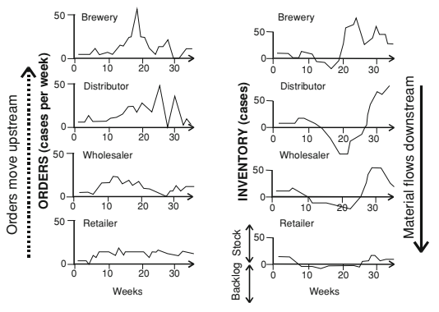
This effect was first observed by Jay Forrester in 1961. Later in the 90s, this effect became apparent in the supply chains of Proctor and Gamble (P&G) and Hewlett-Packard. The term bullwhip was also coined at this moment only.

Figure 1.1: The bullwhip effect in a supply chain: Sterman (1989)
1.2 MOTIVATION
With the arrival of the coronavirus pandemic, organisations around the world suffered a major decrease in demand. The world moved into a recession (World Bank, 2021). Organisations realised the importance of having a lean system in order to prevent losses. The supply chains of various industries are moving towards a more resilient and lean structure. However, the threat posed by the bullwhip effect to a lean supply chain still looms large as information sharing is not viable in the highly competitive economies, moreover, poor demand forecasting methods contribute substantially to the bullwhip effect. (Prakash et al 2014) Implementation of artificial intelligence techniques in the supply chains of various industries can help forecast the demand with a higher accuracy and prevent the demand amplification phenomenon. (Amin et al 2008) These works are the basis of current research as use of AI algorithms in predicting the bullwhip effect has been explored in the current project.
This project aims to model a 4 stage supply chain using the principles laid down by Forrester (1961) and Sternman’s beer game (1983). Using this model, the demand amplification is modelled using the variables such as Demand, Receive, Forecast, Net stock, Lead Time Delivery Safety Stock, Order up to Level, Order and cost. Consequently, three artificial intelligence algorithms would be implemented on the dataset generated, to see which algorithm can predict the value of bullwhip effect accurately. The algorithms would then be compared based on the accuracy they offer.
The system dynamics model laid down by Forrester in 1961 for the supply chain gives us a highly correlated dataset. The values of the variables are derived from one another. Consequently, certain algorithms would perform better at predicting the bullwhip effect than the rest as they are able to deal with multi-collinearity in a better manner. The paper compares Decision Tree Regressor, MLP regressor and KNN algorithms and their ability to predict the bullwhip effectively.
The paper further investigates whether algorithms which deal with multi-collinearity can better predict the bullwhip effect than those which are simple regressors.

1.3 ORGANISATION OF THE REPORT
Chapter 2 offers a concise summary of the effect of bullwhip effect and the correlation between bullwhip and various variables. We continue to explain the 4 stage supply chain model and simulation and lastly, we explain how to measure the bullwhip effect.
Chapter 3 introduces Ways to measure bullwhip and describes the 4 stage supply chain model used to generate the data for analysis.
Chapter 4 illustrates the process of Data Collection for this project applicability for SCRM within a virtual-world supply chain. Then, this chapter also presents various machine learning algorithms used and their advantages and disadvantages. It also talks about the Research methodology. The algorithms used were
• Linear Regression
• KNN
• MLP Regressor
The results are discussed in Chapter 5. Finally, Chapter 6 illustrates the conclusions of the project.

CHAPTER 2: LITERATURE REVIEW
2.1 BULLWHIP EFFECT
Supply Chain management is defined as the strategic, systematic and coordination of business functions and the tactics followed between these functional groups, both within and across companies (Mentzer et al., 2012). The long term performance of individual companies and the entire supply chain is improved. One of the major problems faced in a supply chain is the undulating demand. The demand causes irregular movement of goods making it harder to accurately forecast sales, manage inventory and reduce service levels (Zotteri G, 2013). These fluctuations are known as the Bullwhip Effect. It was first studied by Forrester in 1958. It is observed when the variations in demand orders amplify and move across the supply from a local retailer to a large scale manufacturer (Forrester, 1958). The impact of the bullwhip effect is extremely detrimental to any organisation. Extensive research has been conducted to reduce the Bullwhip effect using methods such as Forecasting and Replenishment, Vendor Managed Inventory, Collaborative Planning etc. (Li et al 2013, Jaipuria et al 2014, Hussain et al 2012, Bhattacharya et al. 2011, Ciancimino et al 2012). Even though there have been major advancements in Information and Communication Technology. The Bullwhip effect still haunts the supply chain.
2.2 CAUSES OF THE BULLWHIP EFFECT
Significant effort has been put in research to find the underlying causes of this effect. Based on the literature, the main causes behind the bullwhip effect can be divided into two major categories namely behavioural and operational causes (Udenio et al., 2017). Behavioural (or psychological) causes include all the causes that arise due to improper decision made by humans responsible for running the supply chain. This can be due to various reasons such as lack of cognitive capability of the individual or stressful work atmosphere (Yang et al., 2021) Mostly, over or underestimation of the supply or demand capabilities is the underlying cause under this category. (Udenio et al., 2017)
The operational reasons for the bullwhip are mentioned below,
- Amplification of demand order variation (Lee et al 1997)
- Lack of coordination between stakeholders in the supply chain (Bhattacharya et al 2011)
- Lack of transparent information sharing (Bhattacharya et al 2011)
- Excess inventories throughout the supply chain to avoid stockout (Suki 2009)
- Inventory Stock-outs (Sun et al 2005)
The operational bullwhip effect can be addressed directly using various techniques. One of the techniques is Improved information sharing between the various stages of the supply chain. The amplification of demand order-variation occurs across the supply chain because of distortion, concealment and minimal sharing of information. The information regarding end user demand is used by the downstream members of the supply chain to estimate the inventory information. When inventory is accumulated, the inventory holding costs increase and chances of inventory obsolescence increase. (Li et al 2013)
Improved demand forecasting is another technique used to reduce the operational bullwhip effect. All the stakeholders of the supply chain can accurately align their production process with customer demand. Moreover, the accurate customer demand predictions can smoothen the fluctuations over time. (Disney et al 2003)
The operational bullwhip effect can be reduced when all organisation in the supply chain implement a robust replenishment policy. The BWE can be controlled with a policy which is devised with the collaboration of all stakeholders and free and open information sharing. (Kim et al 2010)
Lastly, operational bullwhip effects can be reduced by reducing the lead time between the stakeholders of a supply chain, and reduction of lead time. The product availability increases, excess stock decreases. The decision making process is optimised and the overall bullwhip effect decreases. (Li et al 2013)

2.3 ARTIFICIAL INTELLIGENCE AND THE BULLWHIP EFFECT
Prakash et al, 2014 suggested the integration of artificial intelligence in the supply chain to mitigate the bullwhip effect by directly monitoring the demand forecasting and order batching with the aid of machine learning algorithms. Prakash et al, 2014. Implemented artificial neural network in mitigating the bullwhip and compared the results with conventional forecasting methods, wherein artificial neural networks was found to significantly outperform the conventional forecasting methods, which further suggests the idea of exploring other machine learning algorithms for mitigating the bullwhip effect.
Donnel et al, 2006, proved in his study that the bullwhip effect can be significantly mitigated by integrating genetic algorithm by applying it to a beer distribution game, suggesting the capabilities of genetic algorithm to optimally determine order policy when facing irregular demand and lead time. Since genetic algorithm has the capability to find the optimal ordering policy for each member of the supply chain, it solves the problem of sales promotions which poses as one of the major problems associated with the bullwhip effect.

2.4 RESEARCH GAPS
After extensive literature review, we concluded that there aren’t many papers which address the behavioural causes of the bullwhip effect. Mitigating the behavioural causes of the bullwhip effect could help us reduce the effect which plagues the supply chain. Even with a magnitude of papers used to reduce the operational and quantitative factors of the bullwhip effect, the problem still persists. This indicates the need for tools mitigate the behavioural causes of BWE. Moreover, there has been a lack of artificial intelligence tools because of the lack of research on the causes. (De Almedia et al 2015) As mentioned earlier, artificial intelligence can prove to be fruitful in order to reduce the bullwhip effect. To address both the gaps, A 4 stage supply chain model was used to simulate the bullwhip effect and its behavioural causes. Moreover, the data obtained from the model was used to train 3 artificial intelligence algorithms.
2.5 RESEARCH OBJECTIVES
The objective of the paper is to investigate the behavioural cause of the bullwhip effect. We aim to model a 4 stage supply chain model using the principle of industrial dynamics laid down by Forrester in 1961 and include the behavioural aspects of the bullwhip effect by modelling the same on Sternman’s beer game (1983). The model would take customer demand as an input. The behaviour of the subsequent stages of the supply chain are dependent on the customer input. Consequently we model the bullwhip effect caused by the behaviour of the stakeholders in the various supply chains. The characteristics of every stage of the supply chain are monitored. Each stage of the supply chain is characterised variables such as Demand, Receive, Forecast, Net stock, Lead Time Delivery, Safety Stock, Order up to Level, Order and cost.
The date collected from the model is subsequently used to construct 3 artificial intelligence models which aim to predict the bullwhip effect. The models would consequently give help us accurately forecast the bullwhip effect in each stage of he supply chain
Three diverse artificial intelligence models are used in order to compare their performance. A regressor, neural network and KNN algorithms are used. We would like to investigate the performance of each algorithm so as to understand which algorithm works best in a 4 stage supply chain. Each algorithm has its strengths and weaknesses across various types of dataset. This research aims to investigate which algorithm is best suited for the supply chain. The paper further investigates whether algorithms which deal with multi-collinearity can better predict the bullwhip effect than those which are simple regressors.

CHAPTER 3: MODELLING BULLWHIP
This chapter skims through various theories than can qualitatively or quantitatively gauge the bullwhip effect. Subsequently, this chapter explains the working of the 4 stage supply chain model developed to generate the dataset and the pre-processing operations performed on the generated dataset.
3.1 Ways of measuring bullwhip
Geary et al., in 2003, have reviewed a few theories that can help in gaining the knowledge about the current state of bullwhip in a supply chain. The ways in which these theories quantify, or analyse qualitatively, bullwhip effect are written in this section:
3.1.1 Operation research theory:
According to this theory, the bullwhip effect in a simple supply chain can be given by the formula in the equation 3.1 (Chen at al., 2000). Chen’s simple supply chain, identical to this project, used simple moving average as the forecasting method to gauge future demand.
$Bullwhip=\frac{σ_{O}^{2}}{σ_{D}^{2}}$ (3.1)
3.1.2 Filter theory:
In this theory, concept of size of “messages” and “disturbances” are used to determine the value of bullwhip while expressing the problem in the frequency domain. (Towill et al. 1994)
3.1.3 Ad-Hocacy
Sometimes the pragmatic approach of the experienced personnel managing the supply chain can be fruitful. Thus, this theory relies on the hunch of the experienced managers to re-engineering the supply chain, as and when the amplification arises.
3.1.4 Control theory
The quantification of the bullwhip in this theory is quite similar to the operation research theory. It uses an analogy between noise bandwidth and bullwhip, the ratio of variances of output and input (order and demand) is equated to the noise bandwidth (bullwhip) (Y.Z. Tsypkin, 1964).
$Bullwhip=\frac{σ_{O}^{2}}{σ_{D}^{2}}= \frac{1}{π}\int_{0}^{π}{{\left|F^{*}(j\overline{w})\right|}^{2}d\overline{w}}=\frac{W_{n}}{π}$ (3.2)
3.2 Four stage supply chain simulation
3.2.1 Simple 4 stage supply chain
An R based program was used to model a supply chain with four stages working on the same principles as the simple supply chain as Chen et al., 2000. The 4 stages are namely retailer, wholesaler, distributor and factory.
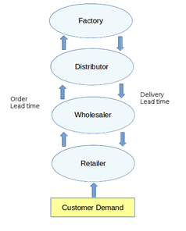
Figure 3.1: Basic 4 stage supply chain model
Each stage in the system is the customer of upstream and a supplier of downstream stage in the supply chain. For instance, the retailer observes customer demand and based on its current inventory situation places orders to its supplier, in this case the wholesaler. It receives orders made after a delivery lead time. The system is non-coordinated that is there is no information being shared between the stages of the supply chain. The decisions made by each stage are based on the simple moving average forecasting method. Each of the stages tries to predict the demand by averaging the last five demands of the stage downstream.
In the subsequent section it can be seen that no external factors affect the supply chain. Only the decisions made by each stage based on the demand forecasting contribute to bullwhip. Furthermore, the various variables that are mentioned in the table 1 except demand is calculated using the formulae mentioned contribute to bullwhip.
3.3.2 Calculations for the dataset generation
The table of data generated by model for each stage is shown in the table 1. As mentioned earlier, the demand of each stage is the order of the stage downstream. The other variables in the table are explained briefly in this section.
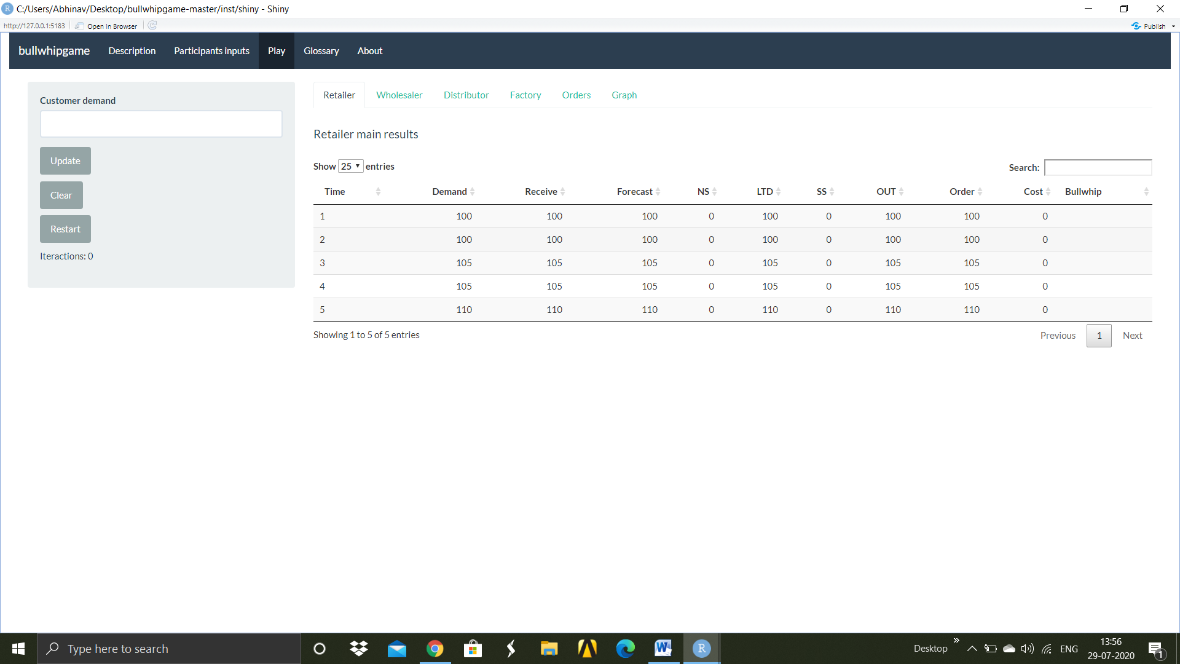
Table 3.1: Variables in the Supply chain Model

Net stock (NS) is defined here as a current inventory level. This is given by,
${NS}_{t}={NS}_{t-1}+Received-Demand$ (3.3)
Safety stock (SS) is the amount of inventory that companies keep in order to protect themselves against stock out situations during lead time. The safety stock is given by the following formula:
$SS=Z×σ×√L$ (3.4)
The σ is standard deviation of the demand. The symbol L is the Lead time, which is the number of days between the time an order is placed and the time it is received. The SS was rounded off to 2 decimal places. Z is the safety factor, which is a constant associated with the service level. Service level is the probability of not running out of stock during the next replenishment cycle.
The service level was taken to be 0.95 in the simulation. Let us see how service level and safety factor are related. Since service level is a probability, it can be expressed as the area under the curve of a standard normal distribution curve. So, safety factor can be defined as the z-score at which the probability of not running out of stock during the next replenishment cycle is equal to the service level. As an example, if Z=1.645 (approx.) then stock will not run out of stock 95 times out of 100.
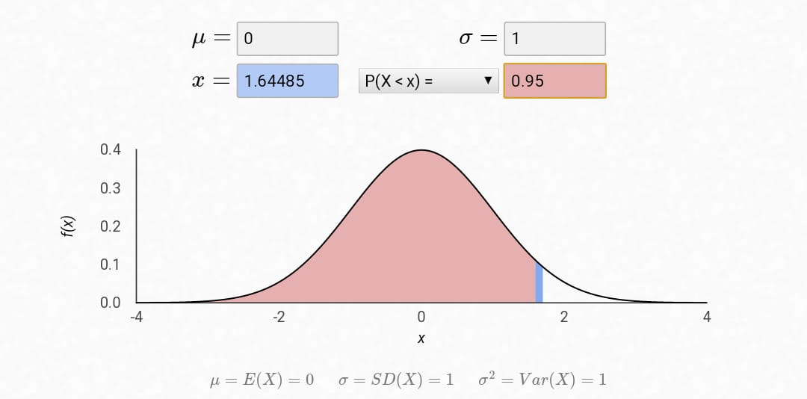
Figure 3.2: Service level in normal distribution
Lead time demand (LTD) is the average demand during lead time. Here, value of lead time was taken to be 1. Lead time demand is given by,
$LTD = Forecast×L$ (3.5)
Order Up to Level (OUT) is a replenishment policy. Each period companies review stock levels and place an order to bring its stock levels up to a target level.
$OUT = LTD + SS$ (3.6)
Order (O), stocks ordered but not yet arrived, is given by,
$O = OUT – NS$ (3.7)
To quantify bullwhip, the operation research model is used. In this model, the ratio of variances is commonly used in dispersion statistics to compare variability from various distributions. If the ratio is greater than 1, it is called as variance amplification. In other case when it is less than one, it is called as the isolation effect. (Campuzano et al. 2011)
Cost, it is the expense incurred in storing the product in inventory and back ordering. For calculating cost, there are two possible cases:
- In the case when the stock is not sufficient to fulfil the demand. It is calculated as:
$Cost = Holding cost per piece × Net stock$, if Net Stock > 0 (3.9)
- In all other cases,
Cost = Backordering cost per piece x Quantity of unfulfilled order (3.10)
For the purpose of the simulation, the back ordering and the holding cost are taken to be 0.5 and 2 units respectively. Also, no external factors other than service level, demand, lead time, number of time periods used for forecasting in simple moving average, affect the bullwhip in the simulation.
CHAPTER 4 AI ON VIRTUAL DATA SET
The data is generated using the bullwhip model above. To implement variability in the demand, the customer demand is simulated using a sinusoidal curve as shown in the figure 4.2.
4.1 Data preparation
In order for the data to be used by the algorithm, data pre-processing is required. This is done to ensure that the raw data is converted into a format that is manageable by the algorithm. Also, in this step all the instances of inconsistent data are removed to avoid errors in prediction and improve efficacy. For the project, the process of data pre-processing had three steps, namely Data Exploration, Data Cleaning, and Data Processing. These steps are described briefly in this section.
4.1 Data Exploration:
In this process, the initial dataset is first visualized by human before further processing it. This is done to check for any inaccuracies such as missing values, typographical errors etc. Apart from this, various visualization tools are also used to see identify patterns in the data and decided which variables must be utilized for the regression.
4.2 Data Cleaning:
In this process, all the unnecessary and incorrect data points are removed in order to increase the accuracy of the analysis. This is done to make the data more consistent with other data points. The data is also standardized in this part of the process only to maintain uniformity in the dataset.
4.3 Data Processing:
In this process, the pre-processed data is converted into a more interpretable form by the application of various algorithms. All the labelled data is encoded with a numerical value. The data table is scaled for the machine learning algorithms in this step only. The dataset is further split into training, testing and validation data sets.
The training data set is used to “train” the neural network, which is essentially the process of deciding the various weights to be used for the analysis. Successively, to check if these weights are selected properly, validation data set is utilized. The outputs of the algorithms are compared with the actual values of the validation dataset to gauge the accuracy of the dataset. Lastly, the test dataset is utilized to evaluate the efficacy of the model.
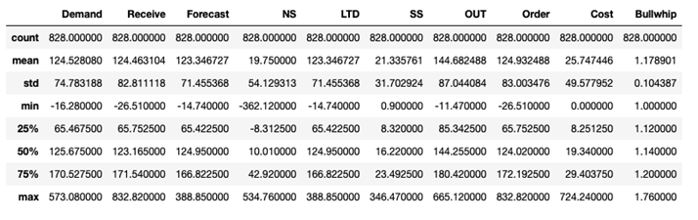Table 4.1: Basic statistical details like percentile, mean, standard deviation etc. of the dataset
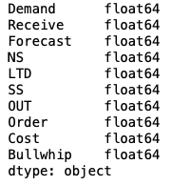
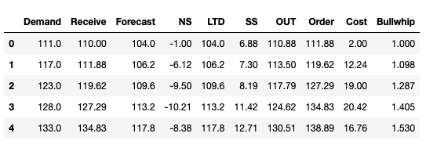Table 4.2: First few rows of the dataset 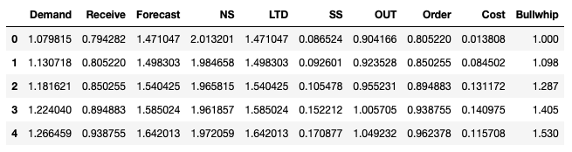Table 4.3: Dataset after processing and scaling the data point
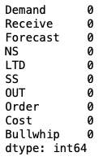

Figure4.1 : A) Exploring the data of each data point B) Checking for missing values in each data point

4.2a 4.2b
4.2c 4.2d
4.2e 4.2f
Figure 4.2: 4.2a represents Customer Demand Signal in the Bullwhip Game; 4.2b represents Customer Demand vs Retailer Demand; 4.2c represents Customer Demand vs Wholesaler Demand; 4.2d represents Customer Demand vs Distributor Demand; 4.2e represents Customer Demand vs Wholesaler Demand; 4.2f represents Customer Demand vs aggregate Demand

4.5 Machine Learning algorithms employed

4.5.1 K-Nearest Neighbours
K-Nearest Neighbours is an instance-based machine learning algorithm which stores history of all available cases and uses the information to classify new cases based on the criteria of similarity measure or distance function, wherein the K value represents the number of neighbours, Javier et al, 2009. The intuitive and simple-to-implement nature of the algorithm, makes it a plausible candidate for integration in the supply chain. Non-parametric nature of KNN allows the algorithm to work for demand fluctuations of any type since there are no preliminary assumptions to be met. KNN, being a lazy learner, responds quickly to changes in the input during real time use. However, KNN suffers from the curse of dimensionality and thus would fail to perform well where input variables for bullwhip effect are too many. Moreover, KNN is a slow algorithm wherein an imbalanced data set can cause problems, making it highly sensitive to outliers.

4.5.2 Decision Tree Regressor
Decision Tree Regressor is a supervised machine learning algorithm that employs an attribute selection measure, such as information gain or gini index, to make a series of if-else trees. Decision Tree Regressor allows complex decision boundaries, making it suitable for complex variations of demand. Decision trees offer very high interpretability, making it highly accessible to an average stakeholder. Decision Trees, unlike K-Nearest Neighbours, performs well even with missing values. Low computation of decision trees make it suitable for oceans of data as seen in several industries. However, Decision Trees suffer heavily from overfitting wherein small variations in inputs lead to different trees, making it suitable only for balanced data sets. Moreover, decision trees can be expensive to train and are prone to error when there are too many classes but training data is small.

4.5.3 Multilayer Perceptron
Multi-Layer Perceptron or MLP (Ramchoun et al, 2016) is a deep learning algorithm wherein multiple layers of perceptrons or nodes, minimum three, are used to map inputs to the outputs. It incorporates backpropagation for training. Multilayer perceptron trains by varying connection weights after each set of data is processed based on the corresponding error in the output compared to the expected results. Multilayer perceptron is easy to design and has few hyper-tuning parameters. However, multilayer perceptron can suffer from slow convergence. Moreover, it poses as a black-box wherein the results can be counter intuitive, unlike decision trees. Figure shows a typical network of MLP wherein input layers are mapped to hidden layers and then finally to output layers.

CHAPTER 5 RESULTS
This section describes the result of experiments of various machine learning algorithms on the datasets described earlier using jupyter notebook. Exactly same datasets have been used for all the machine learning models for valid comparisons.
The proposed machine learning model has nine inputs namely Cost, Order, OUT, SS, LTD, NS, Forecast, Receive and Demand. Bullwhip will be the forecasted output of the model. The computed output, is the numerical value of the bullwhip effect for that Stock position
S.no. | Algorithm | Accuracy
1 | Decision Tree Regressor | 24.52%
2 | MLP Regressor | 25.32%
3 | KNN Algorithm | 54.64%
Table 5.1: Accuracies for applied machine learning algorithms
A correlation Matrix was also constructed to understand the correlation between bullwhip and the various inputs. A multi-correlation matrix was obtained. This explains why the Decision tree regressor gave a poor prediction score (Il-Gyo Chong et al., 2005) of 24.25%. The MLPRegressor algorithm resulted in a prediction score of 25.32%. This can be explained by the fact that the value of bullwhip has a small resolution of upto 2 decimal places. Due to this small resolution, the algorithm is unable to differentiate and predict the bullwhip effect with a high degree of accuracy (Yi-Chung Hu et al 2014).
The KNN algorithm was also used. The algorithm took the projection of the 9 input variables and plotted it against the numerical value of bullwhip. Consequently, the machine tried to look for clusters which can further predict the bullwhip. The machine found the most accurate result at K=5 or 5 clusters. This resulted in a prediction score of 54.64%. The prediction can further be enhanced by increasing the resolution of the numerical value of bullwhip.
Figure 5.1: Correlation Matrix between the 9 Input variables and the output Bullwhip

CHAPTER 6 CONCLUSIONS AND FUTURE SCOPE
6.1 CONCLUSION
The paper’s objective was to model a 4-Stage supply chain, measure the bullwhip effect, understand its underlying causes and possible solutions and model a prediction artificial intelligence algorithm. The Bullwhip effect in supply chains is majorly caused due to demand forecasting, price fluctuation, gaming during shortage and order batching. One proposed solution to the problem can be integration of the entire supply chain with time constraint information sharing. However this is not favourable as the various stages of the supply chain have diverse organizational goals. More over in competitive markets, data theft is a serious concern. New demand forecasting techniques such as ANN, Fuzzy Logic, and Genetic algorithms can be used to forecast the demand with higher accuracy in the absence of supply chain integration. The artificial intelligence technique, artificial neural network forecasts accuracy is better than the traditional approaches (Prakash et al 2014). We concluded that the advanced demand forecasting techniques which use regressors and perform poorly with multi collinearity must not be used to predict the bullwhip effect. Algorithms which use the projection of the data points such as KNN algorithms are effective for its prediction (Rinkaj Goyal et al 2014).
6.2 FUTURE SCOPE
Future research could be aimed at exploring algorithms which handle high degrees of collinearity. Moreover, research with a larger dataset can also be conducted to verify the results of this paper. The advancement in e-commerce and e-business through internet has made the supply chain system more dynamic and requires JIT approach. Further work can be carried out to investigate how e-commerce affects the demand amplification and create satisfied customers.

Appendix 1
Code for implemented Machine Learning Algorithms
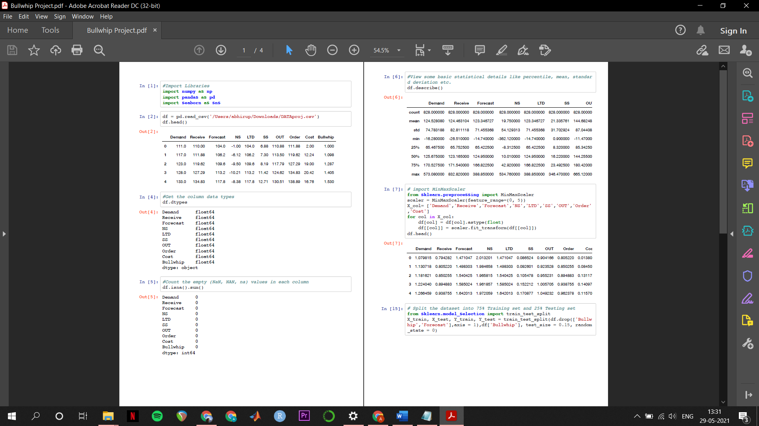



REFERENCES
- Amin-Naseri MR, Tabur BR. Neural network approach to lumpy demand forecasting for spare parts in process industries. Proceedings of the IEEE International Conference on Computer and Communication Engineering. May 13–15, 2008, Kuala Lumpur, Malaysia. 1378–1382p. 978-1-4244-1692-9/08,
- Bhattacharya R, Bandyopadhyay S (2011) A review of the causes of bullwhip effect in a supply chain. Int J Adv Manuf Technol 54(9–12): 1245–1261
- Campuzano F., Mula J. (2011) Bullwhip Effect in Supply Chains. In: Supply Chain Simulation. Springer, London. https://doi.org/10.1007/978-0-85729-719-8_3.
- Chen, F., Drezner, Z., Ryan, J., & Simchi-Levi, D. (2000). Quantifying the Bullwhip Effect in a Simple Supply Chain: The Impact of Forecasting, Lead Times, and Information. Management Science, 46(3), 436-443.
- Ciancimino E, Cannella S, Bruccoleri M, Framinan JM (2012) On the bullwhip avoidance phase: the synchronized supply chain. Eur J Oper Res 221(1):49–63
- D.R. Towill, A. Del Vecchio, Application of filter theory to the study of supply chain dynamics. Prod. Plan. Control. 5, 82–96 (1994)
- Disney SM, Towill DR (2003) Vendor-managed inventory and bull- whip reduction in a two-level supply chain. Int J Oper Prod Manag 23(6):625–651
- Forrester JW (1958) Industrial dynamics—a major breakthrough for decision makers. Harv Bus Rev 36(4):37–66
- Forrester JW. Industrial Dynamics. The M.I.T. Press. 1961.
- Hau L. Lee, V. Padmanabhan, Seungjin Whang, Information Distortion in a Supply Chain: The Bullwhip Effect. Management Science 43 (4) 546-558 [doi: https://doi.org/10.1287/mnsc.43.4.546 }
- Hussain M, Drake PR, Lee DM (2012) Quantifying the impact of a supply chain’s design parameters on the bullwhip effect using simu- lation and Taguchi design of experiments. Int J Phys Distrib Logist Manag 42(10):947–968
- Il-Gyo Chong, Chi-Hyuck Jun, Performance of some variable selection methods when multicollinearity is present, Chemometrics and Intelligent Laboratory Systems, Volume 78, Issues 1–2, 2005, Pages 103-112, ISSN 0169-7439, https://doi.org/10.1016/j.chemolab.2004.12.011
- Jaipuria S, Mahapatra SS (2014) An improved demand forecasting method to reduce bullwhip effect in supply chains. Expert Syst Appl 41(5):2395–2408
- Javier Arroyo, Carlos Maté, Forecasting histogram time series with k-nearest neighbours methods, International Journal of Forecasting, Volume 25, Issue 1, 2009, Pages 192-207, ISSN 0169-2070, [ https://doi.org/10.1016/j.ijforecast.2008.07.003.]
- Kamil J. Mizgier, Stephan M. Wagner, Janusz A. Holyst, Modeling defaults of companies in multi-stage supply chain networks, International Journal of Production Economics, Volume 135, Issue 1, 2012, Pages 14-23, ISSN 0925-5273, [ https://doi.org/10.1016/j.ijpe.2010.09.022.]
- Kim D, Lee RP (2010) Systems collaboration and strategic collabo- ration: their impacts on supply chain responsiveness and market performance. Decis Sci 41(4):955–981 Disney SM, Towill DR (2003) Vendor-managed inventory and bull- whip reduction in a two-level supply chain. Int J Oper Prod Manag 23(6):625–651
- Lee HL, Padmanabhan V, Whang S (1997) Information distortion in a supply chain: the bullwhip effect. Manag Sci 43(4):546–558
- Li C, Liu S (2013) A robust optimization approach to reduce the bullwhip effect of supply chains with vendor order placement lead time delays in an uncertain environment. Appl Math Model 37(3): 707–718
- Martin Christopher Lynette Ryals, (1999),"Supply Chain Strategy: Its Impact on Shareholder Value", The International Journal of Logistics Management, Vol. 10 Iss 1 pp. 1 - 10
- Matteo Coppini , Chiara Rossignoli , Tommaso Rossi & Fernanda Strozzi (2010) Bullwhip effect and inventory oscillations analysis using the beer game model, International Journal of Production Research, 48:13, 3943-3956, DOI: 10.1080/00207540902896204
- Mentzer JT, Dewitt W, Keebler JS, Min S, Nix NW, Smith CD, Zacharia ZG (2001) Defining supply chain management. J Bus Logist 22(2):1–26
- O’donnell, T., Maguire, L., McIvor, R., & Humphreys, P. (2006). Minimizing the bullwhip effect in a supply chain using genetic algorithms. International Journal Of Production Research, 44(8), 1523-1543. [ doi: 10.1080/00207540500431347 ]
- Prakash, Om & Pandey, Vijay. (2014). Reducing the Bullwhip Effect in a Supply Chain Using Artificial Intelligence Technique. International Journal of Production Research. 4. 31-42.
- Prakash, Om & Pandey, Vijay. (2014). Reducing the Bullwhip Effect in a Supply Chain Using Artificial Intelligence Technique. International Journal of Production Research. 4. 31-42.
- Ramchoun, H., Idrissi, M. A. J., Ghanou, Y., & Ettaouil, M. (2016). Multilayer Perceptron: Architecture Optimization and Training. IJIMAI, 4(1), 26-30.
- Rinkaj Goyal, Pravin Chandra, Yogesh Singh, Suitability of KNN Regression in the Development of Interaction based Software Fault Prediction Models, IERI Procedia, Volume 6, 2014, Pages 15-21, ISSN 2212-6678, https://doi.org/10.1016/j.ieri.2014.03.00
- Singh, L.P., Challa, R.T. Integrated Forecasting Using the Discrete Wavelet Theory and Artificial Intelligence Techniques to Reduce the Bullwhip Effect in a Supply Chain. Glob J Flex Syst Manag 17, 157–169 (2016). https://doi.org/10.1007/s40171-015-0115-z [ https://doi.org/10.1007/s40171-015-0115-z ]
- STERMAN, J. D. (1989). Modeling managerial behavior: misperceptions of feedback in a dynamic decision making experiment. Management Science, 35(3), 321–339. [doi:10.1287/mnsc.35.3.321]
- Sucky E (2009) The bullwhip effect in supply chains—an overestimated problem? Int J Prod Econ 118(1):311–322
- Sun HX, Ren YT (2005) The impact of forecasting methods on bullwhip effect in supply chain management. Engineering Management Conference. Proceedings. IEEE International, 11–13 September 2005, pp 215–219
- World Bank. 2021. Global Economic Prospects, January 2021. Washington, DC: World Bank. doi: 10.1596/978-1-4648-1612-3. License: Creative Commons Attribution CC BY 3.0 IGO.
- Y. Yang, J. Lin, G. Liu, L. Zhou, The behavioural causes of bullwhip effect in supply chains: A systematic literature review, International Journal of Production Economics, Volume 236, 2021, 108120, ISSN 0925-5273, https://doi.org/10.1016/j.ijpe.2021.108120.
- Y.Z. Tsypkin, Sampling Systems Theory and Its Application (Pergamon Press, Oxford, 1964)
- Yi-Chung Hu, "Multilayer Perceptron for Robust Nonlinear Interval Regression Analysis Using Genetic Algorithms", The Scientific World Journal, vol. 2014, Article ID 970931, 8 pages, 2014. https://doi.org/10.1155/2014/970931
- Zotteri G (2013) An empirical investigation on causes and effects of the bullwhip-effect: evidence from the personal care sector. Int J Prod Econ 143(2):489–498

PROOF OF PROCEEDING / ACCEPTANCE
Conference: International Conference on Advances in Management and Technological Innovations: Impacting Industries-III

Indexing: Scopus Indexed

Proof of acceptance:




Conference brochure:



Scopus Index proof:






PLAGIARISM REPORT



Place: Delhi
DR. GIRISH KUMAR
Date: 31 May 2021

SUPERVISOR Associate Professor, Department of Mechanical Engineering Delhi Technological University, Bawana Road, Delhi-110042

