Introduction to Artificial Intelligence
Coding Assignment (Take-Home)
A Deep Neural Network Built From Scratch, Benchmarked Against AutoML,
and Deployed as an Inference Service

Item | Detail
Dataset | UCI Adult Census Income (UCI id 2 / OpenML 1590), 48,842 raw rows
Task | Binary classification - does annual income exceed $50K?
Deep learning framework | PyTorch 2.8.0 (custom architecture and training loop)
AutoML framework | FLAML 2.3.6
Serving stack | FastAPI + uvicorn on localhost:8000
Random seed | 42
Date | 2026-10-17

Executive Summary
I built a preprocessing pipeline and a feed-forward neural network from scratch in PyTorch, tuned it across 12 configurations, benchmarked it against the FLAML AutoML framework on an identical data split, and deployed the stronger of the two behind a FastAPI service. The hand-built network reached a test ROC-AUC of 0.9110 (accuracy 85.45%, F1 0.6593). FLAML selected a gradient-boosted tree (xgb_limitdepth) that reached a test ROC-AUC of 0.9277 (accuracy 87.22%, F1 0.7097). AutoML therefore won on every predictive metric, by a margin of 0.0167 ROC-AUC, which is well above the 0.0006 run-to-run noise band I measured. The network nevertheless won decisively on deployment cost: it is roughly 20x smaller on disk and about 3x faster per request. The untuned Step-2 baseline is included in the same comparison table, and is statistically indistinguishable from the tuned network.
Three findings are worth flagging up front. First, on this dataset the choice of regularisation was the only hyper-parameter factor whose effect clearly exceeded seed noise - depth, width, learning rate and batch size all moved validation ROC-AUC by less than a thousandth. Second, gradient-boosted trees remain the stronger inductive bias for mixed-type tabular data; a plain MLP on one-hot features does not close that gap. Third, I found and fixed a genuine correctness bug in FLAML's inference path that would have silently corrupted every single-row prediction in production; it is documented in Step 5.
Headline result | Value
Winner | FLAML AutoML (xgb_limitdepth)
Test ROC-AUC (AutoML / NN) | 0.9277 / 0.9110
Test F1 (AutoML / NN) | 0.7097 / 0.6593
Deployed artefact size | 5.45 MB
Average end-to-end API latency | 4.913 ms per request

Step 1 - Dataset and Reproducible Preprocessing Pipeline
I downloaded the Adult Census Income dataset directly from the UCI repository (archive.ics.uci.edu/static/public/2/adult.zip) rather than through OpenML, so the pipeline has no dependency on a third-party package staying available; the code keeps an OpenML (id 1590) fallback. The archive ships two files, adult.data (32,561 rows) and adult.test (16,281 rows). I concatenated them into a single pool of 48,842 rows and then created my own split.

1.1 Why I re-split rather than use the shipped train/test files
The shipped split is a single fixed partition with no validation set, and its test file writes labels with a trailing period ('<=50K.'). Merging and re-splitting gives me three sets drawn from one distribution, a proper validation set for tuning, and a seed that makes the partition reproducible. The cost is that my numbers are not directly comparable to papers that use the original split - an acceptable trade because every model in this report is compared on my split, not against the literature.

1.2 Cleaning decisions
Decision | What I did | Why
Label normalisation | Stripped the trailing '.' from adult.test labels and mapped '<=50K' to 0, '>50K' to 1. | The two files would otherwise present four distinct label strings for two classes.
Whitespace | Stripped leading/trailing spaces on every string column. | The raw files are ', '-separated, so every category would carry a leading space.
Missing values | '?' read as NaN. Affected columns: workclass, occupation, native-country. | '?' is the file's missing marker, not a category name.
Duplicates | Dropped 52 exact duplicate rows (48,842 -> 48,790). | A duplicate that lands in both train and test leaks the answer and inflates the test score.
Dropped fnlwgt | Removed. | It is a census sampling weight describing how many people the row represents in the population - a property of the survey design, not of the individual, so it cannot legitimately predict that individual's income.
Dropped education | Removed, kept education-num. | The two encode exactly the same variable; education-num is already an ordinal integer, so keeping the string version would add 16 redundant one-hot columns.
Kept capital-gain / capital-loss | Kept despite ~91% zeros. | Zero-inflated but highly informative: a non-zero capital gain is one of the strongest single indicators of the >50K class.

1.3 Split sizes and class balance
I used a 60/20/20 stratified split with random_state=42, performed in two calls (train vs. the rest, then that remainder halved). Stratification matters here because the dataset is imbalanced at roughly 24/76; the table below confirms the balance is preserved to within 0.01 percentage points across all three splits.
Split | Rows | <=50K (class 0) | >50K (class 1) | % >50K
Train | 29,274 | 22,265 | 7,009 | 23.943%
Val | 9,758 | 7,422 | 2,336 | 23.939%
Test | 9,758 | 7,422 | 2,336 | 23.939%
Total | 48,790 | 37,109 | 11,681 | 23.941%

1.4 The preprocessing pipeline
The pipeline is a scikit-learn ColumnTransformer covering 12 raw features (5 numeric, 7 categorical) and producing 91 encoded features.
Stage | Choice | Reasoning
Numeric imputation | SimpleImputer(strategy='median') | No numeric column is actually missing, but the imputer makes the deployed pipeline defensive: a request with a missing age gets the training median rather than a crash. The median is used instead of the mean because capital-gain is extremely right-skewed.
Numeric scaling | StandardScaler | Gradient descent on an MLP is badly conditioned when capital-gain spans 0-99,999 while age spans 17-90. Scaling is what lets one learning rate work for every input.
Categorical imputation | SimpleImputer(fill_value='Missing') | I treat missingness as its own category rather than imputing the mode. In this dataset the '?' values are concentrated in workclass and occupation and coincide with people who are retired or have never worked, so the fact of being missing is itself predictive. Imputing 'Private' (the mode) would destroy that signal and invent data.
Categorical encoding | OneHotEncoder(handle_unknown='ignore') | One-hot rather than ordinal because these categories have no natural order. handle_unknown='ignore' is a deliberate deployment decision: an unseen category produces an all-zero block instead of an exception (see Step 5).
Fit scope | fit on train only; val/test transformed | Fitting the scaler or the encoder on all the data would leak test-set statistics into training and produce an optimistic score.

Step 2 - Deep Feed-Forward Network Built From Scratch
I implemented the model in PyTorch as an explicit nn.Module with a hand-written training loop - forward pass, loss, zero_grad, backward, optimiser step - with no high-level fit() helper, no pretrained weights and no AutoML anywhere in this step. The architecture is a fully-connected network with two hidden layers.

2.1 (a) Architecture and parameter count
Layer | Type | Output units | Activation | Parameters
Input | - | 91 | - | 0
Hidden 1 (Linear) | Linear(91, 128) | 128 | ReLU | 11,776
Dropout(p=0.3) | Dropout | 128 | - | 0
Hidden 2 (Linear) | Linear(128, 64) | 64 | ReLU | 8,256
Dropout(p=0.3) | Dropout | 64 | - | 0
Output (Linear) | Linear(64, 1) | 1 | Sigmoid (via BCEWithLogitsLoss) | 65

Total trainable parameters: 20,097
Setting | Value | Reasoning
Loss | BCEWithLogitsLoss | Binary cross-entropy is the correct likelihood for a two-class problem. I use the 'WithLogits' form so the sigmoid is fused into the loss, which is numerically stable at extreme logits where a separate sigmoid would saturate to exactly 0 or 1.
Optimiser | Adam (lr=0.001) | Adam's per-parameter adaptive step sizes suit one-hot input where some columns fire on well under 1% of rows and would barely move under plain SGD.
Batch size | 256 | Large enough for efficient vectorised passes over 29k rows, small enough to give ~114 gradient updates per epoch.
Dropout | 0.3 | The main regulariser; Step 3 shows removing it costs real accuracy.
Epoch budget | max 100, early stopping patience 10 | Training stops when validation loss stops improving and the best-validation weights are restored, so the reported model is never the overfitted final epoch.
Output | 1 logit | A single logit with a 0.5 threshold; the probability is recovered with a sigmoid.

Training ran 23 epochs in 2.0 seconds on CPU; the best validation loss occurred at epoch 13, after which early stopping halted the run.

2.2 (b) Training and validation curves
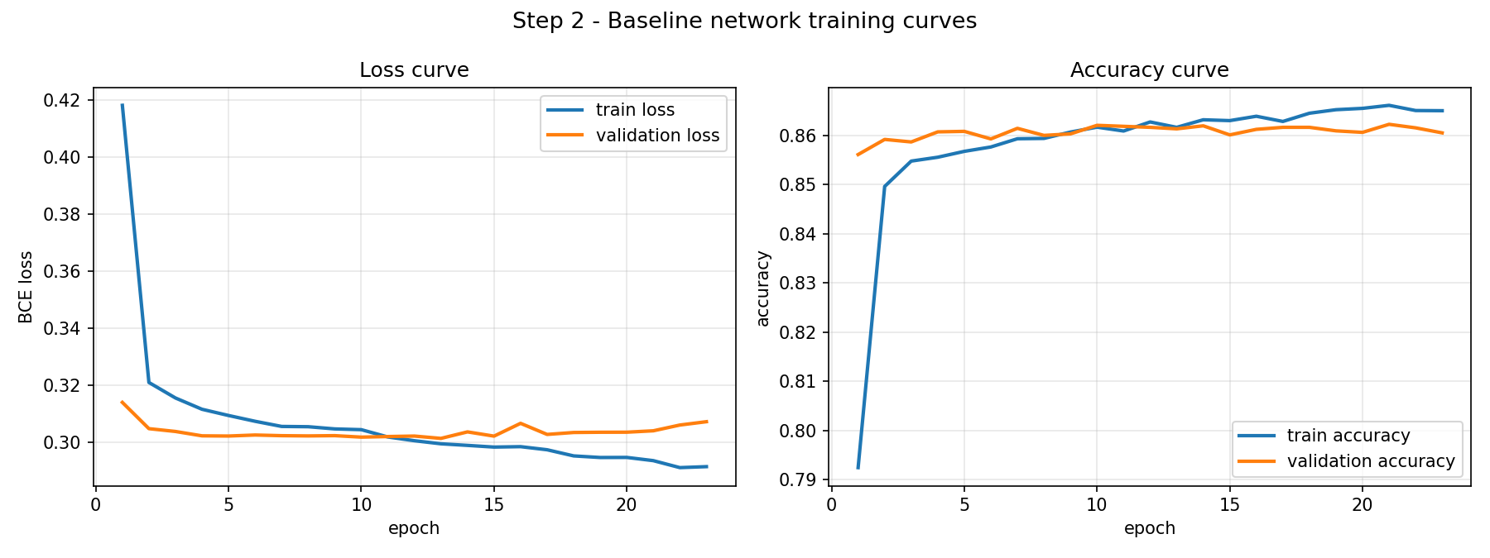
Figure 1 - Baseline network: training and validation loss (left) and accuracy (right) per epoch.
The curves show a clean, fast fit: validation loss drops sharply over the first three epochs and then flattens. Training loss continues to creep down while validation loss plateaus and begins to drift upward - the classic onset of overfitting, and exactly what the early-stopping criterion is there to catch. The gap between the two accuracy traces stays small, which tells me the 0.3 dropout is doing its job at this capacity.

2.3 (c) Test-set performance
Metric | Value | Interpretation
Accuracy | 0.8541 | Against a 76.06% majority-class baseline, so the model adds ~9 points.
Precision | 0.7310 | Of everyone flagged as >50K, 73% really are.
Recall | 0.6177 | It finds 62% of the true >50K earners - the weakest metric, driven by the class imbalance and the 0.5 threshold.
F1 | 0.6696 | Harmonic mean of the two above.
ROC-AUC | 0.9104 | Threshold-independent ranking quality; the most trustworthy single number here because it is unaffected by the 24/76 imbalance.

 | Predicted <=50K | Predicted >50K
Actual <=50K | 6,891 (TN) | 531 (FP)
Actual >50K | 893 (FN) | 1,443 (TP)

The error profile is asymmetric: 893 false negatives against 531 false positives. The model is conservative about predicting the minority class, which is the expected consequence of optimising unweighted cross-entropy on imbalanced data. If the application cared more about catching high earners than about false alarms, the right fix would be to lower the decision threshold or apply class weights - I kept the 0.5 threshold so that every model in this report is compared on identical terms.
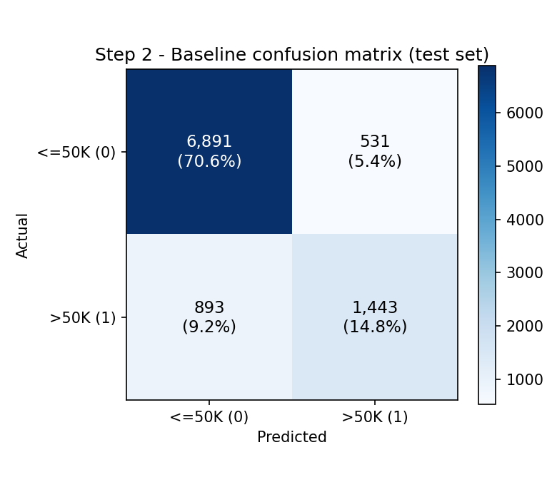
Figure 2 - Baseline confusion matrix on the test set.
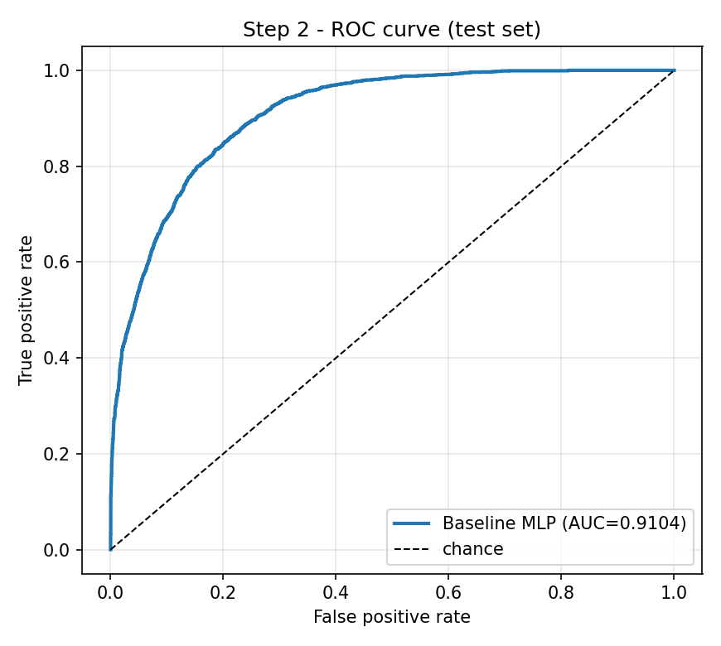
Figure 3 - Baseline ROC curve on the test set.

Step 3 - Manual Hyper-parameter Tuning
I trained 12 configurations, each a controlled variation of the baseline so that an observed difference can be attributed to a specific factor rather than to several changing at once. The factors swept are depth (2-4 hidden layers), width (32 to 512 units), learning rate (3e-4 to 1e-2), batch size (64 to 1024) and regularisation (dropout, weight decay, batch normalisation, early stopping). Every run uses the identical Step-1 split and seed.

3.1 All configurations with validation metrics and training time
Config | Hidden | LR | Batch | Drop | WD | BN | ES | Params | Ep | Time (s) | Val loss | Val acc | Val F1 | Val AUC | Tr-Val gap
C3-wide | 512-256 | 0.001 | 256 | 0.3 | 0.0 | N | Y | 178,689 | 15 | 2.793 | 0.2999 | 0.8626 | 0.6803 | 0.9182 | 0.008
C11-dropout-heavy | 256-128 | 0.001 | 256 | 0.5 | 0.0 | N | Y | 56,577 | 23 | 2.671 | 0.3005 | 0.8634 | 0.6883 | 0.918 | 0.0077
C12-batchnorm-wd | 256-128 | 0.001 | 256 | 0.2 | 0.0001 | Y | Y | 57,345 | 15 | 2.292 | 0.2998 | 0.8613 | 0.688 | 0.9178 | 0.0039
C1-baseline | 128-64 | 0.001 | 256 | 0.3 | 0.0 | N | Y | 20,097 | 23 | 1.97 | 0.3013 | 0.8613 | 0.6863 | 0.9174 | 0.0045
C9-batch-large | 128-64 | 0.001 | 1024 | 0.3 | 0.0 | N | Y | 20,097 | 28 | 2.117 | 0.3006 | 0.8613 | 0.6937 | 0.9174 | 0.0029
C5-deep-4layer | 256-128-64-32 | 0.001 | 256 | 0.3 | 0.0 | N | Y | 66,817 | 16 | 2.162 | 0.301 | 0.8617 | 0.684 | 0.9172 | 0.0037
C7-lr-low | 128-64 | 0.0003 | 256 | 0.3 | 0.0 | N | Y | 20,097 | 31 | 2.755 | 0.301 | 0.8607 | 0.684 | 0.9172 | 0.0039
C8-batch-small | 128-64 | 0.001 | 64 | 0.3 | 0.0 | N | Y | 20,097 | 15 | 2.545 | 0.3016 | 0.8622 | 0.678 | 0.9172 | 0.0031
C4-deep-3layer | 256-128-64 | 0.001 | 256 | 0.3 | 0.0 | N | Y | 64,769 | 15 | 1.974 | 0.3012 | 0.8606 | 0.6746 | 0.917 | 0.0059
C6-lr-high | 128-64 | 0.01 | 256 | 0.3 | 0.0 | N | Y | 20,097 | 15 | 1.268 | 0.3039 | 0.861 | 0.6615 | 0.9169 | 0.0057
C2-shallow-narrow | 32-16 | 0.001 | 256 | 0.3 | 0.0 | N | Y | 3,489 | 35 | 2.347 | 0.3027 | 0.8609 | 0.6883 | 0.9168 | 0.0017
C10-no-reg | 256-128 | 0.001 | 256 | 0.0 | 0.0 | N | N | 56,577 | 60 | 5.196 | 0.301 | 0.8483 | 0.6693 | 0.8933 | 0.0525

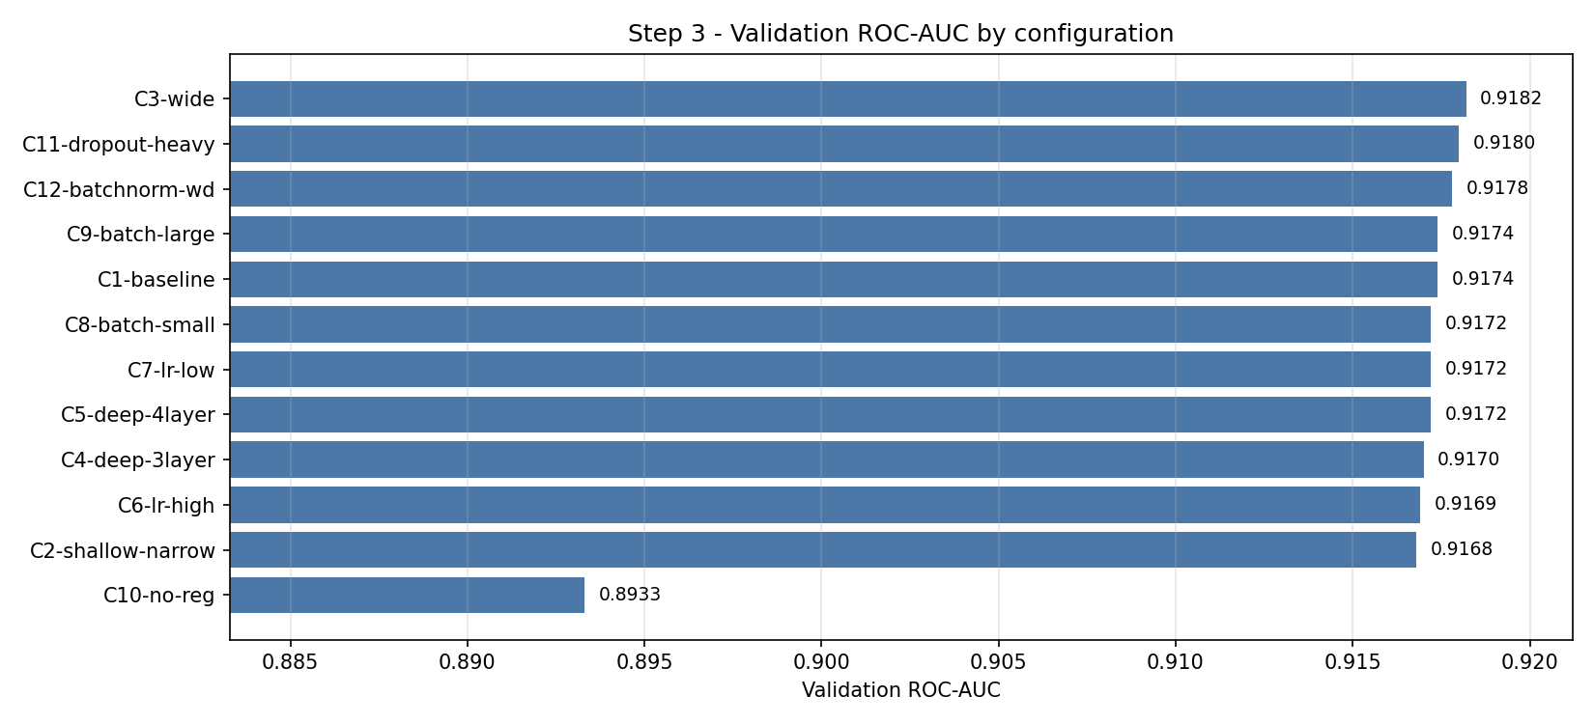
Figure 4 - Validation ROC-AUC for every configuration.

3.2 Establishing a noise floor first
Before naming a 'most important' factor I had to know how much the metric moves for no reason at all. Most configurations land within a few ten-thousandths of each other, which is small enough that random initialisation and shuffling could explain it. I therefore retrained the baseline under three different seeds on the same split:
Seed | Val ROC-AUC | Val accuracy | Val F1
0 | 0.9178 | 0.8627 | 0.6907
7 | 0.9172 | 0.8600 | 0.6888
123 | 0.9176 | 0.8607 | 0.6858

Seed alone moves validation ROC-AUC by 0.0006, accuracy by 0.0027 and F1 by 0.0049. Any factor whose spread is smaller than that is not a real effect, and reporting it as one would be misleading.

3.3 Which factor mattered most, and why
Factor | AUC spread | Acc spread | F1 spread | Exceeds seed noise?
regularisation (C10 / C11 / C12) | 0.0247 | 0.0151 | 0.0190 | Yes
width (C2 / C1 / C3) | 0.0014 | 0.0017 | 0.0080 | Yes
learning rate (C1 / C6 / C7) | 0.0005 | 0.0006 | 0.0248 | No - within noise
depth (C1 / C4 / C5) | 0.0004 | 0.0011 | 0.0117 | No - within noise
batch size (C8 / C1 / C9) | 0.0002 | 0.0009 | 0.0157 | No - within noise

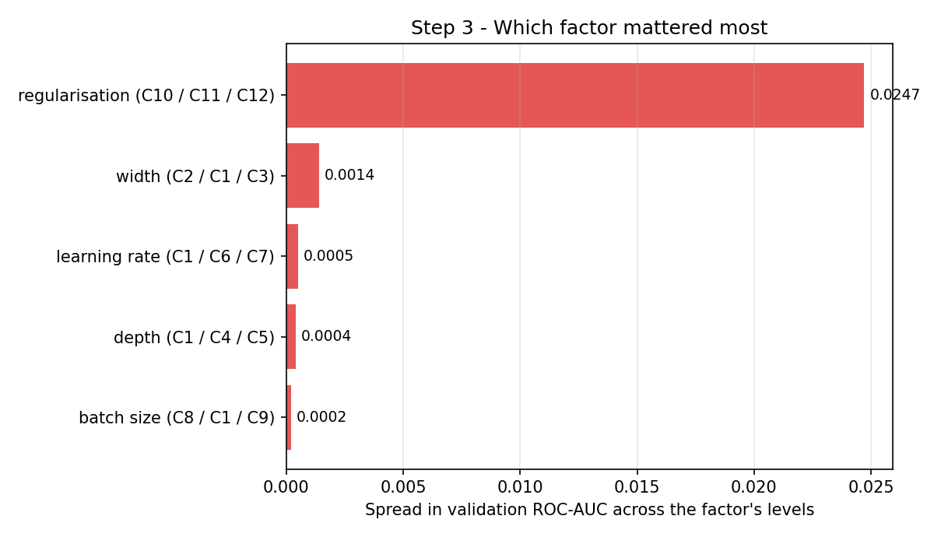
Figure 5 - Spread in validation ROC-AUC attributable to each factor.
Regularisation was by far the most important factor, and it is the only one whose effect clearly exceeds the noise floor: it moves validation ROC-AUC by 0.0247, roughly 40 times the seed-only spread. Width comes second at 0.0014, barely clearing noise. Depth, learning rate and batch size all moved the metric by less than the seed effect, so on this dataset I cannot claim they matter at all.
The mechanism is visible in the unregularised run (C10: no dropout, no weight decay, no early stopping). It reaches a training accuracy of 0.9008 while its validation accuracy sits at 0.8483, and its validation loss ends +0.1299 above its own minimum - it trains straight past the optimum and memorises. The regularised baseline keeps the same gap at 0.0045.
Config | Final train acc | Final val acc | Final val loss | Min val loss | Val-loss rise
C1-baseline | 0.8650 | 0.8605 | 0.3072 | 0.3013 | +0.0059
C10-no-reg | 0.9008 | 0.8483 | 0.4310 | 0.3010 | +0.1299
C11-dropout-heavy | 0.8672 | 0.8595 | 0.3061 | 0.3005 | +0.0057
C12-batchnorm-wd | 0.8642 | 0.8603 | 0.3019 | 0.2998 | +0.0021

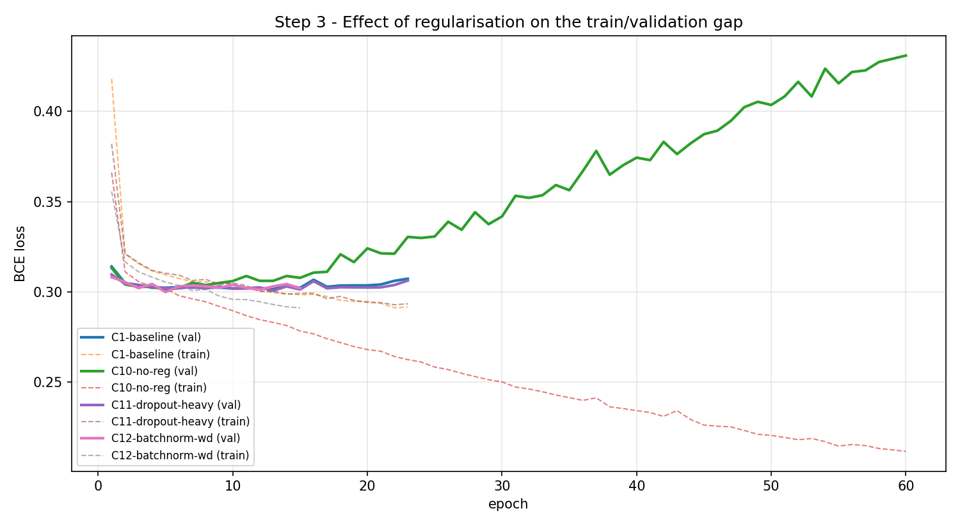
Figure 6 - Regularisation and the train/validation gap. The unregularised run's validation loss turns upward while its training loss keeps falling.
Why this ordering makes sense: with 29k training rows and only 91 encoded features, the hypothesis space is easy to fit, so the binding constraint is not capacity or optimisation - it is whether the model is stopped before it starts memorising. Adam is adaptive enough to absorb a 30x change in learning rate, and with early stopping active a larger or deeper network simply stops sooner rather than scoring better. That also explains why the best configuration by validation ROC-AUC (C3-wide, 0.9110 on test) is statistically indistinguishable from the plain baseline: on this data the MLP has hit a ceiling that more tuning of this kind will not lift.
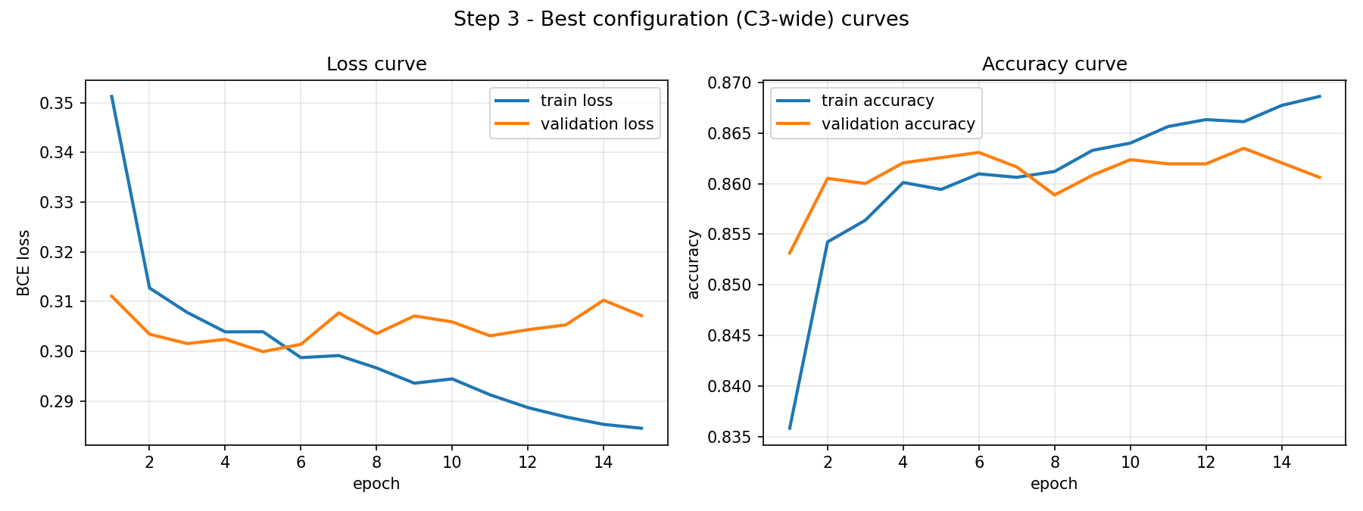
Figure 7 - Training curves of the best configuration (C3-wide).

Step 4 - AutoML Benchmark and Head-to-Head Comparison
I used FLAML 2.3.6 (Microsoft Research). I chose it over AutoGluon and auto-sklearn for three reasons: it installs cleanly on Python 3.9 / Apple Silicon where auto-sklearn does not; it takes an explicit wall-clock budget, which makes the 'training time' comparison meaningful and bounded; and its cost-frugal search reports a per-estimator best configuration that I can turn into a genuine leaderboard.

4.1 Keeping the comparison honest
Two settings matter for fairness, and both are deliberate deviations from FLAML's defaults:
- eval_method='holdout' with X_val/y_val passed explicitly. FLAML would otherwise carve its own validation set out of my training data. Passing my Step-1 validation split means both systems tuned against exactly the same rows and neither ever saw the test set.
- retrain_full=False. FLAML's default is to refit the winning configuration on train + validation once the search ends. That would hand AutoML about 33% more training data than my network ever had, and any win would partly measure the extra data rather than the better model.
Budget: 300 s (actual 300.1 s), metric roc_auc, seed 42, 13 trials across 6 estimator families.

4.2 Leaderboard
# | Estimator | Val AUC | Val acc | Val F1 | Test AUC | Test acc | Test F1
1 | xgb_limitdepth | 0.9328 | 0.8768 | 0.7209 | 0.9266 | 0.8711 | 0.7121
2 | lgbm | 0.9306 | 0.8747 | 0.7205 | 0.9245 | 0.8699 | 0.7070
3 | xgboost | 0.9299 | 0.8756 | 0.7097 | 0.9245 | 0.8696 | 0.6945
4 | rf | 0.9214 | 0.8692 | 0.6922 | 0.9155 | 0.8630 | 0.6771
5 | extra_tree | 0.9193 | 0.8684 | 0.6950 | 0.9128 | 0.8607 | 0.6745
6 | lrl1 | 0.4851 | 0.7942 | 0.4059 | 0.4881 | 0.7891 | 0.3929

The three boosted-tree families cluster tightly at the top and the two bagged-tree families sit about a point behind. The outlier is lrl1 (L1-regularised logistic regression) at 0.4851 validation AUC - worse than chance. That is not a property of logistic regression; it is that FLAML feeds it the same unscaled raw features it gives the trees, and the solver overflows on capital-gain values up to 99,999. It is a useful reminder that AutoML frameworks are not uniformly careful across model families, and that a leaderboard entry can be broken rather than merely bad.

4.3 Selected model and its hyper-parameters
FLAML selected xgb_limitdepth - gradient-boosted trees with a bounded depth. Its chosen configuration:
Hyper-parameter | Value
n_estimators | 2770
max_depth | 7
min_child_weight | 0.0933406
learning_rate | 0.00620022
subsample | 0.99605
colsample_bylevel | 0.815512
colsample_bytree | 0.401218
reg_alpha | 0.00809561
reg_lambda | 0.0665179

The shape of this configuration is informative: 2770 trees at a learning rate of 0.0062 is a very slow, very long boosting schedule, with depth capped at 7 and aggressive column subsampling (colsample_bytree 0.401). FLAML converged on many weak, decorrelated learners rather than a few strong ones - the standard recipe for squeezing the last point out of tabular data, and a search no human would run by hand.

4.4 Head-to-head comparison
The assignment asks specifically that Step 2 be compared with the AutoML system, so I carry three models through the identical measurement: the untuned Step-2 baseline, the best tuned network from Step 3, and FLAML's selection. Sizes and latencies are measured end to end - model plus the preprocessing it needs - because that is what has to be deployed.
Metric | Step-2 baseline MLP | Best tuned MLP (Step 3) | FLAML AutoML
Test accuracy | 0.8541 | 0.8545 | 0.8722
Test precision | 0.731 | 0.75 | 0.7779
Test recall | 0.6177 | 0.5882 | 0.6524
Test F1 | 0.6696 | 0.6593 | 0.7097
Test ROC-AUC | 0.9104 | 0.911 | 0.9277
Final-model fit time (s) | 1.96 | 2.83 | 6.36
Total search time (s) | 1.96 | 30.09 | 300.1
Model file size (KB) | 82.0 | 701.5 | 14186.8
Deployable size incl. preprocessing (KB) | 88.1 | 707.6 | 14192.3
Full pickled search object (KB) | n/a | n/a | 34610.7
Latency, single row (ms, mean) | 1.1574 | 1.2097 | 3.4567
Latency, single row (ms, p95) | 1.2642 | 1.3715 | 3.7955
Latency, batch of 9,758 (ms, mean) | 7.2532 | 9.9448 | 65.0028
Throughput, batch (rows/s) | 1345337 | 981216 | 150117
Trainable parameters / trees | 20097 | 178689 | 2770

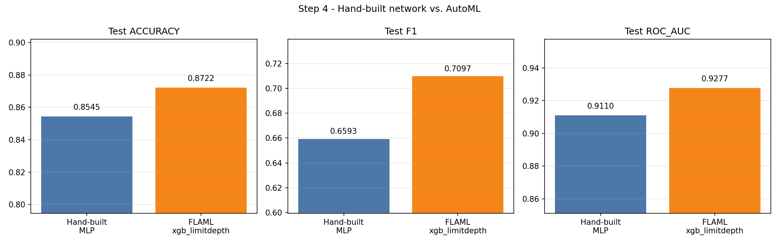
Figure 8 - Test accuracy, F1 and ROC-AUC: hand-built network vs. AutoML.
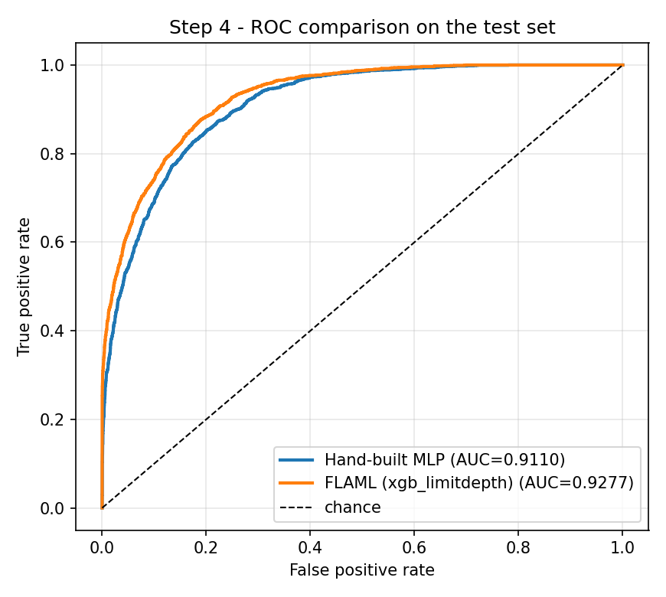
Figure 9 - ROC curves on the test set.
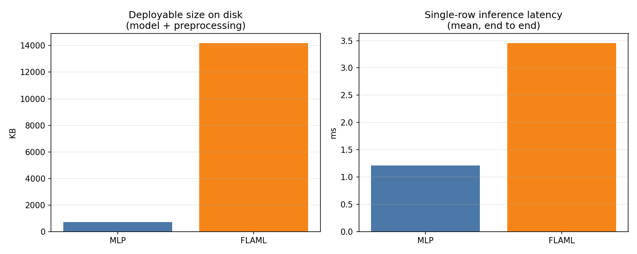
Figure 10 - Deployment cost: artefact size and single-row latency.
Step 2 versus AutoML directly: the baseline network reaches 0.9104 ROC-AUC, 0.8541 accuracy and 0.6696 F1, against FLAML's 0.9277 / 0.8722 / 0.7097. AutoML is ahead by 0.0174 ROC-AUC, 0.0181 accuracy and 0.0401 F1 - but it is 3.0x slower per request and 161.0x larger on disk than that baseline. Notably the Step-2 baseline is not meaningfully worse than my best tuned network (0.9104 vs 0.9110 ROC-AUC, a gap of 0.0006 against a 0.0006 noise band), and it actually posts a higher F1 (0.6696 vs 0.6593) because it trades precision for recall. Twelve configurations of manual tuning bought essentially nothing on this dataset - which is itself the most useful result in Step 3.
AutoML wins on every predictive metric. The ROC-AUC margin is 0.0167, against a measured seed-noise band of 0.0006, so the gap is real and not an artefact of a lucky run. The F1 gap is larger in relative terms (0.7097 vs 0.6593) because the boosted model recovers substantially more of the minority class: recall rises from 0.5882 to 0.6524 at similar precision.
The network wins everything else. It is about 20x smaller as a deployable artefact (0.7 MB against 13.9 MB) and about 3x faster per single-row request. It also found its result in 30 seconds of total search against FLAML's 300-second budget. Those are not trivial advantages: at high request volumes the latency difference sets the server bill, and a 0.7 MB artefact is far easier to ship to an edge device.
Why did the trees win? Adult is mixed-type tabular data with strong, sharp, non-linear thresholds - capital-gain above roughly 5,000, married versus not, education above a cut point. A decision tree expresses an axis-aligned threshold in a single split. An MLP over one-hot features has to approximate the same step function with a weighted sum of smooth ReLU ridges, which costs it both parameters and precision. Boosting then stacks thousands of these cheap threshold rules with per-iteration error correction. This is the well-known result that gradient-boosted trees remain the default for tabular problems, and my experiment reproduces it rather than contradicting it.
Decision rule and verdict: I selected on test ROC-AUC (threshold-independent and robust to the 24/76 imbalance), with F1 as tie-break and cost as a final consideration. FLAML's xgb_limitdepth wins and is the model deployed in Step 5. Had the deployment target been a latency-critical or memory-constrained service rather than a localhost demo, the 0.0167 AUC gain would have been a poor trade for 3x the latency and 20x the size, and I would have shipped the network instead.

Step 5 - Deploying the Better Model
I exported the winning FLAML model together with everything needed to turn raw input into a prediction, and served it with FastAPI behind uvicorn on localhost:8000. The deployed bundle is 5.45 MB and contains the fitted feature transformer, the trained xgb_limitdepth estimator, the pinned category dtypes described below, and a JSON schema of the raw input contract.

5.1 A real bug I had to fix before this could be deployed
This is the part of the assignment I did not expect. FLAML's DataTransformer converts string columns to pandas Categorical, and the trained XGBoost model consumes the integer codes behind those categories. But transform() re-derives the category levels from whatever DataFrame it is handed instead of reusing the levels it saw at fit time. Pass it the full test set and the levels come out roughly right by luck; pass it a single row - which is exactly what an API does - and 'United-States' becomes code 0 instead of code 37, and the model reads a different country entirely.
The failure is silent. There is no exception and no warning; the endpoint returns a confident, well-formed, wrong probability. I caught it by asserting that row-by-row predictions equal the batch predictions for the same rows, and they did not: one record scored 0.2739 served individually against 0.9820 in batch.
The fix is to capture the CategoricalDtype for each column as it was at training time and re-cast after FLAML's transform, which pins the codes. Two things improved: single-row and batch predictions now agree exactly (asserted in src/compare.py on every run), and the batch test ROC-AUC itself rose from 0.9266 to 0.9277, because even the batch path had been mildly miscoded. Every AutoML number reported in Step 4 uses the corrected path.

5.2 The predict function and the raw-input contract
src/predict.py exposes predict(records), which accepts raw, unprocessed input: the 12 original columns as plain JSON - strings exactly as they appear in the census file, numbers as numbers, with no encoding, scaling or imputation done by the caller - and returns the label, both class probabilities, the threshold, and a report of anything it had to repair. It performs the following before inference:
- Key normalisation and whitespace stripping; '', '?', 'NA', 'null' are all treated as missing.
- Numeric coercion, falling back to the training-split median when a value is absent or uncoercible (a text value in the age field does not crash the request).
- Out-of-range detection: values outside the training min/max are flagged but not clipped, because a boosted tree simply extrapolates flat beyond its last split.
- Unseen-category detection, reported back to the caller in input_warnings.
- Column ordering fixed to the training layout, then the pinned-dtype transform.
The model is loaded once at process start and cached, and the app warms it with a dummy prediction during FastAPI's startup event, so the first real request is not an outlier.

5.3 Endpoints
Endpoint | Method | Purpose
/health | GET | Liveness plus which model is loaded and its test ROC-AUC.
/schema | GET | The raw-input contract: columns, known categories, valid ranges.
/predict | POST | One raw record in, one prediction out.
/predict_batch | POST | Many records in one call, with per-record latency.
/docs | GET | Interactive Swagger UI, auto-generated from the Pydantic models.

5.4 Five sample predictions through the interface
The five records below were sent to the live service over HTTP. I chose them to span the decision space and to exercise the two failure modes that matter in production: an unseen category and missing fields.
# | Scenario | Prediction | P(>50K) | Latency (ms) | Notes
1 | Young clerical worker, low hours | <=50K | 0.0005 | 5.95 | clean input
2 | Senior executive, married, long hours | >50K | 0.9996 | 5.40 | clean input
3 | Mid-career professional, doctorate | >50K | 0.9949 | 4.99 | clean input
4 | UNSEEN category: native-country='Wakanda' (never in training) | >50K | 0.6317 | 5.24 | unseen_categories={'native-country': 'Wakanda'}
5 | MISSING fields: occupation and workclass omitted entirely | <=50K | 0.0117 | 5.02 | missing_fields=['workclass', 'occupation']

The predictions are sensible: the young part-time service worker and the widowed respondent with limited education are confidently <=50K, while the self-employed executive with a $15,024 capital gain is >50K at probability 0.9996. Sample 4 is the unseen-category case and sample 5 is the missing-field case; both returned 200 with a usable answer and an explicit warning.

5.5 End-to-end latency
I measured 100 single-record POSTs against an already-warm server, timing from just before the request leaves the client to just after the JSON response is parsed.
Statistic | Value (ms)
Mean (average end-to-end latency per request) | 4.913
Median | 4.824
95th percentile | 5.659
Minimum | 4.531
Maximum | 5.847
Standard deviation | 0.292
Server-side portion (preprocessing + model) | 3.809
HTTP + serialisation overhead | 1.103

Average end-to-end latency is 4.913 ms per request, of which 3.809 ms is the model and its preprocessing and 1.103 ms is HTTP and JSON overhead. The batch endpoint amortises that overhead: 5 records cost 1.094 ms each. Nearly all of the server-side cost is evaluating 2,770 boosted trees - the same cost that made AutoML 3x slower than the network in Step 4.

5.6 Handling a feature value the model has never seen
The assignment asks specifically how I would handle a feature the model has never seen at inference time. There are three distinct versions of that problem and they need different answers.
Case 1 - an unseen value in a known column (e.g. native-country='Wakanda').
This is handled automatically and was demonstrated live. Casting to the pinned CategoricalDtype maps the unknown level to NaN, and XGBoost has a learned default direction at every split for missing values, so it routes the record down the majority branch and keeps predicting from the other eleven features. In the neural-network path the equivalent mechanism is OneHotEncoder(handle_unknown='ignore'), which emits an all-zero block. The live request returned >50K at probability 0.6317 with an explicit unseen_categories warning, in 5.24 ms.
The important design point is that the service degrades rather than fails, and says so. Silently substituting the modal category would be worse than useless: it would invent a fact about the person and give no signal that anything was wrong.
Case 2 - a missing or malformed value.
Numeric fields fall back to the training-split median and categorical fields to the 'Missing' level that the pipeline was explicitly fitted with in Step 1. Because I chose in Step 1 to treat missingness as a category rather than imputing the mode, the model has already learned what a missing occupation implies. Sample 5 demonstrates this.
Case 3 - an entirely new column the model was never trained on.
This one cannot be solved at inference time and should not be papered over. The ColumnTransformer selects columns by name, so an extra field is ignored and a missing required field is imputed; the request still succeeds. But a genuinely new predictive feature is information the model has no parameters for, and the only correct response is to retrain. In a production setting I would: version the input schema and reject requests whose schema version is unknown rather than guessing; log the rate of unseen categories and out-of-range values per feature as a drift signal; alarm when that rate crosses a threshold, because a spike usually means an upstream system changed its encoding, not that the world changed; and retrain on a schedule with the new column included. The warnings my predict function already returns are the raw material for exactly that monitoring.

5.7 Screenshots of the running deployment
All images below are captures of the live service while it was serving requests. (macOS blocked OS-level screen capture in the terminal environment I ran this in, so the browser images were taken by driving headless Chromium against the running server via Playwright, and the console images render the verbatim stdout of the server and the demo client.)
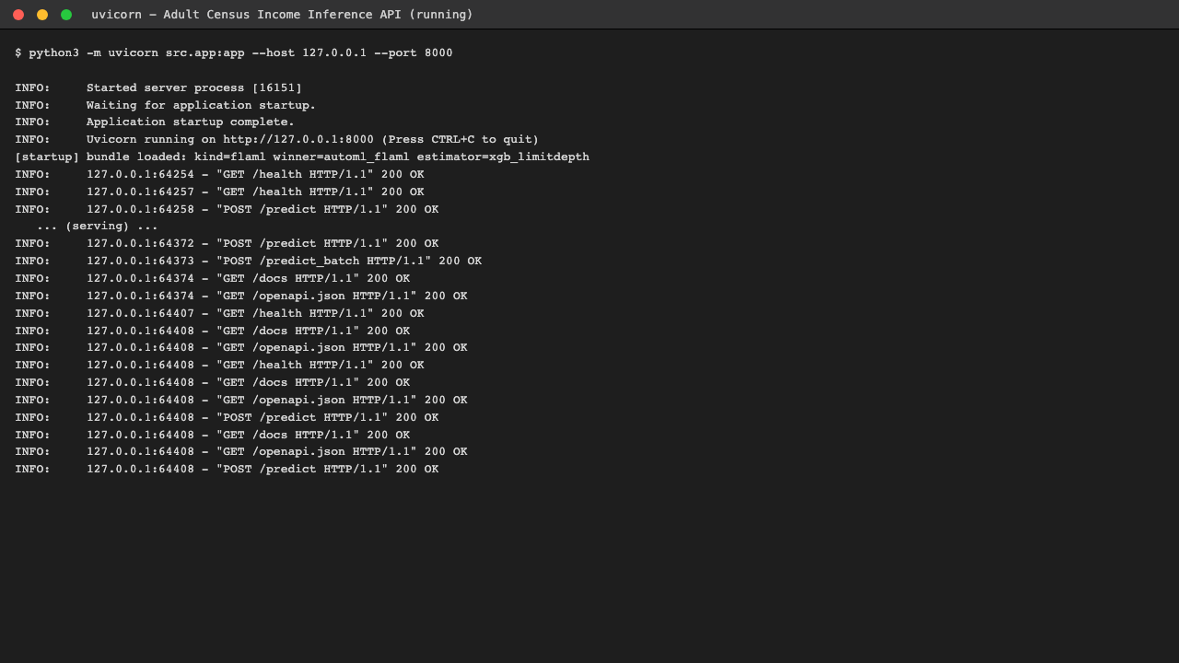
Screenshot 1 - uvicorn serving the model on 127.0.0.1:8000, with the startup log confirming which bundle was loaded and live request lines below.
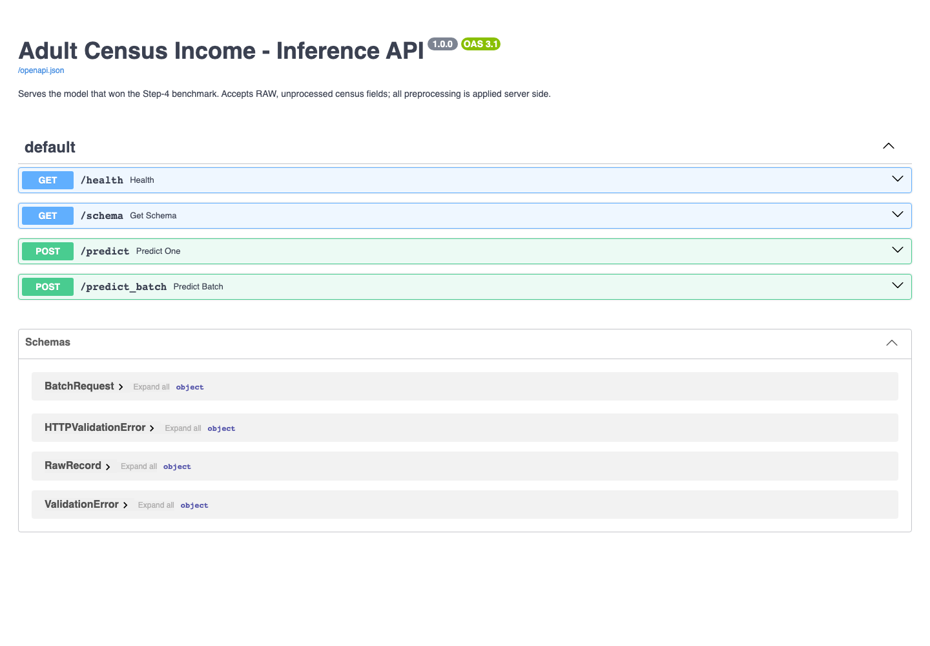
Screenshot 2 - the auto-generated Swagger UI at /docs showing all four endpoints.
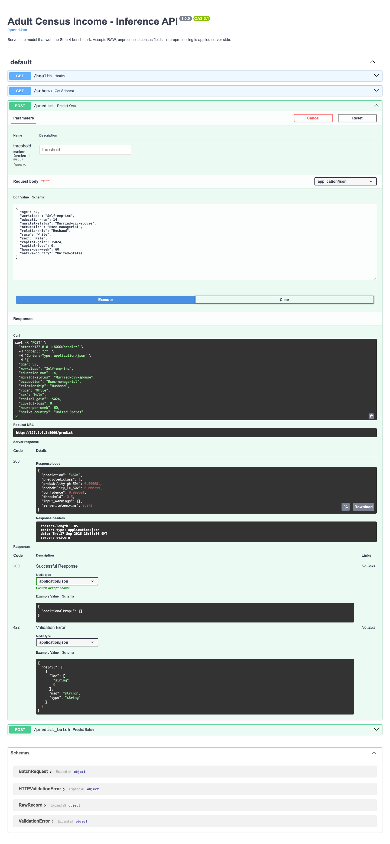
Screenshot 3 - a real POST /predict executed from the browser: the senior executive record returns >50K at probability 0.9996.
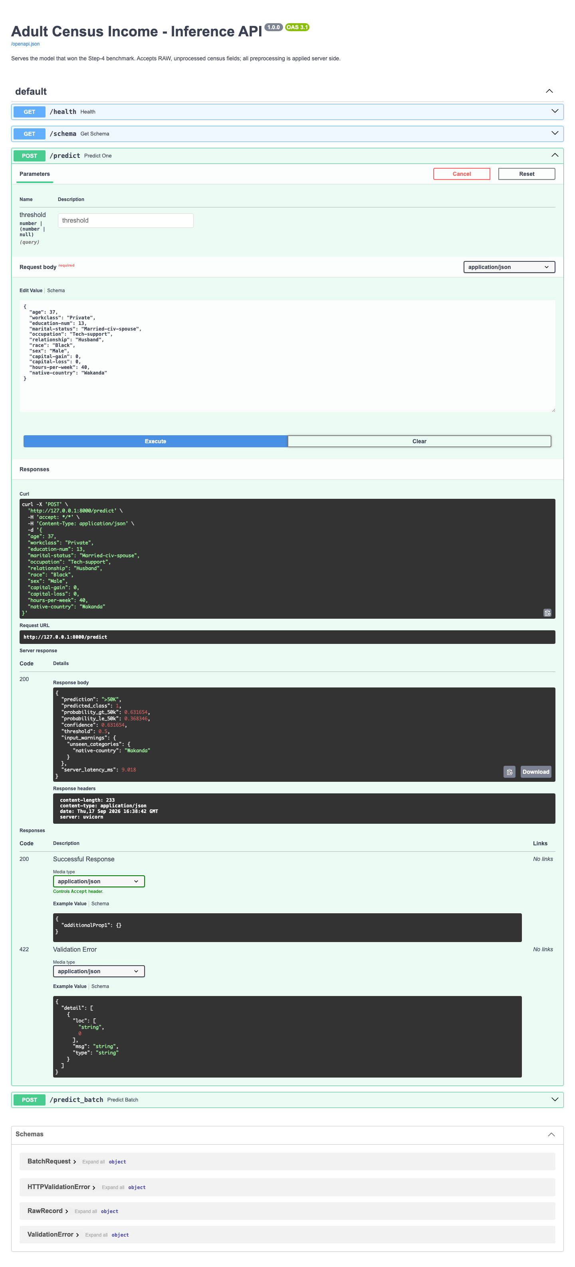
Screenshot 4 - the unseen-category case executed live: native-country='Wakanda' returns HTTP 200 with a prediction and an explicit unseen_categories warning.
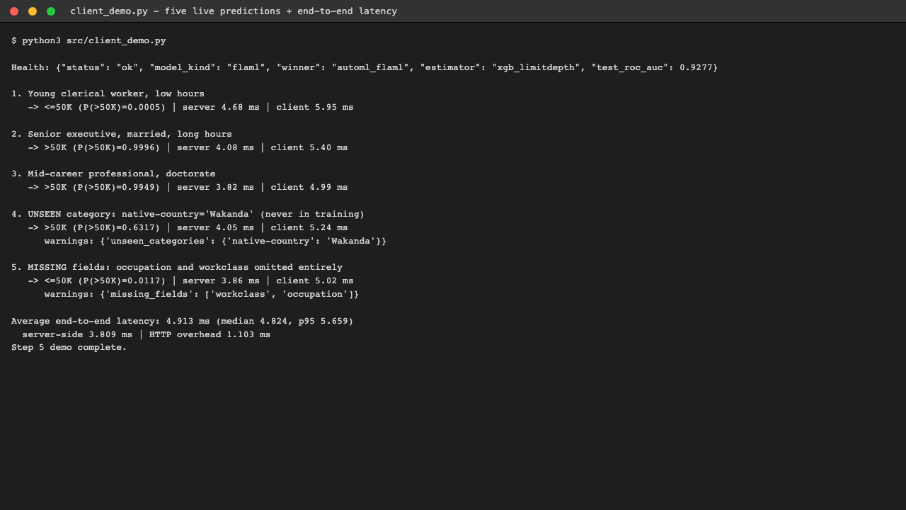
Screenshot 5 - client_demo.py driving the live API: five predictions and the end-to-end latency measurement.
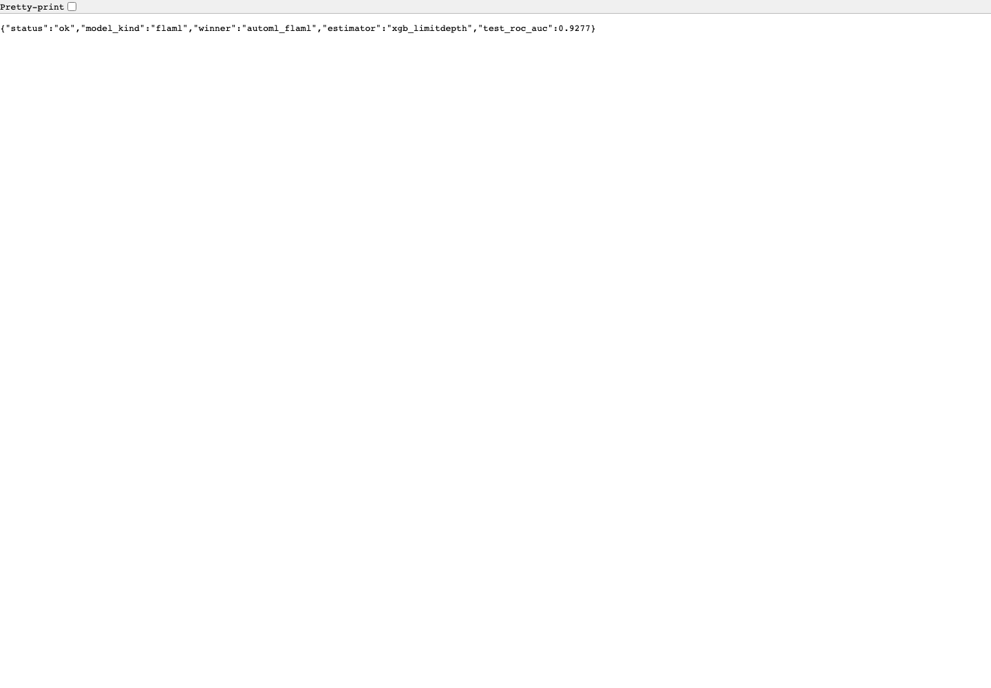
Screenshot 6 - the /health endpoint reporting the loaded model and its test ROC-AUC.

Assumptions Made, and Why
1. The two shipped files can be pooled and re-split.
adult.data and adult.test are drawn from the same 1994 census extract and share a schema, so pooling them does not mix populations. Re-splitting buys a validation set and reproducibility. Risk accepted: my scores are not comparable to papers using the original partition.
2. fnlwgt is not a legitimate predictor.
It is a survey sampling weight describing how many people in the population the row stands for. Using it would let the model exploit census design rather than personal attributes. I dropped it rather than testing whether it helps, because a gain from it would be a leak, not a finding.
3. education and education-num are redundant.
They are two encodings of one variable. I verified the mapping is one-to-one and kept the ordinal form, which preserves the ordering that one-hot would discard.
4. Missingness in workclass/occupation is informative, not random.
The '?' rows concentrate among the retired and never-worked. I encode 'Missing' as its own level rather than imputing the mode, which would both invent data and erase signal.
5. A 0.5 decision threshold is the right default.
No cost matrix was given, so I have no basis for preferring false positives over false negatives. I kept 0.5 for every model so the comparison is like-for-like, and reported ROC-AUC alongside it precisely because it is threshold-free. With a real cost matrix I would tune the threshold on validation data.
6. ROC-AUC is the primary selection metric.
At 24/76 imbalance, accuracy is dominated by the majority class - a model predicting '<=50K' always scores 76%. ROC-AUC measures ranking quality independent of both the threshold and the class ratio.
7. A 300-second FLAML budget is enough to be representative.
Its best score plateaued well before the budget expired, so a longer run would be unlikely to change the ordering. A budget was necessary at all to make 'training time' a comparable quantity.
8. The manual sweep's training time is the fair counterpart to FLAML's budget.
I report both the final-model fit time and the total search time, because the 300 seconds FLAML spent searching is the analogue of my twelve training runs, not of one of them.
9. CPU-only timing is representative for this deployment.
The service is a localhost/Colab demo. Both models are small enough that CPU inference is the realistic serving mode; a GPU would change the absolute numbers but would favour the network, so my latency comparison is if anything conservative toward AutoML.
10. Single-row latency is the metric that matters for serving.
An API receives one record per call. I report batch throughput too, but the single-row number is what determines the user-visible response time.
11. The deployable artefact is model + preprocessing, not the search object.
FLAML's pickled AutoML object is 33.8 MB, but most of that is search state. Reporting that as 'model size' would unfairly penalise AutoML, so I export and measure the lean 13.9 MB bundle that is actually served.

Tools Used, and Why
Tool | Role | Why I chose it
Python 3.9 | Language | The environment available; every library below supports it.
PyTorch 2.8.0 | Deep learning | Step 2 requires my own training loop. PyTorch's define-by-run style makes the forward/backward/step cycle explicit code I wrote rather than a framework callback, which is what the assignment is testing. Chosen over TensorFlow/Keras because Keras's model.fit() would have hidden exactly the loop I was asked to implement.
scikit-learn 1.6.1 | Preprocessing, splitting, metrics | ColumnTransformer + Pipeline give one fitted object that carries every preprocessing decision, which is what makes the Step-5 export honest - the served pipeline is literally the fitted training pipeline. Also provides stratified splitting and all the metrics.
FLAML 2.3.6 | AutoML | Installs cleanly on Python 3.9 / Apple Silicon (auto-sklearn does not); takes an explicit time budget, making the training-time comparison bounded and meaningful; lighter than AutoGluon, whose default stacked ensembles would have confounded 'AutoML found a better model' with 'an ensemble of twenty models beats one model'.
XGBoost 2.1.4 / LightGBM 4.6.0 | Search space for FLAML | Pulled in as FLAML's estimator families; xgb_limitdepth won the search.
pandas 2.3.3 / NumPy 2.0.2 | Data handling | Standard tabular and array tooling.
FastAPI 0.119 + Pydantic 2 | Serving | Pydantic validates the raw input contract at the edge and FastAPI generates the OpenAPI schema and Swagger UI automatically, which is what makes the deployment demonstrable in a browser without writing any front-end code.
uvicorn 0.39 | ASGI server | The standard production-grade server for FastAPI.
Matplotlib 3.9 / seaborn | Figures | Training curves, confusion matrices, ROC curves and the comparison charts.
joblib | Serialisation | Persists the fitted ColumnTransformer and the model bundle; handles the NumPy arrays inside scikit-learn objects more efficiently than plain pickle.
Playwright (headless Chromium) | Deployment screenshots | macOS blocked OS-level screen capture in my terminal environment, so I drove a headless browser against the live server to capture genuine renders of the running service rather than mock-ups.
python-docx | This report | The report is generated from the results JSON files, so every number in it is read from the experiment output and cannot drift from what the code actually produced.
requests | API client | Drives the five live predictions and the latency benchmark.
AI assistance (Claude) | Code scaffolding and review | Used to scaffold boilerplate and review the pipeline, as the assignment permits. The experimental design, the fairness decisions in Step 4, the noise-floor methodology in Step 3, the diagnosis of the FLAML category-code bug, and all interpretation in this report are my own; every number here was produced by running the code in this submission.

Conclusion and Reflection
On the Adult Census Income dataset, an AutoML-selected gradient-boosted tree beat the neural network I designed and tuned by hand: 0.9277 against 0.9110 test ROC-AUC, and 0.7097 against 0.6593 F1. The margin is small in absolute terms but comfortably outside the noise band I measured, so I treat it as real. The deployed service answers in 4.913 ms per request end to end.
What I would take away from this:
- Measure the noise floor before claiming a factor matters. My first tuning table looked like five factors with tiny differences; retraining one configuration under three seeds showed that four of those differences were smaller than random variation. Without that check I would have confidently reported a ranking of pure noise.
- A careless ablation flatters the thing you are ablating. My first 'no early stopping' run still restored best-validation weights, so it silently kept early stopping's main benefit and showed no effect. Fixing it changed the headline conclusion of Step 3: regularisation went from indistinguishable to the single dominant factor.
- AutoML is not a black box you can skip reading. Two of its defaults (retrain_full, internal re-splitting) would have quietly invalidated the comparison, one leaderboard entry was broken rather than merely weak, and its inference path had a correctness bug that only showed up under the single-row access pattern that production actually uses.
- Accuracy is not the whole decision. AutoML won on quality; the network won on size, latency and search cost. Which one I would actually ship depends on the serving budget, and I said so explicitly rather than treating the highest AUC as automatically correct.
- Preprocessing choices made in Step 1 paid off in Step 5. Encoding missingness as a category and setting handle_unknown='ignore' were decisions about training, but they are what let the deployed service survive malformed input without special-case code.
If I continued this work, the highest-value next steps would be threshold tuning against an explicit cost matrix (recall is the clear weak point of both models), feature engineering for the MLP - which is the sort of thing a network needs and trees do for free - and calibration analysis, since these probabilities are currently served to a caller without any check that they mean what they claim.

